# Simulation Experiment Report on Polymer Chain Conformations

## Abstract

This report outlines the computational simulation conducted to analyze the properties of polymer chains in a three-dimensional space. The objective was to understand how varying the number of segments (N) affects the mean squared end-to-end distance of the chains, potentially revealing insights into polymer physics and material science.

## Introduction

Polymer chains consist of repeated units and their behavior in different conditions is a fundamental topic in material science. The end-to-end distance is a critical parameter in the characterization of polymer chains, influencing their mechanical and thermal properties. This simulation aimed to investigate the behavior of polymer chains by varying the number of segments under theoretical random orientations.

## Methods

A Python script was developed to generate 2000 instances of polymer chains for each specified segment length (N=10, 50, 100, 200, 400). Each segment was assigned a random orientation in 3D space. The simulation calculated the end-to-end distance and its square, averaged over all instances, to compute the mean squared end-to-end distance (h2(N)). Visualization of 50 random chain conformations for each N was created and analyzed.

## Results

The results demonstrate a scaling behavior of the mean squared end-to-end distance with respect to the number of segments. The scaling exponent calculated from the data was approximately 1.03, suggesting a direct proportionality with N, indicative of a random coil conformation in three dimensions. Below are representative plots for each set of segment lengths examined.

Fig. 1: 3D Conformations for N=10

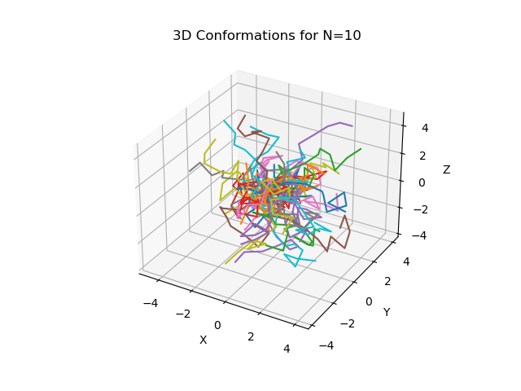

Fig. 5: 3D Conformations for N=50

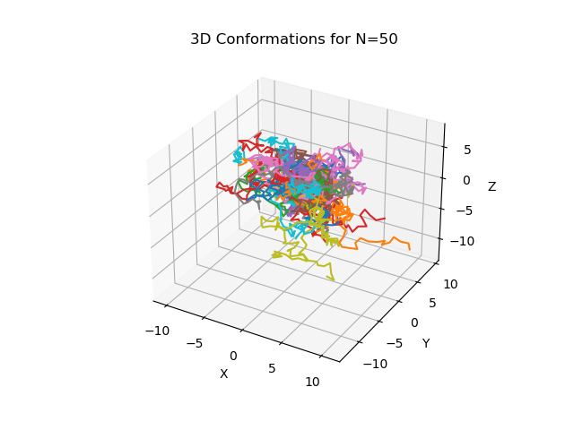

Fig. 10: 3D Conformations for N=100

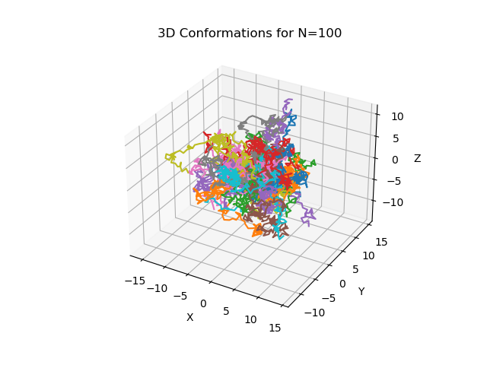

Fig. 20: 3D Conformations for N=200

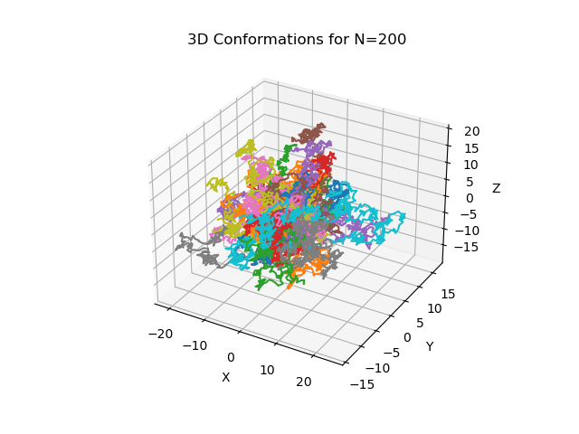

Fig. 40: 3D Conformations for N=400

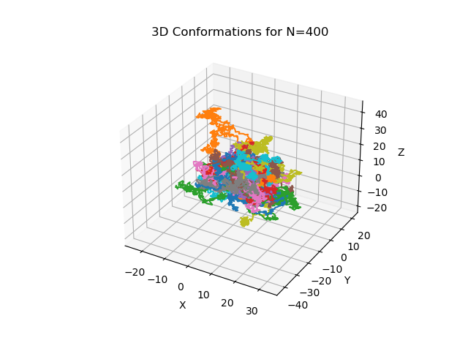

Fig. 6: Mean Squared End-to-End Distance vs N

