# Simulation Experiment Report on Polymer Chains

## Abstract

This report outlines a simulation experiment designed to investigate the behavior of polymer chains in 3D space. The experiment calculates the mean squared end-to-end distance of polymer chains for various segment lengths and examines the scaling behavior of these distances as a function of the number of segments.

## Introduction

Polymer chain modeling is pivotal in understanding material properties at the molecular level. In this experiment, we simulate the random configuration of polymer chains in a three-dimensional space. The objective is to explore how the chain length affects the spatial configuration, quantified by the end-to-end distance.

## Methods

We implemented the simulation using Python. This involved generating unit vectors representing polymer segments randomly oriented in 3D space. For each polymer chain, consisting of segments numbering 10, 50, 100, 200, and 400, we calculated the mean squared end-to-end distance using numpy for vector arithmetic and matplotlib for visual representation.

## Results

The results reveal that the mean squared end-to-end distance increases with the number of segments, following a scaling relation. Plots of these polymer chain conformations and their corresponding end-to-end distances can be found in Figures 1 through 6.

Figure 1: Chain3D10.png

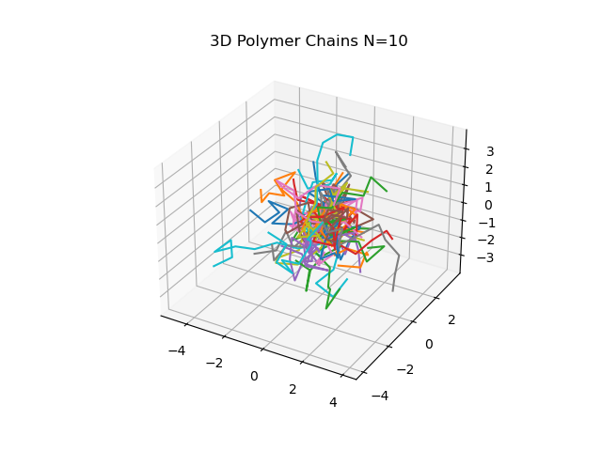

Figure 2: Chain3D50.png

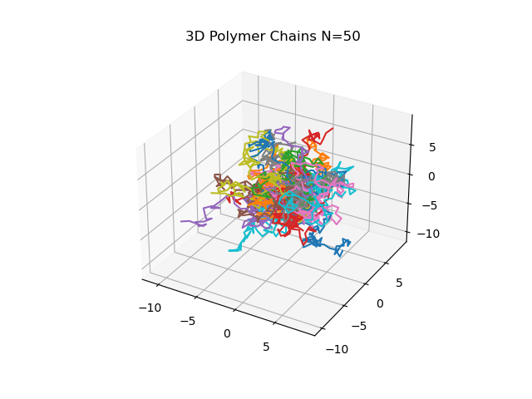

Figure 3: Chain3D100.png

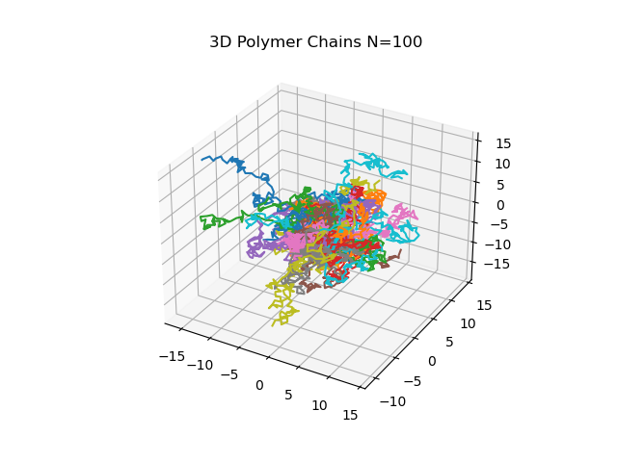

Figure 4: Chain3D200.png

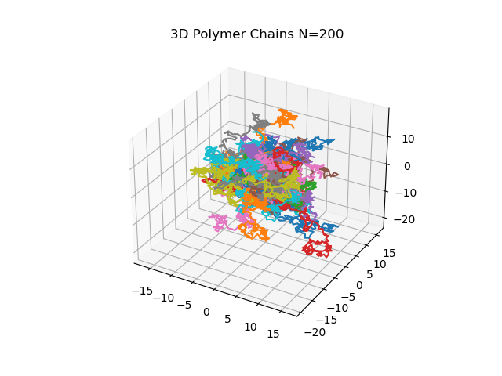

Figure 5: Chain3D400.png

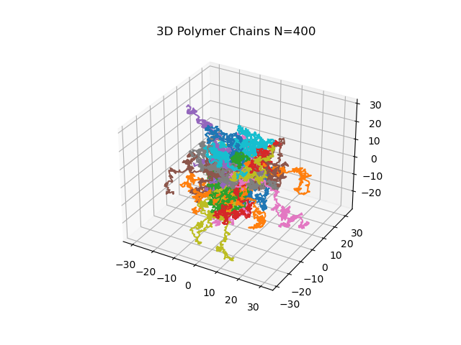

Figure 6: h2vsN.png

