# Polymer Chain Simulation Report

## Abstract

This report provides a detailed analysis of polymer chain simulations. The goal was to explore the end-to-end distance in polymer chains as a function of their segment length. We aimed to understand how the mean squared end-to-end distance scales with the number of segments.

## Introduction

Polymer chains are crucial in various applications across multiple industries. This simulation investigates the physical properties of polymer chains as they relate to chain length. Through statistical modeling and 3D visualization, we aim to gain insights into the scaling relationships of polymers.

## Methods

We employed a Monte Carlo simulation approach to generate random polymer chains in three dimensions. Each chain consists of N segments, and the orientation of each segment was assigned randomly based on a uniform distribution of angles. Our analysis includes polymer chains with lengths of 10, 50, 100, 200, and 400 segments. Python and NumPy were used for computations, while Matplotlib was utilized for generating visualizations.

## Results

The mean squared end-to-end distance was computed for each chain, and the results were plotted against chain length. Chain conformations were visualized to contribute further to our understanding. Refer to the figures below showing the scaling relationships and sample polymer chain conformations.

Fig. Chain3D10: Visualization for N=10

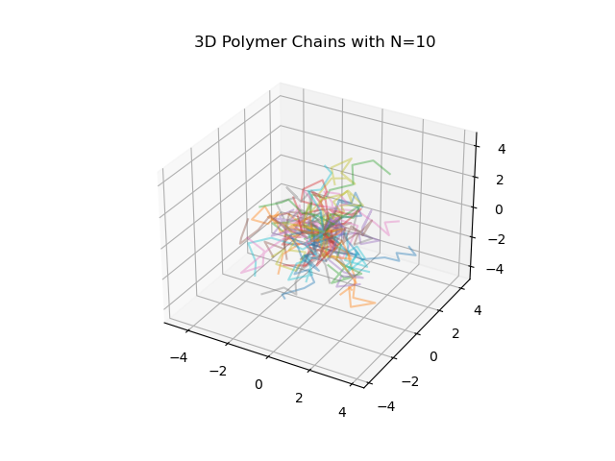

Fig. Chain3D50: Visualization for N=50

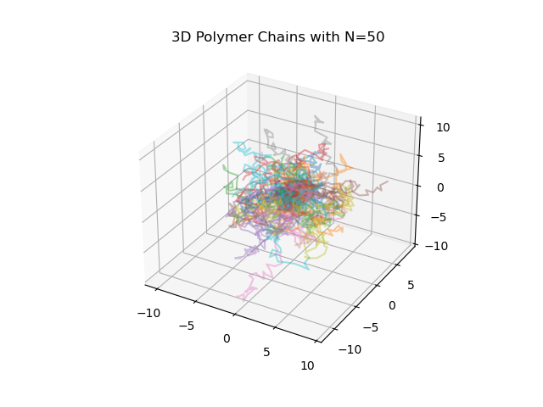

Fig. Chain3D100: Visualization for N=100

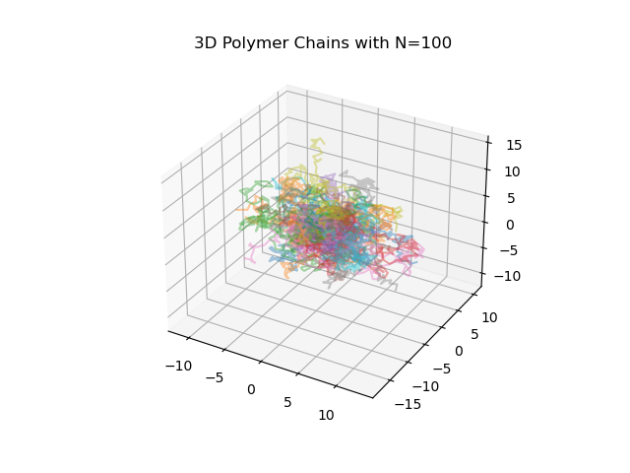

Fig. Chain3D200: Visualization for N=200

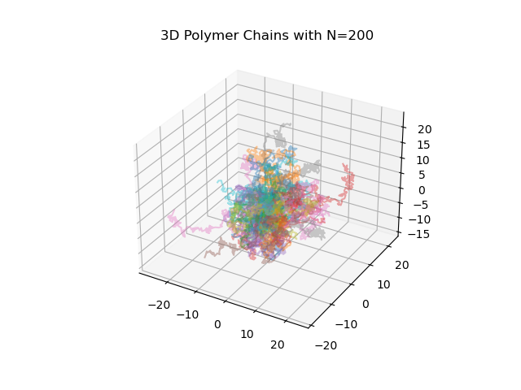

Fig. Chain3D400: Visualization for N=400

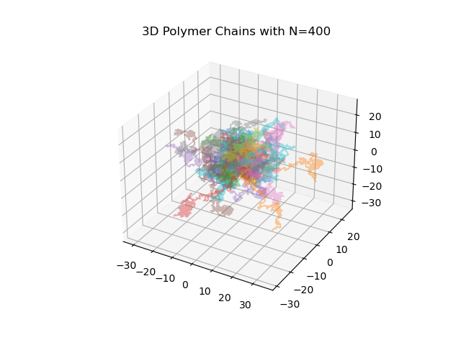

Fig. h2vsN: Visualization for N=all lengths

