# Simulation Experiment Report on Polymer Chains

## Abstract

This report summarises the findings from a simulation study of polymer chains, focusing on their three-dimensional configurations and the scaling of end-to-end distances. The analysis employs computational simulations to explore the behavior of polymer chains with varying segment lengths.

## Introduction

Polymer chain analysis in three-dimensional space is crucial for understanding the microscopic properties of polymers. This simulation experiment aimed to investigate the mean squared end-to-end distance as a function of segment number, illustrating fundamental properties of polymers in solution.

## Methods

Using a Python script, 2000 polymer chains for each specified segment length (N=10, 50, 100, 200, 400) were generated. Each segment of these chains was randomly oriented in 3D space. The end-to-end distance was calculated for each chain, and these values were used to derive the mean squared end-to-end distances and to analyze scaling behaviors.

## Results

The simulation findings reveal a consistent scaling relationship demonstrated through the mean squared end-to-end distance. The plots below illustrate the polymer configurations for different segment numbers and the logarithmic plot of mean squared end-to-end distance against segment number.

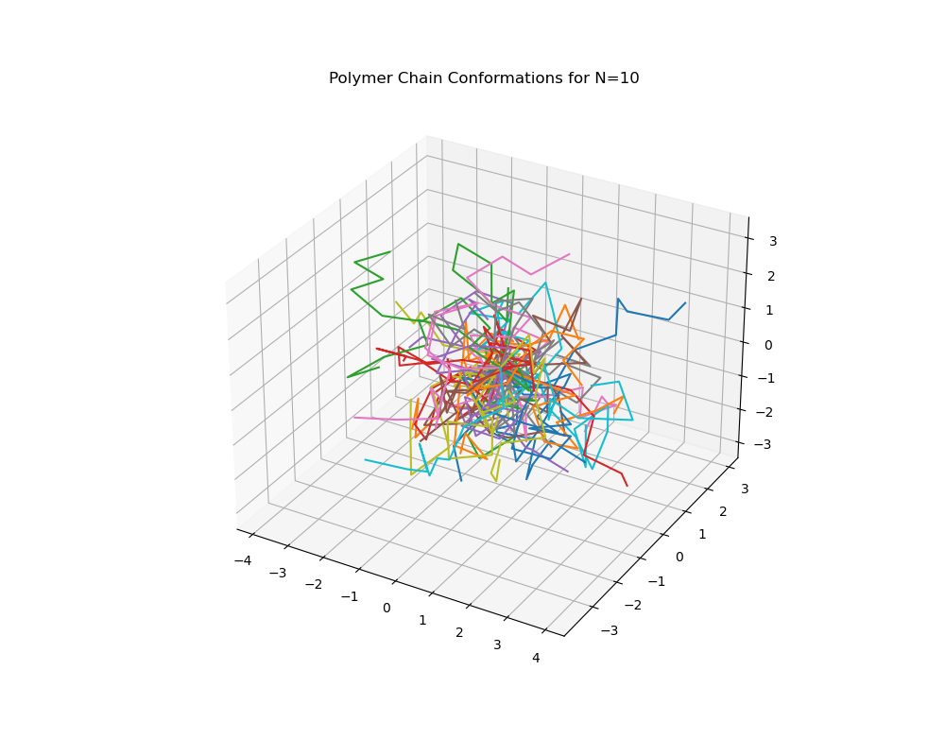

Figure: Chain configurations with N=10 segments.

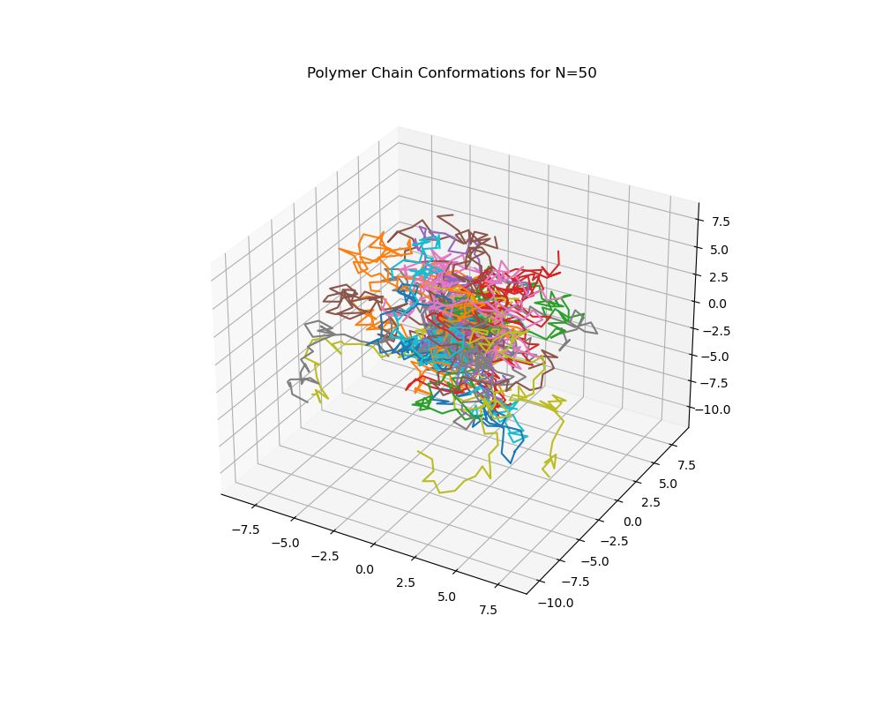

Figure: Chain configurations with N=50 segments.

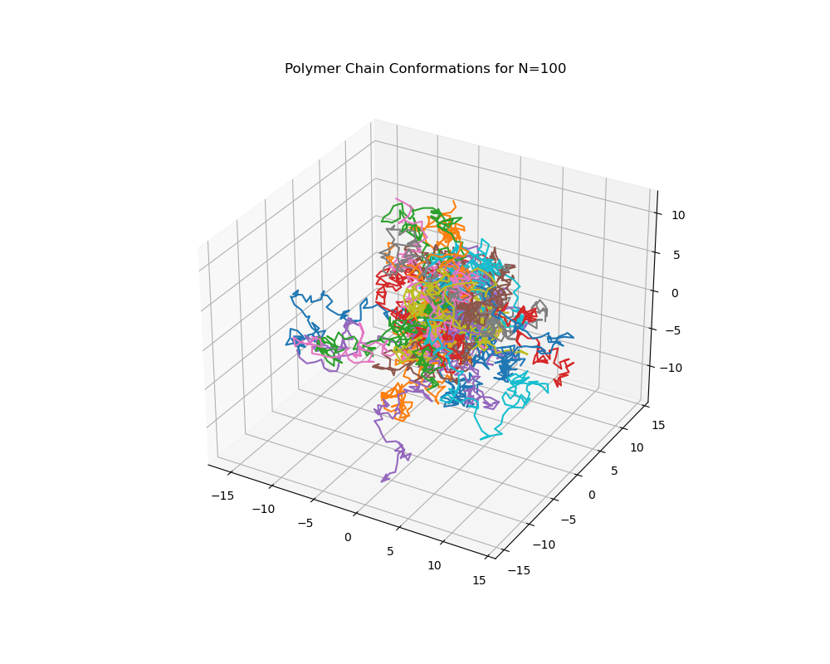

Figure: Chain configurations with N=100 segments.

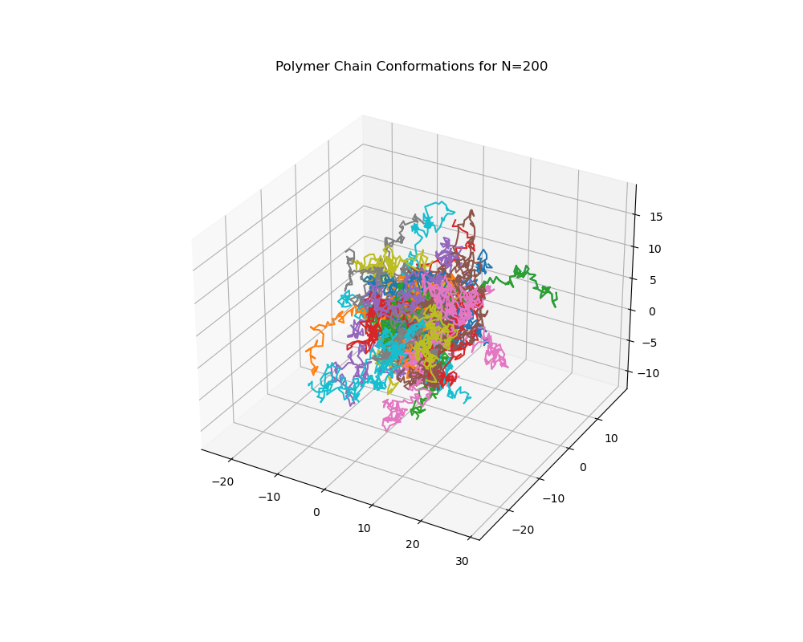

Figure: Chain configurations with N=200 segments.

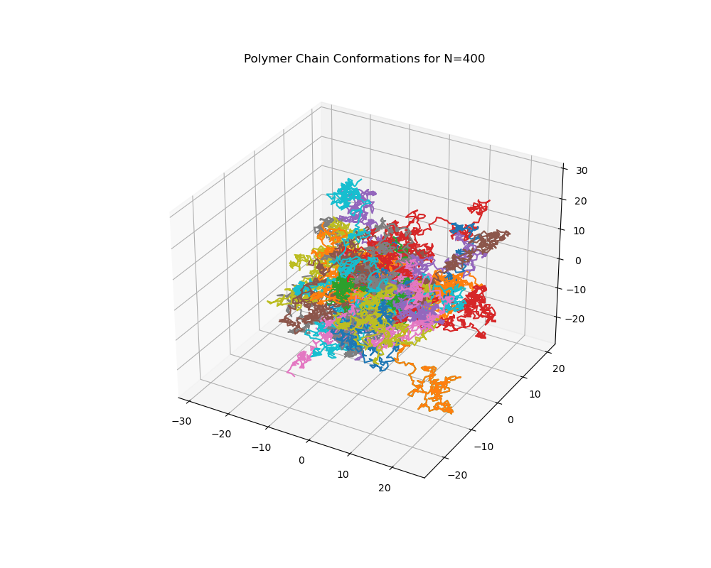

Figure: Chain configurations with N=400 segments.