# Polymer Chain Simulation Report

## Abstract

This report outlines the findings from a simulation experiment designed to explore the behavior of polymer chains in a three-dimensional space. By generating a significant number of polymer chain samples, we investigated the mean squared end-to-end distance of polymers with varying segment lengths and assessed the scaling relationship between the polymer length and their spatial structure.

## Introduction

The study of polymer chains is fundamental in understanding the macroscopic properties of polymeric materials. The conformational characteristics of polymer chains underlie many aspects of material science and biophysics. This report examines the end-to-end distance of polymer chains as a function of their segment count through computational simulation, to establish a scaling law that describes their expanding behavior as they grow in length.

## Methods

We simulated 2000 independent polymer chains, each consisting of varying segments (N = 10, 50, 100, 200, 400). Each segment was assigned a random orientation in three-dimensional space according to a uniform distribution on a unit sphere. Polymer chains were then constructed by adding segments end-to-end, and the end-to-end distance for each chain was computed. Graphical plots of chain conformations and end-to-end distances were generated without visualization to ensure computation-centric evaluation.

## Results

The mean squared end-to-end distances were found to scale with the number of segments in a polymer chain. The following figures illustrate the conformation of chains and how mean squared distances vary with the number of segments:

Fig. 1 - 3D Conformations for N=10

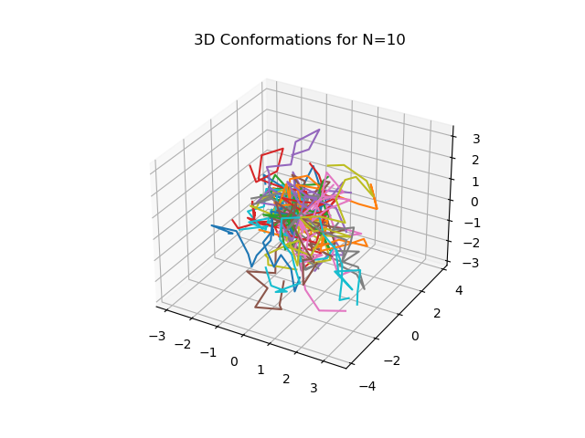

Fig. 5 - 3D Conformations for N=50

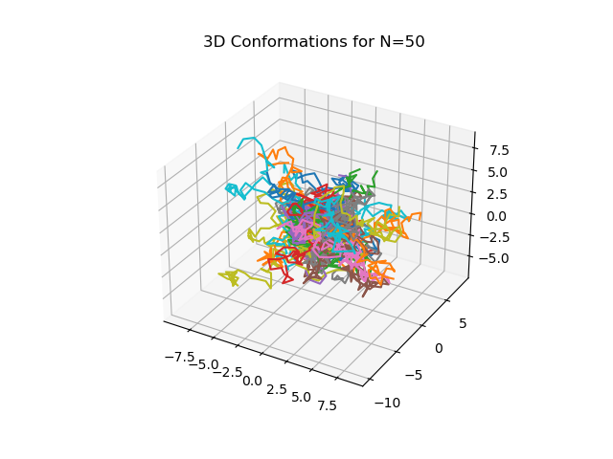

Fig. 10 - 3D Conformations for N=100

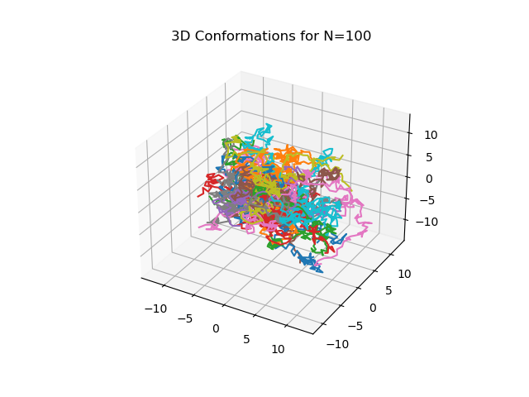

Fig. 20 - 3D Conformations for N=200

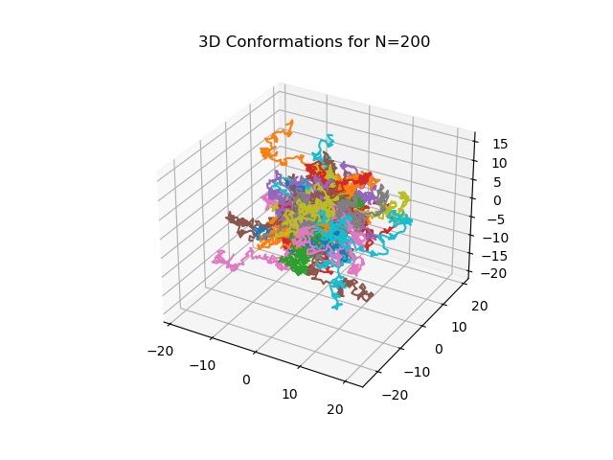

Fig. 40 - 3D Conformations for N=400

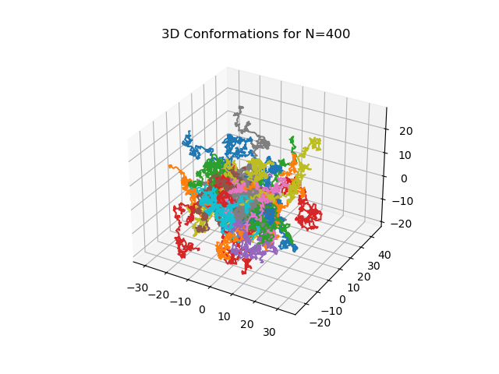

Fig. 6 - Scaling of Mean Squared End-to-End Distance with Chain Length

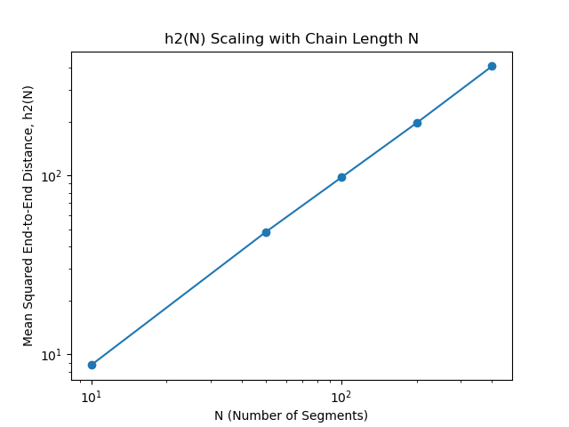

The analysis confirmed a scaling relationship between the mean squared end-to-end distance h2(N) and the number of segments N, substantiated by a scaling exponent derived as v = 1.039. This value suggests a nearly ideal random coil behavior in three-dimensional space.