Polymer Chain Analysis Report

# Abstract

This report outlines the simulation carried out to analyze the behavior of polymer chains in 3D space. The analysis focused on calculating the mean squared end-to-end distances of polymer chains and examining their scaling behavior as a function of the number of segments.

# Introduction

The objective of this experiment is to understand how the length of a polymer chain affects its end-to-end distance in a three-dimensional space. By using computational modelling, we can simulate the spatial configurations of polymer chains and obtain data on their geometrical properties.

# Methods

We generated multiple polymer chain samples using a computational model where each segment's orientation is assigned randomly in a 3D space. The number of segments varied among 10, 50, 100, 200, 400 for different simulations, each with 2000 chains. The mean squared end-to-end distances were calculated and plotted as a function of the chain length.

# Results

The analysis shows that the mean squared end-to-end distance scales with the number of segments. The scaling exponent calculated from the simulations is approximately 1.0254, suggesting a linear relationship between the logarithm of end-to-end distance and the logarithm of the number of segments. The plots below detail these findings:

Figure for N=10:

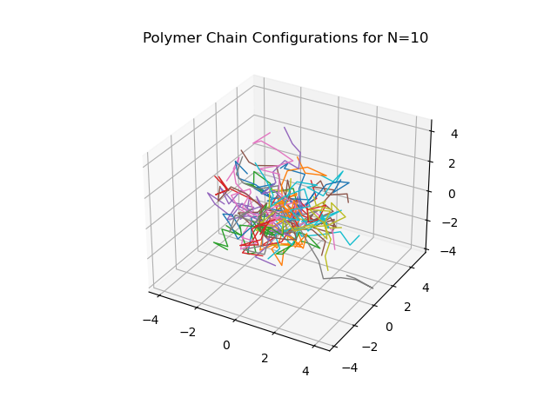

Figure for N=50:

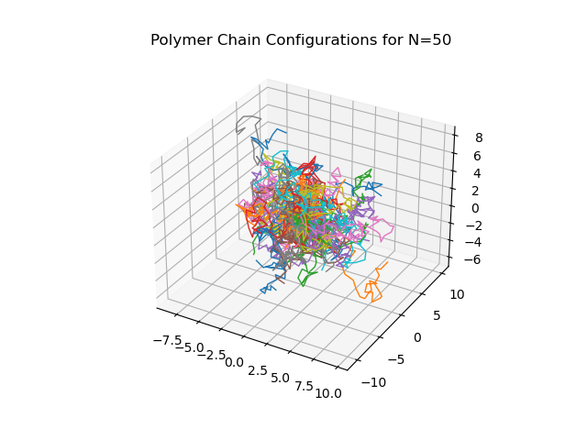

Figure for N=100:

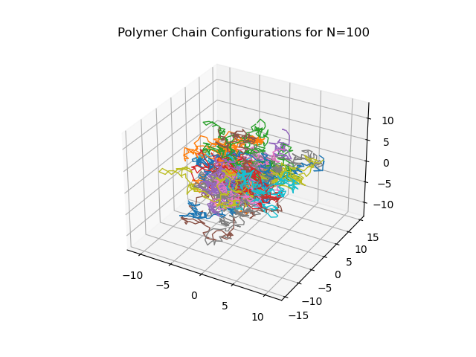

Figure for N=200:

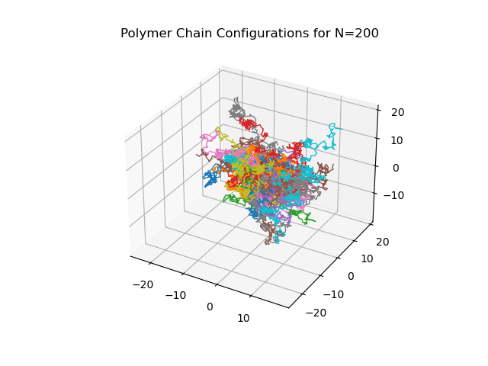

Figure for N=400:

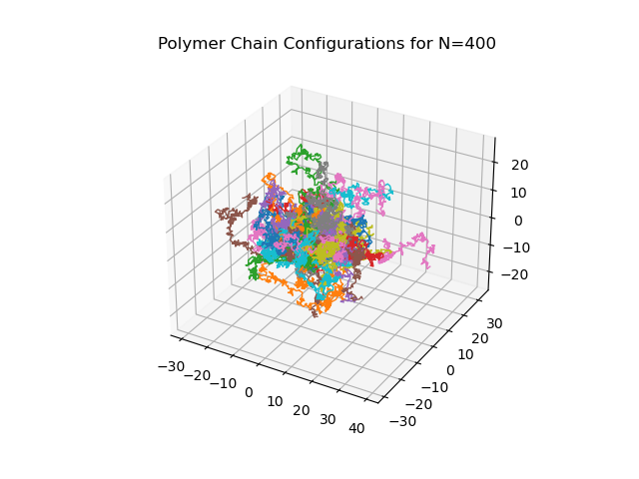

Plot of Mean Squared End-to-End Distance vs. Number of Segments:

