# Polymer Chain Simulation Report

## Abstract

This report outlines the stochastic simulation of polymer chains in a 3D space, focusing on observing the scaling behavior of polymers as a function of their segment length. The primary objective is to explore the mean squared end-to-end distance of polymers with varying segment counts.

## Introduction

Polymer chains are pivotal in various scientific and engineering applications. Understanding their physical behavior in space can aid in designing better materials. This study simulates polymer chains with randomly oriented segments in three-dimensional space and computes key statistical measures to analyze their structural properties.

## Methods

The study generated 2000 polymer chains with segment counts of 10, 50, 100, 200, and 400. Each segment's orientation was assigned randomly based upon a uniform spherical distribution. The Python programming language and libraries such as NumPy and Matplotlib were used for simulation and visualization purposes.

## Results

The results demonstrate a linear relationship between the mean squared end-to-end distance and the number of segments in the polymer chain.

See the figures below for graphical representations of the data.

Figure 1: Polymer Chain with 10 Segments

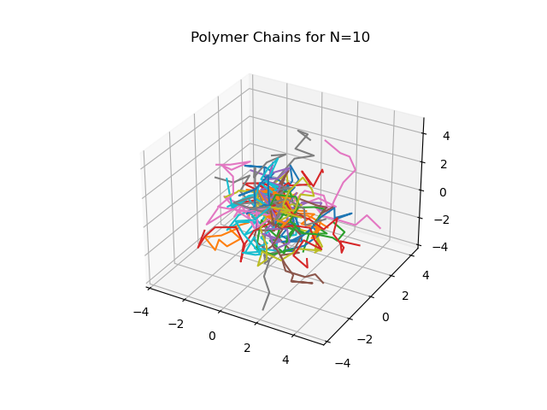

Figure 5: Polymer Chain with 50 Segments

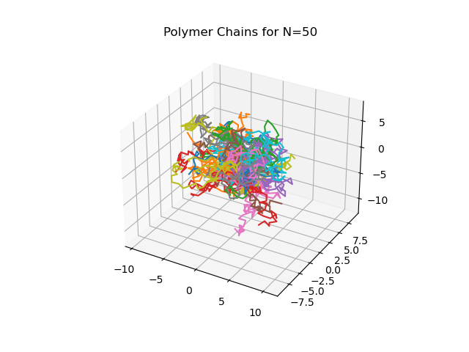

Figure 10: Polymer Chain with 100 Segments

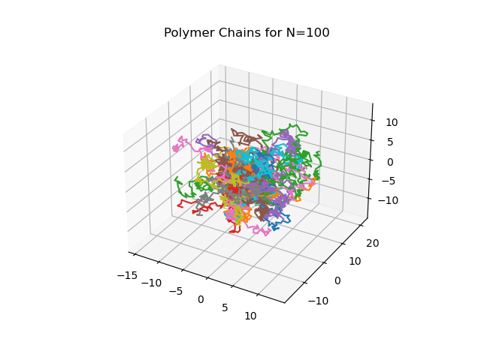

Figure 20: Polymer Chain with 200 Segments

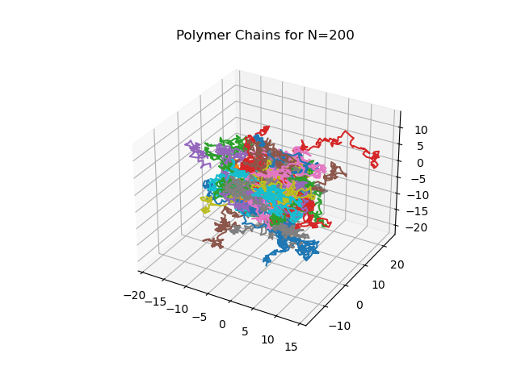

Figure 40: Polymer Chain with 400 Segments

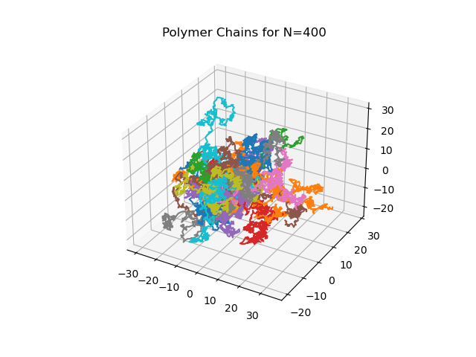

Figure 5: Mean Squared End-to-End Distance vs Number of Segments

