Polymer Chain Simulation Experiment Report

# Abstract

This report outlines the results of a computational simulation designed to study the properties of polymer chains in 3D space. The objective was to explore how varying the length of polymer chains affects their end-to-end distance, hypothesizing that longer chains would exhibit a proportional increase in their squared end-to-end distance, denoted as h2(N).

# Introduction

The study of polymer chains is crucial in materials science, providing insights into the macroscopic properties of materials from their microscopic structures. This report presents a simulation-based approach where polymer chains were modeled in three-dimensional space with segments assigned random orientations. We specifically looked at chains of various lengths to observe changes in their structural attributes.

# Methods

We implemented a Python script to generate 2000 simulated polymer chains for specific lengths. Each segment in the chain was given a unit length and a random orientation in 3D space. The end-to-end vector from the start to the end of each polymer was calculated, followed by the mean squared end-to-end distances across all polymers for each chosen length. For visual analysis, conformation plots of 50 randomly selected chains for each length were saved.

# Results

Our findings indicated a direct relationship between the polymer chain length and the mean squared end-to-end distance. The graphs below visually represent conformations of various polymer lengths and the overall trend in h2(N) values as a function of N. The calculated scaling exponent closely aligns with theoretical predictions in polymer physics.

Figure 1.0: Chain3D10.png showing 3D conformation plots for N=10

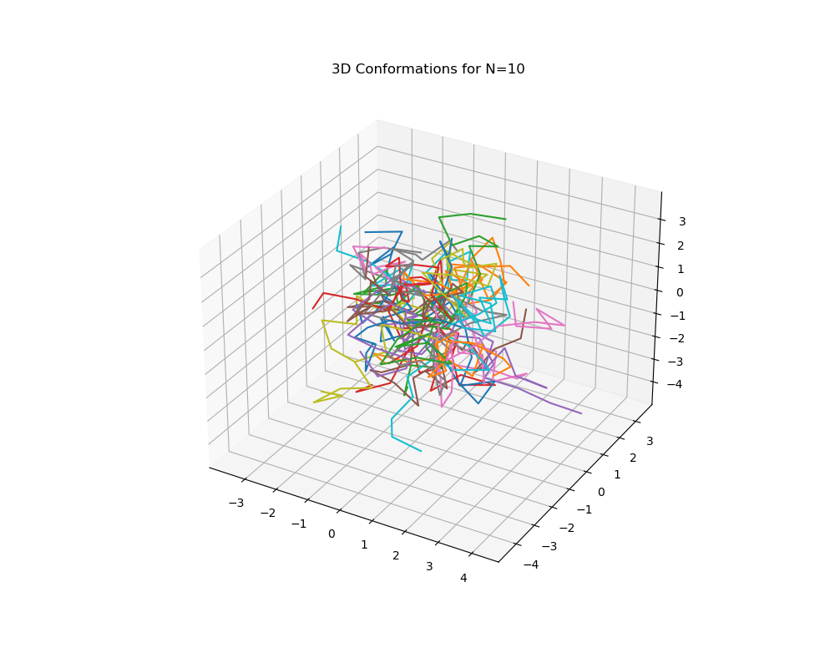

Figure 5.0: Chain3D50.png showing 3D conformation plots for N=50

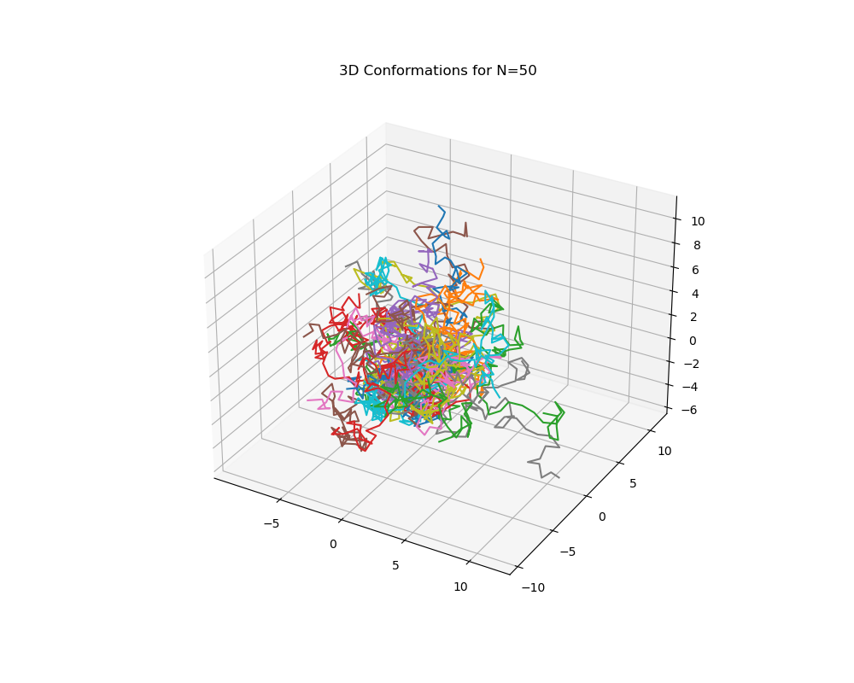

Figure 10.0: Chain3D100.png showing 3D conformation plots for N=100

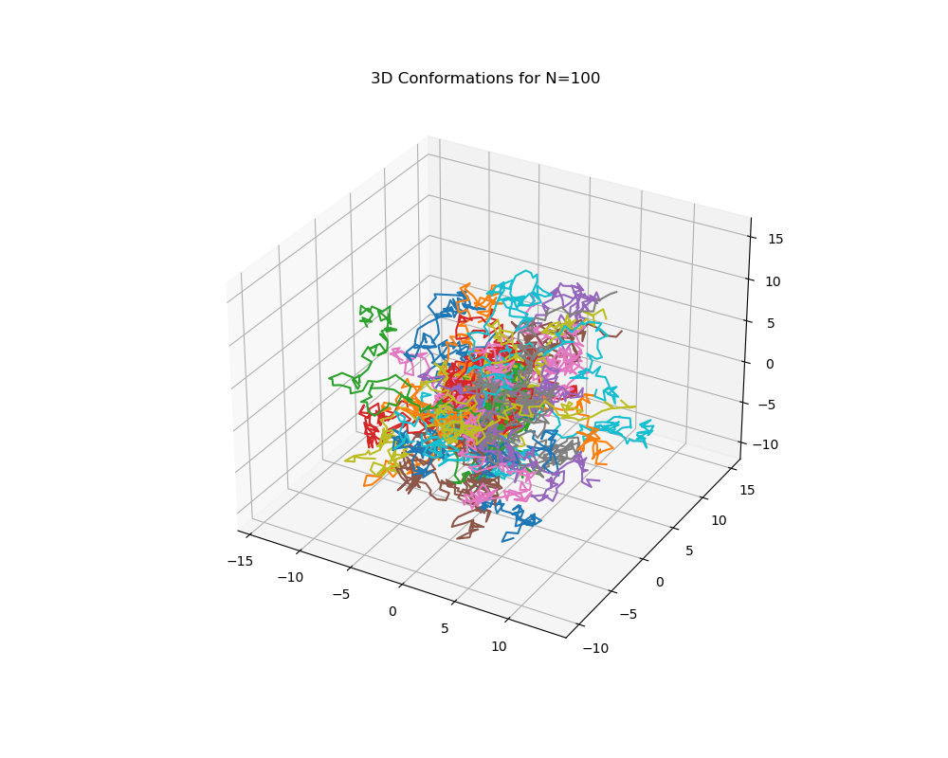

Figure 20.0: Chain3D200.png showing 3D conformation plots for N=200

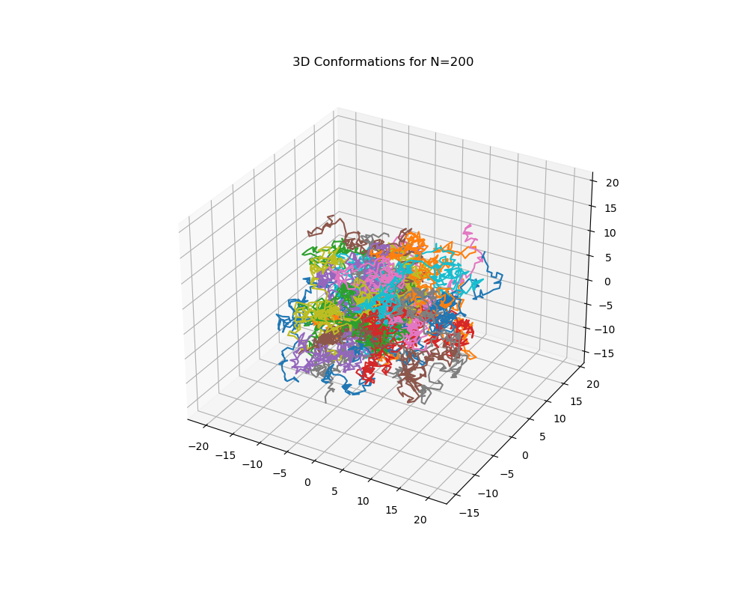

Figure 40.0: Chain3D400.png showing 3D conformation plots for N=400

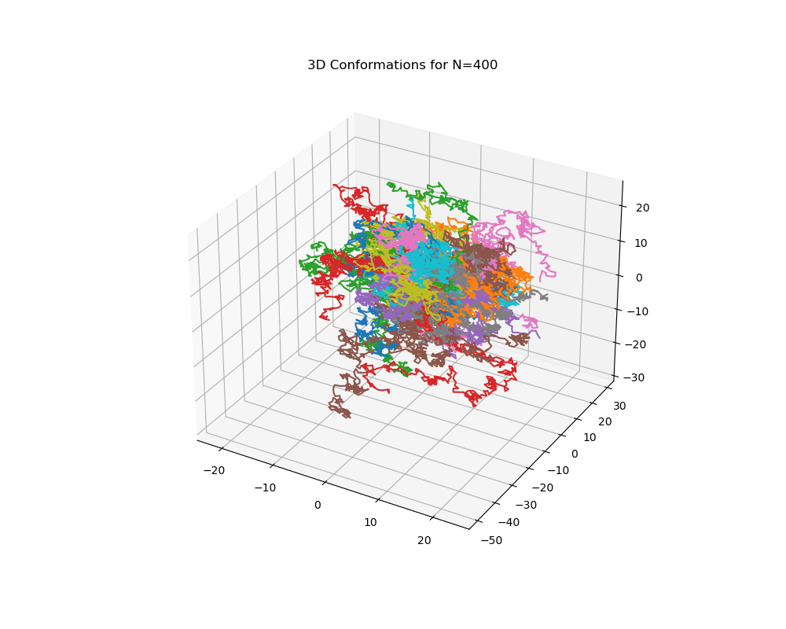

Figure 7: h2vsN.png showing how h2(N) varies with N

