# Polymer Chain Simulation Report

## Abstract

This report presents the findings from a computational experiment designed to simulate and analyze the behavior of 3D polymer chains. Each chain consists of segments with randomized orientations, and the aim was to determine the mean squared end-to-end distances and explore its scaling behaviors.

## Introduction

The study of polymer chains in three-dimensional space provides insight into the physical properties of materials at the molecular level. This simulation addresses the fundamental characteristics of polymer chains, particularly focusing on the statistical property of mean squared end-to-end distance.

## Methods

Using Python, 2000 simulations were performed for polymer chains with varying lengths. Each segment of the chain was assigned a random three-dimensional orientation. The simulation focused on five different chain lengths (N=10, 50, 100, 200, 400), computing the end-to-end distance vector for each polymer.

## Results

The mean squared end-to-ending distance was determined for each set and the scaling relationship was analyzed. The following figures illustrate various polymer chain configurations and the corresponding end-to-end distance statistics.

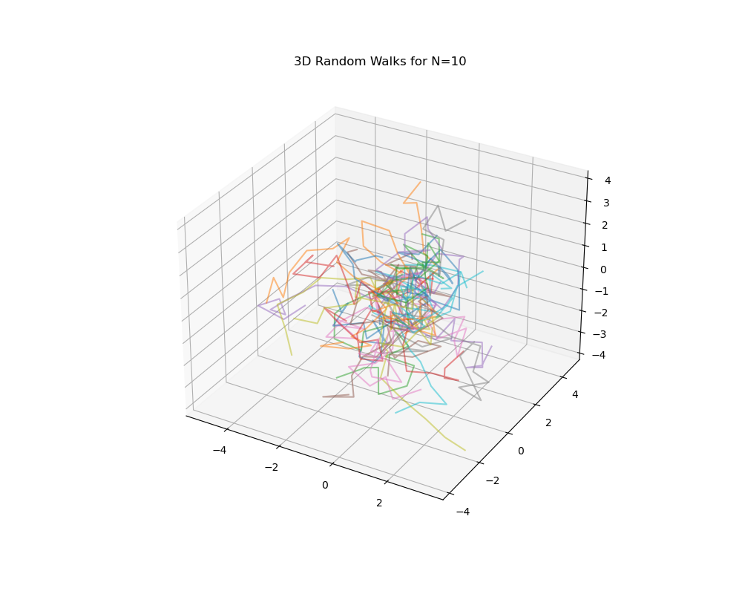

Fig. 0: Polymer Chain Simulation with N=10

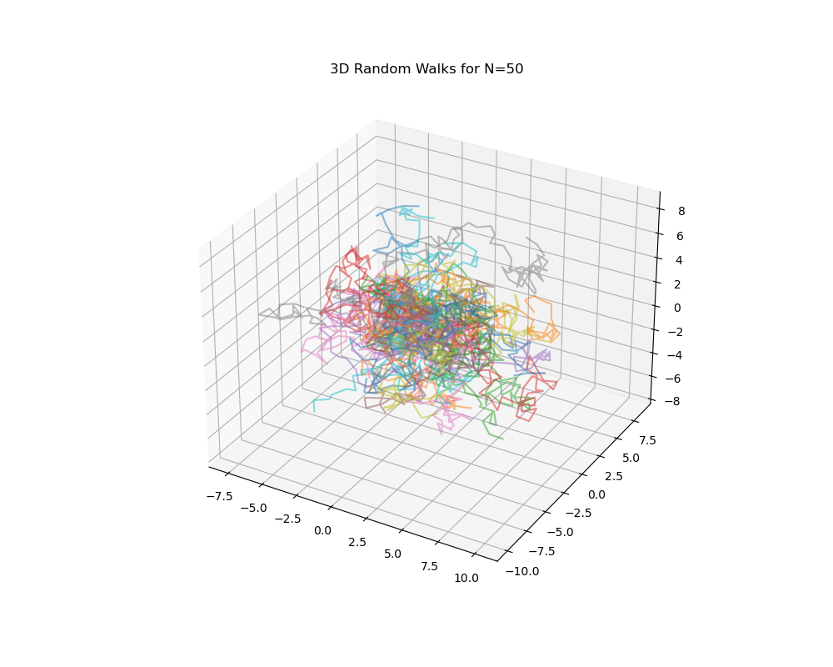

Fig. 4: Polymer Chain Simulation with N=50

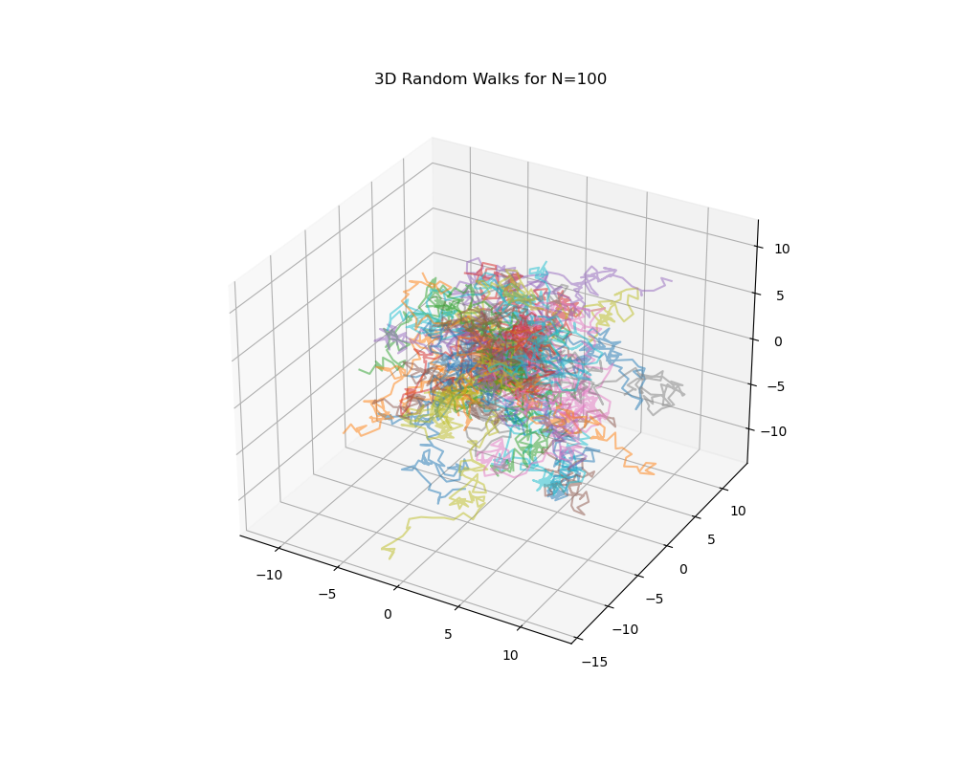

Fig. 9: Polymer Chain Simulation with N=100

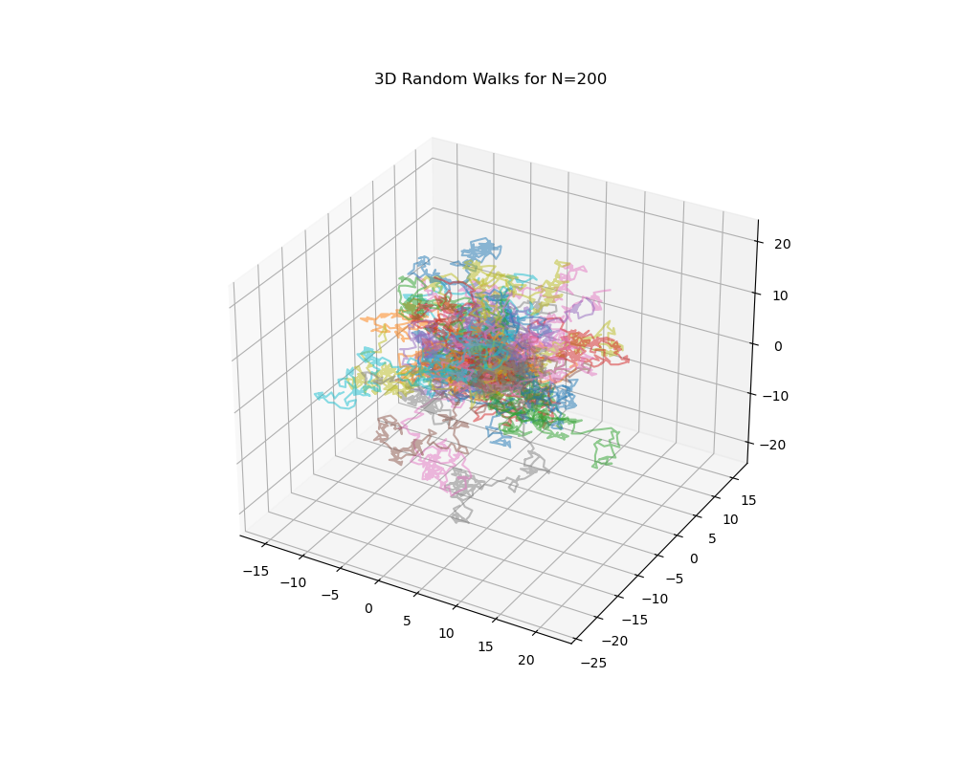

Fig. 19: Polymer Chain Simulation with N=200

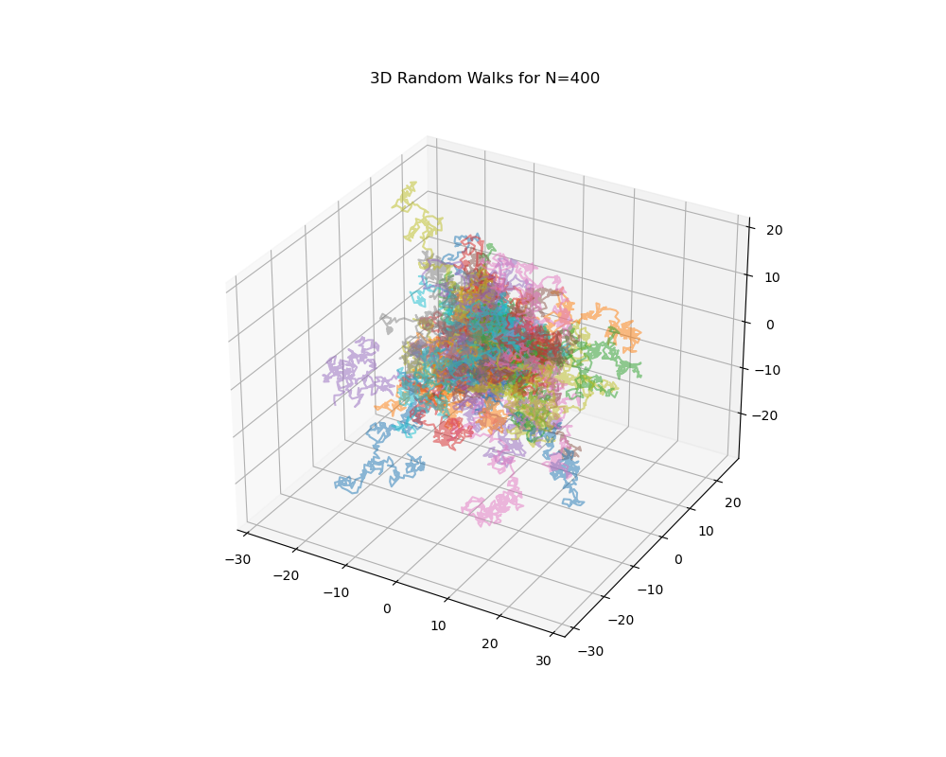

Fig. 39: Polymer Chain Simulation with N=400

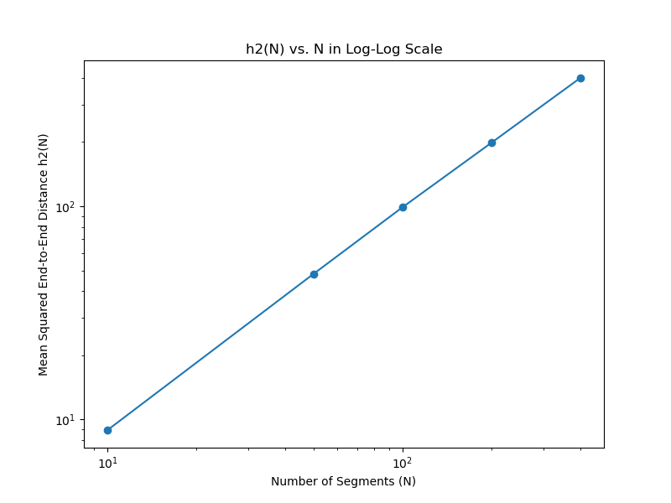

Fig. 5: Log-Log Plot of Mean Squared End-to-End Distance vs. Polymer Length