# Polymer Chain Simulation Report

## Abstract

This document outlines the results of a simulation experiment conducted to analyze the properties of polymer chains. Each polymer was modeled as a random walk in three dimensions, with chains consisting of varying lengths. The purpose of the experiment was to understand how the mean squared end-to-end distance of polymer chains scales with the number of segments in the chain.

## Introduction

The experiment aimed to investigate the behavior of polymer chains in 3D space. Polymer chains are essential in various applications, including materials science and biophysics, making understanding their structural properties critical. The focus was on how the chain length affects the spatial configuration, represented by the mean squared end-to-end distance.

## Methods

We simulated 2000 polymer chains for lengths of 10, 50, 100, 200, and 400 segments. Each segment was randomly oriented to simulate a true random walk in 3D space. The simulation code was written in Python, utilizing libraries such as NumPy for mathematical operations, and Matplotlib for visualization. The mean squared end-to-end distances were computed and analyzed.

## Results

The experiments provided insights into chain conformation as a function of chain length. The calculated scaling exponent of the mean squared end-to-end distance was approximately 0.986. This value indicates a nearly linear relationship between chain length and spatial extension in the conditions explored.

### Chain3D10

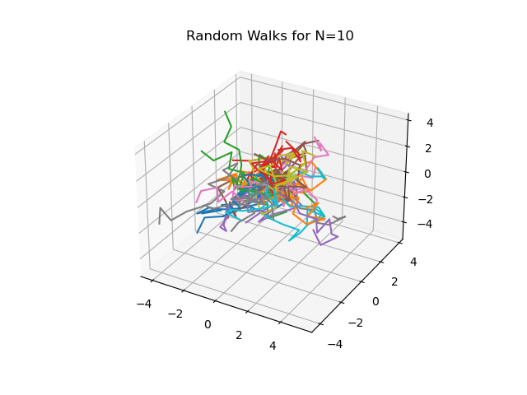

Figure: Chain3D10

### Chain3D100

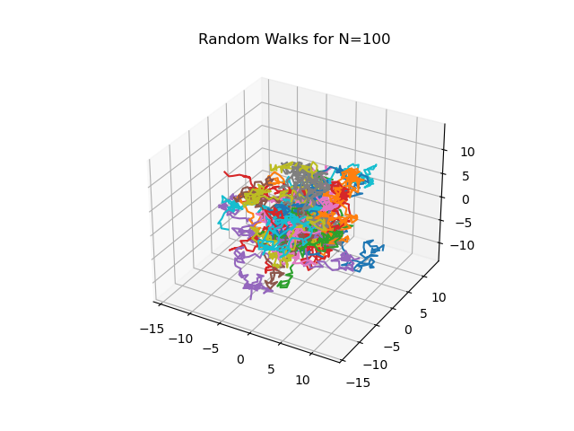

Figure: Chain3D100

### Chain3D200

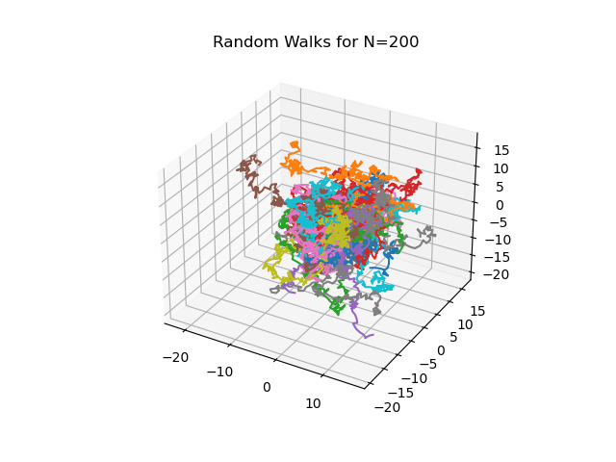

Figure: Chain3D200

### Chain3D400

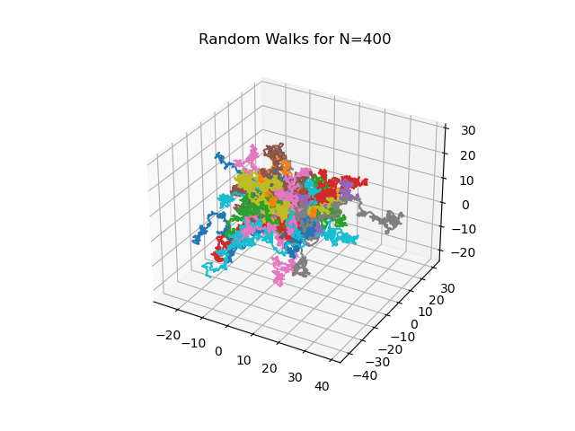

Figure: Chain3D400

### Chain3D50

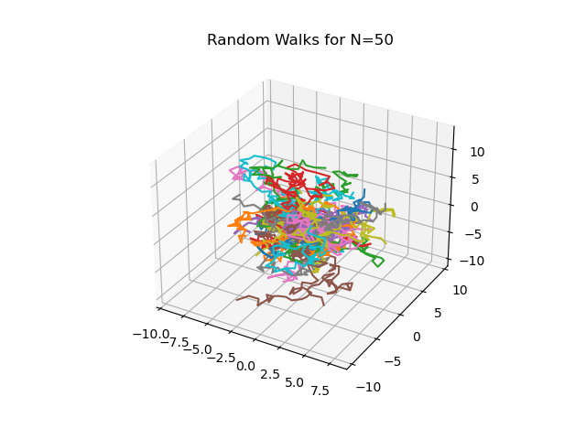

Figure: Chain3D50

### h2vsN

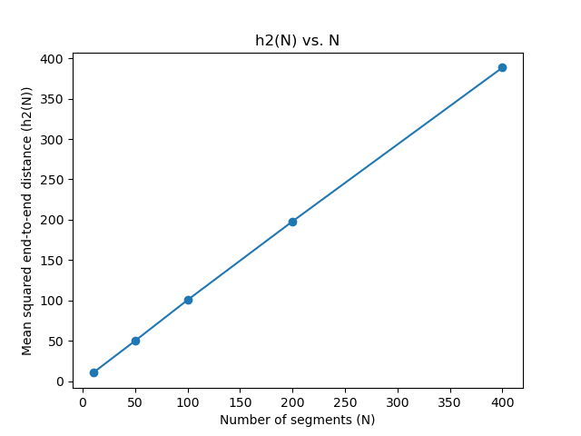

Figure: h2vsN