# Polymer Chain Simulation Experiment Report

## Abstract

This report outlines the results of a simulation performed to analyze the behavior of polymer chains. Each polymer chain consists of segments that randomly orient in a 3D space. The main focus was on determining the mean squared end-to-end distance for varying numbers of segments and understanding how this measure scales with the number of segments.

## Introduction

The study of polymer chains is significant in materials science where understanding the physical properties of polymer materials is crucial. This simulation provides insights into the scaling properties of polymers, which is essential for the development of new materials.

## Methods

The simulation was conducted by generating 2000 instances of polymer chains with segments ranging from 10 to 400. Each segment's orientation was randomly assigned in three-dimensional space to model realistic physical properties of polymers. The mean squared end-to-end distance was computed for each set of polymer chains, analyzing the relationship between chain length and spatial characteristics.

## Results

The results demonstrate a clear scaling relationship between the polymer length (number of segments) and the mean squared end-to-end distance. The collected data suggests that the mean squared distance scales with the number of segments according to a power law relationship. Graphs representing the simulations and computed metrics are included below.

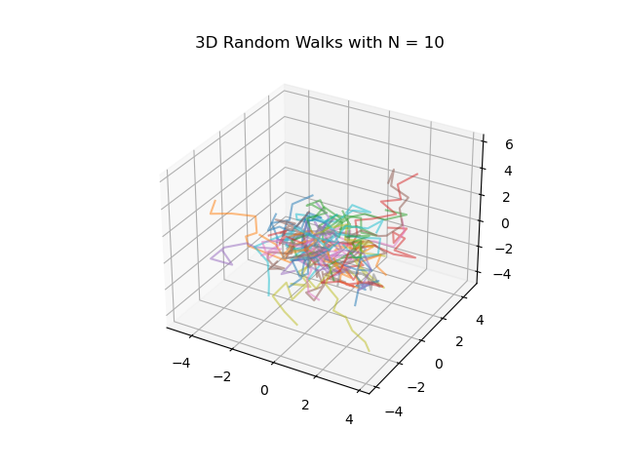

Fig. 1: Polymer chain simulations with 10 segments.

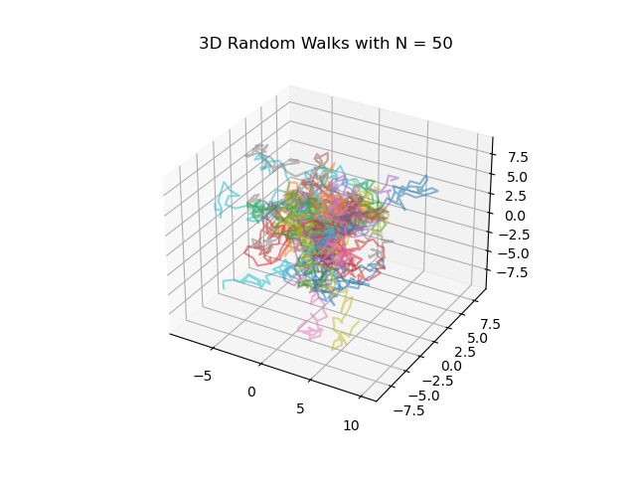

Fig. 5: Polymer chain simulations with 50 segments.

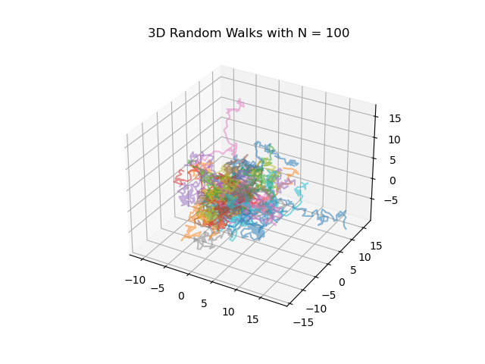

Fig. 10: Polymer chain simulations with 100 segments.

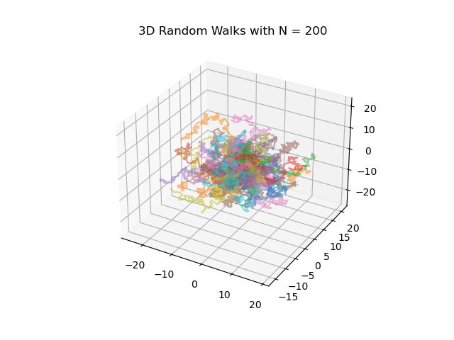

Fig. 20: Polymer chain simulations with 200 segments.

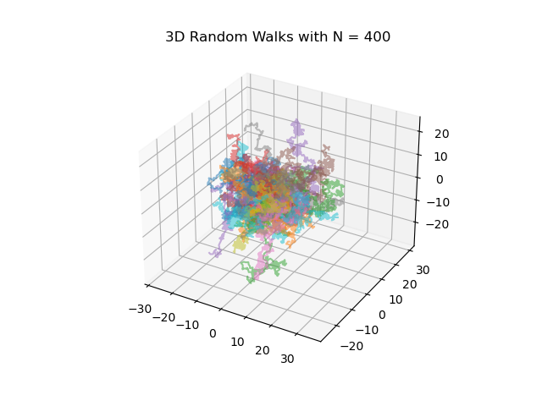

Fig. 40: Polymer chain simulations with 400 segments.

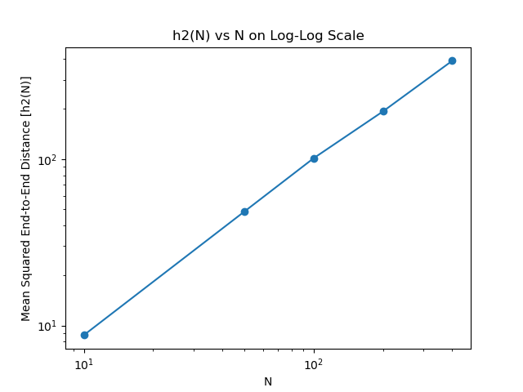

Fig. 6: Plot of the mean squared end-to-end distance vs. number of segments.