# Simulation Experiment Report on Polymer Chains

## Abstract

This report outlines the computational simulation performed to analyze the behavior of polymer chains in 3D. The experiment entailed generating multiple configurations of polymer chains, each consisting of varying segment lengths, and analyzing their mean squared end-to-end distances. This analysis helps in understanding the scaling behavior of polymers in spatial configurations.

## Introduction

Polymers are substantial macromolecules composed of repeating structural units. The physical properties of polymers depend heavily on their shapes and structures in three-dimensional space. Therefore, it becomes important to simulate and understand these structures for material engineering and science. This report discusses a computational approach to simulate and visualize polymer chains in a three-dimensional space and investigate the relationship between chain length and end-to-end distance.

## Methods

Each polymer chain consisted of N segments, each of unit length, randomly oriented in 3D space. The orientations were uniformly distributed, calculated using spherical coordinates transformation. A total of 2000 chains were generated for each specified length of N segments. We computed the mean squared end-to-end distance for these chains and plotted them for visual analysis and further understanding. The simulations were performed using Python, leveraging libraries like NumPy for mathematical operations and Matplotlib for plotting.

## Results

The results of the simulation are visually represented as plots for each specified N (segments count). These graphs demonstrate how the chain segments assume varied configurations in a three-dimensional space. Moreover, a plot of mean squared end-to-end distance versus number of segments is generated to investigate the scaling behavior.

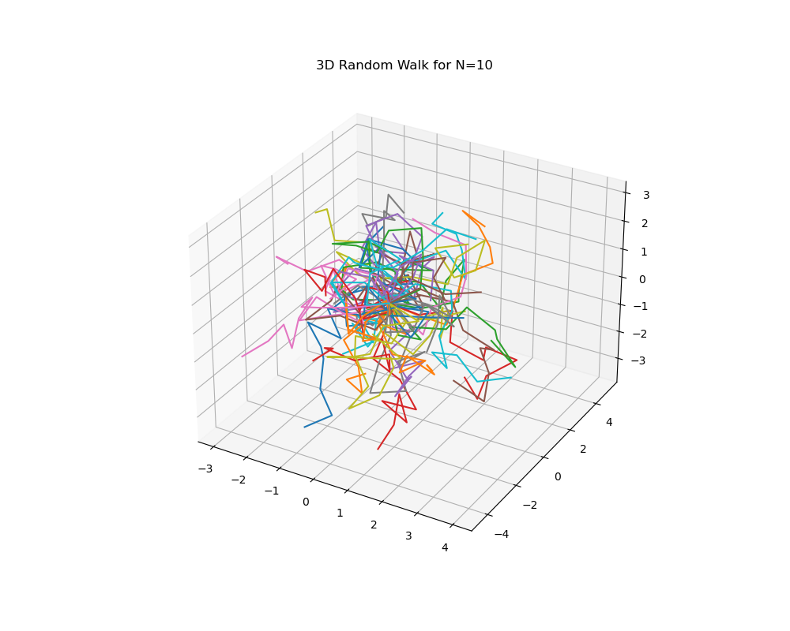

Fig. 1: 3D Visualization for N=10

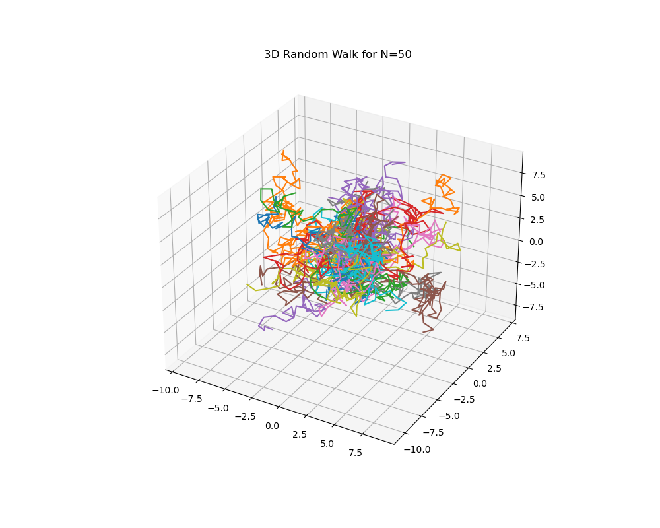

Fig. 2: 3D Visualization for N=50

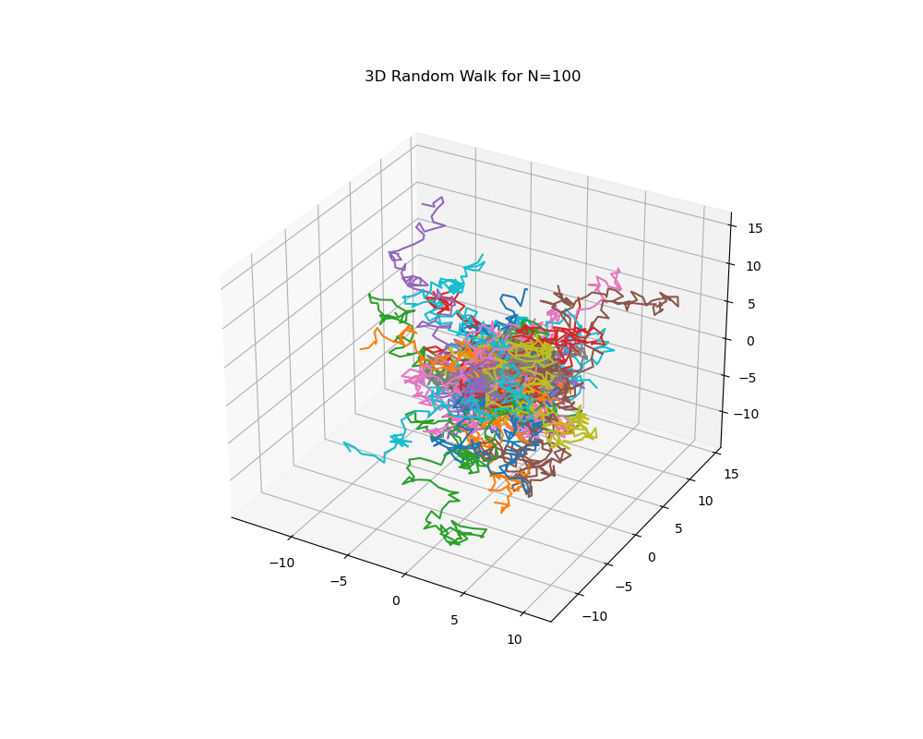

Fig. 3: 3D Visualization for N=100

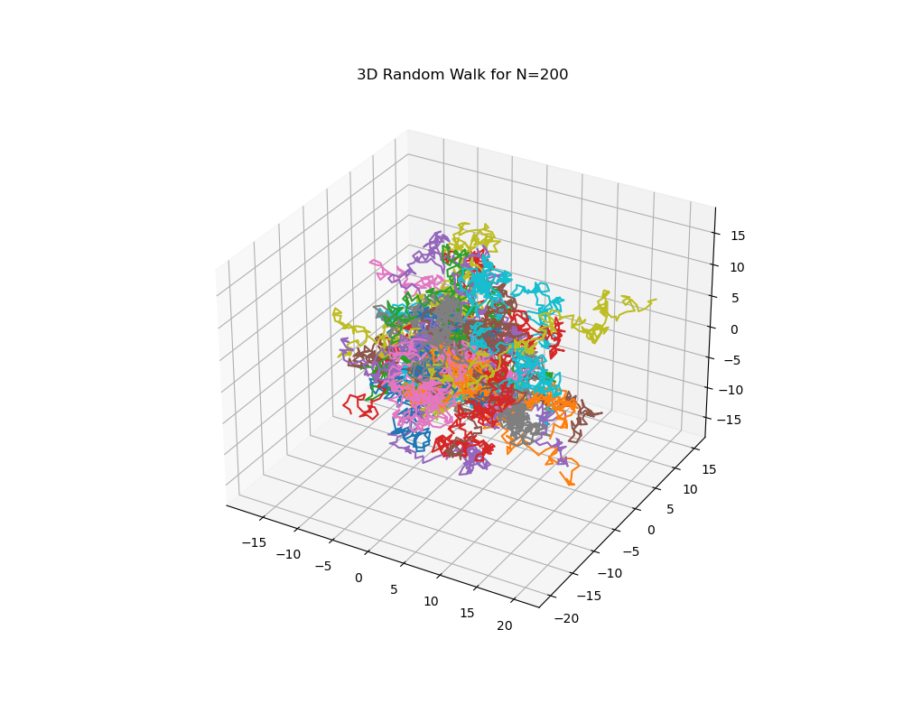

Fig. 4: 3D Visualization for N=200

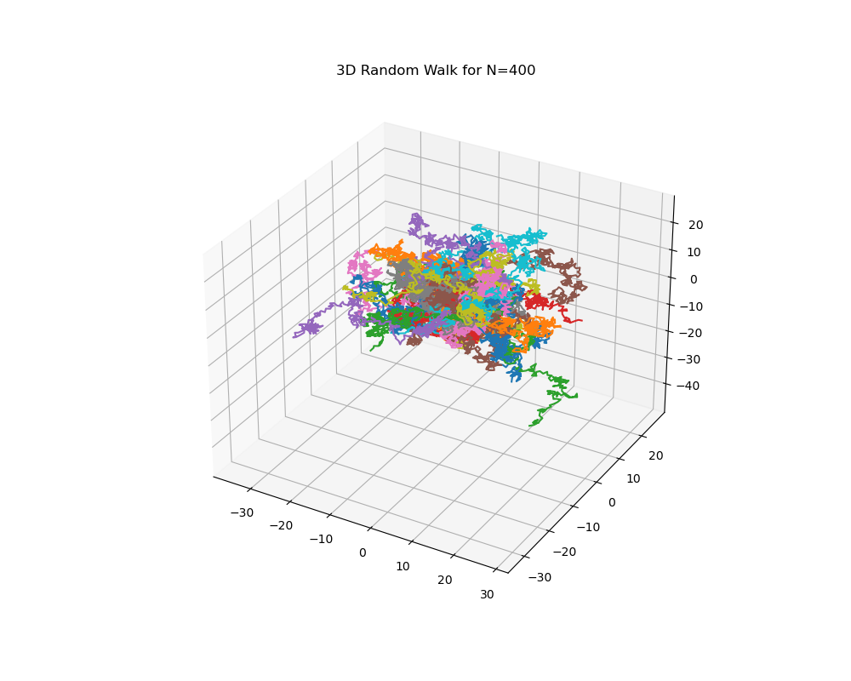

Fig. 5: 3D Visualization for N=400

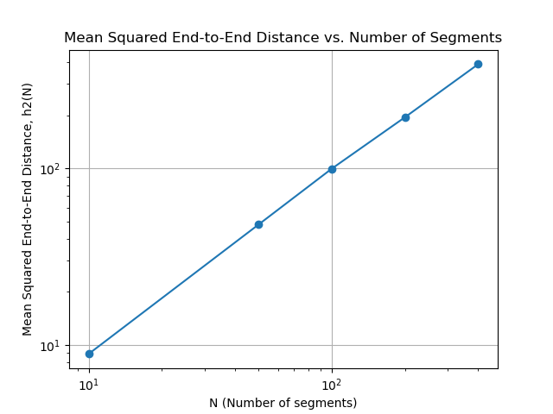

Fig. 6: h2(N) vs N Plot on a Log-Log scale