# Polymer Chain Simulation Report

## Abstract

This document outlines the simulation experiment conducted to examine the behavior of polymer chains in 3D space. The purpose of this simulation is to understand how the end-to-end distance of polymer chains varies as a function of the number of segments, applying principles of molecular dynamics and statistical mechanics.

## Introduction

Polymers are large molecules composed of repeating structural units, and their molecular behavior is of significant interest in materials science. This report details the simulations carried out to model polymer chains with varying lengths and analyze their geometric properties in three dimensions.

## Methods

We used Python for simulation, specifically utilizing numpy for numerical operations and matplotlib for plotting. Polymer chains were simulated as random walks in three-dimensional space with each segment assigned a random orientation uniformly distributed across all possible directions.

## Results

The results from the simulations have been compiled and analyzed. Figures display the polymer chains from different simulations and their corresponding mean squared end-to-end distances plotted against the number of segments.

Figure 1: Simulation of 50 polymer chains with 10 segments each.

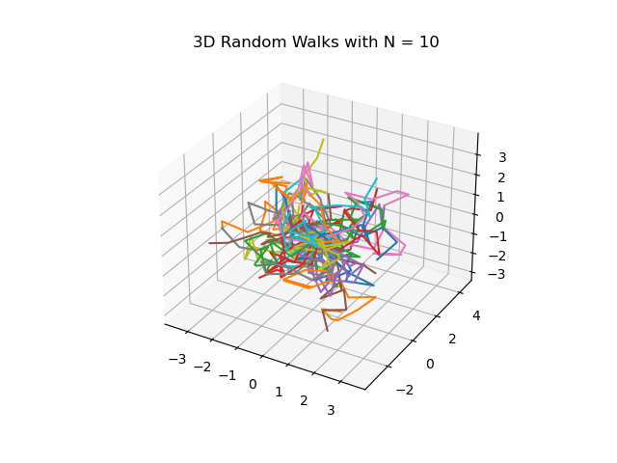

Figure 5: Simulation of 50 polymer chains with 50 segments each.

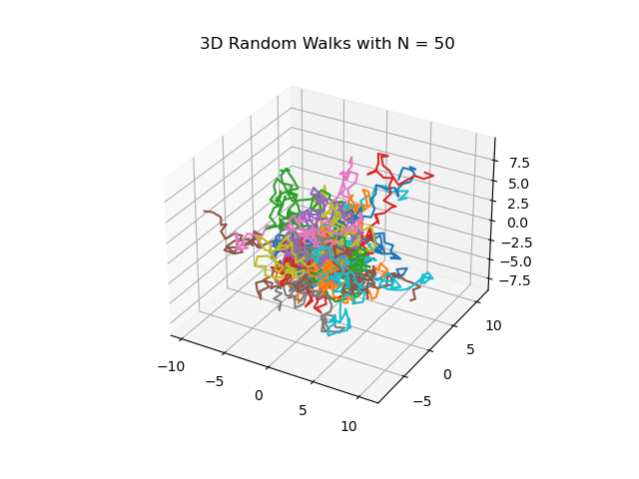

Figure 10: Simulation of 50 polymer chains with 100 segments each.

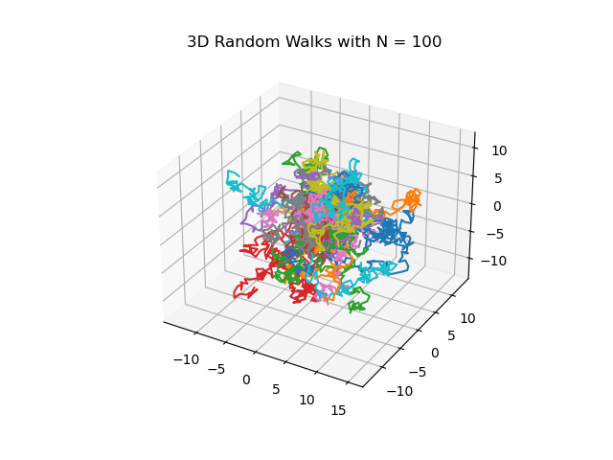

Figure 20: Simulation of 50 polymer chains with 200 segments each.

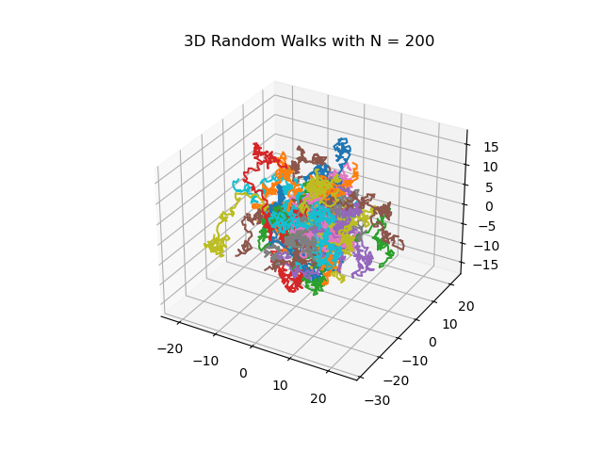

Figure 40: Simulation of 50 polymer chains with 400 segments each.

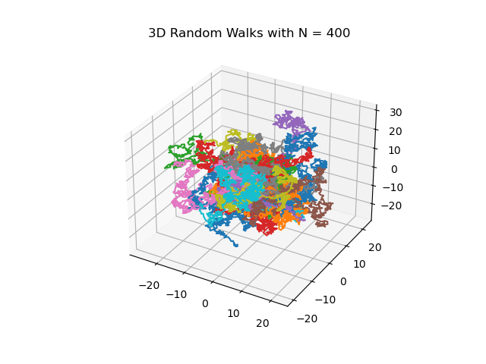

Figure 5: Plot of mean squared end-to-end distance vs. number of segments

