# Polymer Chain Simulation Experiment Report

## Abstract

This report outlines the results of a simulation experiment conducted to analyze the behavior of polymer chains in a three-dimensional space. Each polymer chain consists of N segments of length 1, with each segment's orientation randomly assigned. The purpose of the simulation is to understand the relationship between the number of segments and the polymer's end-to-end distance in a stochastic 3D model.

## Introduction

The study of polymer chains is crucial for understanding materials science, especially the properties of plastics, rubbers, and other synthetic materials. The spatial configuration of polymer chains can highly influence their macroscopic properties. The objective of this simulation is to statistically evaluate the mean squared end-to-end distance of polymer chains with varying lengths and to determine the scaling behavior as described by the exponent v.

## Methods

The simulation was implemented using a Python script. The ensemble of polymer chains was generated with each segment having a randomly assigned orientation in 3D space, ensuring uniform distribution over the unit sphere. For each polymer length N, 2000 chains were generated, and metrics like mean squared end-to-end distance were computed. Significant plots were generated to visually represent the data.

## Results

The resulting mean squared end-to-end distances h2(N) were recorded for various lengths N of polymer chains. Plots for different N values (10, 50, 100, 200, 400) were saved, and a plot of h2(N) versus N was created to depict the scaling relationship. The scaling relationship exponent v was computed to be approximately 1.03. Graphical results are shown below:

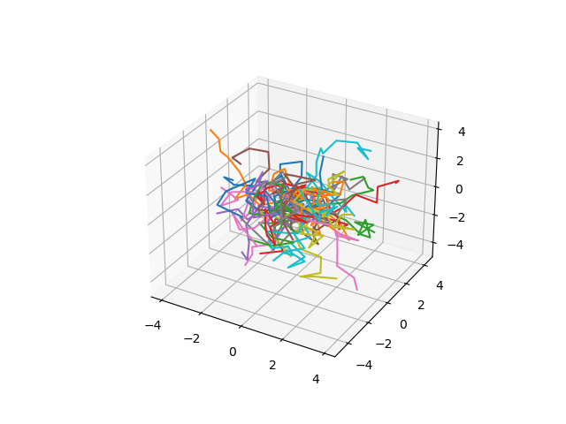

Fig. 1. Plot from file .\Chain3D10.png

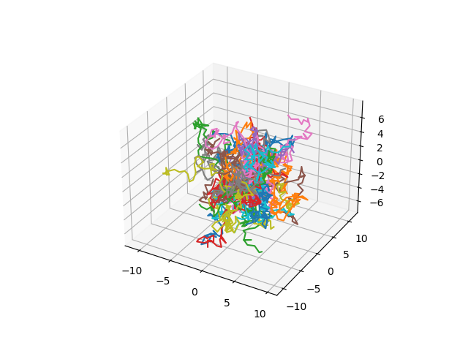

Fig. 2. Plot from file .\Chain3D50.png

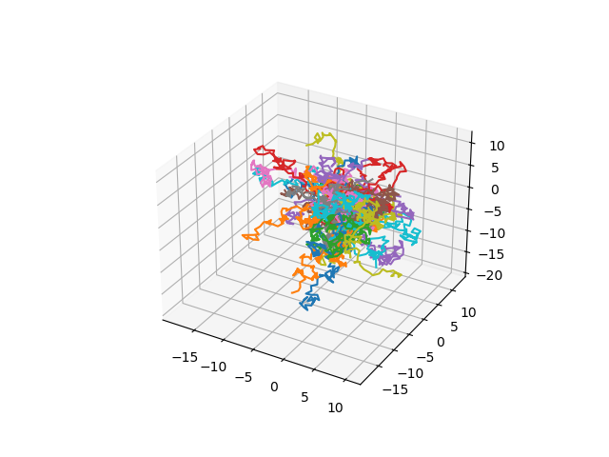

Fig. 3. Plot from file .\Chain3D100.png

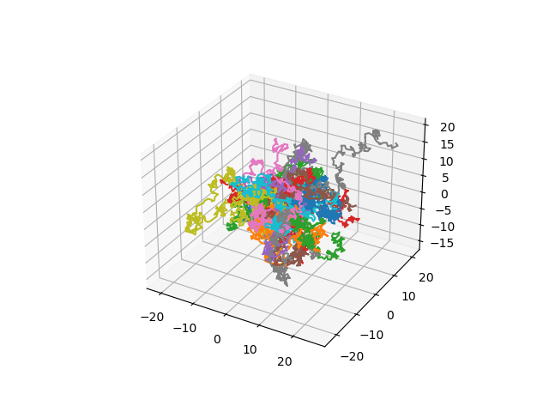

Fig. 4. Plot from file .\Chain3D200.png

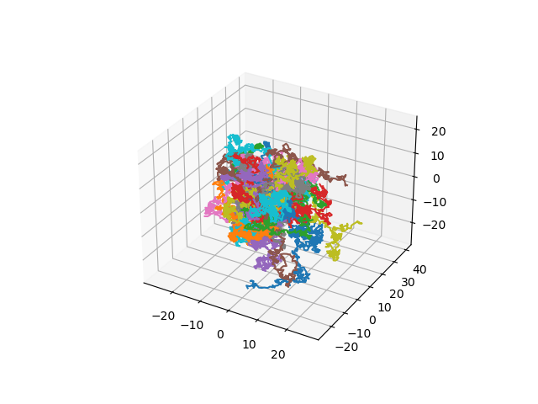

Fig. 5. Plot from file .\Chain3D400.png

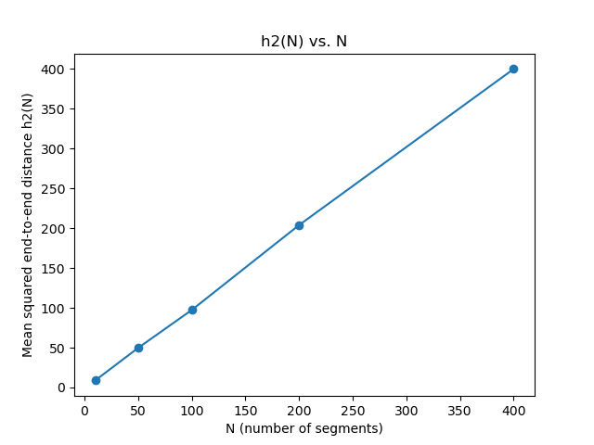

Fig. 6. Plot from file .\h2vsN.png