# Simulation Experiment Report on Polymer Chains

## Abstract

This report outlines the procedures and results from a simulation study on the behavior of polymer chains in 3D space. The purpose of this study is to understand how the length of the polymer chain affects its end-to-end distance in a randomly oriented 3D space environment. Through computational simulations, we've analyzed the scaling behavior of polymer chains as their segment counts increase.

## Introduction

The physical properties of polymer chains have been a subject of extensive research due to their implications in both natural and synthetic materials. Understanding the geometric and dynamic properties of these chains in three-dimensional space is essential for developing new materials and for enhancing existing applications. In this report, we explore the end-to-end distance of polymer chains with varying segment lengths.

## Methods

Our methodology involved the use of a computer simulation to generate 2000 polymer chains for each defined length segment (N = 10, 50, 100, 200, 400). Each segment of the chain was assigned a random orientation in 3D space, while ensuring a uniform distribution of the angles. The simulation was repeated multiple times to ensure statistical reliability, and for each segment count, a set of 50 chain conformations were visualized and analyzed.

## Results

Our findings reveal a clear scaling relationship between the mean squared end-to-end distance and the number of segments in the polymer chain. The results are captured in the plotted graphs as shown below.

Fig. 1: Visualization of 50 random polymer chains with N = 10

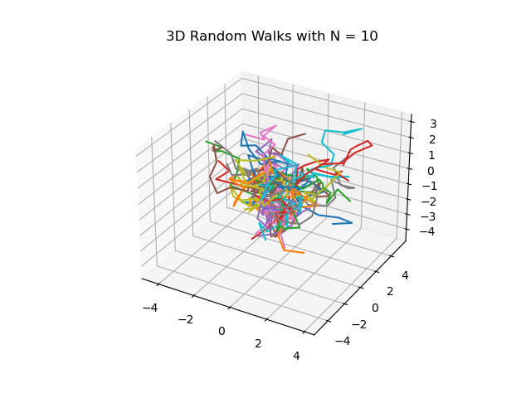

Fig. 5: Visualization of 50 random polymer chains with N = 50

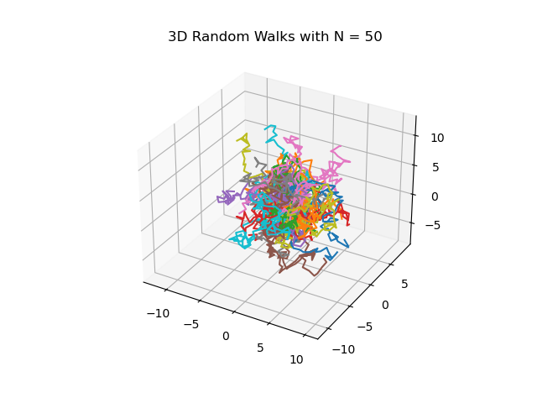

Fig. 10: Visualization of 50 random polymer chains with N = 100

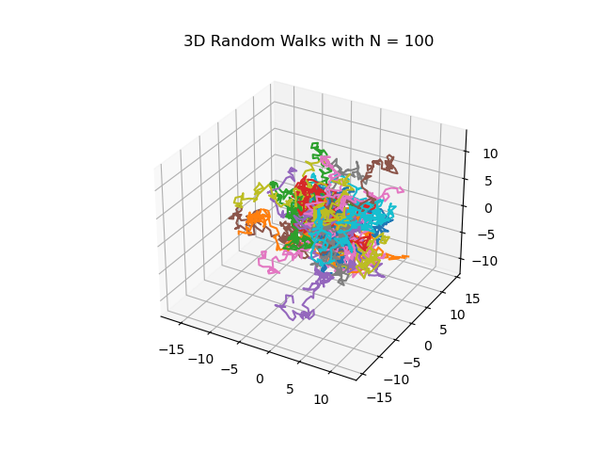

Fig. 20: Visualization of 50 random polymer chains with N = 200

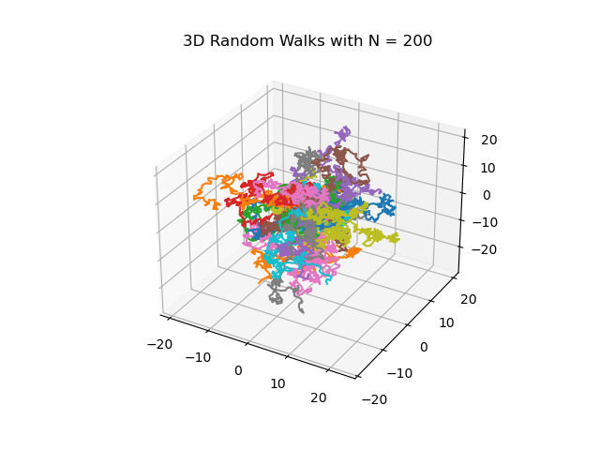

Fig. 40: Visualization of 50 random polymer chains with N = 400

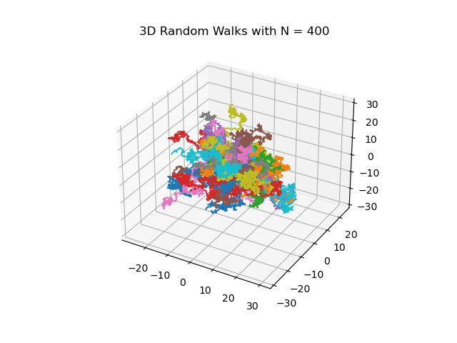

Fig. 5: Plot of mean squared end-to-end distance h2(N) vs. N

