Polymer Chain Simulation Experiment Report

# Abstract

This report outlines the computational simulation findings of polymer chains in 3D space. The experiment aimed to analyze the behavior of polymer chains by calculating the mean squared end-to-end distance for increasingly long polymers, examining their scaling properties relative to chain length.

# Introduction

The objective of this scientific experiment was to perform a series of simulations to understand the physical behavior of polymer chains as their segment length increases. Polymers are large molecules, or macromolecules, composed of many repeated subunits. Understanding their properties is crucial for applications in material science, biology, and nanotechnology.

# Methods

The methodology implemented involved simulating 2000 polymer chains with varying segment lengths. Each segment orientation was randomly assigned in a 3D space. The primary programming language used was Python, utilizing libraries such as NumPy for numerical operations and Matplotlib for plotting. Chains were plotted for different segment counts, and the mean squared end-to-end distance was calculated.

# Results

The findings from the simulation experiment were significant in illustrating the effect of chain length on the end-to-end distance. The plots depicting polymer chains for N=10, 50, 100, 200, and 400 segments are shown below:

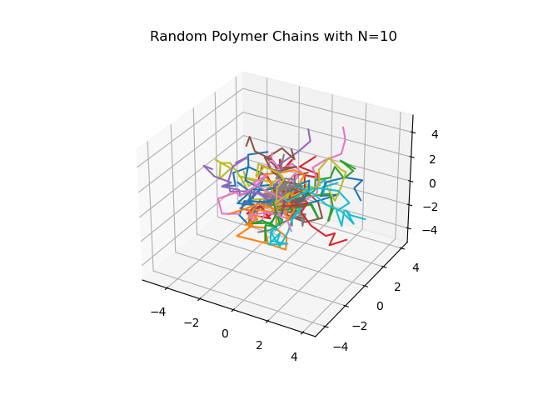

Fig. 1: Polymer chain with 10 segments.

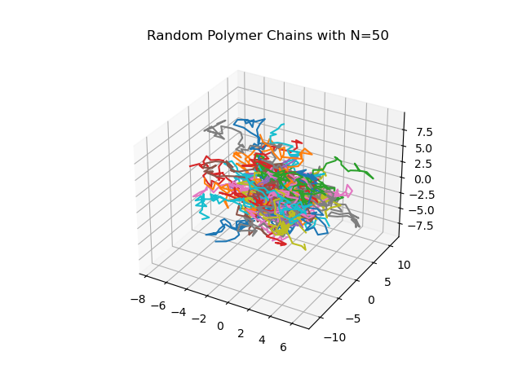

Fig. 5: Polymer chain with 50 segments.

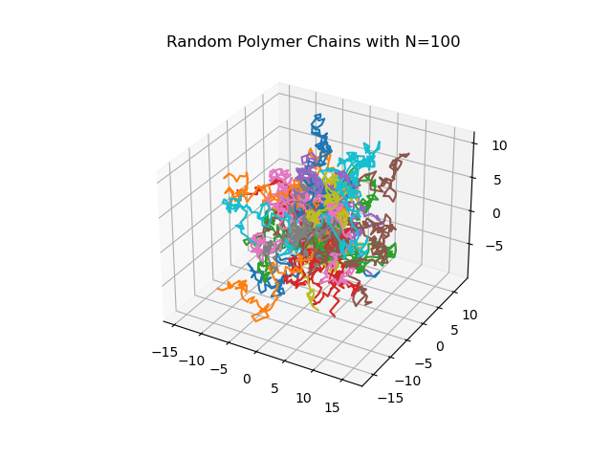

Fig. 10: Polymer chain with 100 segments.

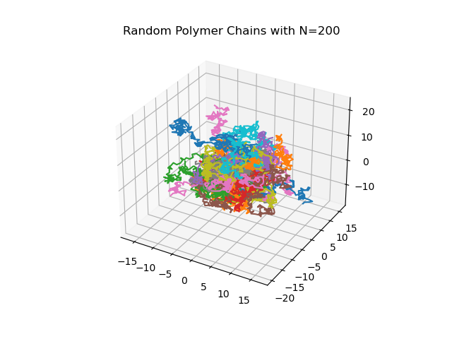

Fig. 20: Polymer chain with 200 segments.

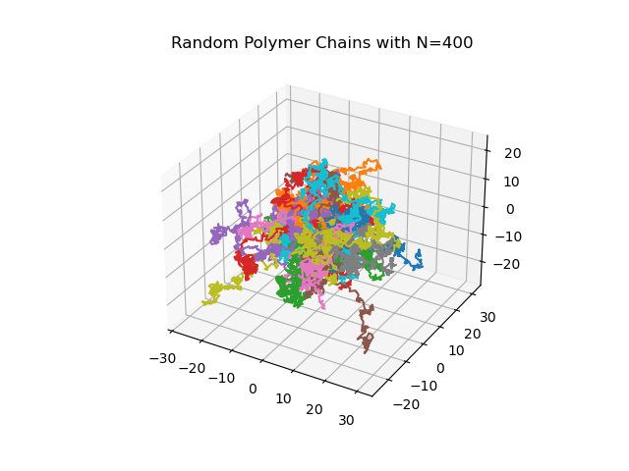

Fig. 40: Polymer chain with 400 segments.

Additionally, a plot of the mean squared end-to-end distance vs. the number of segments (N) revealed a scaling relationship, indicative of a physical polymer's expansive behavior in a three-dimensional space.

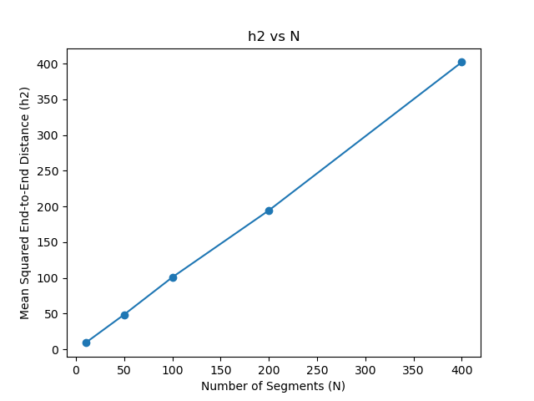

Fig. 6: Plot of mean squared end-to-end distance (h2) vs N.

The scaling exponent v, calculated from the plot, is approximately 1.03, indicating that h2(N) ≈ N^1.03. This value suggests slight deviation from ideal random walk behavior theoretically expected for polymers in a free space.