{ CSS Training }

*#3*

*CSS Font Module*

font-family

The font-family property lists one or more font families, separated by commas. The first hit will be used.

Each font family consists of a „family name” and a „generic name”.

font-family: Gill Sans Extrabold, sans-serif;

family name = Arial, Helvetica...

generic name = when no fonts are available; must not be quoted; last item in a list

* serif – letters have finishing strokes
* sans-serif – letter endings are plain
* monospace – same fixed width
* cursive – joining strokes, italic typeface or cursive characteristics
* fantasy – decorative fonts
* system-ui – default user interface (CSS4)
* emoji, math ... (CSS4)

sans-serif:

Arial, sans-serif;

Helvetica, sans-serif;

Lucida, sans-serif;

Helvetica Narrow, sans-serif;

serif:

Times, serif;

Times New Roman, serif;

monospace:

Courier New, monospace;

Courier, monospace;

Lucidatypewriter, monospace;

Fixed, monospace;

font-weight

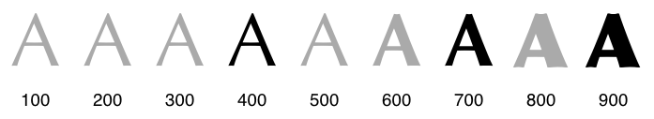

normal (= 400) | bold (= 700) | bolder | lighter | 100 | 200 | 300 | 400 | 500 | 600 | 700 | 800 | 900

bolder / lighter = more or less than inherited value (100, 400, 700)

font-stretch



normal | ultra-condensed | extra-condensed | condensed | semi-condensed | semi-expanded | expanded | extra-expanded | ultra-expanded

font-style

normal | italic | oblique

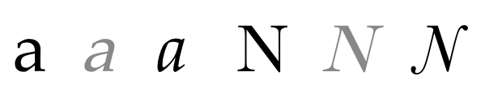

font-size

Value: absolute-size | relative-size | length | percentage

@font-face

@font-face {

font-family: myFirstFont;

src: url(http://example.com/fonts/Gentium.woff);

}

font-variant-position

Value: normal | sub | super

A typical user agent default style for the sub element:

sub {

vertical-align: sub;

font-size: smaller;

line-height: normal;

}

H<sub>2</sub>O

font-variant-caps

Values: normal | small-caps | all-small-caps | petite-caps | all-petite-caps | unicase | titling-caps

Small-caps: uppercase letters but reduced to the size of lowercase letters

<https://developer.mozilla.org/en-US/docs/Web/CSS/text-decoration>