**RATEPULSE - FEEDBACK AND RATINGS SYSTEM FOR PROFESSIONAL INTERACTIONS**

**Project Overview**

This project aims to enhance the user experience by providing a structured system for feedback and ratings after professional interactions within the job portal. Job seekers/candidates and employers can provide feedback to each other after the completion of the application process or an interview. This system serves both job seekers and employers and contributes to building a transparent and trustworthy environment on the platform.

**Technology Which I Used**

***Backend***

* Nodejs
* MySQL db
* Express

***Frontend***

* React Js
* Redux
* HTML
* CSS

***IDE***

* Visual Studio Code (VS Code)

**Project Structure**

The project structure is organized as follows:

* Client: Contains the frontend React.js application code.
* Server: Contains the backend Node.js application code.
* Database: Includes the MySQL database schema and sample data.

**\*\* To Run The Frontend (React) :\*\***

**//Terminal**

npm run dev

The React app should be running on port ` [http://localhost:5173/**`**](http://localhost:5173/%60)**.**

**\*\*To Run The Backend Server :\*\***

**//Terminal**

node index.js (or) npm start

The backend Server is running on port **` http://localhost:8080/ `.**

## Steps to Start Project

**For Backend**

1. cd server
2. npm i
3. npm init -y
4. npm i express sequelize mysql2 cors cookie-parser bcrypt jsonwebtoken
5. npm i multer path nodemon
6. npm start (or) node index.js

**For Frontend**

1. cd zolabzratepulse
2. npm i axios bootstrap react-router-dom bootstrap-icons
3. npm run dev

**Features:**

**Home:**

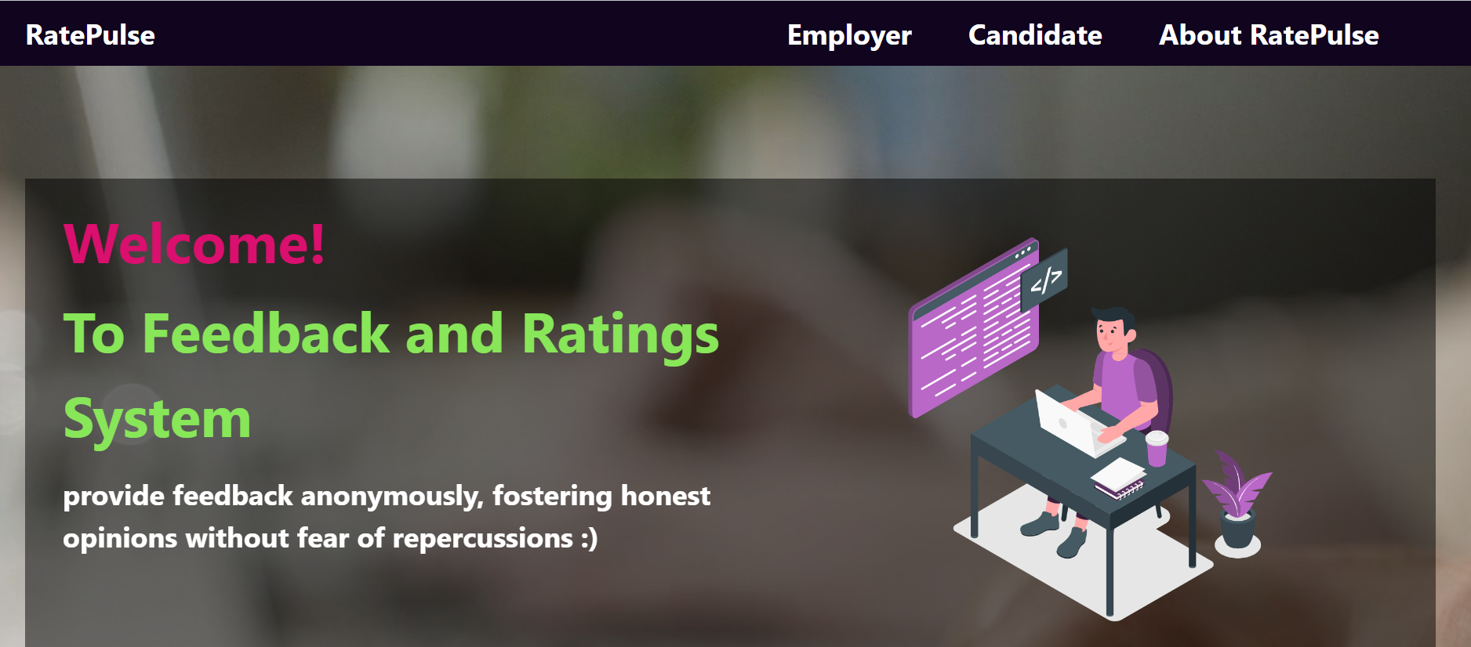

**About Page:**

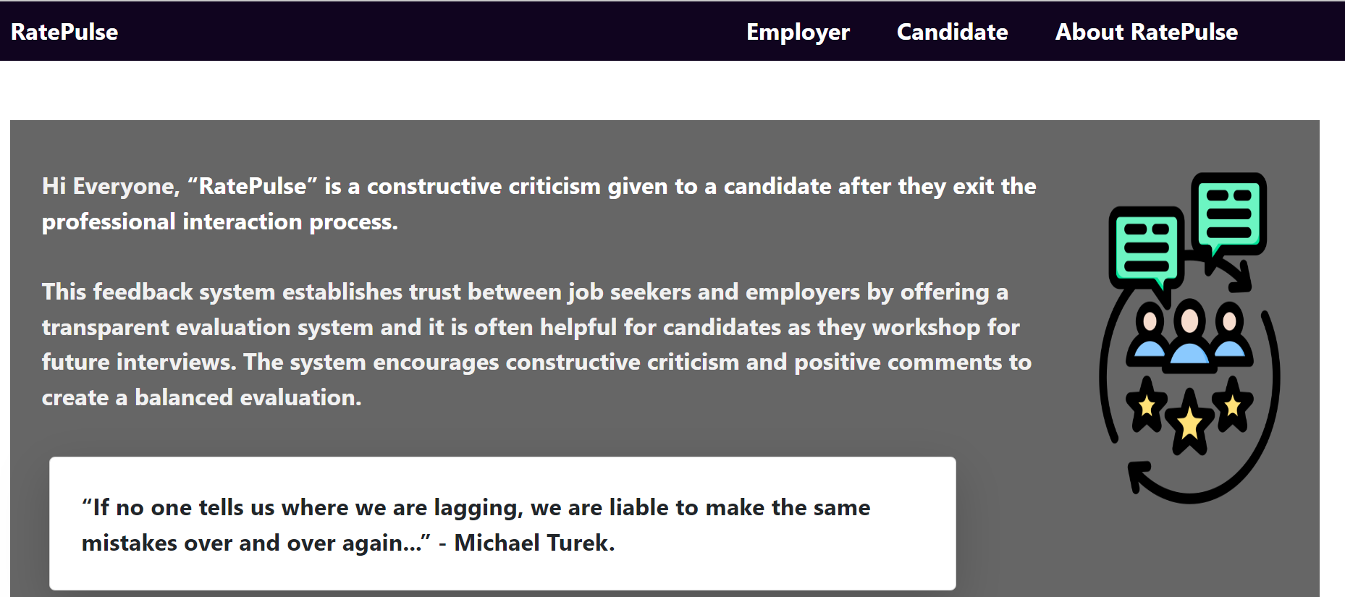

**Register:**

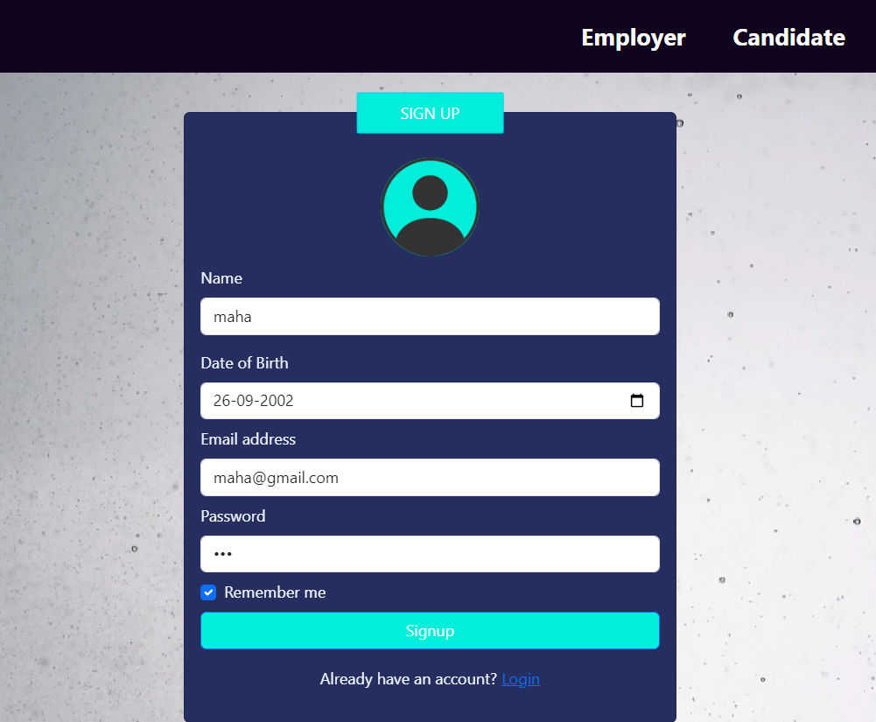

**Login:**

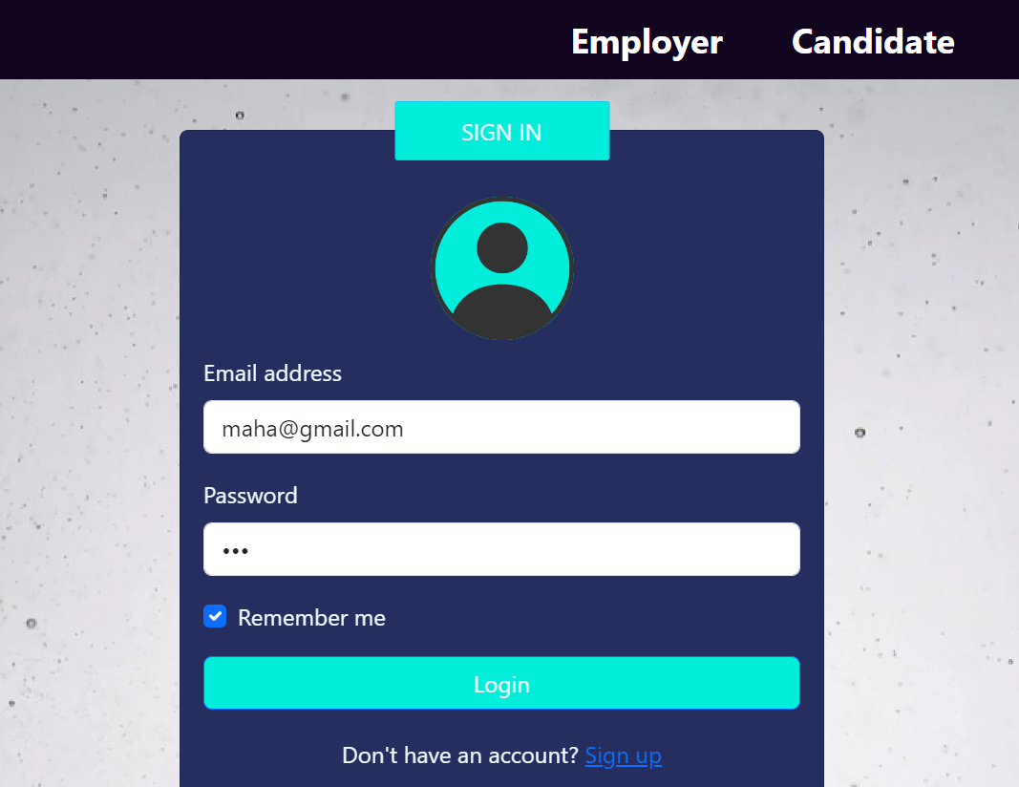

**Dashboard:**

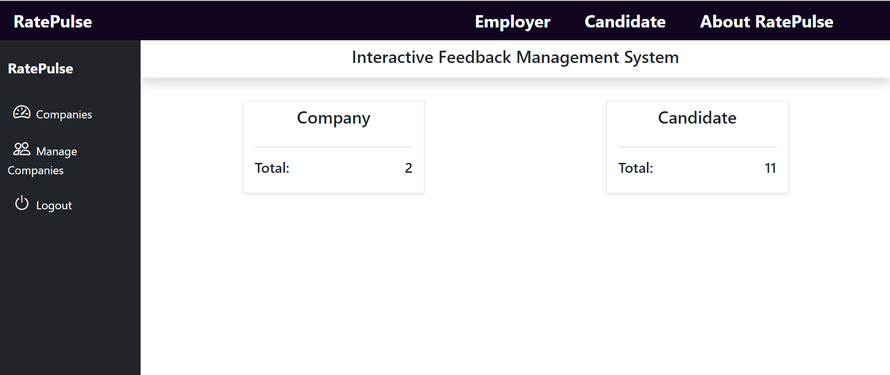

**Add company Page:**

## 

## Company List Page with Edit & Delete Options:

## 

## Edit Company :

## 

## Show Companies Page:

## 

## Company Detail & Add Review Page :

## 

## Reviews:

## 

## Request

#### If you like project then feel free to give Star 😊