**Employee Management**

**Project Overview**

This project aims to develop an Employee Management using various technologies such as Visual Studio Code (VS Code), React.js, Node.js, and XAMPP for MySQL. The system includes functionalities like user authentication, dashboard display for admin, employee, and salary information, category management, adding employee details, and editing/deleting employee records.

**Technologies Used**

* Visual Studio Code (VS Code)
* React.js
* Node.js
* XAMPP (MySQL)

**Project Structure**

The project structure is organized as follows:

* **client**: Contains the frontend React.js application code.
* **server**: Contains the backend Node.js application code.
* **database**: Includes the MySQL database schema and sample data.

**## Table of Contents**

**Setup[(Visual Studio Code)] –**

Download link -(<https://code.visualstudio.com/download/Windows>)

**Backend [(Node.js)]-**Download link-(https://nodejs.org/en/download)

**Frontend** (React)

**\*\*Run the backend server:\*\***

**//Terminal**

node server.js

The backend server should be running on **`http://localhost:5000`.**

**### Frontend (React)**

**//Terminal**

npm start

The React app should be running on `**http://localhost:3000`.**

**Features**

1. **Login Screen**: Provides username and password fields for user authentication.

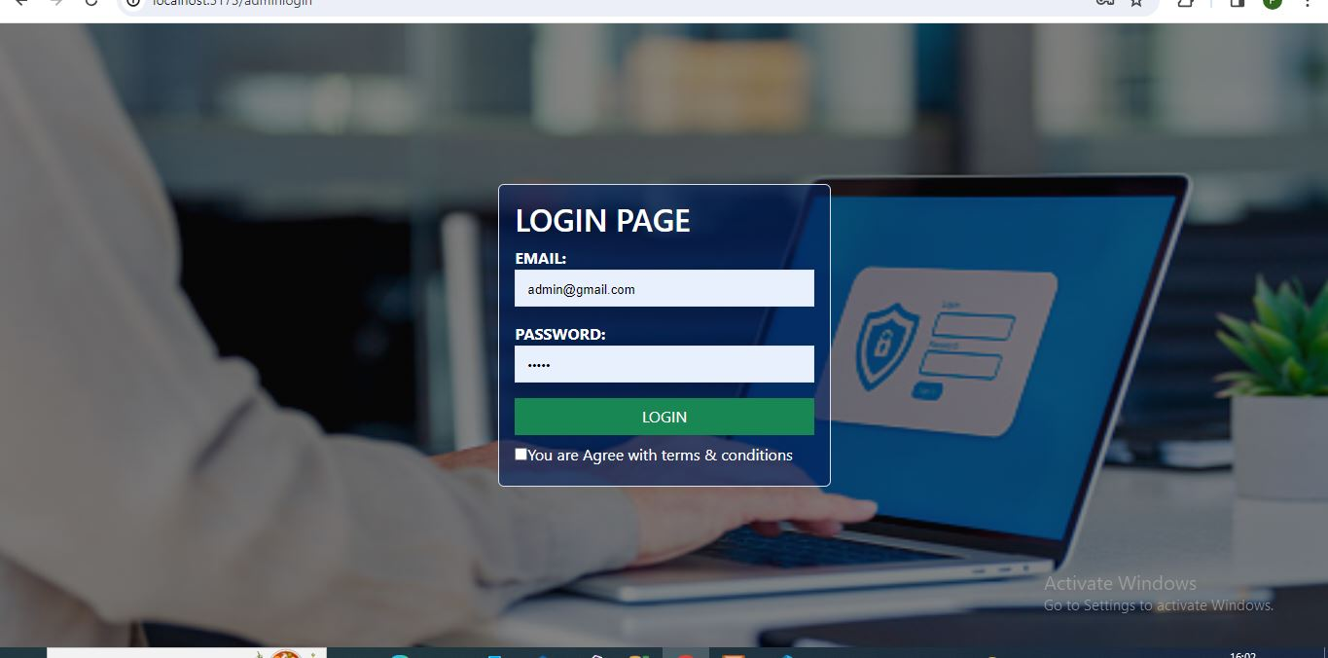

1. **Dashboard Page**:
   * Displays total admin, employee, and salary information.

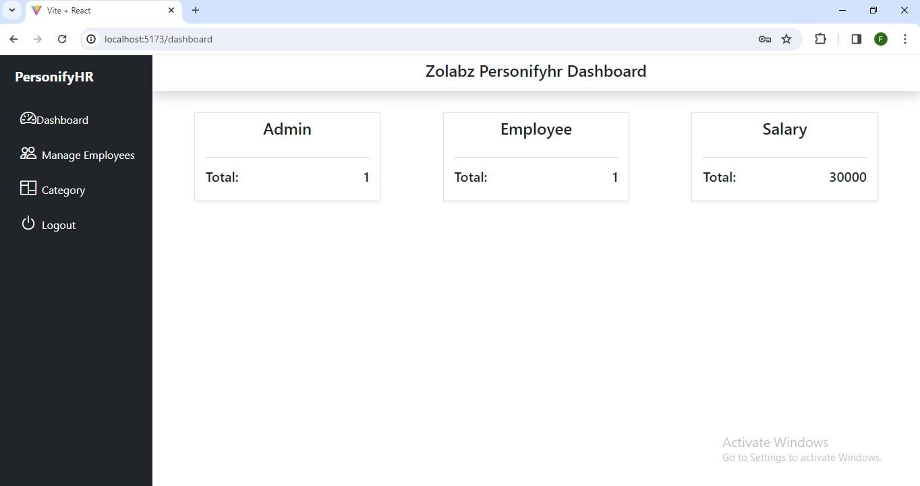

1. **Category Management**:
   * Allows adding categories like developer, supporter, etc.

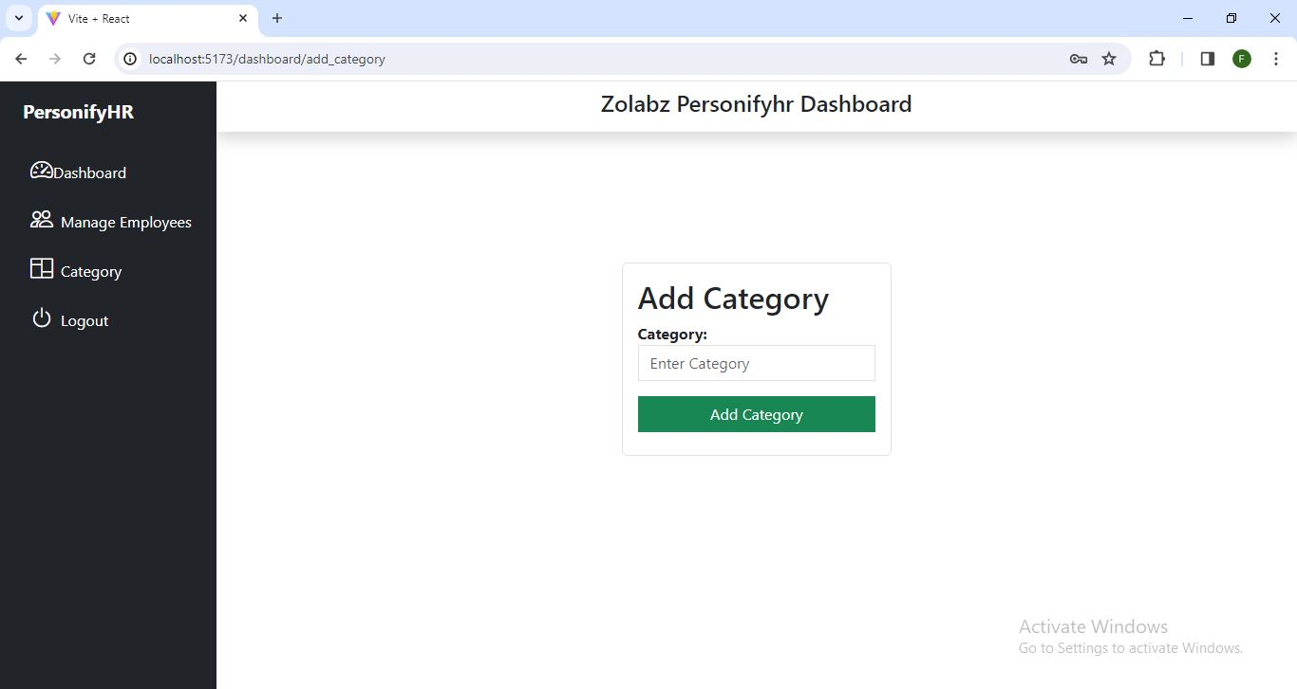

1. **Add Employee Details**:
   * Enables adding new employee details to the system.

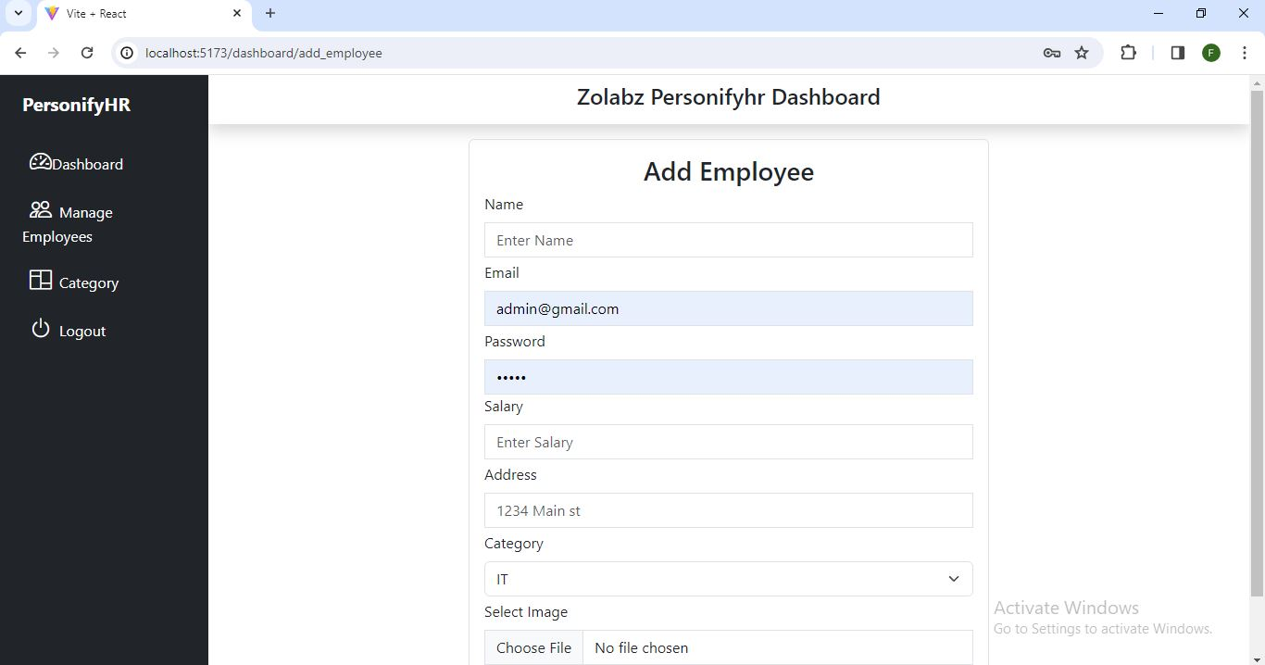

1. **Edit/Delete Employee Records**:
   * Provides edit and delete buttons in the employee list for managing employee records.

