**TaskMaster-Management System**

**Project Overview**

This project aims to develop an Task Management using various technologies such as Visual Studio Code (VS Code), React.js, Node.js, and XAMPP for MySQL. The Project Creation and Planning system facilitates seamless project management by enabling users to establish project objectives, deadlines, and milestones, while providing comprehensive planning tools for task breakdown, resource allocation, and timeline visualization. Task Assignment and Tracking functionalities allow for clear delegation of responsibilities to specific employees or teams, with real-time progress updates and completion tracking. Automated notifications ensure timely awareness of approaching deadlines and overdue tasks, complemented by visual progress indicators and intuitive representations like Gantt charts. Integrated communication tools foster collaboration through task comments and file sharing, while real-time document collaboration enhances efficiency in project-related discussions. Priority and Urgency Management features aid in prioritizing tasks and identifying urgent assignments, maximizing productivity.

**Technologies Used**

* Visual Studio Code (VS Code)
* React.js
* Node.js
* XAMPP (MySQL)

**Project Structure**

The project structure is organized as follows:

* **client**: Contains the frontend React.js application code.
* **server**: Contains the backend Node.js application code.
* **database**: Includes the MySQL database schema and sample data.

**## Table of Contents**

**Setup[(Visual Studio Code)] –**

Download link -(<https://code.visualstudio.com/download/Windows>)

**Backend [(Node.js)]-**Download link-(https://nodejs.org/en/download)

**Frontend** (React)

**\*\*Run the backend server:\*\***

**//Terminal**

cd api and start with “npm start”

The backend server should be running on **`**[**http://localhost:5050**](http://localhost:5050)**`.**

**### Frontend (React)**

**//Terminal**

cd dashboard

and start with “npm run dev”

The React app should be running on `**http://localhost:3000`.**

**Features**

* **Login Screen**: Provides email and password fields for user authentication.

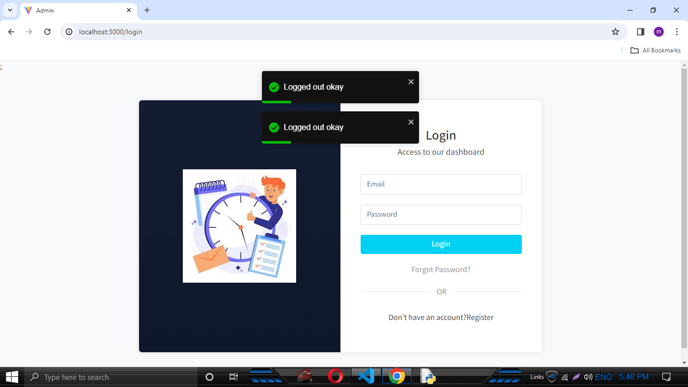

* **Register:**Enables to enter name,email,password to view the dashboard.

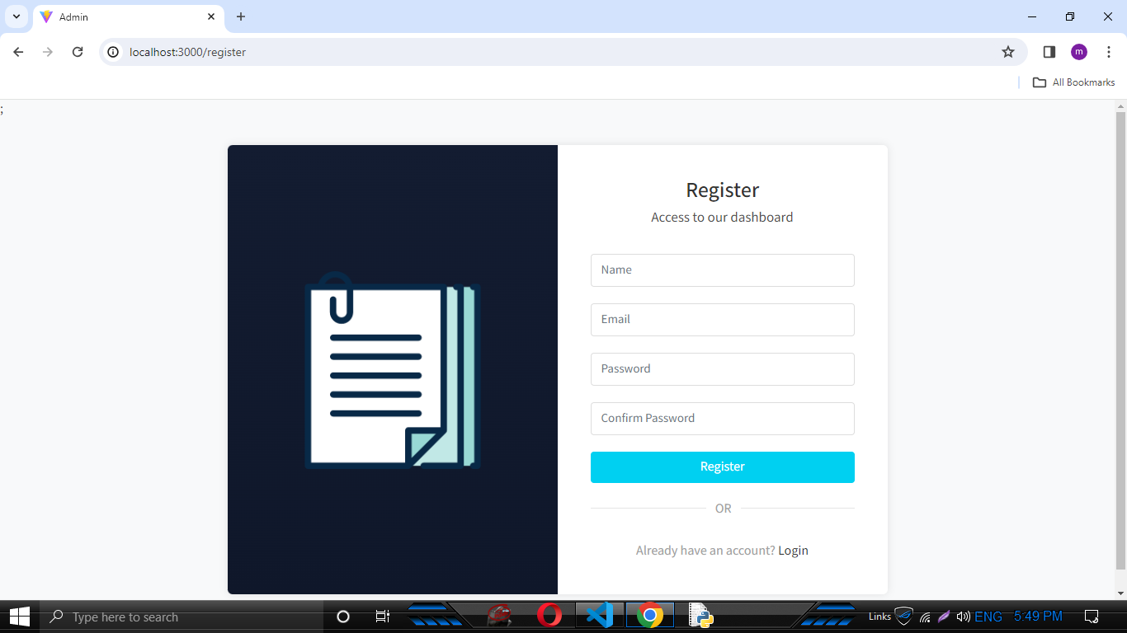

* **Forgot password:** If password is wrong, it sends email and make it correct.

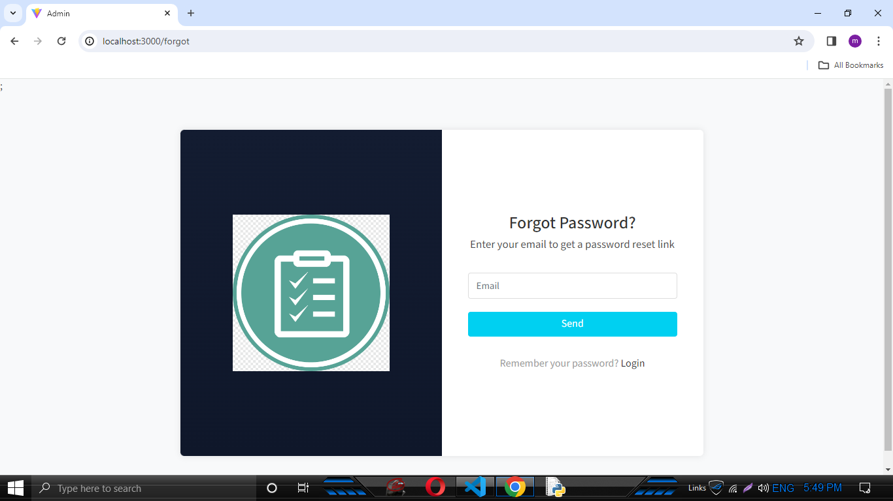

* **Dashboard Page**:Displays about TaskMaster management and pending projects and tasks.

Top of the corner it displays a logout session of admin and profile.

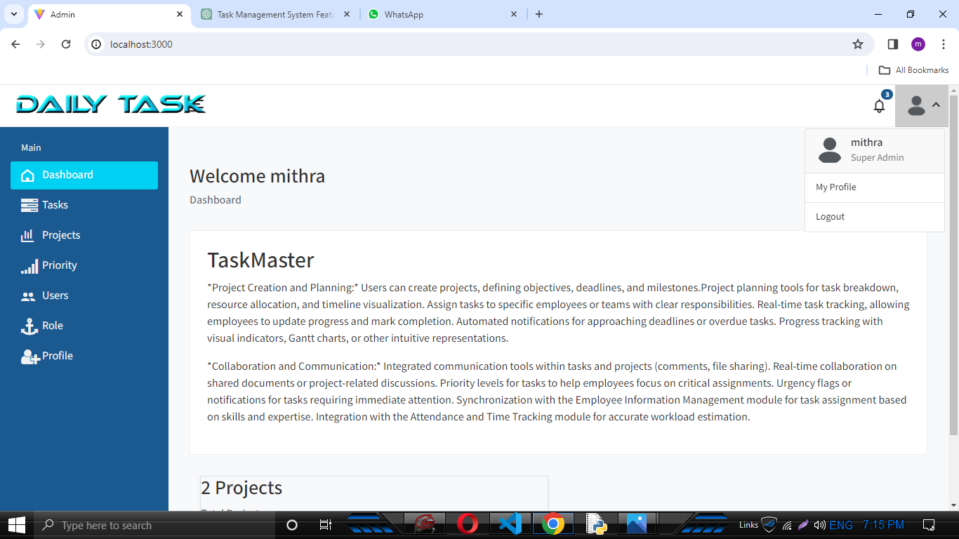

* **Task Management screen:**Allows users to edit,view and delete the task list.Displays the pending task and completed task in different colours.

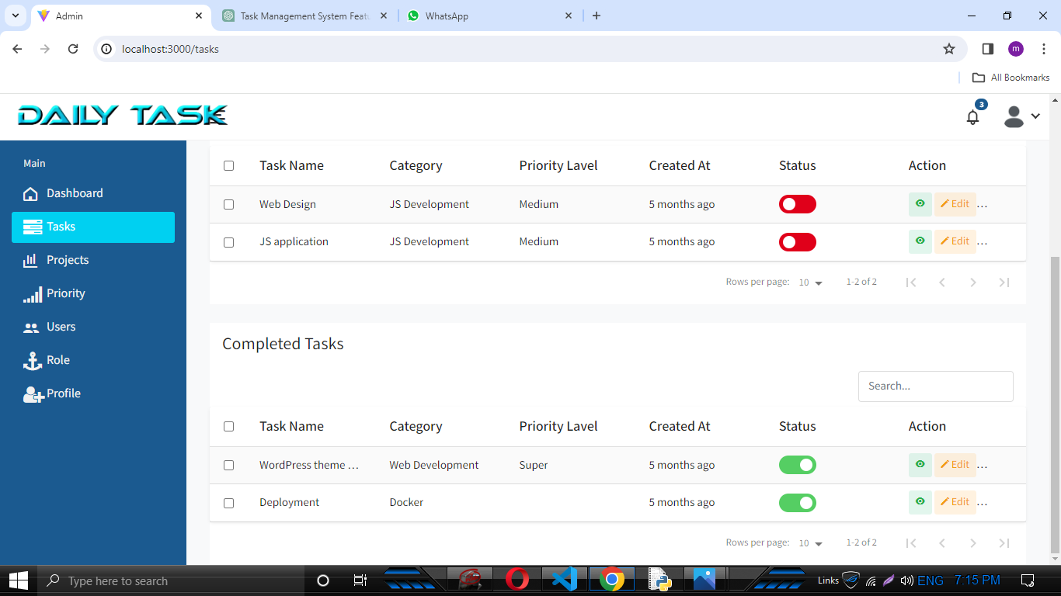

* **Edit Task Details**:Enables adding new task details to the system.

Includes title,description and task category and it update in task list.

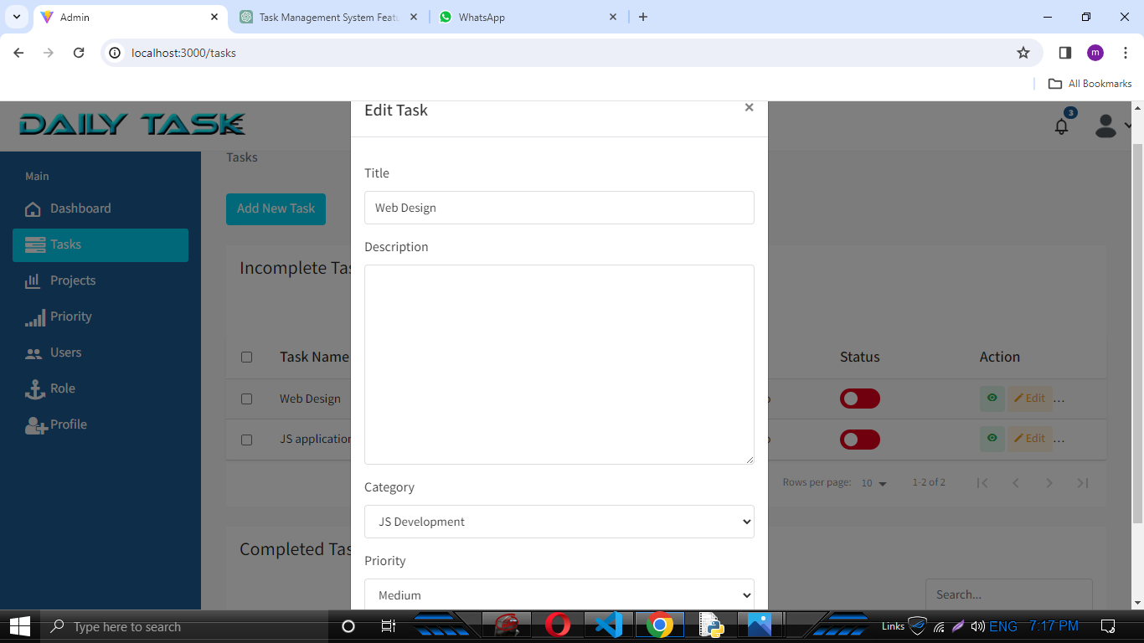

* **Task View screen:** Displays a particular task by clicking a view button.

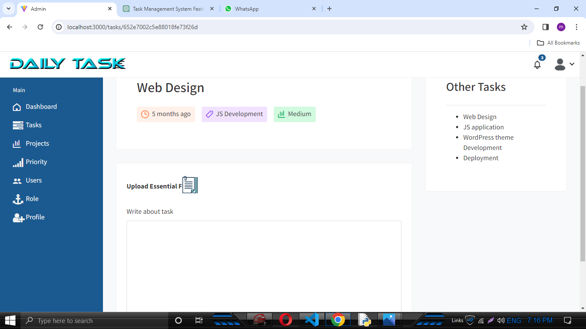

* **Project page:** Displays a list of projects and also it can be edit,delete the lists.

By clicking the status button we can update by scrolling the button left of incomplete or right it can update ,the complete status.

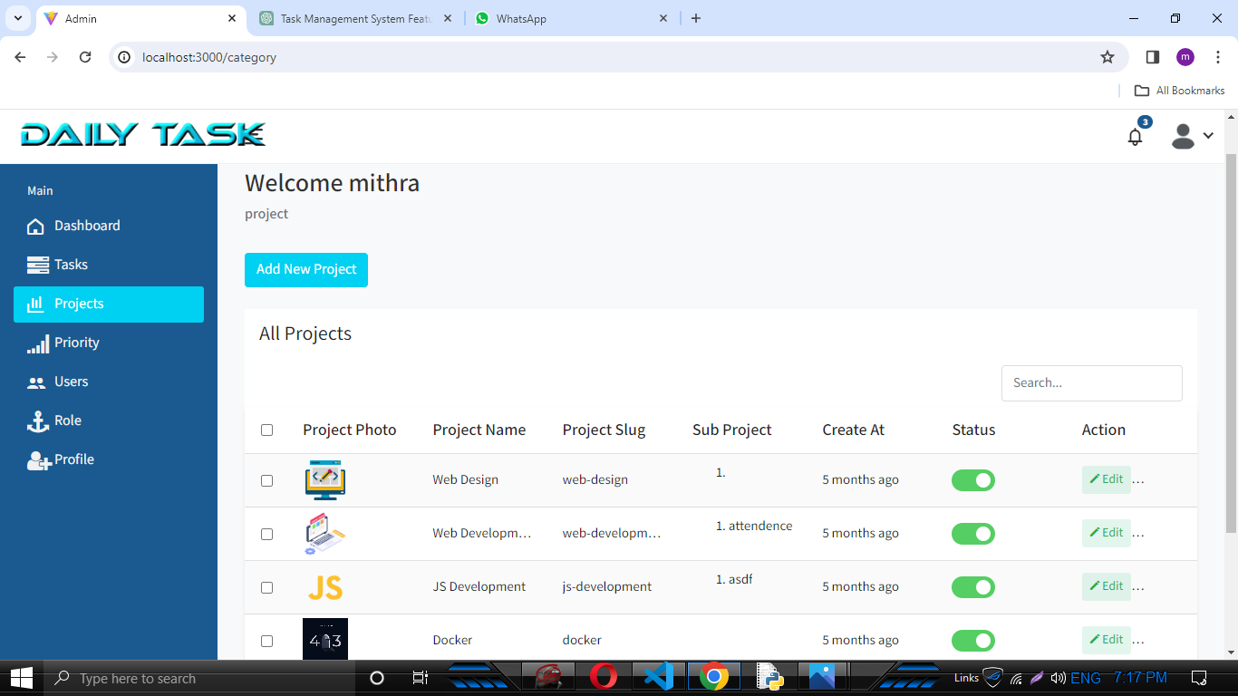

* **Add and edit Project:** Enables to add project name and project photo, it can be add easily.

Enables to edit project name ,category and update it.

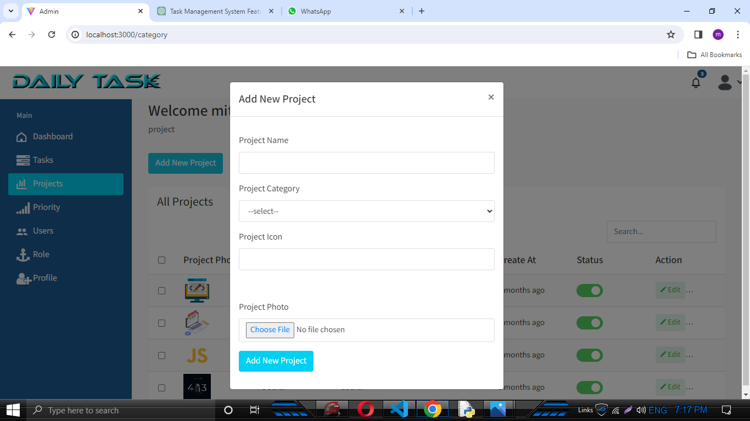

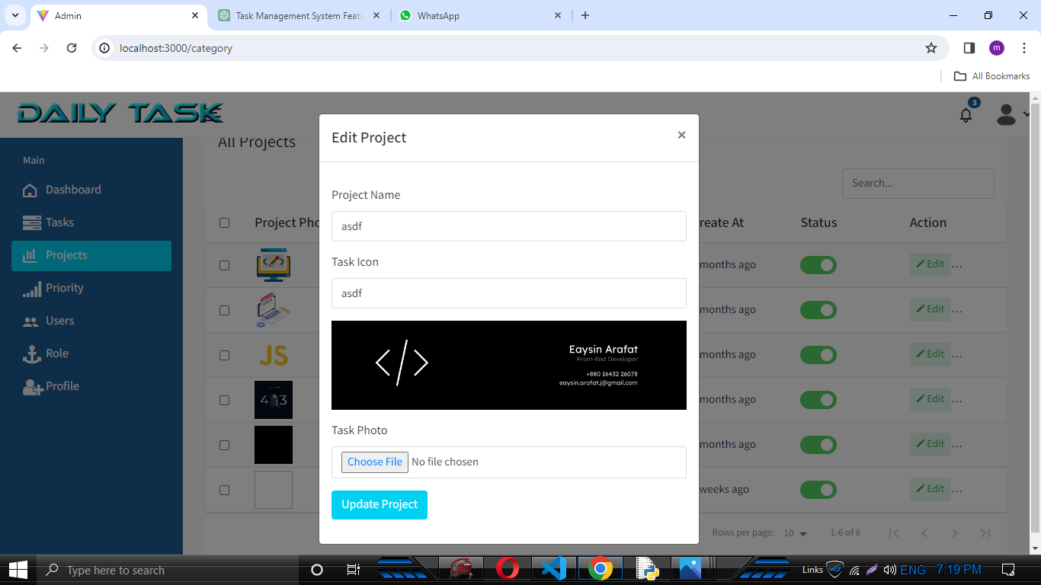

* **Priority screen:** Displays a project in which stage, instead of medium and high.Medium indicates a half completion of project and high indicates the full completion of project.

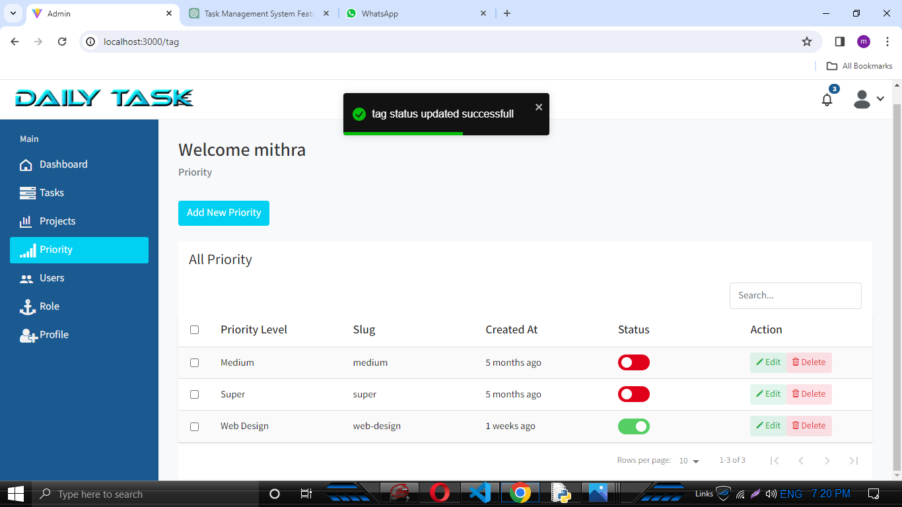

* **User screen:** Enables to create a new user and generate button , automatically generates a strong password of user to update it.

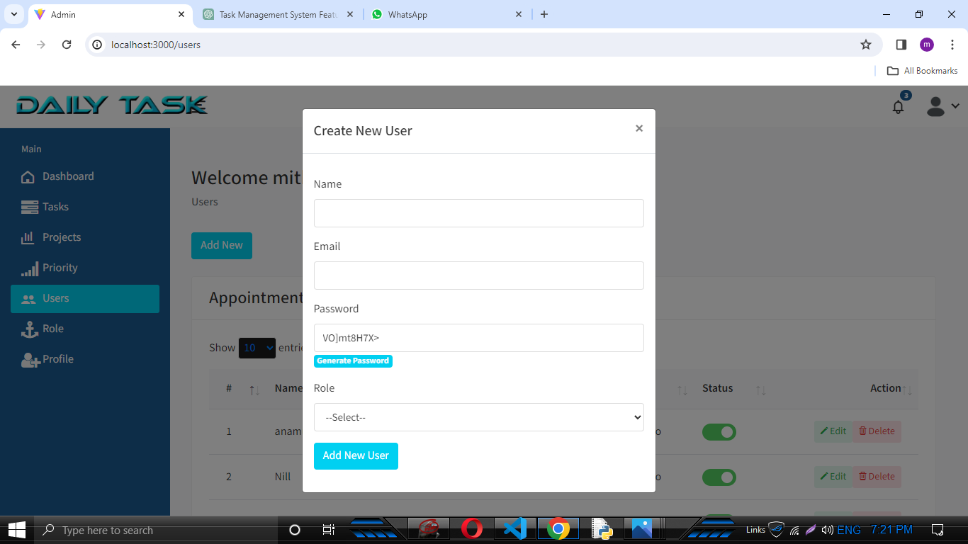

* **Role of project:** Displays a name ,slag of task and projects.Enables to edit,delete and status updation.

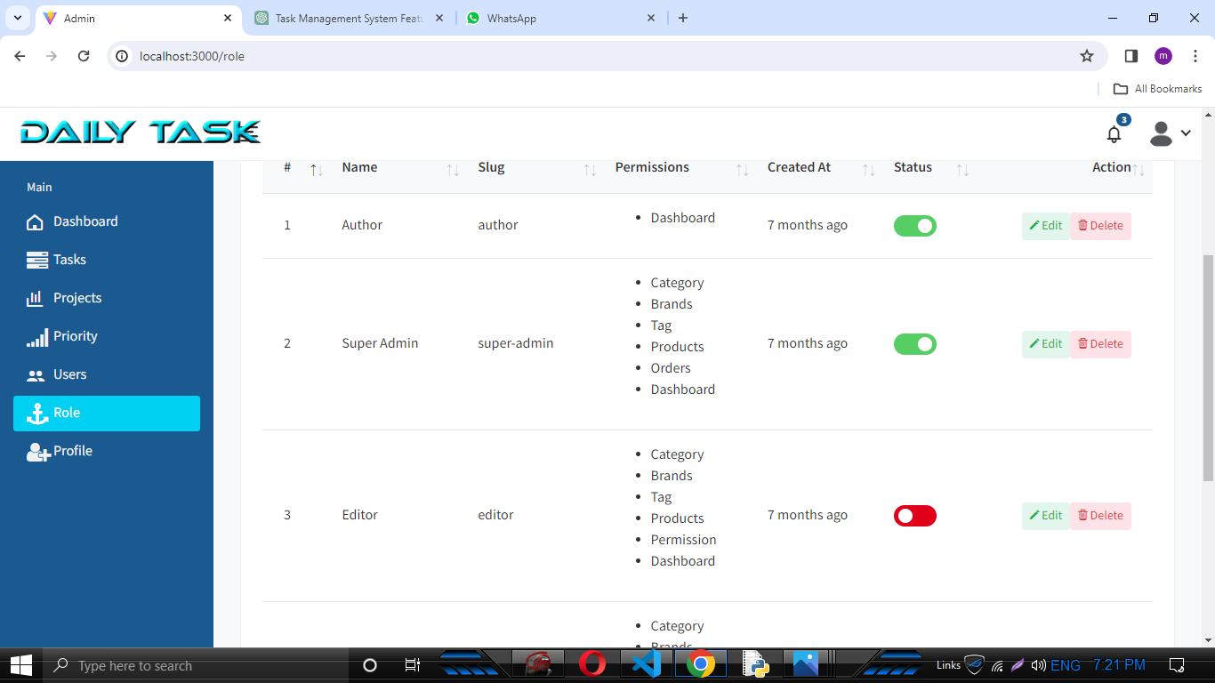

* **Password screen:** Enables to create a new password and confirmation of old password so it can generate a new password or else not.

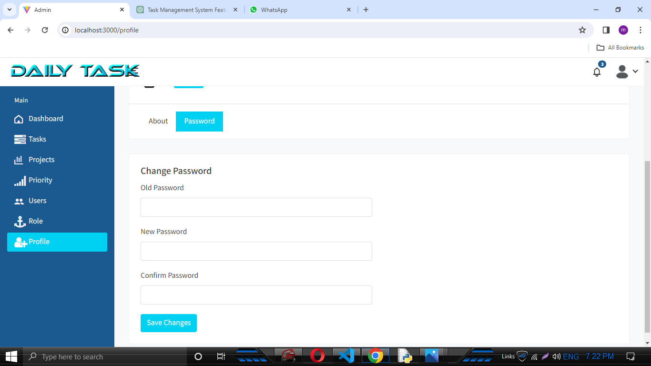

* **Profile screen:** Displays a admin details in the formation of form.

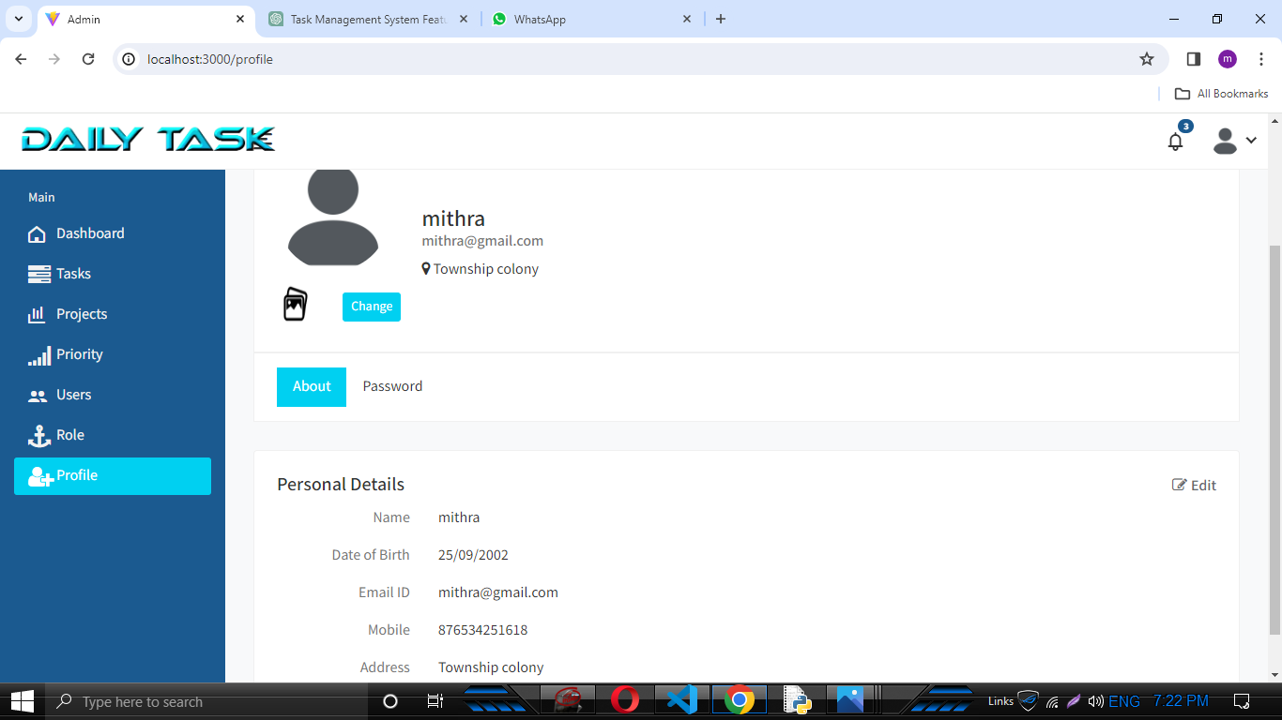

* **Edit user:** Enables to edit profile.

