# COMPUTER VISION

**EXERCISE 2a: Edges Detection with mVision**

Concepts: Gradient operator: Sobel. Drog, Canny

1. Load the *edges* GUI from the *mVisionGUI* menu.
2. Load the *piezas.bmp* image.
3. Detect edges using Sobel3 (the Sobel operator with a 3x3 kernel) and Sobel5 (with a 5x5 kernel). You can play a bit with the gradient image in Sobel3 since it shows the gradient direction clicking on it.
   1. Which is the difference between them (in the result image) with the default threshold (20, pixel intensity in the gradient image for being considered as an edge)?

*We get edges blurrier and with a bigger stroke. We also lose some detections (mostly false positives made by Sobel3).*

* 1. Try both kernels with different thresholds: 20, 40 and 60. What is happening?

*If we increase the threshold, we lose some edges. However, increasing the threshold of Sobel3 helps to eliminate some false positives.*

1. Now use the DroG detector with the default parameters.
   1. Why are detected less borders?

*We are using the derivative of the Gaussian function, so we are more sensible to sharp changes of gradient but we will remove the smoother transitions.*

* 1. Try with a different threshold and explain the result.

*With threshold 4, we can almost see every edge, but we also get some false positives due to shadows and textures. With threshold above 10, we start losing most of the edges. This is due to the small changes in the gradient function after applying DroG.*

* 1. With a threshold of 10, use different values for sigma (smoothing) and report which one provides the best output.

*It seems to be σ = 0.85:*

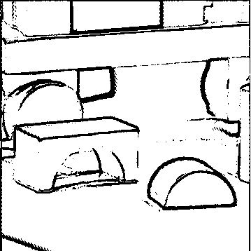

1. Finally, let’s try the Canny detector with the default values.
   1. Again, we are getting a poor edges image. What should we do?

*We can either change the threshold (around 0.13 seems to work fine), change sigma (which doesn’t help too much with such a low threshold like 0.5) or both.*

* 1. Matlab provides a function that detects edges in an image using different techniques, called edge(). Take a look at its syntax with help edge. Since through the GUI we are specifying just a threshold and a value for sigma, which are the values for the *large threshold* and the *small threshold* used by Canny?

*The documentation states that the lower threshold will be 0.4*high_threshold*

* 1. Modify the parameters for getting the best possible edges image. Would be that parameters valid for any image?

*A threshold of 0.12 and a sigma of 1.2 seems to provide a good approximation to the real edges:*

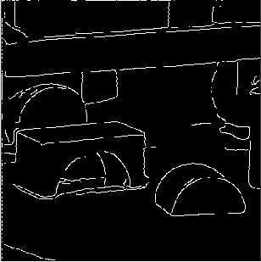

1. In your opinion, which is the best edge detector in terms of lower detection error, localization error, and multiple response?

*It depends. Canny seems to be more precise, but I found difficult to correctly tweak the parameters to get the best performance. The DroG detector that I’ve explained in exercise 5 seems to detect almost all edges, but they are blurrier than the Canny approach.*

**EXERCISE 2b: Implementing edges detection**

Concepts: Gradient operator: Sobel.

1. Design a Matlab function (not a script) that detects edges by means of the Sobel operator. The function must show a figure with 4 sub-plots (2x2), including:
   1. The initial image,
   2. an image with the vertical edges,
   3. an image with the horizontal edges,
   4. and a binary image with edges in green overlapping the initial one.

Input parameters of the function: image name, threshold for the edges image. It has to return a matrix with the edge angle in each pixel, in the range [-…].

**Useful functions**

|  |  |
| --- | --- |
| **img =conv2(img1, img2, type)** | Performs a convolution operation with **img1** and **img2**, taking into account the image border or not depending on the parameter **type**. |
| **mask = fspecial(mask_type)** | Builds a mask of a certain type with 3x3 size (5x5 for LoG). |

**Result**

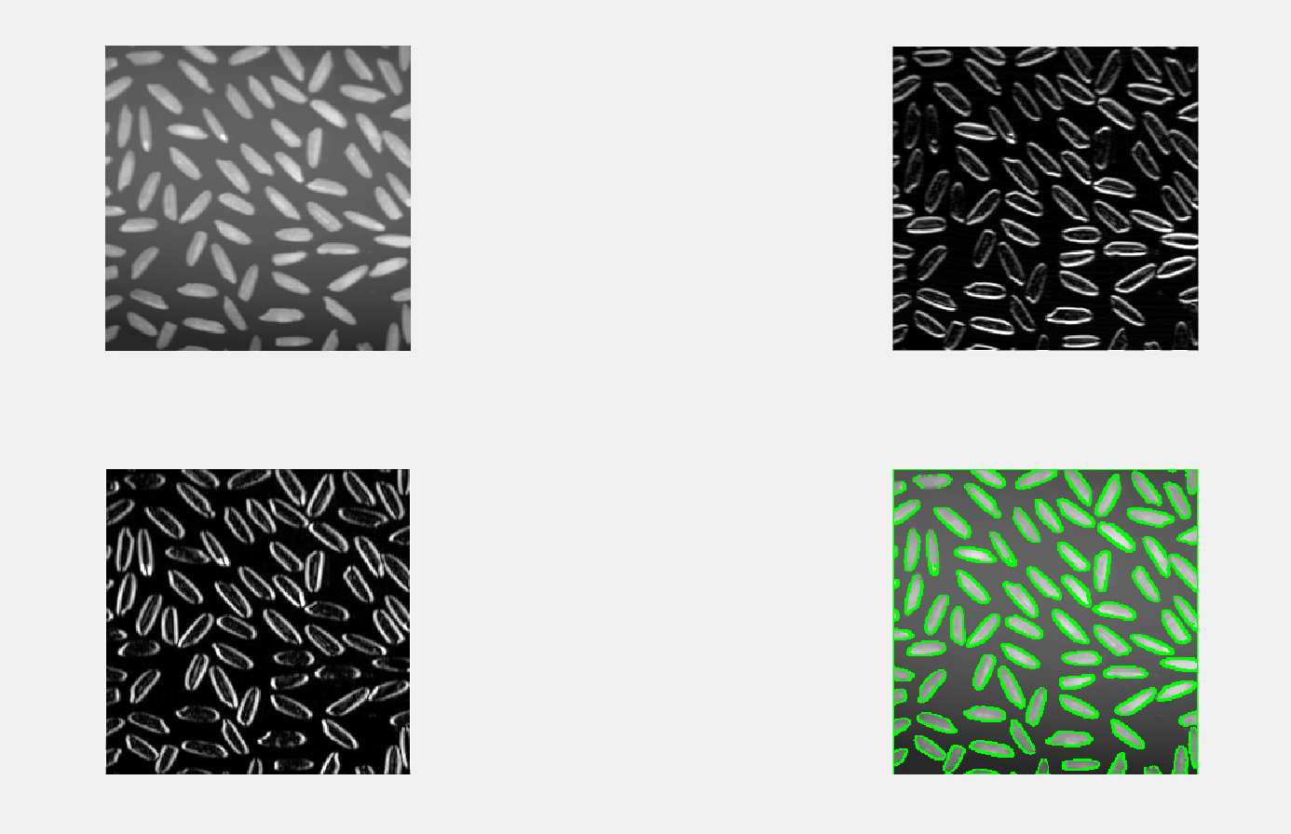

*In order to create the green siluete, I’ve created a new image where the edges which have a value avobe the threshold (0.8) which are overlapping the original image are painted green, while the rest of the image keeps it’s original colour.*