# COMPUTER VISION

**EXERCISE 9: Fundamental matrix**

Concepts: Camera calibration, Harris operator, fundamental matrix, epipolar lines, stereo.

1. **Camera calibration.** Since we are almost experts in computer vision, we are going to calibrate the camera of our smartphone or laptop. For that we are going to use the amazing tutorial and calibration application from MATLAB. The tutorial is full of interesting information and directions about how to calibrate the camera properly, as well as how to interpret the obtained results. To calibrate the camera, you only need the provided application, a pattern with a chessboard, and the camera itself! Take different pictures of the chessboard with different perspectives, run the application, and enjoy!
   * Tutorial url: <https://es.mathworks.com/help/vision/ug/single-camera-calibrator-app.html>

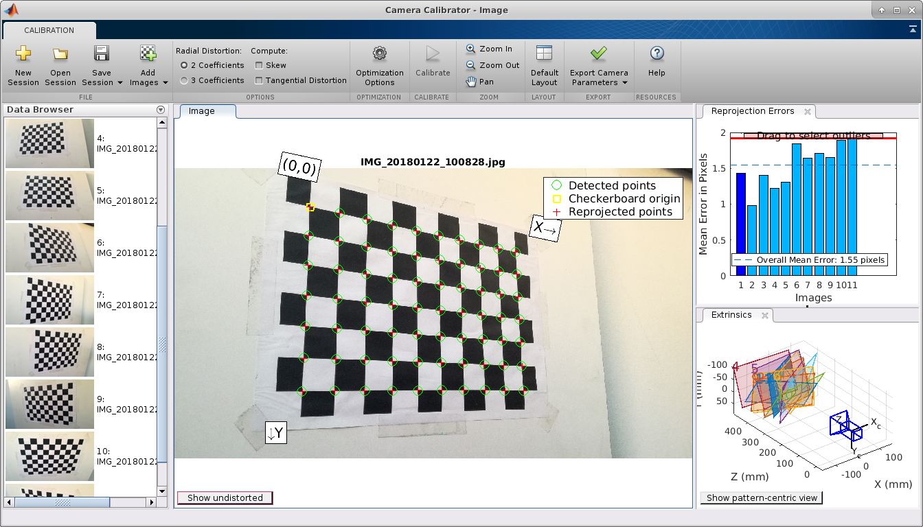

*Matlab Camera Calibrator application after the calibration of a camera.*

* + If you find technical problems to calibrate the camera, report them in your report and use the provided images and camera parameters.

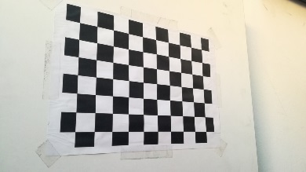 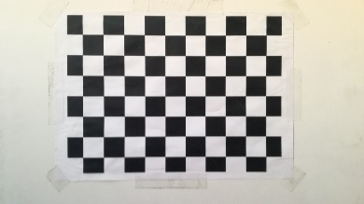 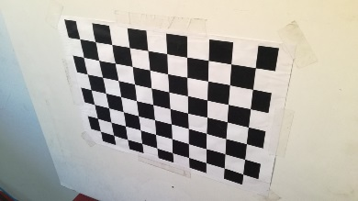

*Example of images observing the calibration pattern from a smartphone.*

* + Recall that in this exercise we are interested in the intrinsic parameters **cx**, **cy**, and **f** (center of the image and focal length, all of them in pixels). Include them in your report, along with the resolution of your camera (if your camera has a high resolution, consider resizing all the images so Matlab doesn’t become too slow).

Once the camera is calibrated, take a pair of pictures from surfaces with visual features , and measure the distance that the camera moved between both shots. It will be our baseline **b**. *Note: 10cm or so is ok.*

 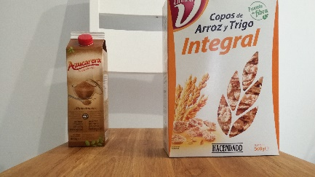 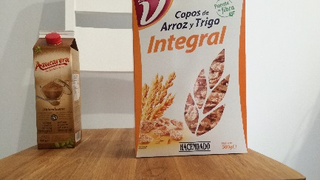

*Example of three images with a planar surface (the cereal box), where the camera moved 5cm to the right from the image on the left to the one in the middle, and 10 cm to the one on the right.*

1. **Fundamental matrix.** Now run the Harris keypoint detector that we designed in a previous exercise, and match the obtained keypoints. Then compute the fundamental matrix using the provided function **ransacfitfundmatrix**. *Note: if you were unable to calibrate your camera use the pepsi_left.tif and pepsi_right.tif images.*

*In order to get only the relevant keypoints, I used a threshold of about 0.85. Then, I stored the pair of keypoints in two arrays, x1 and x2.*

1. **Epipolar lines**. Next, using **ginput**, set any pixel on the left image and draw on the right one the corresponding epipolar line. ¿Where are the epipoles in each image?
2. **Tridimensional reconstruction.** Finally, project in 3D the matched points by cross correlation using the following equations, and represent them in a figure using **plot3**:

|  |
| --- |
| Xi = b*(xli-cx)/di  Yi = b*(yli-cy)/di  Zi = f*b/di |

Use the parameters cx, cy, and f from your camera, and the baseline between the two pictures. If you are working with the provided ones (pepsi images), use the following ones:

b = 0.119 m, cx = 255.64 px, cy = 201.12 px, f = 351.32 px, di= disparity of i-th point

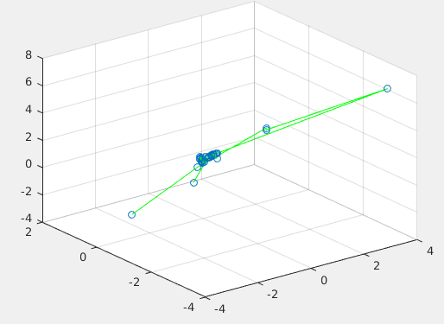*I had troubles in this exercise. I tried to plot the matrices X, Y and Z, but it didn’t make too much sense. Then, I took a closer look and I’ve noticed that those points had some similarity with the original photo:*

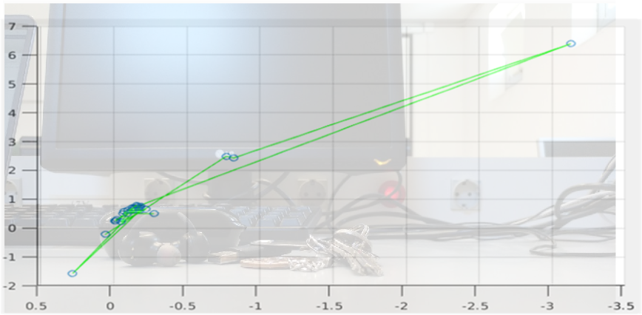*I still think that this is not the correct visualization, but after some research I noticed that mos of the points plotted corresponded to the keypoints with a correlation value over the threshold. However, I don’t think that the cluster of points should be over my earphones. I think they should be more at the right side of the image (maybe I chosen a wrong perspective?).*

*Then, I tried with the images provided pepsi_left.tif and pepsi_right.tif, obtaining much better results:*

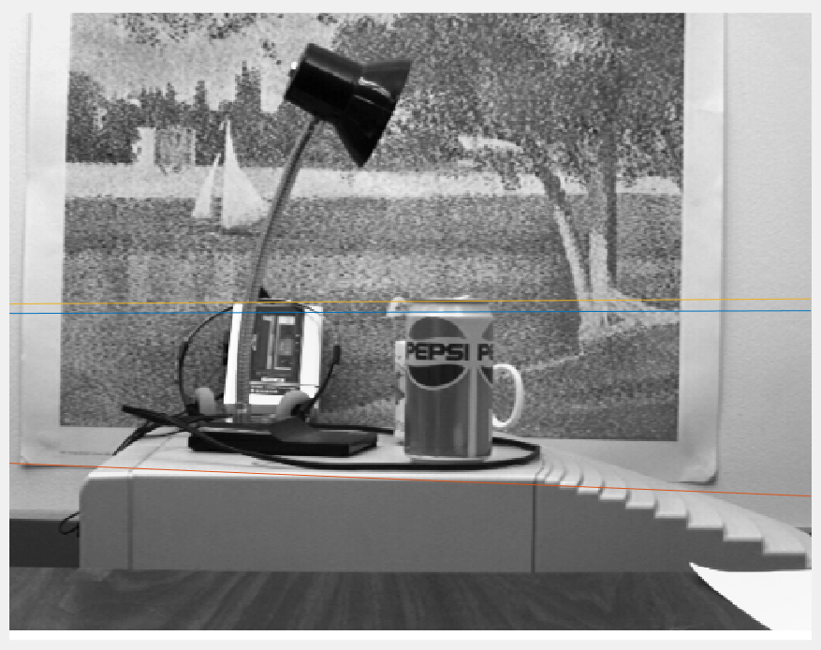

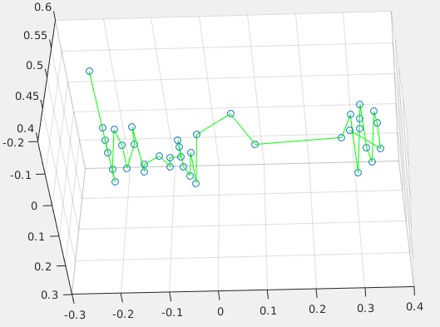*In this last image, we can see how most of the points are in the same plane (the background picture) whereas some of them are closer (the lamp and the pepsi tin can). This results made me think that maybe the problem with the first two photos was the low amount of points to plot.*