Best sellers [See more](https://www.amazon.com/gp/bestsellers/electronics/300189?ref_=Oct_BSellerC_300189_SAll&pf_rd_p=6f74083a-4541-5fc3-91f1-2d621a6b118d&pf_rd_s=merchandised-search-6&pf_rd_t=101&pf_rd_i=300189&pf_rd_m=ATVPDKIKX0DER&pf_rd_r=SA07QM4Q5S23C07F7VTB&pf_rd_r=SA07QM4Q5S23C07F7VTB&pf_rd_p=6f74083a-4541-5fc3-91f1-2d621a6b118d)

[[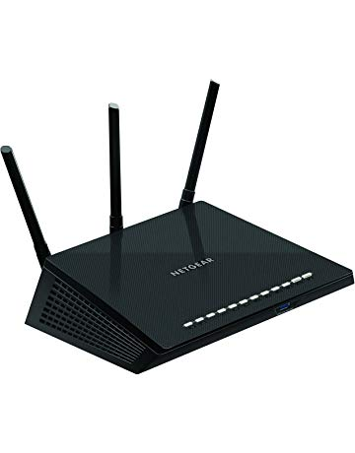](https://www.amazon.com/NETGEAR-R6700-Nighthawk-Gigabit-Ethernet/dp/B00R2AZLD2?ref_=Oct_BSellerC_300189_0&pf_rd_p=6f74083a-4541-5fc3-91f1-2d621a6b118d&pf_rd_s=merchandised-search-6&pf_rd_t=101&pf_rd_i=300189&pf_rd_m=ATVPDKIKX0DER&pf_rd_r=SA07QM4Q5S23C07F7VTB&pf_rd_r=SA07QM4Q5S23C07F7VTB&pf_rd_p=6f74083a-4541-5fc3-91f1-2d621a6b118d)](https://www.amazon.com/NETGEAR-R6700-Nighthawk-Gigabit-Ethernet/dp/B00R2AZLD2?ref_=Oct_BSellerC_300189_0&pf_rd_p=6f74083a-4541-5fc3-91f1-2d621a6b118d&pf_rd_s=merchandised-search-6&pf_rd_t=101&pf_rd_i=300189&pf_rd_m=ATVPDKIKX0DER&pf_rd_r=SA07QM4Q5S23C07F7VTB&pf_rd_r=SA07QM4Q5S23C07F7VTB&pf_rd_p=6f74083a-4541-5fc3-91f1-2d621a6b118d" \o "NETGEAR R6700 Nighthawk AC1750 Dual Band Smart WiFi Router, Gigabit Ethernet (R6700))

[#1](https://www.amazon.com/NETGEAR-R6700-Nighthawk-Gigabit-Ethernet/dp/B00R2AZLD2?ref_=Oct_BSellerC_300189_0&pf_rd_p=6f74083a-4541-5fc3-91f1-2d621a6b118d&pf_rd_s=merchandised-search-6&pf_rd_t=101&pf_rd_i=300189&pf_rd_m=ATVPDKIKX0DER&pf_rd_r=SA07QM4Q5S23C07F7VTB&pf_rd_r=SA07QM4Q5S23C07F7VTB&pf_rd_p=6f74083a-4541-5fc3-91f1-2d621a6b118d" \o "NETGEAR R6700 Nighthawk AC1750 Dual Band Smart WiFi Router, Gigabit Ethernet (R6700))

[price$102.01](https://www.amazon.com/NETGEAR-R6700-Nighthawk-Gigabit-Ethernet/dp/B00R2AZLD2?ref_=Oct_BSellerC_300189_0&pf_rd_p=6f74083a-4541-5fc3-91f1-2d621a6b118d&pf_rd_s=merchandised-search-6&pf_rd_t=101&pf_rd_i=300189&pf_rd_m=ATVPDKIKX0DER&pf_rd_r=SA07QM4Q5S23C07F7VTB&pf_rd_r=SA07QM4Q5S23C07F7VTB&pf_rd_p=6f74083a-4541-5fc3-91f1-2d621a6b118d" \o "NETGEAR R6700 Nighthawk AC1750 Dual Band Smart WiFi Router, Gigabit Ethernet (R6700))

[$129.99](https://www.amazon.com/NETGEAR-R6700-Nighthawk-Gigabit-Ethernet/dp/B00R2AZLD2?ref_=Oct_BSellerC_300189_0&pf_rd_p=6f74083a-4541-5fc3-91f1-2d621a6b118d&pf_rd_s=merchandised-search-6&pf_rd_t=101&pf_rd_i=300189&pf_rd_m=ATVPDKIKX0DER&pf_rd_r=SA07QM4Q5S23C07F7VTB&pf_rd_r=SA07QM4Q5S23C07F7VTB&pf_rd_p=6f74083a-4541-5fc3-91f1-2d621a6b118d" \o "NETGEAR R6700 Nighthawk AC1750 Dual Band Smart WiFi Router, Gigabit Ethernet (R6700))

[NETGEAR R6700 Nighthawk AC1750 Dual Band Smart WiFi Router, Gigabit Ethernet (R6700)](https://www.amazon.com/NETGEAR-R6700-Nighthawk-Gigabit-Ethernet/dp/B00R2AZLD2?ref_=Oct_BSellerC_300189_0&pf_rd_p=6f74083a-4541-5fc3-91f1-2d621a6b118d&pf_rd_s=merchandised-search-6&pf_rd_t=101&pf_rd_i=300189&pf_rd_m=ATVPDKIKX0DER&pf_rd_r=SA07QM4Q5S23C07F7VTB&pf_rd_r=SA07QM4Q5S23C07F7VTB&pf_rd_p=6f74083a-4541-5fc3-91f1-2d621a6b118d" \o "NETGEAR R6700 Nighthawk AC1750 Dual Band Smart WiFi Router, Gigabit Ethernet (R6700))

[[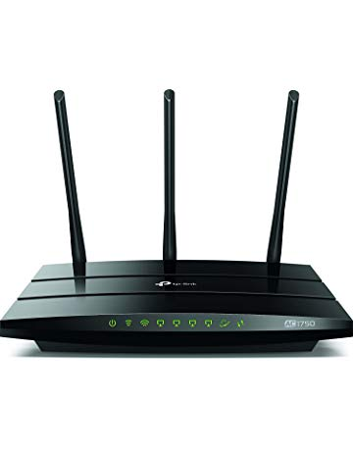](https://www.amazon.com/TP-Link-AC1750-Smart-WiFi-Router/dp/B079JD7F7G?ref_=Oct_BSellerC_300189_1&pf_rd_p=6f74083a-4541-5fc3-91f1-2d621a6b118d&pf_rd_s=merchandised-search-6&pf_rd_t=101&pf_rd_i=300189&pf_rd_m=ATVPDKIKX0DER&pf_rd_r=SA07QM4Q5S23C07F7VTB&pf_rd_r=SA07QM4Q5S23C07F7VTB&pf_rd_p=6f74083a-4541-5fc3-91f1-2d621a6b118d)](https://www.amazon.com/TP-Link-AC1750-Smart-WiFi-Router/dp/B079JD7F7G?ref_=Oct_BSellerC_300189_1&pf_rd_p=6f74083a-4541-5fc3-91f1-2d621a6b118d&pf_rd_s=merchandised-search-6&pf_rd_t=101&pf_rd_i=300189&pf_rd_m=ATVPDKIKX0DER&pf_rd_r=SA07QM4Q5S23C07F7VTB&pf_rd_r=SA07QM4Q5S23C07F7VTB&pf_rd_p=6f74083a-4541-5fc3-91f1-2d621a6b118d" \o "TP-Link AC1750 Smart WiFi Router - 5GHz Dual Band Gigabit Wireless Internet Routers for Home, Works with Alexa, Parental Control&QoS(Archer A7))

[#2](https://www.amazon.com/TP-Link-AC1750-Smart-WiFi-Router/dp/B079JD7F7G?ref_=Oct_BSellerC_300189_1&pf_rd_p=6f74083a-4541-5fc3-91f1-2d621a6b118d&pf_rd_s=merchandised-search-6&pf_rd_t=101&pf_rd_i=300189&pf_rd_m=ATVPDKIKX0DER&pf_rd_r=SA07QM4Q5S23C07F7VTB&pf_rd_r=SA07QM4Q5S23C07F7VTB&pf_rd_p=6f74083a-4541-5fc3-91f1-2d621a6b118d" \o "TP-Link AC1750 Smart WiFi Router - 5GHz Dual Band Gigabit Wireless Internet Routers for Home, Works with Alexa, Parental Control&QoS(Archer A7))

[price$59.99](https://www.amazon.com/TP-Link-AC1750-Smart-WiFi-Router/dp/B079JD7F7G?ref_=Oct_BSellerC_300189_1&pf_rd_p=6f74083a-4541-5fc3-91f1-2d621a6b118d&pf_rd_s=merchandised-search-6&pf_rd_t=101&pf_rd_i=300189&pf_rd_m=ATVPDKIKX0DER&pf_rd_r=SA07QM4Q5S23C07F7VTB&pf_rd_r=SA07QM4Q5S23C07F7VTB&pf_rd_p=6f74083a-4541-5fc3-91f1-2d621a6b118d" \o "TP-Link AC1750 Smart WiFi Router - 5GHz Dual Band Gigabit Wireless Internet Routers for Home, Works with Alexa, Parental Control&QoS(Archer A7))

[$79.99](https://www.amazon.com/TP-Link-AC1750-Smart-WiFi-Router/dp/B079JD7F7G?ref_=Oct_BSellerC_300189_1&pf_rd_p=6f74083a-4541-5fc3-91f1-2d621a6b118d&pf_rd_s=merchandised-search-6&pf_rd_t=101&pf_rd_i=300189&pf_rd_m=ATVPDKIKX0DER&pf_rd_r=SA07QM4Q5S23C07F7VTB&pf_rd_r=SA07QM4Q5S23C07F7VTB&pf_rd_p=6f74083a-4541-5fc3-91f1-2d621a6b118d" \o "TP-Link AC1750 Smart WiFi Router - 5GHz Dual Band Gigabit Wireless Internet Routers for Home, Works with Alexa, Parental Control&QoS(Archer A7))

[TP-Link AC1750 Smart WiFi Router - 5GHz Dual Band Gigabit Wireless Internet Routers for Home, Works with Alexa, Parental Control&QoS(Archer A7)](https://www.amazon.com/TP-Link-AC1750-Smart-WiFi-Router/dp/B079JD7F7G?ref_=Oct_BSellerC_300189_1&pf_rd_p=6f74083a-4541-5fc3-91f1-2d621a6b118d&pf_rd_s=merchandised-search-6&pf_rd_t=101&pf_rd_i=300189&pf_rd_m=ATVPDKIKX0DER&pf_rd_r=SA07QM4Q5S23C07F7VTB&pf_rd_r=SA07QM4Q5S23C07F7VTB&pf_rd_p=6f74083a-4541-5fc3-91f1-2d621a6b118d" \o "TP-Link AC1750 Smart WiFi Router - 5GHz Dual Band Gigabit Wireless Internet Routers for Home, Works with Alexa, Parental Control&QoS(Archer A7))

[[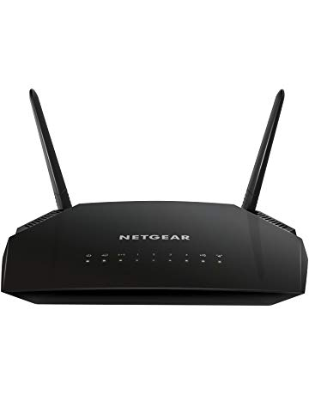](https://www.amazon.com/NETGEAR-AC1200-Router-Gigabit-Ethernet/dp/B0756QFLXP?ref_=Oct_BSellerC_300189_2&pf_rd_p=6f74083a-4541-5fc3-91f1-2d621a6b118d&pf_rd_s=merchandised-search-6&pf_rd_t=101&pf_rd_i=300189&pf_rd_m=ATVPDKIKX0DER&pf_rd_r=SA07QM4Q5S23C07F7VTB&pf_rd_r=SA07QM4Q5S23C07F7VTB&pf_rd_p=6f74083a-4541-5fc3-91f1-2d621a6b118d)](https://www.amazon.com/NETGEAR-AC1200-Router-Gigabit-Ethernet/dp/B0756QFLXP?ref_=Oct_BSellerC_300189_2&pf_rd_p=6f74083a-4541-5fc3-91f1-2d621a6b118d&pf_rd_s=merchandised-search-6&pf_rd_t=101&pf_rd_i=300189&pf_rd_m=ATVPDKIKX0DER&pf_rd_r=SA07QM4Q5S23C07F7VTB&pf_rd_r=SA07QM4Q5S23C07F7VTB&pf_rd_p=6f74083a-4541-5fc3-91f1-2d621a6b118d" \o "NETGEAR AC1200 Dual Band Smart WiFi Router, Gigabit Ethernet (R6230))

[#3](https://www.amazon.com/NETGEAR-AC1200-Router-Gigabit-Ethernet/dp/B0756QFLXP?ref_=Oct_BSellerC_300189_2&pf_rd_p=6f74083a-4541-5fc3-91f1-2d621a6b118d&pf_rd_s=merchandised-search-6&pf_rd_t=101&pf_rd_i=300189&pf_rd_m=ATVPDKIKX0DER&pf_rd_r=SA07QM4Q5S23C07F7VTB&pf_rd_r=SA07QM4Q5S23C07F7VTB&pf_rd_p=6f74083a-4541-5fc3-91f1-2d621a6b118d" \o "NETGEAR AC1200 Dual Band Smart WiFi Router, Gigabit Ethernet (R6230))

[price$69.99](https://www.amazon.com/NETGEAR-AC1200-Router-Gigabit-Ethernet/dp/B0756QFLXP?ref_=Oct_BSellerC_300189_2&pf_rd_p=6f74083a-4541-5fc3-91f1-2d621a6b118d&pf_rd_s=merchandised-search-6&pf_rd_t=101&pf_rd_i=300189&pf_rd_m=ATVPDKIKX0DER&pf_rd_r=SA07QM4Q5S23C07F7VTB&pf_rd_r=SA07QM4Q5S23C07F7VTB&pf_rd_p=6f74083a-4541-5fc3-91f1-2d621a6b118d" \o "NETGEAR AC1200 Dual Band Smart WiFi Router, Gigabit Ethernet (R6230))

[NETGEAR AC1200 Dual Band Smart WiFi Router, Gigabit Ethernet (R6230)](https://www.amazon.com/NETGEAR-AC1200-Router-Gigabit-Ethernet/dp/B0756QFLXP?ref_=Oct_BSellerC_300189_2&pf_rd_p=6f74083a-4541-5fc3-91f1-2d621a6b118d&pf_rd_s=merchandised-search-6&pf_rd_t=101&pf_rd_i=300189&pf_rd_m=ATVPDKIKX0DER&pf_rd_r=SA07QM4Q5S23C07F7VTB&pf_rd_r=SA07QM4Q5S23C07F7VTB&pf_rd_p=6f74083a-4541-5fc3-91f1-2d621a6b118d" \o "NETGEAR AC1200 Dual Band Smart WiFi Router, Gigabit Ethernet (R6230))

[[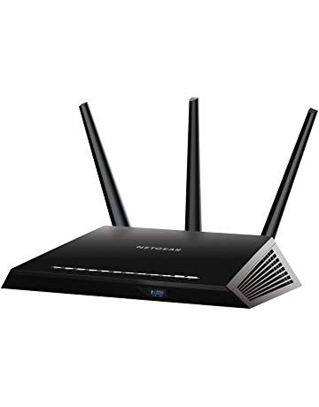](https://www.amazon.com/NETGEAR-Nighthawk-MU-MIMO-Parental-Controls/dp/B07C65K9H9?ref_=Oct_BSellerC_300189_3&pf_rd_p=6f74083a-4541-5fc3-91f1-2d621a6b118d&pf_rd_s=merchandised-search-6&pf_rd_t=101&pf_rd_i=300189&pf_rd_m=ATVPDKIKX0DER&pf_rd_r=SA07QM4Q5S23C07F7VTB&pf_rd_r=SA07QM4Q5S23C07F7VTB&pf_rd_p=6f74083a-4541-5fc3-91f1-2d621a6b118d)](https://www.amazon.com/NETGEAR-Nighthawk-MU-MIMO-Parental-Controls/dp/B07C65K9H9?ref_=Oct_BSellerC_300189_3&pf_rd_p=6f74083a-4541-5fc3-91f1-2d621a6b118d&pf_rd_s=merchandised-search-6&pf_rd_t=101&pf_rd_i=300189&pf_rd_m=ATVPDKIKX0DER&pf_rd_r=SA07QM4Q5S23C07F7VTB&pf_rd_r=SA07QM4Q5S23C07F7VTB&pf_rd_p=6f74083a-4541-5fc3-91f1-2d621a6b118d" \o "NETGEAR Nighthawk AC1900 Dual Band WiFi Router, MU-MIMO, Circle with Disney Smart Parental Controls (R6900P))

[price$99.99](https://www.amazon.com/NETGEAR-Nighthawk-MU-MIMO-Parental-Controls/dp/B07C65K9H9?ref_=Oct_BSellerC_300189_3&pf_rd_p=6f74083a-4541-5fc3-91f1-2d621a6b118d&pf_rd_s=merchandised-search-6&pf_rd_t=101&pf_rd_i=300189&pf_rd_m=ATVPDKIKX0DER&pf_rd_r=SA07QM4Q5S23C07F7VTB&pf_rd_r=SA07QM4Q5S23C07F7VTB&pf_rd_p=6f74083a-4541-5fc3-91f1-2d621a6b118d" \o "NETGEAR Nighthawk AC1900 Dual Band WiFi Router, MU-MIMO, Circle with Disney Smart Parental Controls (R6900P))

[$159.99](https://www.amazon.com/NETGEAR-Nighthawk-MU-MIMO-Parental-Controls/dp/B07C65K9H9?ref_=Oct_BSellerC_300189_3&pf_rd_p=6f74083a-4541-5fc3-91f1-2d621a6b118d&pf_rd_s=merchandised-search-6&pf_rd_t=101&pf_rd_i=300189&pf_rd_m=ATVPDKIKX0DER&pf_rd_r=SA07QM4Q5S23C07F7VTB&pf_rd_r=SA07QM4Q5S23C07F7VTB&pf_rd_p=6f74083a-4541-5fc3-91f1-2d621a6b118d" \o "NETGEAR Nighthawk AC1900 Dual Band WiFi Router, MU-MIMO, Circle with Disney Smart Parental Controls (R6900P))

[NETGEAR Nighthawk AC1900 Dual Band WiFi Router, MU-MIMO, Circle with Disney Smart Parental Controls (R6900P)](https://www.amazon.com/NETGEAR-Nighthawk-MU-MIMO-Parental-Controls/dp/B07C65K9H9?ref_=Oct_BSellerC_300189_3&pf_rd_p=6f74083a-4541-5fc3-91f1-2d621a6b118d&pf_rd_s=merchandised-search-6&pf_rd_t=101&pf_rd_i=300189&pf_rd_m=ATVPDKIKX0DER&pf_rd_r=SA07QM4Q5S23C07F7VTB&pf_rd_r=SA07QM4Q5S23C07F7VTB&pf_rd_p=6f74083a-4541-5fc3-91f1-2d621a6b118d" \o "NETGEAR Nighthawk AC1900 Dual Band WiFi Router, MU-MIMO, Circle with Disney Smart Parental Controls (R6900P))

[[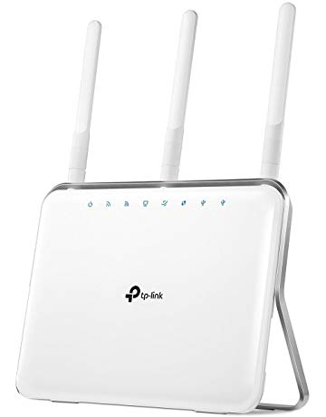](https://www.amazon.com/TP-Link-AC1900-Smart-Wireless-Router/dp/B00PDLRHFW?ref_=Oct_BSellerC_300189_4&pf_rd_p=6f74083a-4541-5fc3-91f1-2d621a6b118d&pf_rd_s=merchandised-search-6&pf_rd_t=101&pf_rd_i=300189&pf_rd_m=ATVPDKIKX0DER&pf_rd_r=SA07QM4Q5S23C07F7VTB&pf_rd_r=SA07QM4Q5S23C07F7VTB&pf_rd_p=6f74083a-4541-5fc3-91f1-2d621a6b118d)](https://www.amazon.com/TP-Link-AC1900-Smart-Wireless-Router/dp/B00PDLRHFW?ref_=Oct_BSellerC_300189_4&pf_rd_p=6f74083a-4541-5fc3-91f1-2d621a6b118d&pf_rd_s=merchandised-search-6&pf_rd_t=101&pf_rd_i=300189&pf_rd_m=ATVPDKIKX0DER&pf_rd_r=SA07QM4Q5S23C07F7VTB&pf_rd_r=SA07QM4Q5S23C07F7VTB&pf_rd_p=6f74083a-4541-5fc3-91f1-2d621a6b118d" \o "TP-Link AC1900 Smart Wireless Router - High Speed, Long Range, Dual Band Gigabit WiFi Internet Routers for Home, Beamforming, Ideal for Gaming(Archer C9))

[price$79.99](https://www.amazon.com/TP-Link-AC1900-Smart-Wireless-Router/dp/B00PDLRHFW?ref_=Oct_BSellerC_300189_4&pf_rd_p=6f74083a-4541-5fc3-91f1-2d621a6b118d&pf_rd_s=merchandised-search-6&pf_rd_t=101&pf_rd_i=300189&pf_rd_m=ATVPDKIKX0DER&pf_rd_r=SA07QM4Q5S23C07F7VTB&pf_rd_r=SA07QM4Q5S23C07F7VTB&pf_rd_p=6f74083a-4541-5fc3-91f1-2d621a6b118d" \o "TP-Link AC1900 Smart Wireless Router - High Speed, Long Range, Dual Band Gigabit WiFi Internet Routers for Home, Beamforming, Ideal for Gaming(Archer C9))

[$109.99](https://www.amazon.com/TP-Link-AC1900-Smart-Wireless-Router/dp/B00PDLRHFW?ref_=Oct_BSellerC_300189_4&pf_rd_p=6f74083a-4541-5fc3-91f1-2d621a6b118d&pf_rd_s=merchandised-search-6&pf_rd_t=101&pf_rd_i=300189&pf_rd_m=ATVPDKIKX0DER&pf_rd_r=SA07QM4Q5S23C07F7VTB&pf_rd_r=SA07QM4Q5S23C07F7VTB&pf_rd_p=6f74083a-4541-5fc3-91f1-2d621a6b118d" \o "TP-Link AC1900 Smart Wireless Router - High Speed, Long Range, Dual Band Gigabit WiFi Internet Routers for Home, Beamforming, Ideal for Gaming(Archer C9))

[TP-Link AC1900 Smart Wireless Router - High Speed, Long Range, Dual Band Gigabit WiFi Internet Routers for Home, Beamforming, Ideal for Gaming(Archer C9)](https://www.amazon.com/TP-Link-AC1900-Smart-Wireless-Router/dp/B00PDLRHFW?ref_=Oct_BSellerC_300189_4&pf_rd_p=6f74083a-4541-5fc3-91f1-2d621a6b118d&pf_rd_s=merchandised-search-6&pf_rd_t=101&pf_rd_i=300189&pf_rd_m=ATVPDKIKX0DER&pf_rd_r=SA07QM4Q5S23C07F7VTB&pf_rd_r=SA07QM4Q5S23C07F7VTB&pf_rd_p=6f74083a-4541-5fc3-91f1-2d621a6b118d" \o "TP-Link AC1900 Smart Wireless Router - High Speed, Long Range, Dual Band Gigabit WiFi Internet Routers for Home, Beamforming, Ideal for Gaming(Archer C9))

[[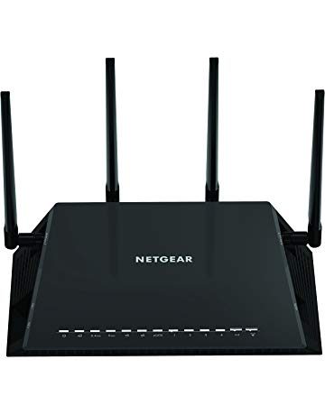](https://www.amazon.com/Netgear-R7800-100NAS-Nighthawk-Ethernet-Compatible/dp/B0192911RA?ref_=Oct_BSellerC_300189_5&pf_rd_p=6f74083a-4541-5fc3-91f1-2d621a6b118d&pf_rd_s=merchandised-search-6&pf_rd_t=101&pf_rd_i=300189&pf_rd_m=ATVPDKIKX0DER&pf_rd_r=SA07QM4Q5S23C07F7VTB&pf_rd_r=SA07QM4Q5S23C07F7VTB&pf_rd_p=6f74083a-4541-5fc3-91f1-2d621a6b118d)](https://www.amazon.com/Netgear-R7800-100NAS-Nighthawk-Ethernet-Compatible/dp/B0192911RA?ref_=Oct_BSellerC_300189_5&pf_rd_p=6f74083a-4541-5fc3-91f1-2d621a6b118d&pf_rd_s=merchandised-search-6&pf_rd_t=101&pf_rd_i=300189&pf_rd_m=ATVPDKIKX0DER&pf_rd_r=SA07QM4Q5S23C07F7VTB&pf_rd_r=SA07QM4Q5S23C07F7VTB&pf_rd_p=6f74083a-4541-5fc3-91f1-2d621a6b118d" \o "Netgear (R7800-100NAS) Nighthawk X4S AC2600 4x4 Dual Band Smart WiFi Router, Gigabit Ethernet, MU-MIMO, Compatible with Amazon Echo/Alexa)

[price$189.00](https://www.amazon.com/Netgear-R7800-100NAS-Nighthawk-Ethernet-Compatible/dp/B0192911RA?ref_=Oct_BSellerC_300189_5&pf_rd_p=6f74083a-4541-5fc3-91f1-2d621a6b118d&pf_rd_s=merchandised-search-6&pf_rd_t=101&pf_rd_i=300189&pf_rd_m=ATVPDKIKX0DER&pf_rd_r=SA07QM4Q5S23C07F7VTB&pf_rd_r=SA07QM4Q5S23C07F7VTB&pf_rd_p=6f74083a-4541-5fc3-91f1-2d621a6b118d" \o "Netgear (R7800-100NAS) Nighthawk X4S AC2600 4x4 Dual Band Smart WiFi Router, Gigabit Ethernet, MU-MIMO, Compatible with Amazon Echo/Alexa)

[$229.99](https://www.amazon.com/Netgear-R7800-100NAS-Nighthawk-Ethernet-Compatible/dp/B0192911RA?ref_=Oct_BSellerC_300189_5&pf_rd_p=6f74083a-4541-5fc3-91f1-2d621a6b118d&pf_rd_s=merchandised-search-6&pf_rd_t=101&pf_rd_i=300189&pf_rd_m=ATVPDKIKX0DER&pf_rd_r=SA07QM4Q5S23C07F7VTB&pf_rd_r=SA07QM4Q5S23C07F7VTB&pf_rd_p=6f74083a-4541-5fc3-91f1-2d621a6b118d" \o "Netgear (R7800-100NAS) Nighthawk X4S AC2600 4x4 Dual Band Smart WiFi Router, Gigabit Ethernet, MU-MIMO, Compatible with Amazon Echo/Alexa)

[Netgear (R7800-100NAS) Nighthawk X4S AC2600 4x4 Dual Band Smart WiFi Router, Gigabit Ethernet, MU-MIMO, Compatible with Amazon Echo/Alexa](https://www.amazon.com/Netgear-R7800-100NAS-Nighthawk-Ethernet-Compatible/dp/B0192911RA?ref_=Oct_BSellerC_300189_5&pf_rd_p=6f74083a-4541-5fc3-91f1-2d621a6b118d&pf_rd_s=merchandised-search-6&pf_rd_t=101&pf_rd_i=300189&pf_rd_m=ATVPDKIKX0DER&pf_rd_r=SA07QM4Q5S23C07F7VTB&pf_rd_r=SA07QM4Q5S23C07F7VTB&pf_rd_p=6f74083a-4541-5fc3-91f1-2d621a6b118d" \o "Netgear (R7800-100NAS) Nighthawk X4S AC2600 4x4 Dual Band Smart WiFi Router, Gigabit Ethernet, MU-MIMO, Compatible with Amazon Echo/Alexa)

[[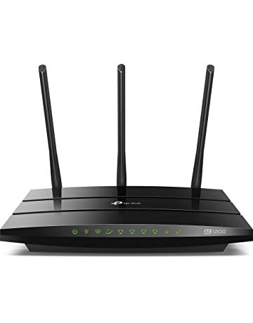](https://www.amazon.com/TP-Link-AC1200-Smart-WiFi-Router/dp/B01IUDUJE0?ref_=Oct_BSellerC_300189_6&pf_rd_p=6f74083a-4541-5fc3-91f1-2d621a6b118d&pf_rd_s=merchandised-search-6&pf_rd_t=101&pf_rd_i=300189&pf_rd_m=ATVPDKIKX0DER&pf_rd_r=SA07QM4Q5S23C07F7VTB&pf_rd_r=SA07QM4Q5S23C07F7VTB&pf_rd_p=6f74083a-4541-5fc3-91f1-2d621a6b118d)](https://www.amazon.com/TP-Link-AC1200-Smart-WiFi-Router/dp/B01IUDUJE0?ref_=Oct_BSellerC_300189_6&pf_rd_p=6f74083a-4541-5fc3-91f1-2d621a6b118d&pf_rd_s=merchandised-search-6&pf_rd_t=101&pf_rd_i=300189&pf_rd_m=ATVPDKIKX0DER&pf_rd_r=SA07QM4Q5S23C07F7VTB&pf_rd_r=SA07QM4Q5S23C07F7VTB&pf_rd_p=6f74083a-4541-5fc3-91f1-2d621a6b118d" \o "TP-Link AC1200 Smart WiFi Router - 5GHz Gigabit Dual Band Wireless Internet Router for Home(Archer C1200))

[price$47.99](https://www.amazon.com/TP-Link-AC1200-Smart-WiFi-Router/dp/B01IUDUJE0?ref_=Oct_BSellerC_300189_6&pf_rd_p=6f74083a-4541-5fc3-91f1-2d621a6b118d&pf_rd_s=merchandised-search-6&pf_rd_t=101&pf_rd_i=300189&pf_rd_m=ATVPDKIKX0DER&pf_rd_r=SA07QM4Q5S23C07F7VTB&pf_rd_r=SA07QM4Q5S23C07F7VTB&pf_rd_p=6f74083a-4541-5fc3-91f1-2d621a6b118d" \o "TP-Link AC1200 Smart WiFi Router - 5GHz Gigabit Dual Band Wireless Internet Router for Home(Archer C1200))

[$74.92](https://www.amazon.com/TP-Link-AC1200-Smart-WiFi-Router/dp/B01IUDUJE0?ref_=Oct_BSellerC_300189_6&pf_rd_p=6f74083a-4541-5fc3-91f1-2d621a6b118d&pf_rd_s=merchandised-search-6&pf_rd_t=101&pf_rd_i=300189&pf_rd_m=ATVPDKIKX0DER&pf_rd_r=SA07QM4Q5S23C07F7VTB&pf_rd_r=SA07QM4Q5S23C07F7VTB&pf_rd_p=6f74083a-4541-5fc3-91f1-2d621a6b118d" \o "TP-Link AC1200 Smart WiFi Router - 5GHz Gigabit Dual Band Wireless Internet Router for Home(Archer C1200))

[TP-Link AC1200 Smart WiFi Router - 5GHz Gigabit Dual Band Wireless Internet Router for Home(Archer C1200)](https://www.amazon.com/TP-Link-AC1200-Smart-WiFi-Router/dp/B01IUDUJE0?ref_=Oct_BSellerC_300189_6&pf_rd_p=6f74083a-4541-5fc3-91f1-2d621a6b118d&pf_rd_s=merchandised-search-6&pf_rd_t=101&pf_rd_i=300189&pf_rd_m=ATVPDKIKX0DER&pf_rd_r=SA07QM4Q5S23C07F7VTB&pf_rd_r=SA07QM4Q5S23C07F7VTB&pf_rd_p=6f74083a-4541-5fc3-91f1-2d621a6b118d" \o "TP-Link AC1200 Smart WiFi Router - 5GHz Gigabit Dual Band Wireless Internet Router for Home(Archer C1200))

[[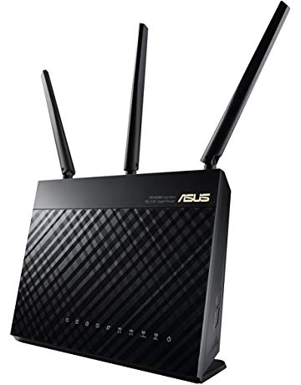](https://www.amazon.com/Dual-Band-AiMesh-Router-AC1900-System/dp/B00FB45SI4?ref_=Oct_BSellerC_300189_7&pf_rd_p=6f74083a-4541-5fc3-91f1-2d621a6b118d&pf_rd_s=merchandised-search-6&pf_rd_t=101&pf_rd_i=300189&pf_rd_m=ATVPDKIKX0DER&pf_rd_r=SA07QM4Q5S23C07F7VTB&pf_rd_r=SA07QM4Q5S23C07F7VTB&pf_rd_p=6f74083a-4541-5fc3-91f1-2d621a6b118d)](https://www.amazon.com/Dual-Band-AiMesh-Router-AC1900-System/dp/B00FB45SI4?ref_=Oct_BSellerC_300189_7&pf_rd_p=6f74083a-4541-5fc3-91f1-2d621a6b118d&pf_rd_s=merchandised-search-6&pf_rd_t=101&pf_rd_i=300189&pf_rd_m=ATVPDKIKX0DER&pf_rd_r=SA07QM4Q5S23C07F7VTB&pf_rd_r=SA07QM4Q5S23C07F7VTB&pf_rd_p=6f74083a-4541-5fc3-91f1-2d621a6b118d" \o "ASUS Whole Home Dual-Band AiMesh Router (AC1900) for Mesh Wifi System (Up to 1900 Mbps) - AiProtection Network Security by Trend Micro, Adaptive QoS & Parental Control (RT-AC68U))

[price$134.90](https://www.amazon.com/Dual-Band-AiMesh-Router-AC1900-System/dp/B00FB45SI4?ref_=Oct_BSellerC_300189_7&pf_rd_p=6f74083a-4541-5fc3-91f1-2d621a6b118d&pf_rd_s=merchandised-search-6&pf_rd_t=101&pf_rd_i=300189&pf_rd_m=ATVPDKIKX0DER&pf_rd_r=SA07QM4Q5S23C07F7VTB&pf_rd_r=SA07QM4Q5S23C07F7VTB&pf_rd_p=6f74083a-4541-5fc3-91f1-2d621a6b118d" \o "ASUS Whole Home Dual-Band AiMesh Router (AC1900) for Mesh Wifi System (Up to 1900 Mbps) - AiProtection Network Security by Trend Micro, Adaptive QoS & Parental Control (RT-AC68U))

[$159.99](https://www.amazon.com/Dual-Band-AiMesh-Router-AC1900-System/dp/B00FB45SI4?ref_=Oct_BSellerC_300189_7&pf_rd_p=6f74083a-4541-5fc3-91f1-2d621a6b118d&pf_rd_s=merchandised-search-6&pf_rd_t=101&pf_rd_i=300189&pf_rd_m=ATVPDKIKX0DER&pf_rd_r=SA07QM4Q5S23C07F7VTB&pf_rd_r=SA07QM4Q5S23C07F7VTB&pf_rd_p=6f74083a-4541-5fc3-91f1-2d621a6b118d" \o "ASUS Whole Home Dual-Band AiMesh Router (AC1900) for Mesh Wifi System (Up to 1900 Mbps) - AiProtection Network Security by Trend Micro, Adaptive QoS & Parental Control (RT-AC68U))

[ASUS Whole Home Dual-Band AiMesh Router (AC1900) for Mesh Wifi System (Up to 1900 Mbps) - AiProtection Network Security by Trend Micro, Adaptive QoS & Parental Control (RT-AC68U)](https://www.amazon.com/Dual-Band-AiMesh-Router-AC1900-System/dp/B00FB45SI4?ref_=Oct_BSellerC_300189_7&pf_rd_p=6f74083a-4541-5fc3-91f1-2d621a6b118d&pf_rd_s=merchandised-search-6&pf_rd_t=101&pf_rd_i=300189&pf_rd_m=ATVPDKIKX0DER&pf_rd_r=SA07QM4Q5S23C07F7VTB&pf_rd_r=SA07QM4Q5S23C07F7VTB&pf_rd_p=6f74083a-4541-5fc3-91f1-2d621a6b118d" \o "ASUS Whole Home Dual-Band AiMesh Router (AC1900) for Mesh Wifi System (Up to 1900 Mbps) - AiProtection Network Security by Trend Micro, Adaptive QoS & Parental Control (RT-AC68U))

[[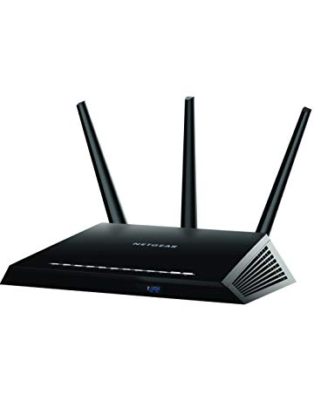](https://www.amazon.com/R7000-100PAS-Nighthawk-Parental-Controls-Compatible/dp/B00F0DD0I6?ref_=Oct_BSellerC_300189_8&pf_rd_p=6f74083a-4541-5fc3-91f1-2d621a6b118d&pf_rd_s=merchandised-search-6&pf_rd_t=101&pf_rd_i=300189&pf_rd_m=ATVPDKIKX0DER&pf_rd_r=SA07QM4Q5S23C07F7VTB&pf_rd_r=SA07QM4Q5S23C07F7VTB&pf_rd_p=6f74083a-4541-5fc3-91f1-2d621a6b118d)](https://www.amazon.com/R7000-100PAS-Nighthawk-Parental-Controls-Compatible/dp/B00F0DD0I6?ref_=Oct_BSellerC_300189_8&pf_rd_p=6f74083a-4541-5fc3-91f1-2d621a6b118d&pf_rd_s=merchandised-search-6&pf_rd_t=101&pf_rd_i=300189&pf_rd_m=ATVPDKIKX0DER&pf_rd_r=SA07QM4Q5S23C07F7VTB&pf_rd_r=SA07QM4Q5S23C07F7VTB&pf_rd_p=6f74083a-4541-5fc3-91f1-2d621a6b118d" \o "Netgear (R7000-100PAS) Nighthawk AC1900 Dual Band WiFi Router, Gigabit Router, Open Source Support, Circle with Smart Parental Controls, Compatible with Amazon Alexa)

[price$142.26](https://www.amazon.com/R7000-100PAS-Nighthawk-Parental-Controls-Compatible/dp/B00F0DD0I6?ref_=Oct_BSellerC_300189_8&pf_rd_p=6f74083a-4541-5fc3-91f1-2d621a6b118d&pf_rd_s=merchandised-search-6&pf_rd_t=101&pf_rd_i=300189&pf_rd_m=ATVPDKIKX0DER&pf_rd_r=SA07QM4Q5S23C07F7VTB&pf_rd_r=SA07QM4Q5S23C07F7VTB&pf_rd_p=6f74083a-4541-5fc3-91f1-2d621a6b118d" \o "Netgear (R7000-100PAS) Nighthawk AC1900 Dual Band WiFi Router, Gigabit Router, Open Source Support, Circle with Smart Parental Controls, Compatible with Amazon Alexa)

[$239.25](https://www.amazon.com/R7000-100PAS-Nighthawk-Parental-Controls-Compatible/dp/B00F0DD0I6?ref_=Oct_BSellerC_300189_8&pf_rd_p=6f74083a-4541-5fc3-91f1-2d621a6b118d&pf_rd_s=merchandised-search-6&pf_rd_t=101&pf_rd_i=300189&pf_rd_m=ATVPDKIKX0DER&pf_rd_r=SA07QM4Q5S23C07F7VTB&pf_rd_r=SA07QM4Q5S23C07F7VTB&pf_rd_p=6f74083a-4541-5fc3-91f1-2d621a6b118d" \o "Netgear (R7000-100PAS) Nighthawk AC1900 Dual Band WiFi Router, Gigabit Router, Open Source Support, Circle with Smart Parental Controls, Compatible with Amazon Alexa)

[Netgear (R7000-100PAS) Nighthawk AC1900 Dual Band WiFi Router, Gigabit Router, Open Source Support, Circle with Smart Parental Controls, Compatible with Amazon Alexa](https://www.amazon.com/R7000-100PAS-Nighthawk-Parental-Controls-Compatible/dp/B00F0DD0I6?ref_=Oct_BSellerC_300189_8&pf_rd_p=6f74083a-4541-5fc3-91f1-2d621a6b118d&pf_rd_s=merchandised-search-6&pf_rd_t=101&pf_rd_i=300189&pf_rd_m=ATVPDKIKX0DER&pf_rd_r=SA07QM4Q5S23C07F7VTB&pf_rd_r=SA07QM4Q5S23C07F7VTB&pf_rd_p=6f74083a-4541-5fc3-91f1-2d621a6b118d" \o "Netgear (R7000-100PAS) Nighthawk AC1900 Dual Band WiFi Router, Gigabit Router, Open Source Support, Circle with Smart Parental Controls, Compatible with Amazon Alexa)

[[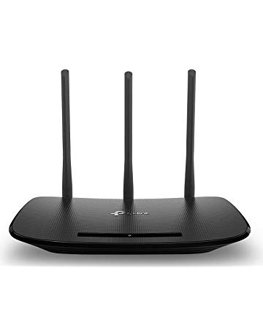](https://www.amazon.com/TP-Link-N450-Wi-Fi-Router-TL-WR940N/dp/B003Y5RYNY?ref_=Oct_BSellerC_300189_9&pf_rd_p=6f74083a-4541-5fc3-91f1-2d621a6b118d&pf_rd_s=merchandised-search-6&pf_rd_t=101&pf_rd_i=300189&pf_rd_m=ATVPDKIKX0DER&pf_rd_r=SA07QM4Q5S23C07F7VTB&pf_rd_r=SA07QM4Q5S23C07F7VTB&pf_rd_p=6f74083a-4541-5fc3-91f1-2d621a6b118d)](https://www.amazon.com/TP-Link-N450-Wi-Fi-Router-TL-WR940N/dp/B003Y5RYNY?ref_=Oct_BSellerC_300189_9&pf_rd_p=6f74083a-4541-5fc3-91f1-2d621a6b118d&pf_rd_s=merchandised-search-6&pf_rd_t=101&pf_rd_i=300189&pf_rd_m=ATVPDKIKX0DER&pf_rd_r=SA07QM4Q5S23C07F7VTB&pf_rd_r=SA07QM4Q5S23C07F7VTB&pf_rd_p=6f74083a-4541-5fc3-91f1-2d621a6b118d" \o "TP-Link N450 Wi-Fi Router - Wireless Internet Router for Home(TL-WR940N))

[price$24.99](https://www.amazon.com/TP-Link-N450-Wi-Fi-Router-TL-WR940N/dp/B003Y5RYNY?ref_=Oct_BSellerC_300189_9&pf_rd_p=6f74083a-4541-5fc3-91f1-2d621a6b118d&pf_rd_s=merchandised-search-6&pf_rd_t=101&pf_rd_i=300189&pf_rd_m=ATVPDKIKX0DER&pf_rd_r=SA07QM4Q5S23C07F7VTB&pf_rd_r=SA07QM4Q5S23C07F7VTB&pf_rd_p=6f74083a-4541-5fc3-91f1-2d621a6b118d" \o "TP-Link N450 Wi-Fi Router - Wireless Internet Router for Home(TL-WR940N))

[$28.99](https://www.amazon.com/TP-Link-N450-Wi-Fi-Router-TL-WR940N/dp/B003Y5RYNY?ref_=Oct_BSellerC_300189_9&pf_rd_p=6f74083a-4541-5fc3-91f1-2d621a6b118d&pf_rd_s=merchandised-search-6&pf_rd_t=101&pf_rd_i=300189&pf_rd_m=ATVPDKIKX0DER&pf_rd_r=SA07QM4Q5S23C07F7VTB&pf_rd_r=SA07QM4Q5S23C07F7VTB&pf_rd_p=6f74083a-4541-5fc3-91f1-2d621a6b118d" \o "TP-Link N450 Wi-Fi Router - Wireless Internet Router for Home(TL-WR940N))

[TP-Link N450 Wi-Fi Router - Wireless Internet Router for Home(TL-WR940N)](https://www.amazon.com/TP-Link-N450-Wi-Fi-Router-TL-WR940N/dp/B003Y5RYNY?ref_=Oct_BSellerC_300189_9&pf_rd_p=6f74083a-4541-5fc3-91f1-2d621a6b118d&pf_rd_s=merchandised-search-6&pf_rd_t=101&pf_rd_i=300189&pf_rd_m=ATVPDKIKX0DER&pf_rd_r=SA07QM4Q5S23C07F7VTB&pf_rd_r=SA07QM4Q5S23C07F7VTB&pf_rd_p=6f74083a-4541-5fc3-91f1-2d621a6b118d" \o "TP-Link N450 Wi-Fi Router - Wireless Internet Router for Home(TL-WR940N))

[[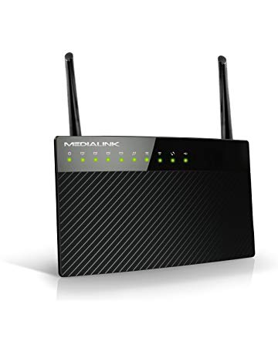](https://www.amazon.com/Medialink-AC1200-Wireless-Gigabit-Router/dp/B01MS84IIF?ref_=Oct_BSellerC_300189_10&pf_rd_p=6f74083a-4541-5fc3-91f1-2d621a6b118d&pf_rd_s=merchandised-search-6&pf_rd_t=101&pf_rd_i=300189&pf_rd_m=ATVPDKIKX0DER&pf_rd_r=SA07QM4Q5S23C07F7VTB&pf_rd_r=SA07QM4Q5S23C07F7VTB&pf_rd_p=6f74083a-4541-5fc3-91f1-2d621a6b118d)](https://www.amazon.com/Medialink-AC1200-Wireless-Gigabit-Router/dp/B01MS84IIF?ref_=Oct_BSellerC_300189_10&pf_rd_p=6f74083a-4541-5fc3-91f1-2d621a6b118d&pf_rd_s=merchandised-search-6&pf_rd_t=101&pf_rd_i=300189&pf_rd_m=ATVPDKIKX0DER&pf_rd_r=SA07QM4Q5S23C07F7VTB&pf_rd_r=SA07QM4Q5S23C07F7VTB&pf_rd_p=6f74083a-4541-5fc3-91f1-2d621a6b118d" \o "Medialink AC1200 Wireless Gigabit Router - Gigabit (1000 Mbps) Wired Speed & AC 1200 Mbps Combined Wireless Speed (Part# MLWR-AC1200R))

[price$67.84](https://www.amazon.com/Medialink-AC1200-Wireless-Gigabit-Router/dp/B01MS84IIF?ref_=Oct_BSellerC_300189_10&pf_rd_p=6f74083a-4541-5fc3-91f1-2d621a6b118d&pf_rd_s=merchandised-search-6&pf_rd_t=101&pf_rd_i=300189&pf_rd_m=ATVPDKIKX0DER&pf_rd_r=SA07QM4Q5S23C07F7VTB&pf_rd_r=SA07QM4Q5S23C07F7VTB&pf_rd_p=6f74083a-4541-5fc3-91f1-2d621a6b118d" \o "Medialink AC1200 Wireless Gigabit Router - Gigabit (1000 Mbps) Wired Speed & AC 1200 Mbps Combined Wireless Speed (Part# MLWR-AC1200R))

[Medialink AC1200 Wireless Gigabit Router - Gigabit (1000 Mbps) Wired Speed & AC 1200 Mbps Combined Wireless Speed (Part# MLWR-AC1200R)](https://www.amazon.com/Medialink-AC1200-Wireless-Gigabit-Router/dp/B01MS84IIF?ref_=Oct_BSellerC_300189_10&pf_rd_p=6f74083a-4541-5fc3-91f1-2d621a6b118d&pf_rd_s=merchandised-search-6&pf_rd_t=101&pf_rd_i=300189&pf_rd_m=ATVPDKIKX0DER&pf_rd_r=SA07QM4Q5S23C07F7VTB&pf_rd_r=SA07QM4Q5S23C07F7VTB&pf_rd_p=6f74083a-4541-5fc3-91f1-2d621a6b118d" \o "Medialink AC1200 Wireless Gigabit Router - Gigabit (1000 Mbps) Wired Speed & AC 1200 Mbps Combined Wireless Speed (Part# MLWR-AC1200R))

[[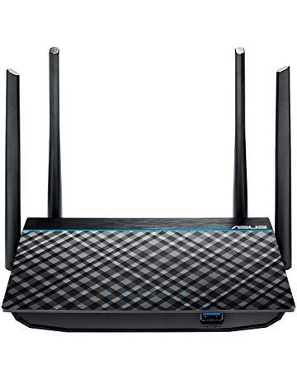](https://www.amazon.com/Dual-Band-Super-Fast-Gigabit-MU-MIMO-RT-ACRH13/dp/B01LXL1AR8?ref_=Oct_BSellerC_300189_11&pf_rd_p=6f74083a-4541-5fc3-91f1-2d621a6b118d&pf_rd_s=merchandised-search-6&pf_rd_t=101&pf_rd_i=300189&pf_rd_m=ATVPDKIKX0DER&pf_rd_r=SA07QM4Q5S23C07F7VTB&pf_rd_r=SA07QM4Q5S23C07F7VTB&pf_rd_p=6f74083a-4541-5fc3-91f1-2d621a6b118d)](https://www.amazon.com/Dual-Band-Super-Fast-Gigabit-MU-MIMO-RT-ACRH13/dp/B01LXL1AR8?ref_=Oct_BSellerC_300189_11&pf_rd_p=6f74083a-4541-5fc3-91f1-2d621a6b118d&pf_rd_s=merchandised-search-6&pf_rd_t=101&pf_rd_i=300189&pf_rd_m=ATVPDKIKX0DER&pf_rd_r=SA07QM4Q5S23C07F7VTB&pf_rd_r=SA07QM4Q5S23C07F7VTB&pf_rd_p=6f74083a-4541-5fc3-91f1-2d621a6b118d" \o "ASUS Dual-Band 2x2 AC1300 Super-Fast Wifi 4-port Gigabit Router with MU-MIMO and USB 3.0 (RT-ACRH13))

[price$59.50](https://www.amazon.com/Dual-Band-Super-Fast-Gigabit-MU-MIMO-RT-ACRH13/dp/B01LXL1AR8?ref_=Oct_BSellerC_300189_11&pf_rd_p=6f74083a-4541-5fc3-91f1-2d621a6b118d&pf_rd_s=merchandised-search-6&pf_rd_t=101&pf_rd_i=300189&pf_rd_m=ATVPDKIKX0DER&pf_rd_r=SA07QM4Q5S23C07F7VTB&pf_rd_r=SA07QM4Q5S23C07F7VTB&pf_rd_p=6f74083a-4541-5fc3-91f1-2d621a6b118d" \o "ASUS Dual-Band 2x2 AC1300 Super-Fast Wifi 4-port Gigabit Router with MU-MIMO and USB 3.0 (RT-ACRH13))

[$69.99](https://www.amazon.com/Dual-Band-Super-Fast-Gigabit-MU-MIMO-RT-ACRH13/dp/B01LXL1AR8?ref_=Oct_BSellerC_300189_11&pf_rd_p=6f74083a-4541-5fc3-91f1-2d621a6b118d&pf_rd_s=merchandised-search-6&pf_rd_t=101&pf_rd_i=300189&pf_rd_m=ATVPDKIKX0DER&pf_rd_r=SA07QM4Q5S23C07F7VTB&pf_rd_r=SA07QM4Q5S23C07F7VTB&pf_rd_p=6f74083a-4541-5fc3-91f1-2d621a6b118d" \o "ASUS Dual-Band 2x2 AC1300 Super-Fast Wifi 4-port Gigabit Router with MU-MIMO and USB 3.0 (RT-ACRH13))

[ASUS Dual-Band 2x2 AC1300 Super-Fast Wifi 4-port Gigabit Router with MU-MIMO and USB 3.0 (RT-ACRH13)](https://www.amazon.com/Dual-Band-Super-Fast-Gigabit-MU-MIMO-RT-ACRH13/dp/B01LXL1AR8?ref_=Oct_BSellerC_300189_11&pf_rd_p=6f74083a-4541-5fc3-91f1-2d621a6b118d&pf_rd_s=merchandised-search-6&pf_rd_t=101&pf_rd_i=300189&pf_rd_m=ATVPDKIKX0DER&pf_rd_r=SA07QM4Q5S23C07F7VTB&pf_rd_r=SA07QM4Q5S23C07F7VTB&pf_rd_p=6f74083a-4541-5fc3-91f1-2d621a6b118d" \o "ASUS Dual-Band 2x2 AC1300 Super-Fast Wifi 4-port Gigabit Router with MU-MIMO and USB 3.0 (RT-ACRH13))

Top rated [See more](https://www.amazon.com/s?n=300189&p_72=4-&ref_=Oct_TopRatedC_300189_SAll&pf_rd_p=6f74083a-4541-5fc3-91f1-2d621a6b118d&pf_rd_s=merchandised-search-6&pf_rd_t=101&pf_rd_i=300189&pf_rd_m=ATVPDKIKX0DER&pf_rd_r=SA07QM4Q5S23C07F7VTB&pf_rd_r=SA07QM4Q5S23C07F7VTB&pf_rd_p=6f74083a-4541-5fc3-91f1-2d621a6b118d)

[[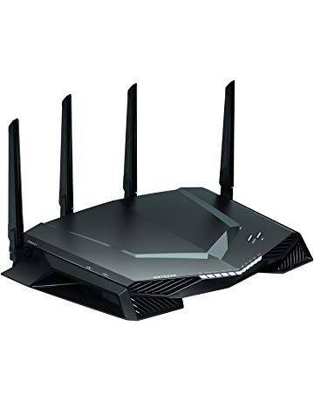](https://www.amazon.com/NETGEAR-Nighthawk-Ethernet-Wireless-Optimized/dp/B078GWJ44Z?ref_=Oct_TopRatedC_300189_0&pf_rd_p=6f74083a-4541-5fc3-91f1-2d621a6b118d&pf_rd_s=merchandised-search-6&pf_rd_t=101&pf_rd_i=300189&pf_rd_m=ATVPDKIKX0DER&pf_rd_r=SA07QM4Q5S23C07F7VTB&pf_rd_r=SA07QM4Q5S23C07F7VTB&pf_rd_p=6f74083a-4541-5fc3-91f1-2d621a6b118d)](https://www.amazon.com/NETGEAR-Nighthawk-Ethernet-Wireless-Optimized/dp/B078GWJ44Z?ref_=Oct_TopRatedC_300189_0&pf_rd_p=6f74083a-4541-5fc3-91f1-2d621a6b118d&pf_rd_s=merchandised-search-6&pf_rd_t=101&pf_rd_i=300189&pf_rd_m=ATVPDKIKX0DER&pf_rd_r=SA07QM4Q5S23C07F7VTB&pf_rd_r=SA07QM4Q5S23C07F7VTB&pf_rd_p=6f74083a-4541-5fc3-91f1-2d621a6b118d" \o "NETGEAR Nighthawk Pro Gaming XR500 WiFi Router with 4 Ethernet Ports and Wireless speeds up to 2.6 Gbps, AC2600, Optimized for Low ping)

[price$284.34](https://www.amazon.com/NETGEAR-Nighthawk-Ethernet-Wireless-Optimized/dp/B078GWJ44Z?ref_=Oct_TopRatedC_300189_0&pf_rd_p=6f74083a-4541-5fc3-91f1-2d621a6b118d&pf_rd_s=merchandised-search-6&pf_rd_t=101&pf_rd_i=300189&pf_rd_m=ATVPDKIKX0DER&pf_rd_r=SA07QM4Q5S23C07F7VTB&pf_rd_r=SA07QM4Q5S23C07F7VTB&pf_rd_p=6f74083a-4541-5fc3-91f1-2d621a6b118d" \o "NETGEAR Nighthawk Pro Gaming XR500 WiFi Router with 4 Ethernet Ports and Wireless speeds up to 2.6 Gbps, AC2600, Optimized for Low ping)

[$299.99](https://www.amazon.com/NETGEAR-Nighthawk-Ethernet-Wireless-Optimized/dp/B078GWJ44Z?ref_=Oct_TopRatedC_300189_0&pf_rd_p=6f74083a-4541-5fc3-91f1-2d621a6b118d&pf_rd_s=merchandised-search-6&pf_rd_t=101&pf_rd_i=300189&pf_rd_m=ATVPDKIKX0DER&pf_rd_r=SA07QM4Q5S23C07F7VTB&pf_rd_r=SA07QM4Q5S23C07F7VTB&pf_rd_p=6f74083a-4541-5fc3-91f1-2d621a6b118d" \o "NETGEAR Nighthawk Pro Gaming XR500 WiFi Router with 4 Ethernet Ports and Wireless speeds up to 2.6 Gbps, AC2600, Optimized for Low ping)

[NETGEAR Nighthawk Pro Gaming XR500 WiFi Router with 4 Ethernet Ports and Wireless speeds up to 2.6 Gbps, AC2600, Optimized for Low ping](https://www.amazon.com/NETGEAR-Nighthawk-Ethernet-Wireless-Optimized/dp/B078GWJ44Z?ref_=Oct_TopRatedC_300189_0&pf_rd_p=6f74083a-4541-5fc3-91f1-2d621a6b118d&pf_rd_s=merchandised-search-6&pf_rd_t=101&pf_rd_i=300189&pf_rd_m=ATVPDKIKX0DER&pf_rd_r=SA07QM4Q5S23C07F7VTB&pf_rd_r=SA07QM4Q5S23C07F7VTB&pf_rd_p=6f74083a-4541-5fc3-91f1-2d621a6b118d" \o "NETGEAR Nighthawk Pro Gaming XR500 WiFi Router with 4 Ethernet Ports and Wireless speeds up to 2.6 Gbps, AC2600, Optimized for Low ping)

[[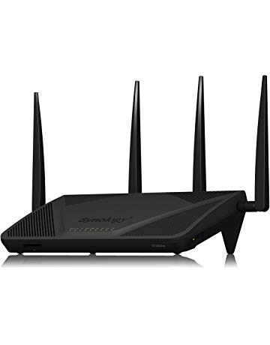](https://www.amazon.com/Synology-RT2600AC-Wi-Fi-Gigabit-Router/dp/B01N5MPTG1?ref_=Oct_TopRatedC_300189_1&pf_rd_p=6f74083a-4541-5fc3-91f1-2d621a6b118d&pf_rd_s=merchandised-search-6&pf_rd_t=101&pf_rd_i=300189&pf_rd_m=ATVPDKIKX0DER&pf_rd_r=SA07QM4Q5S23C07F7VTB&pf_rd_r=SA07QM4Q5S23C07F7VTB&pf_rd_p=6f74083a-4541-5fc3-91f1-2d621a6b118d)](https://www.amazon.com/Synology-RT2600AC-Wi-Fi-Gigabit-Router/dp/B01N5MPTG1?ref_=Oct_TopRatedC_300189_1&pf_rd_p=6f74083a-4541-5fc3-91f1-2d621a6b118d&pf_rd_s=merchandised-search-6&pf_rd_t=101&pf_rd_i=300189&pf_rd_m=ATVPDKIKX0DER&pf_rd_r=SA07QM4Q5S23C07F7VTB&pf_rd_r=SA07QM4Q5S23C07F7VTB&pf_rd_p=6f74083a-4541-5fc3-91f1-2d621a6b118d" \o "Synology RT2600AC Wi-Fi AC 2600 Gigabit Router)

[price$199.99](https://www.amazon.com/Synology-RT2600AC-Wi-Fi-Gigabit-Router/dp/B01N5MPTG1?ref_=Oct_TopRatedC_300189_1&pf_rd_p=6f74083a-4541-5fc3-91f1-2d621a6b118d&pf_rd_s=merchandised-search-6&pf_rd_t=101&pf_rd_i=300189&pf_rd_m=ATVPDKIKX0DER&pf_rd_r=SA07QM4Q5S23C07F7VTB&pf_rd_r=SA07QM4Q5S23C07F7VTB&pf_rd_p=6f74083a-4541-5fc3-91f1-2d621a6b118d" \o "Synology RT2600AC Wi-Fi AC 2600 Gigabit Router)

[Synology RT2600AC Wi-Fi AC 2600 Gigabit Router](https://www.amazon.com/Synology-RT2600AC-Wi-Fi-Gigabit-Router/dp/B01N5MPTG1?ref_=Oct_TopRatedC_300189_1&pf_rd_p=6f74083a-4541-5fc3-91f1-2d621a6b118d&pf_rd_s=merchandised-search-6&pf_rd_t=101&pf_rd_i=300189&pf_rd_m=ATVPDKIKX0DER&pf_rd_r=SA07QM4Q5S23C07F7VTB&pf_rd_r=SA07QM4Q5S23C07F7VTB&pf_rd_p=6f74083a-4541-5fc3-91f1-2d621a6b118d" \o "Synology RT2600AC Wi-Fi AC 2600 Gigabit Router)

[[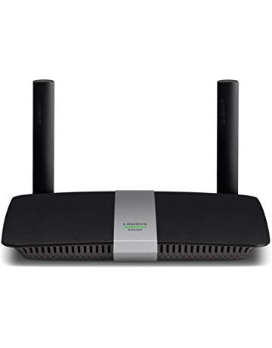](https://www.amazon.com/Linksys-EA6350-Wireless-Dual-Band-Anywhere/dp/B00JZWQW4C?ref_=Oct_TopRatedC_300189_2&pf_rd_p=6f74083a-4541-5fc3-91f1-2d621a6b118d&pf_rd_s=merchandised-search-6&pf_rd_t=101&pf_rd_i=300189&pf_rd_m=ATVPDKIKX0DER&pf_rd_r=SA07QM4Q5S23C07F7VTB&pf_rd_r=SA07QM4Q5S23C07F7VTB&pf_rd_p=6f74083a-4541-5fc3-91f1-2d621a6b118d)](https://www.amazon.com/Linksys-EA6350-Wireless-Dual-Band-Anywhere/dp/B00JZWQW4C?ref_=Oct_TopRatedC_300189_2&pf_rd_p=6f74083a-4541-5fc3-91f1-2d621a6b118d&pf_rd_s=merchandised-search-6&pf_rd_t=101&pf_rd_i=300189&pf_rd_m=ATVPDKIKX0DER&pf_rd_r=SA07QM4Q5S23C07F7VTB&pf_rd_r=SA07QM4Q5S23C07F7VTB&pf_rd_p=6f74083a-4541-5fc3-91f1-2d621a6b118d" \o "Linksys EA6350 Wi-Fi Wireless Dual-Band+ Router with Gigabit & USB Ports, Smart Wi-Fi App Enabled to Control Your Network from Anywhere)

[price$69.95](https://www.amazon.com/Linksys-EA6350-Wireless-Dual-Band-Anywhere/dp/B00JZWQW4C?ref_=Oct_TopRatedC_300189_2&pf_rd_p=6f74083a-4541-5fc3-91f1-2d621a6b118d&pf_rd_s=merchandised-search-6&pf_rd_t=101&pf_rd_i=300189&pf_rd_m=ATVPDKIKX0DER&pf_rd_r=SA07QM4Q5S23C07F7VTB&pf_rd_r=SA07QM4Q5S23C07F7VTB&pf_rd_p=6f74083a-4541-5fc3-91f1-2d621a6b118d" \o "Linksys EA6350 Wi-Fi Wireless Dual-Band+ Router with Gigabit & USB Ports, Smart Wi-Fi App Enabled to Control Your Network from Anywhere)

[$89.99](https://www.amazon.com/Linksys-EA6350-Wireless-Dual-Band-Anywhere/dp/B00JZWQW4C?ref_=Oct_TopRatedC_300189_2&pf_rd_p=6f74083a-4541-5fc3-91f1-2d621a6b118d&pf_rd_s=merchandised-search-6&pf_rd_t=101&pf_rd_i=300189&pf_rd_m=ATVPDKIKX0DER&pf_rd_r=SA07QM4Q5S23C07F7VTB&pf_rd_r=SA07QM4Q5S23C07F7VTB&pf_rd_p=6f74083a-4541-5fc3-91f1-2d621a6b118d" \o "Linksys EA6350 Wi-Fi Wireless Dual-Band+ Router with Gigabit & USB Ports, Smart Wi-Fi App Enabled to Control Your Network from Anywhere)

[Linksys EA6350 Wi-Fi Wireless Dual-Band+ Router with Gigabit & USB Ports, Smart Wi-Fi App Enabled to Control Your Network from Anywhere](https://www.amazon.com/Linksys-EA6350-Wireless-Dual-Band-Anywhere/dp/B00JZWQW4C?ref_=Oct_TopRatedC_300189_2&pf_rd_p=6f74083a-4541-5fc3-91f1-2d621a6b118d&pf_rd_s=merchandised-search-6&pf_rd_t=101&pf_rd_i=300189&pf_rd_m=ATVPDKIKX0DER&pf_rd_r=SA07QM4Q5S23C07F7VTB&pf_rd_r=SA07QM4Q5S23C07F7VTB&pf_rd_p=6f74083a-4541-5fc3-91f1-2d621a6b118d" \o "Linksys EA6350 Wi-Fi Wireless Dual-Band+ Router with Gigabit & USB Ports, Smart Wi-Fi App Enabled to Control Your Network from Anywhere)

[[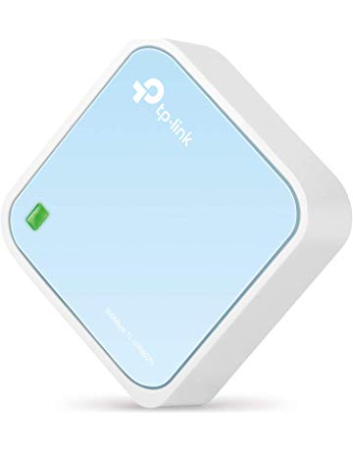](https://www.amazon.com/TP-Link-Wireless-Portable-Travel-Router/dp/B00TQEX8BO?ref_=Oct_TopRatedC_300189_3&pf_rd_p=6f74083a-4541-5fc3-91f1-2d621a6b118d&pf_rd_s=merchandised-search-6&pf_rd_t=101&pf_rd_i=300189&pf_rd_m=ATVPDKIKX0DER&pf_rd_r=SA07QM4Q5S23C07F7VTB&pf_rd_r=SA07QM4Q5S23C07F7VTB&pf_rd_p=6f74083a-4541-5fc3-91f1-2d621a6b118d)](https://www.amazon.com/TP-Link-Wireless-Portable-Travel-Router/dp/B00TQEX8BO?ref_=Oct_TopRatedC_300189_3&pf_rd_p=6f74083a-4541-5fc3-91f1-2d621a6b118d&pf_rd_s=merchandised-search-6&pf_rd_t=101&pf_rd_i=300189&pf_rd_m=ATVPDKIKX0DER&pf_rd_r=SA07QM4Q5S23C07F7VTB&pf_rd_r=SA07QM4Q5S23C07F7VTB&pf_rd_p=6f74083a-4541-5fc3-91f1-2d621a6b118d" \o "TP-Link N300 Wireless Portable Nano Travel Router - WiFi Bridge/Range Extender/Access Point/Client Modes, Mobile in Pocket(TL-WR802N))

[price$25.99](https://www.amazon.com/TP-Link-Wireless-Portable-Travel-Router/dp/B00TQEX8BO?ref_=Oct_TopRatedC_300189_3&pf_rd_p=6f74083a-4541-5fc3-91f1-2d621a6b118d&pf_rd_s=merchandised-search-6&pf_rd_t=101&pf_rd_i=300189&pf_rd_m=ATVPDKIKX0DER&pf_rd_r=SA07QM4Q5S23C07F7VTB&pf_rd_r=SA07QM4Q5S23C07F7VTB&pf_rd_p=6f74083a-4541-5fc3-91f1-2d621a6b118d" \o "TP-Link N300 Wireless Portable Nano Travel Router - WiFi Bridge/Range Extender/Access Point/Client Modes, Mobile in Pocket(TL-WR802N))

[$29.99](https://www.amazon.com/TP-Link-Wireless-Portable-Travel-Router/dp/B00TQEX8BO?ref_=Oct_TopRatedC_300189_3&pf_rd_p=6f74083a-4541-5fc3-91f1-2d621a6b118d&pf_rd_s=merchandised-search-6&pf_rd_t=101&pf_rd_i=300189&pf_rd_m=ATVPDKIKX0DER&pf_rd_r=SA07QM4Q5S23C07F7VTB&pf_rd_r=SA07QM4Q5S23C07F7VTB&pf_rd_p=6f74083a-4541-5fc3-91f1-2d621a6b118d" \o "TP-Link N300 Wireless Portable Nano Travel Router - WiFi Bridge/Range Extender/Access Point/Client Modes, Mobile in Pocket(TL-WR802N))

[TP-Link N300 Wireless Portable Nano Travel Router - WiFi Bridge/Range Extender/Access Point/Client Modes, Mobile in Pocket(TL-WR802N)](https://www.amazon.com/TP-Link-Wireless-Portable-Travel-Router/dp/B00TQEX8BO?ref_=Oct_TopRatedC_300189_3&pf_rd_p=6f74083a-4541-5fc3-91f1-2d621a6b118d&pf_rd_s=merchandised-search-6&pf_rd_t=101&pf_rd_i=300189&pf_rd_m=ATVPDKIKX0DER&pf_rd_r=SA07QM4Q5S23C07F7VTB&pf_rd_r=SA07QM4Q5S23C07F7VTB&pf_rd_p=6f74083a-4541-5fc3-91f1-2d621a6b118d" \o "TP-Link N300 Wireless Portable Nano Travel Router - WiFi Bridge/Range Extender/Access Point/Client Modes, Mobile in Pocket(TL-WR802N))

[[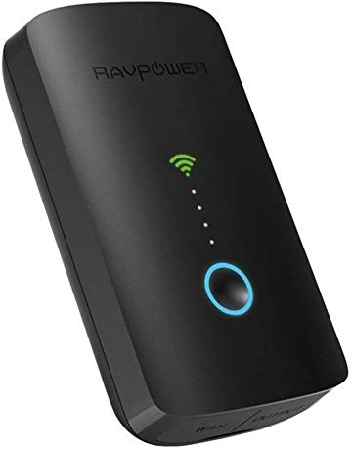](https://www.amazon.com/RAVPower-Wireless-Portable-Streamer-Cellphone/dp/B016ZWS9ZE?ref_=Oct_TopRatedC_300189_4&pf_rd_p=6f74083a-4541-5fc3-91f1-2d621a6b118d&pf_rd_s=merchandised-search-6&pf_rd_t=101&pf_rd_i=300189&pf_rd_m=ATVPDKIKX0DER&pf_rd_r=SA07QM4Q5S23C07F7VTB&pf_rd_r=SA07QM4Q5S23C07F7VTB&pf_rd_p=6f74083a-4541-5fc3-91f1-2d621a6b118d)](https://www.amazon.com/RAVPower-Wireless-Portable-Streamer-Cellphone/dp/B016ZWS9ZE?ref_=Oct_TopRatedC_300189_4&pf_rd_p=6f74083a-4541-5fc3-91f1-2d621a6b118d&pf_rd_s=merchandised-search-6&pf_rd_t=101&pf_rd_i=300189&pf_rd_m=ATVPDKIKX0DER&pf_rd_r=SA07QM4Q5S23C07F7VTB&pf_rd_r=SA07QM4Q5S23C07F7VTB&pf_rd_p=6f74083a-4541-5fc3-91f1-2d621a6b118d" \o "RAVPower FileHub Plus, Wireless Travel Router, Portable SD Card,HDD Backup Unit, DLNA NAS Sharing Media Streamer 6000mAh External Battery Pack (Not a Hotspot) for Android, Laptop, Cellphone, Ipad Pro)

[price$42.99](https://www.amazon.com/RAVPower-Wireless-Portable-Streamer-Cellphone/dp/B016ZWS9ZE?ref_=Oct_TopRatedC_300189_4&pf_rd_p=6f74083a-4541-5fc3-91f1-2d621a6b118d&pf_rd_s=merchandised-search-6&pf_rd_t=101&pf_rd_i=300189&pf_rd_m=ATVPDKIKX0DER&pf_rd_r=SA07QM4Q5S23C07F7VTB&pf_rd_r=SA07QM4Q5S23C07F7VTB&pf_rd_p=6f74083a-4541-5fc3-91f1-2d621a6b118d" \o "RAVPower FileHub Plus, Wireless Travel Router, Portable SD Card,HDD Backup Unit, DLNA NAS Sharing Media Streamer 6000mAh External Battery Pack (Not a Hotspot) for Android, Laptop, Cellphone, Ipad Pro)

[RAVPower FileHub Plus, Wireless Travel Router, Portable SD Card,HDD Backup Unit, DLNA NAS Sharing Media Streamer 6000mAh External Battery Pack (Not a Hotspot) for Android, Laptop, Cellphone, Ipad Pro](https://www.amazon.com/RAVPower-Wireless-Portable-Streamer-Cellphone/dp/B016ZWS9ZE?ref_=Oct_TopRatedC_300189_4&pf_rd_p=6f74083a-4541-5fc3-91f1-2d621a6b118d&pf_rd_s=merchandised-search-6&pf_rd_t=101&pf_rd_i=300189&pf_rd_m=ATVPDKIKX0DER&pf_rd_r=SA07QM4Q5S23C07F7VTB&pf_rd_r=SA07QM4Q5S23C07F7VTB&pf_rd_p=6f74083a-4541-5fc3-91f1-2d621a6b118d" \o "RAVPower FileHub Plus, Wireless Travel Router, Portable SD Card,HDD Backup Unit, DLNA NAS Sharing Media Streamer 6000mAh External Battery Pack (Not a Hotspot) for Android, Laptop, Cellphone, Ipad Pro)

[[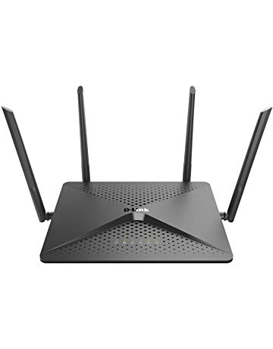](https://www.amazon.com/D-Link-AC2600-MU-MIMO-Wi-Fi-Router/dp/B0711TPTZL?ref_=Oct_TopRatedC_300189_5&pf_rd_p=6f74083a-4541-5fc3-91f1-2d621a6b118d&pf_rd_s=merchandised-search-6&pf_rd_t=101&pf_rd_i=300189&pf_rd_m=ATVPDKIKX0DER&pf_rd_r=SA07QM4Q5S23C07F7VTB&pf_rd_r=SA07QM4Q5S23C07F7VTB&pf_rd_p=6f74083a-4541-5fc3-91f1-2d621a6b118d)](https://www.amazon.com/D-Link-AC2600-MU-MIMO-Wi-Fi-Router/dp/B0711TPTZL?ref_=Oct_TopRatedC_300189_5&pf_rd_p=6f74083a-4541-5fc3-91f1-2d621a6b118d&pf_rd_s=merchandised-search-6&pf_rd_t=101&pf_rd_i=300189&pf_rd_m=ATVPDKIKX0DER&pf_rd_r=SA07QM4Q5S23C07F7VTB&pf_rd_r=SA07QM4Q5S23C07F7VTB&pf_rd_p=6f74083a-4541-5fc3-91f1-2d621a6b118d" \o "D-Link EXO AC2600 MU-MIMO Wi-Fi Router – 4K Streaming and Gaming with USB Ports, 4x4 Dual Band Wireless Router (DIR-882-US))

[price$134.99](https://www.amazon.com/D-Link-AC2600-MU-MIMO-Wi-Fi-Router/dp/B0711TPTZL?ref_=Oct_TopRatedC_300189_5&pf_rd_p=6f74083a-4541-5fc3-91f1-2d621a6b118d&pf_rd_s=merchandised-search-6&pf_rd_t=101&pf_rd_i=300189&pf_rd_m=ATVPDKIKX0DER&pf_rd_r=SA07QM4Q5S23C07F7VTB&pf_rd_r=SA07QM4Q5S23C07F7VTB&pf_rd_p=6f74083a-4541-5fc3-91f1-2d621a6b118d" \o "D-Link EXO AC2600 MU-MIMO Wi-Fi Router – 4K Streaming and Gaming with USB Ports, 4x4 Dual Band Wireless Router (DIR-882-US))

[$149.99](https://www.amazon.com/D-Link-AC2600-MU-MIMO-Wi-Fi-Router/dp/B0711TPTZL?ref_=Oct_TopRatedC_300189_5&pf_rd_p=6f74083a-4541-5fc3-91f1-2d621a6b118d&pf_rd_s=merchandised-search-6&pf_rd_t=101&pf_rd_i=300189&pf_rd_m=ATVPDKIKX0DER&pf_rd_r=SA07QM4Q5S23C07F7VTB&pf_rd_r=SA07QM4Q5S23C07F7VTB&pf_rd_p=6f74083a-4541-5fc3-91f1-2d621a6b118d" \o "D-Link EXO AC2600 MU-MIMO Wi-Fi Router – 4K Streaming and Gaming with USB Ports, 4x4 Dual Band Wireless Router (DIR-882-US))

[D-Link EXO AC2600 MU-MIMO Wi-Fi Router – 4K Streaming and Gaming with USB Ports, 4x4 Dual Band Wireless Router (DIR-882-US)](https://www.amazon.com/D-Link-AC2600-MU-MIMO-Wi-Fi-Router/dp/B0711TPTZL?ref_=Oct_TopRatedC_300189_5&pf_rd_p=6f74083a-4541-5fc3-91f1-2d621a6b118d&pf_rd_s=merchandised-search-6&pf_rd_t=101&pf_rd_i=300189&pf_rd_m=ATVPDKIKX0DER&pf_rd_r=SA07QM4Q5S23C07F7VTB&pf_rd_r=SA07QM4Q5S23C07F7VTB&pf_rd_p=6f74083a-4541-5fc3-91f1-2d621a6b118d" \o "D-Link EXO AC2600 MU-MIMO Wi-Fi Router – 4K Streaming and Gaming with USB Ports, 4x4 Dual Band Wireless Router (DIR-882-US))

[[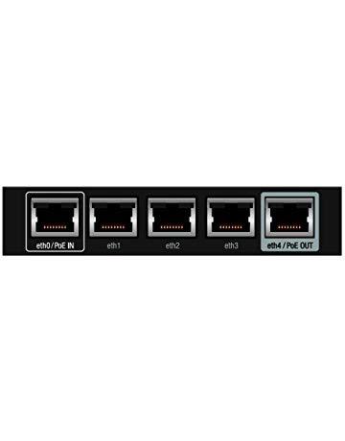](https://www.amazon.com/Ubiquiti-EdgeRouter-Advanced-Gigabit-Ethernet/dp/B00YFJT29C?ref_=Oct_TopRatedC_300189_6&pf_rd_p=6f74083a-4541-5fc3-91f1-2d621a6b118d&pf_rd_s=merchandised-search-6&pf_rd_t=101&pf_rd_i=300189&pf_rd_m=ATVPDKIKX0DER&pf_rd_r=SA07QM4Q5S23C07F7VTB&pf_rd_r=SA07QM4Q5S23C07F7VTB&pf_rd_p=6f74083a-4541-5fc3-91f1-2d621a6b118d)](https://www.amazon.com/Ubiquiti-EdgeRouter-Advanced-Gigabit-Ethernet/dp/B00YFJT29C?ref_=Oct_TopRatedC_300189_6&pf_rd_p=6f74083a-4541-5fc3-91f1-2d621a6b118d&pf_rd_s=merchandised-search-6&pf_rd_t=101&pf_rd_i=300189&pf_rd_m=ATVPDKIKX0DER&pf_rd_r=SA07QM4Q5S23C07F7VTB&pf_rd_r=SA07QM4Q5S23C07F7VTB&pf_rd_p=6f74083a-4541-5fc3-91f1-2d621a6b118d" \o "Ubiquiti EdgeRouter X Advanced Gigabit Ethernet Routers ER-X 256MB Storage 5 Gigabit RJ45 ports)

[price$58.89](https://www.amazon.com/Ubiquiti-EdgeRouter-Advanced-Gigabit-Ethernet/dp/B00YFJT29C?ref_=Oct_TopRatedC_300189_6&pf_rd_p=6f74083a-4541-5fc3-91f1-2d621a6b118d&pf_rd_s=merchandised-search-6&pf_rd_t=101&pf_rd_i=300189&pf_rd_m=ATVPDKIKX0DER&pf_rd_r=SA07QM4Q5S23C07F7VTB&pf_rd_r=SA07QM4Q5S23C07F7VTB&pf_rd_p=6f74083a-4541-5fc3-91f1-2d621a6b118d" \o "Ubiquiti EdgeRouter X Advanced Gigabit Ethernet Routers ER-X 256MB Storage 5 Gigabit RJ45 ports)

[Ubiquiti EdgeRouter X Advanced Gigabit Ethernet Routers ER-X 256MB Storage 5 Gigabit RJ45 ports](https://www.amazon.com/Ubiquiti-EdgeRouter-Advanced-Gigabit-Ethernet/dp/B00YFJT29C?ref_=Oct_TopRatedC_300189_6&pf_rd_p=6f74083a-4541-5fc3-91f1-2d621a6b118d&pf_rd_s=merchandised-search-6&pf_rd_t=101&pf_rd_i=300189&pf_rd_m=ATVPDKIKX0DER&pf_rd_r=SA07QM4Q5S23C07F7VTB&pf_rd_r=SA07QM4Q5S23C07F7VTB&pf_rd_p=6f74083a-4541-5fc3-91f1-2d621a6b118d" \o "Ubiquiti EdgeRouter X Advanced Gigabit Ethernet Routers ER-X 256MB Storage 5 Gigabit RJ45 ports)

[[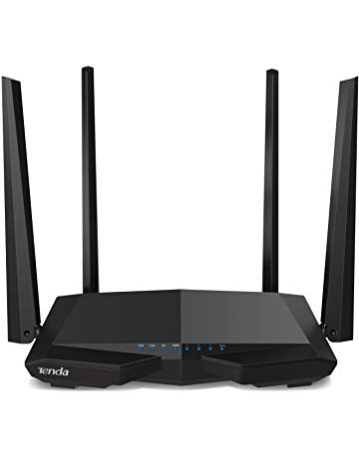](https://www.amazon.com/Tenda-Wireless-Internet-MU-MIMO-AC6/dp/B06X1CHFJ5?ref_=Oct_TopRatedC_300189_7&pf_rd_p=6f74083a-4541-5fc3-91f1-2d621a6b118d&pf_rd_s=merchandised-search-6&pf_rd_t=101&pf_rd_i=300189&pf_rd_m=ATVPDKIKX0DER&pf_rd_r=SA07QM4Q5S23C07F7VTB&pf_rd_r=SA07QM4Q5S23C07F7VTB&pf_rd_p=6f74083a-4541-5fc3-91f1-2d621a6b118d)](https://www.amazon.com/Tenda-Wireless-Internet-MU-MIMO-AC6/dp/B06X1CHFJ5?ref_=Oct_TopRatedC_300189_7&pf_rd_p=6f74083a-4541-5fc3-91f1-2d621a6b118d&pf_rd_s=merchandised-search-6&pf_rd_t=101&pf_rd_i=300189&pf_rd_m=ATVPDKIKX0DER&pf_rd_r=SA07QM4Q5S23C07F7VTB&pf_rd_r=SA07QM4Q5S23C07F7VTB&pf_rd_p=6f74083a-4541-5fc3-91f1-2d621a6b118d" \o "Tenda AC1200 Dual Band WiFi Router, High Speed Wireless Internet Router with Smart App, MU-MIMO for Home (AC6))

[price$36.99](https://www.amazon.com/Tenda-Wireless-Internet-MU-MIMO-AC6/dp/B06X1CHFJ5?ref_=Oct_TopRatedC_300189_7&pf_rd_p=6f74083a-4541-5fc3-91f1-2d621a6b118d&pf_rd_s=merchandised-search-6&pf_rd_t=101&pf_rd_i=300189&pf_rd_m=ATVPDKIKX0DER&pf_rd_r=SA07QM4Q5S23C07F7VTB&pf_rd_r=SA07QM4Q5S23C07F7VTB&pf_rd_p=6f74083a-4541-5fc3-91f1-2d621a6b118d" \o "Tenda AC1200 Dual Band WiFi Router, High Speed Wireless Internet Router with Smart App, MU-MIMO for Home (AC6))

[$49.99](https://www.amazon.com/Tenda-Wireless-Internet-MU-MIMO-AC6/dp/B06X1CHFJ5?ref_=Oct_TopRatedC_300189_7&pf_rd_p=6f74083a-4541-5fc3-91f1-2d621a6b118d&pf_rd_s=merchandised-search-6&pf_rd_t=101&pf_rd_i=300189&pf_rd_m=ATVPDKIKX0DER&pf_rd_r=SA07QM4Q5S23C07F7VTB&pf_rd_r=SA07QM4Q5S23C07F7VTB&pf_rd_p=6f74083a-4541-5fc3-91f1-2d621a6b118d" \o "Tenda AC1200 Dual Band WiFi Router, High Speed Wireless Internet Router with Smart App, MU-MIMO for Home (AC6))

[Tenda AC1200 Dual Band WiFi Router, High Speed Wireless Internet Router with Smart App, MU-MIMO for Home (AC6)](https://www.amazon.com/Tenda-Wireless-Internet-MU-MIMO-AC6/dp/B06X1CHFJ5?ref_=Oct_TopRatedC_300189_7&pf_rd_p=6f74083a-4541-5fc3-91f1-2d621a6b118d&pf_rd_s=merchandised-search-6&pf_rd_t=101&pf_rd_i=300189&pf_rd_m=ATVPDKIKX0DER&pf_rd_r=SA07QM4Q5S23C07F7VTB&pf_rd_r=SA07QM4Q5S23C07F7VTB&pf_rd_p=6f74083a-4541-5fc3-91f1-2d621a6b118d" \o "Tenda AC1200 Dual Band WiFi Router, High Speed Wireless Internet Router with Smart App, MU-MIMO for Home (AC6))

[[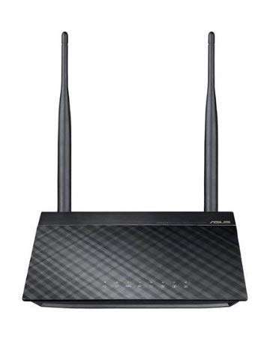](https://www.amazon.com/Wireless-N300-Technology-streaming-performing-RT-N12/dp/B00DWFPDNO?ref_=Oct_TopRatedC_300189_8&pf_rd_p=6f74083a-4541-5fc3-91f1-2d621a6b118d&pf_rd_s=merchandised-search-6&pf_rd_t=101&pf_rd_i=300189&pf_rd_m=ATVPDKIKX0DER&pf_rd_r=SA07QM4Q5S23C07F7VTB&pf_rd_r=SA07QM4Q5S23C07F7VTB&pf_rd_p=6f74083a-4541-5fc3-91f1-2d621a6b118d)](https://www.amazon.com/Wireless-N300-Technology-streaming-performing-RT-N12/dp/B00DWFPDNO?ref_=Oct_TopRatedC_300189_8&pf_rd_p=6f74083a-4541-5fc3-91f1-2d621a6b118d&pf_rd_s=merchandised-search-6&pf_rd_t=101&pf_rd_i=300189&pf_rd_m=ATVPDKIKX0DER&pf_rd_r=SA07QM4Q5S23C07F7VTB&pf_rd_r=SA07QM4Q5S23C07F7VTB&pf_rd_p=6f74083a-4541-5fc3-91f1-2d621a6b118d" \o "ASUS Wireless-N300 (Up to 300Mbps) Router with 2T2R MIMO Technology ideally for streaming 4K HD Video, placing VoIP calls, and performing other essential internet tasks (RT-N12))

[price$29.71](https://www.amazon.com/Wireless-N300-Technology-streaming-performing-RT-N12/dp/B00DWFPDNO?ref_=Oct_TopRatedC_300189_8&pf_rd_p=6f74083a-4541-5fc3-91f1-2d621a6b118d&pf_rd_s=merchandised-search-6&pf_rd_t=101&pf_rd_i=300189&pf_rd_m=ATVPDKIKX0DER&pf_rd_r=SA07QM4Q5S23C07F7VTB&pf_rd_r=SA07QM4Q5S23C07F7VTB&pf_rd_p=6f74083a-4541-5fc3-91f1-2d621a6b118d" \o "ASUS Wireless-N300 (Up to 300Mbps) Router with 2T2R MIMO Technology ideally for streaming 4K HD Video, placing VoIP calls, and performing other essential internet tasks (RT-N12))

[ASUS Wireless-N300 (Up to 300Mbps) Router with 2T2R MIMO Technology ideally for streaming 4K HD Video, placing VoIP calls, and performing other essential internet tasks (RT-N12)](https://www.amazon.com/Wireless-N300-Technology-streaming-performing-RT-N12/dp/B00DWFPDNO?ref_=Oct_TopRatedC_300189_8&pf_rd_p=6f74083a-4541-5fc3-91f1-2d621a6b118d&pf_rd_s=merchandised-search-6&pf_rd_t=101&pf_rd_i=300189&pf_rd_m=ATVPDKIKX0DER&pf_rd_r=SA07QM4Q5S23C07F7VTB&pf_rd_r=SA07QM4Q5S23C07F7VTB&pf_rd_p=6f74083a-4541-5fc3-91f1-2d621a6b118d" \o "ASUS Wireless-N300 (Up to 300Mbps) Router with 2T2R MIMO Technology ideally for streaming 4K HD Video, placing VoIP calls, and performing other essential internet tasks (RT-N12))

[[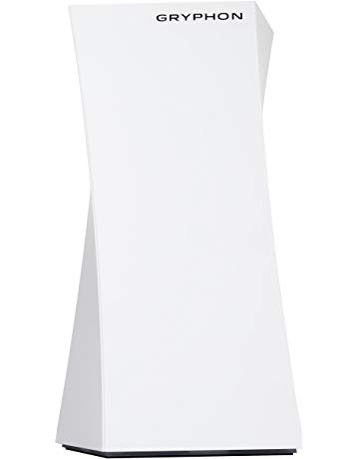](https://www.amazon.com/GRYPHON-Security-Protection-AI-Intrusion-Detection/dp/B078Z3PTJP?ref_=Oct_TopRatedC_300189_9&pf_rd_p=6f74083a-4541-5fc3-91f1-2d621a6b118d&pf_rd_s=merchandised-search-6&pf_rd_t=101&pf_rd_i=300189&pf_rd_m=ATVPDKIKX0DER&pf_rd_r=SA07QM4Q5S23C07F7VTB&pf_rd_r=SA07QM4Q5S23C07F7VTB&pf_rd_p=6f74083a-4541-5fc3-91f1-2d621a6b118d)](https://www.amazon.com/GRYPHON-Security-Protection-AI-Intrusion-Detection/dp/B078Z3PTJP?ref_=Oct_TopRatedC_300189_9&pf_rd_p=6f74083a-4541-5fc3-91f1-2d621a6b118d&pf_rd_s=merchandised-search-6&pf_rd_t=101&pf_rd_i=300189&pf_rd_m=ATVPDKIKX0DER&pf_rd_r=SA07QM4Q5S23C07F7VTB&pf_rd_r=SA07QM4Q5S23C07F7VTB&pf_rd_p=6f74083a-4541-5fc3-91f1-2d621a6b118d" \o "GRYPHON - High Grade Mesh WiFi Security Parental Control Router - Hack Protection w/AI-Intrusion Detection & ESET Malware Protection, Smart Mesh Wireless System w/App, AC3000 Tri-Band (up to 3000sqft))

[price$199.99](https://www.amazon.com/GRYPHON-Security-Protection-AI-Intrusion-Detection/dp/B078Z3PTJP?ref_=Oct_TopRatedC_300189_9&pf_rd_p=6f74083a-4541-5fc3-91f1-2d621a6b118d&pf_rd_s=merchandised-search-6&pf_rd_t=101&pf_rd_i=300189&pf_rd_m=ATVPDKIKX0DER&pf_rd_r=SA07QM4Q5S23C07F7VTB&pf_rd_r=SA07QM4Q5S23C07F7VTB&pf_rd_p=6f74083a-4541-5fc3-91f1-2d621a6b118d" \o "GRYPHON - High Grade Mesh WiFi Security Parental Control Router - Hack Protection w/AI-Intrusion Detection & ESET Malware Protection, Smart Mesh Wireless System w/App, AC3000 Tri-Band (up to 3000sqft))

[$249.99](https://www.amazon.com/GRYPHON-Security-Protection-AI-Intrusion-Detection/dp/B078Z3PTJP?ref_=Oct_TopRatedC_300189_9&pf_rd_p=6f74083a-4541-5fc3-91f1-2d621a6b118d&pf_rd_s=merchandised-search-6&pf_rd_t=101&pf_rd_i=300189&pf_rd_m=ATVPDKIKX0DER&pf_rd_r=SA07QM4Q5S23C07F7VTB&pf_rd_r=SA07QM4Q5S23C07F7VTB&pf_rd_p=6f74083a-4541-5fc3-91f1-2d621a6b118d" \o "GRYPHON - High Grade Mesh WiFi Security Parental Control Router - Hack Protection w/AI-Intrusion Detection & ESET Malware Protection, Smart Mesh Wireless System w/App, AC3000 Tri-Band (up to 3000sqft))

[GRYPHON - High Grade Mesh WiFi Security Parental Control Router - Hack Protection w/AI-Intrusion Detection & ESET Malware Protection, Smart Mesh Wireless System w/App, AC3000 Tri-Band (up to 3000sqft)](https://www.amazon.com/GRYPHON-Security-Protection-AI-Intrusion-Detection/dp/B078Z3PTJP?ref_=Oct_TopRatedC_300189_9&pf_rd_p=6f74083a-4541-5fc3-91f1-2d621a6b118d&pf_rd_s=merchandised-search-6&pf_rd_t=101&pf_rd_i=300189&pf_rd_m=ATVPDKIKX0DER&pf_rd_r=SA07QM4Q5S23C07F7VTB&pf_rd_r=SA07QM4Q5S23C07F7VTB&pf_rd_p=6f74083a-4541-5fc3-91f1-2d621a6b118d" \o "GRYPHON - High Grade Mesh WiFi Security Parental Control Router - Hack Protection w/AI-Intrusion Detection & ESET Malware Protection, Smart Mesh Wireless System w/App, AC3000 Tri-Band (up to 3000sqft))

[[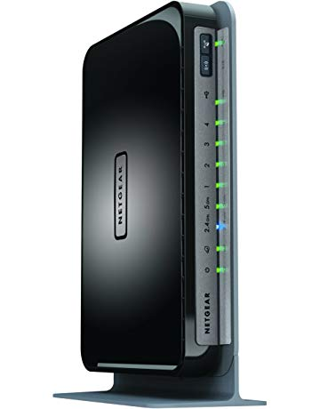](https://www.amazon.com/NETGEAR-Wi-Fi-Gigabit-Router-WNDR4300/dp/B008HO9DK4?ref_=Oct_TopRatedC_300189_10&pf_rd_p=6f74083a-4541-5fc3-91f1-2d621a6b118d&pf_rd_s=merchandised-search-6&pf_rd_t=101&pf_rd_i=300189&pf_rd_m=ATVPDKIKX0DER&pf_rd_r=SA07QM4Q5S23C07F7VTB&pf_rd_r=SA07QM4Q5S23C07F7VTB&pf_rd_p=6f74083a-4541-5fc3-91f1-2d621a6b118d)](https://www.amazon.com/NETGEAR-Wi-Fi-Gigabit-Router-WNDR4300/dp/B008HO9DK4?ref_=Oct_TopRatedC_300189_10&pf_rd_p=6f74083a-4541-5fc3-91f1-2d621a6b118d&pf_rd_s=merchandised-search-6&pf_rd_t=101&pf_rd_i=300189&pf_rd_m=ATVPDKIKX0DER&pf_rd_r=SA07QM4Q5S23C07F7VTB&pf_rd_r=SA07QM4Q5S23C07F7VTB&pf_rd_p=6f74083a-4541-5fc3-91f1-2d621a6b118d" \o "NETGEAR N750 Dual Band 4 Port Wi-Fi Gigabit Router (WNDR4300))

[price$59.99](https://www.amazon.com/NETGEAR-Wi-Fi-Gigabit-Router-WNDR4300/dp/B008HO9DK4?ref_=Oct_TopRatedC_300189_10&pf_rd_p=6f74083a-4541-5fc3-91f1-2d621a6b118d&pf_rd_s=merchandised-search-6&pf_rd_t=101&pf_rd_i=300189&pf_rd_m=ATVPDKIKX0DER&pf_rd_r=SA07QM4Q5S23C07F7VTB&pf_rd_r=SA07QM4Q5S23C07F7VTB&pf_rd_p=6f74083a-4541-5fc3-91f1-2d621a6b118d" \o "NETGEAR N750 Dual Band 4 Port Wi-Fi Gigabit Router (WNDR4300))

[$65.64](https://www.amazon.com/NETGEAR-Wi-Fi-Gigabit-Router-WNDR4300/dp/B008HO9DK4?ref_=Oct_TopRatedC_300189_10&pf_rd_p=6f74083a-4541-5fc3-91f1-2d621a6b118d&pf_rd_s=merchandised-search-6&pf_rd_t=101&pf_rd_i=300189&pf_rd_m=ATVPDKIKX0DER&pf_rd_r=SA07QM4Q5S23C07F7VTB&pf_rd_r=SA07QM4Q5S23C07F7VTB&pf_rd_p=6f74083a-4541-5fc3-91f1-2d621a6b118d" \o "NETGEAR N750 Dual Band 4 Port Wi-Fi Gigabit Router (WNDR4300))

[NETGEAR N750 Dual Band 4 Port Wi-Fi Gigabit Router (WNDR4300)](https://www.amazon.com/NETGEAR-Wi-Fi-Gigabit-Router-WNDR4300/dp/B008HO9DK4?ref_=Oct_TopRatedC_300189_10&pf_rd_p=6f74083a-4541-5fc3-91f1-2d621a6b118d&pf_rd_s=merchandised-search-6&pf_rd_t=101&pf_rd_i=300189&pf_rd_m=ATVPDKIKX0DER&pf_rd_r=SA07QM4Q5S23C07F7VTB&pf_rd_r=SA07QM4Q5S23C07F7VTB&pf_rd_p=6f74083a-4541-5fc3-91f1-2d621a6b118d" \o "NETGEAR N750 Dual Band 4 Port Wi-Fi Gigabit Router (WNDR4300))

[[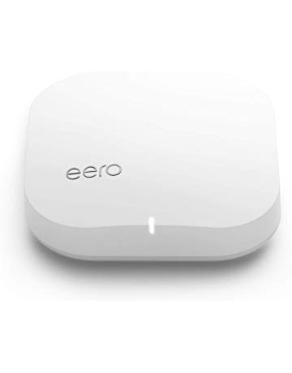](https://www.amazon.com/eero-Home-WiFi-System-Refurbished/dp/B07JF6SKRW?ref_=Oct_TopRatedC_300189_11&pf_rd_p=6f74083a-4541-5fc3-91f1-2d621a6b118d&pf_rd_s=merchandised-search-6&pf_rd_t=101&pf_rd_i=300189&pf_rd_m=ATVPDKIKX0DER&pf_rd_r=SA07QM4Q5S23C07F7VTB&pf_rd_r=SA07QM4Q5S23C07F7VTB&pf_rd_p=6f74083a-4541-5fc3-91f1-2d621a6b118d)](https://www.amazon.com/eero-Home-WiFi-System-Refurbished/dp/B07JF6SKRW?ref_=Oct_TopRatedC_300189_11&pf_rd_p=6f74083a-4541-5fc3-91f1-2d621a6b118d&pf_rd_s=merchandised-search-6&pf_rd_t=101&pf_rd_i=300189&pf_rd_m=ATVPDKIKX0DER&pf_rd_r=SA07QM4Q5S23C07F7VTB&pf_rd_r=SA07QM4Q5S23C07F7VTB&pf_rd_p=6f74083a-4541-5fc3-91f1-2d621a6b118d" \o "eero Home WiFi System - 2nd Generation (Certified Refurbished) - Advanced Mesh WiFi System to Replace WiFi Routers and WiFi Extenders (Pack of 1))

[price$119.00](https://www.amazon.com/eero-Home-WiFi-System-Refurbished/dp/B07JF6SKRW?ref_=Oct_TopRatedC_300189_11&pf_rd_p=6f74083a-4541-5fc3-91f1-2d621a6b118d&pf_rd_s=merchandised-search-6&pf_rd_t=101&pf_rd_i=300189&pf_rd_m=ATVPDKIKX0DER&pf_rd_r=SA07QM4Q5S23C07F7VTB&pf_rd_r=SA07QM4Q5S23C07F7VTB&pf_rd_p=6f74083a-4541-5fc3-91f1-2d621a6b118d" \o "eero Home WiFi System - 2nd Generation (Certified Refurbished) - Advanced Mesh WiFi System to Replace WiFi Routers and WiFi Extenders (Pack of 1))

[eero Home WiFi System - 2nd Generation (Certified Refurbished) - Advanced Mesh WiFi System to Replace WiFi Routers and WiFi Extenders (Pack of 1)](https://www.amazon.com/eero-Home-WiFi-System-Refurbished/dp/B07JF6SKRW?ref_=Oct_TopRatedC_300189_11&pf_rd_p=6f74083a-4541-5fc3-91f1-2d621a6b118d&pf_rd_s=merchandised-search-6&pf_rd_t=101&pf_rd_i=300189&pf_rd_m=ATVPDKIKX0DER&pf_rd_r=SA07QM4Q5S23C07F7VTB&pf_rd_r=SA07QM4Q5S23C07F7VTB&pf_rd_p=6f74083a-4541-5fc3-91f1-2d621a6b118d" \o "eero Home WiFi System - 2nd Generation (Certified Refurbished) - Advanced Mesh WiFi System to Replace WiFi Routers and WiFi Extenders (Pack of 1))

Recommended for you

[[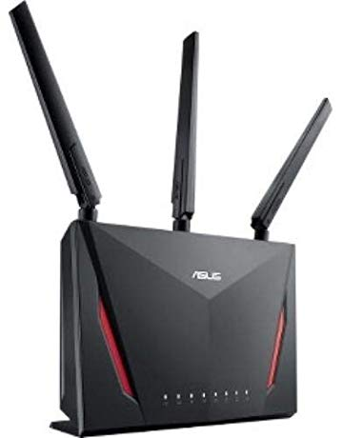](https://www.amazon.com/Dual-band-Dual-core-AiProtection-Compatible-RT-AC86U/dp/B0752FD3XJ?ref_=Oct_RAsinC_Ajax_300189_0&pf_rd_r=SA07QM4Q5S23C07F7VTB&pf_rd_p=6f74083a-4541-5fc3-91f1-2d621a6b118d&pf_rd_s=merchandised-search-6&pf_rd_t=101&pf_rd_i=300189&pf_rd_m=ATVPDKIKX0DER)](https://www.amazon.com/Dual-band-Dual-core-AiProtection-Compatible-RT-AC86U/dp/B0752FD3XJ?ref_=Oct_RAsinC_Ajax_300189_0&pf_rd_r=SA07QM4Q5S23C07F7VTB&pf_rd_p=6f74083a-4541-5fc3-91f1-2d621a6b118d&pf_rd_s=merchandised-search-6&pf_rd_t=101&pf_rd_i=300189&pf_rd_m=ATVPDKIKX0DER" \o "ASUS AC2900 WiFi Dual-band Gigabit Wireless Router with 1.8GHz Dual-core Processor and AiProtection Network Security Powered by Trend Micro, AiMesh Whole Home WiFi System Compatible (RT-AC86U))

[price$168.99](https://www.amazon.com/Dual-band-Dual-core-AiProtection-Compatible-RT-AC86U/dp/B0752FD3XJ?ref_=Oct_RAsinC_Ajax_300189_0&pf_rd_r=SA07QM4Q5S23C07F7VTB&pf_rd_p=6f74083a-4541-5fc3-91f1-2d621a6b118d&pf_rd_s=merchandised-search-6&pf_rd_t=101&pf_rd_i=300189&pf_rd_m=ATVPDKIKX0DER" \o "ASUS AC2900 WiFi Dual-band Gigabit Wireless Router with 1.8GHz Dual-core Processor and AiProtection Network Security Powered by Trend Micro, AiMesh Whole Home WiFi System Compatible (RT-AC86U))

[$199.99](https://www.amazon.com/Dual-band-Dual-core-AiProtection-Compatible-RT-AC86U/dp/B0752FD3XJ?ref_=Oct_RAsinC_Ajax_300189_0&pf_rd_r=SA07QM4Q5S23C07F7VTB&pf_rd_p=6f74083a-4541-5fc3-91f1-2d621a6b118d&pf_rd_s=merchandised-search-6&pf_rd_t=101&pf_rd_i=300189&pf_rd_m=ATVPDKIKX0DER" \o "ASUS AC2900 WiFi Dual-band Gigabit Wireless Router with 1.8GHz Dual-core Processor and AiProtection Network Security Powered by Trend Micro, AiMesh Whole Home WiFi System Compatible (RT-AC86U))

[ASUS AC2900 WiFi Dual-band Gigabit Wireless Router with 1.8GHz Dual-core Processor and AiProtection Network Security Powered by Trend Micro, AiMesh Whole Home WiFi System Compatible (RT-AC86U)](https://www.amazon.com/Dual-band-Dual-core-AiProtection-Compatible-RT-AC86U/dp/B0752FD3XJ?ref_=Oct_RAsinC_Ajax_300189_0&pf_rd_r=SA07QM4Q5S23C07F7VTB&pf_rd_p=6f74083a-4541-5fc3-91f1-2d621a6b118d&pf_rd_s=merchandised-search-6&pf_rd_t=101&pf_rd_i=300189&pf_rd_m=ATVPDKIKX0DER" \o "ASUS AC2900 WiFi Dual-band Gigabit Wireless Router with 1.8GHz Dual-core Processor and AiProtection Network Security Powered by Trend Micro, AiMesh Whole Home WiFi System Compatible (RT-AC86U))

[[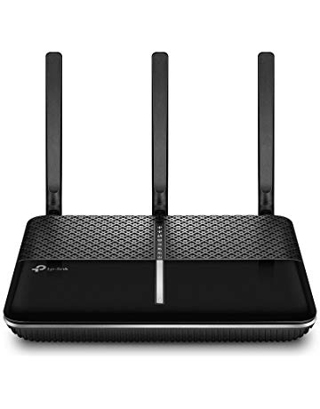](https://www.amazon.com/TP-Link-AC2300-Smart-WiFi-Router/dp/B06XZ3S6B8?ref_=Oct_RAsinC_Ajax_300189_1&pf_rd_r=SA07QM4Q5S23C07F7VTB&pf_rd_p=6f74083a-4541-5fc3-91f1-2d621a6b118d&pf_rd_s=merchandised-search-6&pf_rd_t=101&pf_rd_i=300189&pf_rd_m=ATVPDKIKX0DER)](https://www.amazon.com/TP-Link-AC2300-Smart-WiFi-Router/dp/B06XZ3S6B8?ref_=Oct_RAsinC_Ajax_300189_1&pf_rd_r=SA07QM4Q5S23C07F7VTB&pf_rd_p=6f74083a-4541-5fc3-91f1-2d621a6b118d&pf_rd_s=merchandised-search-6&pf_rd_t=101&pf_rd_i=300189&pf_rd_m=ATVPDKIKX0DER" \o "TP-Link Archer C3200 IEEE 802.11ac Ethernet Wireless Router)

[price$118.42](https://www.amazon.com/TP-Link-AC2300-Smart-WiFi-Router/dp/B06XZ3S6B8?ref_=Oct_RAsinC_Ajax_300189_1&pf_rd_r=SA07QM4Q5S23C07F7VTB&pf_rd_p=6f74083a-4541-5fc3-91f1-2d621a6b118d&pf_rd_s=merchandised-search-6&pf_rd_t=101&pf_rd_i=300189&pf_rd_m=ATVPDKIKX0DER" \o "TP-Link Archer C3200 IEEE 802.11ac Ethernet Wireless Router)

[$169.99](https://www.amazon.com/TP-Link-AC2300-Smart-WiFi-Router/dp/B06XZ3S6B8?ref_=Oct_RAsinC_Ajax_300189_1&pf_rd_r=SA07QM4Q5S23C07F7VTB&pf_rd_p=6f74083a-4541-5fc3-91f1-2d621a6b118d&pf_rd_s=merchandised-search-6&pf_rd_t=101&pf_rd_i=300189&pf_rd_m=ATVPDKIKX0DER" \o "TP-Link Archer C3200 IEEE 802.11ac Ethernet Wireless Router)

[TP-Link Archer C3200 IEEE 802.11ac Ethernet Wireless Router](https://www.amazon.com/TP-Link-AC2300-Smart-WiFi-Router/dp/B06XZ3S6B8?ref_=Oct_RAsinC_Ajax_300189_1&pf_rd_r=SA07QM4Q5S23C07F7VTB&pf_rd_p=6f74083a-4541-5fc3-91f1-2d621a6b118d&pf_rd_s=merchandised-search-6&pf_rd_t=101&pf_rd_i=300189&pf_rd_m=ATVPDKIKX0DER" \o "TP-Link Archer C3200 IEEE 802.11ac Ethernet Wireless Router)

[[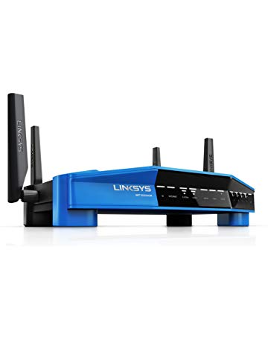](https://www.amazon.com/Linksys-Dual-Band-Wireless-Tri-Stream-WRT3200ACM/dp/B01JOXW3YE?ref_=Oct_RAsinC_Ajax_300189_2&pf_rd_r=SA07QM4Q5S23C07F7VTB&pf_rd_p=6f74083a-4541-5fc3-91f1-2d621a6b118d&pf_rd_s=merchandised-search-6&pf_rd_t=101&pf_rd_i=300189&pf_rd_m=ATVPDKIKX0DER)](https://www.amazon.com/Linksys-Dual-Band-Wireless-Tri-Stream-WRT3200ACM/dp/B01JOXW3YE?ref_=Oct_RAsinC_Ajax_300189_2&pf_rd_r=SA07QM4Q5S23C07F7VTB&pf_rd_p=6f74083a-4541-5fc3-91f1-2d621a6b118d&pf_rd_s=merchandised-search-6&pf_rd_t=101&pf_rd_i=300189&pf_rd_m=ATVPDKIKX0DER" \o "Linksys WRT AC3200 Open Source Dual-Band Gigabit Smart Wireless Router with MU-MIMO, Tri-Stream 160 (WRT3200ACM))

[price$176.99](https://www.amazon.com/Linksys-Dual-Band-Wireless-Tri-Stream-WRT3200ACM/dp/B01JOXW3YE?ref_=Oct_RAsinC_Ajax_300189_2&pf_rd_r=SA07QM4Q5S23C07F7VTB&pf_rd_p=6f74083a-4541-5fc3-91f1-2d621a6b118d&pf_rd_s=merchandised-search-6&pf_rd_t=101&pf_rd_i=300189&pf_rd_m=ATVPDKIKX0DER" \o "Linksys WRT AC3200 Open Source Dual-Band Gigabit Smart Wireless Router with MU-MIMO, Tri-Stream 160 (WRT3200ACM))

[$249.99](https://www.amazon.com/Linksys-Dual-Band-Wireless-Tri-Stream-WRT3200ACM/dp/B01JOXW3YE?ref_=Oct_RAsinC_Ajax_300189_2&pf_rd_r=SA07QM4Q5S23C07F7VTB&pf_rd_p=6f74083a-4541-5fc3-91f1-2d621a6b118d&pf_rd_s=merchandised-search-6&pf_rd_t=101&pf_rd_i=300189&pf_rd_m=ATVPDKIKX0DER" \o "Linksys WRT AC3200 Open Source Dual-Band Gigabit Smart Wireless Router with MU-MIMO, Tri-Stream 160 (WRT3200ACM))

[Linksys WRT AC3200 Open Source Dual-Band Gigabit Smart Wireless Router with MU-MIMO, Tri-Stream 160 (WRT3200ACM)](https://www.amazon.com/Linksys-Dual-Band-Wireless-Tri-Stream-WRT3200ACM/dp/B01JOXW3YE?ref_=Oct_RAsinC_Ajax_300189_2&pf_rd_r=SA07QM4Q5S23C07F7VTB&pf_rd_p=6f74083a-4541-5fc3-91f1-2d621a6b118d&pf_rd_s=merchandised-search-6&pf_rd_t=101&pf_rd_i=300189&pf_rd_m=ATVPDKIKX0DER" \o "Linksys WRT AC3200 Open Source Dual-Band Gigabit Smart Wireless Router with MU-MIMO, Tri-Stream 160 (WRT3200ACM))

[[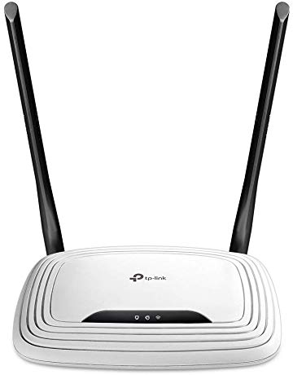](https://www.amazon.com/TP-Link-N300-Wireless-Wi-Fi-Router-TL-WR841N/dp/B001FWYGJS?ref_=Oct_RAsinC_Ajax_300189_3&pf_rd_r=SA07QM4Q5S23C07F7VTB&pf_rd_p=6f74083a-4541-5fc3-91f1-2d621a6b118d&pf_rd_s=merchandised-search-6&pf_rd_t=101&pf_rd_i=300189&pf_rd_m=ATVPDKIKX0DER)](https://www.amazon.com/TP-Link-N300-Wireless-Wi-Fi-Router-TL-WR841N/dp/B001FWYGJS?ref_=Oct_RAsinC_Ajax_300189_3&pf_rd_r=SA07QM4Q5S23C07F7VTB&pf_rd_p=6f74083a-4541-5fc3-91f1-2d621a6b118d&pf_rd_s=merchandised-search-6&pf_rd_t=101&pf_rd_i=300189&pf_rd_m=ATVPDKIKX0DER" \o "TP-Link N300 Wireless Wi-Fi Router - 2 x 5dBi High Power Antennas, Up to 300Mbps (TL-WR841N))

[price$19.99](https://www.amazon.com/TP-Link-N300-Wireless-Wi-Fi-Router-TL-WR841N/dp/B001FWYGJS?ref_=Oct_RAsinC_Ajax_300189_3&pf_rd_r=SA07QM4Q5S23C07F7VTB&pf_rd_p=6f74083a-4541-5fc3-91f1-2d621a6b118d&pf_rd_s=merchandised-search-6&pf_rd_t=101&pf_rd_i=300189&pf_rd_m=ATVPDKIKX0DER" \o "TP-Link N300 Wireless Wi-Fi Router - 2 x 5dBi High Power Antennas, Up to 300Mbps (TL-WR841N))

[TP-Link N300 Wireless Wi-Fi Router - 2 x 5dBi High Power Antennas, Up to 300Mbps (TL-WR841N)](https://www.amazon.com/TP-Link-N300-Wireless-Wi-Fi-Router-TL-WR841N/dp/B001FWYGJS?ref_=Oct_RAsinC_Ajax_300189_3&pf_rd_r=SA07QM4Q5S23C07F7VTB&pf_rd_p=6f74083a-4541-5fc3-91f1-2d621a6b118d&pf_rd_s=merchandised-search-6&pf_rd_t=101&pf_rd_i=300189&pf_rd_m=ATVPDKIKX0DER" \o "TP-Link N300 Wireless Wi-Fi Router - 2 x 5dBi High Power Antennas, Up to 300Mbps (TL-WR841N))

[[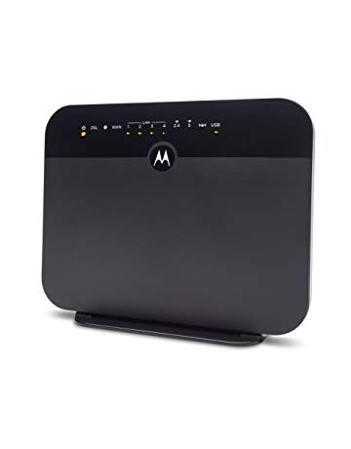](https://www.amazon.com/MOTOROLA-Gigabit-MD1600-CenturyLink-Frontier/dp/B077NNGNJM?ref_=Oct_RAsinC_Ajax_300189_4&pf_rd_r=SA07QM4Q5S23C07F7VTB&pf_rd_p=6f74083a-4541-5fc3-91f1-2d621a6b118d&pf_rd_s=merchandised-search-6&pf_rd_t=101&pf_rd_i=300189&pf_rd_m=ATVPDKIKX0DER)](https://www.amazon.com/MOTOROLA-Gigabit-MD1600-CenturyLink-Frontier/dp/B077NNGNJM?ref_=Oct_RAsinC_Ajax_300189_4&pf_rd_r=SA07QM4Q5S23C07F7VTB&pf_rd_p=6f74083a-4541-5fc3-91f1-2d621a6b118d&pf_rd_s=merchandised-search-6&pf_rd_t=101&pf_rd_i=300189&pf_rd_m=ATVPDKIKX0DER" \o "MOTOROLA VDSL2/ADSL2+ Modem + WiFi AC1600 Gigabit Router, Model MD1600, for CenturyLink, Frontier, and More)

[price$129.99](https://www.amazon.com/MOTOROLA-Gigabit-MD1600-CenturyLink-Frontier/dp/B077NNGNJM?ref_=Oct_RAsinC_Ajax_300189_4&pf_rd_r=SA07QM4Q5S23C07F7VTB&pf_rd_p=6f74083a-4541-5fc3-91f1-2d621a6b118d&pf_rd_s=merchandised-search-6&pf_rd_t=101&pf_rd_i=300189&pf_rd_m=ATVPDKIKX0DER" \o "MOTOROLA VDSL2/ADSL2+ Modem + WiFi AC1600 Gigabit Router, Model MD1600, for CenturyLink, Frontier, and More)

[$159.00](https://www.amazon.com/MOTOROLA-Gigabit-MD1600-CenturyLink-Frontier/dp/B077NNGNJM?ref_=Oct_RAsinC_Ajax_300189_4&pf_rd_r=SA07QM4Q5S23C07F7VTB&pf_rd_p=6f74083a-4541-5fc3-91f1-2d621a6b118d&pf_rd_s=merchandised-search-6&pf_rd_t=101&pf_rd_i=300189&pf_rd_m=ATVPDKIKX0DER" \o "MOTOROLA VDSL2/ADSL2+ Modem + WiFi AC1600 Gigabit Router, Model MD1600, for CenturyLink, Frontier, and More)

[MOTOROLA VDSL2/ADSL2+ Modem + WiFi AC1600 Gigabit Router, Model MD1600, for CenturyLink, Frontier, and More](https://www.amazon.com/MOTOROLA-Gigabit-MD1600-CenturyLink-Frontier/dp/B077NNGNJM?ref_=Oct_RAsinC_Ajax_300189_4&pf_rd_r=SA07QM4Q5S23C07F7VTB&pf_rd_p=6f74083a-4541-5fc3-91f1-2d621a6b118d&pf_rd_s=merchandised-search-6&pf_rd_t=101&pf_rd_i=300189&pf_rd_m=ATVPDKIKX0DER" \o "MOTOROLA VDSL2/ADSL2+ Modem + WiFi AC1600 Gigabit Router, Model MD1600, for CenturyLink, Frontier, and More)

[[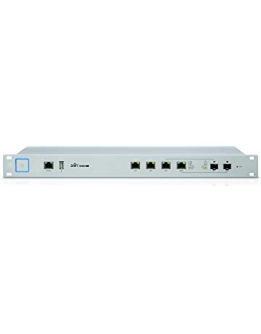](https://www.amazon.com/Ubiquiti-Unifi-Security-Gateway-USG-PRO-4/dp/B019PBEI5W?ref_=Oct_RAsinC_Ajax_300189_5&pf_rd_r=SA07QM4Q5S23C07F7VTB&pf_rd_p=6f74083a-4541-5fc3-91f1-2d621a6b118d&pf_rd_s=merchandised-search-6&pf_rd_t=101&pf_rd_i=300189&pf_rd_m=ATVPDKIKX0DER)](https://www.amazon.com/Ubiquiti-Unifi-Security-Gateway-USG-PRO-4/dp/B019PBEI5W?ref_=Oct_RAsinC_Ajax_300189_5&pf_rd_r=SA07QM4Q5S23C07F7VTB&pf_rd_p=6f74083a-4541-5fc3-91f1-2d621a6b118d&pf_rd_s=merchandised-search-6&pf_rd_t=101&pf_rd_i=300189&pf_rd_m=ATVPDKIKX0DER" \o "Ubiquiti Unifi Security Gateway Pro (USG-PRO-4))

[price$340.01](https://www.amazon.com/Ubiquiti-Unifi-Security-Gateway-USG-PRO-4/dp/B019PBEI5W?ref_=Oct_RAsinC_Ajax_300189_5&pf_rd_r=SA07QM4Q5S23C07F7VTB&pf_rd_p=6f74083a-4541-5fc3-91f1-2d621a6b118d&pf_rd_s=merchandised-search-6&pf_rd_t=101&pf_rd_i=300189&pf_rd_m=ATVPDKIKX0DER" \o "Ubiquiti Unifi Security Gateway Pro (USG-PRO-4))

[$399.99](https://www.amazon.com/Ubiquiti-Unifi-Security-Gateway-USG-PRO-4/dp/B019PBEI5W?ref_=Oct_RAsinC_Ajax_300189_5&pf_rd_r=SA07QM4Q5S23C07F7VTB&pf_rd_p=6f74083a-4541-5fc3-91f1-2d621a6b118d&pf_rd_s=merchandised-search-6&pf_rd_t=101&pf_rd_i=300189&pf_rd_m=ATVPDKIKX0DER" \o "Ubiquiti Unifi Security Gateway Pro (USG-PRO-4))

[Ubiquiti Unifi Security Gateway Pro (USG-PRO-4)](https://www.amazon.com/Ubiquiti-Unifi-Security-Gateway-USG-PRO-4/dp/B019PBEI5W?ref_=Oct_RAsinC_Ajax_300189_5&pf_rd_r=SA07QM4Q5S23C07F7VTB&pf_rd_p=6f74083a-4541-5fc3-91f1-2d621a6b118d&pf_rd_s=merchandised-search-6&pf_rd_t=101&pf_rd_i=300189&pf_rd_m=ATVPDKIKX0DER" \o "Ubiquiti Unifi Security Gateway Pro (USG-PRO-4))

[[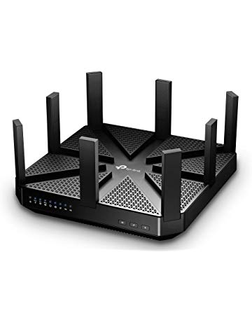](https://www.amazon.com/TP-Link-MU-MIMO-Tri-Band-Streaming-Comprehensive-Antivirus/dp/B01DXVK3KY?ref_=Oct_RAsinC_Ajax_300189_6&pf_rd_r=SA07QM4Q5S23C07F7VTB&pf_rd_p=6f74083a-4541-5fc3-91f1-2d621a6b118d&pf_rd_s=merchandised-search-6&pf_rd_t=101&pf_rd_i=300189&pf_rd_m=ATVPDKIKX0DER)](https://www.amazon.com/TP-Link-MU-MIMO-Tri-Band-Streaming-Comprehensive-Antivirus/dp/B01DXVK3KY?ref_=Oct_RAsinC_Ajax_300189_6&pf_rd_r=SA07QM4Q5S23C07F7VTB&pf_rd_p=6f74083a-4541-5fc3-91f1-2d621a6b118d&pf_rd_s=merchandised-search-6&pf_rd_t=101&pf_rd_i=300189&pf_rd_m=ATVPDKIKX0DER" \o "TP-Link AC5400 Wireless Wi-Fi MU-MIMO Tri-Band Router - Powerful Wi-Fi for Gaming and 4K Streaming, Comprehensive Antivirus and)

[price$239.89](https://www.amazon.com/TP-Link-MU-MIMO-Tri-Band-Streaming-Comprehensive-Antivirus/dp/B01DXVK3KY?ref_=Oct_RAsinC_Ajax_300189_6&pf_rd_r=SA07QM4Q5S23C07F7VTB&pf_rd_p=6f74083a-4541-5fc3-91f1-2d621a6b118d&pf_rd_s=merchandised-search-6&pf_rd_t=101&pf_rd_i=300189&pf_rd_m=ATVPDKIKX0DER" \o "TP-Link AC5400 Wireless Wi-Fi MU-MIMO Tri-Band Router - Powerful Wi-Fi for Gaming and 4K Streaming, Comprehensive Antivirus and)

[$373.75](https://www.amazon.com/TP-Link-MU-MIMO-Tri-Band-Streaming-Comprehensive-Antivirus/dp/B01DXVK3KY?ref_=Oct_RAsinC_Ajax_300189_6&pf_rd_r=SA07QM4Q5S23C07F7VTB&pf_rd_p=6f74083a-4541-5fc3-91f1-2d621a6b118d&pf_rd_s=merchandised-search-6&pf_rd_t=101&pf_rd_i=300189&pf_rd_m=ATVPDKIKX0DER" \o "TP-Link AC5400 Wireless Wi-Fi MU-MIMO Tri-Band Router - Powerful Wi-Fi for Gaming and 4K Streaming, Comprehensive Antivirus and)

[TP-Link AC5400 Wireless Wi-Fi MU-MIMO Tri-Band Router - Powerful Wi-Fi for Gaming and 4K Streaming, Comprehensive Antivirus and](https://www.amazon.com/TP-Link-MU-MIMO-Tri-Band-Streaming-Comprehensive-Antivirus/dp/B01DXVK3KY?ref_=Oct_RAsinC_Ajax_300189_6&pf_rd_r=SA07QM4Q5S23C07F7VTB&pf_rd_p=6f74083a-4541-5fc3-91f1-2d621a6b118d&pf_rd_s=merchandised-search-6&pf_rd_t=101&pf_rd_i=300189&pf_rd_m=ATVPDKIKX0DER" \o "TP-Link AC5400 Wireless Wi-Fi MU-MIMO Tri-Band Router - Powerful Wi-Fi for Gaming and 4K Streaming, Comprehensive Antivirus and)

[[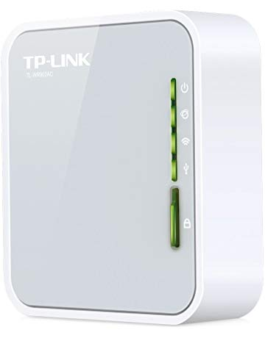](https://www.amazon.com/TP-Link-Wireless-Travel-Router-TL-WR902AC/dp/B01N5RCZQH?ref_=Oct_RAsinC_Ajax_300189_7&pf_rd_r=SA07QM4Q5S23C07F7VTB&pf_rd_p=6f74083a-4541-5fc3-91f1-2d621a6b118d&pf_rd_s=merchandised-search-6&pf_rd_t=101&pf_rd_i=300189&pf_rd_m=ATVPDKIKX0DER)](https://www.amazon.com/TP-Link-Wireless-Travel-Router-TL-WR902AC/dp/B01N5RCZQH?ref_=Oct_RAsinC_Ajax_300189_7&pf_rd_r=SA07QM4Q5S23C07F7VTB&pf_rd_p=6f74083a-4541-5fc3-91f1-2d621a6b118d&pf_rd_s=merchandised-search-6&pf_rd_t=101&pf_rd_i=300189&pf_rd_m=ATVPDKIKX0DER" \o "TP-Link AC750 Wireless Wi-Fi Travel Router (TL-WR902AC))

[price$37.55](https://www.amazon.com/TP-Link-Wireless-Travel-Router-TL-WR902AC/dp/B01N5RCZQH?ref_=Oct_RAsinC_Ajax_300189_7&pf_rd_r=SA07QM4Q5S23C07F7VTB&pf_rd_p=6f74083a-4541-5fc3-91f1-2d621a6b118d&pf_rd_s=merchandised-search-6&pf_rd_t=101&pf_rd_i=300189&pf_rd_m=ATVPDKIKX0DER" \o "TP-Link AC750 Wireless Wi-Fi Travel Router (TL-WR902AC))

[$44.99](https://www.amazon.com/TP-Link-Wireless-Travel-Router-TL-WR902AC/dp/B01N5RCZQH?ref_=Oct_RAsinC_Ajax_300189_7&pf_rd_r=SA07QM4Q5S23C07F7VTB&pf_rd_p=6f74083a-4541-5fc3-91f1-2d621a6b118d&pf_rd_s=merchandised-search-6&pf_rd_t=101&pf_rd_i=300189&pf_rd_m=ATVPDKIKX0DER" \o "TP-Link AC750 Wireless Wi-Fi Travel Router (TL-WR902AC))

[TP-Link AC750 Wireless Wi-Fi Travel Router (TL-WR902AC)](https://www.amazon.com/TP-Link-Wireless-Travel-Router-TL-WR902AC/dp/B01N5RCZQH?ref_=Oct_RAsinC_Ajax_300189_7&pf_rd_r=SA07QM4Q5S23C07F7VTB&pf_rd_p=6f74083a-4541-5fc3-91f1-2d621a6b118d&pf_rd_s=merchandised-search-6&pf_rd_t=101&pf_rd_i=300189&pf_rd_m=ATVPDKIKX0DER" \o "TP-Link AC750 Wireless Wi-Fi Travel Router (TL-WR902AC))

[[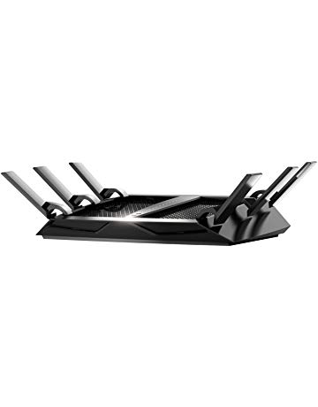](https://www.amazon.com/NETGEAR-Nighthawk-Tri-band-Ethernet-Compatible/dp/B072LZZZXB?ref_=Oct_RAsinC_Ajax_300189_8&pf_rd_r=SA07QM4Q5S23C07F7VTB&pf_rd_p=6f74083a-4541-5fc3-91f1-2d621a6b118d&pf_rd_s=merchandised-search-6&pf_rd_t=101&pf_rd_i=300189&pf_rd_m=ATVPDKIKX0DER)](https://www.amazon.com/NETGEAR-Nighthawk-Tri-band-Ethernet-Compatible/dp/B072LZZZXB?ref_=Oct_RAsinC_Ajax_300189_8&pf_rd_r=SA07QM4Q5S23C07F7VTB&pf_rd_p=6f74083a-4541-5fc3-91f1-2d621a6b118d&pf_rd_s=merchandised-search-6&pf_rd_t=101&pf_rd_i=300189&pf_rd_m=ATVPDKIKX0DER" \o "NETGEAR Nighthawk X6S AC4000 Tri-band WiFi Router, Gigabit Ethernet, MU-MIMO, Compatible with Amazon Echo/Alexa (R8000P))

[price$242.97](https://www.amazon.com/NETGEAR-Nighthawk-Tri-band-Ethernet-Compatible/dp/B072LZZZXB?ref_=Oct_RAsinC_Ajax_300189_8&pf_rd_r=SA07QM4Q5S23C07F7VTB&pf_rd_p=6f74083a-4541-5fc3-91f1-2d621a6b118d&pf_rd_s=merchandised-search-6&pf_rd_t=101&pf_rd_i=300189&pf_rd_m=ATVPDKIKX0DER" \o "NETGEAR Nighthawk X6S AC4000 Tri-band WiFi Router, Gigabit Ethernet, MU-MIMO, Compatible with Amazon Echo/Alexa (R8000P))

[$299.99](https://www.amazon.com/NETGEAR-Nighthawk-Tri-band-Ethernet-Compatible/dp/B072LZZZXB?ref_=Oct_RAsinC_Ajax_300189_8&pf_rd_r=SA07QM4Q5S23C07F7VTB&pf_rd_p=6f74083a-4541-5fc3-91f1-2d621a6b118d&pf_rd_s=merchandised-search-6&pf_rd_t=101&pf_rd_i=300189&pf_rd_m=ATVPDKIKX0DER" \o "NETGEAR Nighthawk X6S AC4000 Tri-band WiFi Router, Gigabit Ethernet, MU-MIMO, Compatible with Amazon Echo/Alexa (R8000P))

[NETGEAR Nighthawk X6S AC4000 Tri-band WiFi Router, Gigabit Ethernet, MU-MIMO, Compatible with Amazon Echo/Alexa (R8000P)](https://www.amazon.com/NETGEAR-Nighthawk-Tri-band-Ethernet-Compatible/dp/B072LZZZXB?ref_=Oct_RAsinC_Ajax_300189_8&pf_rd_r=SA07QM4Q5S23C07F7VTB&pf_rd_p=6f74083a-4541-5fc3-91f1-2d621a6b118d&pf_rd_s=merchandised-search-6&pf_rd_t=101&pf_rd_i=300189&pf_rd_m=ATVPDKIKX0DER" \o "NETGEAR Nighthawk X6S AC4000 Tri-band WiFi Router, Gigabit Ethernet, MU-MIMO, Compatible with Amazon Echo/Alexa (R8000P))

[[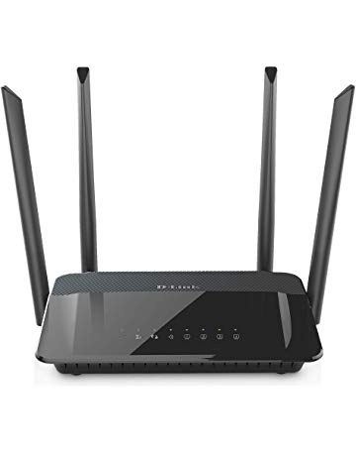](https://www.amazon.com/D-Link-AC1200-Wireless-WiFi-Router/dp/B00PVDVYIS?ref_=Oct_RAsinC_Ajax_300189_9&pf_rd_r=SA07QM4Q5S23C07F7VTB&pf_rd_p=6f74083a-4541-5fc3-91f1-2d621a6b118d&pf_rd_s=merchandised-search-6&pf_rd_t=101&pf_rd_i=300189&pf_rd_m=ATVPDKIKX0DER)](https://www.amazon.com/D-Link-AC1200-Wireless-WiFi-Router/dp/B00PVDVYIS?ref_=Oct_RAsinC_Ajax_300189_9&pf_rd_r=SA07QM4Q5S23C07F7VTB&pf_rd_p=6f74083a-4541-5fc3-91f1-2d621a6b118d&pf_rd_s=merchandised-search-6&pf_rd_t=101&pf_rd_i=300189&pf_rd_m=ATVPDKIKX0DER" \o "D-Link AC1200 Wireless WiFi Router – Smart Dual Band – Gigabit – MU-MIMO – High Power Antennas for Wide Coverage – Easy Setup – Parental Controls (DIR-842))

[price$53.49](https://www.amazon.com/D-Link-AC1200-Wireless-WiFi-Router/dp/B00PVDVYIS?ref_=Oct_RAsinC_Ajax_300189_9&pf_rd_r=SA07QM4Q5S23C07F7VTB&pf_rd_p=6f74083a-4541-5fc3-91f1-2d621a6b118d&pf_rd_s=merchandised-search-6&pf_rd_t=101&pf_rd_i=300189&pf_rd_m=ATVPDKIKX0DER" \o "D-Link AC1200 Wireless WiFi Router – Smart Dual Band – Gigabit – MU-MIMO – High Power Antennas for Wide Coverage – Easy Setup – Parental Controls (DIR-842))

[$59.99](https://www.amazon.com/D-Link-AC1200-Wireless-WiFi-Router/dp/B00PVDVYIS?ref_=Oct_RAsinC_Ajax_300189_9&pf_rd_r=SA07QM4Q5S23C07F7VTB&pf_rd_p=6f74083a-4541-5fc3-91f1-2d621a6b118d&pf_rd_s=merchandised-search-6&pf_rd_t=101&pf_rd_i=300189&pf_rd_m=ATVPDKIKX0DER" \o "D-Link AC1200 Wireless WiFi Router – Smart Dual Band – Gigabit – MU-MIMO – High Power Antennas for Wide Coverage – Easy Setup – Parental Controls (DIR-842))

[D-Link AC1200 Wireless WiFi Router – Smart Dual Band – Gigabit – MU-MIMO – High Power Antennas for Wide Coverage – Easy Setup – Parental Controls (DIR-842)](https://www.amazon.com/D-Link-AC1200-Wireless-WiFi-Router/dp/B00PVDVYIS?ref_=Oct_RAsinC_Ajax_300189_9&pf_rd_r=SA07QM4Q5S23C07F7VTB&pf_rd_p=6f74083a-4541-5fc3-91f1-2d621a6b118d&pf_rd_s=merchandised-search-6&pf_rd_t=101&pf_rd_i=300189&pf_rd_m=ATVPDKIKX0DER" \o "D-Link AC1200 Wireless WiFi Router – Smart Dual Band – Gigabit – MU-MIMO – High Power Antennas for Wide Coverage – Easy Setup – Parental Controls (DIR-842))

[[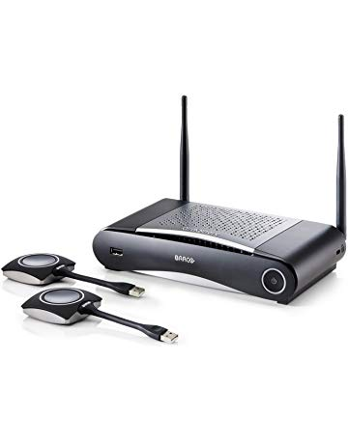](https://www.amazon.com/MAIN-61771-Barco-CSE-200-Wireless-Presentation/dp/B01BL0BSVC?ref_=Oct_RAsinC_Ajax_300189_10&pf_rd_r=SA07QM4Q5S23C07F7VTB&pf_rd_p=6f74083a-4541-5fc3-91f1-2d621a6b118d&pf_rd_s=merchandised-search-6&pf_rd_t=101&pf_rd_i=300189&pf_rd_m=ATVPDKIKX0DER)](https://www.amazon.com/MAIN-61771-Barco-CSE-200-Wireless-Presentation/dp/B01BL0BSVC?ref_=Oct_RAsinC_Ajax_300189_10&pf_rd_r=SA07QM4Q5S23C07F7VTB&pf_rd_p=6f74083a-4541-5fc3-91f1-2d621a6b118d&pf_rd_s=merchandised-search-6&pf_rd_t=101&pf_rd_i=300189&pf_rd_m=ATVPDKIKX0DER" \o "MAIN-61771 Barco CSE-200 | Small Medium Size Meeting Room Wireless Presentation System)

[price$1,294.44](https://www.amazon.com/MAIN-61771-Barco-CSE-200-Wireless-Presentation/dp/B01BL0BSVC?ref_=Oct_RAsinC_Ajax_300189_10&pf_rd_r=SA07QM4Q5S23C07F7VTB&pf_rd_p=6f74083a-4541-5fc3-91f1-2d621a6b118d&pf_rd_s=merchandised-search-6&pf_rd_t=101&pf_rd_i=300189&pf_rd_m=ATVPDKIKX0DER" \o "MAIN-61771 Barco CSE-200 | Small Medium Size Meeting Room Wireless Presentation System)

[MAIN-61771 Barco CSE-200 | Small Medium Size Meeting Room Wireless Presentation System](https://www.amazon.com/MAIN-61771-Barco-CSE-200-Wireless-Presentation/dp/B01BL0BSVC?ref_=Oct_RAsinC_Ajax_300189_10&pf_rd_r=SA07QM4Q5S23C07F7VTB&pf_rd_p=6f74083a-4541-5fc3-91f1-2d621a6b118d&pf_rd_s=merchandised-search-6&pf_rd_t=101&pf_rd_i=300189&pf_rd_m=ATVPDKIKX0DER" \o "MAIN-61771 Barco CSE-200 | Small Medium Size Meeting Room Wireless Presentation System)

[[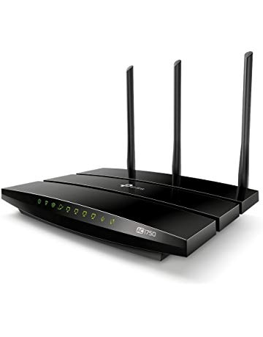](https://www.amazon.com/TP-Link-AC1750-Smart-WiFi-Router/dp/B00BUSDVBQ?ref_=Oct_RAsinC_Ajax_300189_11&pf_rd_r=SA07QM4Q5S23C07F7VTB&pf_rd_p=6f74083a-4541-5fc3-91f1-2d621a6b118d&pf_rd_s=merchandised-search-6&pf_rd_t=101&pf_rd_i=300189&pf_rd_m=ATVPDKIKX0DER)](https://www.amazon.com/TP-Link-AC1750-Smart-WiFi-Router/dp/B00BUSDVBQ?ref_=Oct_RAsinC_Ajax_300189_11&pf_rd_r=SA07QM4Q5S23C07F7VTB&pf_rd_p=6f74083a-4541-5fc3-91f1-2d621a6b118d&pf_rd_s=merchandised-search-6&pf_rd_t=101&pf_rd_i=300189&pf_rd_m=ATVPDKIKX0DER" \o "TP-Link AC1750 Smart WiFi Router - Dual Band Gigabit Wireless Router, 802.11ac Internet Router, Wireless routers for home(Archer C7))

[price$74.99](https://www.amazon.com/TP-Link-AC1750-Smart-WiFi-Router/dp/B00BUSDVBQ?ref_=Oct_RAsinC_Ajax_300189_11&pf_rd_r=SA07QM4Q5S23C07F7VTB&pf_rd_p=6f74083a-4541-5fc3-91f1-2d621a6b118d&pf_rd_s=merchandised-search-6&pf_rd_t=101&pf_rd_i=300189&pf_rd_m=ATVPDKIKX0DER" \o "TP-Link AC1750 Smart WiFi Router - Dual Band Gigabit Wireless Router, 802.11ac Internet Router, Wireless routers for home(Archer C7))

[TP-Link AC1750 Smart WiFi Router - Dual Band Gigabit Wireless Router, 802.11ac Internet Router, Wireless routers for home(Archer C7)](https://www.amazon.com/TP-Link-AC1750-Smart-WiFi-Router/dp/B00BUSDVBQ?ref_=Oct_RAsinC_Ajax_300189_11&pf_rd_r=SA07QM4Q5S23C07F7VTB&pf_rd_p=6f74083a-4541-5fc3-91f1-2d621a6b118d&pf_rd_s=merchandised-search-6&pf_rd_t=101&pf_rd_i=300189&pf_rd_m=ATVPDKIKX0DER" \o "TP-Link AC1750 Smart WiFi Router - Dual Band Gigabit Wireless Router, 802.11ac Internet Router, Wireless routers for home(Archer C7))

Most wished for [See more](https://www.amazon.com/gp/most-wished-for/electronics/300189?ref_=Oct_MWishedForC_300189_SAll&pf_rd_r=SA07QM4Q5S23C07F7VTB&pf_rd_p=6f74083a-4541-5fc3-91f1-2d621a6b118d&pf_rd_s=merchandised-search-6&pf_rd_t=101&pf_rd_i=300189&pf_rd_m=ATVPDKIKX0DER)

[[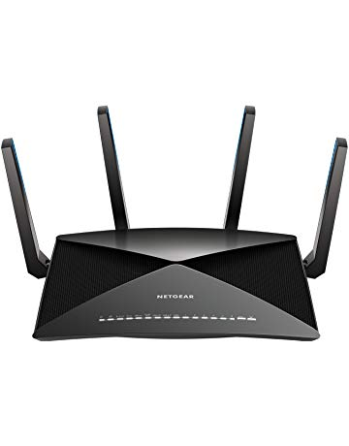](https://www.amazon.com/NETGEAR-Nighthawk-Quad-Stream-Quad-core-Compatible/dp/B01M12RE4A?ref_=Oct_MWishedForC_300189_0&pf_rd_r=SA07QM4Q5S23C07F7VTB&pf_rd_p=6f74083a-4541-5fc3-91f1-2d621a6b118d&pf_rd_s=merchandised-search-6&pf_rd_t=101&pf_rd_i=300189&pf_rd_m=ATVPDKIKX0DER)](https://www.amazon.com/NETGEAR-Nighthawk-Quad-Stream-Quad-core-Compatible/dp/B01M12RE4A?ref_=Oct_MWishedForC_300189_0&pf_rd_r=SA07QM4Q5S23C07F7VTB&pf_rd_p=6f74083a-4541-5fc3-91f1-2d621a6b118d&pf_rd_s=merchandised-search-6&pf_rd_t=101&pf_rd_i=300189&pf_rd_m=ATVPDKIKX0DER" \o "NETGEAR Nighthawk X10 AD7200 802.11ac/ad Quad-Stream WiFi Router, 1.7GHz Quad-core Processor, Plex Media Server, Compatible with Amazon Alexa (R9000))

[price$399.99](https://www.amazon.com/NETGEAR-Nighthawk-Quad-Stream-Quad-core-Compatible/dp/B01M12RE4A?ref_=Oct_MWishedForC_300189_0&pf_rd_r=SA07QM4Q5S23C07F7VTB&pf_rd_p=6f74083a-4541-5fc3-91f1-2d621a6b118d&pf_rd_s=merchandised-search-6&pf_rd_t=101&pf_rd_i=300189&pf_rd_m=ATVPDKIKX0DER" \o "NETGEAR Nighthawk X10 AD7200 802.11ac/ad Quad-Stream WiFi Router, 1.7GHz Quad-core Processor, Plex Media Server, Compatible with Amazon Alexa (R9000))

[NETGEAR Nighthawk X10 AD7200 802.11ac/ad Quad-Stream WiFi Router, 1.7GHz Quad-core Processor, Plex Media Server, Compatible with Amazon Alexa (R9000)](https://www.amazon.com/NETGEAR-Nighthawk-Quad-Stream-Quad-core-Compatible/dp/B01M12RE4A?ref_=Oct_MWishedForC_300189_0&pf_rd_r=SA07QM4Q5S23C07F7VTB&pf_rd_p=6f74083a-4541-5fc3-91f1-2d621a6b118d&pf_rd_s=merchandised-search-6&pf_rd_t=101&pf_rd_i=300189&pf_rd_m=ATVPDKIKX0DER" \o "NETGEAR Nighthawk X10 AD7200 802.11ac/ad Quad-Stream WiFi Router, 1.7GHz Quad-core Processor, Plex Media Server, Compatible with Amazon Alexa (R9000))

[[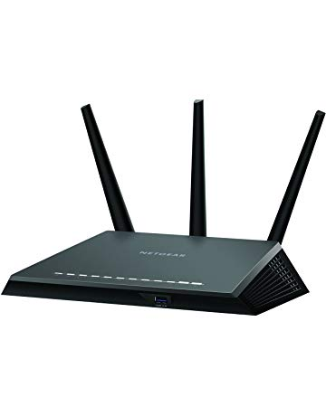](https://www.amazon.com/R7000P-100NAS-Nighthawk-Ethernet-Compatible-Parental/dp/B01NA80JML?ref_=Oct_MWishedForC_300189_1&pf_rd_r=SA07QM4Q5S23C07F7VTB&pf_rd_p=6f74083a-4541-5fc3-91f1-2d621a6b118d&pf_rd_s=merchandised-search-6&pf_rd_t=101&pf_rd_i=300189&pf_rd_m=ATVPDKIKX0DER)](https://www.amazon.com/R7000P-100NAS-Nighthawk-Ethernet-Compatible-Parental/dp/B01NA80JML?ref_=Oct_MWishedForC_300189_1&pf_rd_r=SA07QM4Q5S23C07F7VTB&pf_rd_p=6f74083a-4541-5fc3-91f1-2d621a6b118d&pf_rd_s=merchandised-search-6&pf_rd_t=101&pf_rd_i=300189&pf_rd_m=ATVPDKIKX0DER" \o "Netgear (R7000P-100NAS) Nighthawk AC2300 Dual Band Smart WiFi Router, Gigabit Ethernet, MU-MIMO, Compatible with Amazon Echo/Alexa and Circle Smart Parental Controls)

[price$159.99](https://www.amazon.com/R7000P-100NAS-Nighthawk-Ethernet-Compatible-Parental/dp/B01NA80JML?ref_=Oct_MWishedForC_300189_1&pf_rd_r=SA07QM4Q5S23C07F7VTB&pf_rd_p=6f74083a-4541-5fc3-91f1-2d621a6b118d&pf_rd_s=merchandised-search-6&pf_rd_t=101&pf_rd_i=300189&pf_rd_m=ATVPDKIKX0DER" \o "Netgear (R7000P-100NAS) Nighthawk AC2300 Dual Band Smart WiFi Router, Gigabit Ethernet, MU-MIMO, Compatible with Amazon Echo/Alexa and Circle Smart Parental Controls)

[$199.99](https://www.amazon.com/R7000P-100NAS-Nighthawk-Ethernet-Compatible-Parental/dp/B01NA80JML?ref_=Oct_MWishedForC_300189_1&pf_rd_r=SA07QM4Q5S23C07F7VTB&pf_rd_p=6f74083a-4541-5fc3-91f1-2d621a6b118d&pf_rd_s=merchandised-search-6&pf_rd_t=101&pf_rd_i=300189&pf_rd_m=ATVPDKIKX0DER" \o "Netgear (R7000P-100NAS) Nighthawk AC2300 Dual Band Smart WiFi Router, Gigabit Ethernet, MU-MIMO, Compatible with Amazon Echo/Alexa and Circle Smart Parental Controls)

[Netgear (R7000P-100NAS) Nighthawk AC2300 Dual Band Smart WiFi Router, Gigabit Ethernet, MU-MIMO, Compatible with Amazon Echo/Alexa and Circle Smart Parental Controls](https://www.amazon.com/R7000P-100NAS-Nighthawk-Ethernet-Compatible-Parental/dp/B01NA80JML?ref_=Oct_MWishedForC_300189_1&pf_rd_r=SA07QM4Q5S23C07F7VTB&pf_rd_p=6f74083a-4541-5fc3-91f1-2d621a6b118d&pf_rd_s=merchandised-search-6&pf_rd_t=101&pf_rd_i=300189&pf_rd_m=ATVPDKIKX0DER" \o "Netgear (R7000P-100NAS) Nighthawk AC2300 Dual Band Smart WiFi Router, Gigabit Ethernet, MU-MIMO, Compatible with Amazon Echo/Alexa and Circle Smart Parental Controls)

[[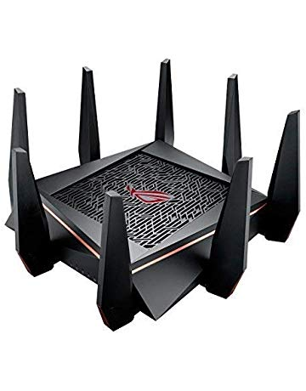](https://www.amazon.com/streaming-Quad-Core-processor-AiProtection-GT-AC5300/dp/B071DPCKQ6?ref_=Oct_MWishedForC_300189_2&pf_rd_r=SA07QM4Q5S23C07F7VTB&pf_rd_p=6f74083a-4541-5fc3-91f1-2d621a6b118d&pf_rd_s=merchandised-search-6&pf_rd_t=101&pf_rd_i=300189&pf_rd_m=ATVPDKIKX0DER)](https://www.amazon.com/streaming-Quad-Core-processor-AiProtection-GT-AC5300/dp/B071DPCKQ6?ref_=Oct_MWishedForC_300189_2&pf_rd_r=SA07QM4Q5S23C07F7VTB&pf_rd_p=6f74083a-4541-5fc3-91f1-2d621a6b118d&pf_rd_s=merchandised-search-6&pf_rd_t=101&pf_rd_i=300189&pf_rd_m=ATVPDKIKX0DER" \o "ASUS Gaming Router Tri-band WiFi (Up to 5334 Mbps) for VR & 4K streaming, 1.8GHz Quad-Core processor, Gaming Port, Whole Home Mesh System, & AiProtection network with 8 x Gigabit LAN ports(GT-AC5300))

[price$359.99](https://www.amazon.com/streaming-Quad-Core-processor-AiProtection-GT-AC5300/dp/B071DPCKQ6?ref_=Oct_MWishedForC_300189_2&pf_rd_r=SA07QM4Q5S23C07F7VTB&pf_rd_p=6f74083a-4541-5fc3-91f1-2d621a6b118d&pf_rd_s=merchandised-search-6&pf_rd_t=101&pf_rd_i=300189&pf_rd_m=ATVPDKIKX0DER" \o "ASUS Gaming Router Tri-band WiFi (Up to 5334 Mbps) for VR & 4K streaming, 1.8GHz Quad-Core processor, Gaming Port, Whole Home Mesh System, & AiProtection network with 8 x Gigabit LAN ports(GT-AC5300))

[$399.99](https://www.amazon.com/streaming-Quad-Core-processor-AiProtection-GT-AC5300/dp/B071DPCKQ6?ref_=Oct_MWishedForC_300189_2&pf_rd_r=SA07QM4Q5S23C07F7VTB&pf_rd_p=6f74083a-4541-5fc3-91f1-2d621a6b118d&pf_rd_s=merchandised-search-6&pf_rd_t=101&pf_rd_i=300189&pf_rd_m=ATVPDKIKX0DER" \o "ASUS Gaming Router Tri-band WiFi (Up to 5334 Mbps) for VR & 4K streaming, 1.8GHz Quad-Core processor, Gaming Port, Whole Home Mesh System, & AiProtection network with 8 x Gigabit LAN ports(GT-AC5300))

[ASUS Gaming Router Tri-band WiFi (Up to 5334 Mbps) for VR & 4K streaming, 1.8GHz Quad-Core processor, Gaming Port, Whole Home Mesh System, & AiProtection network with 8 x Gigabit LAN ports(GT-AC5300)](https://www.amazon.com/streaming-Quad-Core-processor-AiProtection-GT-AC5300/dp/B071DPCKQ6?ref_=Oct_MWishedForC_300189_2&pf_rd_r=SA07QM4Q5S23C07F7VTB&pf_rd_p=6f74083a-4541-5fc3-91f1-2d621a6b118d&pf_rd_s=merchandised-search-6&pf_rd_t=101&pf_rd_i=300189&pf_rd_m=ATVPDKIKX0DER" \o "ASUS Gaming Router Tri-band WiFi (Up to 5334 Mbps) for VR & 4K streaming, 1.8GHz Quad-Core processor, Gaming Port, Whole Home Mesh System, & AiProtection network with 8 x Gigabit LAN ports(GT-AC5300))

[[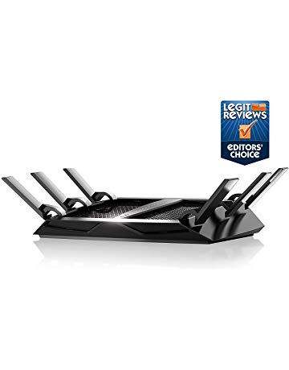](https://www.amazon.com/R8000-100NAS-Nighthawk-Tri-Band-Ethernet-Compatible/dp/B00KWHMR6G?ref_=Oct_MWishedForC_300189_3&pf_rd_r=SA07QM4Q5S23C07F7VTB&pf_rd_p=6f74083a-4541-5fc3-91f1-2d621a6b118d&pf_rd_s=merchandised-search-6&pf_rd_t=101&pf_rd_i=300189&pf_rd_m=ATVPDKIKX0DER)](https://www.amazon.com/R8000-100NAS-Nighthawk-Tri-Band-Ethernet-Compatible/dp/B00KWHMR6G?ref_=Oct_MWishedForC_300189_3&pf_rd_r=SA07QM4Q5S23C07F7VTB&pf_rd_p=6f74083a-4541-5fc3-91f1-2d621a6b118d&pf_rd_s=merchandised-search-6&pf_rd_t=101&pf_rd_i=300189&pf_rd_m=ATVPDKIKX0DER" \o "Netgear (R8000-100NAS) Nighthawk X6 AC3200 Tri-Band WiFi Router, Gigabit Ethernet, Compatible with Amazon Echo/Alexa)

[price$209.98](https://www.amazon.com/R8000-100NAS-Nighthawk-Tri-Band-Ethernet-Compatible/dp/B00KWHMR6G?ref_=Oct_MWishedForC_300189_3&pf_rd_r=SA07QM4Q5S23C07F7VTB&pf_rd_p=6f74083a-4541-5fc3-91f1-2d621a6b118d&pf_rd_s=merchandised-search-6&pf_rd_t=101&pf_rd_i=300189&pf_rd_m=ATVPDKIKX0DER" \o "Netgear (R8000-100NAS) Nighthawk X6 AC3200 Tri-Band WiFi Router, Gigabit Ethernet, Compatible with Amazon Echo/Alexa)

[$259.99](https://www.amazon.com/R8000-100NAS-Nighthawk-Tri-Band-Ethernet-Compatible/dp/B00KWHMR6G?ref_=Oct_MWishedForC_300189_3&pf_rd_r=SA07QM4Q5S23C07F7VTB&pf_rd_p=6f74083a-4541-5fc3-91f1-2d621a6b118d&pf_rd_s=merchandised-search-6&pf_rd_t=101&pf_rd_i=300189&pf_rd_m=ATVPDKIKX0DER" \o "Netgear (R8000-100NAS) Nighthawk X6 AC3200 Tri-Band WiFi Router, Gigabit Ethernet, Compatible with Amazon Echo/Alexa)

[Netgear (R8000-100NAS) Nighthawk X6 AC3200 Tri-Band WiFi Router, Gigabit Ethernet, Compatible with Amazon Echo/Alexa](https://www.amazon.com/R8000-100NAS-Nighthawk-Tri-Band-Ethernet-Compatible/dp/B00KWHMR6G?ref_=Oct_MWishedForC_300189_3&pf_rd_r=SA07QM4Q5S23C07F7VTB&pf_rd_p=6f74083a-4541-5fc3-91f1-2d621a6b118d&pf_rd_s=merchandised-search-6&pf_rd_t=101&pf_rd_i=300189&pf_rd_m=ATVPDKIKX0DER" \o "Netgear (R8000-100NAS) Nighthawk X6 AC3200 Tri-Band WiFi Router, Gigabit Ethernet, Compatible with Amazon Echo/Alexa)

[[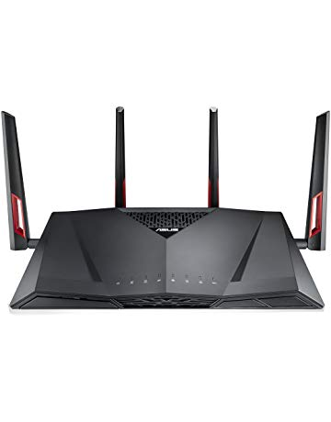](https://www.amazon.com/Dual-Band-supporting-AiProtection-Accelerator-RT-AC88U/dp/B016EWKQAQ?ref_=Oct_MWishedForC_300189_4&pf_rd_r=SA07QM4Q5S23C07F7VTB&pf_rd_p=6f74083a-4541-5fc3-91f1-2d621a6b118d&pf_rd_s=merchandised-search-6&pf_rd_t=101&pf_rd_i=300189&pf_rd_m=ATVPDKIKX0DER)](https://www.amazon.com/Dual-Band-supporting-AiProtection-Accelerator-RT-AC88U/dp/B016EWKQAQ?ref_=Oct_MWishedForC_300189_4&pf_rd_r=SA07QM4Q5S23C07F7VTB&pf_rd_p=6f74083a-4541-5fc3-91f1-2d621a6b118d&pf_rd_s=merchandised-search-6&pf_rd_t=101&pf_rd_i=300189&pf_rd_m=ATVPDKIKX0DER" \o "ASUS Dual-Band Gigabit WiFi Gaming Router (AC3100) with MU-MIMO, supporting AiProtection network security by Trend Micro, AiMesh for Mesh WiFi system, and WTFast game Accelerator (RT-AC88U))

[price$238.70](https://www.amazon.com/Dual-Band-supporting-AiProtection-Accelerator-RT-AC88U/dp/B016EWKQAQ?ref_=Oct_MWishedForC_300189_4&pf_rd_r=SA07QM4Q5S23C07F7VTB&pf_rd_p=6f74083a-4541-5fc3-91f1-2d621a6b118d&pf_rd_s=merchandised-search-6&pf_rd_t=101&pf_rd_i=300189&pf_rd_m=ATVPDKIKX0DER" \o "ASUS Dual-Band Gigabit WiFi Gaming Router (AC3100) with MU-MIMO, supporting AiProtection network security by Trend Micro, AiMesh for Mesh WiFi system, and WTFast game Accelerator (RT-AC88U))

[$299.99](https://www.amazon.com/Dual-Band-supporting-AiProtection-Accelerator-RT-AC88U/dp/B016EWKQAQ?ref_=Oct_MWishedForC_300189_4&pf_rd_r=SA07QM4Q5S23C07F7VTB&pf_rd_p=6f74083a-4541-5fc3-91f1-2d621a6b118d&pf_rd_s=merchandised-search-6&pf_rd_t=101&pf_rd_i=300189&pf_rd_m=ATVPDKIKX0DER" \o "ASUS Dual-Band Gigabit WiFi Gaming Router (AC3100) with MU-MIMO, supporting AiProtection network security by Trend Micro, AiMesh for Mesh WiFi system, and WTFast game Accelerator (RT-AC88U))

[ASUS Dual-Band Gigabit WiFi Gaming Router (AC3100) with MU-MIMO, supporting AiProtection network security by Trend Micro, AiMesh for Mesh WiFi system, and WTFast game Accelerator (RT-AC88U)](https://www.amazon.com/Dual-Band-supporting-AiProtection-Accelerator-RT-AC88U/dp/B016EWKQAQ?ref_=Oct_MWishedForC_300189_4&pf_rd_r=SA07QM4Q5S23C07F7VTB&pf_rd_p=6f74083a-4541-5fc3-91f1-2d621a6b118d&pf_rd_s=merchandised-search-6&pf_rd_t=101&pf_rd_i=300189&pf_rd_m=ATVPDKIKX0DER" \o "ASUS Dual-Band Gigabit WiFi Gaming Router (AC3100) with MU-MIMO, supporting AiProtection network security by Trend Micro, AiMesh for Mesh WiFi system, and WTFast game Accelerator (RT-AC88U))

[[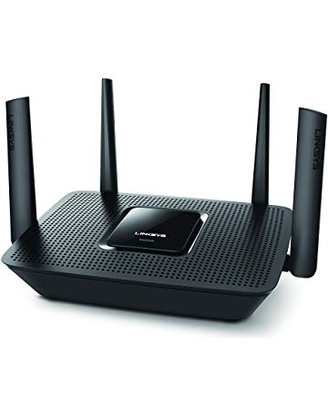](https://www.amazon.com/Linksys-Max-Stream-Tri-band-Wireless-EA8300/dp/B06X9CPC45?ref_=Oct_MWishedForC_300189_5&pf_rd_r=SA07QM4Q5S23C07F7VTB&pf_rd_p=6f74083a-4541-5fc3-91f1-2d621a6b118d&pf_rd_s=merchandised-search-6&pf_rd_t=101&pf_rd_i=300189&pf_rd_m=ATVPDKIKX0DER)](https://www.amazon.com/Linksys-Max-Stream-Tri-band-Wireless-EA8300/dp/B06X9CPC45?ref_=Oct_MWishedForC_300189_5&pf_rd_r=SA07QM4Q5S23C07F7VTB&pf_rd_p=6f74083a-4541-5fc3-91f1-2d621a6b118d&pf_rd_s=merchandised-search-6&pf_rd_t=101&pf_rd_i=300189&pf_rd_m=ATVPDKIKX0DER" \o "Linksys - Max-Stream AC2200 Tri-Band Wi-Fi Router (EA8300) Black - New)

[price$139.99](https://www.amazon.com/Linksys-Max-Stream-Tri-band-Wireless-EA8300/dp/B06X9CPC45?ref_=Oct_MWishedForC_300189_5&pf_rd_r=SA07QM4Q5S23C07F7VTB&pf_rd_p=6f74083a-4541-5fc3-91f1-2d621a6b118d&pf_rd_s=merchandised-search-6&pf_rd_t=101&pf_rd_i=300189&pf_rd_m=ATVPDKIKX0DER" \o "Linksys - Max-Stream AC2200 Tri-Band Wi-Fi Router (EA8300) Black - New)

[$199.99](https://www.amazon.com/Linksys-Max-Stream-Tri-band-Wireless-EA8300/dp/B06X9CPC45?ref_=Oct_MWishedForC_300189_5&pf_rd_r=SA07QM4Q5S23C07F7VTB&pf_rd_p=6f74083a-4541-5fc3-91f1-2d621a6b118d&pf_rd_s=merchandised-search-6&pf_rd_t=101&pf_rd_i=300189&pf_rd_m=ATVPDKIKX0DER" \o "Linksys - Max-Stream AC2200 Tri-Band Wi-Fi Router (EA8300) Black - New)

[Linksys - Max-Stream AC2200 Tri-Band Wi-Fi Router (EA8300) Black - New](https://www.amazon.com/Linksys-Max-Stream-Tri-band-Wireless-EA8300/dp/B06X9CPC45?ref_=Oct_MWishedForC_300189_5&pf_rd_r=SA07QM4Q5S23C07F7VTB&pf_rd_p=6f74083a-4541-5fc3-91f1-2d621a6b118d&pf_rd_s=merchandised-search-6&pf_rd_t=101&pf_rd_i=300189&pf_rd_m=ATVPDKIKX0DER" \o "Linksys - Max-Stream AC2200 Tri-Band Wi-Fi Router (EA8300) Black - New)

[[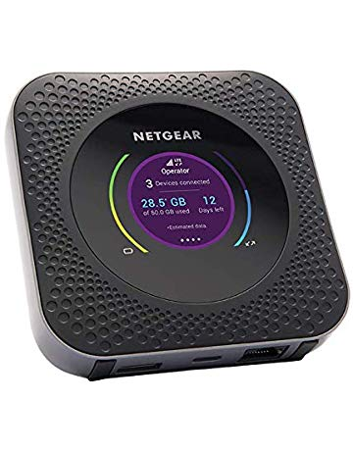](https://www.amazon.com/Netgear-Nighthawk-MR1100-GSM-Unlocked/dp/B07G5KWZ3H?ref_=Oct_MWishedForC_300189_6&pf_rd_r=SA07QM4Q5S23C07F7VTB&pf_rd_p=6f74083a-4541-5fc3-91f1-2d621a6b118d&pf_rd_s=merchandised-search-6&pf_rd_t=101&pf_rd_i=300189&pf_rd_m=ATVPDKIKX0DER)](https://www.amazon.com/Netgear-Nighthawk-MR1100-GSM-Unlocked/dp/B07G5KWZ3H?ref_=Oct_MWishedForC_300189_6&pf_rd_r=SA07QM4Q5S23C07F7VTB&pf_rd_p=6f74083a-4541-5fc3-91f1-2d621a6b118d&pf_rd_s=merchandised-search-6&pf_rd_t=101&pf_rd_i=300189&pf_rd_m=ATVPDKIKX0DER" \o "Netgear Nighthawk M1 MR1100 GSM/LTE Unlocked)

[price$255.78](https://www.amazon.com/Netgear-Nighthawk-MR1100-GSM-Unlocked/dp/B07G5KWZ3H?ref_=Oct_MWishedForC_300189_6&pf_rd_r=SA07QM4Q5S23C07F7VTB&pf_rd_p=6f74083a-4541-5fc3-91f1-2d621a6b118d&pf_rd_s=merchandised-search-6&pf_rd_t=101&pf_rd_i=300189&pf_rd_m=ATVPDKIKX0DER" \o "Netgear Nighthawk M1 MR1100 GSM/LTE Unlocked)

[Netgear Nighthawk M1 MR1100 GSM/LTE Unlocked](https://www.amazon.com/Netgear-Nighthawk-MR1100-GSM-Unlocked/dp/B07G5KWZ3H?ref_=Oct_MWishedForC_300189_6&pf_rd_r=SA07QM4Q5S23C07F7VTB&pf_rd_p=6f74083a-4541-5fc3-91f1-2d621a6b118d&pf_rd_s=merchandised-search-6&pf_rd_t=101&pf_rd_i=300189&pf_rd_m=ATVPDKIKX0DER" \o "Netgear Nighthawk M1 MR1100 GSM/LTE Unlocked)

[[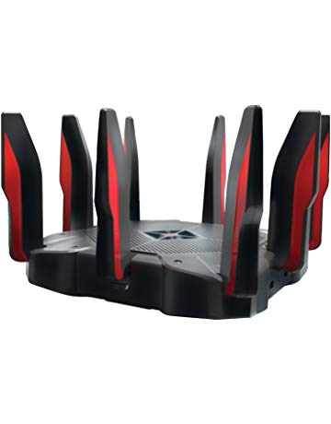](https://www.amazon.com/TP-Link-AC5400-Band-Gaming-Router/dp/B076HRZJ66?ref_=Oct_MWishedForC_300189_7&pf_rd_r=SA07QM4Q5S23C07F7VTB&pf_rd_p=6f74083a-4541-5fc3-91f1-2d621a6b118d&pf_rd_s=merchandised-search-6&pf_rd_t=101&pf_rd_i=300189&pf_rd_m=ATVPDKIKX0DER)](https://www.amazon.com/TP-Link-AC5400-Band-Gaming-Router/dp/B076HRZJ66?ref_=Oct_MWishedForC_300189_7&pf_rd_r=SA07QM4Q5S23C07F7VTB&pf_rd_p=6f74083a-4541-5fc3-91f1-2d621a6b118d&pf_rd_s=merchandised-search-6&pf_rd_t=101&pf_rd_i=300189&pf_rd_m=ATVPDKIKX0DER" \o "TP-Link AC5400 Tri Band Gaming Router MU-MIMO 1.8GHz Quad-Core 64-bit CPU Archer C5400X)

[price$361.05](https://www.amazon.com/TP-Link-AC5400-Band-Gaming-Router/dp/B076HRZJ66?ref_=Oct_MWishedForC_300189_7&pf_rd_r=SA07QM4Q5S23C07F7VTB&pf_rd_p=6f74083a-4541-5fc3-91f1-2d621a6b118d&pf_rd_s=merchandised-search-6&pf_rd_t=101&pf_rd_i=300189&pf_rd_m=ATVPDKIKX0DER" \o "TP-Link AC5400 Tri Band Gaming Router MU-MIMO 1.8GHz Quad-Core 64-bit CPU Archer C5400X)

[$399.99](https://www.amazon.com/TP-Link-AC5400-Band-Gaming-Router/dp/B076HRZJ66?ref_=Oct_MWishedForC_300189_7&pf_rd_r=SA07QM4Q5S23C07F7VTB&pf_rd_p=6f74083a-4541-5fc3-91f1-2d621a6b118d&pf_rd_s=merchandised-search-6&pf_rd_t=101&pf_rd_i=300189&pf_rd_m=ATVPDKIKX0DER" \o "TP-Link AC5400 Tri Band Gaming Router MU-MIMO 1.8GHz Quad-Core 64-bit CPU Archer C5400X)

[TP-Link AC5400 Tri Band Gaming Router MU-MIMO 1.8GHz Quad-Core 64-bit CPU Archer C5400X](https://www.amazon.com/TP-Link-AC5400-Band-Gaming-Router/dp/B076HRZJ66?ref_=Oct_MWishedForC_300189_7&pf_rd_r=SA07QM4Q5S23C07F7VTB&pf_rd_p=6f74083a-4541-5fc3-91f1-2d621a6b118d&pf_rd_s=merchandised-search-6&pf_rd_t=101&pf_rd_i=300189&pf_rd_m=ATVPDKIKX0DER" \o "TP-Link AC5400 Tri Band Gaming Router MU-MIMO 1.8GHz Quad-Core 64-bit CPU Archer C5400X)

[[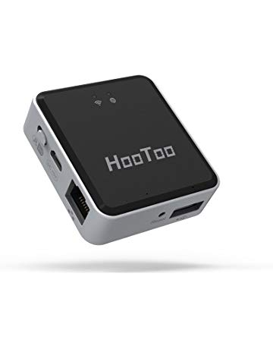](https://www.amazon.com/HooToo-Wireless-Performance-TripMate-Hotspot/dp/B00HZWOQZ6?ref_=Oct_MWishedForC_300189_8&pf_rd_r=SA07QM4Q5S23C07F7VTB&pf_rd_p=6f74083a-4541-5fc3-91f1-2d621a6b118d&pf_rd_s=merchandised-search-6&pf_rd_t=101&pf_rd_i=300189&pf_rd_m=ATVPDKIKX0DER)](https://www.amazon.com/HooToo-Wireless-Performance-TripMate-Hotspot/dp/B00HZWOQZ6?ref_=Oct_MWishedForC_300189_8&pf_rd_r=SA07QM4Q5S23C07F7VTB&pf_rd_p=6f74083a-4541-5fc3-91f1-2d621a6b118d&pf_rd_s=merchandised-search-6&pf_rd_t=101&pf_rd_i=300189&pf_rd_m=ATVPDKIKX0DER" \o "HooToo Wireless Travel Router, USB Port, N150 Wi-Fi Router, USB Powered, High Performance, Mini Router- TripMate Nano (Not a Hotspot))

[price$19.99](https://www.amazon.com/HooToo-Wireless-Performance-TripMate-Hotspot/dp/B00HZWOQZ6?ref_=Oct_MWishedForC_300189_8&pf_rd_r=SA07QM4Q5S23C07F7VTB&pf_rd_p=6f74083a-4541-5fc3-91f1-2d621a6b118d&pf_rd_s=merchandised-search-6&pf_rd_t=101&pf_rd_i=300189&pf_rd_m=ATVPDKIKX0DER" \o "HooToo Wireless Travel Router, USB Port, N150 Wi-Fi Router, USB Powered, High Performance, Mini Router- TripMate Nano (Not a Hotspot))

[HooToo Wireless Travel Router, USB Port, N150 Wi-Fi Router, USB Powered, High Performance, Mini Router- TripMate Nano (Not a Hotspot)](https://www.amazon.com/HooToo-Wireless-Performance-TripMate-Hotspot/dp/B00HZWOQZ6?ref_=Oct_MWishedForC_300189_8&pf_rd_r=SA07QM4Q5S23C07F7VTB&pf_rd_p=6f74083a-4541-5fc3-91f1-2d621a6b118d&pf_rd_s=merchandised-search-6&pf_rd_t=101&pf_rd_i=300189&pf_rd_m=ATVPDKIKX0DER" \o "HooToo Wireless Travel Router, USB Port, N150 Wi-Fi Router, USB Powered, High Performance, Mini Router- TripMate Nano (Not a Hotspot))

[[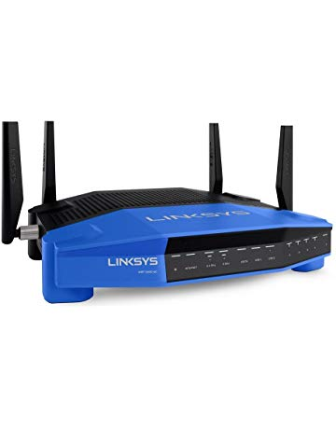](https://www.amazon.com/Linksys-AC1900-Source-Wireless-WRT1900AC/dp/B014MIBLSA?ref_=Oct_MWishedForC_300189_9&pf_rd_r=SA07QM4Q5S23C07F7VTB&pf_rd_p=6f74083a-4541-5fc3-91f1-2d621a6b118d&pf_rd_s=merchandised-search-6&pf_rd_t=101&pf_rd_i=300189&pf_rd_m=ATVPDKIKX0DER)](https://www.amazon.com/Linksys-AC1900-Source-Wireless-WRT1900AC/dp/B014MIBLSA?ref_=Oct_MWishedForC_300189_9&pf_rd_r=SA07QM4Q5S23C07F7VTB&pf_rd_p=6f74083a-4541-5fc3-91f1-2d621a6b118d&pf_rd_s=merchandised-search-6&pf_rd_t=101&pf_rd_i=300189&pf_rd_m=ATVPDKIKX0DER" \o "Linksys WRT AC1900 Open Source Dual-Band Gigabit WiFi Wireless Router (WRT1900ACS))

[price$149.99](https://www.amazon.com/Linksys-AC1900-Source-Wireless-WRT1900AC/dp/B014MIBLSA?ref_=Oct_MWishedForC_300189_9&pf_rd_r=SA07QM4Q5S23C07F7VTB&pf_rd_p=6f74083a-4541-5fc3-91f1-2d621a6b118d&pf_rd_s=merchandised-search-6&pf_rd_t=101&pf_rd_i=300189&pf_rd_m=ATVPDKIKX0DER" \o "Linksys WRT AC1900 Open Source Dual-Band Gigabit WiFi Wireless Router (WRT1900ACS))

[$249.99](https://www.amazon.com/Linksys-AC1900-Source-Wireless-WRT1900AC/dp/B014MIBLSA?ref_=Oct_MWishedForC_300189_9&pf_rd_r=SA07QM4Q5S23C07F7VTB&pf_rd_p=6f74083a-4541-5fc3-91f1-2d621a6b118d&pf_rd_s=merchandised-search-6&pf_rd_t=101&pf_rd_i=300189&pf_rd_m=ATVPDKIKX0DER" \o "Linksys WRT AC1900 Open Source Dual-Band Gigabit WiFi Wireless Router (WRT1900ACS))

[Linksys WRT AC1900 Open Source Dual-Band Gigabit WiFi Wireless Router (WRT1900ACS)](https://www.amazon.com/Linksys-AC1900-Source-Wireless-WRT1900AC/dp/B014MIBLSA?ref_=Oct_MWishedForC_300189_9&pf_rd_r=SA07QM4Q5S23C07F7VTB&pf_rd_p=6f74083a-4541-5fc3-91f1-2d621a6b118d&pf_rd_s=merchandised-search-6&pf_rd_t=101&pf_rd_i=300189&pf_rd_m=ATVPDKIKX0DER" \o "Linksys WRT AC1900 Open Source Dual-Band Gigabit WiFi Wireless Router (WRT1900ACS))

[[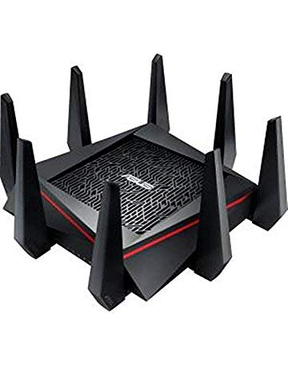](https://www.amazon.com/Tri-Band-Supporting-AiProtection-Accelerator-RT-AC5300/dp/B0167HG1V6?ref_=Oct_MWishedForC_300189_10&pf_rd_r=SA07QM4Q5S23C07F7VTB&pf_rd_p=6f74083a-4541-5fc3-91f1-2d621a6b118d&pf_rd_s=merchandised-search-6&pf_rd_t=101&pf_rd_i=300189&pf_rd_m=ATVPDKIKX0DER)](https://www.amazon.com/Tri-Band-Supporting-AiProtection-Accelerator-RT-AC5300/dp/B0167HG1V6?ref_=Oct_MWishedForC_300189_10&pf_rd_r=SA07QM4Q5S23C07F7VTB&pf_rd_p=6f74083a-4541-5fc3-91f1-2d621a6b118d&pf_rd_s=merchandised-search-6&pf_rd_t=101&pf_rd_i=300189&pf_rd_m=ATVPDKIKX0DER" \o "ASUS AC5300 Tri-Band WiFi Gaming Router(Up to 5330 Mbps) w/MU-MIMO, Supporting AiProtection Network Security by Trend Micro, AiMesh for Mesh WiFi System, Built-in WTFast Game Accelerator (RT-AC5300))

[price$297.99](https://www.amazon.com/Tri-Band-Supporting-AiProtection-Accelerator-RT-AC5300/dp/B0167HG1V6?ref_=Oct_MWishedForC_300189_10&pf_rd_r=SA07QM4Q5S23C07F7VTB&pf_rd_p=6f74083a-4541-5fc3-91f1-2d621a6b118d&pf_rd_s=merchandised-search-6&pf_rd_t=101&pf_rd_i=300189&pf_rd_m=ATVPDKIKX0DER" \o "ASUS AC5300 Tri-Band WiFi Gaming Router(Up to 5330 Mbps) w/MU-MIMO, Supporting AiProtection Network Security by Trend Micro, AiMesh for Mesh WiFi System, Built-in WTFast Game Accelerator (RT-AC5300))

[$349.99](https://www.amazon.com/Tri-Band-Supporting-AiProtection-Accelerator-RT-AC5300/dp/B0167HG1V6?ref_=Oct_MWishedForC_300189_10&pf_rd_r=SA07QM4Q5S23C07F7VTB&pf_rd_p=6f74083a-4541-5fc3-91f1-2d621a6b118d&pf_rd_s=merchandised-search-6&pf_rd_t=101&pf_rd_i=300189&pf_rd_m=ATVPDKIKX0DER" \o "ASUS AC5300 Tri-Band WiFi Gaming Router(Up to 5330 Mbps) w/MU-MIMO, Supporting AiProtection Network Security by Trend Micro, AiMesh for Mesh WiFi System, Built-in WTFast Game Accelerator (RT-AC5300))

[ASUS AC5300 Tri-Band WiFi Gaming Router(Up to 5330 Mbps) w/MU-MIMO, Supporting AiProtection Network Security by Trend Micro, AiMesh for Mesh WiFi System, Built-in WTFast Game Accelerator (RT-AC5300)](https://www.amazon.com/Tri-Band-Supporting-AiProtection-Accelerator-RT-AC5300/dp/B0167HG1V6?ref_=Oct_MWishedForC_300189_10&pf_rd_r=SA07QM4Q5S23C07F7VTB&pf_rd_p=6f74083a-4541-5fc3-91f1-2d621a6b118d&pf_rd_s=merchandised-search-6&pf_rd_t=101&pf_rd_i=300189&pf_rd_m=ATVPDKIKX0DER" \o "ASUS AC5300 Tri-Band WiFi Gaming Router(Up to 5330 Mbps) w/MU-MIMO, Supporting AiProtection Network Security by Trend Micro, AiMesh for Mesh WiFi System, Built-in WTFast Game Accelerator (RT-AC5300))

Most gifted [See more](https://www.amazon.com/gp/most-gifted/electronics/300189?ref_=Oct_MGiftedC_300189_SAll&pf_rd_r=SA07QM4Q5S23C07F7VTB&pf_rd_p=6f74083a-4541-5fc3-91f1-2d621a6b118d&pf_rd_s=merchandised-search-6&pf_rd_t=101&pf_rd_i=300189&pf_rd_m=ATVPDKIKX0DER)

[[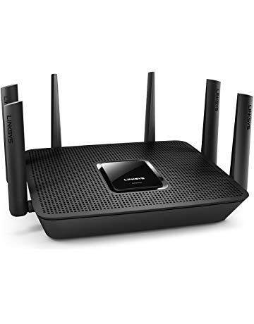](https://www.amazon.com/Linksys-Max-Stream-EA9300-802-11ac-Ethernet/dp/B071DKY952?ref_=Oct_MGiftedC_300189_0&pf_rd_r=SA07QM4Q5S23C07F7VTB&pf_rd_p=6f74083a-4541-5fc3-91f1-2d621a6b118d&pf_rd_s=merchandised-search-6&pf_rd_t=101&pf_rd_i=300189&pf_rd_m=ATVPDKIKX0DER)](https://www.amazon.com/Linksys-Max-Stream-EA9300-802-11ac-Ethernet/dp/B071DKY952?ref_=Oct_MGiftedC_300189_0&pf_rd_r=SA07QM4Q5S23C07F7VTB&pf_rd_p=6f74083a-4541-5fc3-91f1-2d621a6b118d&pf_rd_s=merchandised-search-6&pf_rd_t=101&pf_rd_i=300189&pf_rd_m=ATVPDKIKX0DER" \o "Linksys Max-Stream AC4000 MU-MIMO Tri-Band Wireless Smart WiFi Router (EA9300))

[price$187.97](https://www.amazon.com/Linksys-Max-Stream-EA9300-802-11ac-Ethernet/dp/B071DKY952?ref_=Oct_MGiftedC_300189_0&pf_rd_r=SA07QM4Q5S23C07F7VTB&pf_rd_p=6f74083a-4541-5fc3-91f1-2d621a6b118d&pf_rd_s=merchandised-search-6&pf_rd_t=101&pf_rd_i=300189&pf_rd_m=ATVPDKIKX0DER" \o "Linksys Max-Stream AC4000 MU-MIMO Tri-Band Wireless Smart WiFi Router (EA9300))

[$299.99](https://www.amazon.com/Linksys-Max-Stream-EA9300-802-11ac-Ethernet/dp/B071DKY952?ref_=Oct_MGiftedC_300189_0&pf_rd_r=SA07QM4Q5S23C07F7VTB&pf_rd_p=6f74083a-4541-5fc3-91f1-2d621a6b118d&pf_rd_s=merchandised-search-6&pf_rd_t=101&pf_rd_i=300189&pf_rd_m=ATVPDKIKX0DER" \o "Linksys Max-Stream AC4000 MU-MIMO Tri-Band Wireless Smart WiFi Router (EA9300))

[Linksys Max-Stream AC4000 MU-MIMO Tri-Band Wireless Smart WiFi Router (EA9300)](https://www.amazon.com/Linksys-Max-Stream-EA9300-802-11ac-Ethernet/dp/B071DKY952?ref_=Oct_MGiftedC_300189_0&pf_rd_r=SA07QM4Q5S23C07F7VTB&pf_rd_p=6f74083a-4541-5fc3-91f1-2d621a6b118d&pf_rd_s=merchandised-search-6&pf_rd_t=101&pf_rd_i=300189&pf_rd_m=ATVPDKIKX0DER" \o "Linksys Max-Stream AC4000 MU-MIMO Tri-Band Wireless Smart WiFi Router (EA9300))

[[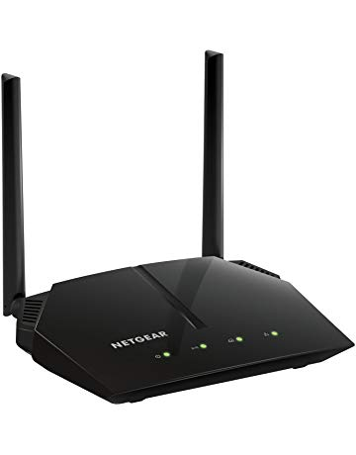](https://www.amazon.com/NETGEAR-AC1000-Router-Ethernet-R6080/dp/B071J24FNY?ref_=Oct_MGiftedC_300189_1&pf_rd_r=SA07QM4Q5S23C07F7VTB&pf_rd_p=6f74083a-4541-5fc3-91f1-2d621a6b118d&pf_rd_s=merchandised-search-6&pf_rd_t=101&pf_rd_i=300189&pf_rd_m=ATVPDKIKX0DER)](https://www.amazon.com/NETGEAR-AC1000-Router-Ethernet-R6080/dp/B071J24FNY?ref_=Oct_MGiftedC_300189_1&pf_rd_r=SA07QM4Q5S23C07F7VTB&pf_rd_p=6f74083a-4541-5fc3-91f1-2d621a6b118d&pf_rd_s=merchandised-search-6&pf_rd_t=101&pf_rd_i=300189&pf_rd_m=ATVPDKIKX0DER" \o "NETGEAR AC1000 Dual Band Smart WiFi Router, Fast Ethernet (R6080))

[price$50.80](https://www.amazon.com/NETGEAR-AC1000-Router-Ethernet-R6080/dp/B071J24FNY?ref_=Oct_MGiftedC_300189_1&pf_rd_r=SA07QM4Q5S23C07F7VTB&pf_rd_p=6f74083a-4541-5fc3-91f1-2d621a6b118d&pf_rd_s=merchandised-search-6&pf_rd_t=101&pf_rd_i=300189&pf_rd_m=ATVPDKIKX0DER" \o "NETGEAR AC1000 Dual Band Smart WiFi Router, Fast Ethernet (R6080))

[$54.99](https://www.amazon.com/NETGEAR-AC1000-Router-Ethernet-R6080/dp/B071J24FNY?ref_=Oct_MGiftedC_300189_1&pf_rd_r=SA07QM4Q5S23C07F7VTB&pf_rd_p=6f74083a-4541-5fc3-91f1-2d621a6b118d&pf_rd_s=merchandised-search-6&pf_rd_t=101&pf_rd_i=300189&pf_rd_m=ATVPDKIKX0DER" \o "NETGEAR AC1000 Dual Band Smart WiFi Router, Fast Ethernet (R6080))

[NETGEAR AC1000 Dual Band Smart WiFi Router, Fast Ethernet (R6080)](https://www.amazon.com/NETGEAR-AC1000-Router-Ethernet-R6080/dp/B071J24FNY?ref_=Oct_MGiftedC_300189_1&pf_rd_r=SA07QM4Q5S23C07F7VTB&pf_rd_p=6f74083a-4541-5fc3-91f1-2d621a6b118d&pf_rd_s=merchandised-search-6&pf_rd_t=101&pf_rd_i=300189&pf_rd_m=ATVPDKIKX0DER" \o "NETGEAR AC1000 Dual Band Smart WiFi Router, Fast Ethernet (R6080))

[[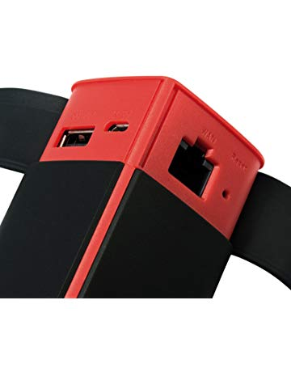](https://www.amazon.com/HooToo-Wireless-10400mAh-External-Performance/dp/B074LHG47K?ref_=Oct_MGiftedC_300189_2&pf_rd_r=SA07QM4Q5S23C07F7VTB&pf_rd_p=6f74083a-4541-5fc3-91f1-2d621a6b118d&pf_rd_s=merchandised-search-6&pf_rd_t=101&pf_rd_i=300189&pf_rd_m=ATVPDKIKX0DER)](https://www.amazon.com/HooToo-Wireless-10400mAh-External-Performance/dp/B074LHG47K?ref_=Oct_MGiftedC_300189_2&pf_rd_r=SA07QM4Q5S23C07F7VTB&pf_rd_p=6f74083a-4541-5fc3-91f1-2d621a6b118d&pf_rd_s=merchandised-search-6&pf_rd_t=101&pf_rd_i=300189&pf_rd_m=ATVPDKIKX0DER" \o "HooToo Wireless Travel Router, FileHub, 10400mAh External Battery, USB Port, High Performance Travel Charger - TripMate Titan 300Mbps (Not a Hotspot))

[price$42.99](https://www.amazon.com/HooToo-Wireless-10400mAh-External-Performance/dp/B074LHG47K?ref_=Oct_MGiftedC_300189_2&pf_rd_r=SA07QM4Q5S23C07F7VTB&pf_rd_p=6f74083a-4541-5fc3-91f1-2d621a6b118d&pf_rd_s=merchandised-search-6&pf_rd_t=101&pf_rd_i=300189&pf_rd_m=ATVPDKIKX0DER" \o "HooToo Wireless Travel Router, FileHub, 10400mAh External Battery, USB Port, High Performance Travel Charger - TripMate Titan 300Mbps (Not a Hotspot))

[HooToo Wireless Travel Router, FileHub, 10400mAh External Battery, USB Port, High Performance Travel Charger - TripMate Titan 300Mbps (Not a Hotspot)](https://www.amazon.com/HooToo-Wireless-10400mAh-External-Performance/dp/B074LHG47K?ref_=Oct_MGiftedC_300189_2&pf_rd_r=SA07QM4Q5S23C07F7VTB&pf_rd_p=6f74083a-4541-5fc3-91f1-2d621a6b118d&pf_rd_s=merchandised-search-6&pf_rd_t=101&pf_rd_i=300189&pf_rd_m=ATVPDKIKX0DER" \o "HooToo Wireless Travel Router, FileHub, 10400mAh External Battery, USB Port, High Performance Travel Charger - TripMate Titan 300Mbps (Not a Hotspot))

[[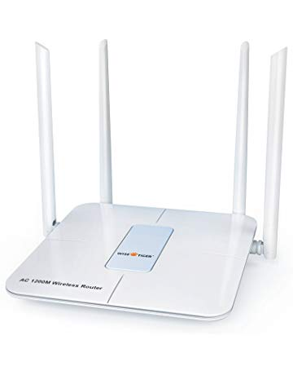](https://www.amazon.com/WISE-TIGER-Wireless-1200mbps-Restaurant/dp/B07CWVR1KH?ref_=Oct_MGiftedC_300189_3&pf_rd_r=SA07QM4Q5S23C07F7VTB&pf_rd_p=6f74083a-4541-5fc3-91f1-2d621a6b118d&pf_rd_s=merchandised-search-6&pf_rd_t=101&pf_rd_i=300189&pf_rd_m=ATVPDKIKX0DER)](https://www.amazon.com/WISE-TIGER-Wireless-1200mbps-Restaurant/dp/B07CWVR1KH?ref_=Oct_MGiftedC_300189_3&pf_rd_r=SA07QM4Q5S23C07F7VTB&pf_rd_p=6f74083a-4541-5fc3-91f1-2d621a6b118d&pf_rd_s=merchandised-search-6&pf_rd_t=101&pf_rd_i=300189&pf_rd_m=ATVPDKIKX0DER" \o "WISE TIGER Wireless Router 1200mbps Long Range Wifi Router Ac High Speed Dual Band Router with 4 Lan Ports for Home Office internet Restaurant Amazon Alexa with Wifi Extender for 2.4ghz)

[price$36.64](https://www.amazon.com/WISE-TIGER-Wireless-1200mbps-Restaurant/dp/B07CWVR1KH?ref_=Oct_MGiftedC_300189_3&pf_rd_r=SA07QM4Q5S23C07F7VTB&pf_rd_p=6f74083a-4541-5fc3-91f1-2d621a6b118d&pf_rd_s=merchandised-search-6&pf_rd_t=101&pf_rd_i=300189&pf_rd_m=ATVPDKIKX0DER" \o "WISE TIGER Wireless Router 1200mbps Long Range Wifi Router Ac High Speed Dual Band Router with 4 Lan Ports for Home Office internet Restaurant Amazon Alexa with Wifi Extender for 2.4ghz)

[$49.99](https://www.amazon.com/WISE-TIGER-Wireless-1200mbps-Restaurant/dp/B07CWVR1KH?ref_=Oct_MGiftedC_300189_3&pf_rd_r=SA07QM4Q5S23C07F7VTB&pf_rd_p=6f74083a-4541-5fc3-91f1-2d621a6b118d&pf_rd_s=merchandised-search-6&pf_rd_t=101&pf_rd_i=300189&pf_rd_m=ATVPDKIKX0DER" \o "WISE TIGER Wireless Router 1200mbps Long Range Wifi Router Ac High Speed Dual Band Router with 4 Lan Ports for Home Office internet Restaurant Amazon Alexa with Wifi Extender for 2.4ghz)

[WISE TIGER Wireless Router 1200mbps Long Range Wifi Router Ac High Speed Dual Band Router with 4 Lan Ports for Home Office internet Restaurant Amazon Alexa with Wifi Extender for 2.4ghz](https://www.amazon.com/WISE-TIGER-Wireless-1200mbps-Restaurant/dp/B07CWVR1KH?ref_=Oct_MGiftedC_300189_3&pf_rd_r=SA07QM4Q5S23C07F7VTB&pf_rd_p=6f74083a-4541-5fc3-91f1-2d621a6b118d&pf_rd_s=merchandised-search-6&pf_rd_t=101&pf_rd_i=300189&pf_rd_m=ATVPDKIKX0DER" \o "WISE TIGER Wireless Router 1200mbps Long Range Wifi Router Ac High Speed Dual Band Router with 4 Lan Ports for Home Office internet Restaurant Amazon Alexa with Wifi Extender for 2.4ghz)

[[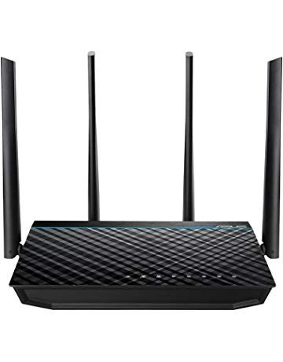](https://www.amazon.com/ASUS-Wireless-AC1700-Gigabit-Router-RT-ACRH17/dp/B07628HLTM?ref_=Oct_MGiftedC_300189_4&pf_rd_r=SA07QM4Q5S23C07F7VTB&pf_rd_p=6f74083a-4541-5fc3-91f1-2d621a6b118d&pf_rd_s=merchandised-search-6&pf_rd_t=101&pf_rd_i=300189&pf_rd_m=ATVPDKIKX0DER)](https://www.amazon.com/ASUS-Wireless-AC1700-Gigabit-Router-RT-ACRH17/dp/B07628HLTM?ref_=Oct_MGiftedC_300189_4&pf_rd_r=SA07QM4Q5S23C07F7VTB&pf_rd_p=6f74083a-4541-5fc3-91f1-2d621a6b118d&pf_rd_s=merchandised-search-6&pf_rd_t=101&pf_rd_i=300189&pf_rd_m=ATVPDKIKX0DER" \o "ASUS Wireless-AC1700 Dual Band Gigabit Router (Up to 1700 Mbps) with USB 3.0 (RT-ACRH17))

[price$89.99](https://www.amazon.com/ASUS-Wireless-AC1700-Gigabit-Router-RT-ACRH17/dp/B07628HLTM?ref_=Oct_MGiftedC_300189_4&pf_rd_r=SA07QM4Q5S23C07F7VTB&pf_rd_p=6f74083a-4541-5fc3-91f1-2d621a6b118d&pf_rd_s=merchandised-search-6&pf_rd_t=101&pf_rd_i=300189&pf_rd_m=ATVPDKIKX0DER" \o "ASUS Wireless-AC1700 Dual Band Gigabit Router (Up to 1700 Mbps) with USB 3.0 (RT-ACRH17))

[ASUS Wireless-AC1700 Dual Band Gigabit Router (Up to 1700 Mbps) with USB 3.0 (RT-ACRH17)](https://www.amazon.com/ASUS-Wireless-AC1700-Gigabit-Router-RT-ACRH17/dp/B07628HLTM?ref_=Oct_MGiftedC_300189_4&pf_rd_r=SA07QM4Q5S23C07F7VTB&pf_rd_p=6f74083a-4541-5fc3-91f1-2d621a6b118d&pf_rd_s=merchandised-search-6&pf_rd_t=101&pf_rd_i=300189&pf_rd_m=ATVPDKIKX0DER" \o "ASUS Wireless-AC1700 Dual Band Gigabit Router (Up to 1700 Mbps) with USB 3.0 (RT-ACRH17))

[[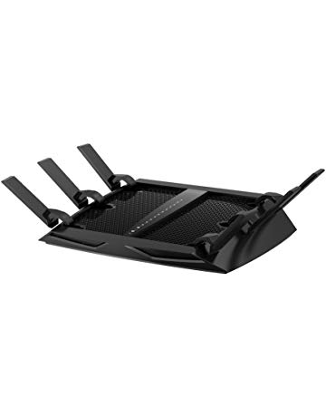](https://www.amazon.com/Certified-Refurbished-R8000-100NAR-Nighthawk-Tri-Band/dp/B01I99720O?ref_=Oct_MGiftedC_300189_5&pf_rd_r=SA07QM4Q5S23C07F7VTB&pf_rd_p=6f74083a-4541-5fc3-91f1-2d621a6b118d&pf_rd_s=merchandised-search-6&pf_rd_t=101&pf_rd_i=300189&pf_rd_m=ATVPDKIKX0DER)](https://www.amazon.com/Certified-Refurbished-R8000-100NAR-Nighthawk-Tri-Band/dp/B01I99720O?ref_=Oct_MGiftedC_300189_5&pf_rd_r=SA07QM4Q5S23C07F7VTB&pf_rd_p=6f74083a-4541-5fc3-91f1-2d621a6b118d&pf_rd_s=merchandised-search-6&pf_rd_t=101&pf_rd_i=300189&pf_rd_m=ATVPDKIKX0DER" \o "Netgear Certified Refurbished R8000-100NAR Nighthawk X6 AC3200 Tri-Band Gigabit Wi-Fi Router)

[price$169.99](https://www.amazon.com/Certified-Refurbished-R8000-100NAR-Nighthawk-Tri-Band/dp/B01I99720O?ref_=Oct_MGiftedC_300189_5&pf_rd_r=SA07QM4Q5S23C07F7VTB&pf_rd_p=6f74083a-4541-5fc3-91f1-2d621a6b118d&pf_rd_s=merchandised-search-6&pf_rd_t=101&pf_rd_i=300189&pf_rd_m=ATVPDKIKX0DER" \o "Netgear Certified Refurbished R8000-100NAR Nighthawk X6 AC3200 Tri-Band Gigabit Wi-Fi Router)

[$179.99](https://www.amazon.com/Certified-Refurbished-R8000-100NAR-Nighthawk-Tri-Band/dp/B01I99720O?ref_=Oct_MGiftedC_300189_5&pf_rd_r=SA07QM4Q5S23C07F7VTB&pf_rd_p=6f74083a-4541-5fc3-91f1-2d621a6b118d&pf_rd_s=merchandised-search-6&pf_rd_t=101&pf_rd_i=300189&pf_rd_m=ATVPDKIKX0DER" \o "Netgear Certified Refurbished R8000-100NAR Nighthawk X6 AC3200 Tri-Band Gigabit Wi-Fi Router)

[Netgear Certified Refurbished R8000-100NAR Nighthawk X6 AC3200 Tri-Band Gigabit Wi-Fi Router](https://www.amazon.com/Certified-Refurbished-R8000-100NAR-Nighthawk-Tri-Band/dp/B01I99720O?ref_=Oct_MGiftedC_300189_5&pf_rd_r=SA07QM4Q5S23C07F7VTB&pf_rd_p=6f74083a-4541-5fc3-91f1-2d621a6b118d&pf_rd_s=merchandised-search-6&pf_rd_t=101&pf_rd_i=300189&pf_rd_m=ATVPDKIKX0DER" \o "Netgear Certified Refurbished R8000-100NAR Nighthawk X6 AC3200 Tri-Band Gigabit Wi-Fi Router)

[[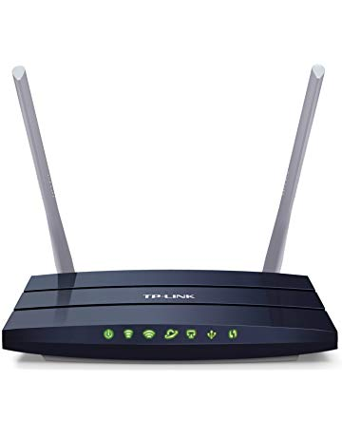](https://www.amazon.com/TP-Link-AC1200-Dual-Band-Router/dp/B0168G0KZY?ref_=Oct_MGiftedC_300189_6&pf_rd_r=SA07QM4Q5S23C07F7VTB&pf_rd_p=6f74083a-4541-5fc3-91f1-2d621a6b118d&pf_rd_s=merchandised-search-6&pf_rd_t=101&pf_rd_i=300189&pf_rd_m=ATVPDKIKX0DER)](https://www.amazon.com/TP-Link-AC1200-Dual-Band-Router/dp/B0168G0KZY?ref_=Oct_MGiftedC_300189_6&pf_rd_r=SA07QM4Q5S23C07F7VTB&pf_rd_p=6f74083a-4541-5fc3-91f1-2d621a6b118d&pf_rd_s=merchandised-search-6&pf_rd_t=101&pf_rd_i=300189&pf_rd_m=ATVPDKIKX0DER" \o "TP-Link AC1200 Dual Band Router - Wireless AC Router for Home(Archer C50))

[price$39.98](https://www.amazon.com/TP-Link-AC1200-Dual-Band-Router/dp/B0168G0KZY?ref_=Oct_MGiftedC_300189_6&pf_rd_r=SA07QM4Q5S23C07F7VTB&pf_rd_p=6f74083a-4541-5fc3-91f1-2d621a6b118d&pf_rd_s=merchandised-search-6&pf_rd_t=101&pf_rd_i=300189&pf_rd_m=ATVPDKIKX0DER" \o "TP-Link AC1200 Dual Band Router - Wireless AC Router for Home(Archer C50))

[$59.99](https://www.amazon.com/TP-Link-AC1200-Dual-Band-Router/dp/B0168G0KZY?ref_=Oct_MGiftedC_300189_6&pf_rd_r=SA07QM4Q5S23C07F7VTB&pf_rd_p=6f74083a-4541-5fc3-91f1-2d621a6b118d&pf_rd_s=merchandised-search-6&pf_rd_t=101&pf_rd_i=300189&pf_rd_m=ATVPDKIKX0DER" \o "TP-Link AC1200 Dual Band Router - Wireless AC Router for Home(Archer C50))

[TP-Link AC1200 Dual Band Router - Wireless AC Router for Home(Archer C50)](https://www.amazon.com/TP-Link-AC1200-Dual-Band-Router/dp/B0168G0KZY?ref_=Oct_MGiftedC_300189_6&pf_rd_r=SA07QM4Q5S23C07F7VTB&pf_rd_p=6f74083a-4541-5fc3-91f1-2d621a6b118d&pf_rd_s=merchandised-search-6&pf_rd_t=101&pf_rd_i=300189&pf_rd_m=ATVPDKIKX0DER" \o "TP-Link AC1200 Dual Band Router - Wireless AC Router for Home(Archer C50))

[[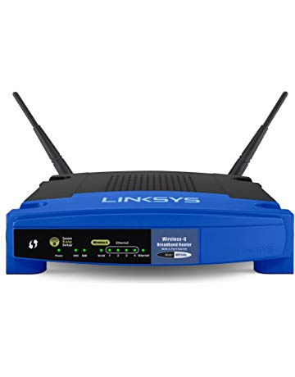](https://www.amazon.com/Linksys-WRT54GL-Wireless-G-Broadband-Router/dp/B000BTL0OA?ref_=Oct_MGiftedC_300189_7&pf_rd_r=SA07QM4Q5S23C07F7VTB&pf_rd_p=6f74083a-4541-5fc3-91f1-2d621a6b118d&pf_rd_s=merchandised-search-6&pf_rd_t=101&pf_rd_i=300189&pf_rd_m=ATVPDKIKX0DER)](https://www.amazon.com/Linksys-WRT54GL-Wireless-G-Broadband-Router/dp/B000BTL0OA?ref_=Oct_MGiftedC_300189_7&pf_rd_r=SA07QM4Q5S23C07F7VTB&pf_rd_p=6f74083a-4541-5fc3-91f1-2d621a6b118d&pf_rd_s=merchandised-search-6&pf_rd_t=101&pf_rd_i=300189&pf_rd_m=ATVPDKIKX0DER" \o "Linksys WRT54GL Wi-Fi Wireless-G Broadband Router)

[price$29.99](https://www.amazon.com/Linksys-WRT54GL-Wireless-G-Broadband-Router/dp/B000BTL0OA?ref_=Oct_MGiftedC_300189_7&pf_rd_r=SA07QM4Q5S23C07F7VTB&pf_rd_p=6f74083a-4541-5fc3-91f1-2d621a6b118d&pf_rd_s=merchandised-search-6&pf_rd_t=101&pf_rd_i=300189&pf_rd_m=ATVPDKIKX0DER" \o "Linksys WRT54GL Wi-Fi Wireless-G Broadband Router)

[$79.99](https://www.amazon.com/Linksys-WRT54GL-Wireless-G-Broadband-Router/dp/B000BTL0OA?ref_=Oct_MGiftedC_300189_7&pf_rd_r=SA07QM4Q5S23C07F7VTB&pf_rd_p=6f74083a-4541-5fc3-91f1-2d621a6b118d&pf_rd_s=merchandised-search-6&pf_rd_t=101&pf_rd_i=300189&pf_rd_m=ATVPDKIKX0DER" \o "Linksys WRT54GL Wi-Fi Wireless-G Broadband Router)

[Linksys WRT54GL Wi-Fi Wireless-G Broadband Router](https://www.amazon.com/Linksys-WRT54GL-Wireless-G-Broadband-Router/dp/B000BTL0OA?ref_=Oct_MGiftedC_300189_7&pf_rd_r=SA07QM4Q5S23C07F7VTB&pf_rd_p=6f74083a-4541-5fc3-91f1-2d621a6b118d&pf_rd_s=merchandised-search-6&pf_rd_t=101&pf_rd_i=300189&pf_rd_m=ATVPDKIKX0DER" \o "Linksys WRT54GL Wi-Fi Wireless-G Broadband Router)

[[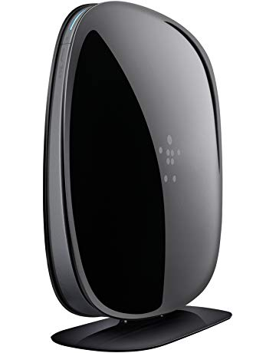](https://www.amazon.com/Belkin-Dual-Band-AC-Gigabit-F9K1124/dp/B01IRRFH3C?ref_=Oct_MGiftedC_300189_8&pf_rd_r=SA07QM4Q5S23C07F7VTB&pf_rd_p=6f74083a-4541-5fc3-91f1-2d621a6b118d&pf_rd_s=merchandised-search-6&pf_rd_t=101&pf_rd_i=300189&pf_rd_m=ATVPDKIKX0DER)](https://www.amazon.com/Belkin-Dual-Band-AC-Gigabit-F9K1124/dp/B01IRRFH3C?ref_=Oct_MGiftedC_300189_8&pf_rd_r=SA07QM4Q5S23C07F7VTB&pf_rd_p=6f74083a-4541-5fc3-91f1-2d621a6b118d&pf_rd_s=merchandised-search-6&pf_rd_t=101&pf_rd_i=300189&pf_rd_m=ATVPDKIKX0DER" \o "Belkin AC1900 Wi-Fi Dual-Band AC+ Gigabit Router (F9K1124))

[price$34.00](https://www.amazon.com/Belkin-Dual-Band-AC-Gigabit-F9K1124/dp/B01IRRFH3C?ref_=Oct_MGiftedC_300189_8&pf_rd_r=SA07QM4Q5S23C07F7VTB&pf_rd_p=6f74083a-4541-5fc3-91f1-2d621a6b118d&pf_rd_s=merchandised-search-6&pf_rd_t=101&pf_rd_i=300189&pf_rd_m=ATVPDKIKX0DER" \o "Belkin AC1900 Wi-Fi Dual-Band AC+ Gigabit Router (F9K1124))

[Belkin AC1900 Wi-Fi Dual-Band AC+ Gigabit Router (F9K1124)](https://www.amazon.com/Belkin-Dual-Band-AC-Gigabit-F9K1124/dp/B01IRRFH3C?ref_=Oct_MGiftedC_300189_8&pf_rd_r=SA07QM4Q5S23C07F7VTB&pf_rd_p=6f74083a-4541-5fc3-91f1-2d621a6b118d&pf_rd_s=merchandised-search-6&pf_rd_t=101&pf_rd_i=300189&pf_rd_m=ATVPDKIKX0DER" \o "Belkin AC1900 Wi-Fi Dual-Band AC+ Gigabit Router (F9K1124))

[[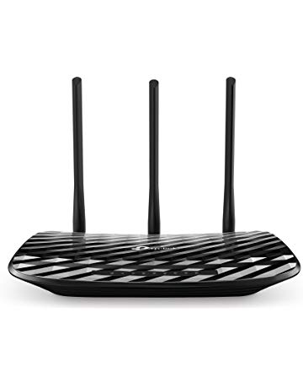](https://www.amazon.com/TP-Link-AC900-Gigabit-Router-Reliable/dp/B074MGY628?ref_=Oct_MGiftedC_300189_9&pf_rd_r=SA07QM4Q5S23C07F7VTB&pf_rd_p=6f74083a-4541-5fc3-91f1-2d621a6b118d&pf_rd_s=merchandised-search-6&pf_rd_t=101&pf_rd_i=300189&pf_rd_m=ATVPDKIKX0DER)](https://www.amazon.com/TP-Link-AC900-Gigabit-Router-Reliable/dp/B074MGY628?ref_=Oct_MGiftedC_300189_9&pf_rd_r=SA07QM4Q5S23C07F7VTB&pf_rd_p=6f74083a-4541-5fc3-91f1-2d621a6b118d&pf_rd_s=merchandised-search-6&pf_rd_t=101&pf_rd_i=300189&pf_rd_m=ATVPDKIKX0DER" \o "TP-Link AC900 Gigabit Router - Reliable AC Router, 802.11ac Internet Router(Archer C900))

[price$32.99](https://www.amazon.com/TP-Link-AC900-Gigabit-Router-Reliable/dp/B074MGY628?ref_=Oct_MGiftedC_300189_9&pf_rd_r=SA07QM4Q5S23C07F7VTB&pf_rd_p=6f74083a-4541-5fc3-91f1-2d621a6b118d&pf_rd_s=merchandised-search-6&pf_rd_t=101&pf_rd_i=300189&pf_rd_m=ATVPDKIKX0DER" \o "TP-Link AC900 Gigabit Router - Reliable AC Router, 802.11ac Internet Router(Archer C900))

[$34.99](https://www.amazon.com/TP-Link-AC900-Gigabit-Router-Reliable/dp/B074MGY628?ref_=Oct_MGiftedC_300189_9&pf_rd_r=SA07QM4Q5S23C07F7VTB&pf_rd_p=6f74083a-4541-5fc3-91f1-2d621a6b118d&pf_rd_s=merchandised-search-6&pf_rd_t=101&pf_rd_i=300189&pf_rd_m=ATVPDKIKX0DER" \o "TP-Link AC900 Gigabit Router - Reliable AC Router, 802.11ac Internet Router(Archer C900))

[TP-Link AC900 Gigabit Router - Reliable AC Router, 802.11ac Internet Router(Archer C900)](https://www.amazon.com/TP-Link-AC900-Gigabit-Router-Reliable/dp/B074MGY628?ref_=Oct_MGiftedC_300189_9&pf_rd_r=SA07QM4Q5S23C07F7VTB&pf_rd_p=6f74083a-4541-5fc3-91f1-2d621a6b118d&pf_rd_s=merchandised-search-6&pf_rd_t=101&pf_rd_i=300189&pf_rd_m=ATVPDKIKX0DER" \o "TP-Link AC900 Gigabit Router - Reliable AC Router, 802.11ac Internet Router(Archer C900))

[[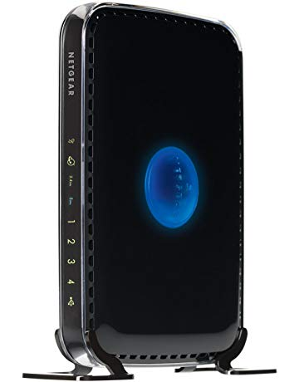](https://www.amazon.com/NETGEAR-N600-Wi-Fi-Router-WNDR3400/dp/B0041LYY6K?ref_=Oct_MGiftedC_300189_10&pf_rd_r=SA07QM4Q5S23C07F7VTB&pf_rd_p=6f74083a-4541-5fc3-91f1-2d621a6b118d&pf_rd_s=merchandised-search-6&pf_rd_t=101&pf_rd_i=300189&pf_rd_m=ATVPDKIKX0DER)](https://www.amazon.com/NETGEAR-N600-Wi-Fi-Router-WNDR3400/dp/B0041LYY6K?ref_=Oct_MGiftedC_300189_10&pf_rd_r=SA07QM4Q5S23C07F7VTB&pf_rd_p=6f74083a-4541-5fc3-91f1-2d621a6b118d&pf_rd_s=merchandised-search-6&pf_rd_t=101&pf_rd_i=300189&pf_rd_m=ATVPDKIKX0DER" \o "NETGEAR N600 Dual Band Wi-Fi Router (WNDR3400))

[price$42.99](https://www.amazon.com/NETGEAR-N600-Wi-Fi-Router-WNDR3400/dp/B0041LYY6K?ref_=Oct_MGiftedC_300189_10&pf_rd_r=SA07QM4Q5S23C07F7VTB&pf_rd_p=6f74083a-4541-5fc3-91f1-2d621a6b118d&pf_rd_s=merchandised-search-6&pf_rd_t=101&pf_rd_i=300189&pf_rd_m=ATVPDKIKX0DER" \o "NETGEAR N600 Dual Band Wi-Fi Router (WNDR3400))

[NETGEAR N600 Dual Band Wi-Fi Router (WNDR3400)](https://www.amazon.com/NETGEAR-N600-Wi-Fi-Router-WNDR3400/dp/B0041LYY6K?ref_=Oct_MGiftedC_300189_10&pf_rd_r=SA07QM4Q5S23C07F7VTB&pf_rd_p=6f74083a-4541-5fc3-91f1-2d621a6b118d&pf_rd_s=merchandised-search-6&pf_rd_t=101&pf_rd_i=300189&pf_rd_m=ATVPDKIKX0DER" \o "NETGEAR N600 Dual Band Wi-Fi Router (WNDR3400))

[[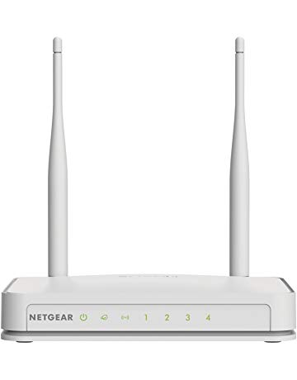](https://www.amazon.com/NETGEAR-Router-External-Antennas-WNR2020v2/dp/B00MRVJYEI?ref_=Oct_MGiftedC_300189_11&pf_rd_r=SA07QM4Q5S23C07F7VTB&pf_rd_p=6f74083a-4541-5fc3-91f1-2d621a6b118d&pf_rd_s=merchandised-search-6&pf_rd_t=101&pf_rd_i=300189&pf_rd_m=ATVPDKIKX0DER)](https://www.amazon.com/NETGEAR-Router-External-Antennas-WNR2020v2/dp/B00MRVJYEI?ref_=Oct_MGiftedC_300189_11&pf_rd_r=SA07QM4Q5S23C07F7VTB&pf_rd_p=6f74083a-4541-5fc3-91f1-2d621a6b118d&pf_rd_s=merchandised-search-6&pf_rd_t=101&pf_rd_i=300189&pf_rd_m=ATVPDKIKX0DER" \o "NETGEAR N300 Wi-Fi Router with High Power 5dBi External Antennas (WNR2020v2))

[price$24.54](https://www.amazon.com/NETGEAR-Router-External-Antennas-WNR2020v2/dp/B00MRVJYEI?ref_=Oct_MGiftedC_300189_11&pf_rd_r=SA07QM4Q5S23C07F7VTB&pf_rd_p=6f74083a-4541-5fc3-91f1-2d621a6b118d&pf_rd_s=merchandised-search-6&pf_rd_t=101&pf_rd_i=300189&pf_rd_m=ATVPDKIKX0DER" \o "NETGEAR N300 Wi-Fi Router with High Power 5dBi External Antennas (WNR2020v2))

[$29.99](https://www.amazon.com/NETGEAR-Router-External-Antennas-WNR2020v2/dp/B00MRVJYEI?ref_=Oct_MGiftedC_300189_11&pf_rd_r=SA07QM4Q5S23C07F7VTB&pf_rd_p=6f74083a-4541-5fc3-91f1-2d621a6b118d&pf_rd_s=merchandised-search-6&pf_rd_t=101&pf_rd_i=300189&pf_rd_m=ATVPDKIKX0DER" \o "NETGEAR N300 Wi-Fi Router with High Power 5dBi External Antennas (WNR2020v2))

[NETGEAR N300 Wi-Fi Router with High Power 5dBi External Antennas (WNR2020v2)](https://www.amazon.com/NETGEAR-Router-External-Antennas-WNR2020v2/dp/B00MRVJYEI?ref_=Oct_MGiftedC_300189_11&pf_rd_r=SA07QM4Q5S23C07F7VTB&pf_rd_p=6f74083a-4541-5fc3-91f1-2d621a6b118d&pf_rd_s=merchandised-search-6&pf_rd_t=101&pf_rd_i=300189&pf_rd_m=ATVPDKIKX0DER" \o "NETGEAR N300 Wi-Fi Router with High Power 5dBi External Antennas (WNR2020v2))

Hot new releases [See more](https://www.amazon.com/gp/new-releases/electronics/300189?ref_=Oct_NReleaseC_300189_SAll&pf_rd_r=SA07QM4Q5S23C07F7VTB&pf_rd_p=6f74083a-4541-5fc3-91f1-2d621a6b118d&pf_rd_s=merchandised-search-6&pf_rd_t=101&pf_rd_i=300189&pf_rd_m=ATVPDKIKX0DER)

[[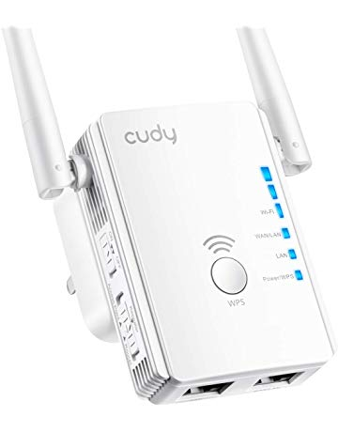](https://www.amazon.com/Cudy-Extender-750Mbps-Booster-RE750/dp/B07FR55QGV?ref_=Oct_NReleaseC_300189_0&pf_rd_r=SA07QM4Q5S23C07F7VTB&pf_rd_p=6f74083a-4541-5fc3-91f1-2d621a6b118d&pf_rd_s=merchandised-search-6&pf_rd_t=101&pf_rd_i=300189&pf_rd_m=ATVPDKIKX0DER)](https://www.amazon.com/Cudy-Extender-750Mbps-Booster-RE750/dp/B07FR55QGV?ref_=Oct_NReleaseC_300189_0&pf_rd_r=SA07QM4Q5S23C07F7VTB&pf_rd_p=6f74083a-4541-5fc3-91f1-2d621a6b118d&pf_rd_s=merchandised-search-6&pf_rd_t=101&pf_rd_i=300189&pf_rd_m=ATVPDKIKX0DER" \o "Cudy AC750 Dual Band WiFi Range Extender, 750Mbps WiFi Booster, Access Point Mode, 2 LAN Ports, WPS, Extends 2.4G and 5G WiFi Range to Smart Home & Alexa Devices (RE750))

[price$29.99](https://www.amazon.com/Cudy-Extender-750Mbps-Booster-RE750/dp/B07FR55QGV?ref_=Oct_NReleaseC_300189_0&pf_rd_r=SA07QM4Q5S23C07F7VTB&pf_rd_p=6f74083a-4541-5fc3-91f1-2d621a6b118d&pf_rd_s=merchandised-search-6&pf_rd_t=101&pf_rd_i=300189&pf_rd_m=ATVPDKIKX0DER" \o "Cudy AC750 Dual Band WiFi Range Extender, 750Mbps WiFi Booster, Access Point Mode, 2 LAN Ports, WPS, Extends 2.4G and 5G WiFi Range to Smart Home & Alexa Devices (RE750))

[Cudy AC750 Dual Band WiFi Range Extender, 750Mbps WiFi Booster, Access Point Mode, 2 LAN Ports, WPS, Extends 2.4G and 5G WiFi Range to Smart Home & Alexa Devices (RE750)](https://www.amazon.com/Cudy-Extender-750Mbps-Booster-RE750/dp/B07FR55QGV?ref_=Oct_NReleaseC_300189_0&pf_rd_r=SA07QM4Q5S23C07F7VTB&pf_rd_p=6f74083a-4541-5fc3-91f1-2d621a6b118d&pf_rd_s=merchandised-search-6&pf_rd_t=101&pf_rd_i=300189&pf_rd_m=ATVPDKIKX0DER" \o "Cudy AC750 Dual Band WiFi Range Extender, 750Mbps WiFi Booster, Access Point Mode, 2 LAN Ports, WPS, Extends 2.4G and 5G WiFi Range to Smart Home & Alexa Devices (RE750))

[[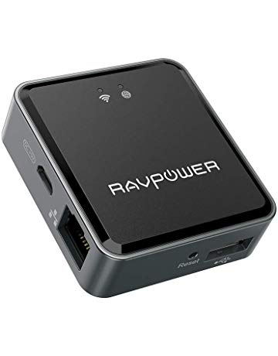](https://www.amazon.com/RAVPower-Filehub-Wireless-Transfer-Streamer/dp/B07K6MPMRZ?ref_=Oct_NReleaseC_300189_1&pf_rd_r=SA07QM4Q5S23C07F7VTB&pf_rd_p=6f74083a-4541-5fc3-91f1-2d621a6b118d&pf_rd_s=merchandised-search-6&pf_rd_t=101&pf_rd_i=300189&pf_rd_m=ATVPDKIKX0DER)](https://www.amazon.com/RAVPower-Filehub-Wireless-Transfer-Streamer/dp/B07K6MPMRZ?ref_=Oct_NReleaseC_300189_1&pf_rd_r=SA07QM4Q5S23C07F7VTB&pf_rd_p=6f74083a-4541-5fc3-91f1-2d621a6b118d&pf_rd_s=merchandised-search-6&pf_rd_t=101&pf_rd_i=300189&pf_rd_m=ATVPDKIKX0DER" \o "RAVPower Filehub, Wireless Travel Router N300, USB HDD Data Transfer Unit, DLNA NAS Sharing Media Streamer - TripMate Nano Update Version (Not a Hotspot))

[price$23.99](https://www.amazon.com/RAVPower-Filehub-Wireless-Transfer-Streamer/dp/B07K6MPMRZ?ref_=Oct_NReleaseC_300189_1&pf_rd_r=SA07QM4Q5S23C07F7VTB&pf_rd_p=6f74083a-4541-5fc3-91f1-2d621a6b118d&pf_rd_s=merchandised-search-6&pf_rd_t=101&pf_rd_i=300189&pf_rd_m=ATVPDKIKX0DER" \o "RAVPower Filehub, Wireless Travel Router N300, USB HDD Data Transfer Unit, DLNA NAS Sharing Media Streamer - TripMate Nano Update Version (Not a Hotspot))

[RAVPower Filehub, Wireless Travel Router N300, USB HDD Data Transfer Unit, DLNA NAS Sharing Media Streamer - TripMate Nano Update Version (Not a Hotspot)](https://www.amazon.com/RAVPower-Filehub-Wireless-Transfer-Streamer/dp/B07K6MPMRZ?ref_=Oct_NReleaseC_300189_1&pf_rd_r=SA07QM4Q5S23C07F7VTB&pf_rd_p=6f74083a-4541-5fc3-91f1-2d621a6b118d&pf_rd_s=merchandised-search-6&pf_rd_t=101&pf_rd_i=300189&pf_rd_m=ATVPDKIKX0DER" \o "RAVPower Filehub, Wireless Travel Router N300, USB HDD Data Transfer Unit, DLNA NAS Sharing Media Streamer - TripMate Nano Update Version (Not a Hotspot))

[[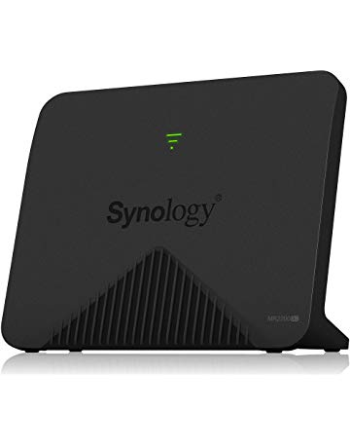](https://www.amazon.com/Synology-MR2200ac-Mesh-Wi-Fi-Router/dp/B07HPSQZKN?ref_=Oct_NReleaseC_300189_2&pf_rd_r=SA07QM4Q5S23C07F7VTB&pf_rd_p=6f74083a-4541-5fc3-91f1-2d621a6b118d&pf_rd_s=merchandised-search-6&pf_rd_t=101&pf_rd_i=300189&pf_rd_m=ATVPDKIKX0DER)](https://www.amazon.com/Synology-MR2200ac-Mesh-Wi-Fi-Router/dp/B07HPSQZKN?ref_=Oct_NReleaseC_300189_2&pf_rd_r=SA07QM4Q5S23C07F7VTB&pf_rd_p=6f74083a-4541-5fc3-91f1-2d621a6b118d&pf_rd_s=merchandised-search-6&pf_rd_t=101&pf_rd_i=300189&pf_rd_m=ATVPDKIKX0DER" \o "Synology MR2200ac Mesh Wi-Fi Router)

[price$139.99](https://www.amazon.com/Synology-MR2200ac-Mesh-Wi-Fi-Router/dp/B07HPSQZKN?ref_=Oct_NReleaseC_300189_2&pf_rd_r=SA07QM4Q5S23C07F7VTB&pf_rd_p=6f74083a-4541-5fc3-91f1-2d621a6b118d&pf_rd_s=merchandised-search-6&pf_rd_t=101&pf_rd_i=300189&pf_rd_m=ATVPDKIKX0DER" \o "Synology MR2200ac Mesh Wi-Fi Router)

[Synology MR2200ac Mesh Wi-Fi Router](https://www.amazon.com/Synology-MR2200ac-Mesh-Wi-Fi-Router/dp/B07HPSQZKN?ref_=Oct_NReleaseC_300189_2&pf_rd_r=SA07QM4Q5S23C07F7VTB&pf_rd_p=6f74083a-4541-5fc3-91f1-2d621a6b118d&pf_rd_s=merchandised-search-6&pf_rd_t=101&pf_rd_i=300189&pf_rd_m=ATVPDKIKX0DER" \o "Synology MR2200ac Mesh Wi-Fi Router)

[[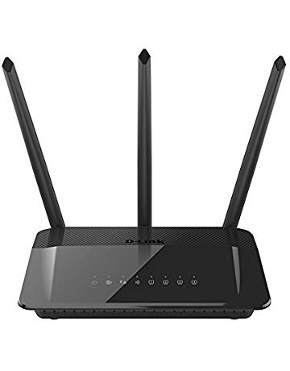](https://www.amazon.com/D-Link-AC1750-Gigabit-Wi-Fi-Router/dp/B00PVCZI40?ref_=Oct_NReleaseC_300189_3&pf_rd_r=SA07QM4Q5S23C07F7VTB&pf_rd_p=6f74083a-4541-5fc3-91f1-2d621a6b118d&pf_rd_s=merchandised-search-6&pf_rd_t=101&pf_rd_i=300189&pf_rd_m=ATVPDKIKX0DER)](https://www.amazon.com/D-Link-AC1750-Gigabit-Wi-Fi-Router/dp/B00PVCZI40?ref_=Oct_NReleaseC_300189_3&pf_rd_r=SA07QM4Q5S23C07F7VTB&pf_rd_p=6f74083a-4541-5fc3-91f1-2d621a6b118d&pf_rd_s=merchandised-search-6&pf_rd_t=101&pf_rd_i=300189&pf_rd_m=ATVPDKIKX0DER" \o "D-Link AC1750 Gigabit Wi-Fi Router – High Power Amplifiers – Dual Band Speeds (DIR-859))

[price$78.21](https://www.amazon.com/D-Link-AC1750-Gigabit-Wi-Fi-Router/dp/B00PVCZI40?ref_=Oct_NReleaseC_300189_3&pf_rd_r=SA07QM4Q5S23C07F7VTB&pf_rd_p=6f74083a-4541-5fc3-91f1-2d621a6b118d&pf_rd_s=merchandised-search-6&pf_rd_t=101&pf_rd_i=300189&pf_rd_m=ATVPDKIKX0DER" \o "D-Link AC1750 Gigabit Wi-Fi Router – High Power Amplifiers – Dual Band Speeds (DIR-859))

[D-Link AC1750 Gigabit Wi-Fi Router – High Power Amplifiers – Dual Band Speeds (DIR-859)](https://www.amazon.com/D-Link-AC1750-Gigabit-Wi-Fi-Router/dp/B00PVCZI40?ref_=Oct_NReleaseC_300189_3&pf_rd_r=SA07QM4Q5S23C07F7VTB&pf_rd_p=6f74083a-4541-5fc3-91f1-2d621a6b118d&pf_rd_s=merchandised-search-6&pf_rd_t=101&pf_rd_i=300189&pf_rd_m=ATVPDKIKX0DER" \o "D-Link AC1750 Gigabit Wi-Fi Router – High Power Amplifiers – Dual Band Speeds (DIR-859))

[[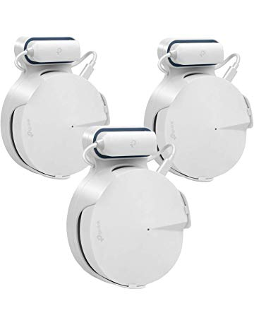](https://www.amazon.com/STANSTAR-TP-Link-System-Bracket-Without/dp/B07JD4QL49?ref_=Oct_NReleaseC_300189_4&pf_rd_r=SA07QM4Q5S23C07F7VTB&pf_rd_p=6f74083a-4541-5fc3-91f1-2d621a6b118d&pf_rd_s=merchandised-search-6&pf_rd_t=101&pf_rd_i=300189&pf_rd_m=ATVPDKIKX0DER)](https://www.amazon.com/STANSTAR-TP-Link-System-Bracket-Without/dp/B07JD4QL49?ref_=Oct_NReleaseC_300189_4&pf_rd_r=SA07QM4Q5S23C07F7VTB&pf_rd_p=6f74083a-4541-5fc3-91f1-2d621a6b118d&pf_rd_s=merchandised-search-6&pf_rd_t=101&pf_rd_i=300189&pf_rd_m=ATVPDKIKX0DER" \o "STANSTAR Wall Mount for TP-Link Deco M5 Whole Home Mesh WiFi System, Sturdy Bracket Holder for TP-Link Deco M5 Space Saving TP-Link Router Wall Holder Plug in Without Messy Wires or Screws)

[price$18.99](https://www.amazon.com/STANSTAR-TP-Link-System-Bracket-Without/dp/B07JD4QL49?ref_=Oct_NReleaseC_300189_4&pf_rd_r=SA07QM4Q5S23C07F7VTB&pf_rd_p=6f74083a-4541-5fc3-91f1-2d621a6b118d&pf_rd_s=merchandised-search-6&pf_rd_t=101&pf_rd_i=300189&pf_rd_m=ATVPDKIKX0DER" \o "STANSTAR Wall Mount for TP-Link Deco M5 Whole Home Mesh WiFi System, Sturdy Bracket Holder for TP-Link Deco M5 Space Saving TP-Link Router Wall Holder Plug in Without Messy Wires or Screws)

[STANSTAR Wall Mount for TP-Link Deco M5 Whole Home Mesh WiFi System, Sturdy Bracket Holder for TP-Link Deco M5 Space Saving TP-Link Router Wall Holder Plug in Without Messy Wires or Screws](https://www.amazon.com/STANSTAR-TP-Link-System-Bracket-Without/dp/B07JD4QL49?ref_=Oct_NReleaseC_300189_4&pf_rd_r=SA07QM4Q5S23C07F7VTB&pf_rd_p=6f74083a-4541-5fc3-91f1-2d621a6b118d&pf_rd_s=merchandised-search-6&pf_rd_t=101&pf_rd_i=300189&pf_rd_m=ATVPDKIKX0DER" \o "STANSTAR Wall Mount for TP-Link Deco M5 Whole Home Mesh WiFi System, Sturdy Bracket Holder for TP-Link Deco M5 Space Saving TP-Link Router Wall Holder Plug in Without Messy Wires or Screws)

[[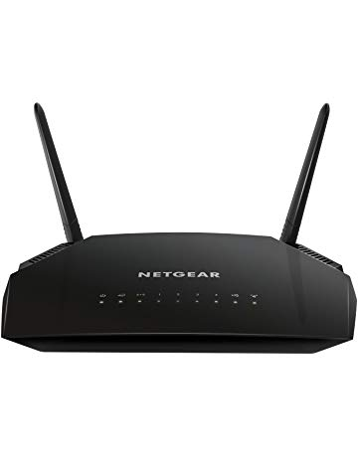](https://www.amazon.com/NETGEAR-Gigabit-Ethernet-Certified-Refurbished/dp/B07KXWND3L?ref_=Oct_NReleaseC_300189_5&pf_rd_r=SA07QM4Q5S23C07F7VTB&pf_rd_p=6f74083a-4541-5fc3-91f1-2d621a6b118d&pf_rd_s=merchandised-search-6&pf_rd_t=101&pf_rd_i=300189&pf_rd_m=ATVPDKIKX0DER)](https://www.amazon.com/NETGEAR-Gigabit-Ethernet-Certified-Refurbished/dp/B07KXWND3L?ref_=Oct_NReleaseC_300189_5&pf_rd_r=SA07QM4Q5S23C07F7VTB&pf_rd_p=6f74083a-4541-5fc3-91f1-2d621a6b118d&pf_rd_s=merchandised-search-6&pf_rd_t=101&pf_rd_i=300189&pf_rd_m=ATVPDKIKX0DER" \o "NETGEAR AC1200 Dual Band Smart WiFi Router, Gigabit Ethernet (R6230) (Certified Refurbished))

[price$43.11](https://www.amazon.com/NETGEAR-Gigabit-Ethernet-Certified-Refurbished/dp/B07KXWND3L?ref_=Oct_NReleaseC_300189_5&pf_rd_r=SA07QM4Q5S23C07F7VTB&pf_rd_p=6f74083a-4541-5fc3-91f1-2d621a6b118d&pf_rd_s=merchandised-search-6&pf_rd_t=101&pf_rd_i=300189&pf_rd_m=ATVPDKIKX0DER" \o "NETGEAR AC1200 Dual Band Smart WiFi Router, Gigabit Ethernet (R6230) (Certified Refurbished))

[NETGEAR AC1200 Dual Band Smart WiFi Router, Gigabit Ethernet (R6230) (Certified Refurbished)](https://www.amazon.com/NETGEAR-Gigabit-Ethernet-Certified-Refurbished/dp/B07KXWND3L?ref_=Oct_NReleaseC_300189_5&pf_rd_r=SA07QM4Q5S23C07F7VTB&pf_rd_p=6f74083a-4541-5fc3-91f1-2d621a6b118d&pf_rd_s=merchandised-search-6&pf_rd_t=101&pf_rd_i=300189&pf_rd_m=ATVPDKIKX0DER" \o "NETGEAR AC1200 Dual Band Smart WiFi Router, Gigabit Ethernet (R6230) (Certified Refurbished))

[[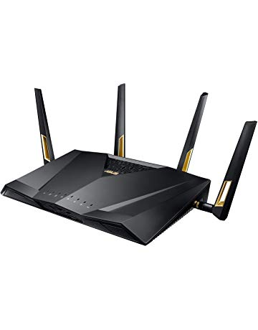](https://www.amazon.com/Quad-Core-Wireless-802-11Ax-Adaptive-RT-AX88U/dp/B07HM6KJN8?ref_=Oct_NReleaseC_300189_6&pf_rd_r=SA07QM4Q5S23C07F7VTB&pf_rd_p=6f74083a-4541-5fc3-91f1-2d621a6b118d&pf_rd_s=merchandised-search-6&pf_rd_t=101&pf_rd_i=300189&pf_rd_m=ATVPDKIKX0DER)](https://www.amazon.com/Quad-Core-Wireless-802-11Ax-Adaptive-RT-AX88U/dp/B07HM6KJN8?ref_=Oct_NReleaseC_300189_6&pf_rd_r=SA07QM4Q5S23C07F7VTB&pf_rd_p=6f74083a-4541-5fc3-91f1-2d621a6b118d&pf_rd_s=merchandised-search-6&pf_rd_t=101&pf_rd_i=300189&pf_rd_m=ATVPDKIKX0DER" \o "ASUS Quad-Core Wireless 802.11Ax Dual Band Wi-Fi Adaptive Qos AX6000 Router (RT-AX88U))

[price$349.99](https://www.amazon.com/Quad-Core-Wireless-802-11Ax-Adaptive-RT-AX88U/dp/B07HM6KJN8?ref_=Oct_NReleaseC_300189_6&pf_rd_r=SA07QM4Q5S23C07F7VTB&pf_rd_p=6f74083a-4541-5fc3-91f1-2d621a6b118d&pf_rd_s=merchandised-search-6&pf_rd_t=101&pf_rd_i=300189&pf_rd_m=ATVPDKIKX0DER" \o "ASUS Quad-Core Wireless 802.11Ax Dual Band Wi-Fi Adaptive Qos AX6000 Router (RT-AX88U))

[ASUS Quad-Core Wireless 802.11Ax Dual Band Wi-Fi Adaptive Qos AX6000 Router (RT-AX88U)](https://www.amazon.com/Quad-Core-Wireless-802-11Ax-Adaptive-RT-AX88U/dp/B07HM6KJN8?ref_=Oct_NReleaseC_300189_6&pf_rd_r=SA07QM4Q5S23C07F7VTB&pf_rd_p=6f74083a-4541-5fc3-91f1-2d621a6b118d&pf_rd_s=merchandised-search-6&pf_rd_t=101&pf_rd_i=300189&pf_rd_m=ATVPDKIKX0DER" \o "ASUS Quad-Core Wireless 802.11Ax Dual Band Wi-Fi Adaptive Qos AX6000 Router (RT-AX88U))

[[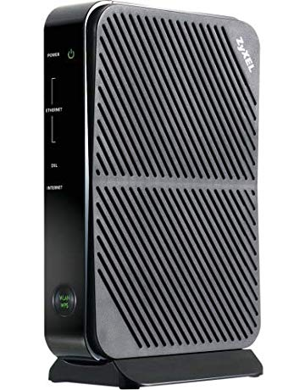](https://www.amazon.com/Compatible-CenturyLink-Broadband-Providers-P660HN-51/dp/B07FSQJ71N?ref_=Oct_NReleaseC_300189_7&pf_rd_r=SA07QM4Q5S23C07F7VTB&pf_rd_p=6f74083a-4541-5fc3-91f1-2d621a6b118d&pf_rd_s=merchandised-search-6&pf_rd_t=101&pf_rd_i=300189&pf_rd_m=ATVPDKIKX0DER)](https://www.amazon.com/Compatible-CenturyLink-Broadband-Providers-P660HN-51/dp/B07FSQJ71N?ref_=Oct_NReleaseC_300189_7&pf_rd_r=SA07QM4Q5S23C07F7VTB&pf_rd_p=6f74083a-4541-5fc3-91f1-2d621a6b118d&pf_rd_s=merchandised-search-6&pf_rd_t=101&pf_rd_i=300189&pf_rd_m=ATVPDKIKX0DER" \o "ZYXEL Adsl/ Adsl2+ WiFi Router with Built-in Modem Compatible with CenturyLink, Frontier, AT&T and Other Broadband Providers [P660HN-51])

[price$59.99](https://www.amazon.com/Compatible-CenturyLink-Broadband-Providers-P660HN-51/dp/B07FSQJ71N?ref_=Oct_NReleaseC_300189_7&pf_rd_r=SA07QM4Q5S23C07F7VTB&pf_rd_p=6f74083a-4541-5fc3-91f1-2d621a6b118d&pf_rd_s=merchandised-search-6&pf_rd_t=101&pf_rd_i=300189&pf_rd_m=ATVPDKIKX0DER" \o "ZYXEL Adsl/ Adsl2+ WiFi Router with Built-in Modem Compatible with CenturyLink, Frontier, AT&T and Other Broadband Providers [P660HN-51])

[ZYXEL Adsl/ Adsl2+ WiFi Router with Built-in Modem Compatible with CenturyLink, Frontier, AT&T and Other Broadband Providers [P660HN-51]](https://www.amazon.com/Compatible-CenturyLink-Broadband-Providers-P660HN-51/dp/B07FSQJ71N?ref_=Oct_NReleaseC_300189_7&pf_rd_r=SA07QM4Q5S23C07F7VTB&pf_rd_p=6f74083a-4541-5fc3-91f1-2d621a6b118d&pf_rd_s=merchandised-search-6&pf_rd_t=101&pf_rd_i=300189&pf_rd_m=ATVPDKIKX0DER" \o "ZYXEL Adsl/ Adsl2+ WiFi Router with Built-in Modem Compatible with CenturyLink, Frontier, AT&T and Other Broadband Providers [P660HN-51])

[[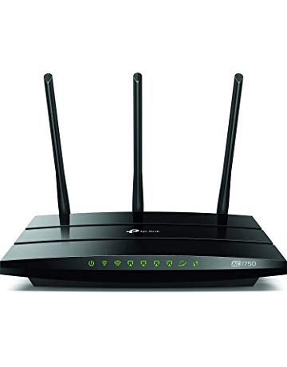](https://www.amazon.com/TP-Link-AC1750-Smart-WiFi-Router/dp/B07KGH7R5X?ref_=Oct_NReleaseC_300189_8&pf_rd_r=SA07QM4Q5S23C07F7VTB&pf_rd_p=6f74083a-4541-5fc3-91f1-2d621a6b118d&pf_rd_s=merchandised-search-6&pf_rd_t=101&pf_rd_i=300189&pf_rd_m=ATVPDKIKX0DER)](https://www.amazon.com/TP-Link-AC1750-Smart-WiFi-Router/dp/B07KGH7R5X?ref_=Oct_NReleaseC_300189_8&pf_rd_r=SA07QM4Q5S23C07F7VTB&pf_rd_p=6f74083a-4541-5fc3-91f1-2d621a6b118d&pf_rd_s=merchandised-search-6&pf_rd_t=101&pf_rd_i=300189&pf_rd_m=ATVPDKIKX0DER" \o "TP-Link AC1750 Smart WiFi Router - 5GHz Dual Band Gigabit Wireless Internet Routers for Home, Works with Alexa, Parental Control&QoS(Archer A7) (Certified Refurbished))

[price$47.99](https://www.amazon.com/TP-Link-AC1750-Smart-WiFi-Router/dp/B07KGH7R5X?ref_=Oct_NReleaseC_300189_8&pf_rd_r=SA07QM4Q5S23C07F7VTB&pf_rd_p=6f74083a-4541-5fc3-91f1-2d621a6b118d&pf_rd_s=merchandised-search-6&pf_rd_t=101&pf_rd_i=300189&pf_rd_m=ATVPDKIKX0DER" \o "TP-Link AC1750 Smart WiFi Router - 5GHz Dual Band Gigabit Wireless Internet Routers for Home, Works with Alexa, Parental Control&QoS(Archer A7) (Certified Refurbished))

[TP-Link AC1750 Smart WiFi Router - 5GHz Dual Band Gigabit Wireless Internet Routers for Home, Works with Alexa, Parental Control&QoS(Archer A7) (Certified Refurbished)](https://www.amazon.com/TP-Link-AC1750-Smart-WiFi-Router/dp/B07KGH7R5X?ref_=Oct_NReleaseC_300189_8&pf_rd_r=SA07QM4Q5S23C07F7VTB&pf_rd_p=6f74083a-4541-5fc3-91f1-2d621a6b118d&pf_rd_s=merchandised-search-6&pf_rd_t=101&pf_rd_i=300189&pf_rd_m=ATVPDKIKX0DER" \o "TP-Link AC1750 Smart WiFi Router - 5GHz Dual Band Gigabit Wireless Internet Routers for Home, Works with Alexa, Parental Control&QoS(Archer A7) (Certified Refurbished))

[[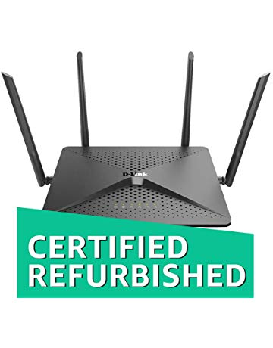](https://www.amazon.com/D-Link-Streaming-DIR-882-US-Certified-Refurbished/dp/B07J4XS1HV?ref_=Oct_NReleaseC_300189_9&pf_rd_r=SA07QM4Q5S23C07F7VTB&pf_rd_p=6f74083a-4541-5fc3-91f1-2d621a6b118d&pf_rd_s=merchandised-search-6&pf_rd_t=101&pf_rd_i=300189&pf_rd_m=ATVPDKIKX0DER)](https://www.amazon.com/D-Link-Streaming-DIR-882-US-Certified-Refurbished/dp/B07J4XS1HV?ref_=Oct_NReleaseC_300189_9&pf_rd_r=SA07QM4Q5S23C07F7VTB&pf_rd_p=6f74083a-4541-5fc3-91f1-2d621a6b118d&pf_rd_s=merchandised-search-6&pf_rd_t=101&pf_rd_i=300189&pf_rd_m=ATVPDKIKX0DER" \o "D-Link EXO AC2600 MU-MIMO 4x4 Wi-Fi Router Gaming and 4K Streaming with 2 USB Ports, Dual Band Wireless Router (DIR-882-US/RE) (Certified Refurbished))

[price$79.99](https://www.amazon.com/D-Link-Streaming-DIR-882-US-Certified-Refurbished/dp/B07J4XS1HV?ref_=Oct_NReleaseC_300189_9&pf_rd_r=SA07QM4Q5S23C07F7VTB&pf_rd_p=6f74083a-4541-5fc3-91f1-2d621a6b118d&pf_rd_s=merchandised-search-6&pf_rd_t=101&pf_rd_i=300189&pf_rd_m=ATVPDKIKX0DER" \o "D-Link EXO AC2600 MU-MIMO 4x4 Wi-Fi Router Gaming and 4K Streaming with 2 USB Ports, Dual Band Wireless Router (DIR-882-US/RE) (Certified Refurbished))

[D-Link EXO AC2600 MU-MIMO 4x4 Wi-Fi Router Gaming and 4K Streaming with 2 USB Ports, Dual Band Wireless Router (DIR-882-US/RE) (Certified Refurbished)](https://www.amazon.com/D-Link-Streaming-DIR-882-US-Certified-Refurbished/dp/B07J4XS1HV?ref_=Oct_NReleaseC_300189_9&pf_rd_r=SA07QM4Q5S23C07F7VTB&pf_rd_p=6f74083a-4541-5fc3-91f1-2d621a6b118d&pf_rd_s=merchandised-search-6&pf_rd_t=101&pf_rd_i=300189&pf_rd_m=ATVPDKIKX0DER" \o "D-Link EXO AC2600 MU-MIMO 4x4 Wi-Fi Router Gaming and 4K Streaming with 2 USB Ports, Dual Band Wireless Router (DIR-882-US/RE) (Certified Refurbished))

[[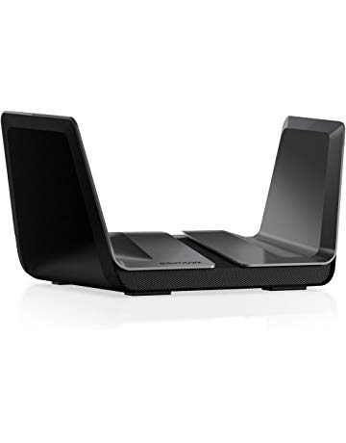](https://www.amazon.com/NETGEAR-Nighthawk-8-Stream-AX6000-Router/dp/B01MQDZXA4?ref_=Oct_NReleaseC_300189_10&pf_rd_r=SA07QM4Q5S23C07F7VTB&pf_rd_p=6f74083a-4541-5fc3-91f1-2d621a6b118d&pf_rd_s=merchandised-search-6&pf_rd_t=101&pf_rd_i=300189&pf_rd_m=ATVPDKIKX0DER)](https://www.amazon.com/NETGEAR-Nighthawk-8-Stream-AX6000-Router/dp/B01MQDZXA4?ref_=Oct_NReleaseC_300189_10&pf_rd_r=SA07QM4Q5S23C07F7VTB&pf_rd_p=6f74083a-4541-5fc3-91f1-2d621a6b118d&pf_rd_s=merchandised-search-6&pf_rd_t=101&pf_rd_i=300189&pf_rd_m=ATVPDKIKX0DER" \o "NETGEAR Nighthawk AX8 8-Stream AX6000 WiFi Router, Wi-Fi 6 (RAX80))

[price$399.99](https://www.amazon.com/NETGEAR-Nighthawk-8-Stream-AX6000-Router/dp/B01MQDZXA4?ref_=Oct_NReleaseC_300189_10&pf_rd_r=SA07QM4Q5S23C07F7VTB&pf_rd_p=6f74083a-4541-5fc3-91f1-2d621a6b118d&pf_rd_s=merchandised-search-6&pf_rd_t=101&pf_rd_i=300189&pf_rd_m=ATVPDKIKX0DER" \o "NETGEAR Nighthawk AX8 8-Stream AX6000 WiFi Router, Wi-Fi 6 (RAX80))

[NETGEAR Nighthawk AX8 8-Stream AX6000 WiFi Router, Wi-Fi 6 (RAX80)](https://www.amazon.com/NETGEAR-Nighthawk-8-Stream-AX6000-Router/dp/B01MQDZXA4?ref_=Oct_NReleaseC_300189_10&pf_rd_r=SA07QM4Q5S23C07F7VTB&pf_rd_p=6f74083a-4541-5fc3-91f1-2d621a6b118d&pf_rd_s=merchandised-search-6&pf_rd_t=101&pf_rd_i=300189&pf_rd_m=ATVPDKIKX0DER" \o "NETGEAR Nighthawk AX8 8-Stream AX6000 WiFi Router, Wi-Fi 6 (RAX80))

Under $25 [See more](https://www.amazon.com/s?n=300189&price=1253503011&ref_=Oct_UPriceC_300189_SAll&pf_rd_r=SA07QM4Q5S23C07F7VTB&pf_rd_p=6f74083a-4541-5fc3-91f1-2d621a6b118d&pf_rd_s=merchandised-search-6&pf_rd_t=101&pf_rd_i=300189&pf_rd_m=ATVPDKIKX0DER)

[[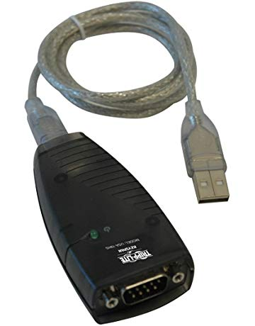](https://www.amazon.com/Tripp-Lite-Keyspan-High-Speed-USA-19HS/dp/B0000VYJRY?ref_=Oct_UPriceC_300189_0&pf_rd_r=SA07QM4Q5S23C07F7VTB&pf_rd_p=6f74083a-4541-5fc3-91f1-2d621a6b118d&pf_rd_s=merchandised-search-6&pf_rd_t=101&pf_rd_i=300189&pf_rd_m=ATVPDKIKX0DER)](https://www.amazon.com/Tripp-Lite-Keyspan-High-Speed-USA-19HS/dp/B0000VYJRY?ref_=Oct_UPriceC_300189_0&pf_rd_r=SA07QM4Q5S23C07F7VTB&pf_rd_p=6f74083a-4541-5fc3-91f1-2d621a6b118d&pf_rd_s=merchandised-search-6&pf_rd_t=101&pf_rd_i=300189&pf_rd_m=ATVPDKIKX0DER" \o "Tripp Lite Keyspan High-Speed USB to Serial Adapter, PC & Mac (USA-19HS))

[price$24.97](https://www.amazon.com/Tripp-Lite-Keyspan-High-Speed-USA-19HS/dp/B0000VYJRY?ref_=Oct_UPriceC_300189_0&pf_rd_r=SA07QM4Q5S23C07F7VTB&pf_rd_p=6f74083a-4541-5fc3-91f1-2d621a6b118d&pf_rd_s=merchandised-search-6&pf_rd_t=101&pf_rd_i=300189&pf_rd_m=ATVPDKIKX0DER" \o "Tripp Lite Keyspan High-Speed USB to Serial Adapter, PC & Mac (USA-19HS))

[$45.99](https://www.amazon.com/Tripp-Lite-Keyspan-High-Speed-USA-19HS/dp/B0000VYJRY?ref_=Oct_UPriceC_300189_0&pf_rd_r=SA07QM4Q5S23C07F7VTB&pf_rd_p=6f74083a-4541-5fc3-91f1-2d621a6b118d&pf_rd_s=merchandised-search-6&pf_rd_t=101&pf_rd_i=300189&pf_rd_m=ATVPDKIKX0DER" \o "Tripp Lite Keyspan High-Speed USB to Serial Adapter, PC & Mac (USA-19HS))

[Tripp Lite Keyspan High-Speed USB to Serial Adapter, PC & Mac (USA-19HS)](https://www.amazon.com/Tripp-Lite-Keyspan-High-Speed-USA-19HS/dp/B0000VYJRY?ref_=Oct_UPriceC_300189_0&pf_rd_r=SA07QM4Q5S23C07F7VTB&pf_rd_p=6f74083a-4541-5fc3-91f1-2d621a6b118d&pf_rd_s=merchandised-search-6&pf_rd_t=101&pf_rd_i=300189&pf_rd_m=ATVPDKIKX0DER" \o "Tripp Lite Keyspan High-Speed USB to Serial Adapter, PC & Mac (USA-19HS))

[[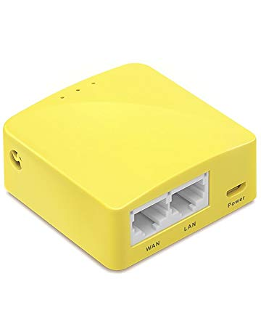](https://www.amazon.com/GL-iNet-GL-MT300N-V2-Repeater-Performance-Compatible/dp/B073TSK26W?ref_=Oct_UPriceC_300189_1&pf_rd_r=SA07QM4Q5S23C07F7VTB&pf_rd_p=6f74083a-4541-5fc3-91f1-2d621a6b118d&pf_rd_s=merchandised-search-6&pf_rd_t=101&pf_rd_i=300189&pf_rd_m=ATVPDKIKX0DER)](https://www.amazon.com/GL-iNet-GL-MT300N-V2-Repeater-Performance-Compatible/dp/B073TSK26W?ref_=Oct_UPriceC_300189_1&pf_rd_r=SA07QM4Q5S23C07F7VTB&pf_rd_p=6f74083a-4541-5fc3-91f1-2d621a6b118d&pf_rd_s=merchandised-search-6&pf_rd_t=101&pf_rd_i=300189&pf_rd_m=ATVPDKIKX0DER" \o "GL.iNet GL-MT300N-V2 Mini Travel Router, Repeater Bridge, 300Mbps High Performance, 128MB RAM, OpenVPN Client, Tor Compatible)

[price$19.99](https://www.amazon.com/GL-iNet-GL-MT300N-V2-Repeater-Performance-Compatible/dp/B073TSK26W?ref_=Oct_UPriceC_300189_1&pf_rd_r=SA07QM4Q5S23C07F7VTB&pf_rd_p=6f74083a-4541-5fc3-91f1-2d621a6b118d&pf_rd_s=merchandised-search-6&pf_rd_t=101&pf_rd_i=300189&pf_rd_m=ATVPDKIKX0DER" \o "GL.iNet GL-MT300N-V2 Mini Travel Router, Repeater Bridge, 300Mbps High Performance, 128MB RAM, OpenVPN Client, Tor Compatible)

[GL.iNet GL-MT300N-V2 Mini Travel Router, Repeater Bridge, 300Mbps High Performance, 128MB RAM, OpenVPN Client, Tor Compatible](https://www.amazon.com/GL-iNet-GL-MT300N-V2-Repeater-Performance-Compatible/dp/B073TSK26W?ref_=Oct_UPriceC_300189_1&pf_rd_r=SA07QM4Q5S23C07F7VTB&pf_rd_p=6f74083a-4541-5fc3-91f1-2d621a6b118d&pf_rd_s=merchandised-search-6&pf_rd_t=101&pf_rd_i=300189&pf_rd_m=ATVPDKIKX0DER" \o "GL.iNet GL-MT300N-V2 Mini Travel Router, Repeater Bridge, 300Mbps High Performance, 128MB RAM, OpenVPN Client, Tor Compatible)

[[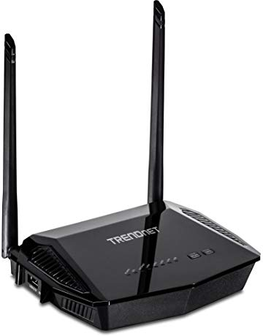](https://www.amazon.com/TRENDnet-Wireless-Router-Pre-Encrypted-TEW-723BRM/dp/B072M7MFVL?ref_=Oct_UPriceC_300189_2&pf_rd_r=SA07QM4Q5S23C07F7VTB&pf_rd_p=6f74083a-4541-5fc3-91f1-2d621a6b118d&pf_rd_s=merchandised-search-6&pf_rd_t=101&pf_rd_i=300189&pf_rd_m=ATVPDKIKX0DER)](https://www.amazon.com/TRENDnet-Wireless-Router-Pre-Encrypted-TEW-723BRM/dp/B072M7MFVL?ref_=Oct_UPriceC_300189_2&pf_rd_r=SA07QM4Q5S23C07F7VTB&pf_rd_p=6f74083a-4541-5fc3-91f1-2d621a6b118d&pf_rd_s=merchandised-search-6&pf_rd_t=101&pf_rd_i=300189&pf_rd_m=ATVPDKIKX0DER" \o "TRENDnet N300 Wireless Ads 2+ Modem Router, 4 X 10/100 Mbps LAN Ports, 1 X RJ-11 Port, Pre-Encrypted, TEW-723BRM, Black)

[price$24.99](https://www.amazon.com/TRENDnet-Wireless-Router-Pre-Encrypted-TEW-723BRM/dp/B072M7MFVL?ref_=Oct_UPriceC_300189_2&pf_rd_r=SA07QM4Q5S23C07F7VTB&pf_rd_p=6f74083a-4541-5fc3-91f1-2d621a6b118d&pf_rd_s=merchandised-search-6&pf_rd_t=101&pf_rd_i=300189&pf_rd_m=ATVPDKIKX0DER" \o "TRENDnet N300 Wireless Ads 2+ Modem Router, 4 X 10/100 Mbps LAN Ports, 1 X RJ-11 Port, Pre-Encrypted, TEW-723BRM, Black)

[TRENDnet N300 Wireless Ads 2+ Modem Router, 4 X 10/100 Mbps LAN Ports, 1 X RJ-11 Port, Pre-Encrypted, TEW-723BRM, Black](https://www.amazon.com/TRENDnet-Wireless-Router-Pre-Encrypted-TEW-723BRM/dp/B072M7MFVL?ref_=Oct_UPriceC_300189_2&pf_rd_r=SA07QM4Q5S23C07F7VTB&pf_rd_p=6f74083a-4541-5fc3-91f1-2d621a6b118d&pf_rd_s=merchandised-search-6&pf_rd_t=101&pf_rd_i=300189&pf_rd_m=ATVPDKIKX0DER" \o "TRENDnet N300 Wireless Ads 2+ Modem Router, 4 X 10/100 Mbps LAN Ports, 1 X RJ-11 Port, Pre-Encrypted, TEW-723BRM, Black)

[[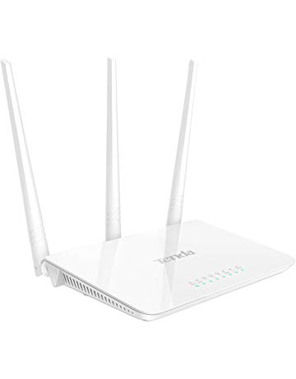](https://www.amazon.com/Tenda-Wireless-Router-Antennas-F3/dp/B01CA5SN1K?ref_=Oct_UPriceC_300189_3&pf_rd_r=SA07QM4Q5S23C07F7VTB&pf_rd_p=6f74083a-4541-5fc3-91f1-2d621a6b118d&pf_rd_s=merchandised-search-6&pf_rd_t=101&pf_rd_i=300189&pf_rd_m=ATVPDKIKX0DER)](https://www.amazon.com/Tenda-Wireless-Router-Antennas-F3/dp/B01CA5SN1K?ref_=Oct_UPriceC_300189_3&pf_rd_r=SA07QM4Q5S23C07F7VTB&pf_rd_p=6f74083a-4541-5fc3-91f1-2d621a6b118d&pf_rd_s=merchandised-search-6&pf_rd_t=101&pf_rd_i=300189&pf_rd_m=ATVPDKIKX0DER" \o "Tenda N300 Wireless Wi-Fi Router with High Power 5dBi Antennas (F3))

[price$18.99](https://www.amazon.com/Tenda-Wireless-Router-Antennas-F3/dp/B01CA5SN1K?ref_=Oct_UPriceC_300189_3&pf_rd_r=SA07QM4Q5S23C07F7VTB&pf_rd_p=6f74083a-4541-5fc3-91f1-2d621a6b118d&pf_rd_s=merchandised-search-6&pf_rd_t=101&pf_rd_i=300189&pf_rd_m=ATVPDKIKX0DER" \o "Tenda N300 Wireless Wi-Fi Router with High Power 5dBi Antennas (F3))

[Tenda N300 Wireless Wi-Fi Router with High Power 5dBi Antennas (F3)](https://www.amazon.com/Tenda-Wireless-Router-Antennas-F3/dp/B01CA5SN1K?ref_=Oct_UPriceC_300189_3&pf_rd_r=SA07QM4Q5S23C07F7VTB&pf_rd_p=6f74083a-4541-5fc3-91f1-2d621a6b118d&pf_rd_s=merchandised-search-6&pf_rd_t=101&pf_rd_i=300189&pf_rd_m=ATVPDKIKX0DER" \o "Tenda N300 Wireless Wi-Fi Router with High Power 5dBi Antennas (F3))

[[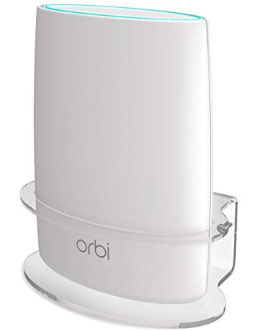](https://www.amazon.com/Netgear-BASSTOP-Acrylic-Bracket-NETGEAR/dp/B075N6JQND?ref_=Oct_UPriceC_300189_4&pf_rd_r=SA07QM4Q5S23C07F7VTB&pf_rd_p=6f74083a-4541-5fc3-91f1-2d621a6b118d&pf_rd_s=merchandised-search-6&pf_rd_t=101&pf_rd_i=300189&pf_rd_m=ATVPDKIKX0DER)](https://www.amazon.com/Netgear-BASSTOP-Acrylic-Bracket-NETGEAR/dp/B075N6JQND?ref_=Oct_UPriceC_300189_4&pf_rd_r=SA07QM4Q5S23C07F7VTB&pf_rd_p=6f74083a-4541-5fc3-91f1-2d621a6b118d&pf_rd_s=merchandised-search-6&pf_rd_t=101&pf_rd_i=300189&pf_rd_m=ATVPDKIKX0DER" \o "Netgear Orbi Wall Mount, BASSTOP Sturdy Clear Acrylic Wall Mount Bracket for NETGEAR ORBI AC3000/AC2200 Tri Band Home WiFi Router- (1 Pack))

[price$18.99](https://www.amazon.com/Netgear-BASSTOP-Acrylic-Bracket-NETGEAR/dp/B075N6JQND?ref_=Oct_UPriceC_300189_4&pf_rd_r=SA07QM4Q5S23C07F7VTB&pf_rd_p=6f74083a-4541-5fc3-91f1-2d621a6b118d&pf_rd_s=merchandised-search-6&pf_rd_t=101&pf_rd_i=300189&pf_rd_m=ATVPDKIKX0DER" \o "Netgear Orbi Wall Mount, BASSTOP Sturdy Clear Acrylic Wall Mount Bracket for NETGEAR ORBI AC3000/AC2200 Tri Band Home WiFi Router- (1 Pack))

[Netgear Orbi Wall Mount, BASSTOP Sturdy Clear Acrylic Wall Mount Bracket for NETGEAR ORBI AC3000/AC2200 Tri Band Home WiFi Router- (1 Pack)](https://www.amazon.com/Netgear-BASSTOP-Acrylic-Bracket-NETGEAR/dp/B075N6JQND?ref_=Oct_UPriceC_300189_4&pf_rd_r=SA07QM4Q5S23C07F7VTB&pf_rd_p=6f74083a-4541-5fc3-91f1-2d621a6b118d&pf_rd_s=merchandised-search-6&pf_rd_t=101&pf_rd_i=300189&pf_rd_m=ATVPDKIKX0DER" \o "Netgear Orbi Wall Mount, BASSTOP Sturdy Clear Acrylic Wall Mount Bracket for NETGEAR ORBI AC3000/AC2200 Tri Band Home WiFi Router- (1 Pack))

[[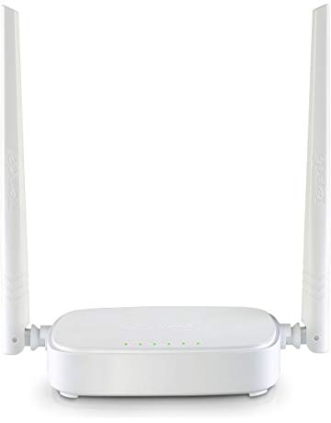](https://www.amazon.com/Tenda-N301-Wireless-Router-300Mbps/dp/B0167N0B70?ref_=Oct_UPriceC_300189_5&pf_rd_r=SA07QM4Q5S23C07F7VTB&pf_rd_p=6f74083a-4541-5fc3-91f1-2d621a6b118d&pf_rd_s=merchandised-search-6&pf_rd_t=101&pf_rd_i=300189&pf_rd_m=ATVPDKIKX0DER)](https://www.amazon.com/Tenda-N301-Wireless-Router-300Mbps/dp/B0167N0B70?ref_=Oct_UPriceC_300189_5&pf_rd_r=SA07QM4Q5S23C07F7VTB&pf_rd_p=6f74083a-4541-5fc3-91f1-2d621a6b118d&pf_rd_s=merchandised-search-6&pf_rd_t=101&pf_rd_i=300189&pf_rd_m=ATVPDKIKX0DER" \o "Tenda N301 N300 Wireless Wi-Fi Router, Easy Setup, Up to 300Mbps, White)

[price$16.98](https://www.amazon.com/Tenda-N301-Wireless-Router-300Mbps/dp/B0167N0B70?ref_=Oct_UPriceC_300189_5&pf_rd_r=SA07QM4Q5S23C07F7VTB&pf_rd_p=6f74083a-4541-5fc3-91f1-2d621a6b118d&pf_rd_s=merchandised-search-6&pf_rd_t=101&pf_rd_i=300189&pf_rd_m=ATVPDKIKX0DER" \o "Tenda N301 N300 Wireless Wi-Fi Router, Easy Setup, Up to 300Mbps, White)

[$18.99](https://www.amazon.com/Tenda-N301-Wireless-Router-300Mbps/dp/B0167N0B70?ref_=Oct_UPriceC_300189_5&pf_rd_r=SA07QM4Q5S23C07F7VTB&pf_rd_p=6f74083a-4541-5fc3-91f1-2d621a6b118d&pf_rd_s=merchandised-search-6&pf_rd_t=101&pf_rd_i=300189&pf_rd_m=ATVPDKIKX0DER" \o "Tenda N301 N300 Wireless Wi-Fi Router, Easy Setup, Up to 300Mbps, White)

[Tenda N301 N300 Wireless Wi-Fi Router, Easy Setup, Up to 300Mbps, White](https://www.amazon.com/Tenda-N301-Wireless-Router-300Mbps/dp/B0167N0B70?ref_=Oct_UPriceC_300189_5&pf_rd_r=SA07QM4Q5S23C07F7VTB&pf_rd_p=6f74083a-4541-5fc3-91f1-2d621a6b118d&pf_rd_s=merchandised-search-6&pf_rd_t=101&pf_rd_i=300189&pf_rd_m=ATVPDKIKX0DER" \o "Tenda N301 N300 Wireless Wi-Fi Router, Easy Setup, Up to 300Mbps, White)

[[](https://www.amazon.com/TP-Link-Reliable-Dual-band-Certified-Refurbished/dp/B07CGMNM1B?ref_=Oct_UPriceC_300189_6&pf_rd_r=SA07QM4Q5S23C07F7VTB&pf_rd_p=6f74083a-4541-5fc3-91f1-2d621a6b118d&pf_rd_s=merchandised-search-6&pf_rd_t=101&pf_rd_i=300189&pf_rd_m=ATVPDKIKX0DER)](https://www.amazon.com/TP-Link-Reliable-Dual-band-Certified-Refurbished/dp/B07CGMNM1B?ref_=Oct_UPriceC_300189_6&pf_rd_r=SA07QM4Q5S23C07F7VTB&pf_rd_p=6f74083a-4541-5fc3-91f1-2d621a6b118d&pf_rd_s=merchandised-search-6&pf_rd_t=101&pf_rd_i=300189&pf_rd_m=ATVPDKIKX0DER" \o "TP-Link Archer AC1200 Reliable Dual-band WiFi Router (C50)(Certified Refurbished))

[price$19.99](https://www.amazon.com/TP-Link-Reliable-Dual-band-Certified-Refurbished/dp/B07CGMNM1B?ref_=Oct_UPriceC_300189_6&pf_rd_r=SA07QM4Q5S23C07F7VTB&pf_rd_p=6f74083a-4541-5fc3-91f1-2d621a6b118d&pf_rd_s=merchandised-search-6&pf_rd_t=101&pf_rd_i=300189&pf_rd_m=ATVPDKIKX0DER" \o "TP-Link Archer AC1200 Reliable Dual-band WiFi Router (C50)(Certified Refurbished))

[TP-Link Archer AC1200 Reliable Dual-band WiFi Router (C50)(Certified Refurbished)](https://www.amazon.com/TP-Link-Reliable-Dual-band-Certified-Refurbished/dp/B07CGMNM1B?ref_=Oct_UPriceC_300189_6&pf_rd_r=SA07QM4Q5S23C07F7VTB&pf_rd_p=6f74083a-4541-5fc3-91f1-2d621a6b118d&pf_rd_s=merchandised-search-6&pf_rd_t=101&pf_rd_i=300189&pf_rd_m=ATVPDKIKX0DER" \o "TP-Link Archer AC1200 Reliable Dual-band WiFi Router (C50)(Certified Refurbished))

[[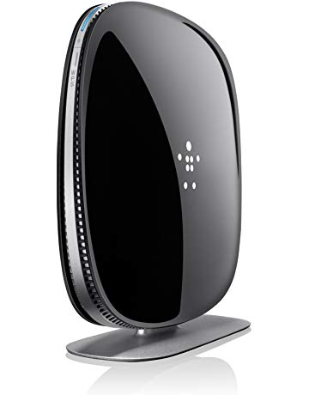](https://www.amazon.com/Belkin-AC1200-Wireless-Router-F9K1123/dp/B00JY4QCJQ?ref_=Oct_UPriceC_300189_7&pf_rd_r=SA07QM4Q5S23C07F7VTB&pf_rd_p=6f74083a-4541-5fc3-91f1-2d621a6b118d&pf_rd_s=merchandised-search-6&pf_rd_t=101&pf_rd_i=300189&pf_rd_m=ATVPDKIKX0DER)](https://www.amazon.com/Belkin-AC1200-Wireless-Router-F9K1123/dp/B00JY4QCJQ?ref_=Oct_UPriceC_300189_7&pf_rd_r=SA07QM4Q5S23C07F7VTB&pf_rd_p=6f74083a-4541-5fc3-91f1-2d621a6b118d&pf_rd_s=merchandised-search-6&pf_rd_t=101&pf_rd_i=300189&pf_rd_m=ATVPDKIKX0DER" \o "Belkin AC1200 Dual Band AC Wireless Router (F9K1123))

[price$19.99](https://www.amazon.com/Belkin-AC1200-Wireless-Router-F9K1123/dp/B00JY4QCJQ?ref_=Oct_UPriceC_300189_7&pf_rd_r=SA07QM4Q5S23C07F7VTB&pf_rd_p=6f74083a-4541-5fc3-91f1-2d621a6b118d&pf_rd_s=merchandised-search-6&pf_rd_t=101&pf_rd_i=300189&pf_rd_m=ATVPDKIKX0DER" \o "Belkin AC1200 Dual Band AC Wireless Router (F9K1123))

[$89.99](https://www.amazon.com/Belkin-AC1200-Wireless-Router-F9K1123/dp/B00JY4QCJQ?ref_=Oct_UPriceC_300189_7&pf_rd_r=SA07QM4Q5S23C07F7VTB&pf_rd_p=6f74083a-4541-5fc3-91f1-2d621a6b118d&pf_rd_s=merchandised-search-6&pf_rd_t=101&pf_rd_i=300189&pf_rd_m=ATVPDKIKX0DER" \o "Belkin AC1200 Dual Band AC Wireless Router (F9K1123))

[Belkin AC1200 Dual Band AC Wireless Router (F9K1123)](https://www.amazon.com/Belkin-AC1200-Wireless-Router-F9K1123/dp/B00JY4QCJQ?ref_=Oct_UPriceC_300189_7&pf_rd_r=SA07QM4Q5S23C07F7VTB&pf_rd_p=6f74083a-4541-5fc3-91f1-2d621a6b118d&pf_rd_s=merchandised-search-6&pf_rd_t=101&pf_rd_i=300189&pf_rd_m=ATVPDKIKX0DER" \o "Belkin AC1200 Dual Band AC Wireless Router (F9K1123))

[[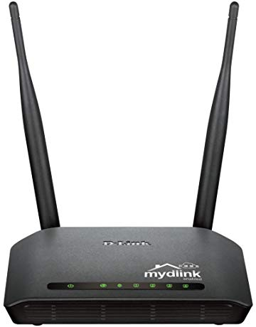](https://www.amazon.com/D-Link-Wireless-App-Enabled-Broadband-DIR-605L/dp/B006TZM6XO?ref_=Oct_UPriceC_300189_8&pf_rd_r=SA07QM4Q5S23C07F7VTB&pf_rd_p=6f74083a-4541-5fc3-91f1-2d621a6b118d&pf_rd_s=merchandised-search-6&pf_rd_t=101&pf_rd_i=300189&pf_rd_m=ATVPDKIKX0DER)](https://www.amazon.com/D-Link-Wireless-App-Enabled-Broadband-DIR-605L/dp/B006TZM6XO?ref_=Oct_UPriceC_300189_8&pf_rd_r=SA07QM4Q5S23C07F7VTB&pf_rd_p=6f74083a-4541-5fc3-91f1-2d621a6b118d&pf_rd_s=merchandised-search-6&pf_rd_t=101&pf_rd_i=300189&pf_rd_m=ATVPDKIKX0DER" \o "D-Link Wireless N 300 Mbps Home Cloud App-Enabled Broadband Router (DIR-605L))

[price$19.99](https://www.amazon.com/D-Link-Wireless-App-Enabled-Broadband-DIR-605L/dp/B006TZM6XO?ref_=Oct_UPriceC_300189_8&pf_rd_r=SA07QM4Q5S23C07F7VTB&pf_rd_p=6f74083a-4541-5fc3-91f1-2d621a6b118d&pf_rd_s=merchandised-search-6&pf_rd_t=101&pf_rd_i=300189&pf_rd_m=ATVPDKIKX0DER" \o "D-Link Wireless N 300 Mbps Home Cloud App-Enabled Broadband Router (DIR-605L))

[D-Link Wireless N 300 Mbps Home Cloud App-Enabled Broadband Router (DIR-605L)](https://www.amazon.com/D-Link-Wireless-App-Enabled-Broadband-DIR-605L/dp/B006TZM6XO?ref_=Oct_UPriceC_300189_8&pf_rd_r=SA07QM4Q5S23C07F7VTB&pf_rd_p=6f74083a-4541-5fc3-91f1-2d621a6b118d&pf_rd_s=merchandised-search-6&pf_rd_t=101&pf_rd_i=300189&pf_rd_m=ATVPDKIKX0DER" \o "D-Link Wireless N 300 Mbps Home Cloud App-Enabled Broadband Router (DIR-605L))

[[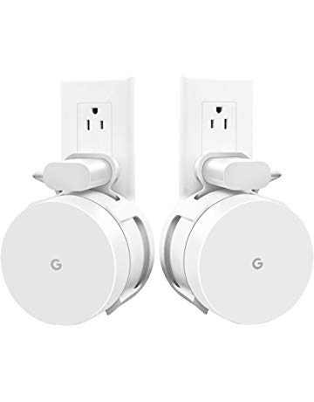](https://www.amazon.com/AMORTEK-Upgraded-Google-Accessories-Without/dp/B07DL3XSBC?ref_=Oct_UPriceC_300189_9&pf_rd_r=SA07QM4Q5S23C07F7VTB&pf_rd_p=6f74083a-4541-5fc3-91f1-2d621a6b118d&pf_rd_s=merchandised-search-6&pf_rd_t=101&pf_rd_i=300189&pf_rd_m=ATVPDKIKX0DER)](https://www.amazon.com/AMORTEK-Upgraded-Google-Accessories-Without/dp/B07DL3XSBC?ref_=Oct_UPriceC_300189_9&pf_rd_r=SA07QM4Q5S23C07F7VTB&pf_rd_p=6f74083a-4541-5fc3-91f1-2d621a6b118d&pf_rd_s=merchandised-search-6&pf_rd_t=101&pf_rd_i=300189&pf_rd_m=ATVPDKIKX0DER" \o "[Upgraded] Google WiFi Wall Mount, WiFi Accessories for Google Mesh WiFi System and Google WiFi Router Without Messy Wires or Screws (White(2 Pack)))

[price$13.99](https://www.amazon.com/AMORTEK-Upgraded-Google-Accessories-Without/dp/B07DL3XSBC?ref_=Oct_UPriceC_300189_9&pf_rd_r=SA07QM4Q5S23C07F7VTB&pf_rd_p=6f74083a-4541-5fc3-91f1-2d621a6b118d&pf_rd_s=merchandised-search-6&pf_rd_t=101&pf_rd_i=300189&pf_rd_m=ATVPDKIKX0DER" \o "[Upgraded] Google WiFi Wall Mount, WiFi Accessories for Google Mesh WiFi System and Google WiFi Router Without Messy Wires or Screws (White(2 Pack)))

[[Upgraded] Google WiFi Wall Mount, WiFi Accessories for Google Mesh WiFi System and Google WiFi Router Without Messy Wires or Screws (White(2 Pack))](https://www.amazon.com/AMORTEK-Upgraded-Google-Accessories-Without/dp/B07DL3XSBC?ref_=Oct_UPriceC_300189_9&pf_rd_r=SA07QM4Q5S23C07F7VTB&pf_rd_p=6f74083a-4541-5fc3-91f1-2d621a6b118d&pf_rd_s=merchandised-search-6&pf_rd_t=101&pf_rd_i=300189&pf_rd_m=ATVPDKIKX0DER" \o "[Upgraded] Google WiFi Wall Mount, WiFi Accessories for Google Mesh WiFi System and Google WiFi Router Without Messy Wires or Screws (White(2 Pack)))

[[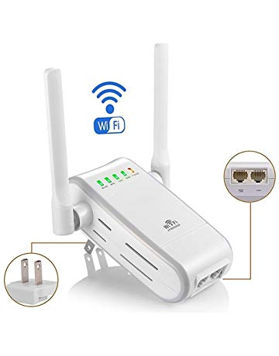](https://www.amazon.com/DHMXDC-Wireless-N-Extender-Wireless-Repeater/dp/B01JOFIBV6?ref_=Oct_UPriceC_300189_10&pf_rd_r=SA07QM4Q5S23C07F7VTB&pf_rd_p=6f74083a-4541-5fc3-91f1-2d621a6b118d&pf_rd_s=merchandised-search-6&pf_rd_t=101&pf_rd_i=300189&pf_rd_m=ATVPDKIKX0DER)](https://www.amazon.com/DHMXDC-Wireless-N-Extender-Wireless-Repeater/dp/B01JOFIBV6?ref_=Oct_UPriceC_300189_10&pf_rd_r=SA07QM4Q5S23C07F7VTB&pf_rd_p=6f74083a-4541-5fc3-91f1-2d621a6b118d&pf_rd_s=merchandised-search-6&pf_rd_t=101&pf_rd_i=300189&pf_rd_m=ATVPDKIKX0DER" \o "DHMXDC Wireless-N 300Mbps WiFi Range Extender Wireless Router/Repeater/AP/Wps Mini Dual External Antennas Wireless Booster Signal Wireless Access Point)

[price$25.00](https://www.amazon.com/DHMXDC-Wireless-N-Extender-Wireless-Repeater/dp/B01JOFIBV6?ref_=Oct_UPriceC_300189_10&pf_rd_r=SA07QM4Q5S23C07F7VTB&pf_rd_p=6f74083a-4541-5fc3-91f1-2d621a6b118d&pf_rd_s=merchandised-search-6&pf_rd_t=101&pf_rd_i=300189&pf_rd_m=ATVPDKIKX0DER" \o "DHMXDC Wireless-N 300Mbps WiFi Range Extender Wireless Router/Repeater/AP/Wps Mini Dual External Antennas Wireless Booster Signal Wireless Access Point)

[DHMXDC Wireless-N 300Mbps WiFi Range Extender Wireless Router/Repeater/AP/Wps Mini Dual External Antennas Wireless Booster Signal Wireless Access Point](https://www.amazon.com/DHMXDC-Wireless-N-Extender-Wireless-Repeater/dp/B01JOFIBV6?ref_=Oct_UPriceC_300189_10&pf_rd_r=SA07QM4Q5S23C07F7VTB&pf_rd_p=6f74083a-4541-5fc3-91f1-2d621a6b118d&pf_rd_s=merchandised-search-6&pf_rd_t=101&pf_rd_i=300189&pf_rd_m=ATVPDKIKX0DER" \o "DHMXDC Wireless-N 300Mbps WiFi Range Extender Wireless Router/Repeater/AP/Wps Mini Dual External Antennas Wireless Booster Signal Wireless Access Point)

[[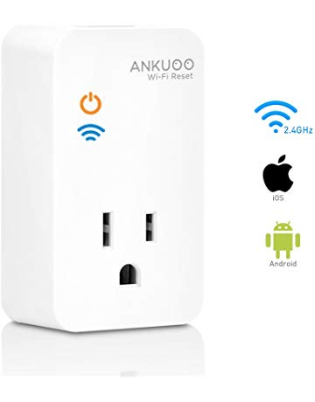](https://www.amazon.com/Router-Access-Points-Reseter-Monitor-Reset/dp/B07BXJPQD7?ref_=Oct_UPriceC_300189_11&pf_rd_r=SA07QM4Q5S23C07F7VTB&pf_rd_p=6f74083a-4541-5fc3-91f1-2d621a6b118d&pf_rd_s=merchandised-search-6&pf_rd_t=101&pf_rd_i=300189&pf_rd_m=ATVPDKIKX0DER)](https://www.amazon.com/Router-Access-Points-Reseter-Monitor-Reset/dp/B07BXJPQD7?ref_=Oct_UPriceC_300189_11&pf_rd_r=SA07QM4Q5S23C07F7VTB&pf_rd_p=6f74083a-4541-5fc3-91f1-2d621a6b118d&pf_rd_s=merchandised-search-6&pf_rd_t=101&pf_rd_i=300189&pf_rd_m=ATVPDKIKX0DER" \o "Wi-Fi Router Reset, Wi-Fi Router/Modem/Access Points Reseter, Auto Monitor and Reset if Wi-Fi Fails, Works with REC App, White)

[price$20.99](https://www.amazon.com/Router-Access-Points-Reseter-Monitor-Reset/dp/B07BXJPQD7?ref_=Oct_UPriceC_300189_11&pf_rd_r=SA07QM4Q5S23C07F7VTB&pf_rd_p=6f74083a-4541-5fc3-91f1-2d621a6b118d&pf_rd_s=merchandised-search-6&pf_rd_t=101&pf_rd_i=300189&pf_rd_m=ATVPDKIKX0DER" \o "Wi-Fi Router Reset, Wi-Fi Router/Modem/Access Points Reseter, Auto Monitor and Reset if Wi-Fi Fails, Works with REC App, White)

[Wi-Fi Router Reset, Wi-Fi Router/Modem/Access Points Reseter, Auto Monitor and Reset if Wi-Fi Fails, Works with REC App, White](https://www.amazon.com/Router-Access-Points-Reseter-Monitor-Reset/dp/B07BXJPQD7?ref_=Oct_UPriceC_300189_11&pf_rd_r=SA07QM4Q5S23C07F7VTB&pf_rd_p=6f74083a-4541-5fc3-91f1-2d621a6b118d&pf_rd_s=merchandised-search-6&pf_rd_t=101&pf_rd_i=300189&pf_rd_m=ATVPDKIKX0DER" \o "Wi-Fi Router Reset, Wi-Fi Router/Modem/Access Points Reseter, Auto Monitor and Reset if Wi-Fi Fails, Works with REC App, White)

1-24 of over 2,000 results for [Electronics](https://www.amazon.com/s/ref=lp_300189_hi_1?rh=n%3A172282&ie=UTF8&qid=1546450385) : [Computers & Accessories](https://www.amazon.com/s/ref=lp_300189_hi_2?rh=n%3A172282%2Cn%3A%21493964%2Cn%3A541966&ie=UTF8&qid=1546450385) : [Networking Products](https://www.amazon.com/s/ref=lp_300189_hi_3?rh=n%3A172282%2Cn%3A%21493964%2Cn%3A541966%2Cn%3A172504&ie=UTF8&qid=1546450385) : Routers

أعلى النموذج

Sort by  <input type="image" src="https://images-na.ssl-images-amazon.com/images/G/01/buttons/go-orange-trans._CB192189913_.gif" width="21" alt="Go" align="top" value="Go" height="21" border="0" />

أسفل النموذج

[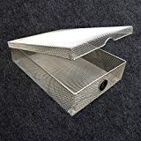](https://www.amazon.com/WiFi-Router-Guard-Large-Blocks/dp/B01IJD22YG/ref=lp_300189_1_1?s=pc&ie=UTF8&qid=1546450385&sr=1-1)

[WiFi Router Guard - Blocks EMF Exposure](https://www.amazon.com/WiFi-Router-Guard-Large-Blocks/dp/B01IJD22YG/ref=lp_300189_1_1?s=pc&ie=UTF8&qid=1546450385&sr=1-1" \o "WiFi Router Guard - Blocks EMF Exposure)

by Router Guard

[$52.95 $ 52 95](https://www.amazon.com/WiFi-Router-Guard-Large-Blocks/dp/B01IJD22YG/ref=lp_300189_1_1?s=pc&ie=UTF8&qid=1546450385&sr=1-1)

[3.6 out of 5 stars](javascript:void(0)) [30](https://www.amazon.com/WiFi-Router-Guard-Large-Blocks/dp/B01IJD22YG/ref=lp_300189_1_1?s=pc&ie=UTF8&qid=1546450385&sr=1-1#customerReviews)

[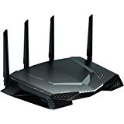](https://www.amazon.com/NETGEAR-Nighthawk-Optimized-Certified-Refurbished/dp/B07KXWG9Q2/ref=lp_300189_1_2?s=pc&ie=UTF8&qid=1546450385&sr=1-2)

[NETGEAR Nighthawk Pro Gaming XR500 WiFi Router with 4 Ethernet Ports and Wireless speeds up to 2.6 Gbps, AC2600, Optimized for Low ping (Certified Refurbished)](https://www.amazon.com/NETGEAR-Nighthawk-Optimized-Certified-Refurbished/dp/B07KXWG9Q2/ref=lp_300189_1_2?s=pc&ie=UTF8&qid=1546450385&sr=1-2" \o "NETGEAR Nighthawk Pro Gaming XR500 WiFi Router with 4 Ethernet Ports and Wireless speeds up to 2.6 Gbps, AC2600, Optimized for Low ping (Certified Refurbished))

by NETGEAR

[$278.63 $ 278 63](https://www.amazon.com/NETGEAR-Nighthawk-Optimized-Certified-Refurbished/dp/B07KXWG9Q2/ref=lp_300189_1_2?s=pc&ie=UTF8&qid=1546450385&sr=1-2)

Only 5 left in stock - order soon.

[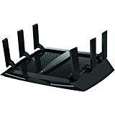](https://www.amazon.com/R7000P-100NAS-Nighthawk-Compatible-Certified-Refurbished/dp/B07K3Z892V/ref=lp_300189_1_3?s=pc&ie=UTF8&qid=1546450385&sr=1-3)

[Netgear (R7000P-100NAS) Nighthawk AC2300 Dual Band Smart WiFi Router, Gigabit Ethernet, MU-MIMO, Compatible with Amazon Echo/Alexa and Circle Smart Parental Controls (Certified Refurbished)](https://www.amazon.com/R7000P-100NAS-Nighthawk-Compatible-Certified-Refurbished/dp/B07K3Z892V/ref=lp_300189_1_3?s=pc&ie=UTF8&qid=1546450385&sr=1-3" \o "Netgear (R7000P-100NAS) Nighthawk AC2300 Dual Band Smart WiFi Router, Gigabit Ethernet, MU-MIMO, Compatible with Amazon Echo/Alexa and Circle Smart Parental Controls (Certified Refurbished))

by NETGEAR

[$155.81 $ 155 81](https://www.amazon.com/R7000P-100NAS-Nighthawk-Compatible-Certified-Refurbished/dp/B07K3Z892V/ref=lp_300189_1_3?s=pc&ie=UTF8&qid=1546450385&sr=1-3)

[4.6 out of 5 stars](javascript:void(0)) [3](https://www.amazon.com/R7000P-100NAS-Nighthawk-Compatible-Certified-Refurbished/dp/B07K3Z892V/ref=lp_300189_1_3?s=pc&ie=UTF8&qid=1546450385&sr=1-3#customerReviews)

[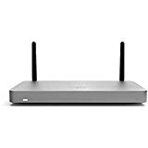](https://www.amazon.com/MX67W-HW-Cisco-Meraki-Managed-Firewall/dp/B07KKYHDKF/ref=lp_300189_1_4?s=pc&ie=UTF8&qid=1546450385&sr=1-4)

[MX67W-HW Cisco Meraki, MX67W Meraki Cloud Managed Firewall with: LIC-ENT-3YR - 3 Year Cisco Meraki Enterprise License](https://www.amazon.com/MX67W-HW-Cisco-Meraki-Managed-Firewall/dp/B07KKYHDKF/ref=lp_300189_1_4?s=pc&ie=UTF8&qid=1546450385&sr=1-4" \o "MX67W-HW Cisco Meraki, MX67W Meraki Cloud Managed Firewall with: LIC-ENT-3YR - 3 Year Cisco Meraki Enterprise License)

by Meraki

[$1,167.95 $ 1,167 95](https://www.amazon.com/MX67W-HW-Cisco-Meraki-Managed-Firewall/dp/B07KKYHDKF/ref=lp_300189_1_4?s=pc&ie=UTF8&qid=1546450385&sr=1-4)

[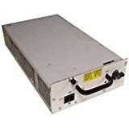](https://www.amazon.com/Cisco-PWR-GSR8-AC-12008-Router-Supply/dp/B071L9DTPH/ref=lp_300189_1_5?s=pc&ie=UTF8&qid=1546450385&sr=1-5)

[Cisco PWR-GSR8-AC 12008 Router AC Power Supply](https://www.amazon.com/Cisco-PWR-GSR8-AC-12008-Router-Supply/dp/B071L9DTPH/ref=lp_300189_1_5?s=pc&ie=UTF8&qid=1546450385&sr=1-5" \o "Cisco PWR-GSR8-AC 12008 Router AC Power Supply)

by CscoSystems

[$579.99(1 used offer)](https://www.amazon.com/gp/offer-listing/B071L9DTPH/ref=lp_300189_1_5_olp?s=pc&ie=UTF8&qid=1546450385&sr=1-5&condition=used)

[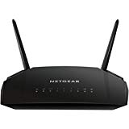](https://www.amazon.com/NETGEAR-Gigabit-Ethernet-Certified-Refurbished/dp/B07KXWND3L/ref=lp_300189_1_6?s=pc&ie=UTF8&qid=1546450385&sr=1-6)

[NETGEAR AC1200 Dual Band Smart WiFi Router, Gigabit Ethernet (R6230) (Certified Refurbished)](https://www.amazon.com/NETGEAR-Gigabit-Ethernet-Certified-Refurbished/dp/B07KXWND3L/ref=lp_300189_1_6?s=pc&ie=UTF8&qid=1546450385&sr=1-6" \o "NETGEAR AC1200 Dual Band Smart WiFi Router, Gigabit Ethernet (R6230) (Certified Refurbished))

by NETGEAR

[$45.51 $ 45 51](https://www.amazon.com/NETGEAR-Gigabit-Ethernet-Certified-Refurbished/dp/B07KXWND3L/ref=lp_300189_1_6?s=pc&ie=UTF8&qid=1546450385&sr=1-6)

Only 8 left in stock - order soon.

[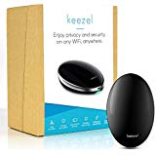](https://www.amazon.com/Keezel-VPN-Portable-Router-Connection/dp/B07JJ87V6K/ref=lp_300189_1_7?s=pc&ie=UTF8&qid=1546450385&sr=1-7)

[Keezel VPN Portable Router: for Wireless Internet Connection with Built in Firewall – Premium VPN Router That Creates Online Security and Privacy on Any Wi-Fi Network - Travel Power Bank Included](https://www.amazon.com/Keezel-VPN-Portable-Router-Connection/dp/B07JJ87V6K/ref=lp_300189_1_7?s=pc&ie=UTF8&qid=1546450385&sr=1-7" \o "Keezel VPN Portable Router: for Wireless Internet Connection with Built in Firewall – Premium VPN Router That Creates Online Security and Privacy on Any Wi-Fi Network - Travel Power Bank Included)

by Keezel

[$499.00 $ 499 00](https://www.amazon.com/Keezel-VPN-Portable-Router-Connection/dp/B07JJ87V6K/ref=lp_300189_1_7?s=pc&ie=UTF8&qid=1546450385&sr=1-7)

Only 19 left in stock - order soon.

[Save 5% with coupon](https://www.amazon.com/Keezel-VPN-Portable-Router-Connection/dp/B07JJ87V6K/ref=lp_300189_1_7_cpbg?s=pc&ie=UTF8&qid=1546450385&sr=1-7)

[3.1 out of 5 stars](javascript:void(0)) [24](https://www.amazon.com/Keezel-VPN-Portable-Router-Connection/dp/B07JJ87V6K/ref=lp_300189_1_7?s=pc&ie=UTF8&qid=1546450385&sr=1-7#customerReviews)

[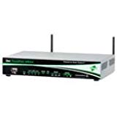](https://www.amazon.com/WR44-L5F1-TE1-RF-Cellular-Router-Transport-WR44R/dp/B07DY8TQYY/ref=lp_300189_1_8?s=pc&ie=UTF8&qid=1546450385&sr=1-8)

[DIGI WR44-L5F1-TE1-RF Cellular Router, Transport WR44R - LTE North America Multi-Carrier, 700/850/1700AWS/1900 MHz, Fleet I/O, Dual WiFi B/G/N, Enterp SW Package, 5 VPN Tunnels, Exted Temp,](https://www.amazon.com/WR44-L5F1-TE1-RF-Cellular-Router-Transport-WR44R/dp/B07DY8TQYY/ref=lp_300189_1_8?s=pc&ie=UTF8&qid=1546450385&sr=1-8" \o "DIGI WR44-L5F1-TE1-RF Cellular Router, Transport WR44R - LTE North America Multi-Carrier, 700/850/1700AWS/1900 MHz, Fleet I/O, Dual WiFi B/G/N, Enterp SW Package, 5 VPN Tunnels, Exted Temp,)

by Digi

[$1,899.00 $ 1,899 00](https://www.amazon.com/WR44-L5F1-TE1-RF-Cellular-Router-Transport-WR44R/dp/B07DY8TQYY/ref=lp_300189_1_8?s=pc&ie=UTF8&qid=1546450385&sr=1-8)

Only 3 left in stock - order soon.

[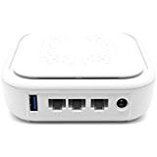](https://www.amazon.com/Hidden-WiFi-Router-Service-Included/dp/B07BNP5HDR/ref=lp_300189_1_9?s=pc&ie=UTF8&qid=1546450385&sr=1-9)

[Hidden WiFi VPN Router (1 Year VPN Service Included)](https://www.amazon.com/Hidden-WiFi-Router-Service-Included/dp/B07BNP5HDR/ref=lp_300189_1_9?s=pc&ie=UTF8&qid=1546450385&sr=1-9" \o "Hidden WiFi VPN Router (1 Year VPN Service Included))

by Hidden Router

[$315.51(1 new offer)](https://www.amazon.com/gp/offer-listing/B07BNP5HDR/ref=lp_300189_1_9_olp?s=pc&ie=UTF8&qid=1546450385&sr=1-9&condition=new)

[5 out of 5 stars](javascript:void(0)) [1](https://www.amazon.com/Hidden-WiFi-Router-Service-Included/dp/B07BNP5HDR/ref=lp_300189_1_9?s=pc&ie=UTF8&qid=1546450385&sr=1-9#customerReviews)

[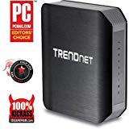](https://www.amazon.com/TRENDnet-TEW-812DRU-Wireless-Certified-Refurbished/dp/B017WPUAL4/ref=lp_300189_1_10?s=pc&ie=UTF8&qid=1546450385&sr=1-10)

[TRENDnet TEW-812DRU V1.0R AC1750 Dual Band Wireless Router (Certified Refurbished)](https://www.amazon.com/TRENDnet-TEW-812DRU-Wireless-Certified-Refurbished/dp/B017WPUAL4/ref=lp_300189_1_10?s=pc&ie=UTF8&qid=1546450385&sr=1-10" \o "TRENDnet TEW-812DRU V1.0R AC1750 Dual Band Wireless Router (Certified Refurbished))

by TRENDnet

[$19.95(1 new offer)](https://www.amazon.com/gp/offer-listing/B017WPUAL4/ref=lp_300189_1_10_olp?s=pc&ie=UTF8&qid=1546450385&sr=1-10&condition=new)

[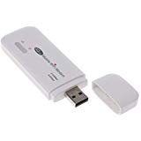](https://www.amazon.com/BYNNIX-Router-150Mbps-Hotspot-Unlocked/dp/B07K2SY9SX/ref=lp_300189_1_11?s=pc&ie=UTF8&qid=1546450385&sr=1-11)

[BYNNIX 4G LTE FDD WiFi Router 150Mbps Mobile Hotspot WiFi Modem Unlocked 3G 4G Router](https://www.amazon.com/BYNNIX-Router-150Mbps-Hotspot-Unlocked/dp/B07K2SY9SX/ref=lp_300189_1_11?s=pc&ie=UTF8&qid=1546450385&sr=1-11" \o "BYNNIX 4G LTE FDD WiFi Router 150Mbps Mobile Hotspot WiFi Modem Unlocked 3G 4G Router)

by BYNNIX

[$23.99 $ 23 99](https://www.amazon.com/BYNNIX-Router-150Mbps-Hotspot-Unlocked/dp/B07K2SY9SX/ref=lp_300189_1_11?s=pc&ie=UTF8&qid=1546450385&sr=1-11)

[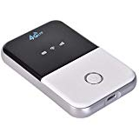](https://www.amazon.com/Portable-yodaliy-Unlocked-Networks-Configuration/dp/B07J4LDXF8/ref=lp_300189_1_12?s=pc&ie=UTF8&qid=1546450385&sr=1-12)

[Portable WiFi Router, yodaliy 4G Travel Wi-Fi Hotspot, Unlocked to All World Networks, No Configuration Required 4G Mobile LTE MIFI Router at Home and Abroad](https://www.amazon.com/Portable-yodaliy-Unlocked-Networks-Configuration/dp/B07J4LDXF8/ref=lp_300189_1_12?s=pc&ie=UTF8&qid=1546450385&sr=1-12" \o "Portable WiFi Router, yodaliy 4G Travel Wi-Fi Hotspot, Unlocked to All World Networks, No Configuration Required 4G Mobile LTE MIFI Router at Home and Abroad)

by yodaliy

[$33.99(1 new offer)](https://www.amazon.com/gp/offer-listing/B07J4LDXF8/ref=lp_300189_1_12_olp?s=pc&ie=UTF8&qid=1546450385&sr=1-12&condition=new)

[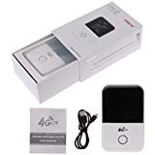](https://www.amazon.com/Yuly-Wireless-Portable-Hotspot-Display/dp/B07GLMC926/ref=lp_300189_1_13?s=pc&ie=UTF8&qid=1546450385&sr=1-13)

[Yuly 4G WiFi Router Wireless Portable Pocket WiFi Mobile Hotspot Car Wi-fi Router 3G 4G LTE with Sim Card Slot with 1.45 inch LCD Display MF825s(Mini)](https://www.amazon.com/Yuly-Wireless-Portable-Hotspot-Display/dp/B07GLMC926/ref=lp_300189_1_13?s=pc&ie=UTF8&qid=1546450385&sr=1-13" \o "Yuly 4G WiFi Router Wireless Portable Pocket WiFi Mobile Hotspot Car Wi-fi Router 3G 4G LTE with Sim Card Slot with 1.45 inch LCD Display MF825s(Mini))

by Yuly

[$32.04(1 new offer)](https://www.amazon.com/gp/offer-listing/B07GLMC926/ref=lp_300189_1_13_olp?s=pc&ie=UTF8&qid=1546450385&sr=1-13&condition=new)

[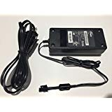](https://www.amazon.com/Supply-Adapter-SonicWall-TZ-105W-APL41-0BA/dp/B07FLHLG55/ref=lp_300189_1_14?s=pc&ie=UTF8&qid=1546450385&sr=1-14)

[Power Supply Adapter SonicWall Sonic Wall TZ400 TZ300 TZ210 TZ205W TZ-105W APL41-0BA](https://www.amazon.com/Supply-Adapter-SonicWall-TZ-105W-APL41-0BA/dp/B07FLHLG55/ref=lp_300189_1_14?s=pc&ie=UTF8&qid=1546450385&sr=1-14" \o "Power Supply Adapter SonicWall Sonic Wall TZ400 TZ300 TZ210 TZ205W TZ-105W APL41-0BA)

by Sonicwall

[$29.99(1 used offer)](https://www.amazon.com/gp/offer-listing/B07FLHLG55/ref=lp_300189_1_14_olp?s=pc&ie=UTF8&qid=1546450385&sr=1-14&condition=used)

[](https://www.amazon.com/FORTINET-Fortigate-Supply-FortiGate-60D-FG-60D/dp/B07G1BZXJK/ref=lp_300189_1_15?s=pc&ie=UTF8&qid=1546450385&sr=1-15)

[FORTINET Fortigate Power Supply FortiGate-60D FG-60D FG-60C FG-40C FG30E FG-50E](https://www.amazon.com/FORTINET-Fortigate-Supply-FortiGate-60D-FG-60D/dp/B07G1BZXJK/ref=lp_300189_1_15?s=pc&ie=UTF8&qid=1546450385&sr=1-15" \o "FORTINET Fortigate Power Supply FortiGate-60D FG-60D FG-60C FG-40C FG30E FG-50E)

by FORTINET

[$29.99(1 used offer)](https://www.amazon.com/gp/offer-listing/B07G1BZXJK/ref=lp_300189_1_15_olp?s=pc&ie=UTF8&qid=1546450385&sr=1-15&condition=used)

[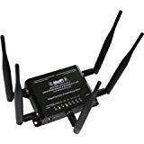](https://www.amazon.com/MOFI4500-4GXeLTE-SIM4-GPS-Router-T-Mobile-Verizon-Embedded/dp/B01N8VD8XT/ref=lp_300189_1_16?s=pc&ie=UTF8&qid=1546450385&sr=1-16)

[MOFI4500-4GXeLTE-SIM4-GPS 4G/LTE GPS Router AT&T T-Mobile Verizon Embedded SIM with Band 12](https://www.amazon.com/MOFI4500-4GXeLTE-SIM4-GPS-Router-T-Mobile-Verizon-Embedded/dp/B01N8VD8XT/ref=lp_300189_1_16?s=pc&ie=UTF8&qid=1546450385&sr=1-16" \o "MOFI4500-4GXeLTE-SIM4-GPS 4G/LTE GPS Router AT&T T-Mobile Verizon Embedded SIM with Band 12)

by MOFINETWORK

[$399.99 $ 399 99](https://www.amazon.com/MOFI4500-4GXeLTE-SIM4-GPS-Router-T-Mobile-Verizon-Embedded/dp/B01N8VD8XT/ref=lp_300189_1_16?s=pc&ie=UTF8&qid=1546450385&sr=1-16)

[1 out of 5 stars](javascript:void(0)) [1](https://www.amazon.com/MOFI4500-4GXeLTE-SIM4-GPS-Router-T-Mobile-Verizon-Embedded/dp/B01N8VD8XT/ref=lp_300189_1_16?s=pc&ie=UTF8&qid=1546450385&sr=1-16#customerReviews)

[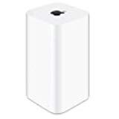](https://www.amazon.com/Apple-Wireless-Certified-Refurbished-Condition/dp/B07D4KZLHL/ref=lp_300189_1_17?s=pc&ie=UTF8&qid=1546450385&sr=1-17)

[Apple AirPort Extreme Base Station Wireless Router Condition Includes a90 Day Warranty(Refurbished)](https://www.amazon.com/Apple-Wireless-Certified-Refurbished-Condition/dp/B07D4KZLHL/ref=lp_300189_1_17?s=pc&ie=UTF8&qid=1546450385&sr=1-17" \o "Apple AirPort Extreme Base Station Wireless Router Condition Includes a90 Day Warranty(Refurbished))

by Apple

[$128.00 $ 128 00](https://www.amazon.com/Apple-Wireless-Certified-Refurbished-Condition/dp/B07D4KZLHL/ref=lp_300189_1_17?s=pc&ie=UTF8&qid=1546450385&sr=1-17)

Only 1 left in stock - order soon.

[[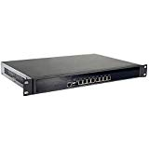](https://www.amazon.com/Firewall-Mikrotik-Rackmount-Appliance-HUNSN/dp/B07G5DR2QD/ref=lp_300189_1_18?s=pc&ie=UTF8&qid=1546450385&sr=1-18)](https://www.amazon.com/Firewall-Mikrotik-Rackmount-Appliance-HUNSN/dp/B07G5DR2QD/ref=lp_300189_1_18?s=pc&ie=UTF8&qid=1546450385&sr=1-18)

[Firewall, Mikrotik, Pfsense, VPN, 1U Rackmount, Network Security Appliance,AES-NI,Router PC,Intel Core I5 2467M/2557M,(Gray),[HUNSN RS14],[8 Intel Gigabit Lan/2USB3.0/1COM/1VGA],(4G RAM/32G SSD)](https://www.amazon.com/Firewall-Mikrotik-Rackmount-Appliance-HUNSN/dp/B07G5DR2QD/ref=lp_300189_1_18?s=pc&ie=UTF8&qid=1546450385&sr=1-18" \o "Firewall, Mikrotik, Pfsense, VPN, 1U Rackmount, Network Security Appliance,AES-NI,Router PC,Intel Core I5 2467M/2557M,(Gray),[HUNSN RS14],[8 Intel Gigabit Lan/2USB3.0/1COM/1VGA],(4G RAM/32G SSD))

by HUNSN

[$391.99 $ 391 99](https://www.amazon.com/Firewall-Mikrotik-Rackmount-Appliance-HUNSN/dp/B07G5DR2QD/ref=lp_300189_1_18?s=pc&ie=UTF8&qid=1546450385&sr=1-18)

Only 9 left in stock - order soon.

Price may vary by color

[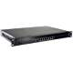](https://www.amazon.com/dp/B07DHBQH3G/ref=lp_300189_1_18_twi_col_2?s=pc&ie=UTF8&qid=1546450385&sr=1-18)

[](https://www.amazon.com/dp/B07DHCCCJV/ref=lp_300189_1_18_twi_col_3?s=pc&ie=UTF8&qid=1546450385&sr=1-18)

[](https://www.amazon.com/dp/B07DHCGML1/ref=lp_300189_1_18_twi_col_4?s=pc&ie=UTF8&qid=1546450385&sr=1-18)

[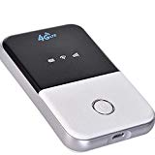](https://www.amazon.com/Mobile-Wireless-Hotspot-Portable-Partner/dp/B07JZ4JDMD/ref=lp_300189_1_19?s=pc&ie=UTF8&qid=1546450385&sr=1-19)

[4G LTE Mobile WiFi Wireless Pocket Hotspot Portable Router Modem Travel Partner Mini Router](https://www.amazon.com/Mobile-Wireless-Hotspot-Portable-Partner/dp/B07JZ4JDMD/ref=lp_300189_1_19?s=pc&ie=UTF8&qid=1546450385&sr=1-19" \o "4G LTE Mobile WiFi Wireless Pocket Hotspot Portable Router Modem Travel Partner Mini Router)

by Boger

[$42.87 $ 42 87](https://www.amazon.com/Mobile-Wireless-Hotspot-Portable-Partner/dp/B07JZ4JDMD/ref=lp_300189_1_19?s=pc&ie=UTF8&qid=1546450385&sr=1-19)

[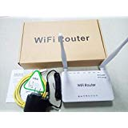](https://www.amazon.com/BTFLY-Butterfly-Traveler-Converter-Portable/dp/B07J6SZ2G9/ref=lp_300189_1_20?s=pc&ie=UTF8&qid=1546450385&sr=1-20)

[BTFLY Butterfly VPN Router Traveler Mini Router WiFi Converter Portable VPN Device (Home VPN Router)](https://www.amazon.com/BTFLY-Butterfly-Traveler-Converter-Portable/dp/B07J6SZ2G9/ref=lp_300189_1_20?s=pc&ie=UTF8&qid=1546450385&sr=1-20" \o "BTFLY Butterfly VPN Router Traveler Mini Router WiFi Converter Portable VPN Device (Home VPN Router))

by BTFLY

[$85.00(1 new offer)](https://www.amazon.com/gp/offer-listing/B07J6SZ2G9/ref=lp_300189_1_20_olp?s=pc&ie=UTF8&qid=1546450385&sr=1-20&condition=new)

[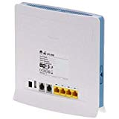](https://www.amazon.com/FidgetFidget-Wireless-Unlocked-B593s-22-Gateway/dp/B07KQFH44R/ref=lp_300189_1_21?s=pc&ie=UTF8&qid=1546450385&sr=1-21)

[FidgetFidget Wireless Router for Unlocked LTE CPE Huaewi B593 B593s-22 4G Router Gateway 150Mbps](https://www.amazon.com/FidgetFidget-Wireless-Unlocked-B593s-22-Gateway/dp/B07KQFH44R/ref=lp_300189_1_21?s=pc&ie=UTF8&qid=1546450385&sr=1-21" \o "FidgetFidget Wireless Router for Unlocked LTE CPE Huaewi B593 B593s-22 4G Router Gateway 150Mbps)

by FidgetFidget

[$197.10(1 new offer)](https://www.amazon.com/gp/offer-listing/B07KQFH44R/ref=lp_300189_1_21_olp?s=pc&ie=UTF8&qid=1546450385&sr=1-21&condition=new)

[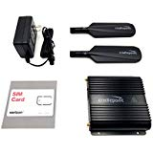](https://www.amazon.com/Cradlepoint-IBR650B-LP4-Integrated-Broadband-Wireless/dp/B07HCRSHBP/ref=lp_300189_1_22?s=pc&ie=UTF8&qid=1546450385&sr=1-22)

[Cradlepoint IBR650B-LP4 Integrated Broadband Router Bundle with Verizon Wireless SIM Card](https://www.amazon.com/Cradlepoint-IBR650B-LP4-Integrated-Broadband-Wireless/dp/B07HCRSHBP/ref=lp_300189_1_22?s=pc&ie=UTF8&qid=1546450385&sr=1-22" \o "Cradlepoint IBR650B-LP4 Integrated Broadband Router Bundle with Verizon Wireless SIM Card)

by Cradlepoint

[$429.00 $ 429 00](https://www.amazon.com/Cradlepoint-IBR650B-LP4-Integrated-Broadband-Wireless/dp/B07HCRSHBP/ref=lp_300189_1_22?s=pc&ie=UTF8&qid=1546450385&sr=1-22)

Only 12 left in stock - order soon.

More Buying Choices

[$283.27(1 used offer)](https://www.amazon.com/gp/offer-listing/B07HCRSHBP/ref=lp_300189_1_22_olp?s=pc&ie=UTF8&qid=1546450385&sr=1-22&condition=used)

[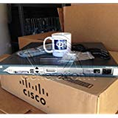](https://www.amazon.com/CISCO2811-HSEC-CISCO-ROUTER-AIM-VPN-ADvIPServ/dp/B006WQNS6E/ref=lp_300189_1_23?s=pc&ie=UTF8&qid=1546450385&sr=1-23)

[CISCO2811-HSEC/K9 CISCO ROUTER 2811 BNDL W/AIM-VPN/SSL-2,ADvIPServ,10 SSL LIC,64F/256D](https://www.amazon.com/CISCO2811-HSEC-CISCO-ROUTER-AIM-VPN-ADvIPServ/dp/B006WQNS6E/ref=lp_300189_1_23?s=pc&ie=UTF8&qid=1546450385&sr=1-23" \o "CISCO2811-HSEC/K9 CISCO ROUTER 2811 BNDL W/AIM-VPN/SSL-2,ADvIPServ,10 SSL LIC,64F/256D)

by CISCO SYSTEMS - ENTERPRISE

[$98.82(4 used offers)](https://www.amazon.com/gp/offer-listing/B006WQNS6E/ref=lp_300189_1_23_olp?s=pc&ie=UTF8&qid=1546450385&sr=1-23&condition=used)

[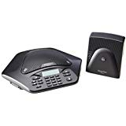](https://www.amazon.com/Wireless-Conference-910-158-400-Certified-Refurbished/dp/B07FW7DGX5/ref=lp_300189_1_24?s=pc&ie=UTF8&qid=1546450385&sr=1-24)

[Clear One Max Wireless One Phone Conference System RoHS 910-158-400 (Certified Refurbished)](https://www.amazon.com/Wireless-Conference-910-158-400-Certified-Refurbished/dp/B07FW7DGX5/ref=lp_300189_1_24?s=pc&ie=UTF8&qid=1546450385&sr=1-24" \o "Clear One Max Wireless One Phone Conference System RoHS 910-158-400 (Certified Refurbished))

by ClearOne

[$249.00(1 new offer)](https://www.amazon.com/gp/offer-listing/B07FW7DGX5/ref=lp_300189_1_24_olp?s=pc&ie=UTF8&qid=1546450385&sr=1-24&condition=new)

[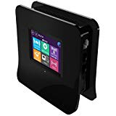](https://www.amazon.com/gp/slredirect/picassoRedirect.html/ref=pa_sp_btf_browse_computers_sr_pg1_1?ie=UTF8&adId=A073239135Z5LUHUTXLE5&url=https://www.amazon.com/Securifi-Almond-Touchscreen-Wireless-Extender/dp/B0087NZ31S/ref%3Dlp_300189_1_25_sspa?s%3Dpc%26ie%3DUTF8%26qid%3D1546450385%26sr%3D1-25-spons%26psc%3D1&qualifier=1546450384&id=1852909495579490&widgetName=sp_btf_browse)

Sponsored <img alt="" src="https://fls-na.amazon.com/1/amazon-clicks/1/OP/?requestId=SA07QM4Q5S23C07F7VTB&amp;childRequestId=SA07QM4Q5S23C07F7VTB&amp;widgetName=sp_btf_browse&amp;searchResultNumber=1&amp;impressionRankOnAsin=1&amp;qualifier=1546450384&amp;id=1852909495579490"> <img alt="" src="/gp/sponsored-products/logging/log-action.html?qualifier=1546450384&amp;id=1852909495579490&amp;widgetName=sp_btf_browse&amp;adId=200006796482431&amp;eventType=2&amp;adIndex=3"> <img alt="" src="/gp/sponsored-products/logging/log-action.html?qualifier=1546450384&amp;id=1852909495579490&amp;widgetName=sp_btf_browse&amp;adId=200006796482431&amp;adIndex=3&amp;eventType=101">

These are ads for products you'll find on Amazon.com.   
Clicking an ad will take you to the product's page.[Learn more about Sponsored Products.](https://advertising.amazon.com/products-self-serve?ref_=ext_amzn_wtsp)

See a problem with these advertisements?[Leave ad feedback](https://www.amazon.com/Routers-Networking-Online-Communication-Add-Ons/b?node=300189)

[[Sponsored]Securifi Almond - (3 Minute Setup) Touchscreen WiFi Wireless Router/Range Extender/Access Point/Wireless Bridge - Works with Amazon Alexa](https://www.amazon.com/gp/slredirect/picassoRedirect.html/ref=pa_sp_btf_browse_computers_sr_pg1_1?ie=UTF8&adId=A073239135Z5LUHUTXLE5&url=https%3A%2F%2Fwww.amazon.com%2FSecurifi-Almond-Touchscreen-Wireless-Extender%2Fdp%2FB0087NZ31S%2Fref%3Dlp_300189_1_25_sspa%3Fs%3Dpc%26ie%3DUTF8%26qid%3D1546450385%26sr%3D1-25-spons%26psc%3D1&qualifier=1546450384&id=1852909495579490&widgetName=sp_btf_browse" \o "Securifi Almond - (3 Minute Setup) Touchscreen WiFi Wireless Router/Range Extender/Access Point/Wireless Bridge - Works with Amazon Alexa)

by Securifi

Eligible for Shipping to Yemen

[$89.99 $ 89 99](https://www.amazon.com/gp/slredirect/picassoRedirect.html/ref=pa_sp_btf_browse_computers_sr_pg1_1?ie=UTF8&adId=A073239135Z5LUHUTXLE5&url=https%3A%2F%2Fwww.amazon.com%2FSecurifi-Almond-Touchscreen-Wireless-Extender%2Fdp%2FB0087NZ31S%2Fref%3Dlp_300189_1_25_sspa%3Fs%3Dpc%26ie%3DUTF8%26qid%3D1546450385%26sr%3D1-25-spons%26psc%3D1&qualifier=1546450384&id=1852909495579490&widgetName=sp_btf_browse)

[4.1 out of 5 stars](javascript:void(0)) [12,684](https://www.amazon.com/gp/slredirect/picassoRedirect.html/ref=pa_sp_btf_browse_computers_sr_pg1_1?ie=UTF8&adId=A073239135Z5LUHUTXLE5&url=https%3A%2F%2Fwww.amazon.com%2FSecurifi-Almond-Touchscreen-Wireless-Extender%2Fdp%2FB0087NZ31S%2Fref%3Dlp_300189_1_25_sspa%3Fs%3Dpc%26ie%3DUTF8%26qid%3D1546450385%26sr%3D1-25-spons%26psc%3D1%23customerReviews&qualifier=1546450384&id=1852909495579490&widgetName=sp_btf_browse)

[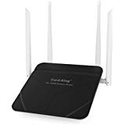](https://www.amazon.com/gp/slredirect/picassoRedirect.html/ref=pa_sp_btf_browse_computers_sr_pg1_2?ie=UTF8&adId=A06997051H0XIB1MYOLLX&url=https://www.amazon.com/Wireless-Repeater-1200mbps-Extender-Restauran/dp/B075V12B48/ref%3Dlp_300189_1_26_sspa?s%3Dpc%26ie%3DUTF8%26qid%3D1546450385%26sr%3D1-26-spons%26psc%3D1&qualifier=1546450384&id=1852909495579490&widgetName=sp_btf_browse)

Sponsored <img alt="" src="https://fls-na.amazon.com/1/amazon-clicks/1/OP/?requestId=SA07QM4Q5S23C07F7VTB&amp;childRequestId=SA07QM4Q5S23C07F7VTB&amp;widgetName=sp_btf_browse&amp;searchResultNumber=1&amp;impressionRankOnAsin=2&amp;qualifier=1546450384&amp;id=1852909495579490"> <img alt="" src="/gp/sponsored-products/logging/log-action.html?qualifier=1546450384&amp;id=1852909495579490&amp;widgetName=sp_btf_browse&amp;adId=200011459395781&amp;eventType=2&amp;adIndex=4"> <img alt="" src="/gp/sponsored-products/logging/log-action.html?qualifier=1546450384&amp;id=1852909495579490&amp;widgetName=sp_btf_browse&amp;adId=200011459395781&amp;adIndex=4&amp;eventType=101">

These are ads for products you'll find on Amazon.com.   
Clicking an ad will take you to the product's page.[Learn more about Sponsored Products.](https://advertising.amazon.com/products-self-serve?ref_=ext_amzn_wtsp)

See a problem with these advertisements?[Leave ad feedback](https://www.amazon.com/Routers-Networking-Online-Communication-Add-Ons/b?node=300189)

[[Sponsored]Wireless Router with Wifi Repeater Long range Ac 1200mbps High Speed WiFi Range Extender Dual Band with 4 Lan ports for Home Office internet Restauran Amazon Alexa Both Router / Repeater](https://www.amazon.com/gp/slredirect/picassoRedirect.html/ref=pa_sp_btf_browse_computers_sr_pg1_2?ie=UTF8&adId=A06997051H0XIB1MYOLLX&url=https%3A%2F%2Fwww.amazon.com%2FWireless-Repeater-1200mbps-Extender-Restauran%2Fdp%2FB075V12B48%2Fref%3Dlp_300189_1_26_sspa%3Fs%3Dpc%26ie%3DUTF8%26qid%3D1546450385%26sr%3D1-26-spons%26psc%3D1&qualifier=1546450384&id=1852909495579490&widgetName=sp_btf_browse" \o "Wireless Router with Wifi Repeater Long range Ac 1200mbps High Speed WiFi Range Extender Dual Band with 4 Lan ports for Home Office internet Restauran Amazon Alexa Both Router / Repeater)

by Card-King

Eligible for Shipping to Yemen

[$36.49 $ 36 49](https://www.amazon.com/gp/slredirect/picassoRedirect.html/ref=pa_sp_btf_browse_computers_sr_pg1_2?ie=UTF8&adId=A06997051H0XIB1MYOLLX&url=https%3A%2F%2Fwww.amazon.com%2FWireless-Repeater-1200mbps-Extender-Restauran%2Fdp%2FB075V12B48%2Fref%3Dlp_300189_1_26_sspa%3Fs%3Dpc%26ie%3DUTF8%26qid%3D1546450385%26sr%3D1-26-spons%26psc%3D1&qualifier=1546450384&id=1852909495579490&widgetName=sp_btf_browse)

[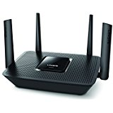](https://www.amazon.com/gp/slredirect/picassoRedirect.html/ref=pa_sp_btf_browse_computers_sr_pg1_3?ie=UTF8&adId=A08271351SHYNW83PNK7F&url=https://www.amazon.com/Linksys-Max-Stream-Tri-band-Wireless-EA8300-x/dp/B06X9CPC45/ref%3Dlp_300189_1_27_sspa?s%3Dpc%26ie%3DUTF8%26qid%3D1546450385%26sr%3D1-27-spons%26psc%3D1&qualifier=1546450384&id=1852909495579490&widgetName=sp_btf_browse)

Sponsored <img alt="" src="https://fls-na.amazon.com/1/amazon-clicks/1/OP/?requestId=SA07QM4Q5S23C07F7VTB&amp;childRequestId=SA07QM4Q5S23C07F7VTB&amp;widgetName=sp_btf_browse&amp;searchResultNumber=1&amp;impressionRankOnAsin=3&amp;qualifier=1546450384&amp;id=1852909495579490"> <img alt="" src="/gp/sponsored-products/logging/log-action.html?qualifier=1546450384&amp;id=1852909495579490&amp;widgetName=sp_btf_browse&amp;adId=200005264122061&amp;eventType=2&amp;adIndex=5"> <img alt="" src="/gp/sponsored-products/logging/log-action.html?qualifier=1546450384&amp;id=1852909495579490&amp;widgetName=sp_btf_browse&amp;adId=200005264122061&amp;adIndex=5&amp;eventType=101">

These are ads for products you'll find on Amazon.com.   
Clicking an ad will take you to the product's page.[Learn more about Sponsored Products.](https://advertising.amazon.com/products-self-serve?ref_=ext_amzn_wtsp)

See a problem with these advertisements?[Leave ad feedback](https://www.amazon.com/Routers-Networking-Online-Communication-Add-Ons/b?node=300189)

[[Sponsored]Linksys - Max-Stream AC2200 Tri-Band Wi-Fi Router (EA8300) Black - New](https://www.amazon.com/gp/slredirect/picassoRedirect.html/ref=pa_sp_btf_browse_computers_sr_pg1_3?ie=UTF8&adId=A08271351SHYNW83PNK7F&url=https%3A%2F%2Fwww.amazon.com%2FLinksys-Max-Stream-Tri-band-Wireless-EA8300-x%2Fdp%2FB06X9CPC45%2Fref%3Dlp_300189_1_27_sspa%3Fs%3Dpc%26ie%3DUTF8%26qid%3D1546450385%26sr%3D1-27-spons%26psc%3D1&qualifier=1546450384&id=1852909495579490&widgetName=sp_btf_browse" \o "Linksys - Max-Stream AC2200 Tri-Band Wi-Fi Router (EA8300) Black - New)

by Linksys

[4.1 out of 5 stars](javascript:void(0)) [10,342](https://www.amazon.com/gp/slredirect/picassoRedirect.html/ref=pa_sp_btf_browse_computers_sr_pg1_3?ie=UTF8&adId=A08271351SHYNW83PNK7F&url=https%3A%2F%2Fwww.amazon.com%2FLinksys-Max-Stream-Tri-band-Wireless-EA8300-x%2Fdp%2FB06X9CPC45%2Fref%3Dlp_300189_1_27_sspa%3Fs%3Dpc%26ie%3DUTF8%26qid%3D1546450385%26sr%3D1-27-spons%26psc%3D1%23customerReviews&qualifier=1546450384&id=1852909495579490&widgetName=sp_btf_browse)