# Visualization

# 11/09/2014

# Kevin Zollicoffer

## Task 1

The store in postal code SW1P 3AU sells the most configurations. The 3 most popular configurations are: 15, 31, and 213

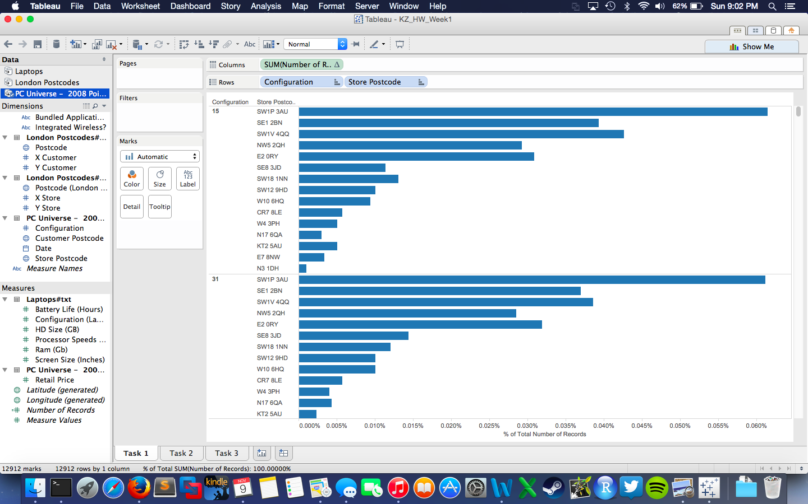

## Task 2

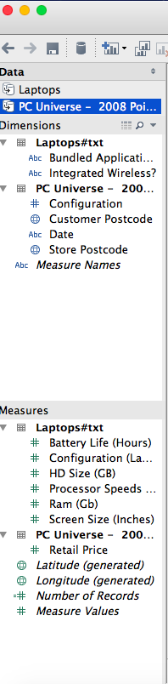

## Task 3

The store in Postal Code SW1P 3AU is centrally located in London and attracts visitors from a large radius around its location. From Task1 we see this store is one of the top sellers. We have to exclusively highlight it in the scatterplot to see it’s true sales footprint relative to the others.

