# Visualization

# 11/23/2014

# Kevin Zollicoffer

## Task 1

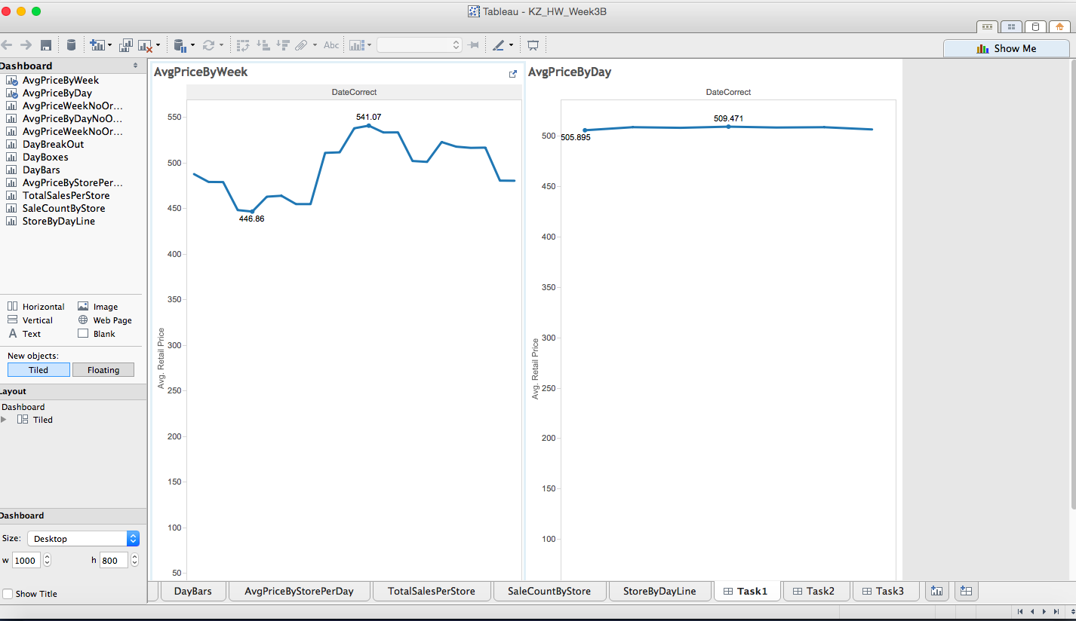

## Task 2

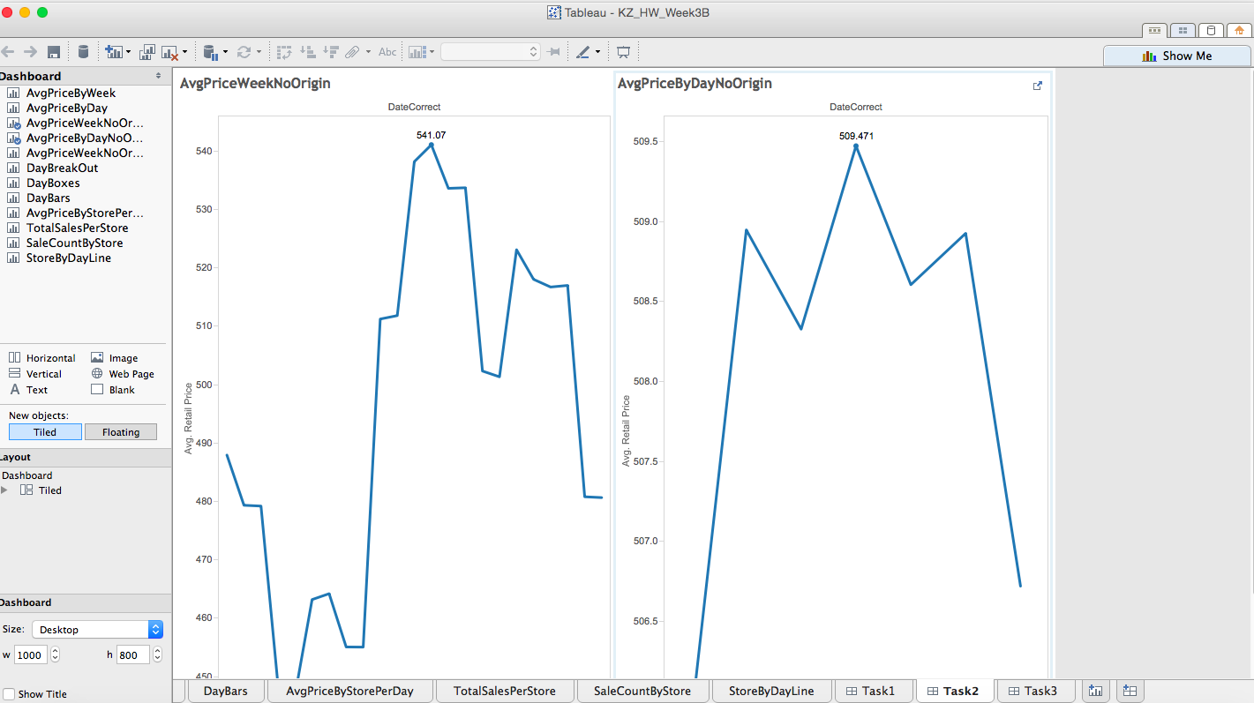

## Task 3

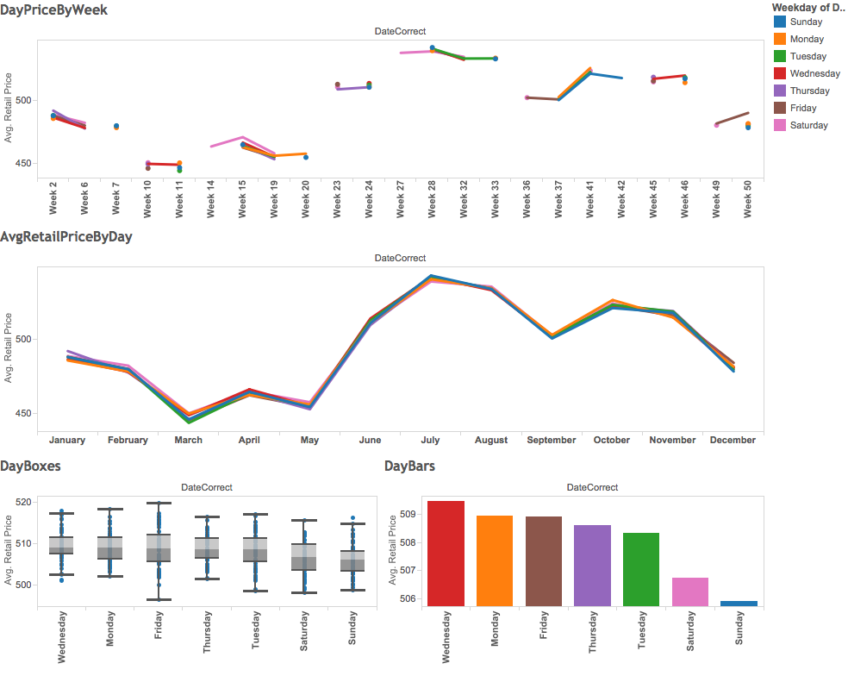

* Wednesday has the highest average retail price
* Friday is the day with the most variability in price.
* All days seem to follow a global, yearly season with avg sales peaking in the summer, and weakest in late winter to early spring.
* We are missing values for retail price in some cases
* Sunday is the weakest sales day

## Task 4

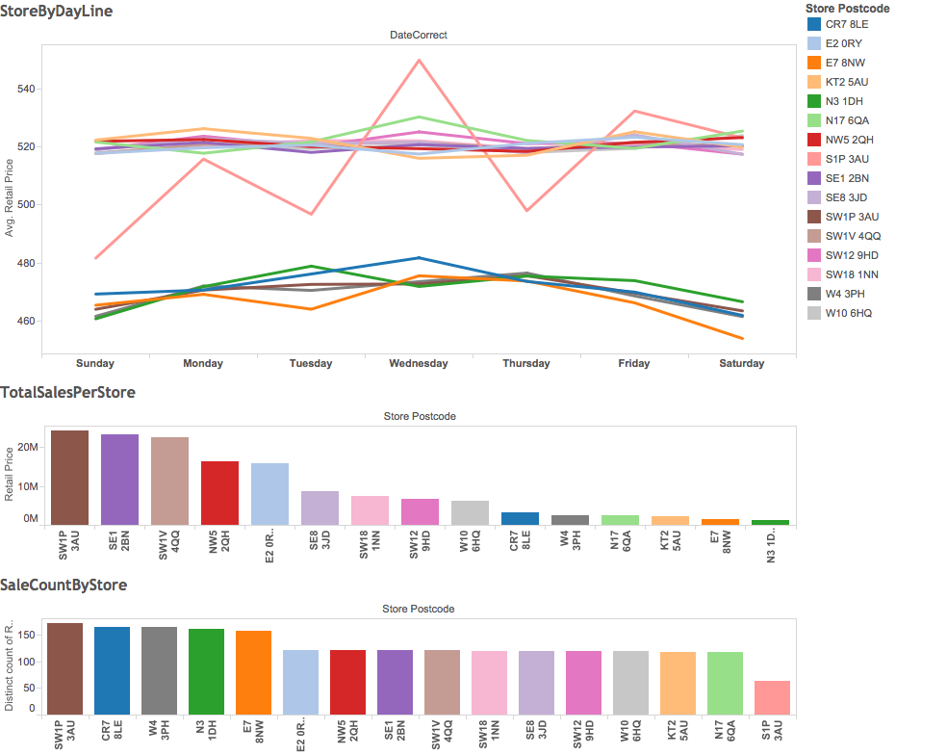

SW1P3AU has the highest total sales, however it is doing this with volume, selling many goods at a low average retail price relative to the other stores. This can be seen in the highlight below …

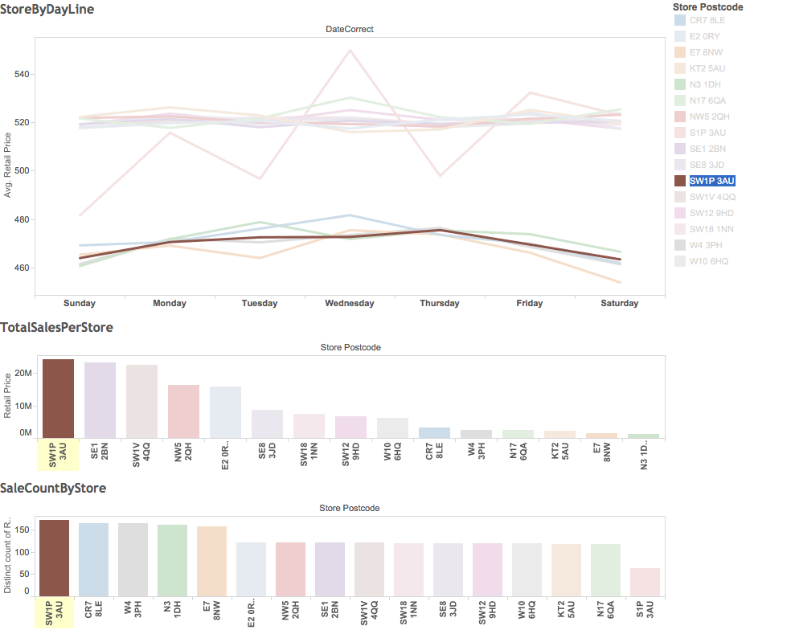

The #2, and #3 stores in total sales make their numbers by fewer high average priced goods …

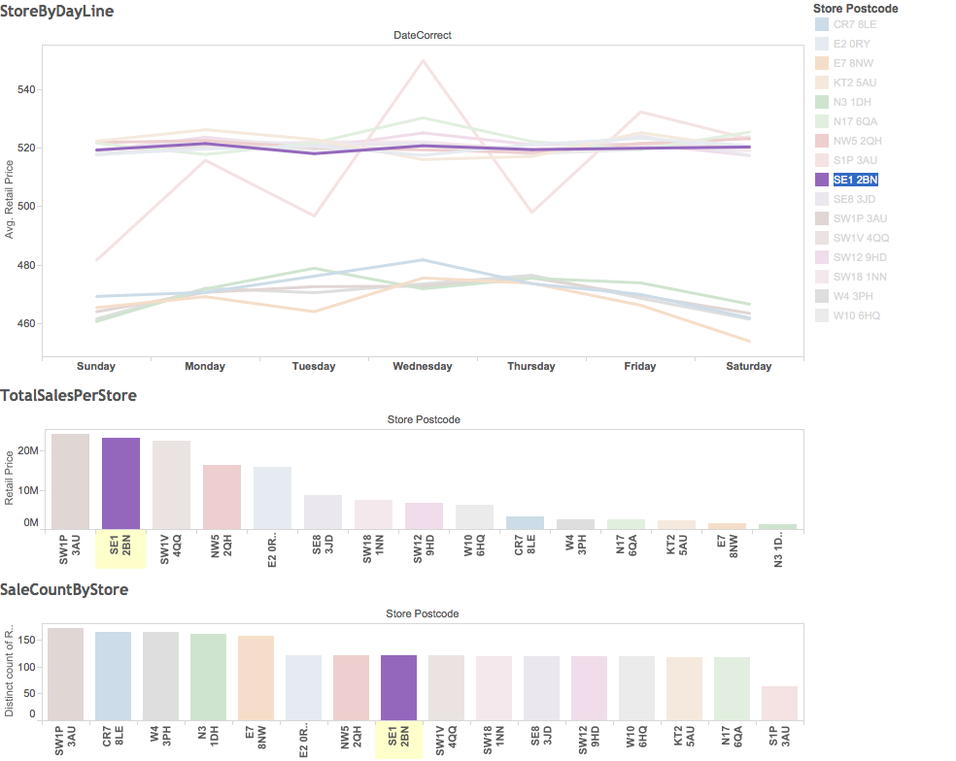

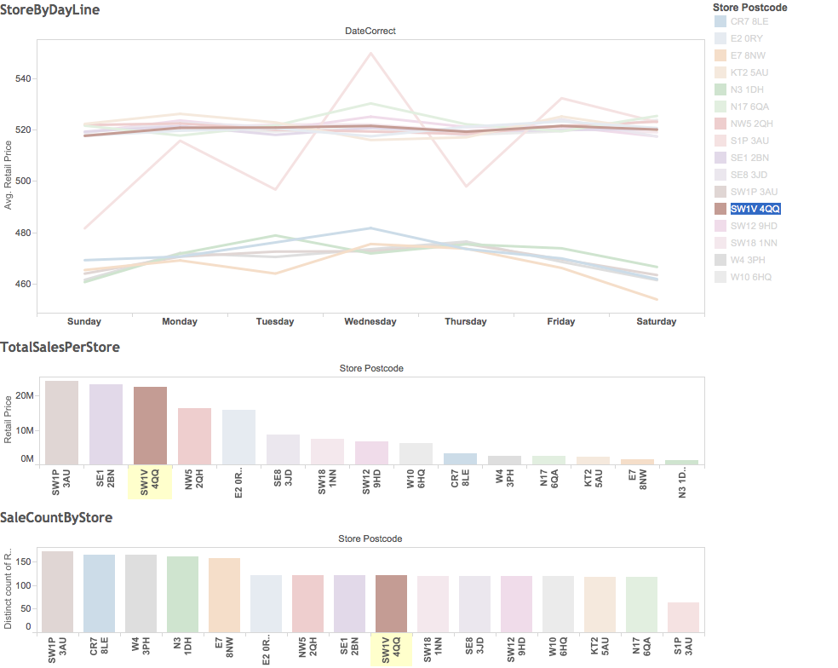

## Task 5

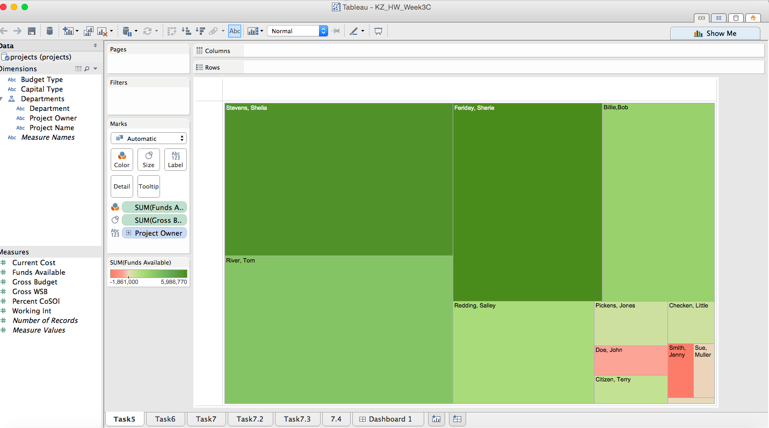

* Shelia Stevens has the largest gross budget
* John Doe, and Jenny Smith are overspending

## Task 6

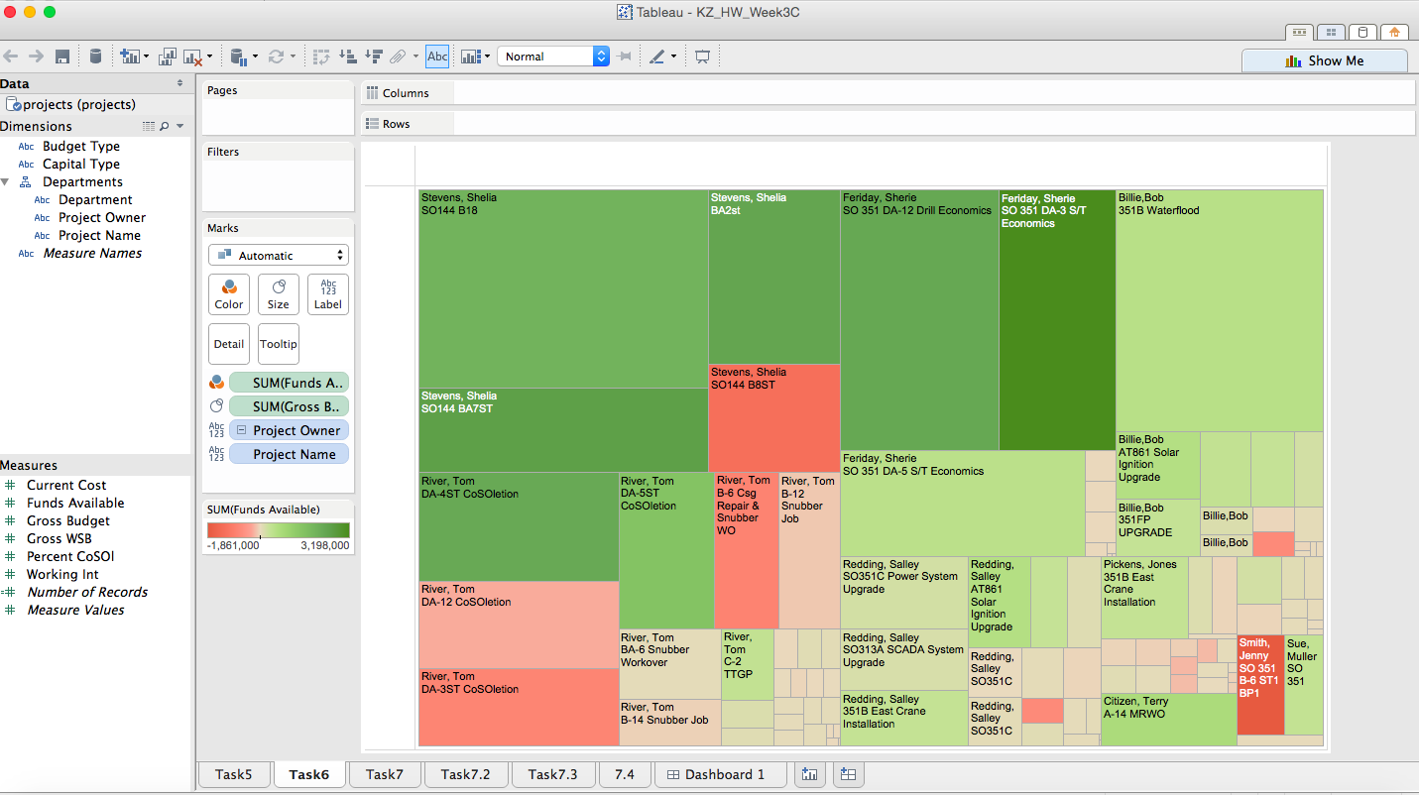

## Task 7

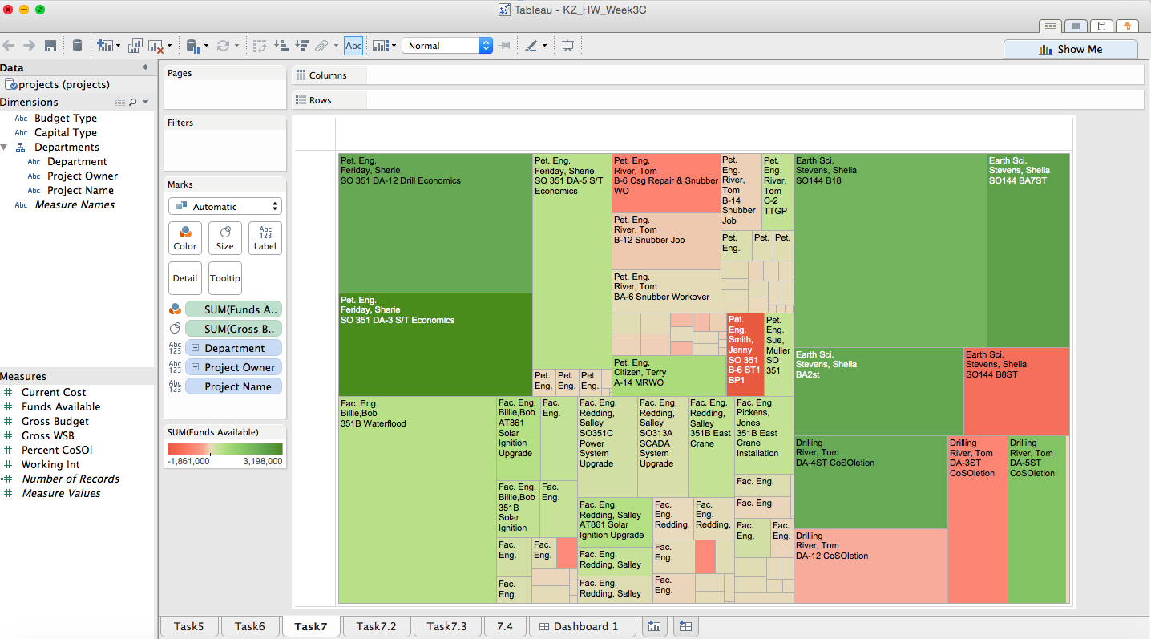

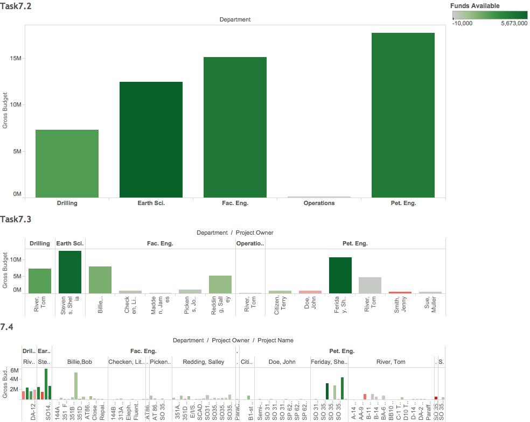

* The tree map clearly shows the financial health of projects by project owner, and department.
* For example Tom River has several projects over budget
* Sherrie Feridy has several large projects in good health, however several smaller projects that are about on budget.
* The Pet Eng department has the most funds available for projects.

## Task 8

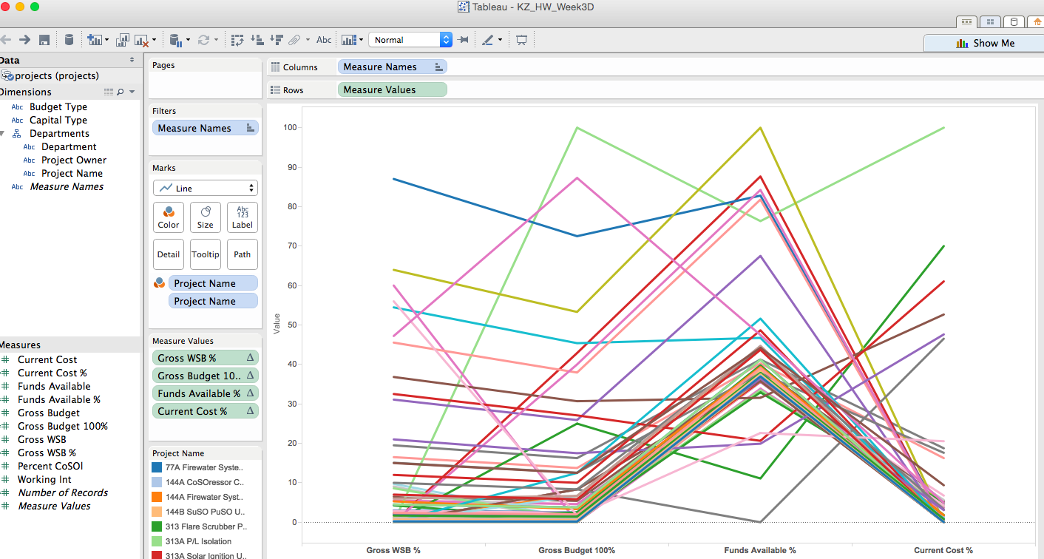

1. Yes, the common pattern is the triangle shape with peak at Funds Available %. However some data do not follow this trend.

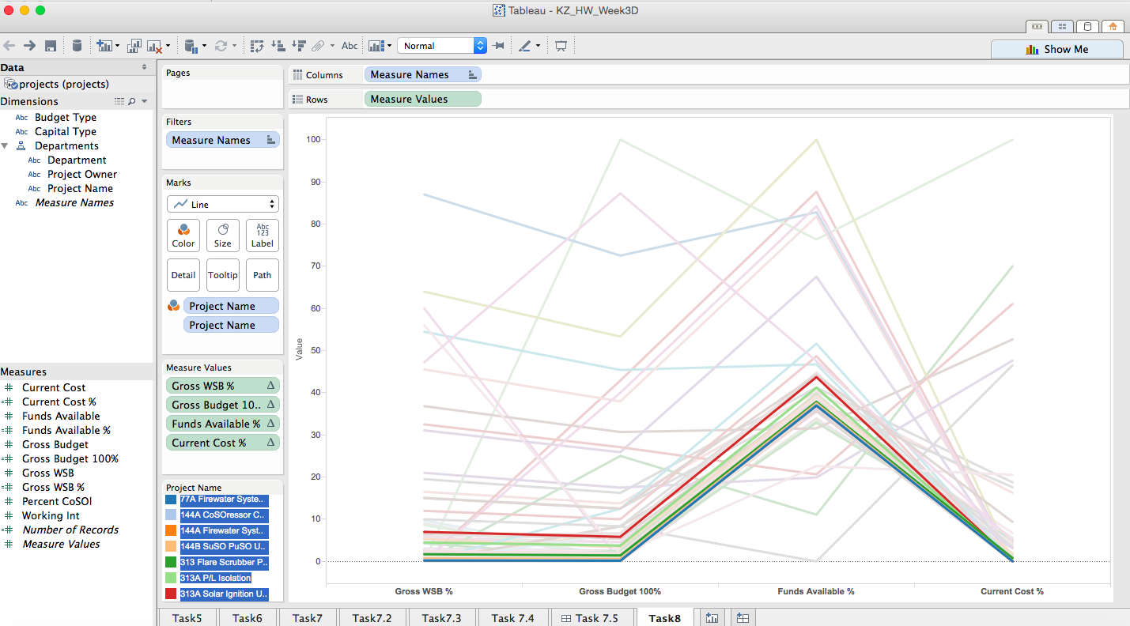

1. It appears to be in the common pattern, in that they are nearly always equal, however the exception patterns so both positive and negative correlation so it is hard to see how the two are related. Overall there is a general relation with exceptions.
2. If current cost % is greater than funds available, the project is going over budget.

1. Fac. Eng. has relatively many projects that are on or under budget. Most have a mix of on or under budget together with some over budget projects. Operations has only one small project.

