# Visualization

# 11/30/2014

# Kevin Zollicoffer

## Task 1.1

Paddy, Maize, and Potato are top crops in terms of total production weight.

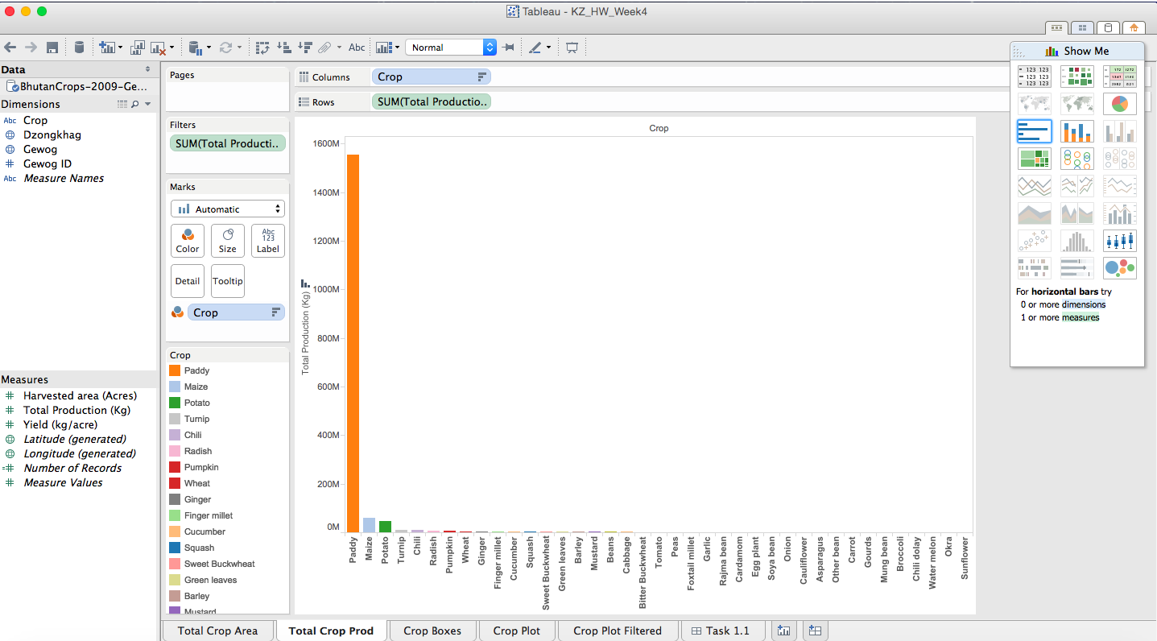

There is much land relative to other crops devoted to Paddy, Maize, and Potato as well. As will be shown next Cucumber, Gourds, Pumpkin, and Watermelon data are removed with a NULL filter as they contain all null values. The Chili dolay, and Squash data are suspect. In addition there are outliers that make it difficult to interpret the main cash crops.

A total crop area bar chart is given next however the Squash data is not reliable as discussed next.

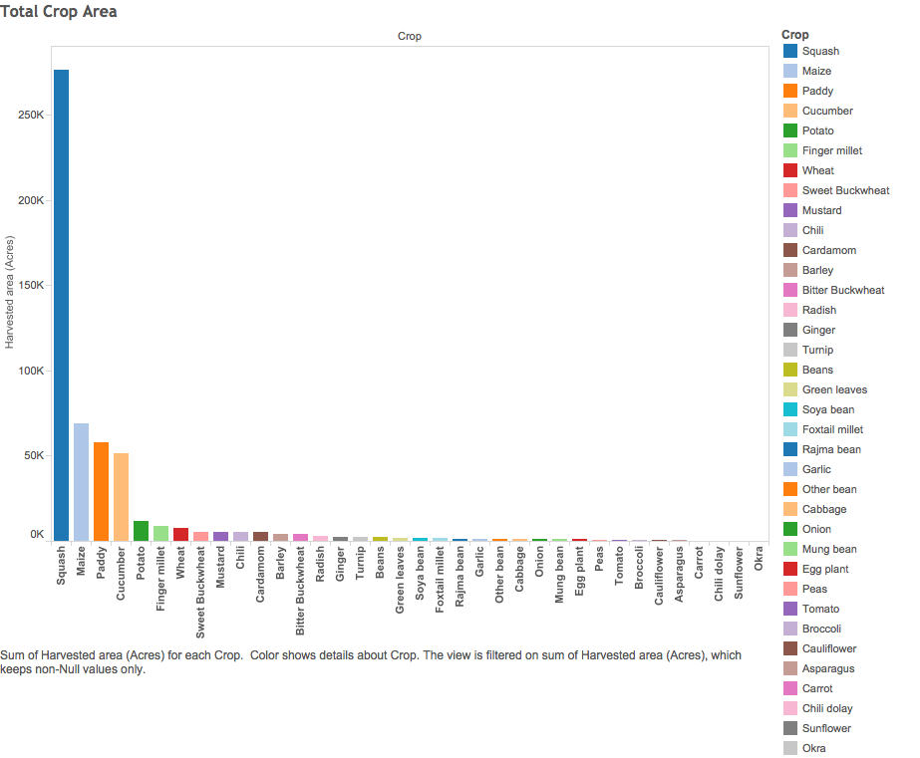

## Task 1.2

First a plot with all data

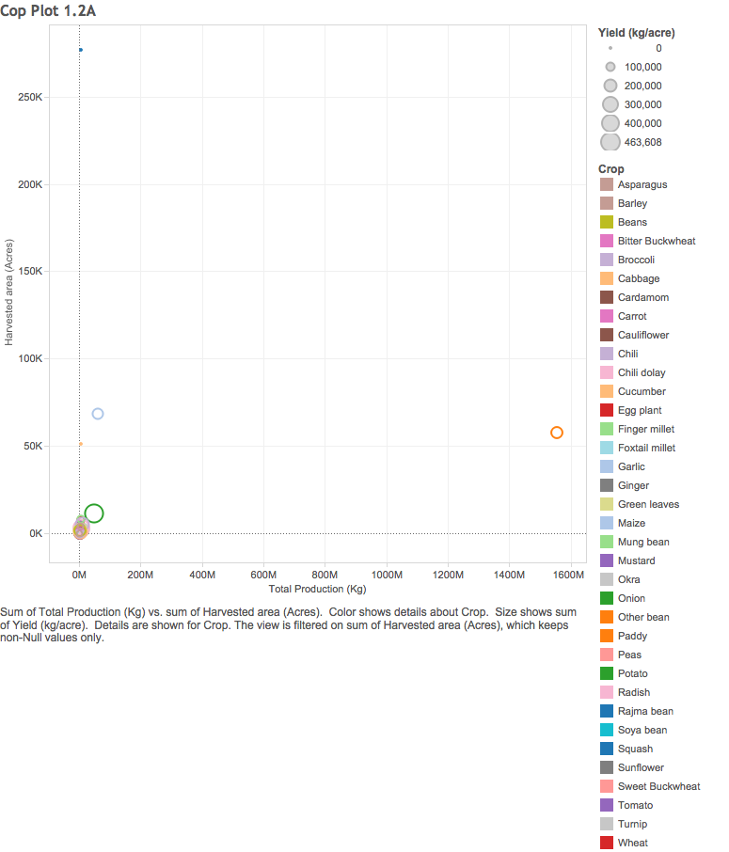

The Chili dolay, and Squash data do not look viable due to missing values and one sole extreme value for Squash.

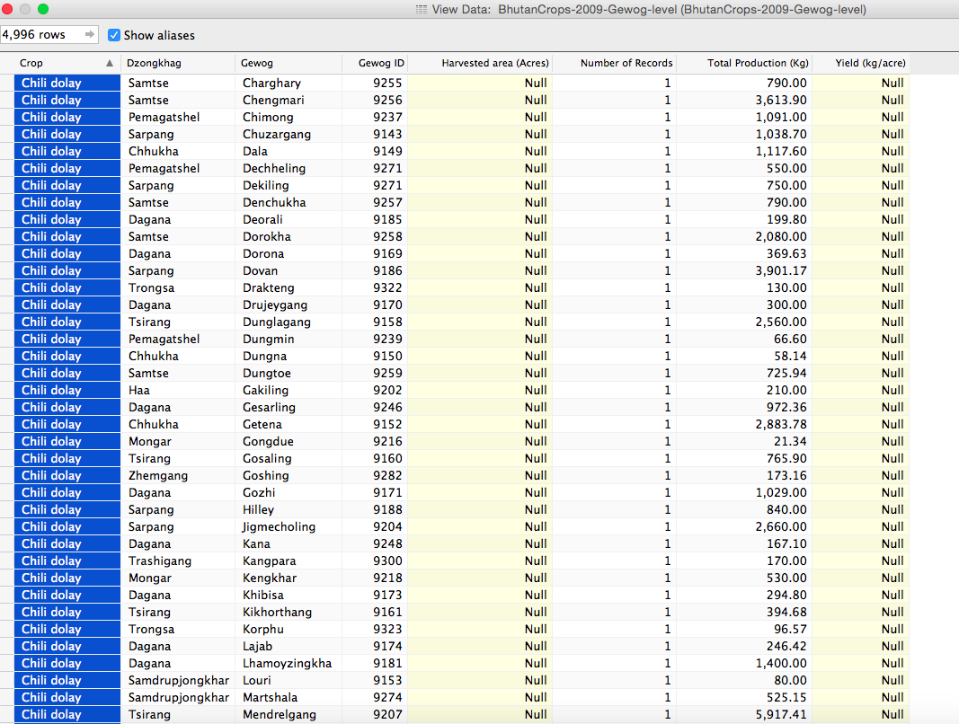

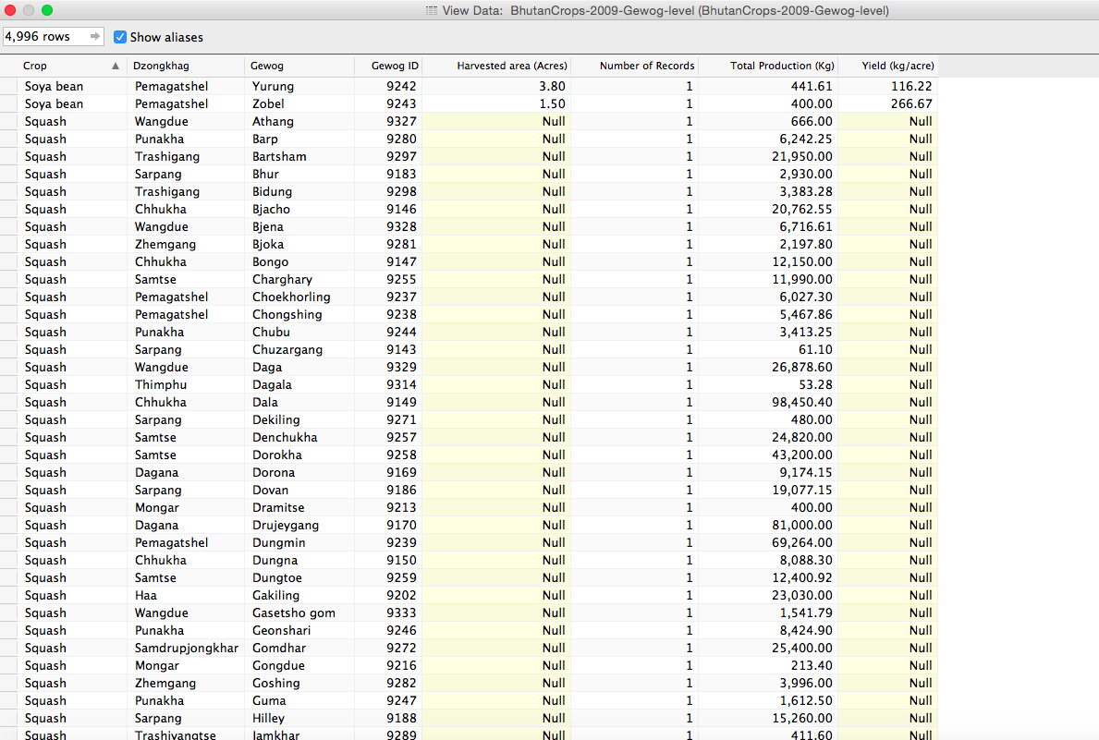

So we remove those in the next plot

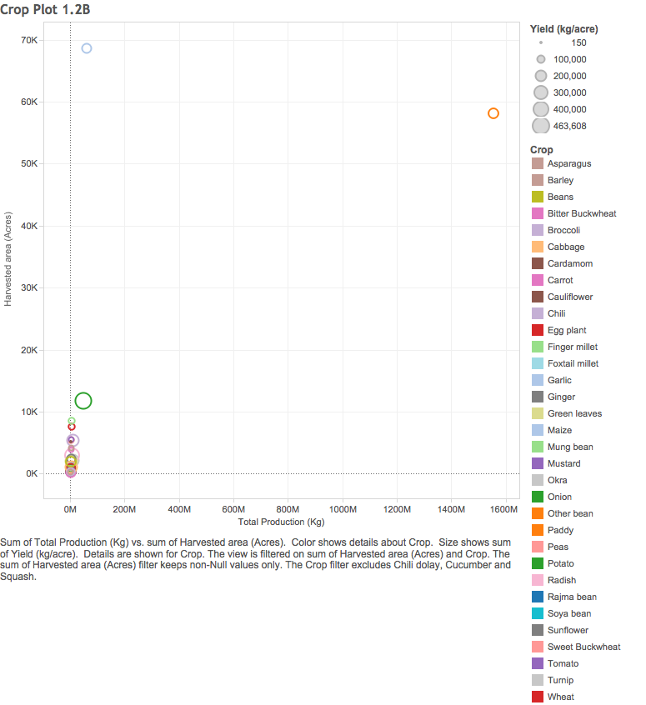

In addition, there are some outliers we will remove to make the data easier to interpret for the main cash crops. In the next plot we set a filter to remove data where Total Production (kg) is less than 3,000,000. Without the filter, a lot of minimally produced crops overlap each other. Although, even with this overlap the diameter of the circle can tell us which ones are most productive in terms of yield.

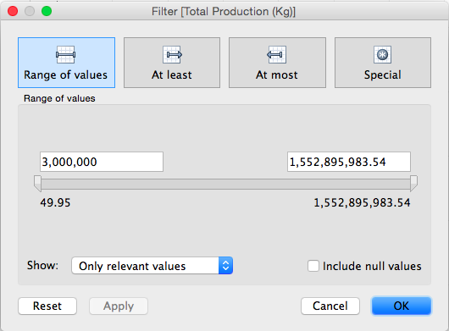

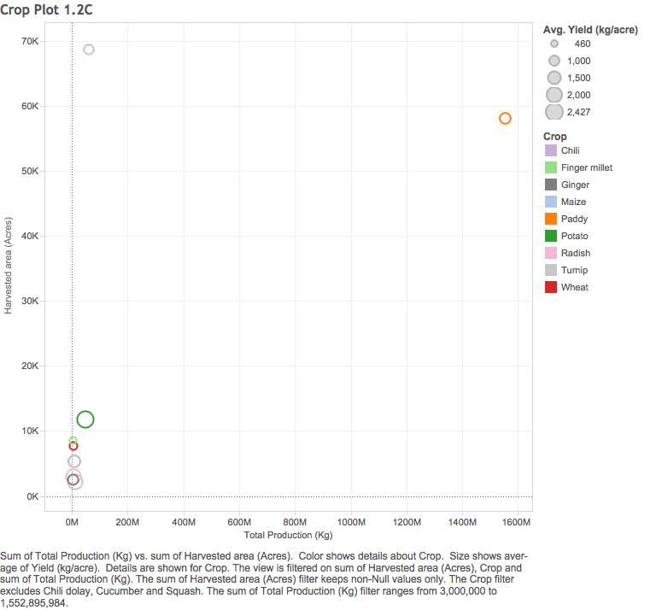

Here it can be seen that by weight, Paddy is by far the most produced crop, however the Potato gives the most significant yield among relevant crops. Maize has relatively high land use given its yield. Chili is mediocre in yield, however this may be due to its low consumer end weight. Turnips and Radishes are high yield crops. This may be due to the fact that they are root based and therefore the weight of the end product is high relative to the plant structure required to produce it.

## Task 1.3

### A

Here is a general map of Total Yield per Dzongkhag

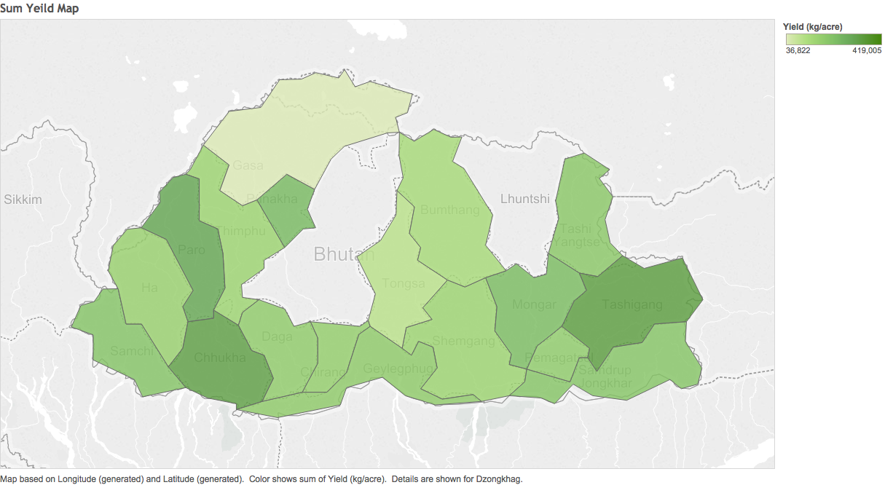

Paro, Chhuckha, and Tashigang are high yield crop producers.

## B

Here is map of Chili Yield per Dzongkhag

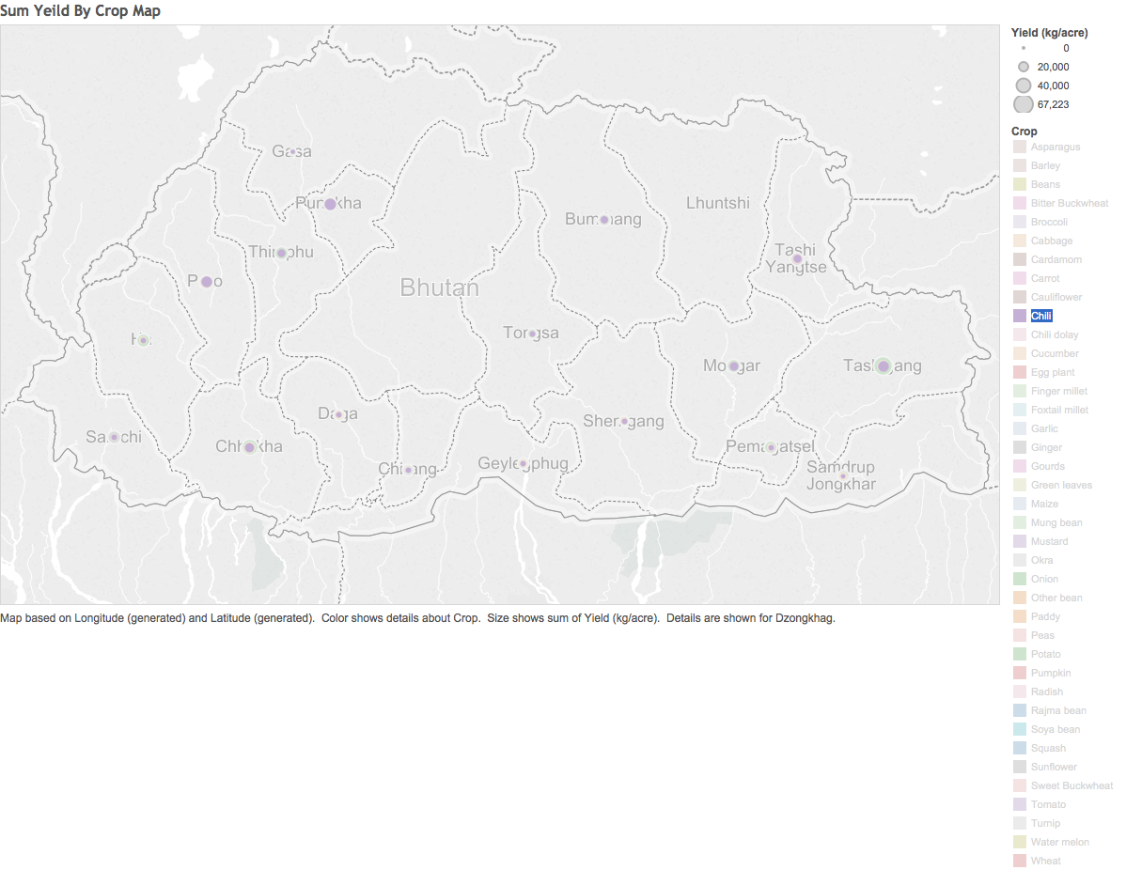

The diameter or the circle denotes Yield, however, this is easier to see with a bar chart as follows.

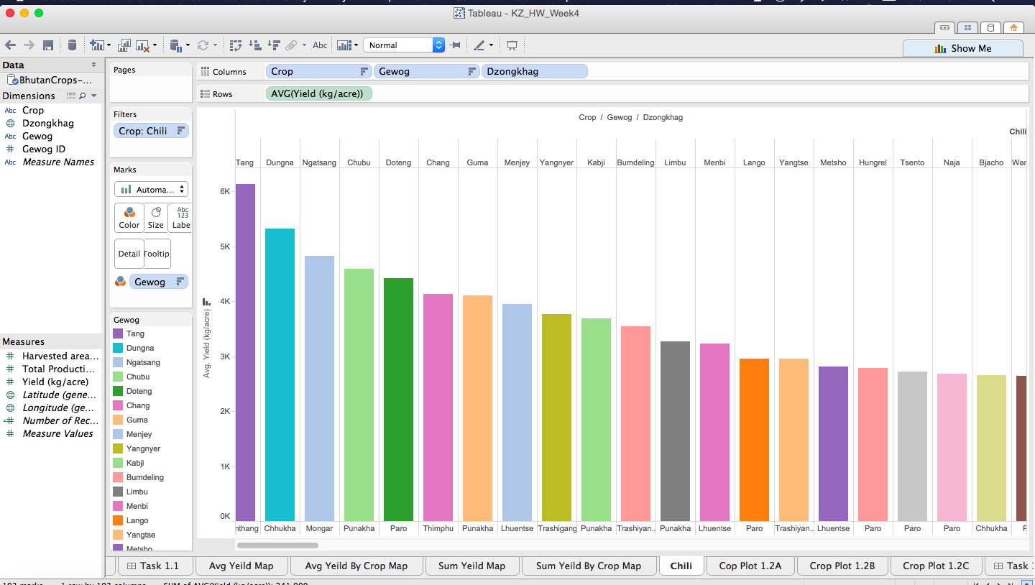

Therefore the top 3 producing Gewogs for Chili are:

1. Tang
2. Dungna
3. Ngatsang

All 3 of these Gewogs are in distinct Dzongkhags, respectively:

1. Bumthang
2. Chhukha
3. Mongar

## Task 2.1

I found the following bar graph to be effective as it is simple, clear, and ordered. It is not taking on too much and this adds ease to the interpretation.

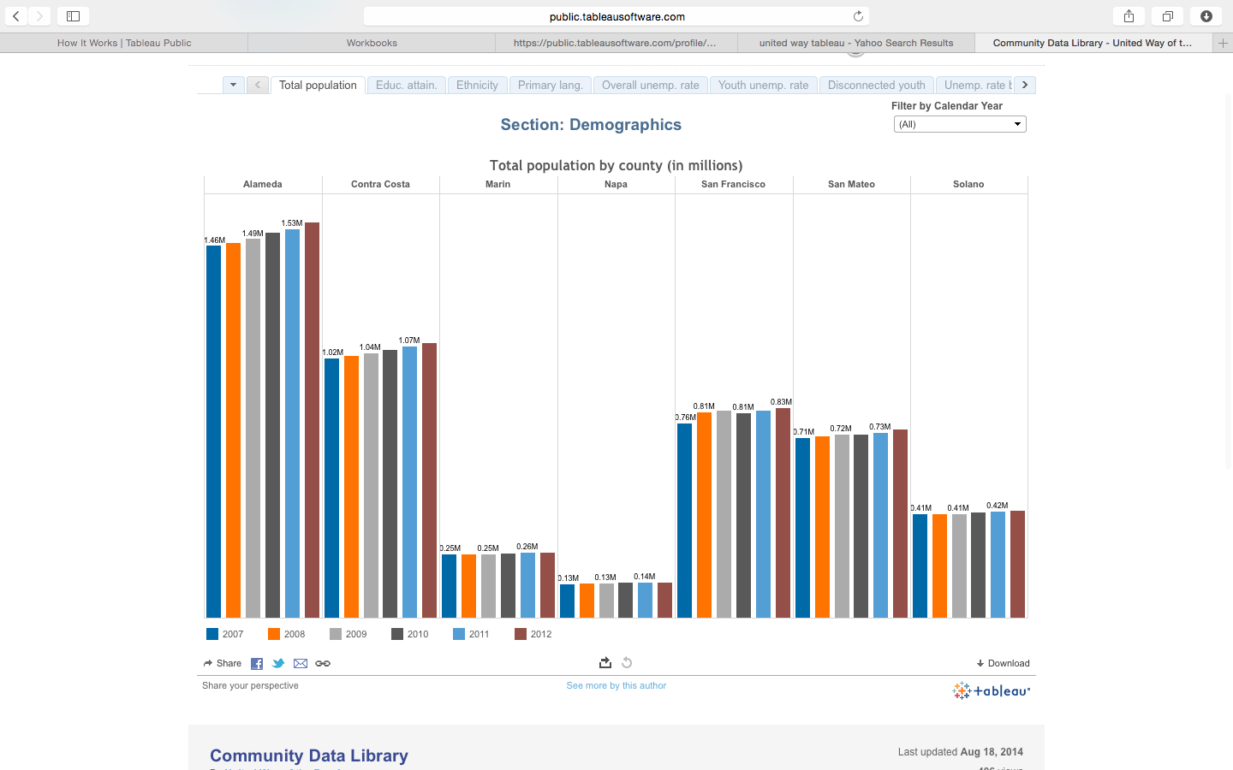

## Task 2.2

I found the following to be ineffective due to the use of the same color for multiple meanings, and the non-ordered bars. It’s also not clear what the main purpose of the Visualization is.

