DESIGN OF EXPERIMENTS HOMEWORK
FOR
STATISTICS.COM (WEEK 1)

HW1: Write an IPO for a process you are interested in. Can you measure all the inputs and outputs?

HW2: Using your IPO above, give a realistic example of an interaction plot between two inputs.

HW3: Complete the column for the AB interaction.

Run | Input A | Input B | AB
1 | +1 | +1 | 1
2 | -1 | +1 | -1
3 | -1 | 0 | 0
4 | -1 | -1 | 1

HW4: For the data below, create an interaction plot for the AB interaction of the process center ().
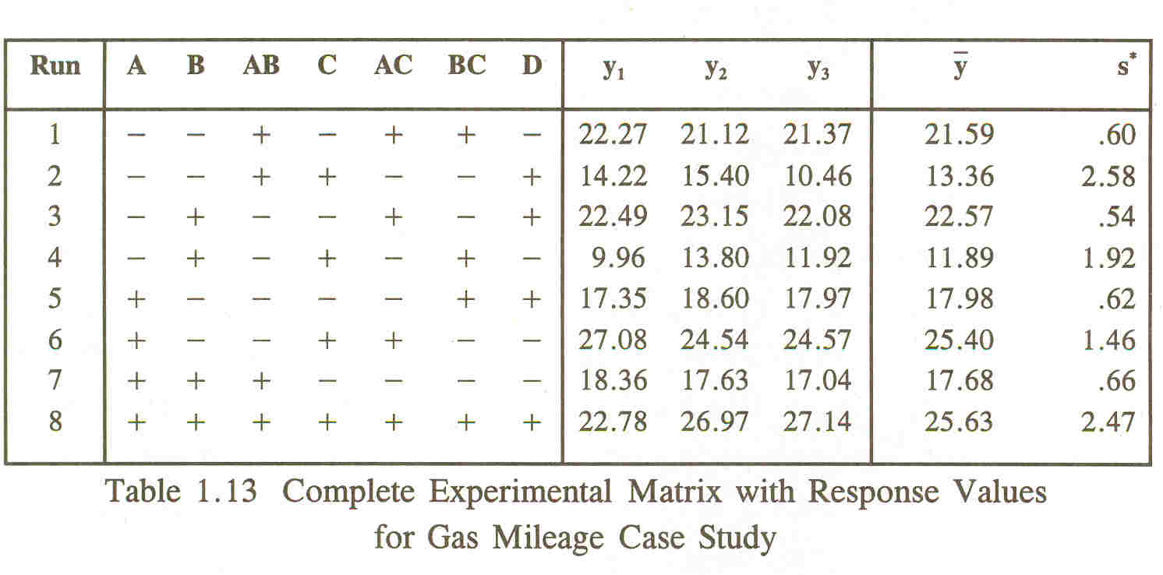

HW5: Describe what is meant by a robust design.

