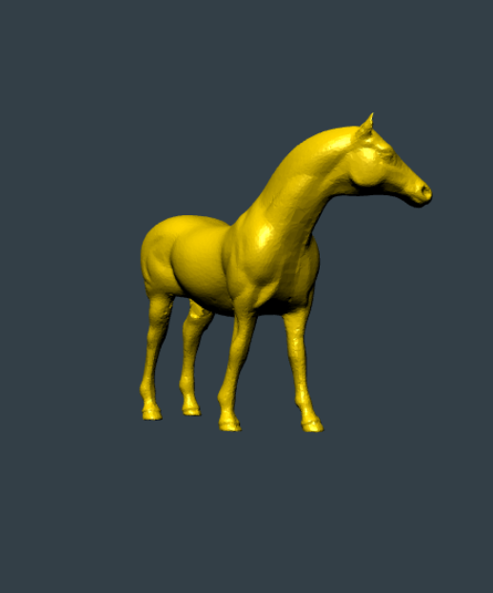  Assignment 1  WebGL Basics | Abstract  The aim of this project is to focus on the practice of WebGL. To set up a canvas or environment and be able to upload an OBJ file into the scene. The mesh also has materials and lighting implemented on it. There are orbit controls that allow rotation and translation of the camera.  Cristian Cabrera

4636005
2/23/17
The program is ready for a full live demon on my ocelot account. The link to the program is
http://ocelot.aul.fiu.edu/~ccabr071/webGL/ASS1/

Description:
The first step is converting the models from OBJ files to JSON files. Complete the process by running a python script. For each individual file, execute this line in the models folder of the server.
“python convert_obj_three.py -i infile.obj -o jsConverted/outfile.js”
Infile.obj is the name of the initial OBJ file to be converted. The oufile.js file is the output and “jsConverted” is the folder where all the converted JSON files are stored. After the file is converted, you are able to display the new model on the web using the same methods of the other objects. (#modelName)
The program identifies each step to create the entire WebGL environment and loading the JSON model file. The program creates a mesh for the model and applies a material to it. The program loads it into the scene. The scene now has the finished mesh with material. A camera object allows the user to view the scene. The program defines a lighting object that illuminate the scene. The scene is now completed with the mesh, camera, and lighting. The program requests for the animation frame in the render loop. Orbit controls allow the user to control the camera using mouse or touch screen. A rotation function spins the mesh around the y-axis at a speed of 0.05 units a frame. Most meshes have a uniform scaling to appear of equal size.

Read Me:
To execute the program and see the live demo
- Go to the web page on the FIO ocelot server (http://ocelot.aul.fiu.edu/~ccabr071/webGL/)
- Scroll down and click on the first Assignment link. “ASSIGNMENT 1”
You are now experiencing the live demo.
To control the demo:
- Click and drag/Swipe to rotate object in that direction
- Zoom in or out/Pinch or spread to zoom in or out of the scene
- Right click and drag/Long press and swipe to pan camera in that direction.
- To change the model loaded write #MODELNAME and replace “MODELNAME” with one of the available models. Then refresh the page.
Example: http://ocelot.aul.fiu.edu/~ccabr071/webGL/testing/#horse
- Or click on the names at the bottom (You must refresh after)

Work Cases:
Please visit the live demo and inspect the source code for the main app to see a presentation of the work cases.

Summary:
Done:
- Learned how to create a WebGL environment with and without three.js framework.
- Learned how to convert OBJ files into JSON files.
- Learned how to import JSON files into WebGL and make a mesh out of it.
- Learned the basics of a scene. (Models, camera, lighting, materials, animation, etc.)
On Going:
- Creating more models on blender.
- Learning animations that are more complicated.
- Making dynamic objects, materials, and lighting.
To Do:
- Fix uncaught type error (still works with it though)
- Add more models to the loader.
- Fix response time for reloading different objects
- Validate input better
- Create an array of all JSON files in the folder for easier validation and selection
In conclusion, I was able to learn the basics of WebGL and I became engaged into learning more. It was difficult to learn at first, but now I am able to write my code fluidly. One of the issues I had was finding a way to scale all the models uniformly at once. I decided to do it manually for now. I will make scale properly latter. I would really like to explore three.js more and maybe regular WebGL as well since it is a very interesting topic.

