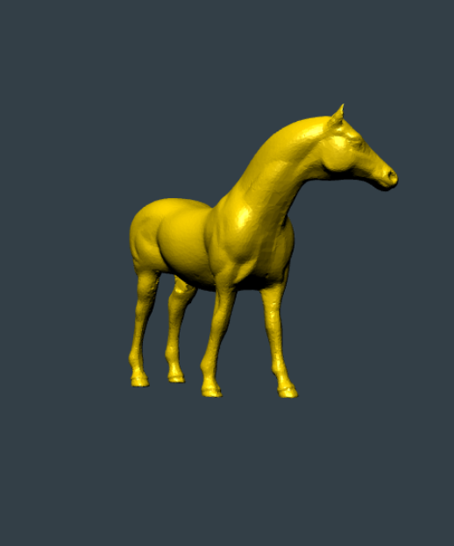  Assignment 2  WebGL Half Edge | Abstract  The aim of this project is to use HalfEdge data structure and know how to carry out the Euler operations. To set up a canvas or environment and be able to upload an OBJ file into the scene. The file is converted into a HalfEdge mesh. The number of faces, edges, and vertices are computer. As well as the Euler number, Genus and Gaussian.  Cristian Cabrera

4636005
4/20/17
The program is ready for a full live demon on my ocelot account. The link to the program is
http://ocelot.aul.fiu.edu/~ccabr071/webGL/ASS2/

Description:
The first step is converting the models from OBJ files to JSON files. Complete the process by running a python script. For each individual file, execute this line in the models folder of the server.
“python convert_obj_three.py -i infile.obj -o jsConverted/outfile.js”
Infile.obj is the name of the initial OBJ file to be converted. The oufile.js file is the output and “jsConverted” is the folder where all the converted JSON files are stored. After the file is converted, you are able to display the new model on the web using the same methods of the other objects. This is all the same like the previous assignment. In this assignment to change between models I used dat.gui.
The program identifies each step to create the entire WebGL environment and loading the JSON model file. The program creates a mesh for the model and applies a material to it. The program loads it into the scene. The scene now has the finished mesh with material. A camera object allows the user to view the scene. The program defines a lighting object that illuminate the scene. The scene is now completed with the mesh, camera, and lighting. The program requests for the animation frame in the render loop. Orbit controls allow the user to control the camera using mouse or touch screen.
The main difference now is that the model is now a half edge structure. This allows for the edges, faces, and vertices to be counted. The numbers are plugged in to two formulas. The Euler formula that computes the Euler number based on the vertices, faces, and edges. And the other formula of the Gauss-Bonnet theorem. It calculates the discrete Gauss curvature for all of the vertices. And using the Euler number the value of both sides are compared.

Read Me:
To execute the program and see the live demo
- Go to the web page on the FIO ocelot server (http://ocelot.aul.fiu.edu/~ccabr071/webGL/)
- Scroll down and click on the first Assignment link. “ASSIGNMENT 2”
You are now experiencing the live demo.
To control the demo:
- Click and drag/Swipe to rotate object in that direction
- Zoom in or out/Pinch or spread to zoom in or out of the scene
- Right click and drag/Long press and swipe to pan camera in that direction.
- To change the model loaded write #MODELNAME and replace “MODELNAME” with one of the available models. Then refresh the page.
Example: http://ocelot.aul.fiu.edu/~ccabr071/webGL/testing/#horse
- Or click on the names at the bottom (You must refresh after)

Work Cases:
Please visit the live demo and inspect the source code for the main app to see a presentation of the work cases.

Summary:
Done:
- Learned how to create a WebGL environment with and without three.js framework.
- Learned how to convert OBJ files into JSON files.
- Learned how convert JSON files into a half edge structure
- Learned the Euler formula to compute Euler numbers of meshes with the half edge structure
- Learned the Gauss-Bonnet theorem and how it compares with Euler numbers and what it explains about the structure.
- Learned how to use dat.gui
On Going:
- Creating a more dynamic dat.gui experience
- Creating folders for dat.gui
- Making more meshes to compute Euler numbers and Gauss curvatures.
To Do:
- Add more models to the loader.
- Fix response time for reloading different objects
- Load models dynamically without having to hard wire it
- Fix computation errors with the Euler formula and Gauss curvature.

