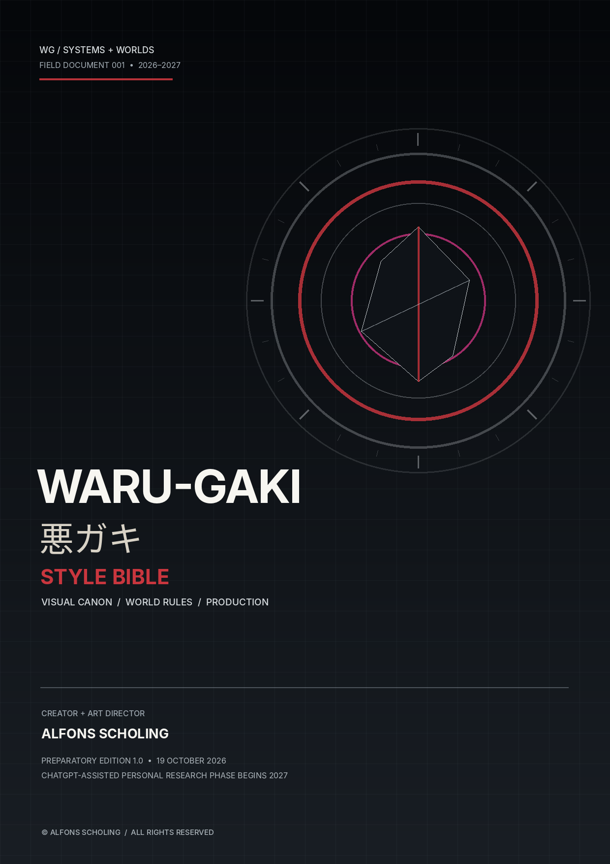

00 / DOCUMENT CONTROL

A working canon, not a mood board
A production standard for all WARU-GAKI worlds, visual assets and future research.
THE ONE-LINE RULE
Every WARU-GAKI image, object, character or story must express an underlying world rule. Form follows function; beauty comes from making that function visible.

Owner and author: Alfons Scholing. Role: creator, concept author, design lead and art director. WARU-GAKI / 悪ガキ is a standalone universe and brand; it is not an IKZ sub-brand.
DOCUMENT FIELD | CURRENT DEFINITION
Document | WARU-GAKI / 悪ガキ — Style Bible 1.0
Status | Preparatory edition, prepared 19 October 2026; baseline rules for Alfons Scholing’s ChatGPT-assisted personal research phase, beginning 2027.
Primary purpose | Keep the visual language, world logic and production outputs coherent across independent ontologies.
Source of truth | The current Style Bible plus explicitly approved world sheets; ArtStation pages are the public-facing index, not the only canon record.
Change authority | Alfons Scholing approves canon changes, design direction, credits and release status.
AI role | A production and research tool. AI output is not an independent authorial authority and does not approve canon.

This edition turns published project descriptions into an operational standard. Rules inferred from repeated patterns are marked as house recommendations; world-specific rules already stated on the portfolio are treated as existing canon.
Use the standard to create consistent outputs, not to flatten every world into the same aesthetic. Shared construction quality does not mean identical palettes, silhouettes or narrative tones.

01 / INTEGRATION

What IKZ contributes — and what stays separate
A method transfer, not a visual or brand merger.
IK ZIE ZOMBIES documented a broad research method: connect references, identify relationships, examine assumptions, preserve a navigable archive and distinguish evidence from interpretation. Its core maxim is “AI is the tool. The ontology is the structure. The human remains the author.” [S1, S2]
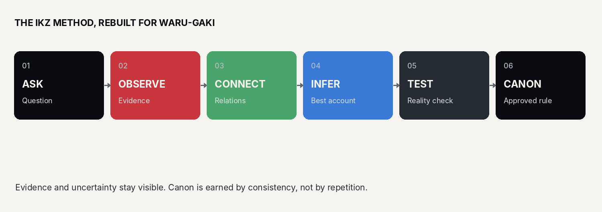
Working pipeline for WARU-GAKI: question → evidence → relations → inference → test → approved rule.
INHERIT FROM IKZ | DO NOT IMPORT AS WARU-GAKI IDENTITY | BUILD FOR WARU-GAKI
Critical questioning and research traceability | IKZ logos, zombie iconography, satire-led brand tone or legacy character canon | A distinct Japanese–European 3D concept-studio identity
Reference mapping and interconnected documentation | The assumption that every new world must resemble the old archive | Independent world laws, entities, visual grammars and versioned canon
Systems thinking: entities, relations, transformation and boundaries | Old site structure as the only navigation model | Lean production specs that can generate designs, scenes and interaction
Human-led direction with AI assistance | Unverified model output treated as factual research | Logged prompts, sources, decisions, tests and human approvals

BOUNDARY RULE
IKZ is a closed historical project and a methodological reference. WARU-GAKI is a new, separate universe. Use IKZ to understand the research method; use WARU-GAKI canon to decide what WARU-GAKI looks like.

02 / BRAND IDENTITY

Name, signature and tone
The brand should read as deliberate, engineered, and unmistakably authored.
ELEMENT | STANDARD
Primary wordmark | WARU-GAKI / 悪ガキ
Japanese form | 悪ガキ. Preserve the exact characters. Japanese copy should be proofread for native usage when published.
Romanization | Use WARU-GAKI in authored titles and brand locks. WARUGAKI may appear where a platform or URL requires a compact form. Do not alternate spellings casually within one asset.
Descriptor | Japanese–European International Concept Studio. This is the recommended corrected wording; the current site contains “Japanes-European,” which should be corrected before re-use.
Creator credit | Created and art-directed by Alfons Scholing.
Voice | Precise, curious, mischievous, conceptually rigorous. Explain the mechanism; do not hide behind vague mysticism or hype.
Audience posture | Intelligent and accessible. The work can be playful without becoming childish, and technically serious without becoming a sterile corporate dashboard.

Brand language: preferred / avoid
PREFER | AVOID
“Unknown, not yet understood.” | “It is magic” as a substitute for mechanism in MUSHI.
“An engineered system that…” | Decorative jargon that never explains what the object does.
“A proposed product architecture.” | Presenting speculative concepts as deployed real-world systems.
“A Japanese–European design language.” | Exoticising Japanese culture or relying on borrowed franchise shorthand.
“Created and art-directed by Alfons Scholing.” | Ambiguous credits, creatorless AI-output framing, or implying that a tool initiated the canon.

The current portfolio uses Japanese titles alongside English explanatory copy. Preserve this bilingual character, but make terminology deliberate: one canonical spelling per concept, stable punctuation, and no machine-translated filler.

03 / VISUAL NORTH STAR

Premium 3D concept design with a working mechanism
A sculptural object language with cinematic clarity and physical credibility.
STYLE TARGET
European–Japanese concept design expressed through premium stylised 3D: hard-surface engineering, bold silhouettes, controlled material contrast, clean visual hierarchy and cinematic lighting. The image should feel designed and buildable, not merely generated.

PILLAR | VISUAL BEHAVIOUR | REVIEW QUESTION
Engineered | Every joint, panel, lens, cable, seam or opening has a mechanical, structural, narrative or interface purpose. | Could this part be explained or built?
Sculptural | Clear large shapes first; small detail supports the primary massing. Silhouette survives thumbnail scale. | Can I read the subject in one second?
Premium | Material response is deliberate; edges, reflections and roughness are controlled. No cheap plastic by default. | Does it look art-directed rather than randomly glossy?
Cinematic | A single primary read; layered depth; purposeful negative space; lighting supports the ontology. | Does lighting reveal form and function?
World-specific | The shared craft standard remains stable, but each world sets its own palette, shape language and emotional register. | Does this belong to this world and no other?

Default visual exclusions
- Flat illustration, unintentional photorealism, generic horror, generic fantasy armour and unfinished grey-box presentation for final hero art.
- Unmotivated greebles, random cables, ornamental vents, excessive bevels or glowing parts that do not serve the underlying mechanism.
- Rainbow palettes in serious system concepts; noisy particle storms; fog that hides the silhouette; over-designed backgrounds competing with the subject.
- Literal collages of every example in a concept description. Translate the principle into form instead of illustrating the prompt word by word.

04 / COLOUR SYSTEM

One neutral core, several semantic colour roles
World-level palettes are allowed; colour must communicate rather than decorate.
The general WARU-GAKI surface family is dark and mineral: obsidian, graphite, blue-grey and warm/dirty ivory, with warning red used sparingly. This is explicit in the Rat concept. The Student ontology defines a separate six-colour semantic system; it adds functions to the base colours rather than replacing them. [S3, S4]
OBSIDIAN  #090B10  unknown / depth | GRAPHITE  #252B32  structure | BLUE-GREY  #53616F  engineered metal | IVORY  #D8D2C6  legible evidence | SIGNAL RED  #C9363E  warning / emphasis

Recommended global material palette. Values are starting specifications; calibrate against the final display and render pipeline.

Student ontology: six colours with jobs
BLACK  #090B10  unknown / boundary | WHITE  #F5F4F0  visible evidence | HOT PINK  #F13B95  question / disruption | RED  #C9363E  observe / measure | GREEN  #49A56B  connect / hypothesise | BLUE  #397AD7  challenge / verify

Do not apply all six colours to every asset. Outside the Student system, red/green/blue are not universal character assignments; use them only where the ontology or narrative gives them a semantic role.
ACCENT | RULE
Gold / warm metal | Reserve for a deliberate premium signal, a “Golden Ticket” asset or world-specific object. It is not part of the default palette.
Glow / emissive | Use only to communicate a sensor, energy state, signal, warning or other defined function.
Pink | A semantic colour for the Student system’s question/disruption layer, not a compulsory studio-wide accent.

05 / FORM AND MATERIALS

Build from silhouette to mechanism
The object must remain legible before the viewer reads the caption.

Construction sequence
- Block the silhouette in three values. Establish the dominant mass, counter-mass, support points and negative spaces.
- Assign function to every structural feature: protection, movement, sensing, connection, containment, heat management, access or transformation.
- Separate primary, secondary and tertiary detail. Secondary panels reinforce the main form; tertiary detail appears only at close range.
- Choose materials based on the function and emotional condition: matte graphite for absorption and weight; polished black for precious/precise engineered objects; worn ivory for evidence, age or exposed structure; restricted red for warnings.
- Validate a front, three-quarter and silhouette view before spending time on micro-detail. Check plausible attachment, movement range and contact with the environment.

Material library
MATERIAL FAMILY | LOOK | USE
Matte graphite / blue-black | Low-to-medium sheen; fine surface grain; controlled edge highlights. | Structural mass, machinery, architectural hardware, Rat ontology base.
Polished black / obsidian | Deep reflections, crisp highlights, rich but readable surface. | Hero mechanism, jewel-like engineering, critical artefact when concept calls for refinement.
Brushed or satin metal | Directional response, visible machining or finish logic. | Moving joints, rails, housings, fasteners, interface parts.
Warm / dirty ivory | Soft roughness, subtle wear; avoid pure blank white except as a deliberate evidence field. | Exposed substrate, documentation surfaces, pale contrast plane.
Emissive / translucent | Small, clear source with controlled spill; not a lighting substitute. | Optics, status indicators, instrument windows, engineered illusion.

THE JEWEL RULE
A beautiful object must still be structurally plausible. “Billion-dollar jewel” means precision, surface control, silhouette and deliberate detail - not random gold trim or excessive ornament.

06 / CAMERA AND RENDERING

Show the form; let the mechanism explain the world
Default hero presentation is a 16:9 horizontal frame unless the output has a specified purpose.
CONTROL | HOUSE STANDARD
Frame | 16:9 for hero concept art, world scenes and studio presentations. Use square for icons/product-like object studies; use portrait only for character sheets or a specifically portrait-oriented platform asset.
Camera | Start with a three-quarter view for engineered objects. Use frontal views for insignia, diagnostic layouts or symmetry. Use low angles only when scale/power is part of the concept.
Lens / perspective | Readable perspective; avoid extreme distortion that hides proportion or creates accidental comedy.
Lighting | One clear key, useful fill and a controlled rim or environmental edge. Highlights describe curvature and material boundaries; red warning accents should not wash the whole image.
Background | A restrained stage or environment with enough context to explain function. Negative space is a design component. Detail falls off away from the focal mechanism.
Grounding | Contact shadows, plausible weight, consistent reflection direction, coherent scale and environmental bounce.
Render finish | Clean, deliberate surface response; subtle wear only where use or story justifies it; no unfinished viewport or grey-box as final hero art.

Composition test
- At thumbnail size, the silhouette and primary action are still clear.
- At full size, secondary details reward inspection but do not fight the subject.
- The brightest or highest-contrast area points to the intended mechanism, not a random background light.
- The image has one dominant focal point and a deliberate visual path through the frame.
- The background expresses the world law, not a generic “sci-fi” setting.
NO DEFAULT RAINBOW
A rainbow palette requires a specific in-world reason. It is not a shortcut for diversity, complexity or futuristic energy.

07 / ONTOLOGY TO OUTPUT

Shared process; distinct world identities
The canon is the rule system that makes multiple outputs belong to one coherent world.
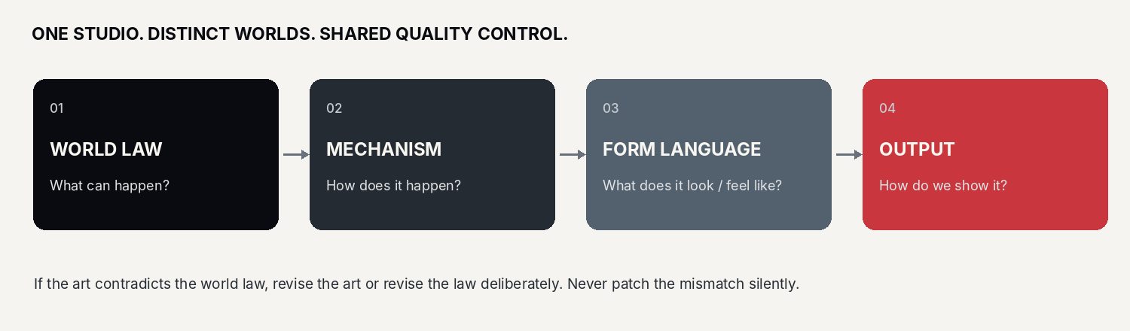
Every approved design follows this chain. A render is a test of the world model, not a substitute for one.

Investigation model: The Student
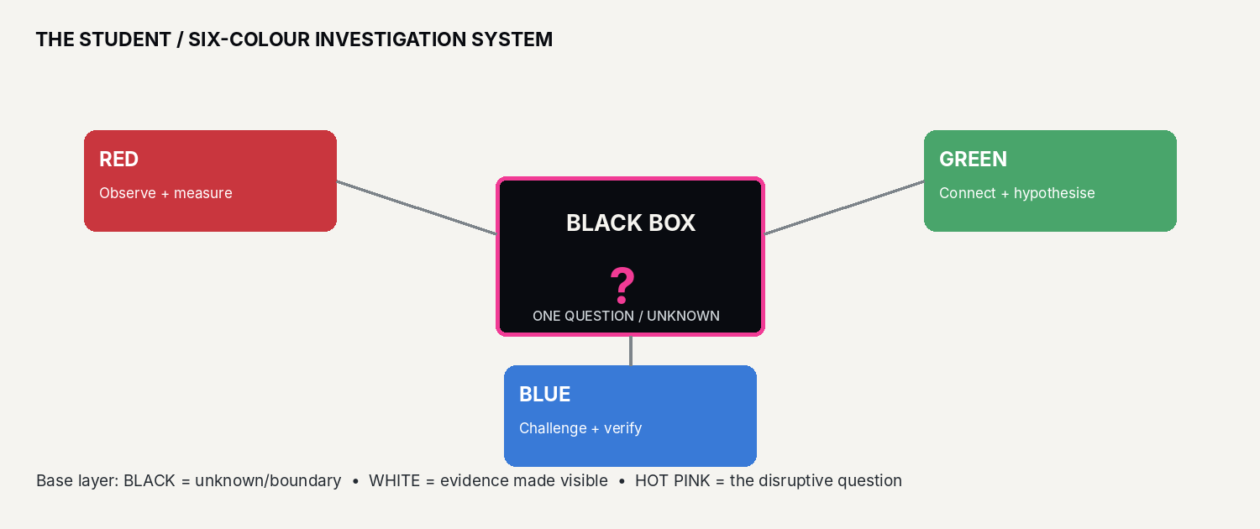
The Student’s source-defined colour semantics: black/white/hot pink plus red/green/blue. [S3]
The answer is not decided by majority vote. The three positions contribute different kinds of inquiry: RED observes and measures; GREEN maps relationships and hypotheses; BLUE checks the inference and searches for counter-explanations. All three can learn the other roles. Where evidence is insufficient, “not yet known” is a valid result. [S3]

08 / WORLD CANON CARDS

The foundational sequence and current world set
Use these summaries as production-facing anchors; the linked ArtStation descriptions remain the detailed source texts.
WORLD / CANON | CORE LAW | VISUAL CONSEQUENCE
001 — THE BALANCE | Existence and non-existence become distinguishable through a first contradiction/boundary. The creation account is philosophical fiction, not a scientific theory. [S5] | Paired forces, balance, thresholds, negative space, emergent geometry. Avoid literal cosmology clichés.
002 — THE STUDENT | An answer is investigated through one question, three independent perspectives and triangulation. Evidence, hypothesis, inference and open questions stay distinct. [S3] | Compact, readable silhouettes; black-box motif; semantic colours used with discipline; expressive instruments or markers only when functional.
003 — THE TEACHER / SHISHŌ MUSASHI | Integrates multiple perspectives and opposing hypotheses to recognise hidden structure; does not merely hand over answers. [S6] | Composed, strategic, layered viewpoint; controlled asymmetry; deliberate visual evidence of adaptability, not a generic “wise samurai” costume.
MUSHI | Unknown phenomena have mechanisms. No magic: physics, mathematics, materials, mechanisms, optics, information processing and engineering explain the impossible-looking. [S4] | Optical systems, engineered mirrors, hidden geometry, mechanism-driven reveals; wonder through explanation.
TATE / 盾 — Resilience OS | Interoperable resilience across industry, infrastructure, information, institutions, trust and recovery; proposed architecture, not a claim that a global OS already exists. [S7] | Modular components, interfaces, dependency maps, service layers, access/trust signals; capability over military spectacle.
ROMANCE ONTOLOGY | Desire → expectation → failure → agency → transformation. Love is connection, not ownership; characters retain independent will. [S8] | Warmth can enter the shared 3D language. Design interactions, posture and space around agency and relationship, not decorative “romance” symbols.
THE RAT / 鼠鬼 | Corruption grows from within desire, fear, environment and distorted institutions. It turns system weaknesses into propagation mechanisms. [S9] | Matte graphite, blue-black, dirty ivory and restrained warning red; hard-surface animal-mechanism hybrid; never generic horror.

Canon governance note: the public pages currently label both TATE and THE RAT as “Part Five.” Preserve the titles and distinct world laws, but do not repeat part numbering in new artwork until Alfons approves one master sequence.

09 / CHARACTER AND NARRATIVE DESIGN

Entities behave according to the ontology
Do not let a visual trope decide what a character is allowed to do.

Entity design checklist
- Identity: what is the entity’s purpose, need, limitation and point of view?
- Anatomy / assembly: how does it stand, move, sense, interact, carry load, protect itself or change state?
- Relationships: what does it depend on, resist, protect, exploit or transform?
- Agency: what can it choose, refuse, misunderstand or learn? Do not make a character merely a symbol with no decisions.
- Failure mode: what happens when its assumptions or core mechanism fail?
- Recognisability: one dominant silhouette cue and a limited number of repeatable features; avoid detail that cannot survive animation or alternate views.

Narrative engine
STEP | QUESTION FOR DESIGN
Desire / purpose | What does the entity want or what function must it perform?
Expectation / model | What does it predict will happen? Which assumption is hidden?
Failure / contradiction | What invalidates the prediction, blocks the task or exposes a dependency?
Agency / response | Does it adapt, test, negotiate, resist, repair, or refuse?
Transformation / consequence | What changes in the entity, relationship, system or world after the action?

ROMANCE-SPECIFIC RULE
Do not confuse attraction with entitlement, protection with control, or an expected outcome with consent. A character’s independent agency is a plot engine, not an exception. [S8]

10 / TYPOGRAPHY, LOGO AND LAYOUT

A clear editorial system for a bilingual concept studio
Keep the brand quiet enough for the object to be the hero.
ELEMENT | RECOMMENDATION
Display type | Inter Display Bold or a comparable clean, compact grotesk for English wordmarks, headings and asset labels.
Body type | Inter Regular / Medium. Prioritise legibility in long concept descriptions and production notes.
Japanese type | Noto Sans CJK JP for interface and explanatory copy. Use Japanese punctuation and spacing consistently; have final Japanese copy checked before public release.
Hierarchy | World title → ontology/part identifier → one-line law → short explanatory copy → technical metadata.
Numbers and codes | Use stable three-digit ontology IDs where an ID is canonically established: 001, 002, 003. Do not invent or duplicate part numbers.
Logo master | Use the approved source artwork. Do not redraw, stretch, skew, bevel, recolour or add a 3D treatment to the master logo without an explicit logo-animation / materialised-logo brief.
3D brand expression | The “logo comes to life” concept and Golden Ticket may be treated as specific assets, not as permission to turn every logo application into a 3D object. [S10, S11]
Clear space | Keep clear space around the wordmark at least the cap height of the “W” on all sides. Do not crowd with labels, frames or secondary marks.
Layout | Use a disciplined grid, strong alignment, generous negative space, technical labels and one controlled accent. Never let UI decoration compete with the focal object.

Naming convention
CANONICAL LOCKUP
WARU-GAKI / 悪ガキ | [WORLD TITLE] | [ONTOLOGY ID only if confirmed] | Created and art-directed by Alfons Scholing

Site correction to make before publishing the next branded asset: change “Japanes-European International Concept Studio” to “Japanese–European International Concept Studio.” Keep the intended meaning; this is an editorial spelling correction, not a rebrand.

11 / PROMPT AND PRODUCTION TEMPLATE

The prompt describes the mechanism, not a pile of references
Use this structure for text-to-image, 3D concept art and image-to-video briefs.
MASTER PROMPT ORDER
WORLD LAW → SUBJECT / FUNCTION → CORE MECHANISM → SILHOUETTE → MATERIALS → PALETTE → CAMERA / LIGHT → ENVIRONMENT → FORMAT → EXCLUSIONS → CANON CHECK

Reusable prompt scaffold
WARU-GAKI / 悪ガキ — [WORLD / ONTOLOGY].
Create a premium, fully realised 3D concept-art asset of [SUBJECT], designed by Alfons Scholing.
World law: [WHAT IS POSSIBLE / IMPOSSIBLE IN THIS WORLD].
Core mechanism: [WHAT THE SUBJECT DOES AND HOW IT WORKS]. Make the mechanism drive the silhouette, construction and visual hierarchy; do not illustrate the reference examples literally.
Form: [PRIMARY MASS], [SECONDARY STRUCTURES], [JOINTS / CONNECTIONS], [DISTINCTIVE SILHOUETTE]. Every detail must be functional, structural or semantically necessary.
Materials: [WORLD-SPECIFIC MATERIALS] with physically credible roughness, reflections, edge response and contact.
Palette: [WORLD PALETTE] with [ACCENT] reserved for [MEANING].
Composition: [16:9 HERO / TURNAROUND / PORTRAIT / SQUARE], [CAMERA], [LIGHTING], clear negative space, focal subject dominant, full readable silhouette.
Quality: high-end stylised hard-surface 3D, sculptural clarity, production-quality modelling, cinematic but controlled lighting.
Exclude: generic fantasy, generic horror, flat illustration, photorealism when stylised 3D is requested, unfinished grey-box, meaningless greebles, excessive emissive glow, rainbow palette, franchise-specific borrowed designs.
Canon check: the final image must show [TESTABLE VISUAL CONSEQUENCE OF THE WORLD LAW].

Examples of the mechanism clause
WORLD | MECHANISM CLAUSE EXAMPLE
MUSHI | “The apparently impossible space is produced through calibrated reflections, controlled angles, hidden geometry and a real mechanical arrangement; no supernatural force.”
THE RAT | “The tail is an information-and-infrastructure coupling mechanism: its contact points show where an internal fault propagates through the larger system.”
TATE | “The object visualises a resilient capability layer: its modules expose dependencies and recovery paths without depicting a fantasy military command centre.”
ROMANCE | “The scene makes two independent intentions legible through distance, posture, choice and consequence; neither character is a prop for the other.”

12 / ASSET PRODUCTION

Ship coherent sets, not isolated hero images
Every published asset should be reusable, traceable and consistent in follow-up views.

Minimum production set for a new entity
- Ontology card: purpose, world law, capabilities, limitations, relationships and failure modes.
- Silhouette test: black-on-white shape at thumbnail scale; confirm distinctiveness before material work.
- Hero view: approved 16:9 presentation with the core mechanism visually clear.
- Construction views: front, side, rear or exploded view when needed to validate build logic.
- Material / colour sheet: palette and material response; include colour semantics if the world defines them.
- Interaction test: one scene, pose or diagram showing the subject operating under its world law.
- Publication record: title, author credit, date, version, prompt, tool/model if used, human edits, references and approval status.

File naming
RECOMMENDED PATTERN
WG_[WORLD]_[SUBJECT]_[ASSETTYPE]_v001_YYYYMMDD.ext

Examples: WG_MUSHI_MIRROR-ENGINE_HERO_v001_20270115.png | WG_RAT_PROPAGATION-TAIL_TURNAROUND_v002_20270304.png | WG_STUDENT_BLACK-BOX_DIAGRAM_v001_20270201.svg

Version status labels
STATUS | MEANING
CONCEPT | Exploratory. Not yet canon.
IN REVIEW | Being tested against world laws and visual standards.
APPROVED | Approved by Alfons Scholing for the stated use.
SUPERSEDED | Replaced by a later version; retain for provenance.
RETIRED | No longer part of active canon; keep only in historical records.

13 / QUALITY GATE

Approve only when the world and the image agree
Use this checklist before publishing an ArtStation project or delivering a visual asset.
CHECK | PASS CONDITION
AUTHORITY | The title, world, design decisions and credits are approved by Alfons Scholing.
CANON | The image obeys the current world law and does not quietly contradict established facts.
MECHANISM | The central mechanism is visible, inferable or clearly documented. The design is not only decorative.
SILHOUETTE | The subject reads at thumbnail size and remains identifiable without colour.
FORM | Panels, joints, cables, seams, openings and emitters have a reason. Nothing important floats accidentally.
MATERIAL | Reflections, roughness, scale, lighting and contact feel coherent with the chosen materials.
PALETTE | Global neutrals and world-specific semantic accents follow their intended roles.
COMPOSITION | The focal point is clear; negative space and environment support the subject.
ORIGINALITY | No copied character, logo, proprietary design or franchise identity is being reproduced. References are transformed, not traced.
BILINGUAL COPY | English and Japanese titles are consistent, correct and not accidentally machine-mangled.
DISCLOSURE | Sources, tool usage, human contribution and uncertainty are recorded where relevant.
FILE RECORD | Version, date, author credit, prompt/edit history and status are saved.

STOP CONDITION
If the render is beautiful but the mechanism is unclear, return to the ontology. If the ontology is strong but the render is generic, return to silhouette, materials and composition. Do not solve a design problem by adding more detail.

14 / RESEARCH PHASE 2027

Turn the style system into a tested production method
Proposed schedule for the formal personal research project; timing can be adjusted by the author.
PHASE | FOCUS | OUTPUT / TEST
Preparation / Oct–Dec 2026 | Consolidate current canon; standardise names, credits and visual defaults; identify contradictions. | Style Bible 1.0; world index; decision log; numbering issue opened.
Q1 2027 — Define | Build world cards for each ontology: entities, relations, transformation, boundaries, mechanism and generation. | Ontology template; current-canon matrix; glossary; reference ledger.
Q2 2027 — Prototype | Produce one hero object/character and one functional test per world; check visual differences between worlds. | Controlled prompt set; hero renders; silhouette/material studies; consistency review.
Q3 2027 — Cross-media test | Test whether the same rules hold across concept art, turnarounds, diagrams and short motion studies. | Cross-output audit; prompt revisions; contradictions list; revised style rules.
Q4 2027 — Consolidate | Publish approved canon and archive superseded work with provenance. | Style Bible 1.1 or 2.0; approved asset library; research report and changelog.

Research discipline
- Separate CANON (approved rule), EVIDENCE (direct source), HYPOTHESIS (proposed explanation), REFERENCE (external inspiration) and OPEN QUESTION (unresolved).
- Every new claim should have a source or be labelled as authored fiction, working hypothesis or design proposal.
- Every revision should state what changed, why it changed, and which assets or world rules are affected.
- An AI-generated result is an experiment, not a source. The author selects, edits, rejects and approves outputs; do not let a model silently rewrite canon.
RESEARCH QUESTION
Can a clearly specified ontology reliably produce distinct, beautiful and internally consistent worlds across multiple visual outputs?

15 / AUTHORSHIP AND SOURCES

Copyright, contribution and provenance
The document attributes the project to its creator and defines how future research records should be kept.
AUTHORSHIP NOTICE
WARU-GAKI / 悪ガキ — conceived, authored, designed and art-directed by Alfons Scholing. © Alfons Scholing. All rights reserved. This notice applies to original project concepts, world specifications, authored text, design systems and project documentation to the extent protected by applicable law.

ChatGPT is the assistant tool in Alfons Scholing’s independent personal research project beginning in 2027; this does not make WARU-GAKI an official OpenAI or ChatGPT project. AI tools may assist with research, drafting, concept iteration, images and production experiments. They are tools within a human-directed process. Keep evidence of creative decisions, prompt development, selection, editing and final approval for each important asset.
Third-party materials remain the property of their respective rights holders. Referenced books, philosophies, media or designs are research inputs, not assets to reproduce. This statement records authorship and intended attribution; it is not a legal opinion or a guarantee that every AI-generated component is independently copyrightable in every jurisdiction.

Primary project sources checked 19 October 2026
S1 — IKZ / IK ZIE ZOMBIES automatic diagnostic reference system — https://alfonsscholing.artstation.com/projects/31EKag
Method: source-first review, pattern and contradiction mapping, ontology, human remains author.
S2 — IKZ Master Reference 2026 — https://alfonsscholing.artstation.com/projects/31EOVA
Archive navigation, manuals, history and project relationships.
S3 — WARU-GAKI Ontology 002: THE STUDENT — https://waru-gaki.artstation.com/projects/JwwOzz
Black-box method, triangulation and six-colour semantic system.
S4 — WARU-GAKI MUSHI — https://waru-gaki.artstation.com/projects/yAAKxn
Engineering-only world; optics, materials, mechanisms and information processing.
S5 — WARU-GAKI THE BALANCE — https://waru-gaki.artstation.com/projects/Y88R6b
Origin ontology framed as philosophical fiction.
S6 — WARU-GAKI SHISHŌ MUSASHI / THE TEACHER — https://waru-gaki.artstation.com/projects/zzzkr6
Integration of multiple viewpoints and hypotheses.
S7 — WARU-GAKI TATE / Resilience OS — https://waru-gaki.artstation.com/projects/9BBRoo
Resilience architecture, interoperability and trust layers.
S8 — WARU-GAKI The Romance Ontology — https://waru-gaki.artstation.com/projects/kwwz60
Desire–expectation–failure–agency–transformation; character agency.
S9 — WARU-GAKI The Rat / 鼠鬼 — https://waru-gaki.artstation.com/projects/Xaabl0
Internal system corruption, material palette and 16:9 3D direction.
S10 — WARU-GAKI “What if the Branding Logo came to life?” — https://waru-gaki.artstation.com/projects/yAAodK
A specific 3D logo exploration.
S11 — WARU-GAKI Golden Ticket Concept — https://waru-gaki.artstation.com/projects/eggxOP
A distinct premium identity asset.
Project root — WARU-GAKI / 悪ガキ — https://waru-gaki.artstation.com/
Current public index of the new universe.
IKZ domain status checked — https://ikziezombies.com/
Redirected to Alfons Scholing’s ArtStation portfolio when checked; treat as an archive/method reference, not WARU-GAKI identity.
Editorial decisions for Alfons: (1) confirm the final Part/Fifth Ontology sequence for TATE and THE RAT; (2) approve the descriptor spelling correction; (3) approve this as the baseline before the formal 2027 research phase.

