Output File for PA1.

Broadly this output file has three basic cases:-
- File transfer
- Case when same file are there in multi Peer
- Automatic Server update
- Unlinking when Peer is shutdown
Create a Peer folder in remote location and copy Client interface and classes to that location for testing remote location work.
Peer1 , 2 and 3 (all are in E drive with same client code)
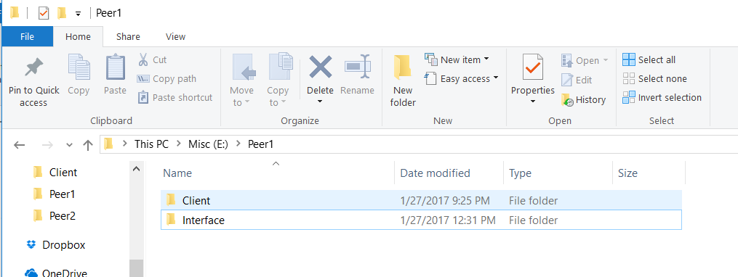
Server
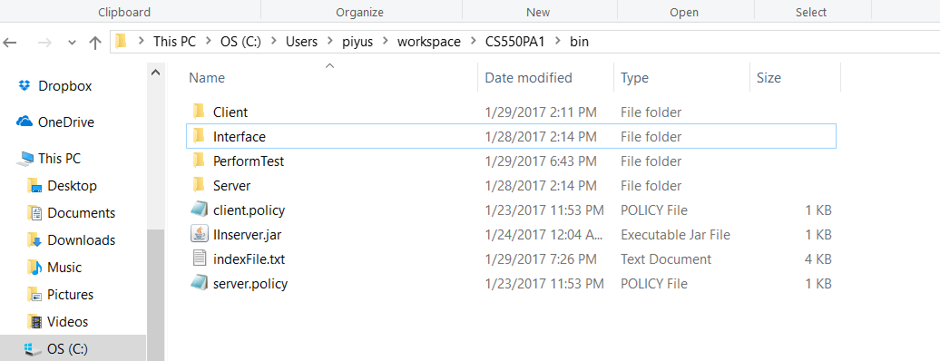
started RMI registry for server with port number 5000:-
start rmiregistry 5000 Here 5000 port is given to server.

C:\Users\piyus\workspace\CS550PA1\bin>java -Djava.rmi.server.hostname=localhost Server.IndexingServer 5000
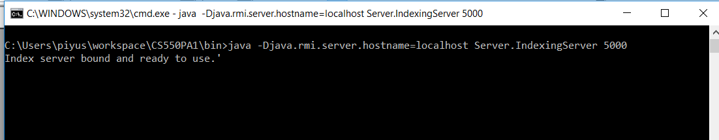

Once the server is started we will start Peer1. But before starting peer1 we have to start rmiregistry for Peer1 with new port number which is going to be for client.
Start rmiregistry 5001

To start client code we have to execute below mentioned code
E:\Peer1>java Client.Peer localhost 5000 5001

system will ask to key in Peername. So that system can further communication with peername to server.

- Enter Peer Name:--> then select the action needed by Peer.
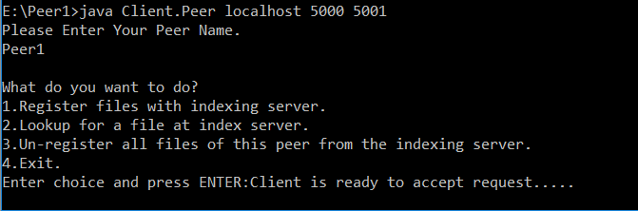
- When 1 is selected :Peer will create a folder with the name of Peer1 entered by user and ask user to place the files to the folder or if already exists ,then peer will update the server with the files detail to register.
For testing purpose ,i have created a new file called test.txt and placed in Peer1 folder which got created due to option 1 . (We can also create a peerid name folder,it just that make sure folder name should be same as peer name)
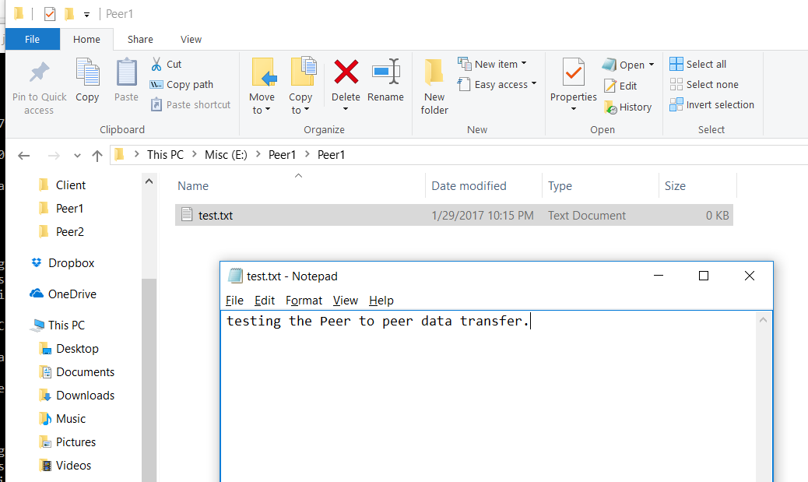
here please note,Peer1 is the Peer name given by user.
Now when we press 1 ,we got success message and Server got updated with the files as well.
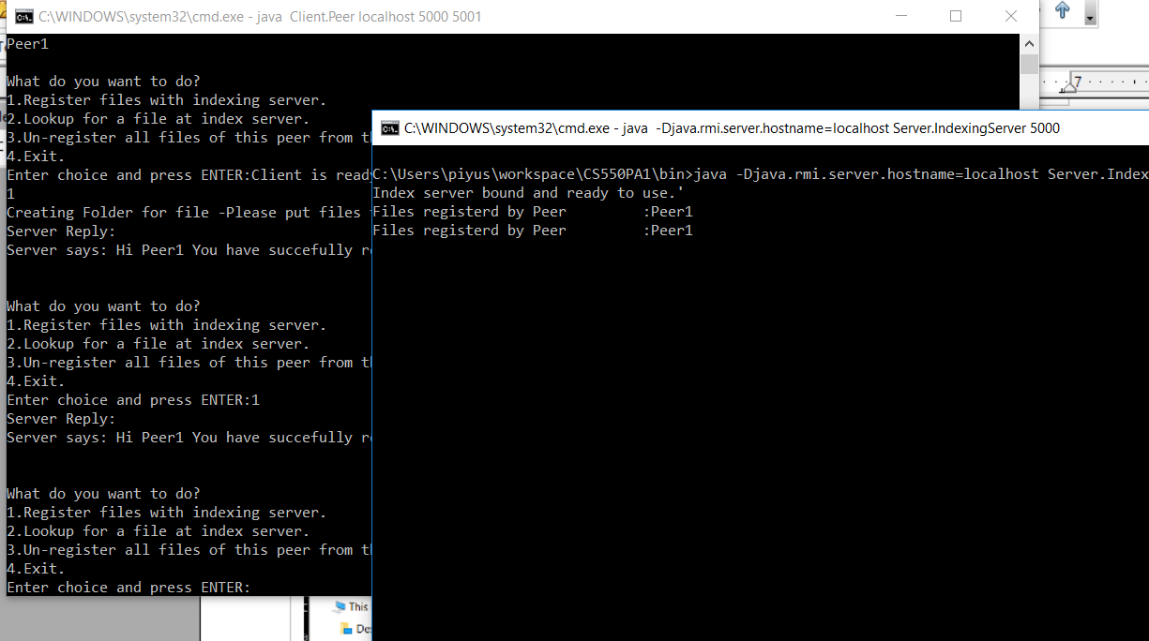

- Now to check the functionality of lookup: We will initiate Another peer, called Peer2.
Step1 : Start rmiregistry 5002
step 2: E:\Peer2>java Client.Peer localhost 5000 5002
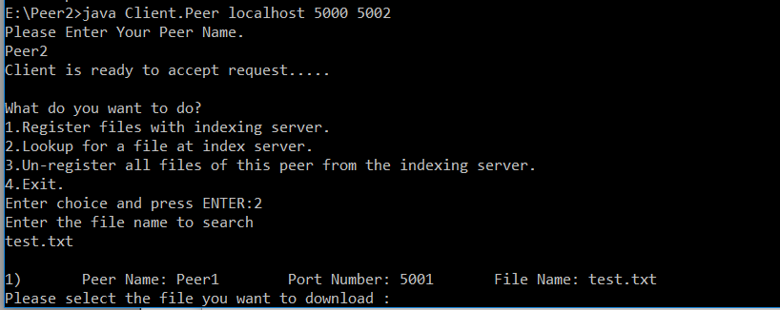
When we select option 2 and enter the file which we wanted to download(test.txt), we will get the option to select the peer from where we want to download the file.
Once we give the serial number of file which needed to be downloaded , we will get the success message and the file will be downloaded to the Peer2's local directory with folder name as Peerid.
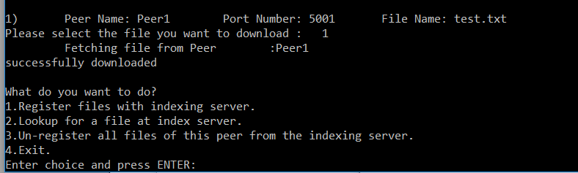
Success copied file.
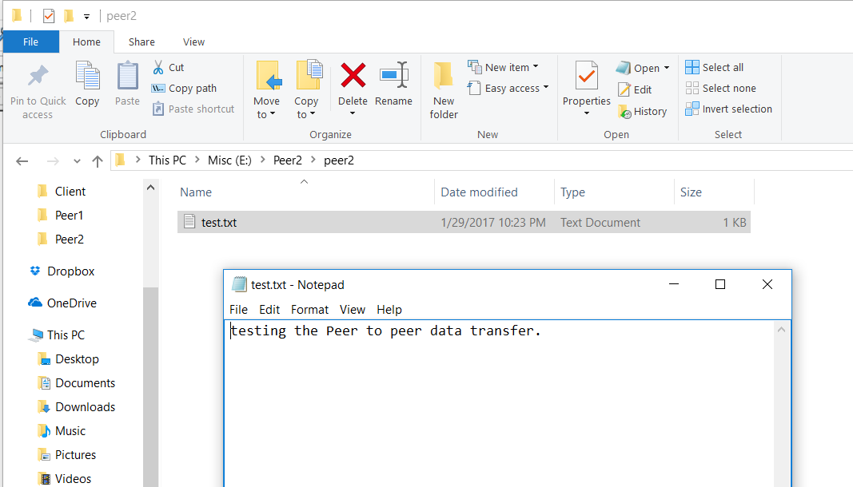

CASE when there are same name file in multi Peer:
Since earlier we had transferred test.txt ,the file is there in both peer1 and peer2. So when we request same file from peer 3 we will get the details for both peer1 and peer2.
Peer 3 will have an option to download from either of the peer.
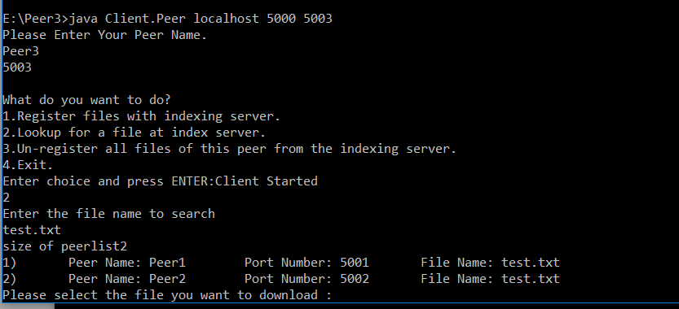
And when we select eitehr of the slno,that file gets downloaded to local path of peer3.

Case for automatic file details updation to server when files are added or removed.
For this we a thread running in background ,which will keep on updating the server with files details,
to test this functionality, we will add a new file in Peer3 and the Peer is kept on running, after 4 minutes system will update the hashmap value in surver with the update file list. Here User can remove some files or add as well.
For confirmation,we will share the screen shot of file search result from different peer before adding the files in Peer3 and after adding the file in Peer3 folder but not taking any other actions.(this is a method where periodically peer sents the detail to server with its file count).
Before adding file to Peer3 folder,we searched file in Peer2.
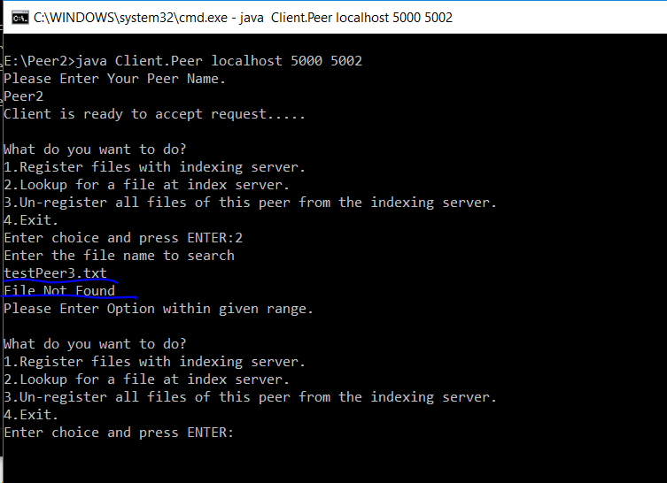
We are adding file physical path to Peer3 folder.
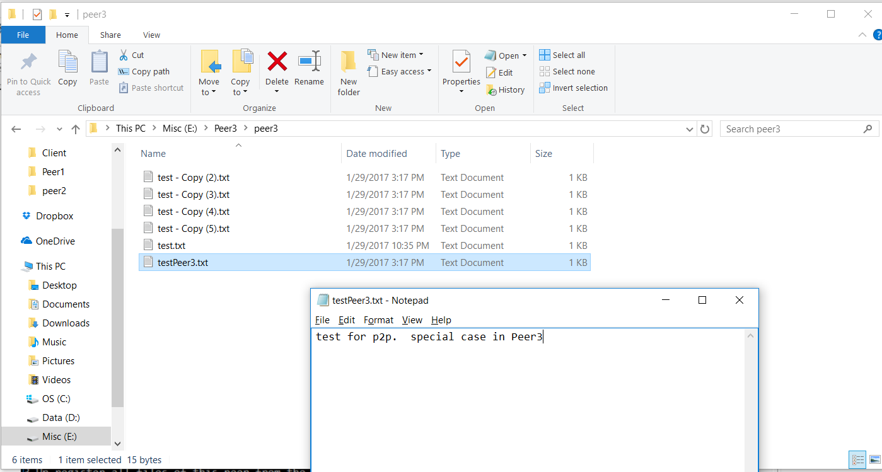
@server end:server will get a periodic update by all the active peers,which are connected to the server.
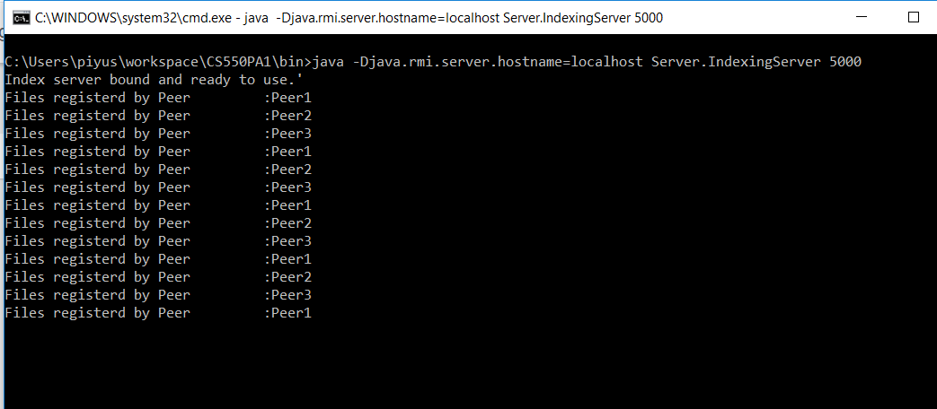
Now after this update which is done automatically when we search in peer2, we are able to find the same file.
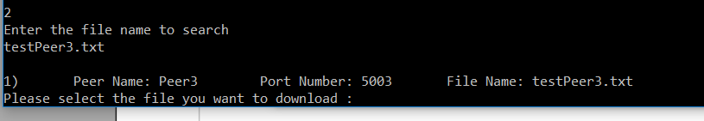

Case when we shutdown a Peer.
For this case we are going to shutdown Peer3 through system,and when we observe,we will see that Peer3 file will be removed from server. Here we will search for testPeer3.txt after exiting Peer3.

Exiting Peer 3.
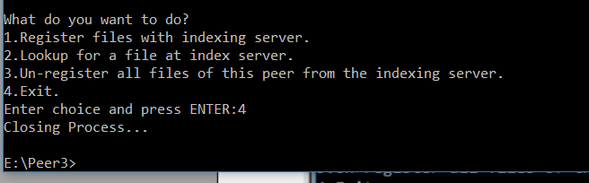
Now search for file in Peer2,which we were able to find earlier.
