

CountCat User Guide
Installation and Migration Guide

2017.12.14
Version 2.0.1

Contents
Introduction 4
Reasons for Migration 4
CountCat Installation 5
Brief Description 5
Supported Operating Systems 5
Installation 5
Invoking CountCat 5
ccat Command Line Options 6
Script Flow 7
Features/Bugs 7
Selecting Source and Target Systems 8
Source File Audit 8
File Audit 8
Header File Analysis 9
Code Analysis 9
System Calls 9
Solaris threads and POSIX pthreads 12
LinuxThreads 13
Other Thread Differences 14
Common Solaris Threads with Linux Alternatives 14
Common Solaris Threads Without Linux Alternatives 15
Mutex Threads 15
Semaphores 15
Semaphore Concepts 15
Linux Compatible 16
Solaris Only Semaphores 16
Sockets 16
Running CountCat 17
Types of Code Audit 19
Full Audit Example 20
CountCat output Files 21
ccat.html 21
ccat_detail.html 23

Update History

Edition | Date | What change/Reason | Changes | Author
Pre 1.0 | 08-10-31 | Halloween Release – Pretty Scary | Just started | Andy Prowse
Pre 1.1 | 08-11-14 | Halfway there | Added information | Andy Prowse
Pre 1.2 | 08-12-04 | Added screen shots | Added information | Andy Prowse
1.0 | 08-12-11 | Minor changes, first release | Added information | Andy Prowse
1.1 | 09-01-09 | Format fix |  | Andy Prowse
1.2 | 09-05-26 | Updated to match version ccat 1.0.5 | Added functionality | Andy Prowse
1.3 | 09-06-01 | Milestone release corresponding with ccat 1.3.0 universal script | Added functionality and universal | Andy Prowse
1.3a | 09-08-19 | Fixing various grammar/spelling issues |  | Andy Prowse
1.4.0 | 10-05-03 | Freshen | Dropped universal script temporarily | Andy Prowse
2.0.0 | 13-11-03 | Update |  | Andy Prowse
2.0.1 | 17-12-14 | Updates |  | Andy Prowse

References:

No. | Document | Author
1 | Solaris Man Pages | Sun Microsystems
2 | Linux Man Pages | RedHat, Many Others
3 | The GNU C Library Reference Manual | S. Loosemoore

Introduction

This document is intended to aid in the migration of SPARC Solaris specific code to an Intel x86 based environment utilizing Linux. The target systems may be virtualized, or on bare metal.

We hope that the CountCat User Guide will assist in the analysis of source code, and make the code porting easier. With CountCat, and your compiler, finding areas that require modification for linux should be easy to spot. Always use the latest version of CountCat as it is continually being refined and improved.

Happy Porting,
The CountCat Development Team.

Reasons for Migration

There are many good reasons to migrate an application or system to a new platform. Some will make sense for your organization, others will not. There are some applications that are best suited to stay on a SPARC system, either for economic, hardware/software or performance reasons. That is perfectly fine. What should be addressed are the systems that make economic sense to move, be that economic reason is financial, environmental or footprint.

With x86 hardware development outpacing current SPARC technology, many benefits can be passed to the data centre. Even older applications that are locked into a historical release of Solaris can be migrated to newer x86 technologies with significant gains in performance and reliability through emulation software.

CountCat Installation

Brief Description

CountCat performs a quick and dirty analysis of lines of SPARC Solaris C-source code and tries to determine the effort required in porting to a Linux based system. During the analysis of the source code, CountCat will flag any areas that may be of concern during the porting of the code.

Supported Operating Systems

For Solaris, both SPARC and x86 is supported.

For Linux, SUSE, RedHat and Ubuntu are supported. It should also work on any other Linux that uses the ksh shell, although it may not be tested in our environment.

Installation
RPM Based Systems:

# rpm -ivh ccat-2.0.0.i386.rpm

For other systems that do not use RPM, install the tarball.
As root expand and untar the ccat tarball in the / directory. This will install the CountCat script into the /opt/ccat directory. Under the /opt/ccat/bin directory, you will find the ccat script.

Invoking CountCat
Once the installation is complete, run ccat in the root of the source tree.

On the first run of the ccat script, it will ask for the source system OS level, and also the OS of the target system.

Example:

# cd [source_code_dir]
# /opt/ccat/bin/ccat [quick|script|clean|reset|help]

During the execution of the script, ccat will provide a quick summary on the console. In addition, CountCat will leave an html formatted report, and ccat.html, a more in depth, detailed report called ccat_detail.html. For easier data management, you will also find a CSV file called ccat.csv. The CSV file uses “---” as delimiters.

The CountCat generated reports, in addition to this migration guide, will help to identify the occurrences and levels of difficulty of any possible issues on migrating code from SPARC Solaris to x86 Linux.

ccat is to be used in conjunction with the Migration Guide.

ccat Command Line Options

ccat has five command line options:

help

Help will display a brief description of the command line options.

quick

Quick will give an inventory of C code files and header files, along with a count of total lines.

script

Script will inventory all the scripts that are located in the source code directory, and itemize them in order of type.

clean

ccat will restore itself back to it's initial `install fresh` condition before running. This allows for selecting which release of Solaris the source code is coming from, and to which release of Linux the code is being ported to.

reset

Reset is the same as clean, but does not launch the ccat script after cleaning.

No command line option will run ccat in full. This can take some time to execute.

Script Flow

The initial phase of ccat inventories the source code tree and itemizes the files and the total number of lines of both C-source and header files.

Next, the header files are compared and sorted as follows:

- Header files that are common between both Solaris and Linux
- Header files that are in Solaris only
- Header files that are included in the source code

Following this, pattern matching is performed looking for Solaris only system calls, library calls, socket calls, POSIX and Solaris threads ands semaphores. Also, binary calls, union declarations, terminal I/O error messages and other such code will be looked for.

Scripts are also searched, as they will have differences between the two platforms.

Features/Bugs

Currently ccat does not distinguish comment lines from code.

CountCat Flow

Selecting Source and Target Systems
When invoking CountCat for the first time, it will prompt for the source and target system for the migration.

For the source system, you are provided with a choice of:
- Solaris 7
- Solaris 8
- Solaris 9
- Solaris 10
- Solaris 11 (including Open Solaris)

For the target system, the choices are as follows:
- RedHat Enterprise Linux 4
- RedHat Enterprise Linux 5
- RedHat Enterprise Linux 6
- RedHat Enterprise Linux 7
- SUSE Linux Enterprise Server 10
- Analyse from current system

At this point, the databases will be generated to match the source code to.

Source File Audit

File Audit
The initial phase of the audit will count the total number of C source code files and lines. A listing of the files, locations and lines per will be displayed in the ccat.html file. This is repeated again for the header files. A total of all lines and the number of files is then generated.

Header File Analysis

Once the files are audited, the analysis begins. The first step is to match the header files against the files supplied by the source Solaris system, the target Linux system and what is provided in the source code itself.

The first stage gives a total of unique header files that are referenced in the C source code.

The second stage lists the headers that included in the source code tree. These header files will need to be analysed for Linux compatibility.

The third stage lists the header files that common to both Solaris and Linux. At this point in time, they will need to be manually audited as the differences have yet to be documented.

The fourth stage lists the header files that are in Solaris only. Alternatives to these files will need to be located, or written to satisfy the requirements of the code. It may also be possible to modify the C code itself to work around any of these header issues.

Code Analysis

System Calls

These are system calls that are in Solaris, but not present in Linux.

Solaris System Call | Linux | Comment
acl | None | Get or set a file's Access Control List (ACL)
audit | None | Write a record to the audit log
auditon | None | Manipulate auditing
auditsvc | None | Write audit log to specified file descriptor
facl | None | Get or set a file's Access Control List (ACL)
fork1 | None | Create a new process
fstatat | None | Get file status
getacct | None | Get, put, or write extended accounting data
getaudit | None | Get and set process audit information
getaudit_addr | None | Get and set process audit information
getauid | None | Get and set user audit identity
getprojid | None | Set or get task or project id
getrctl | None | Set or get resource control names
gettaskid | None | Set or get task or project id
_lwp_cond_broadcast | None | Signal a condition variable
_lwp_cond_realtimedwait | None | Wait on a condition variable
_lwp_cond_signal | None | Signal a condition variable
_lwp_cond_timedwait | None | Wait on a condition variable
_lwp_cond_wait | None | Wait on a condition variable
_lwp_info | None | Return the time accounting information of a single LWP
_lwp_kill | None | Send a signal to a LWP
_lwp_mutex_lock | None | Mutual exclusion
_lwp_mutex_trylock | None | Mutual exclusion
_lwp_mutex_unlock | None | Mutual exclusion
_lwp_self | None | Get LWP identifier
_lwp_sema_init | None | Semaphore operations
_lwp_sema_post | None | Semaphore operations
_lwp_sema_trywait | None | Semaphore operations
_lwp_sema_wait | None | Semaphore operations
memcntl | None | Memory management control
msgids | None | Discover all message queue identifiers
ntp_adjtime | None | Adjust local clock parameters
ntp_gettime | None | Get local clock values
pcsample | None | Program execution time profile
priocntl | None | Process schedular control
priocntlset | None | Generalised process schedular control
processor_bind | None | Bind LWPs to a processor
processor_info | None | Determine type and status of a processor
pset_assign | None | Manage sets of processors
pset_bind | None | Bind LWPs to a set of processors
pset_create | None | Manage sets of processors
pset_destroy | None | Manage sets of processors
pset_getattr | None | Get processor set attributes
pset_info | None | Get information about a processor set
pset_list | None | Get a list of processor sets
pset_setattr | None | Set processor set attributes
putacct | None | Get, put, or write extended accounting data
resolvepath | None | Resolve all symbolic links of a path name
semids | None | Discover all semaphore identifiers
setaskid | None | Set or get task or project id
setaudit | None | get and set process audit information
setaudit_addr | None | Get and set process audit information
setauid | None | Get and set user audit identity
setrctl | None | Set or get resource control names
shmids | None | Discover all shared memory identifiers
sigsend | None | Send a signal to a process or a group of processes
sigsendset | None | Send a signal to a process or a group of processes
__sparc_utrap_install | None | Install a SPARC V9 trap handler
swapctl | None | Manage swap space
uadmin | None | Administrative control
umount2 | None | Unmount a file system
wracct | None | Get, put, or write extended accounting data
yield | None | Yield execution to another LWP

Different means that there are fundamental differences in the way that the system call functions between Solaris and Linux. Each of these calls need to be looked at , and any modifications made for the application to perform as anticipated.
Solaris System Call | Linux | Comment
futimesat | Different | Set file access and modification times
getdents | Different | Get directory entries
llseek | Different | Reposition read/write file offset
mount | Different | Mount and unmount a file system
openat | Different | Open a file
readv | Different | Read from a file
unlinkat | Different | Remove a directory entry
umount | Different | Mount and unmount a file system
utime | Different | Change access and/or modification times of an inode
utimes | Different | Change access and/or modification times of an inode
waitid | Different | Wait for a process to change state
writev | Different | Write to a file
Small Differences require the addition of another header file, or checking that the data passed to the call is in the correct format. The easiest way to determine the differences is to look at the man pages from both the source and target systems.
Solaris System Call | Linux | Comment
fstat | Small Differences | Get file status
getmsg | Small Differences | Get next message off a stream
getpmsg | Small Differences | Get next message off a stream
lstat | Small Differences | Get file status
msgctl | Small Differences | Message control operations
msgget | Small Differences | Get message queue
msgrcv | Small Differences | Message receive operation
msgsnd | Small Differences | Message send operation
open | Small Differences | Open or create a file
stat | Small Differences | Get file status
These System Calls require the _BSD_SOURCE macro to be defined – If this macro is defined, 4.3 BSD Unix functionality is included as well as ANSI C, POSIX.1 and POSIX.2. There are conflicts between some features of 4.3 BSD and POSIX.1. Enabling this macro caused the 4.3 BSD definitions to take priority over the POSIX.1 definitions.
Solaris System Call | Linux | Comment
adjtime | _BSD_SOURCE | Correct the time to allow synchronization of the system clock
These System Calls require the _XOPEN_SOURCE=500 macro to be defined – Includes all definitions that are included by _XOPEN_SOURCE_EXTENDED.
Solaris System Call | Linux | Comment
pread | _XOPEN_SOURCE=500 | Read from a file
pwrite | _XOPEN_SOURCE=500 | Write on a file

Solaris threads and POSIX pthreads
POSIX and Solaris threads each have their own implementation of the threads library. The libpthread library is associated with POSIX; and the libthread library is associated with Solaris. Both implementations are interoperable, their functionality similar, and can be used with the same application. Only POSIX threads are guaranteed to be fully portable to other POSIX-compliant environments. POSIX and Solaris threads require different source, include files and linking libraries. It is this problem that will cause issues with the migration of the code form Solaris to Linux.
Most of the functions in the libpthread and libthread libraries have counterparts in the other corresponding library. POSIX function names, with the exception of the semaphore names, have pthread pre-pended to it. Function names for similar POSIX ans Solaris have similar endings. Typically, similar POSIX and Solaris functions have the same number and use of arguments.
- POSIX pthreads and Solaris threads differ in the following ways:
- POSIX pthreads are more portable.
- POSIX pthreads establish characteristics for each thread according to configurable attribute objects.
- POSIX pthreads implement thread cancellation.
- POSIX pthreads enforce scheduling algorithms.
- POSIX pthreads allow for clean-up handlers for fork(2) calls.
- Solaris threads can be suspended and continued.
- Solaris threads implement an optimized mutex and interprocess robust mutex locks.
- Solaris threads implement daemon threads, for whose demise the process does not wait.

LinuxThreads
LinuxThreads deviates from the POSIX.1 thread specification in a number of ways, including the following:
- Calls to getpid(2) return a different value in each thread.
- Calls to getppid(2) in threads other than the main thread return the process ID of the manager thread; instead getppid(2) in these threads should return the same value as getppid(2) in the main thread.
- When one thread creates a new child process using fork(2), any thread should be able to wait(2) on the child. However, the implementation only allows the thread that created the child to wait(2) on it.
- When a thread calls execve(2), all other threads are terminated (as required by POSIX.1). However, the resulting process has the same PID as the thread that called execve(2): it should have the same PID as the main thread.
- Threads do not share user and group IDs. This can cause complications with set-user-ID programs and can cause failures in Pthreads functions if an application changes its credentials using seteuid(2) or similar.
- Threads do not share a common session ID and process group ID.
- Threads do not share record locks created using fcntl(2).
- The information returned by times(2) and getrusage(2) is per-thread rather than process-wide.
- Threads do not share semaphore undo values (see semop(2)).
- Threads do not share interval timers.
- Threads do not share a common nice value.
- POSIX.1 distinguishes the notions of signals that are directed to the process as a whole and signals are directed to individual threads. According to POSIX.1, a process-directed signal (sent using kill(2), for example) should be handled by a single, arbitrarily selected thread within the process. LinuxThreads does not support the notion of process-directed signals: signals may only be sent to specific threads.
- Threads have distinct alternate signal stack settings. However, a new thread’s alternate signal stack settings are copied from the thread that created it, so that the threads initially share an alternate signal stack. (A new thread should start with no alternate signal stack defined. If two threads handle signals on their shared alternate signal stack at the same time, unpredictable program failures are likely to occur.)

Other Thread Differences

Common Solaris Threads with Linux Alternatives
Linux also uses a different naming convention for some of their threads. This is a reference list for what Solaris thread is most like what Linux thread. Some changes will need to be made for the migration.
Solaris Threads | Linux Threads | Comment
cond_broadcast | pthread_cond_broadcast | Similar invocation, requires pthread.h
cond_destroy | pthread_cond_destroy | Similar invocation, requires pthread.h
cond_init | pthread_cond_init | Similar invocation, requires pthread.h
cond_signal | pthread_cond_signal | Similar invocation, requires pthread.h
cond_timedwait | pthread_cond_timedwait | Similar invocation, requires pthread.h
cond_wait | pthread_cond_wait | Similar invocation, requires pthread.h
thr_create | pthread_create | Check for compatibility, requires pthread.h
thr_exit | pthread_exit | Check for compatibility, requires pthread.h
thr_getspecific | pthread_getspecific | Check for compatibility, requires pthread.h
thr_join | pthread_join | Check for compatibility, requires pthread.h
thr_kill | pthread_kill | Check for compatibility, requires pthread.h
thr_self | pthread_self | Check for compatibility, requires pthread.h
thr_setspecific | pthread_setspecific | Check for compatibility, requires pthread.h
rwlock_destroy | pthread_rwlock_destroy | Similar invocation, requires pthread.h
rwlock_init | pthread_rwlock_init | Check for compatibility, requires pthread.h
rw_rdlock | pthread_rwlock_rdlock | Similar invocation, requires pthread.h
rw_wrlock | pthread_rwlock_wrlock | Similar invocation, requires pthread.h
rw_unlock | pthread_rwlock_unlock | Similar invocation, requires pthread.h
rw_tryrdlock | pthread_rwlock_tryrdlock | Similar invocation, requires pthread.h
rw_trywrlock | pthread_rwlock_trywrlock | Similar invocation, requires pthread.h

Common Solaris Threads Without Linux Alternatives
There are no Linux alternatives for the following:
Solaris Threads | Linux Threads | Comment
pthread_rwlock_realtimedlock_np | None | An alternative must be found
pthread_rwlock_realtimedwrlock_np | None | An alternative must be found
thr_getprio | None | An alternative must be found
thr_keycreate | None | An alternative must be found
thr_setprio | None | An alternative must be found
thr_sigsetmask | None | An alternative must be found
thr_yield | None | An alternative must be found

Mutex Threads
These mutex threads are available in Linux. To use them, include <pthread.h>.
Solaris Mutex Threads | Linux | Comment
mutex_destroy | pthread_mutex_destroy | Similar invocation, requires pthread.h
mutex_init | pthread_mutex_init | Similar invocation, requires pthread.h
mutex_lock | pthread_mutex_lock | Similar invocation, requires pthread.h
mutex_trylock | pthread_mutex_trylock | Similar invocation, requires pthread.h
mutex_unlock | pthread_mutex_unlock | Similar invocation, requires pthread.h
pthread_mutexattr_getprioceiling | Same | Similar invocation, requires pthread.h
pthread_mutexattr_getprotocol | Same | Similar invocation, requires pthread.h
pthread_mutexattr_setprioceiling | Same | Similar invocation, requires pthread.h
pthread_mutexattr_setprotocol | Same | Similar invocation, requires pthread.h
pthread_mutex_getprioceiling | Same | Similar invocation, requires pthread.h
pthread_mutex_setprioceiling | Same | Similar invocation, requires pthread.h

The following mutex threads do not have a Linux version, alternatives will need to be found.

Solaris Mutex Threads | Linux | Comment
pthread_mutexattr_getrobust_np | None | An alternative must be found
pthread_mutexattr_setrobust_np | None | An alternative must be found
pthread_mutex_realtimedlock_np | None | An alternative must be found

Semaphores

Semaphore Concepts
A semaphore is a non-negative integer count and is generally used to co-ordinate access to resources. The initial semaphore count is set to the number of free resources, then threads slowly increment or decrement this count as resources are added or removed.
Semaphores are part of the Threads Library, but are separated here for simplicity.

Linux Compatible
Linux prefaces its semaphore routines with 'sem_' as opposed to the Solaris 'sema_'. Linux also requires the inclusion of the semaphore.h library. The invocation of these semaphores is the same, with the exception of sema_init, which has different variables.
The compatible semaphores would include:
Solaris Semaphore Call | Linux | Comment
sema_destroy | sem_destroy | Same invocation, requires #include <semaphores.h>
sema_init | sem_init | Different invocation, requires #include <semaphores.h>
sema_post | sem_post | Same invocation, requires #include <semaphores.h>
sema_trywait | sem_trywait | Same invocation, requires #include <semaphores.h>
sema_wait | sem_wait | Same invocation, requires #include <semaphores.h>

Solaris Only Semaphores
These semaphores have no Linux equivalent, as they are Solaris DDI (Device Driver Interface) specific. Alternatives must be found in these cases.
Solaris Semaphore Call | Linux | Comment
sema_p | None | An alternative must be found
sema_psig | None | An alternative must be found
sema_tryp | None | An alternative must be found
sema_v | None | An alternative must be found

Sockets

Another area of concern when porting from Solaris to Linux is in the area of sockets.

Keep in mind that the understood socket protocols differ between the two systems. Check out the socket man page from both systems to compare the defined formats and types.

Running CountCat

As mentioned before, when CountCat is invoked the first time, it will create the database required for the code analysis.

Once you change to the root directory of the source code, run ccat.

The first question asked will be ‘What release of Solaris is the source from?’

Enter the release of Solaris that the code was compiled on.

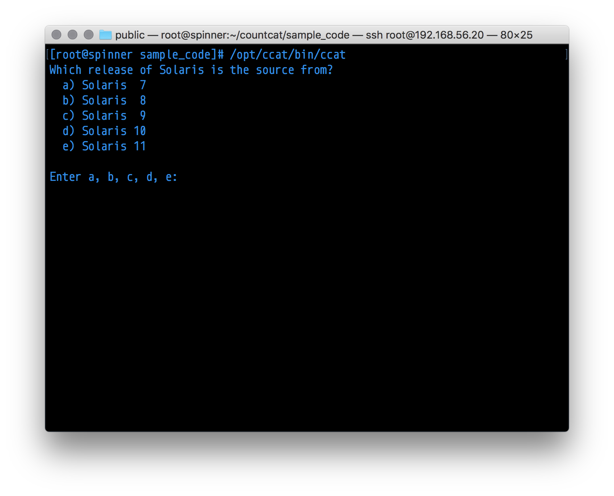
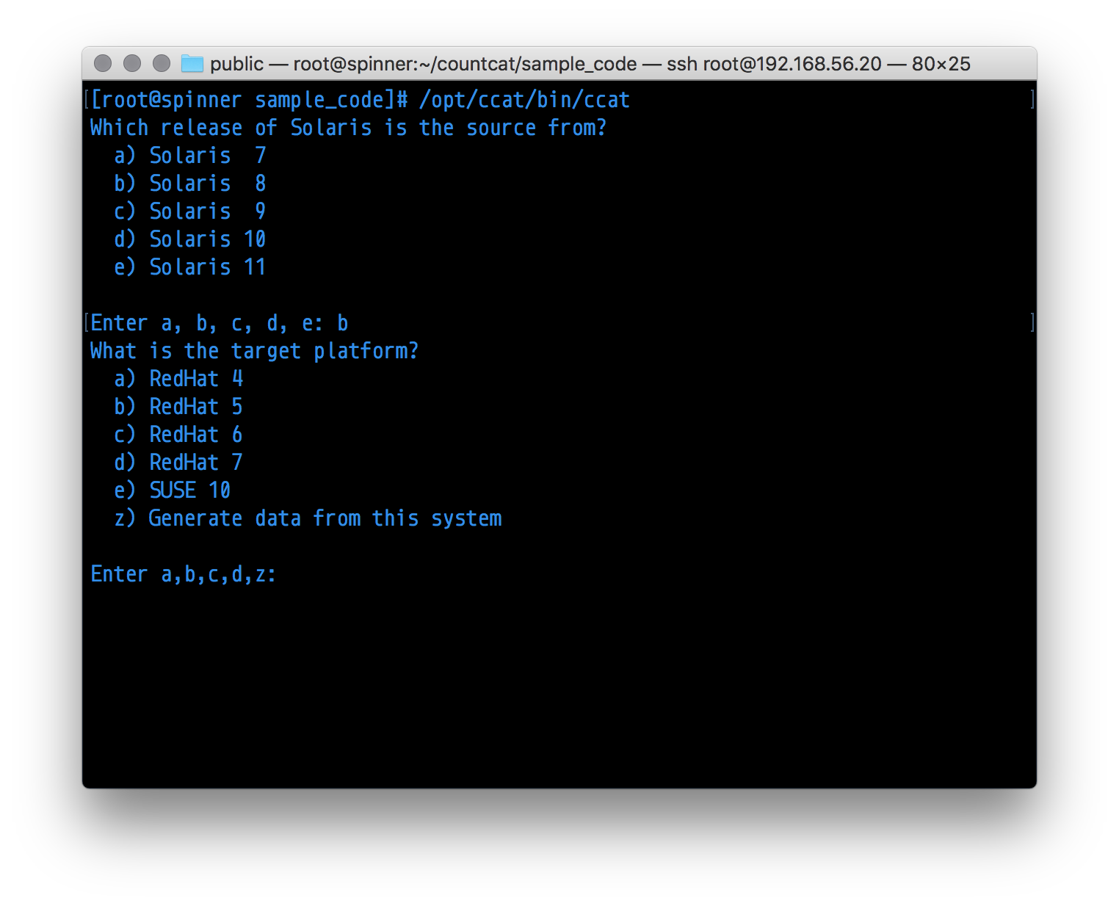Next, the target system is determined. Currently the options are RedHat 4-7, SUSE 10 and ‘current system’. If you are performing the source migration on the server running CountCat, it is preferable to perform ‘z, Generate data from this system’.

Next, with the version information, the databases will be created.
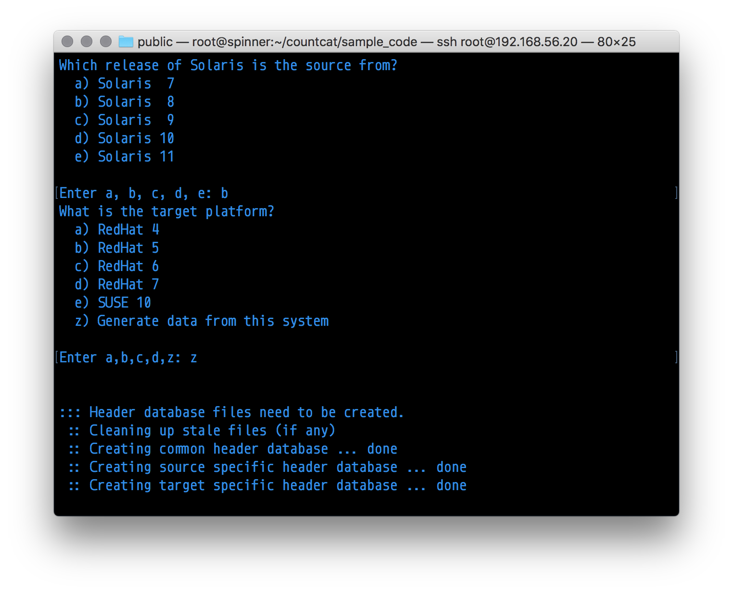

Types of Code Audit

There are two types of code audit, a quick audit that will count the c files and header files, and the total number of lines of code. CountCat does not differentiate between lines of source code and comments.

Full Audit Example
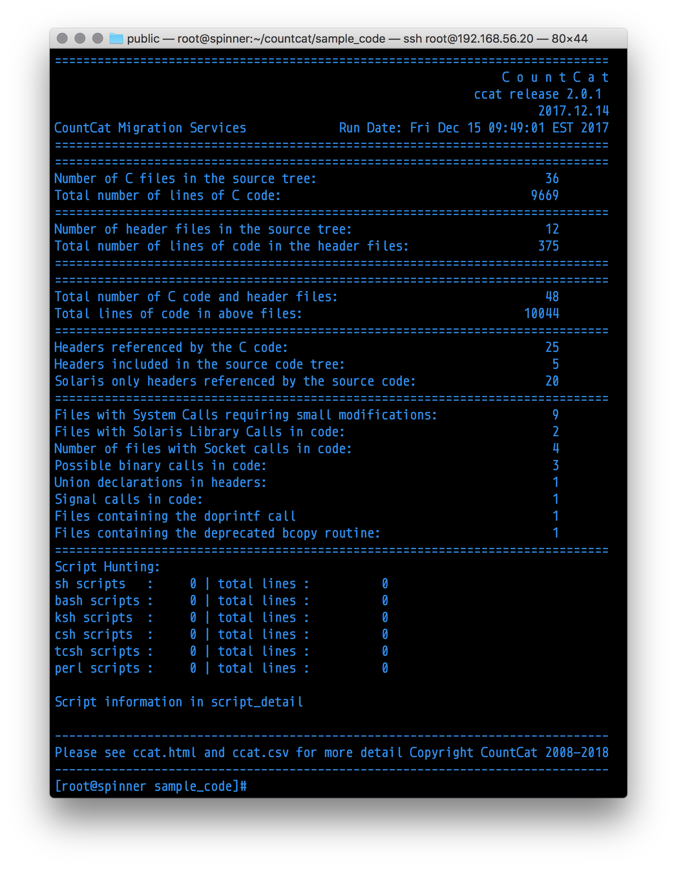

CountCat output Files

ccat.html
ccat.html has all the information from the console output, and also lists the files found, counts and database matches in a summary manner.
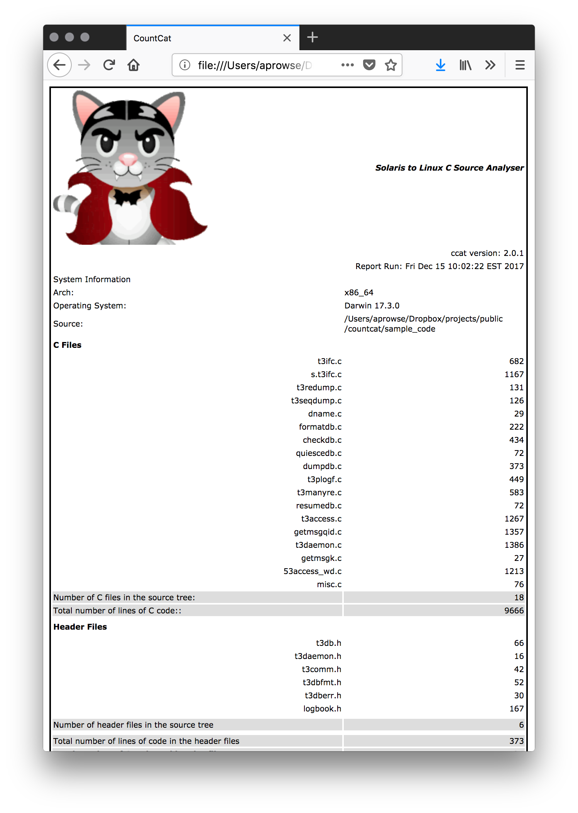
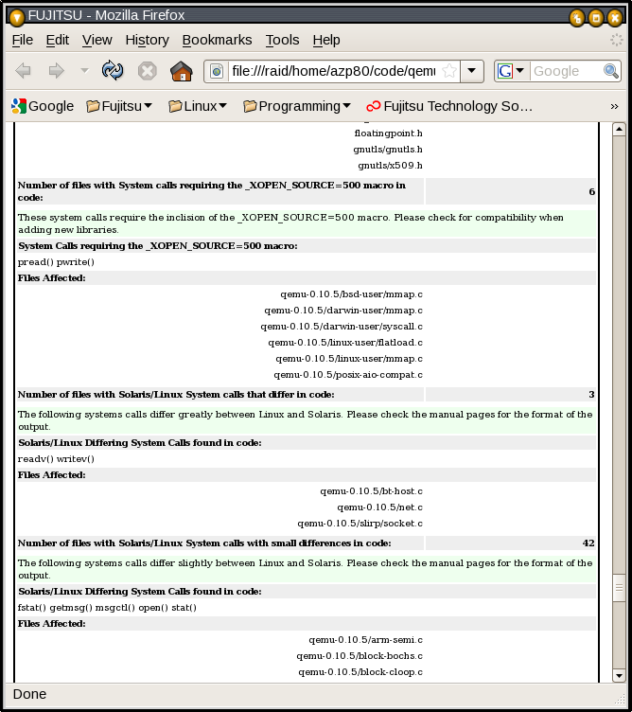
More ccat.html detail.
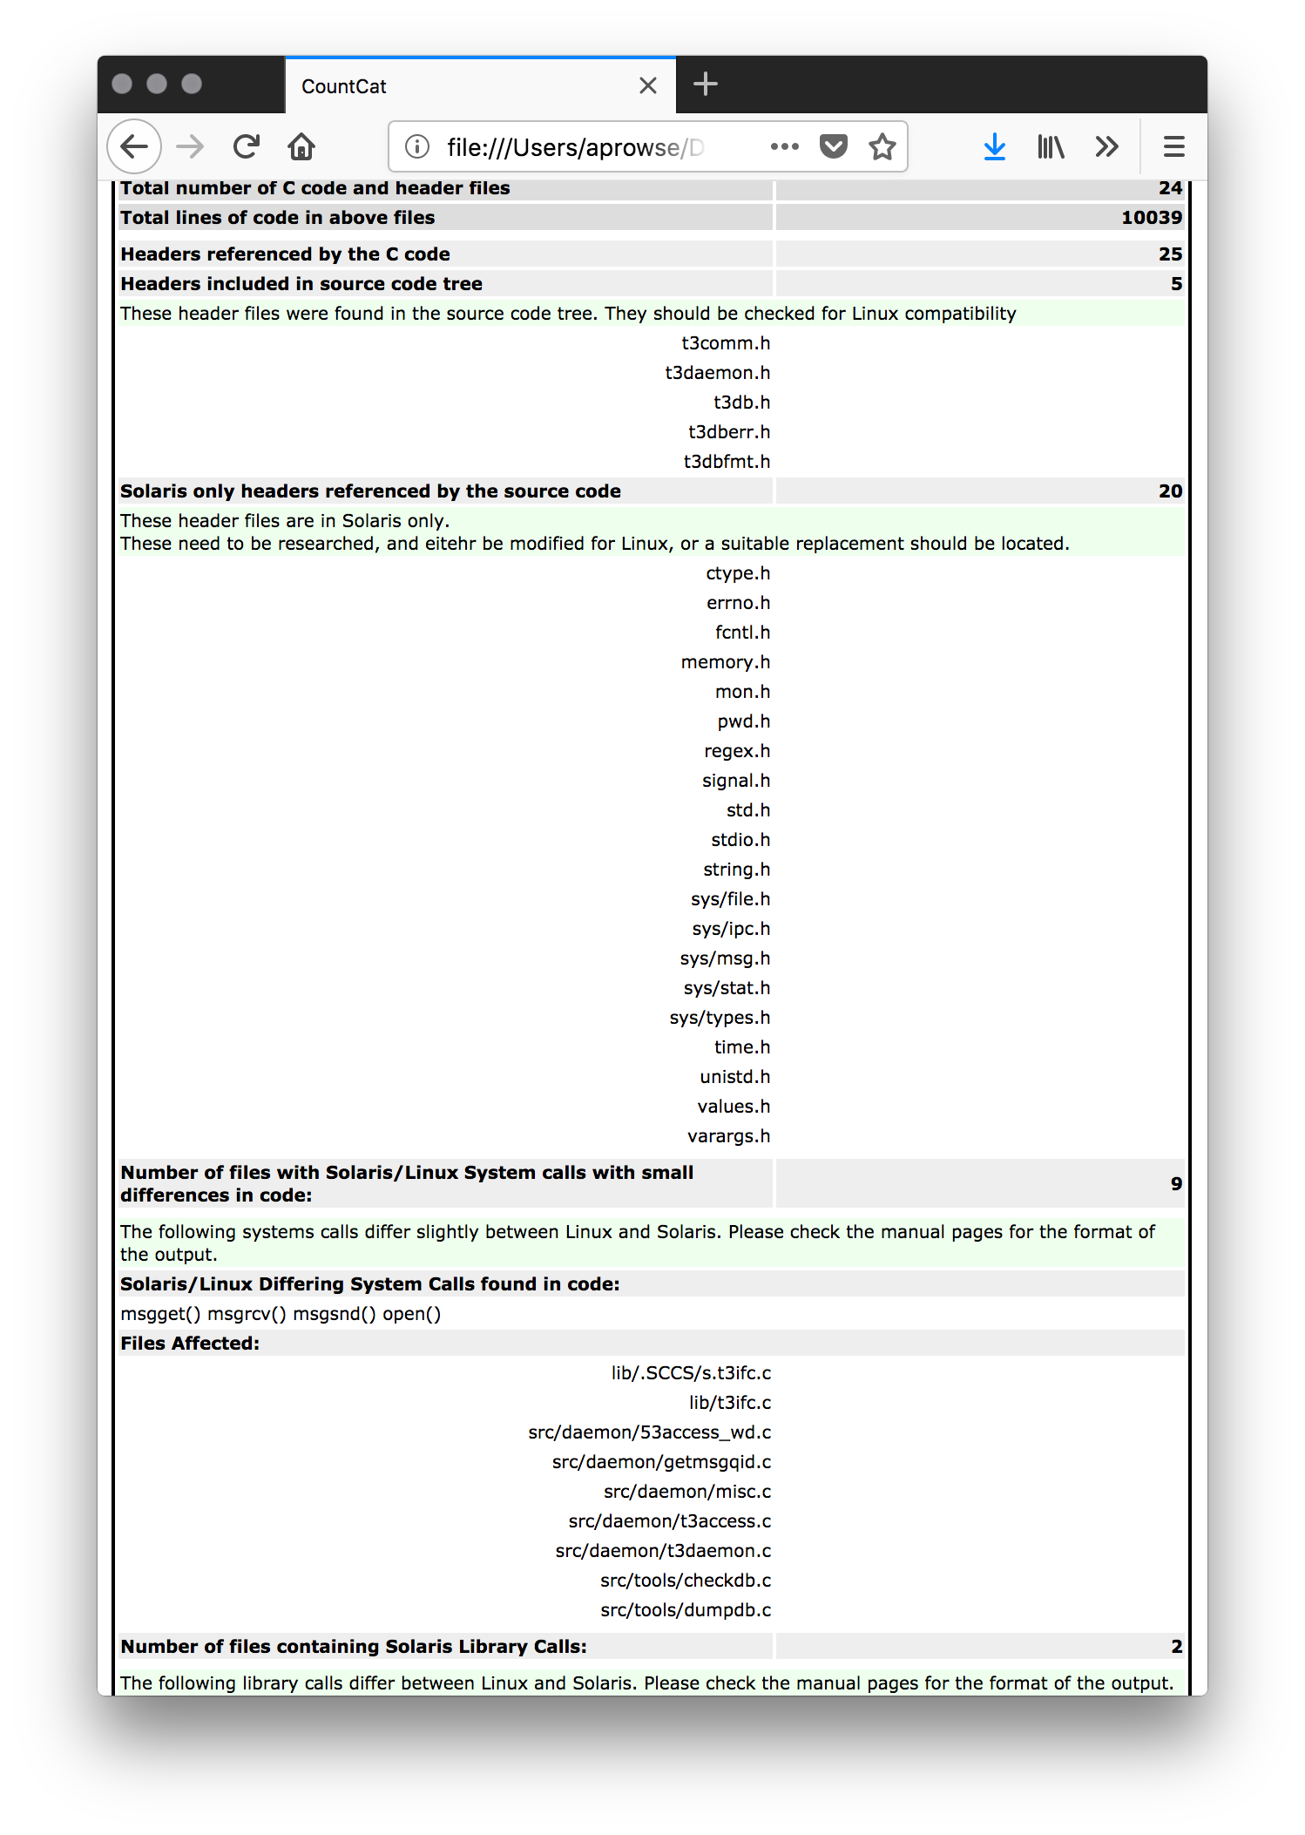

At the bottom, there is a link to script_detail.html and ccat_detail.html

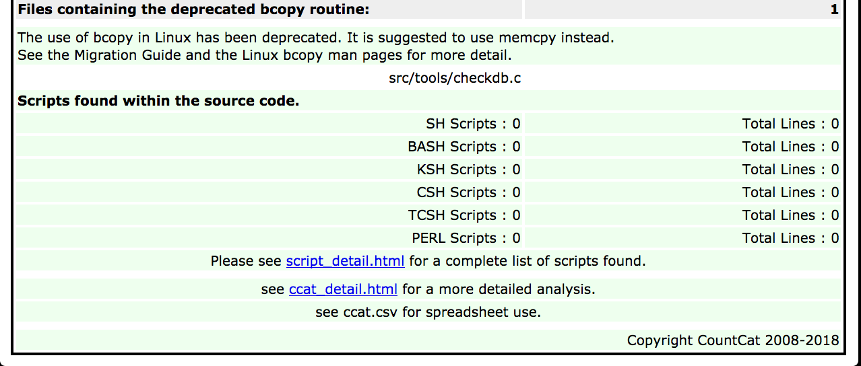

ccat_detail.html

There is a much more detailed report that is generated at the same time. This file will display the filename, the match that was detected, and the line of code and the line number.
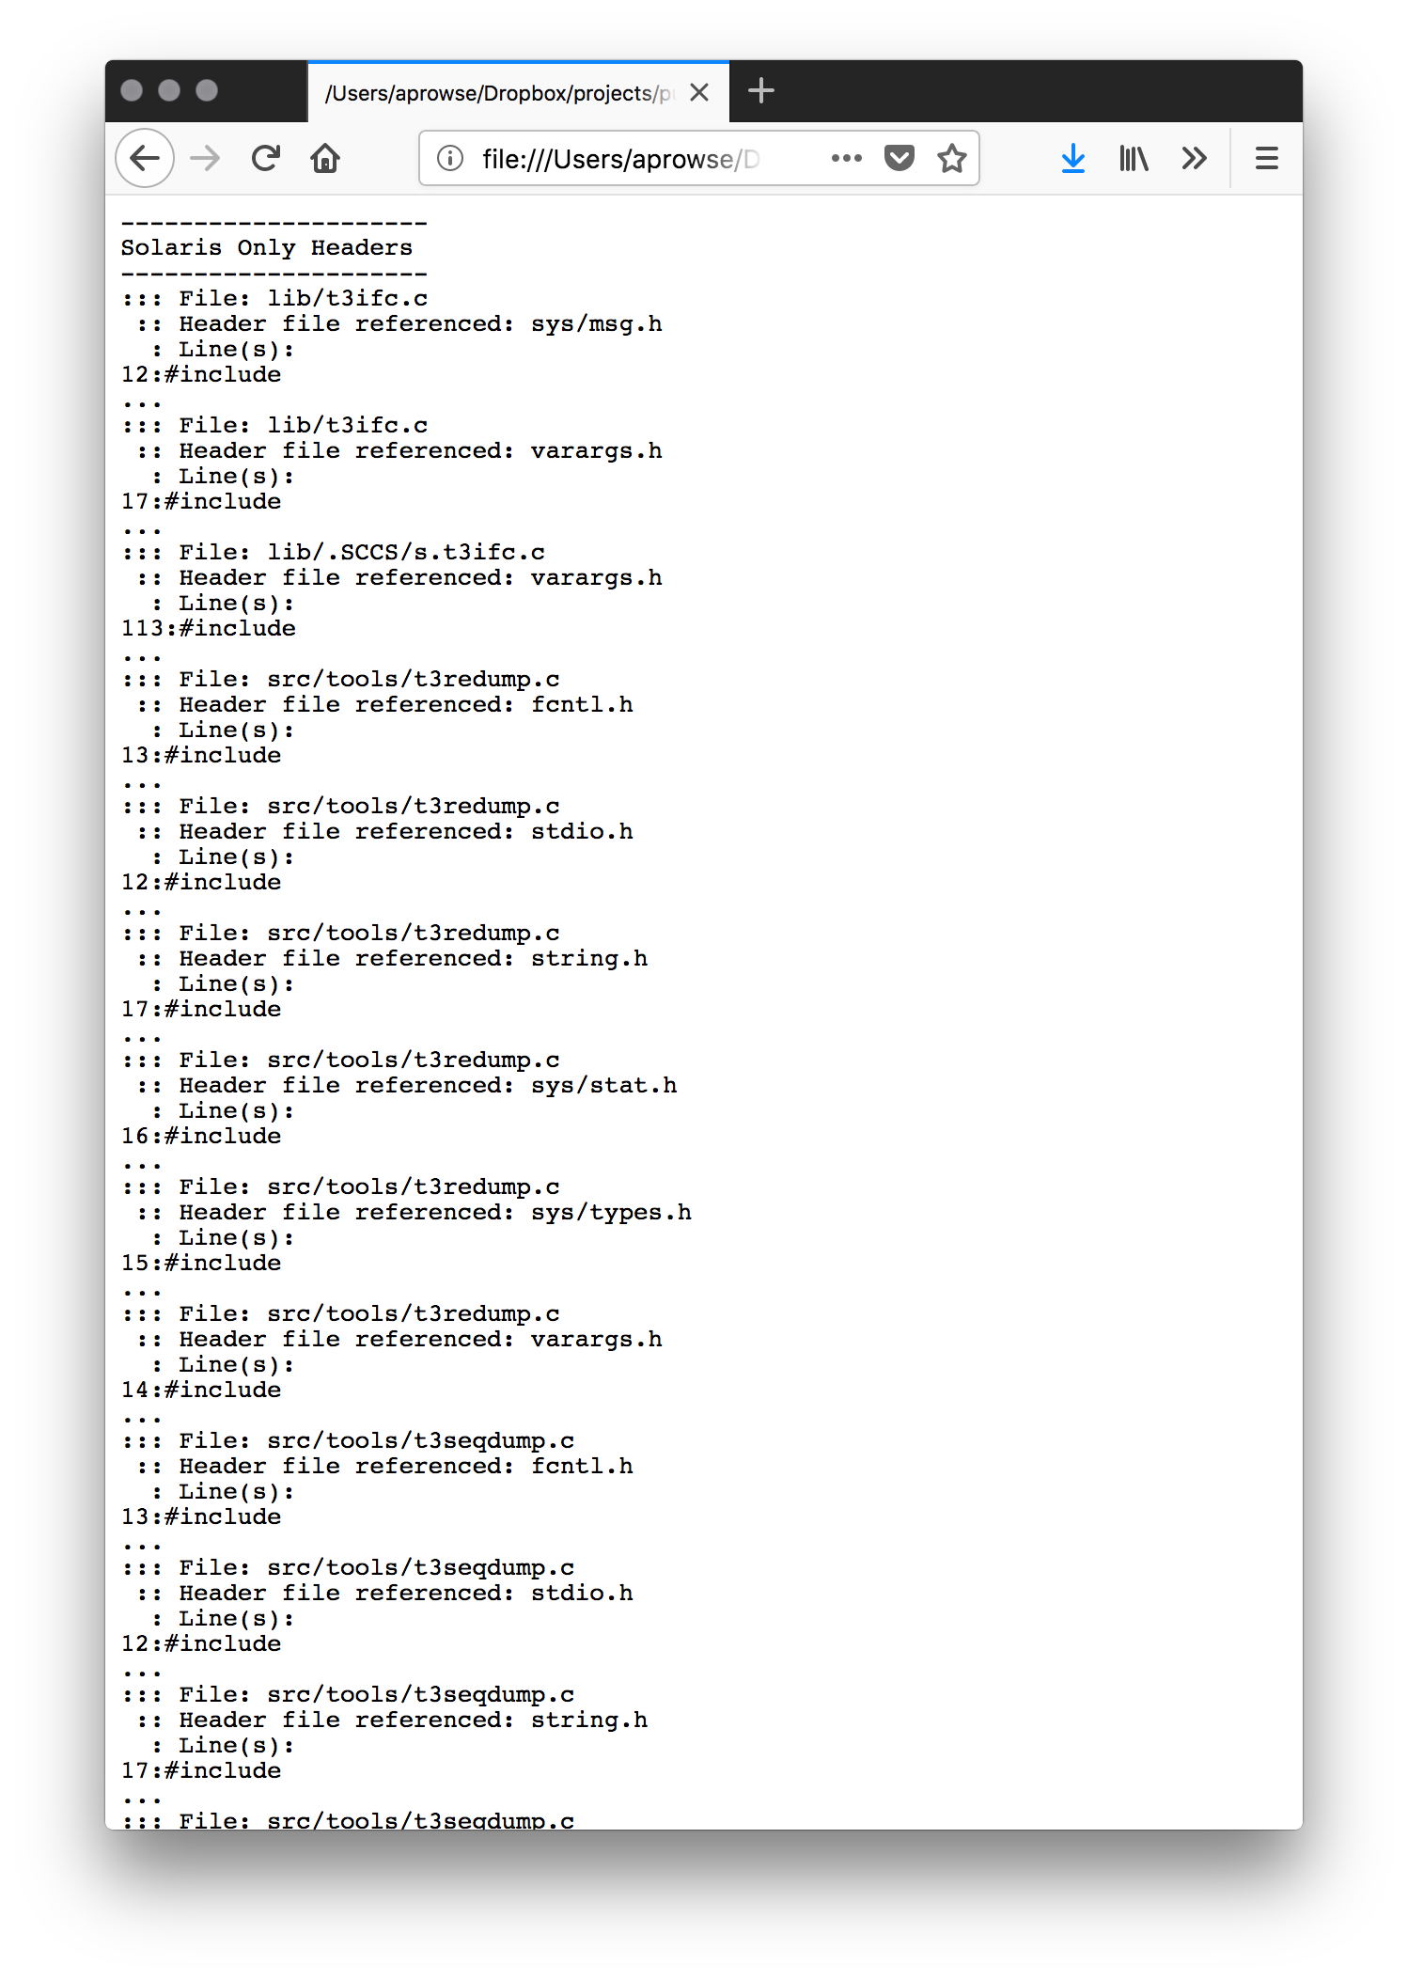
Here is an example of the output from the script hunting:

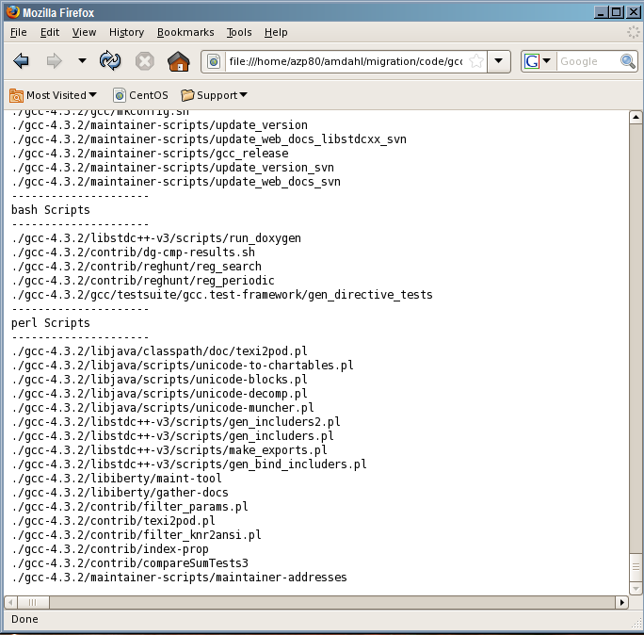

A csv formatted file is created, which can be brought into a spread sheet.

