WASTELAND FIREBIRD’S BIG LIST OF THE BEST THINGS ON ROUTE 66
Wasteland Firebird (John Binns)
2026 Centennial Second Edition

Copyright © 2026 John Binns
All rights reserved
wastelandfirebird@gmail.com
youtube.com/wastelandfirebird
wastelandfirebird.com

In 1987, Angel Delgadillo saved Route 66.
In 2006, Pixar’s Cars saved Route 66.
2026 is the Centennial of Route 66.
Who will save it now, if not you and me?

PREPARE TO BE INSPIRED
On July 4, 1976, I wasn’t even four years old. But, that year, I learned a big word. Bicentennial. Everyone was saying it so much. How could I not have learned it? “Bicentennial.” It was spoken with such obvious reverence that my young ears paid attention.
Fifty years later, I am the one speaking reverence to young ears. Are you paying attention?
Say it with me. “Semiquincentennial.” Do any three-year-olds know that word? How many adults know it? Semiquincentennial.
Semi means half, quin means five, cent means hundred, ennial means years. The United States of America has now existed for half of 500 years.
I was hoping for another Freedom Train, a Wagon Train Pilgrimage, New York City’s Operation Sail, TV shows, special edition coins, special edition cars, fireworks, air shows, car shows, parades, and red-white-and-blue everything.
A few of those things are happening, but something has changed in the last fifty years. The reverence is gone.
When I discovered that Route 66 would have its Centennial in the same year as America’s Semiquincentennial, I knew that I had to do something to bring that reverence back.
I traveled Route 66 four times. I made a lot of YouTube videos. I took a lot of notes. I set up a free Route 66 tour I called The Great Route 66 Centennial Convergence. I made flyers, t-shirts, patches, and keychains based on my hand-drawn art. I commissioned miniature “Muffler Man” action figures of myself. I promoted the event so much that I was kicked off of Facebook forever for being a “spammer.”
And I created the first edition of this book. Like the t-shirts, patches, keychains, and action figures, the first edition was never for sale. It was free for Convergence participants.
The Great Route 66 Centennial Convergence came to an end on April 30, 2026. But people kept asking for copies of the book. So here it is, the 2026 Centennial Second Edition, with plenty of updates. You can now buy this book at wastelandfirebird.com.
You might still manage to get a copy of this book for free, if you look hard enough. Be sure to check the Route 66 of Chenoa IL Roadside Attraction Tourist Info booth. You never know what cool stuff people might leave there.
Route 66 goes from Chicago to LA. It represents the idea of going West. Americans have always held out hope that things would be better out West. The Europeans got to the Americas in the first place by heading west.
If we save Route 66, we save the American Dream. If we save the American Dream, we save America. If we save America, we save the world. Because the American Dream is not just America’s dream. It’s everyone’s dream.

“Washington [DC] is not a place to live in. The rents are high, the food is bad, the dust is disgusting and the morals are deplorable. Go West, young man, go West and grow up with the country.” - Horace Greely
“If [Americans] attained Paradise, they would move on if they heard of a better place farther west.” - John Murray

HOW TO USE THIS BOOK
This book is a list of addresses and QR codes that represent online directions to each of my favorite places on Route 66. You can enter each address manually into your navigation app. Or, you can scan the QR codes with your phone by pointing your phone’s camera at them. If you visit every place in this book, you will approximately follow Route 66 all the way from Chicago to Santa Monica.
You can use this book on its own, or in conjunction with other guides. The locations in this book are in order from east to west, because that’s the direction of America’s story. Driving west-to-east on Route 66 is like watching a movie backwards. But this book will work backwards just as well as it will work forwards.
I don’t include any images. I don’t include any descriptions. You’re not supposed to be looking at this book. You’re supposed to be looking around you. You’re not supposed to know what you’re getting into. You’re supposed to be getting into it.
There will be errors in this book. Please email them to wastelandfirebird@gmail.com. Don’t follow your phone’s directions into the middle of nowhere. When visited in order, most of these locations will be fairly close to one another. For most of this trip, you should be just a mile or two away from a major interstate highway.
The beautiful part of this journey is that the places you visit will feel much more remote than that. You’ll often forget that the interstate is even there.
Many businesses along the Route have custom rubber stamps. I’ve left an empty space beside all of the QR codes for these stamps. You could also use those spaces for signatures, stickers, or just big checkmarks.
Be aware that some of the “passport” books you’ll find on the Route require small businesses to pay thousands of dollars for the privilege of being advertised in them.
No one paid to be in this book. This book is nothing more than a list of places and people that I love.

Navy Pier
600 E Grand Ave, Chicago IL 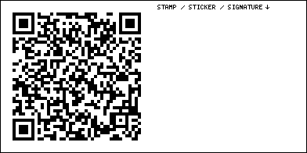
The new official beginning of Route 66. Some say it’s ridiculous. The road itself never began here. I say it’s perfect. The opening image of a story should be a bookend, a mirror for the closing image of the story. The story of Route 66 ends at a pier. Now it begins at a pier, too. Maybe someday I’ll set up a little shack here, and sell this book from it.

Billy Goat Tavern
Lower 430 North, N Michigan Ave, Chicago IL 

Ohio House Motel
600 N La Salle Dr, Chicago IL 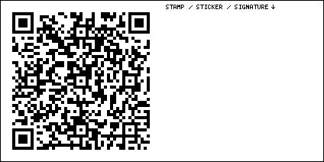
Room 110 has a hidden secret behind the mirror. Find out more by searching for “Room Attack” on Wasteland Firebird’s YouTube channel.

Cloud Gate mirrored bean sculpture
201 E Randolph St, Chicago IL 
Most people who travel Route 66 will only travel it once. So pay attention to the story that the road tells you.

Chicago Athletic Association
12 S Michigan Ave, Chicago IL 
A cool, luxurious, renovated old hotel that has retained some of its sports club roots.

Art Institute of Chicago
111 S Michigan Ave, Chicago IL 
Monet’s every stroke contains frivolity. He used to say, “I like to paint as a bird sings.” Viewing a Monet is an active process. You can’t properly appreciate a Monet while seated. You have to approach the painting, then step back, then look away, then look back. A work by Monet is a three dimensional object, just as much a sculpture as a painting. Van Gogh was a better artist, but Monet had more fun.

Historic Route 66 sign
E Adams St & S Michigan Ave, Chicago IL 
As you listen to the story of the road, you’re also writing your own story. And you’re the main character! Stand up tall, proud, and curious. You’ve been waiting your whole life for this. A good story can change you. A good story can change the world.

Lou Mitchell’s
565 W Jackson Blvd, Chicago IL 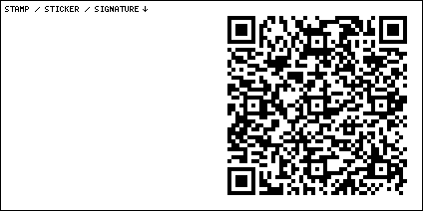
Route 66 is more than just a road. It’s more than just a fun vacation. Route 66 represents the idea of going West in search of a better life. Route 66 represents the American Dream.

Lulu’s Hot Dogs
1000 S Leavitt St, Chicago IL 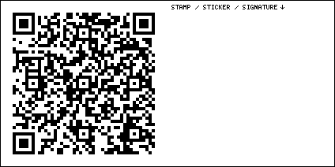
You won’t be able to eat everything you see on the Route. I still haven’t eaten here. Whether you eat at these places or not, stop in, say hello, and drop a tip in the jar. The food itself doesn’t always matter. I put places on this list because they’re beautiful, quirky, old, luxurious, or delicious. They don’t have to be all of those things at once.

Steak ’n Egger
5647 Ogden Ave, Cicero IL 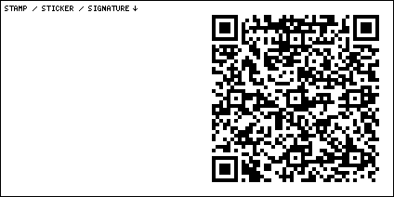

Henry’s Drive-In
6031 Ogden Ave, Cicero IL 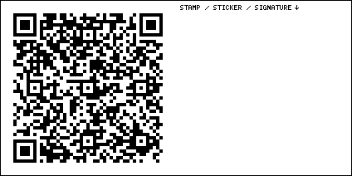

Cigars & Stripes BBQ Lounge
6715 Ogden Ave, Berwyn IL 
There is a “Muffler Man” here, the first of many. It’s important that you learn what a Muffler Man is. These are giant, human-shaped fiberglass sculptures. They dotted the landscape of mid-Twentieth century America. They sometimes held mufflers in their hands. Some are old, some are new. Wait till you see Atlanta Illinois and Tulsa Oklahoma.

Dell Rhea’s Chicken Basket
645 Joliet Rd, Willowbrook IL 
See what I mean, when I say you can’t eat everything you see? How many restaurants have we passed already, six? Go in and leave them a tip anyway.

White Fence Farm Restaurant
1376 Joliet Rd, Romeoville IL 

Old Joliet Prison
1125 Collins St, Joliet IL 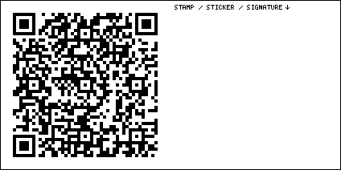
We can’t talk about Joliet Prison without talking about The Blues Brothers. That film is an archive of Americana. The music in that film spanned the entire Twentieth Century. Cab Calloway started making music in 1927, the year Angel Delgadillo was born, and one year after Route 66 came into being. Due to swift advances in music and communication technology, the Twentieth Century spawned a new genre of music every single decade. When was the last time you heard a truly new genre of music?

Rialto Square Theatre
102 N Chicago St, Joliet IL 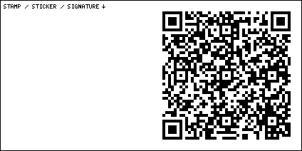
Look at all the light bulbs on these old theaters.

Blues Brothers Copmobile
2410 S Chicago St, Joliet IL 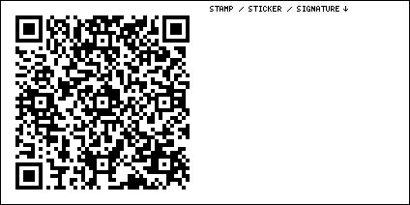
My favorite scene in The Blues Brothers is when they park their car at the end of a narrow alley, in a tiny electrical closet just a few inches wider than the car itself. This was originally supposed to be an explanation of how the car got its supernatural powers. I always saw it as a humorous but accurate depiction of the hassles of city parking. If you have no idea what scene I’m talking about, that could be because it was cut from some versions of the film.

Gemini Giant
201 Bridge St, Wilmington IL 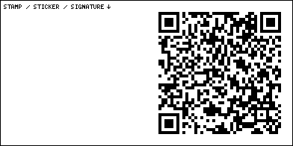
Another Muffler Man. Get out and get a close look at his metal-flake suit.

Polk-A-Dot Drive In
222 N Front St, Braidwood IL 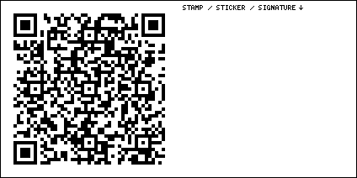

Shop on Route 66
315 N Center St, Gardner IL 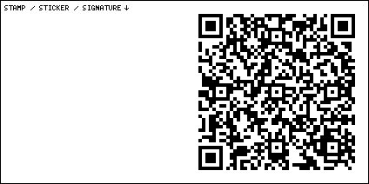

Gothic Church Dwight Townhall
201 N Franklin St, Dwight IL 

80s Car Museum
316 W Waupansie St, Dwight IL 
In the 80s, we were pretty sure that modern cars would not be loved and preserved like the cars from the glory days of the 50s, 60s, and 70s. Safety and fuel economy were making cars boring. Or at least, that’s what we thought. Nowadays, these 80s cars seem quirky and fun compared to the nondescript blobs that silently and cleanly traverse the interstates that parallel Route 66.

Dwight Coin Laundry
404 W Waupansie St, Dwight IL 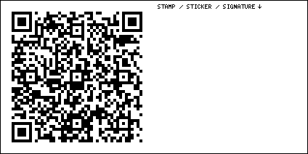

Ambler’s Texaco Gas Station
W Waupansie St, Dwight IL 

Standard Oil Gas Station
400 S West St, Odell IL 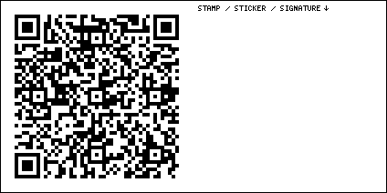

Old Log Cabin restaurant
18700 Old Rte 66, Pontiac IL 
I think you can get a piece of cherry pie here. I’m always looking for a good piece of cherry pie. That was meant to be taken literally but I guess you can take it figuratively if that amuses you.

Route 66 Association of Illinois
110 W Howard St, Pontiac IL 
Bob Waldmire was a Route 66 artist. His name is one of the names you should learn and remember during this trip. His orange Volkswagen bus is here. His “Land Yacht” school bus is also here, sometimes. In 2024, by sheer chance, I ended up here right on one of the rare days that the bus was here and the interior was open to the public. I put some video of the Land Yacht up on YouTube. Search for “Wasteland Firebird Route 66.”

Pontiac Oakland Auto Museum
205 N Mill St, Pontiac IL 
My name is Wasteland Firebird because I own a 1975 Pontiac Firebird Trans Am, and I drive it around in the wasteland. I came here from an alternate timeline where a near-apocalyptic event happened in the year 1981. I came here to tell you that you don’t know how good you have it.

Wally’s
1 Holiday Rd, Pontiac IL 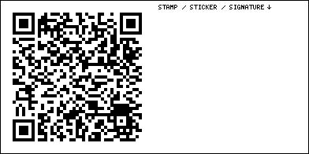
The first couple of times that I saw this place, I drove right by it. I figured there was no way it could be as good as Buc-ee’s. Don’t make the same mistake I did.

Route 66 of Chenoa Roadside Attraction Tourist Info
501 W Cemetery Ave, Chenoa IL 
Normally, this is just a little closet full of flyers. But every time I come by, I populate it with t-shirts, books, or art. There’s a little sign that says you’re supposed to call a number for permission to leave stuff here. I’ve never called it.

Lexington Route 66 Memory Lane
Parade Rd, Lexington IL 
Entropy cannot be stopped. The Route is crumbling before our eyes. There are some nostalgic signs here. But this section used to be covered in beautiful trees. Now it’s just a bare stretch of road. I got some video of this spot with all of its trees back in 2024, you can find it on my YouTube channel.

Shake Shack
512 W Main St, Lexington IL 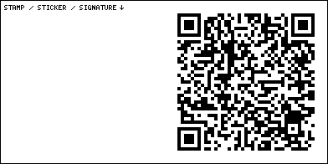
I’m pretty sure I had some fried corn nuggets here. Corn nuggets are my favorite bit of semi-obscure American food. If this place is closed, don’t worry, you’ll have another chance try fried corn nuggets on this trip.

Sprague’s Super Service Station
305 Pine St, Normal IL 
Just knock if it’s dark out when you arrive. There might still be someone there.

Carl’s Ice Cream Factory
1700 W College Ave, Normal IL 
Two muffler People of unmatched size live here. I refer to them as Small Carl and Large Marge.

Funks Grove Pure Maple Sirup Farm
Funks Grove Township IL 
When traveling, you might think you have little need for maple syrup. But think a little harder. Most restaurants give you the fake stuff nowadays. Wouldn’t it be good to have your own supply of the good stuff? And what if you run out of coolant or wiper fluid? I’m sure maple syrup would work fine for that. You can also just buy a really small piece of candy made out of syrup.

Arcadia America’s Playable Arcade Museum
107 S Hamilton St, McLean IL 
I’m an expert at playing those Ms. Pac Man machines where they flip a switch, or swap a chip, that makes Ms. Pac Man go extra fast. Be sure to check out their pinball place across the street, too.

Country-Aire Restaurant
606 E South St, Atlanta IL 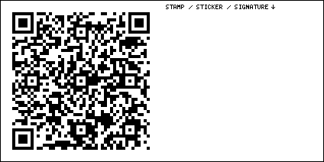
A Muffler Woman with a pie lives here.

American Giants Museum
100 SW Arch St, Atlanta IL 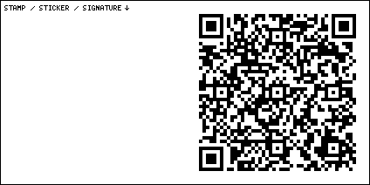
Not all of Route 66 is crumbling. Some of it is being revived. This place is a museum of Muffler People. Joel Baker is another name you should know. He’s been obsessed with these giants for his entire life. He researches, finds, buys, restores, and sells them. And he makes YouTube videos about the whole process. Some of the giants at this museum belong to him.

Hot Dog Muffler Man
112 SW Arch St, Atlanta IL 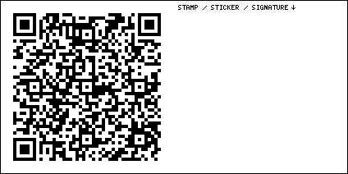

Mill Museum
738 S Washington St, Lincoln IL 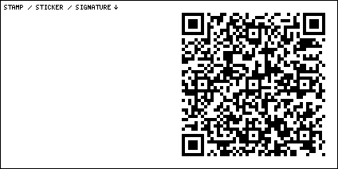

Wild Hare Cafe
104 Governor Oglesby St, Elkhart IL 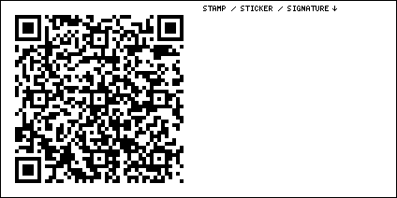

Old Station
117 Elm St, Williamsville IL 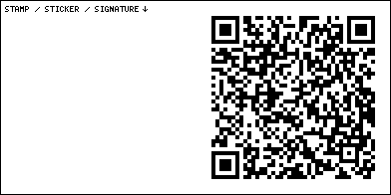

Outkast Tattoo Studio
2828 N Peoria Rd, Springfield IL 

Illinois State Fair Route 66 Experience
801 E Sangamon Ave, Springfield IL 
Go at night. Drive around it. Some gates are sometimes closed, other gates are sometimes open. There is a custom brick here from Wasteland Firebird.

Route 66 Hotel Conference Center
625 E St Joseph St, Springfield IL 
There is a secret hidden behind the mirror in Room 163. Find out more by searching for “Room Attack” on Wasteland Firebird’s YouTube channel.

Shea’s Filling Station
2075 N Peoria Rd, Springfield IL 

Maid-Rite
118 N Pasfield St, Springfield IL 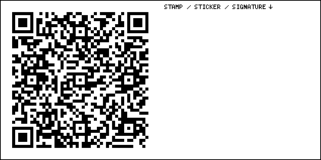

Pharmacy Gallery Art Space
623 E Adams St, Springfield IL 
They tell me there’s a Bob Waldmire exhibit here, Fridays and Saturdays in 2026.

Springfield Southeast High School
2350 E Ash St, Springfield IL 
Go here to find the Spartan Viking Muffler Man.

Mel-O-Cream Donuts
217 E Laurel St, Springfield IL 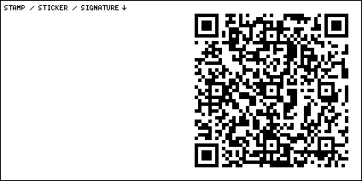

Ace Sign Co.
2540 S 1st St, Springfield IL 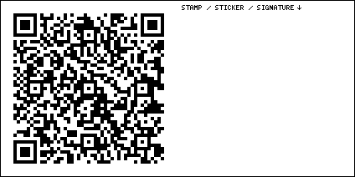
This place is pretty nondescript on the outside. They really do make signs here. But there’s also a sign museum. I still need to visit this place when it’s open.

Charlie Parker’s Diner
700 W North St, Springfield IL 

Lauterbach Muffler Man
1569 Wabash Ave, Springfield IL 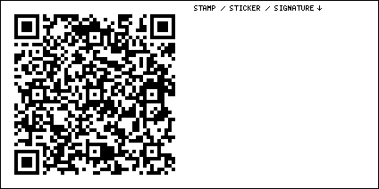

Pinky Elephant with Martini
2723 S 6th St, Springfield IL 
For some reason, Route 66 has a fascination with pink elephants. This isn’t the only one.

Cozy Dog
2935 S 6th St, Springfield IL 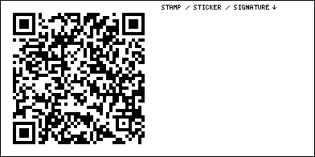
This place is still owned by the Waldmire family. Bob Waldmire’s works are all over the walls. You might even find something by Wasteland Firebird on the flyer rack.

Route 66 Motorheads Bar and Grill
600 Toronto Rd, Springfield IL 
Big Ron the extra-big Muffler Man is here.

Chatham Railroad Museum
100 N State St, Chatham IL 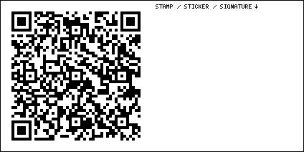

Illinois Brick Road
4995-4790 Snell Rd, Auburn IL 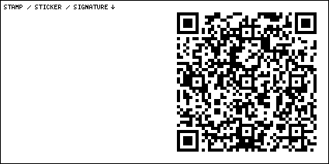
The road is made of bricks. Old, original Route 66 bricks.

Sly Fox Bookstore
123 N Springfield St, Virden IL 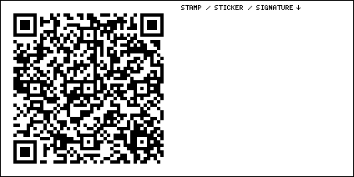

Doc’s Just Off 66
133 S 2nd St, Girard IL 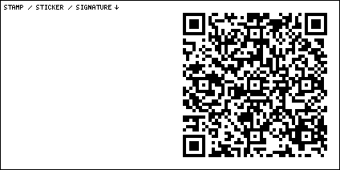

Whirl A Whip
309 S 3rd St, Girard IL 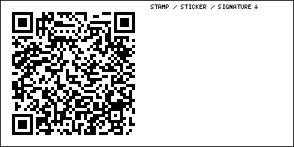

Turkey Tracks
26618-27306 Donaldson Rd, Girard IL 
A bird ran through the wet concrete, and its footprints are still there. Look for a small sign and a white square on the road.

Skyview Drive-In
1500 Old Rte 66 N, Litchfield IL 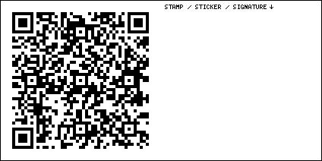

Niehaus Cycle Sales
718 Old Rte 66 N, Litchfield IL 

Ariston Cafe
413 Old Rte 66 N, Litchfield IL 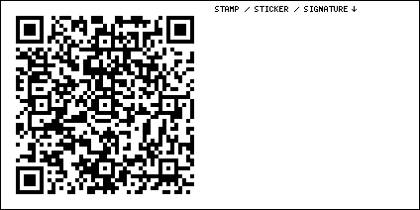

Litchfield Museum
334 Old Rte 66 N, Litchfield IL 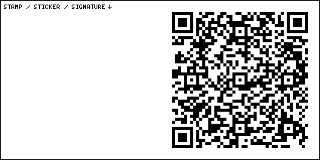

Soulsby Service Station
710 W 1st St, Mt Olive IL 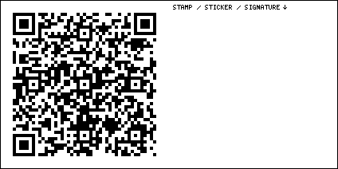
When I first saw this place, I stood outside and enjoyed the fact that it existed. Then I turned and walked away. But my traveling companion tried the door, and found it open. You’re free to walk around alone in here. It’s a profound experience, knowing that someone you don’t know trusts you, and knowing that they put all of this here for you.

Henry’s Rabbit Ranch
1107 Historic Old Rte 66, Staunton IL 
At some point you’re going to figure out that not everything on this list is still open for business. We’re just lucky that these places still exist at all.

DeCamp Station
8767 State Rte 4, Staunton IL 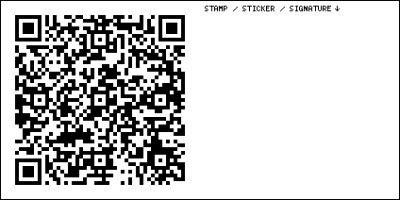

Pink Elephant Antique Mall
908 Veterans Memorial Dr, Livingston IL 
I told you there’d be more pink elephants. There’s a wild collection of Muffler People and other Muffler Species here. Maybe even some Muffler Aliens.

Route 66 Creamery
11 S Old Rte 66, Hamel IL 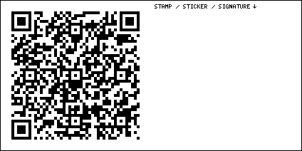
I’ve stopped here on two separate occasions, and met two completely different sets of employees. But they all had something in common. The employees here are the most pure, kind, well-adjusted, hard-working young people I’ve ever met. Hamel Illinois is America at its best.

Weezy’s
108 Old Rte 66, Hamel IL 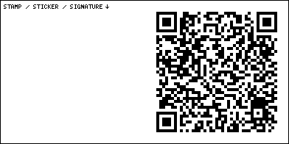

Wildey Theatre
252 N Main St, Edwardsville IL 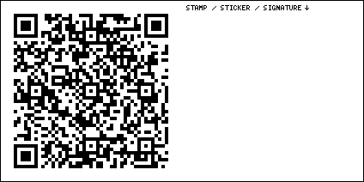

West End Service Station
620 St Louis St, Edwardsville IL 

Luna Cafe
201 E Chain of Rocks Rd, Granite City IL 

Old Chain of Rocks Bridge
10820 Riverview Dr, St Louis MO 
Nowadays you don’t drive it. But you can go for a walk across it.

O’Brien Tire & Auto Care
3924 Nameoki Rd, Granite City IL 
Earl the Mechanic Muffler Man is here. And when was the last time you had your oil changed?

Mr. Twist Ice Cream
2649 Madison Ave, Granite City IL 

It’s Electric Neon Sign Park
1300 19th St, Granite City IL 

Rusty the Muffler Man
614 Niedringhaus Ave, Granite City IL 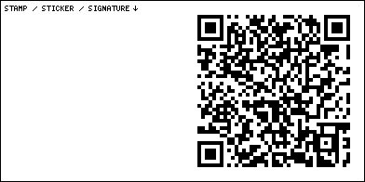
Rusty the Muffler Man is here. He might not be on your map, but if you go to this address, he’s here.

Crown Candy Kitchen
1401 St Louis Ave, St Louis MO 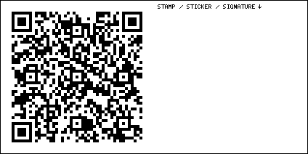
If we see the journey down Route 66 as a story, we’re breaking into Act II. The hero accepts the call to adventure! Not all of this journey will be fun and games. Sometimes you’ll have to go through a bad part of town to get to a good part of town. Are you ready for adventure? The Crown Candy Kitchen is all about fat and sugar.

Chili Mac’s Diner
510 Pine St, St Louis MO 
The St. Louis Arch is known as “The Gateway to the West.” Manifest Destiny was the idea that God wanted the Europeans to spread out into America. I don’t think that any supernatural being really cared where Europeans ended up living. And there were some people living here already. The Europeans did some bad things to those people. But ultimately, we all came together to make the best country on Earth.

Neon Museum of St Louis
3537 Chouteau Ave, St Louis MO 
When I say the USA is the best country on Earth, you might reply that I’m biased since I was born in the USA. But I’ve traveled the world and I’ve spent a lot of time doing my best to overcome my biases. I firmly believe that America has things about it that make it truly exceptional.

Donut Drive In
6525 Chippewa St, St Louis MO 
America was the first country on Earth where your social class didn’t matter. It didn’t matter who you knew or who your parents were. All that mattered was what you were capable of. If you were hard-working, creative, passionate, skilled, talented, good at marketing, good at networking, able to see things through, and willing to risk it all, you’d almost certainly succeed. That’s the American Dream. Over time, the founding principles of the United States forged the world’s first self-organizing meritocracy.

Ted Drewes Frozen Custard
6726 Chippewa St, St Louis MO 

Wally’s
950 Assembly Pkwy, Fenton MO 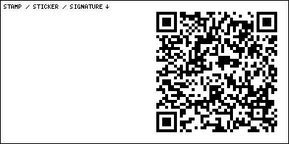

Malt Shop
1751 Smizer Station Rd, Fenton MO 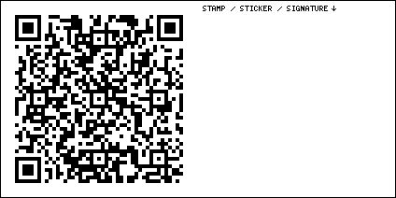
Don’t ever just order a milkshake. Always ask for a malt. For some reason malts are slowly being forgotten. They’re harder to find now. The “malt” is just powdered barley extract but it adds a great bit of flavor.

Route 66 State Park
97 N Outer Rd, Eureka MO 

Campbell’s Service
18625 Historic Rte 66, Pacific MO 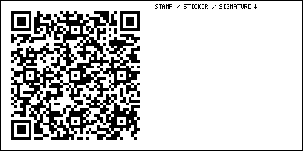

Red Cedar Inn Museum and Visitor Center
1047 E Osage St, Pacific MO 

Hoffman’s Drive-In
306 S 1st St, Pacific MO 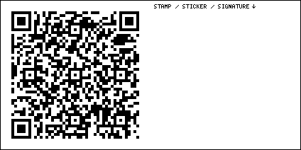

Gardenway Motel sign
2827 MO-100, Villa Ridge MO 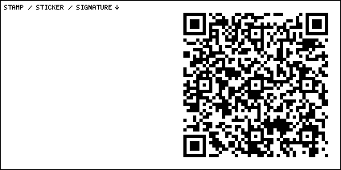
It’s just a sign now. But oh, what a sign it is.

Old Sunset Motel
976 Osage Villa Ct, Villa Ridge MO 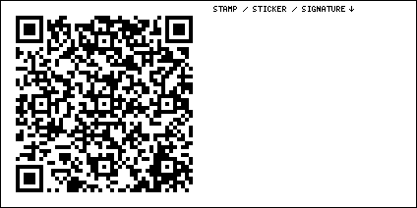

International Shoe Company Building
160 N Main St, St Clair MO 

Creative Chainsaw Carvings
151 State Rte W, Sullivan MO 
Ask her about her late husband. You will never forget her story.

Meramec Caverns
1135 Hwy W, Sullivan MO 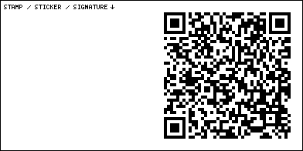
Some people go for the nature stuff. I’m more into the midcentury Americana. But I figured this place was obligatory, so I went. I didn’t expect to walk out in tears. Not only is the place gorgeous, but at the end, they project a patriotic short film about America on the cavern walls.

Terror On Route 66
1143 N Service Rd W, Sullivan MO 
I’ve been meaning to check this place out, but I’m too scared.

Shamrock Court Motel
101 Shamrock, Sullivan MO 
Newly restored by Route 66 hero Roamin’ Rich Dinkela.

Missouri Hick Barbeque
913 E Washington Blvd, Cuba MO 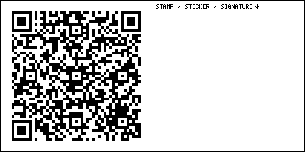

Wagon Wheel Motel
901 E Washington Blvd, Cuba MO 
You can hear the neon sign buzz on and off. This property is now owned by the magnificent steward known as Roamin’ Rich Dinkela.

Weir on 66 Rich’s Famous Burgers
102 W Washington St, Cuba MO 
This old building has been many things throughout the years. Go in and buy some of whatever it is they’re selling these days.

Fanning Outpost Rocking Chair
5957 State Hwy ZZ, Cuba MO 
Say hi to Fluffy the cat. If you pet her long enough, she’ll climb into your lap.

Mule Trading Post
11160 Dillon Outer Rd, Rolla MO 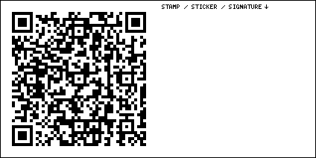
I’m not claiming this place is open. I’m just claiming it’s worth stopping at. Check out those signs.

Vernelle’s Motel
10887 Arlington Road, Newburg MO 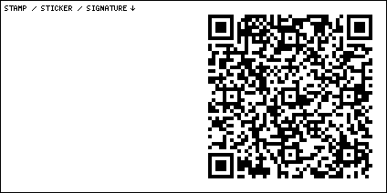
Entropy cannot be stopped. We can only delay it for a while.

John’s Modern Cabins
11107 Arlington Outer Rd, Newburg MO 

Devil’s Elbow Bridge
Big Piney River, Devils Elbow MO 

Uranus Fudge Factory
14400 State Hwy Z, St Robert MO 
My notes describe the giant here as the “Mega Mayor Patriot Golfer Muffler Man.” I’m not sure I got his name right, but go take a look and tell me that name doesn’t fit him. Here’s a tip. If you pronounce it YER-uh-nuss you’ll ruin all of their jokes.

Route 66 Diner
126 St Robert Blvd, St Robert MO 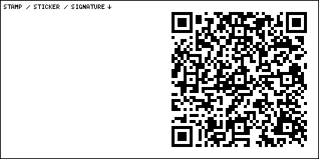
I hung some of my art on the wall here, next to the kids’ art. Maybe it’s still there.

Route 66 Neon Sign Park
133 Reed Pkwy, St Robert MO 

Old Stagecoach Stop
106 N Lynn St, Waynesville MO 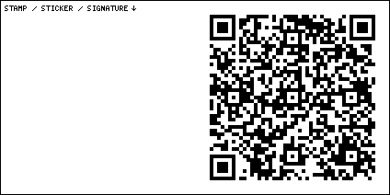
It’s not just a building. It’s the oldest building in the USA.

Gascozark Store
30568 State Hwy AB, Richland MO 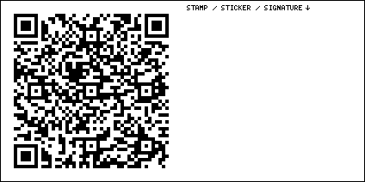

Route 66 Gasconade Bridge
Richland MO 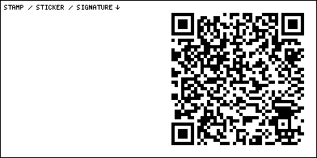

Munger Moss Motel
1336 US Rt 66, Lebanon MO 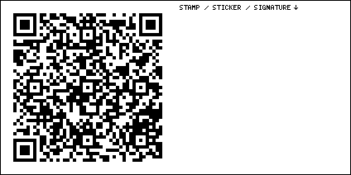
The organization that is restoring the sign is different from the organization that runs the motel, and the motel isn’t exactly a motel because it’s more like apartments, but they tell me that might be changing, and maybe you can stay here like it’s a motel again. I dunno, just go look at the sign.

Smokin’ Jones BBQ Wrink’s Market
135 Wrinkle Ave, Lebanon MO 
You can get a piece of cherry pie here.

Taylor’s Dairy Joy
1205 US Rte 66, Lebanon MO 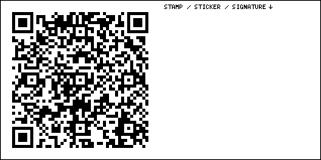

Manor Inn
505 E Elm St, Lebanon MO 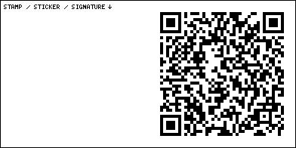

Boswell Park Camp Joy
51 Drury Ln, Lebanon MO 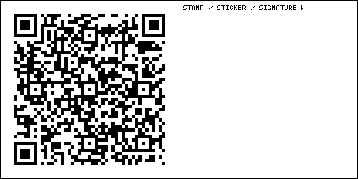
I’m not here to tell you what things are. I’m here to tell you where to go. Ask questions, read the plaques, or just drive by and enjoy.

Redmon’s Candy Factory
330 Pine St, Phillipsburg MO 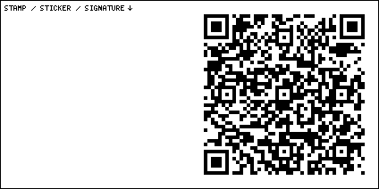

Little Clay House
238 N Clay St, Marshfield MO 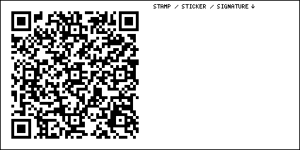
I haven’t actually been to this place, but it looks nice.

Buc-ee’s
3284 N Mulroy Rd, Springfield MO 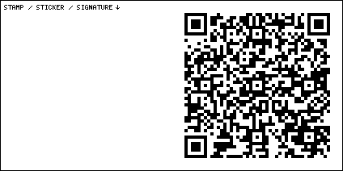
Ah, here we are. Buc-ee’s started in Texas but now has many locations. The company has only existed since 1982, but I’m sure that in 2082, future Route travelers will consider this place a magnificent historical landmark. Buc-ee’s is privately held, so they can focus on customer happiness without worrying about short-term shareholder profits.

Rest Haven Court
2000 E Kearney St, Springfield MO 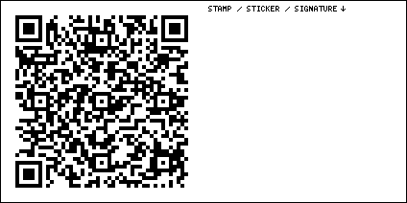

Andy’s Frozen Custard
2119 N Glenstone Ave, Springfield MO 

Glenstone Court Motel
2023 N Glenstone Ave, Springfield MO 

Best Western Route 66 Rail Haven
203 S Glenstone Ave, Springfield MO 
They have some cool old signs here.

Steak ’n Shake
1158 E St Louis St, Springfield MO 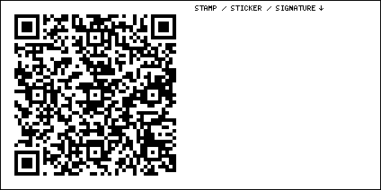

Gillioz Theatre
325 Park Central E, Springfield MO 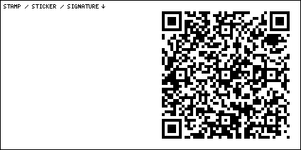

History Museum on the Square
154 Park Central Square, Springfield MO 
Some museums on the Route are just a bunch of flat images blown up so big you can see the pixels. I call these “flat museums.” They’re funded with multimillion dollar taxpayer-funded grants, while the Route’s legacy small businesses are dying. But at this museum, you can find the original telegram from Cyrus Avery on April 30, 1926 declaring that the Route would be known as “66.”

1984 Arcade
400 S Jefferson Ave, Springfield MO 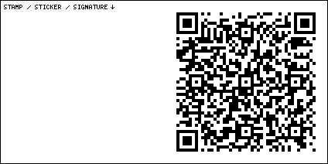

Rogue Barber Co
639 W Walnut St, Springfield MO 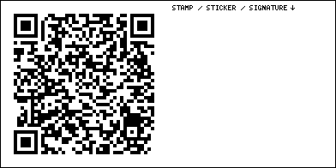
It’s a historic building. If you don’t have any hair on your head, go in and get something waxed.

College Street Cafe
1622 W College St, Springfield MO 

Route 66 Car Museum
1634 W College St, Springfield MO 
I heard this place might close soon. Enjoy it while you can.

Rockwood Motor Court
2200 W College St, Springfield MO 

Route 66 KOA Holiday
5775 W Farm Rd 140, Springfield MO 

Gary’s Gay Parita Sinclair
21118 Old 66, Ash Grove MO 
I think there’s still a signed copy of my book, Heads Will Rock: A chronicle of postapocalyptic mayhem hidden in this place. It’s free for the taking. It’s about a postapocalyptic journey up Route 66, to recommission the old destroyed Pontiac Firebird factory in Norwood Ohio.

Spencer Station
19720 Lawrence 2062, Miller MO 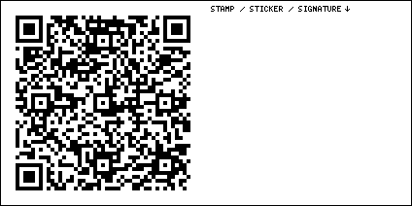

Red Oak II
12275 Kafir Rd, Carthage MO 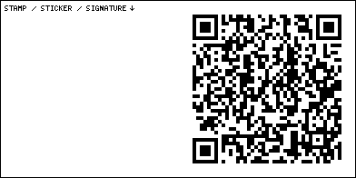

Campbell 66 Express
426 High St, Carthage MO 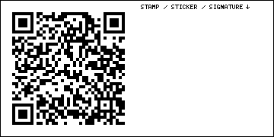

Boots Court Motel
125 S Garrison Ave, Carthage MO 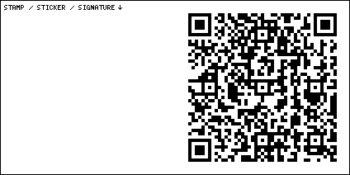

66 Drive In
17231 Old 66 Blvd, Carthage MO 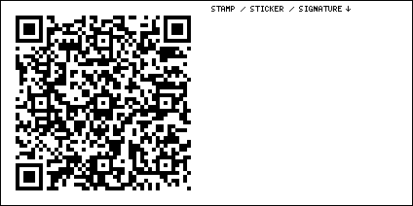

SuperTam on 66
221 W Main St, Carterville MO 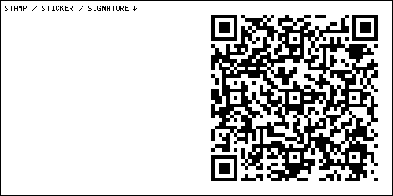
Some places have been many things through the years, but they’re usually only one thing at a time. This place is many things at a time. Something about Superman and ice cream.

Route 66 Center
112 W Broadway St, Webb City MO 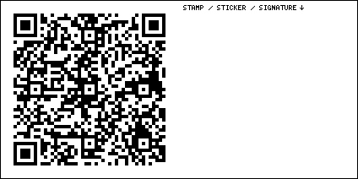

Granny Shaffer’s Restaurant
2728 N Rangeline Rd, Joplin MO 

Royale Cinema Lounge
715 E Broadway St, Joplin MO 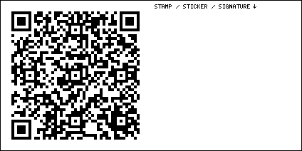

Wilder’s Steakhouse
1216 S Main St, Joplin MO 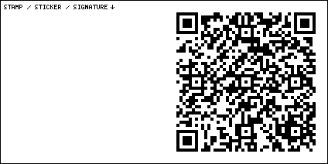

Cars on the Route Kan-O-Tex Service Station
199 N Main St, Galena KS 
The vehicular inspiration for Tow Mater, the tow truck from Pixar’s Cars, is here.

Gearhead Curios
520 S Main St, Galena KS 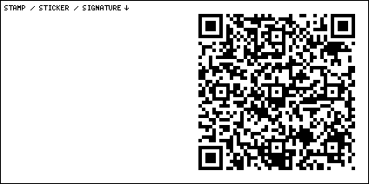
Things are about to get weird. Route 66 is not just a road anymore. Nowadays, Route 66 is a collective project to preserve, restore, and revive the art, architecture, and history of mid-Twentieth century America. Aaron Perry from Gearhead Curios understands this far better than most.

Galena Mining & Historical Museum
319 W 7th St, Galena KS 

Old Riverton Store
7109 KS-66, Riverton KS 

Rainbow Bridge
SE Beasley Rd, Baxter Springs KS 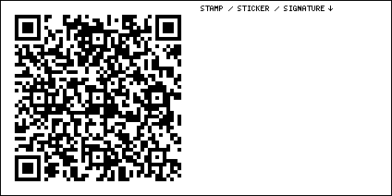

Baxter Springs Heritage Center & Museum
740 East Ave, Baxter Springs KS 
I haven’t actually checked this place out yet, but I’ve seen photos of a freaky painting of a gunfight that lives here. I gotta see this one in person.

Route 66 Visitors Center
940 Military Ave, Baxter Springs KS 

Dallas’ Dairyette
103 N Main St, Quapaw OK 
In my video “Route 66 from Carthage to Catoosa, April 16, 2025,” I asked six middle-school students if they’d ever heard of the American Dream. They all said no. I hope that was because they’re like fish who don’t know that they’re swimming in something called “water.” Even so, we must teach the next generation not to take prosperity for granted. Poverty and suffering is humanity’s default state. Wealth and happiness is a rare exception in human history.

Dairy King
100 N Main St, Commerce OK 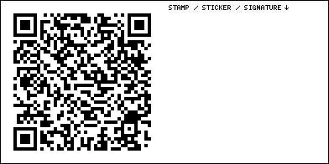
The current owners took over this place in 1980 and I don’t think their prices have changed since. Last time I was here, the lady accidentally charged me $2.50 for an $8.50 order. When I pointed out the error, she used a calculator to determine the amount I still had left to pay. But if I’m ever lucky enough to reach her age, I’ll be satisfied if I have half of her mental acuity. Her elderly son gets up every day at 3am to run 10 miles, and he rides around in the only car ever offered with a factory flame job: a Chrysler PT Cruiser.

Waylan’s Ku-Ku
915 N Main St, Miami OK 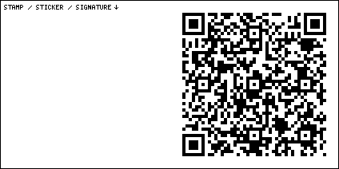

Coleman Theater
103 N Main St, Miami OK 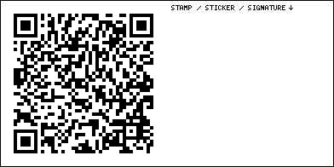
It’s a gorgeous, old, zillion-dollar theater in the middle of nowhere.

Route 66 Sidewalk Hwy
S 540 Rd, Miami OK 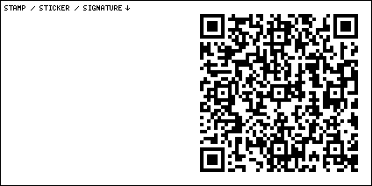
I wouldn’t recommend actually driving down this piece of original road, but go take a look at it.

Crosstar Flag and Tag Museum
103 S Central Ave, Afton OK 
Some things are better left unexplained.

Clanton’s Cafe
319 E Illinois Ave, Vinita OK 
I haven’t tried the food here yet, but any restaurant with a giant sign that just says “EAT” on it gets to be in this book.

Center Theater
124 S Wilson St, Vinita OK 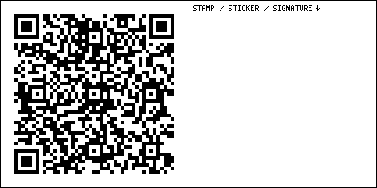

Hi-Way Cafe Western Motel
437918 US-60, Vinita OK 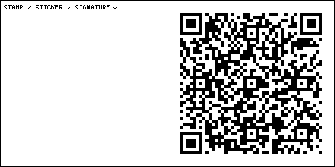
Big Bill the Muffler Man, the Big Indian, and Big Al the Chef are all here.

Pryor Creek Bridge
Chelsea OK 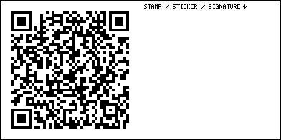

Ed Galloway’s Totem Pole Park
21300 OK-28A, Chelsea OK 
One man’s weird way of paying tribute to the First Nations peoples of the Americas.

Annie’s Diner
12015 Poplar St, Claremore OK 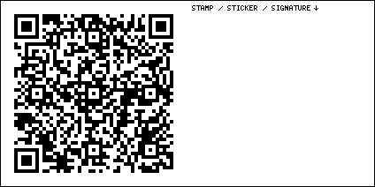
It’s closed now, but I did get some good corn nuggets here once.

JM Davis Arms Historical Museum
330 N JM Davis Blvd, Claremore OK 
If you’re visiting from some un-American place where you can’t have guns, be sure to check this place out.

Blue Whale of Catoosa
2600 OK-66, Catoosa OK 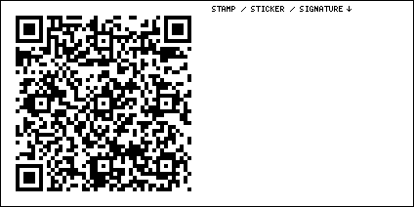
It’s a big blue whale. It looks good at night. It might still be under renovation, but you can see it from the road.

Desert Hills Motel
5220 E 11th St, Tulsa OK 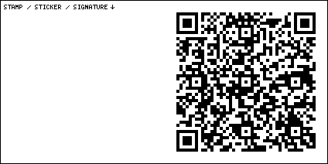

Tally’s Good Food Cafe
1102 S Yale Ave, Tulsa OK 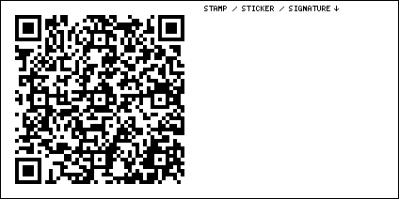

Coney I-Lander
2838 E 11th St, Tulsa OK 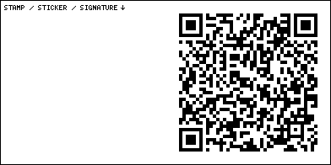

Campbell Hotel
2636 E 11th St, Tulsa OK 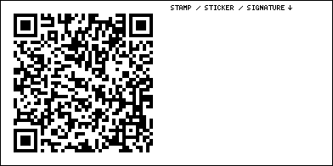

Ike’s Chili
1503 E 11th St, Tulsa OK 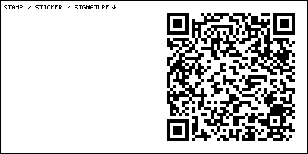
Tulsa is a neon revival town. Try to see the signs at night.

Buck Atom’s Cosmic Curios on 66
1347 E 11th St, Tulsa OK 
Mary Beth Babcock is another name you should remember. She’s at the center of the modern-day Route 66 revival. She’s the dreamer behind the long strip of Muffler Men in Tulsa now known as the Land of the Giants. Buck Atom. Stella Atom. Cowboy Bob. Rosie the Riveter. Meadow Gold Mack.

Buck’s Vintage
1317 E 11th St, Tulsa OK 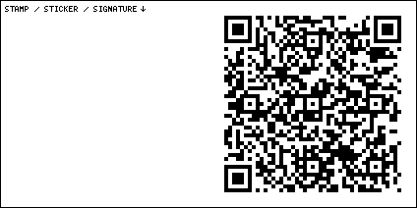
A carefully curated collection of the coolest vintage stuff you’ll ever find. Wasteland Firebird has an engraved brick at the base of Cowboy Bob.

Meadow Gold Mack
1306 E 11th St, Tulsa OK 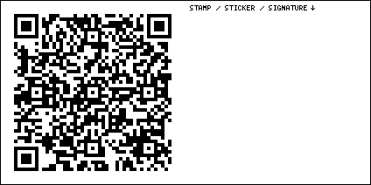
Great work from local artists.

Toynbee Tile
600 S Boston Ave, Tulsa OK 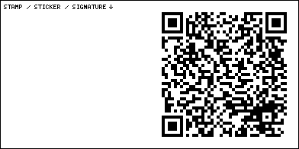
Cross in the crosswalks, looking down at the ground. There is a small linoleum “Toynbee Tile” mosaic embedded in the asphalt. Mosaics like these have been mysteriously appearing in cities around the world since the early 80s. I’d make a documentary about them, but someone already did. It’s called Resurrect Dead: The Mystery of the Toynbee Tiles.

Cyrus Avery Centennial Plaza
Southwest Blvd, Tulsa OK 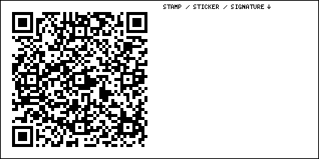
I rarely say this. But, what a sculpture.

Route 66 Neon Sign Park
1450 Southwest Blvd, Tulsa OK 

Route 66 Historical Village
3770 Southwest Blvd, Tulsa OK 

Ollie’s Station
4070 Southwest Blvd, Tulsa OK 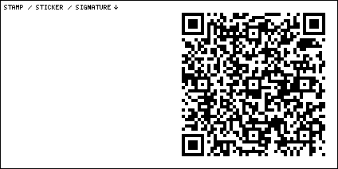

Roller Dome
9661 New Sapulpa Rd, Sapulpa OK 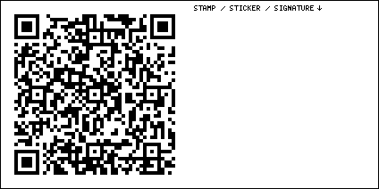
There is a gorgeous old hand-painted sign out front.

Happy Burger
215 N Mission St, Sapulpa OK 

Gasoline Alley Classics
24 N Main St, Sapulpa OK 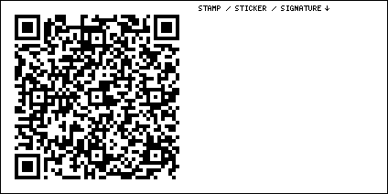
There’s a friendly competition going on between Michael Jones of Gasoline Alley Classics and Aaron Perry of Gearhead Curios to have the best bathroom on Route 66. Everyone agrees that the third best is Buc-ee’s.

Heart of Route 66 Auto Museum
13 Sahoma Lake Rd, Sapulpa OK 

Rock Creek Bridge
W Ozark Trail, Sapulpa OK 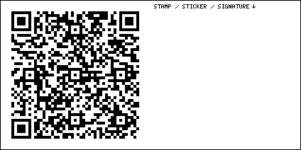

Tee Pee Drive-in
13166 W Ozark Trail, Sapulpa OK 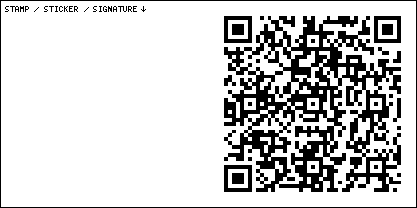

J’s Country Kitchen
31 Oak St, Kellyville OK 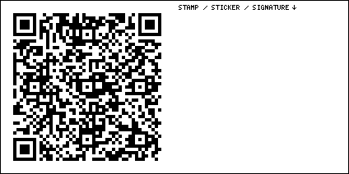

Bristow Train Depot Museum
1 Railroad Pl, Bristow OK 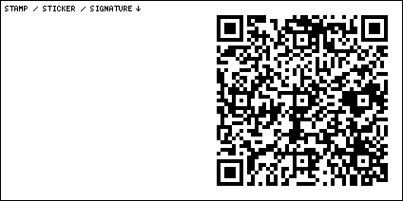

Rock Cafe
114 W Main St, Stroud OK 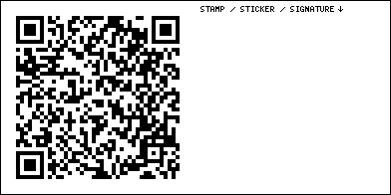
Stroud is a neon revival town. Try to look at the signs at night.

Route 66 Spirit of America Museum
220 W Main St, Stroud OK 
If you’ve been searching for the American Dream, you just found it.

Skyliner Motel
717 W Main St, Stroud OK 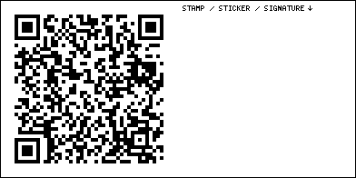
During The Great Route 66 Centennial Convergence, we sold out this place for the first time since its recent renovation.

Route 66 Bowl
920 E 1st St, Chandler OK 

Lincoln Motel
740 E 1st St, Chandler OK 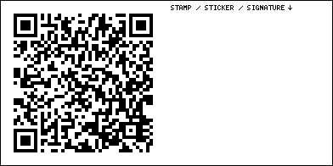

McJerry’s Route 66 Gallery
306 Manvel Ave, Chandler OK 
I think Jerry McClanahan wrote some kind of Route 66 guide, but the real reason to stop here is his amazing painting 666 EXPRESS.

Westfall Phillips 66 Station
701 Manvel Ave, Chandler OK 

Seaba Station Motorcycle Museum
336992 E OK-66, Warwick OK 

John’s Place Museum
13441 OK-66, Arcadia OK 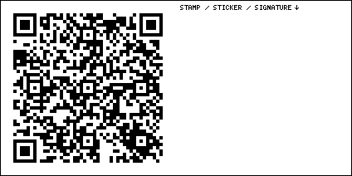

Chicken Shack
212 OK-66, Arcadia OK 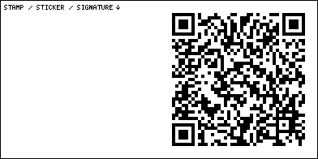

Arcadia Round Barn
107 OK-66, Arcadia OK 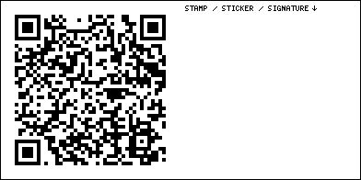

Pops 66
660 OK-66, Arcadia OK 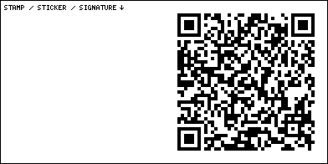
I’m a connoisseur of soda pop, and I highly recommend this place. If you don’t know what to try, I’d suggest a Moxie. If you think it tastes like medicine, that’s because it originally was medicine. And if you think moxie is a cool word to name a soda after, you’ve got it backwards. The soda came first.

1889 Territorial School
124 E 2nd St, Edmond OK 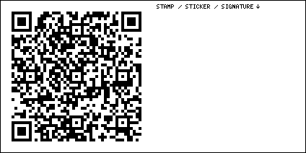

Tower Theatre
425 NW 23rd St, Oklahoma City OK 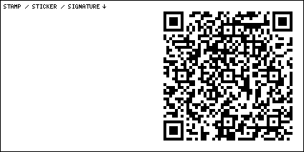

Milk Bottle Grocery
2426 N Classen Blvd, Oklahoma City OK 

Western Motel
7600 NW 39th Expy, Bethany OK 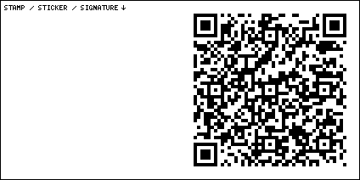

Lake Overholser Bridge
8703-8709 Overholser Dr, Bethany OK 

Lakeview Market
9025 N Overholser Dr, Yukon OK 

Yukon Mill Grain Co
Yukon OK 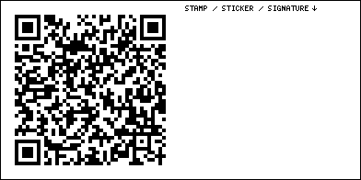

Ranger Motel
1201 SE 27th St, El Reno OK 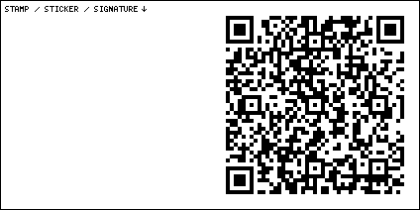

Johnnie’s Grill
301 S Rock Island Ave, El Reno OK 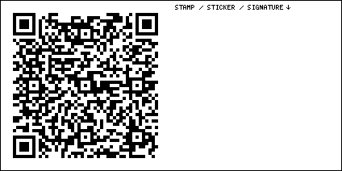
Get the onion burger. But save room for three more.

Robert’s Grill
300 S Bickford Ave, El Reno OK 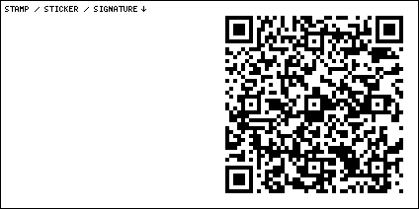
Get the onion burger. But save room for two more.

Sid’s Diner
300 S Choctaw Ave, El Reno OK 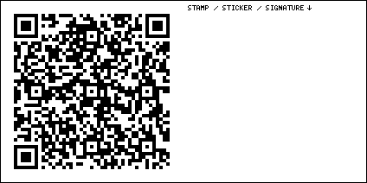
Get the onion burger. But save room for one more.

Jobe’s Country Boy Drive-In
1220 Sunset Dr, El Reno OK 
Get the onion burger.

Indian Trading Post
825 S Walbaum Rd, Calumet OK 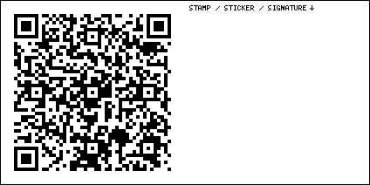

Bridgeport Bridge
US-281, Hinton OK 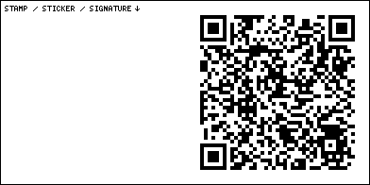

Hinton Junctions Courts and Cafe
16153 Old 66 Rd, Hinton OK 

Lucille’s Historic Highway Gas Station
US Rte 66, Hydro OK 

Major Tom Astronaut
201 W Main St, Weatherford OK 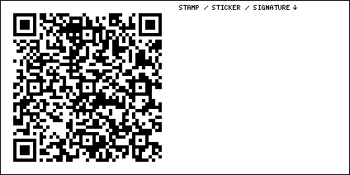
In the Twentieth Century, we traveled by horses, cars, airplanes, and space rockets, all in the same century. My grandfather saw it all. By the time we got to the moon landing, he refused to believe it was real. He wasn’t a conspiracy theorist. His brain just couldn’t grasp that such a thing was possible.

Glancy Motel
217 W Gary Blvd, Clinton OK 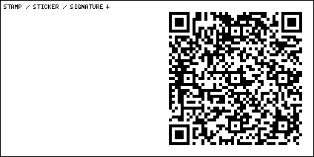
There never was, and never will be, another century like the Twentieth. One day, historians will speak of “The Twentieth Century” the way we today speak of “The Renaissance,” or “The Enlightenment.”

Cotton Boll Motel sign
605 Old US Hwy 66, Canute OK 
Here’s a list of some stuff that was either discovered, invented, perfected, or widely adopted in the Twentieth Century. Antibiotics, anesthesia, surgery, contraception, clean water, indoor plumbing, biotechnology, Norman Borlaug’s miracle strains of wheat, batteries, light bulbs, air conditioning and refrigeration, washing machines, nuclear power, solar power, telephones, mobile phones, photography, radio, movies, television, computers, internet, cars, airplanes, and space travel.

United Supermarkets
2700 W 3rd St, Elk City OK 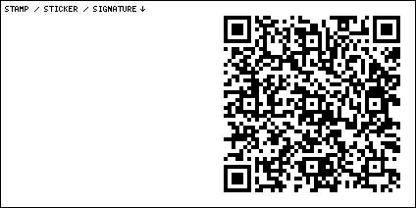
Keep in mind that all of this happened despite two world wars, the Great Depression, and the worldwide threat of Soviet and Chinese communist expansion during the Cold War. In just a hundred years we figured out more stuff than we had figured out in the entire hundred thousand years that preceded it. Sure there was fire and the wheel. Agriculture and domestication. Spoken language and written language and the printing press. But that ain’t much to figure out in a hundred thousand years.

National Route 66 & Transportation Museum
2717 W 3rd St, Elk City OK 
It’s a weird museum. But weird is good, right?

Sandhill Curiosity Shop
201 S Sheb Wooley Ave, Erick OK 
Harley Russell is here. He was the human inspiration for the vehicular character Tow Mater from Pixar’s Cars. They had to make a few changes to his personality, because it was a movie for kids.

Sam’s Town on 66
401 W Roger Miller Blvd, Erick OK 
When we were here, a dirt-encrusted man came down the street, handed us bags of fresh pecans still in their shells, then walked away. Maybe that was Sam?

West Winds Motel
617 W Roger Miller Blvd, Erick OK 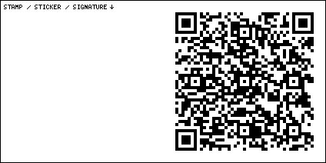
They tell me that the neon sign has been restored, and it lights up again.

U-Drop Inn Cafe
105 E 12th St, Shamrock TX 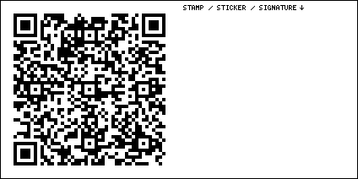

Restored 1929 Route 66 Gas Station
212 First St, McLean TX 

Cactus Inn
101 Pine St, McLean TX 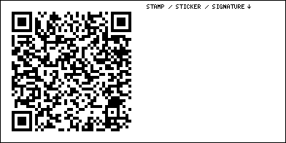

Red River Steakhouse
101 US Rte 66, McLean TX 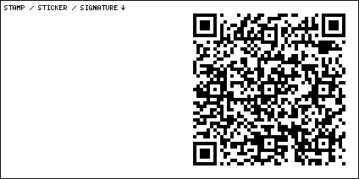

Alanreed
Alanreed TX 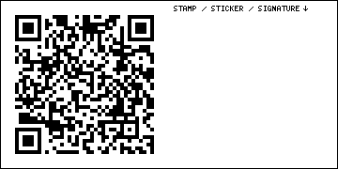

Jericho Gap
5989 State Hwy 70, Clarendon TX 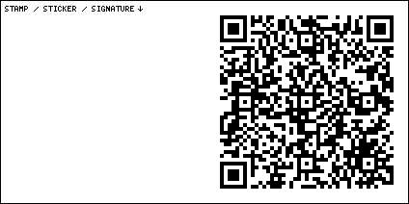

Leaning Tower of Texas
Groom TX 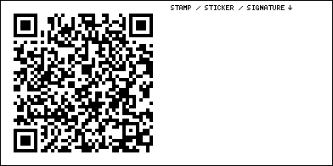
Why is it leaning? I dunno, it was probably aliens.

Buc-ee’s
9900 E I-40, Amarillo TX 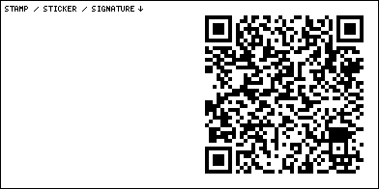
If you want to try something weird and American, something that even a lot of Americans haven’t tried, look for a Chick-O-Stick. Peanut butter and toasted coconut, no chocolate. Fresh ones are better, so buy them from a high-traffic business like Buc-ee’s. If they’re crunchy, they’re fresh. If they’re chewy or sticky, they’re stale.

Big Texan Steak Ranch & Brewery
7701 I-40, Amarillo TX 
Some places are just a gimmick, and that’s fine. But this gimmick has some of the best food on the Route, and it’s a great motel, too. Some say The Big Texan is not actually on Route 66. I say The Big Texan is like the Eiffel Tower. If I happened to be passing two blocks away from it, I’d make a point to stop by.

Slug Bug Ranch
1415 Sunrise Dr, Amarillo TX 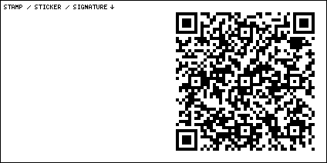
A miniature version of the Cadillac Ranch. Bring some spray paint. You’re allowed to paint the cars.

Texas Route 66 Visitor Center
1900 SW 6th Ave, Amarillo TX 

Elmo’s Drive Inn
2618 SW 3rd Ave, Amarillo TX 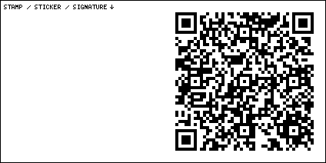
I thought this beautiful old joint was abandoned, but when I pulled in, friendly people appeared and came up to my car, ready to help. I’d just eaten, but I gave them enough money to buy free food for the next three customers.

Lile Art Gallery
2719 SW 6th Ave, Amarillo TX 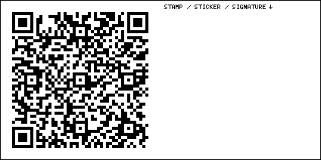
In the old car factories in Detroit, paint used to build up in layers on the walls in the areas where they painted the cars. You could chip pieces off and polish them into beautiful multicolored “stones” called “Fordite.” Spray paint builds up on the cars at the Cadillac Ranch, too. Bob Lile harvests this paint to create “Cadillite” jewelry.

Smokey Joe’s
2903 SW 6th Ave, Amarillo TX 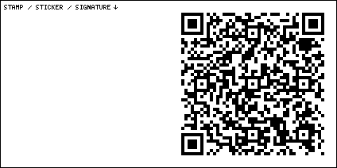

GoldenLight Cafe & Cantina
2906 SW 6th Ave, Amarillo TX 

Texas Ivy Antiques
3511 SW 6th Ave, Amarillo TX 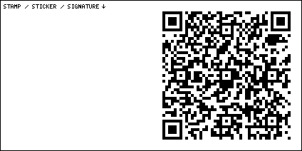

Handle Bar and Grill
3514 SW 6th Ave, Amarillo TX 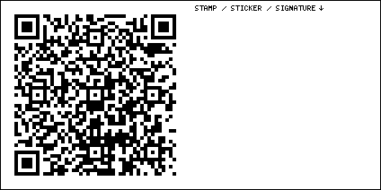

Meme’s Cafe
3700 SW 6th Ave, Amarillo TX 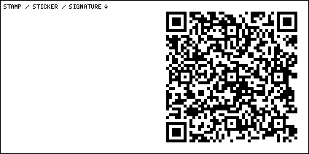

2nd Amendment Cowboy Muffler Man
2601 Hope Rd, Amarillo TX 
Just beside the Cadillac Ranch, there’s a Muffler Man with opinions about what an awesome document the Bill of Rights is.

Cadillac Ranch
13651 I-40 Frontage Rd, Amarillo TX 
If you see nothing else on Route 66, see this. Bring spray paint. You’re allowed to paint the cars. There is a small linoleum “Toynbee Tile” mosaic embedded into the asphalt near the entrance.

Milburn-Price Culture Museum
1005 Coke St, Vega TX 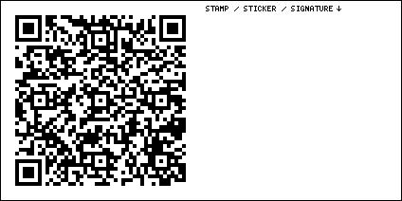
The best places defy description. The first time I visited, I made a recording of my ten-step philosophy of life via a telephone booth. The second time I visited, I held a tarantula in my hands. The third time I visited, I mentioned that my pocket knife had been stolen, and the owner gifted me one from his huge stash. What is it you’re actually supposed to be doing here? I still haven’t figured that out.

Mama Jo’s Pies
922 E Main St, Vega TX 
They have cherry pies here.

Midpoint Cafe
305 Historic Rte 66, Adrian TX 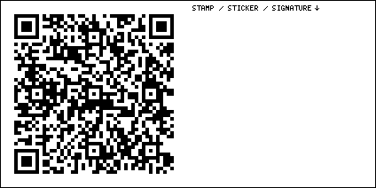
You’re at the midpoint of Route 66. The two most crucial points in a story are the midpoint (halfway through the story) and the all-is-lost moment (two-thirds of the way through the story). The midpoint and the all-is-lost moment tend to mirror each other. Things seem good now. But the story isn’t over. Things are about to take a turn.

Dream Maker Station
307 US Rte 66, Adrian TX 

Glenrio TX Ghost Town
I-40BL, Hereford TX 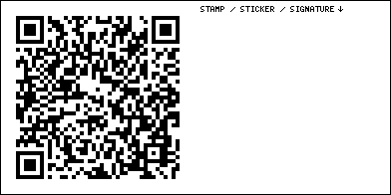
See what I mean about the story taking a turn?

Russell’s Travel Center
1583 Frontage Rd 4132, Glenrio NM 
It looks pretty much like a normal gas station, but go inside, and be delighted.

World’s Largest Flip Flop
602 Rte 66, San Jon NM 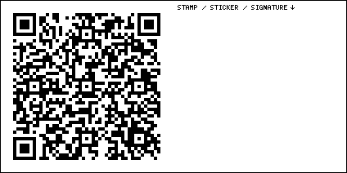
A dream is something real that exists only in the mind of a lazy person. The World’s Largest Flip Flop was once just a dream. Now it is real.

Palomino Motel
1215 E Rte 66 Blvd, Tucumcari NM 
Tucumcari is the closest you will come to experiencing Route 66 as it was in the old days. It’s not just a neon revival town. Some of those old signs are still buzzing, unrestored.

Watson’s BBQ
502 S Lake St, Tucumcari NM 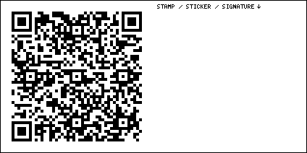
I don’t know if this place is still open, but it’s pretty fun to look at from the outside, too.

Del’s Restaurant
1202 US Rte 66, Tucumcari NM 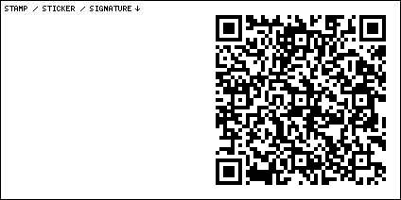

Roadrunner Lodge Motel
1023 E Rte 66 Blvd, Tucumcari NM 

TeePee Curios
924 E Rte 66 Blvd, Tucumcari NM 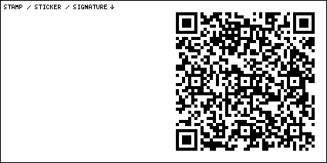
I really do buy very few antiques and souvenirs. If I buy something, the place must be really good. I bought a beautiful vintage New Mexico road runner license plate here.

Blue Swallow Motel
815 E Rte 66 Blvd, Tucumcari NM 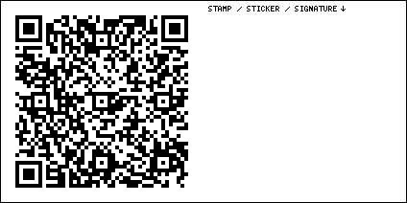
Does Tucumcari need and deserve a mass infusion of cash? Yes, but the money should only be used for preservation. Nothing new should be added.

Motel Safari
722 E Rte 66 Blvd, Tucumcari NM 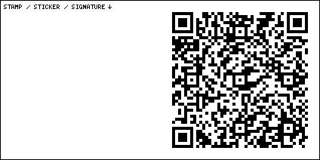

Tucumcari Historical Museum
416 S Adams St, Tucumcari NM 

La Cita
820 S 1st St, Tucumcari NM 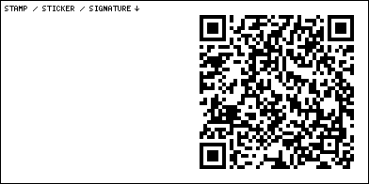

Blake’s Lotaburger
2523 S 1st St, Tucumcari NM 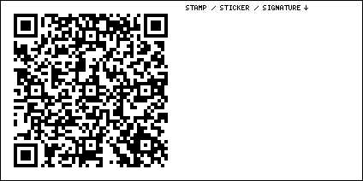

Ranch House Cafe
1017 W Tucumcari Blvd, Tucumcari NM 

Tristar Inn Xpress
1302 W Rte 66 Blvd, Tucumcari NM 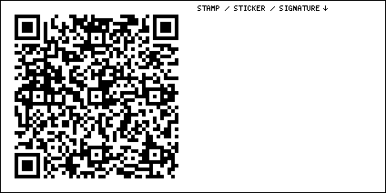
Room 118 has a secret hidden behind the mirror. Search for “Room Attack” on Wasteland Firebird’s YouTube channel if you want to know more.

Richardson Store
Tucumcari, NM 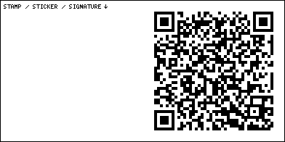

Cuervo Ghost Town
Cuervo NM 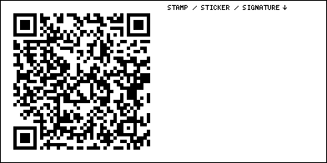

Route 66 Auto Museum
2463 Historic Rte 66, Santa Rosa NM 

Old Rio Pecos Ranch Truck Terminal
2358 US Rte 66, Santa Rosa NM 

Sun & Sand Restaurant
2050 US Rte 66, Santa Rosa NM 
Last time I came through, the most beautiful sign on Route 66 was lying on the ground, destroyed by rust, wind, and entropy. Just one year before, I’d seen it standing, proud and tall. It’s ok to cry. Not just for the sign. For all of Route 66. For everyone who’s come and gone. For the American Dream that’s been all but forgotten.

Bowlin’s Flying C Ranch
Exit 234, I-40, Encino NM 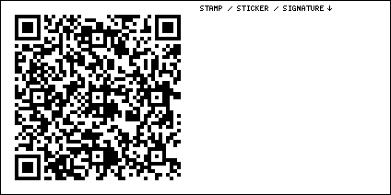

Clines Corners Travel Center
Clines Corners NM 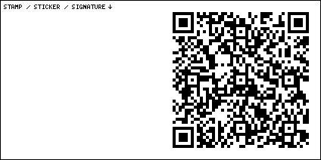
This successful business has cheap apartments on-site and good paying jobs. It would be a great place for a young person to get started building their own American Dream. It’s a bit desolate, but no one said it would be easy. If you know a young person who’s “failed to launch,” (still living with their parents in their twenties or thirties) offer to buy them a bus ticket to Clines Corners.

Sal & Inez’s Service Station
421 US Rte 66, Moriarty NM 

Country Friends Antiques
1005 Old US Rte 66, Moriarty NM 
This place features a rare sputnik-style Roto-Sphere sign on top of the building.

Tinkertown Museum
121 Sandia Crest Rd, Sandia Park NM 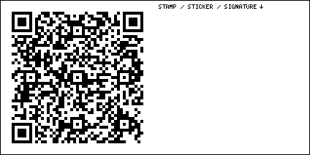
One man built this place while the rest of us were watching television.

Bow & Arrow Lodge
8300 Central Ave SE, Albuquerque NM 
The works of Vince Gilligan, set in Albuquerque, ranked: 1. Pluribus (the most important battle humanity has ever fought, but you might have trouble deciding which side you’re on). 2. Better Call Saul (watch it before Breaking Bad, it’s better, and it’s a prequel anyway). 3. Breaking Bad.

Loma Verde Motel sign
7503 Central Ave NE, Albuquerque NM 
I’m not here to show you a good time. I’m here to show you America, for better or for worse. Some towns on Route 66 are now worse than ghost towns. They are zombie towns.

Hotel Zazz
3711 Central Ave NE, Albuquerque NM 

M’tucci’s Bar Roma
3222 Central Ave SE, Albuquerque NM 

Frontier Restaurant
2400 Central Ave SE, Albuquerque NM 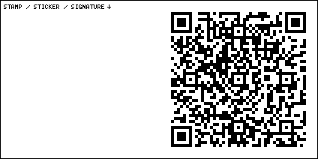

66 Diner
1405 Central Ave NE, Albuquerque NM 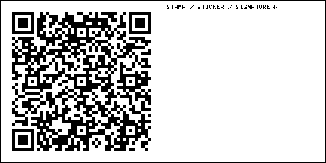
Sometimes they have cherry pie.

The Imperial
701 Central Ave NE, Albuquerque NM 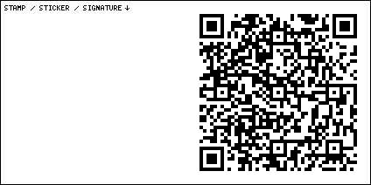
This is the place to stay when in Albuquerque.

Kimo Theatre
423 Central Ave NW, Albuquerque NM 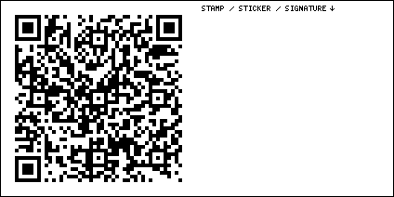

Dog House Drive In
1216 Central Ave NW, Albuquerque NM 

El Vado Motel
2500 Central Ave SW, Albuquerque NM 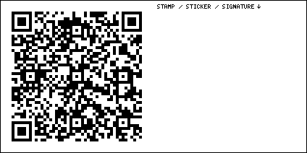

Golden Pride
5231 Central Ave NW, Albuquerque NM 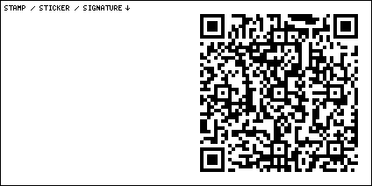

Western View Steak Diner & House
6411 Central Ave NW, Albuquerque NM 

Route 66 Visitor Center
12300 Central Ave SW, Albuquerque NM 
This site is still under development, but now you can go in. It’s getting good. There’s a neon sign park out front.

Budville Trading Post
HC 77 Box 1A, Seama NM 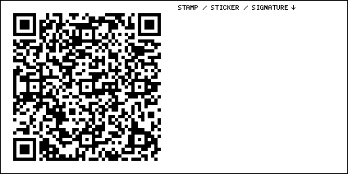

Villa de Cubero Trading Post
1406 NM 124, Casa Blanca NM 

Ruins of Whiting Brothers Gas Station
San Fidel NM 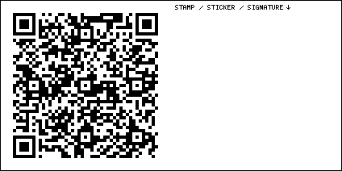

West Theatre
118 W Santa Fe Ave, Grants NM 

New Mexico Mining Museum
100 Iron Ave, Grants NM 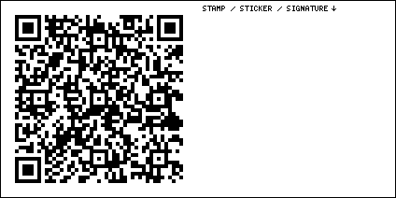
Go down the elevator.

Old Bluewater Motel
2331 NM-122, Bluewater NM 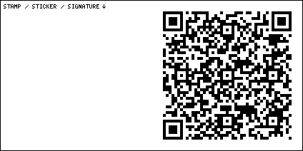

Bowlin’s Bluewater Outpost
136 Main St, Bluewater NM 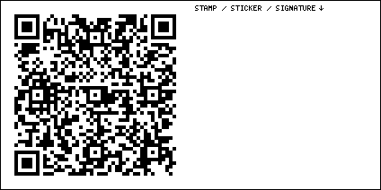

Indian Village Gift Shop
101 US Rte 66, Continental Divide NM 

Fort Wingate Army Depot
506 US Rte 66, Church Rock NM 

Earl’s Family Restaurant
1400 E Hwy 66, Gallup NM 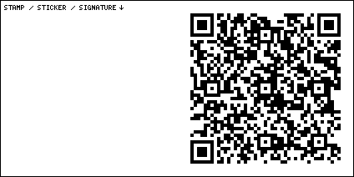
Probably not what you’re expecting.

Blue Spruce Lodge
1119 E Hwy 66, Gallup NM 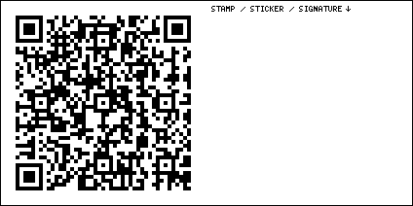

Historic El Rancho Hotel
1000 E Hwy 66, Gallup NM 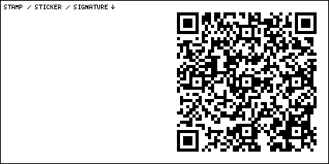

John’s Used Cars
416 W Coal Ave, Gallup NM 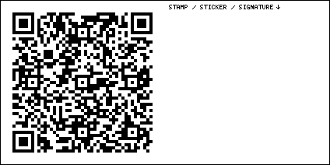
There’s a used car salesman Muffler Man here.

Yellowhorse Trading Post
I-40 Exit 359, Lupton AZ 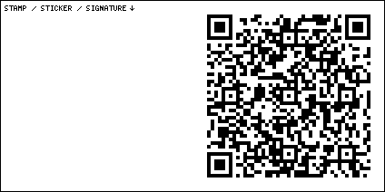
I prefer using the Canadian term “First Nations” instead of saying “Indian” (they’re not from India) or “Native American” (anyone born in America is native to America). But I’m happy to refer to someone in any way that they ask me to.

Fort Courage
Houck AZ 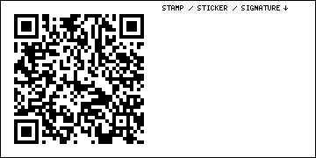
The Pancake House that used to be here was destroyed in 2026. Last time I visited, the fort building inspired by the TV show F-Troop was still here, but who knows what you’ll find by the time you read this. We’ve reached the all-is-lost moment in our story. We’re two-thirds of the way through. It’s the mirror of the midpoint, back when things still seemed so good. Things don’t seem so good, now. We’re about to break into Act III, the climax. Let’s hope things get better.

Dotch Windsor’s Painted Desert Trading Post
Chambers AZ 
Take exit 320, head east a bit, then take the dirt road north half a mile. Stop at the gate that has a tiny sign that says Painted Desert Trading Post. There is a lock with a code on it. You can call the number on the sign to get the code, you will need to text them a photo of your id. Enter the code into the lock and hit the unlock button. Go through the gate and close it behind you. Immediately turn left, go west 2.6 miles. When you get to the Trading Post, you can go in, but make sure to keep all gates closed when you leave.

Petrified Forest National Park
Petrified Forest AZ 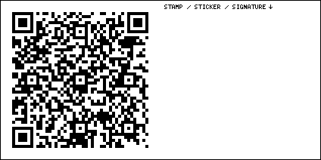
The “forest” is actually a bunch of fallen, crystalized logs. You have to get out and look at them up close to understand.

Stewart’s Petrified Wood Shop
Washboard Rd, Holbrook AZ 

Knife City Outlet
7699 Sun Valley Rd, Sun Valley AZ 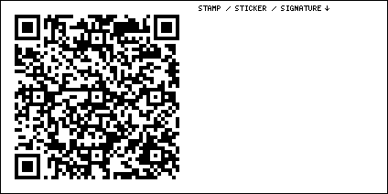
Last time I visited this place, the flamethrowers were gone. But you can still ask them to show you several types of weapons that are illegal in Chicago and Los Angeles. And most other Western countries.

El Rancho Restaurant & Motel
867 Navajo Blvd, Holbrook AZ 

Wigwam Motel
811 W Hopi Dr, Holbrook AZ 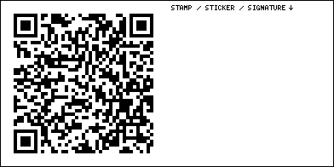
You gotta reserve these funky hotels early. I’ve never found one with a vacancy upon arrival.

Geronimo Trading Post
5372 Geronimo Rd, Joseph City AZ 

Here It Is Jack Rabbit Trading Post
3386 US Rte 66, Joseph City AZ 
The most iconic old shop on the entire Route.

Falcon Restaurant & Lounge
1113 E 3rd St, Winslow AZ 

Earl’s Route 66 Motor Court
512 E 3rd St, Winslow AZ 

La Posada Hotel
303 E 2nd St, Winslow AZ 
My absolute favorite hotel on Route 66. Quirky, old, and luxurious. Unlike big city hotels, you can park you own car. You don’t need a porter to take your bags to your room. And you can open the gosh-danged windows. That’s what I call luxury.

Route 66 Delta Motel
2141 W 3rd St, Winslow AZ 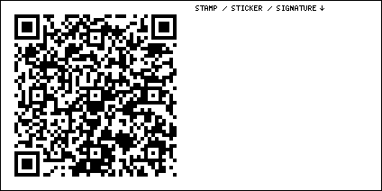

Meteor City Trading Post
40440 Interstate 40 WB, Winslow AZ 
This place was recently reopened and it’s a lot of fun. I rented a four-person bike. I pedaled as fast as I could through the park, completing the journey in under a minute and terrifying my companions.

Meteor Crater
Meteor Crater Rd AZ 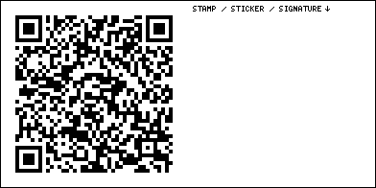

Two Guns
Two Guns AZ 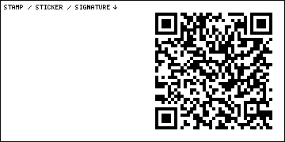
The first time I visited this place, it was for a group photo shoot. I ended up taking sexy photos of a woman who later went on to indirectly cause a noteworthy shooting death on a movie set. No one has ever seen these photos. If any tabloid is interested in making me rich, get in touch. If you think you saw these photos in my YouTube video, oh no, you didn’t. You saw the ones that were safe for YouTube.

Twin Arrows Trading Post Ruins
East of Flagstaff AZ 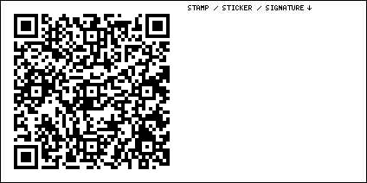
There’s only one arrow here now. Someone should make a perfect replica and surreptitiously install it in the middle of the night. Or just put the original one back. The rumor is, it’s still out there somewhere.

Walnut Canyon Bridge
Townsend-Winona Rd, Winona AZ 

Americana Motor Hotel
2650 E Rte 66, Flagstaff AZ 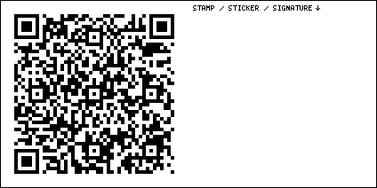

Route 66 Dog Haus
1302 E Rte 66, Flagstaff AZ 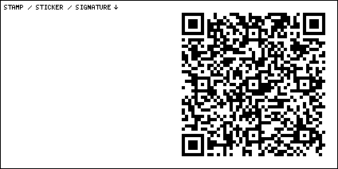

Flagstaff Visitor Center
1 E Rte 66, Flagstaff AZ 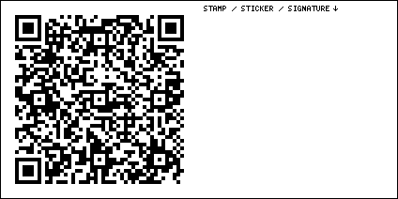

Weatherford Hotel
23 N Leroux St, Flagstaff AZ 

J Lawrence Walkup Skydome
1705 S San Francisco St, Flagstaff AZ 
There are two Muffler Men here, one on each side.

Galaxy Diner
931 W Rte 66, Flagstaff AZ 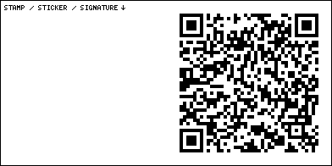

Pine Breeze Inn
10520 W Rte 66, Flagstaff AZ 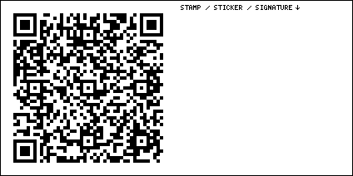

Old Route 66 Parks Store
12963 Old Rte 66 Ste 50340, Parks AZ 

Bearizona Wildlife Park
1500 E Rte 66, Williams AZ 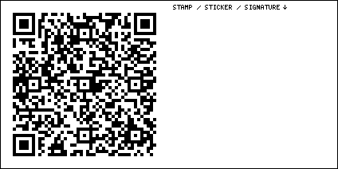
I hate most zoos. They’re like prisons for animals that didn’t do anything wrong. But this one is nice. And they trust you enough to let you drive right through it, just like in the old days.

Rod’s Steak House
301 E Historic Rte 66, Williams AZ 
Williams is a neon revival town. Try to get a look at its signs at night.

Pete’s Route 66 Gas Station Museum
101 E Rte 66, Williams AZ 

Historic Grand Canyon Hotel
145 Historic Rte 66, Williams AZ 

Williams Visitor Center
200 W Railroad Ave, Williams AZ 

Cruiser’s Route 66 Cafe
233 W Rte 66, Williams AZ 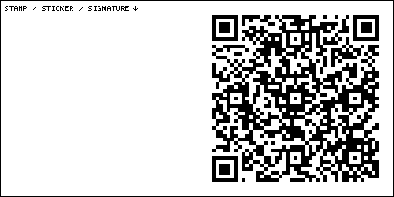

Arizona 9 Motor Hotel
315 W Rte 66, Williams AZ 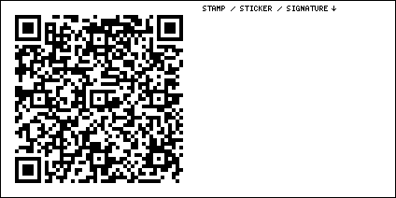

Ash Fork Route 66 Museum
901 Old Rte 66, Ash Fork AZ 
They might have the old Hi-Line Motel sign here.

Aztec Motel & Creative Space
22200 Historic Rte 66, Seligman AZ 

Delgadillo’s Snow Cap
301 AZ-66, Seligman AZ 
Angel Delgadillo has lived in Seligman for his entire life. He’s one year younger than the Route. He saved Route 66 in 1987 by founding the Historic Route 66 Association of Arizona.

Route 66 Road Relics
22255 W Old Highway 66, Seligman AZ 

Delgadillo’s Gift Shop
22265 Historic Rte 66, Seligman AZ 

Rusty Bolt
22345 W Old Highway 66, Seligman AZ 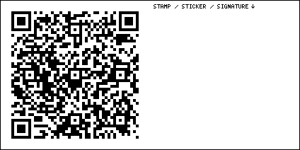
I sometimes leave copies of my books on the used book shelf here. They sell for 50¢ each.

Supai Motel
22450 AZ-66, Seligman AZ 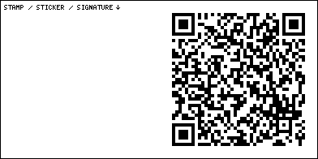
Room 3 has a hidden secret. It’s not behind the mirror. Good luck finding it. If you need help, search for “Room Attack” on Wasteland Firebird’s YouTube channel.

Roadkill Cafe
22830 W AZ-66, Seligman AZ 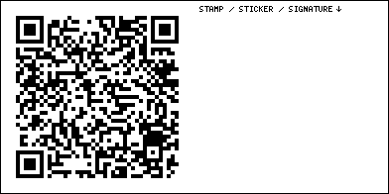

Westside Lilo’s Cafe
22855 AZ-66, Seligman AZ 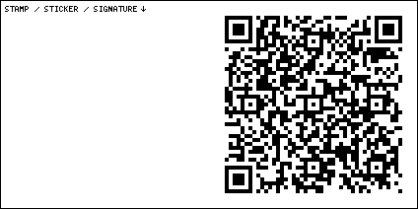

Frontier Motel Cafe
16118 Historic Rte 66, Valentine AZ 
The best hand-painted sign on Route 66 is the dude with the long arms.

Old 76 Station
12526 Historic Rte 66, Valentine AZ 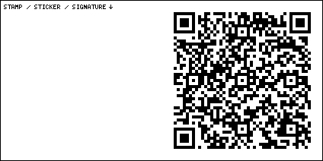

Hackberry General Store
11255 AZ-66, Kingman AZ 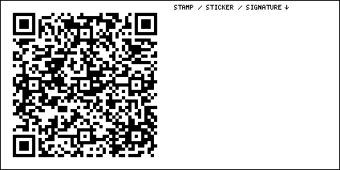
Pet the cat’s tummy.

Arcadia Lodge sign
909 E Andy Devine Ave, Kingman AZ 

TNT Auto Center
535 E Andy Devine Ave, Kingman AZ 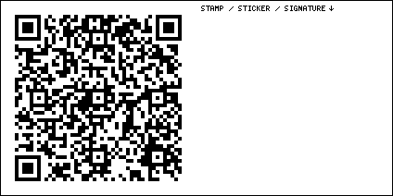
There is a Bob Waldmire mural here.

Kingman Railroad Museum
402 E Andy Devine Ave, Kingman AZ 

Sirens Cafe
419 Beale St, Kingman AZ 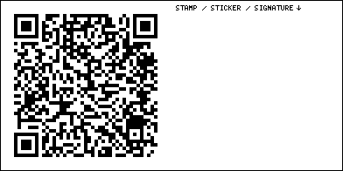

Hotel Beale sign
331 E Andy Devine Ave, Kingman AZ 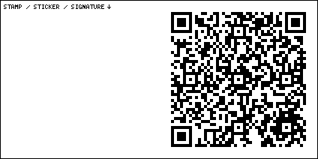
The sign lights up again, after decades of darkness.

Tin Can Alley
211 E Andy Devine Ave, Kingman AZ 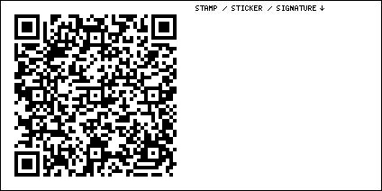
Downtown glamping.

Mr. D’z Route 66 Diner
105 E Andy Devine Ave, Kingman AZ 
The 70s electric Citicars are an odd choice, but if they’d been 57 Chevys, they’d just blend into the background.

Cool Springs Station
8275 Oatman Rd, Golden Valley AZ 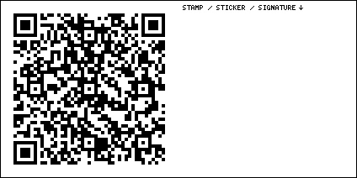
Large vehicles and vehicles with large trailers, beware the upcoming curvy road known as the Sidewinder. But try not to miss Oatman.

Oatman
Oatman AZ 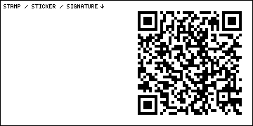
The first time I drove through this town, I had no idea what it was or why it was here. Somehow, for some reason, I had been teleported back in time to the Old West.

Claypool & Co building
719 W Broadway St, Needles CA 

Wagon Wheel Restaurant
2420 Needles Hwy, Needles CA 

Rio Del Sol Inn
1111 Pashard St, Needles CA 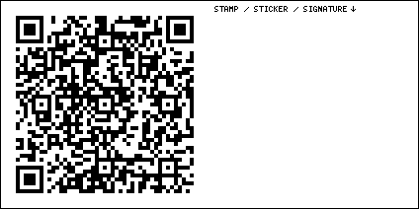

Goffs Schoolhouse
37198 Lanfair Rd, Essex CA 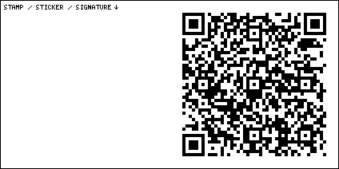

Guardian Lion East
National Trails Hwy, Amboy CA 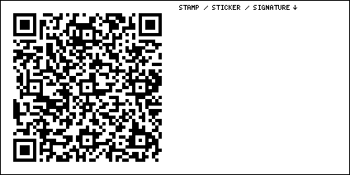
Anyone can spray paint a bridge overpass. Only a true genius can hand-carve two multi-ton lions out of marble, transport and install them with no one noticing, leave people confused, and make one of them disappear for the entire year of 2019 for some reason.

Road Runner’s Retreat
Chambless CA 
This one is out of order for a reason. If you’ve navigated the road closures and construction detours and made it to Guardian Lion East, you can probably find the Road Runner’s Retreat sign. Head back the way you came, five miles east on 66. Do not make the left onto Kelbaker Rd. Instead, drive around the road closed signs. The road is in great condition all the way to the Retreat sign. Those road closed signs should really be moved back a couple miles. Beyond the Retreat sign, road conditions are anyone’s guess. Recently restored, this sign even lights up sometimes in the evenings.

Guardian Lion West
National Trails Hwy, Amboy CA 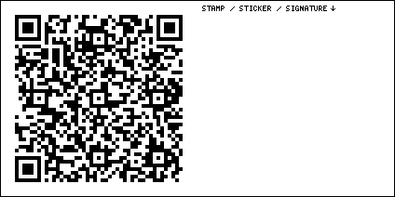

Roy’s Motel & Cafe
87520 National Trails Hwy, Amboy CA 
The most iconic operating gas station on Route 66. They made a cake for The Great Route 66 Centennial Convergence. It had a picture of my face on it. They clearly recognize my eminence and genius.

Former Whiting Brothers Gas Station
68517 County Rd 66, Ludlow CA 
People used to live and work in these buildings. They lived their entire lives here.

Ludlow Cafe
68315 National Trails Hwy, Ludlow CA 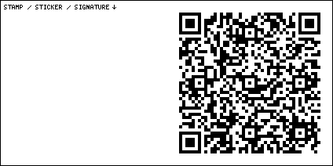
I’ve never made it to this place during business hours, but I’m gonna keep trying.

Whiting Brothers Service and Tony’s Spaghetti building
46756 National Trails Hwy, Newberry Springs CA 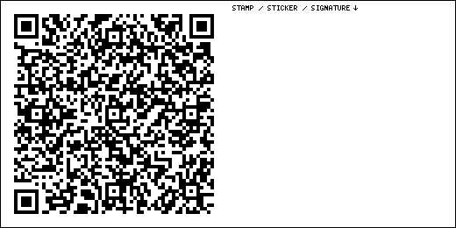
Attachment leads to suffering.

Bagdad Cafe
46548 National Trails Hwy, Newberry Springs CA 
This place is beloved by weird German tourists because of the 1987 film Bagdad Cafe. That film is about weird German tourists finding their home-away-from-home at this place. Owner Andrea Pruett slept on a mattress on the floor here while rain dripped through the leaky roof. She did this to keep the place alive for you and me. She’s no longer with us. Leave a tip in the jar.

Sand-swallowed abandoned homes
Newberry Rd & Palma Vista Rd, Newberry Springs CA 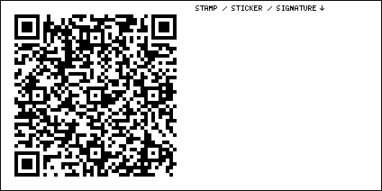
I haven’t found these buildings yet, but they tell me you can find them just beyond this intersection. Don’t drive in sand.

The Barn
44560 National Trails Hwy, Newberry Springs CA 
Like Roy’s Cafe, The Barn always treats me like the celebrity that I am. I’m sure they’ll be nice to you peons, too.

Russian House
35421 County Rd 66, Daggett CA 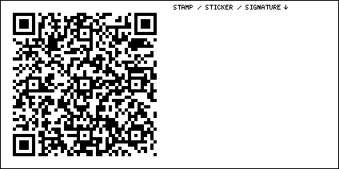

Desert Market
35596 Santa Fe St, Daggett CA 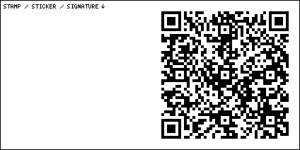

Daggett Garage
35565 Santa Fe St, Daggett CA 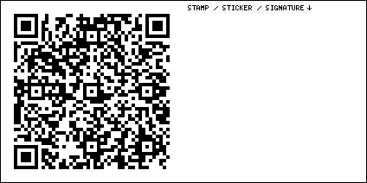

Daggett Historical Museum
33703 2nd St, Daggett CA 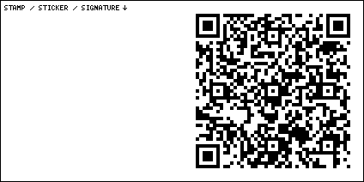

Penny’s Diner
35450 Yermo Rd, Yermo CA 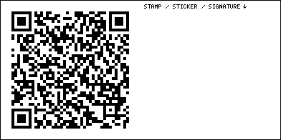

Peggy Sue’s 50’s Diner
35654 Yermo Rd, Yermo CA 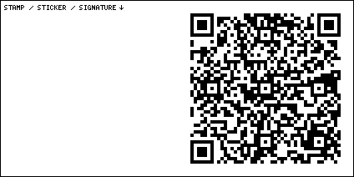

Liberty Sculpture Park
37570 Yermo Rd, Yermo CA 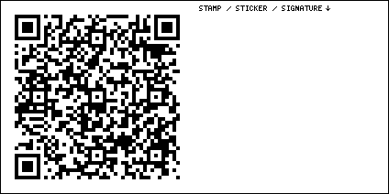
Communism simply doesn’t work.

EddieWorld
36017 Calico Rd, Yermo CA 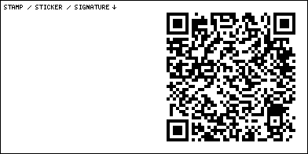
Capitalism creates inequality, but overall, it works best for everyone. World GDP sat still for all of human history. Then capitalism came along and made that graph look like a hockey stick.

Thrift & More
457 W Yermo Rd, Yermo CA 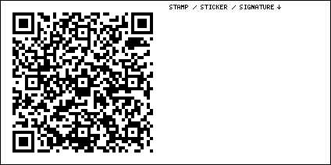

Original Del Taco Location
38434 E Yermo Rd, Yermo CA 

Calico Ghost Town
Calico CA 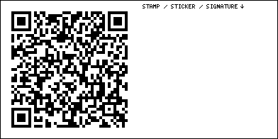

Skyline Drive-In Theater
31175 Old Hwy 58, Barstow CA 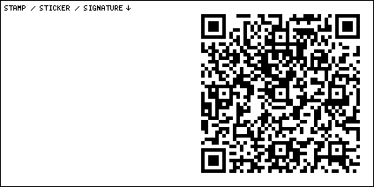

Barstow Train McDonald’s
1611 E Main St, Barstow CA 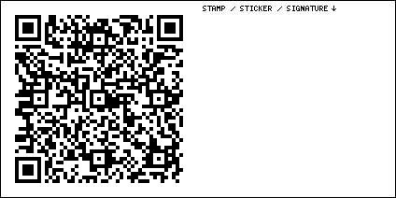
It’s just a McDonalds, but the dining rooms are made of real train cars.

Mojave River Valley Museum
270 E Virginia Way, Barstow CA 

Route 66 Motel
195 Main St, Barstow CA 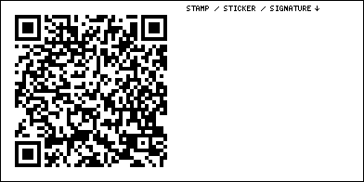

Harvey House
685 N 1st Ave, Barstow CA 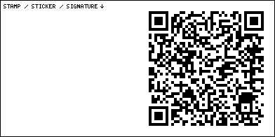

Elmer’s Bottle Tree Ranch
24266 National Trails Hwy, Oro Grande CA 

Emma Jean’s Holland Burger Cafe
17143 N D St, Victorville CA 

California Route 66 Museum
16825 D St, Victorville CA 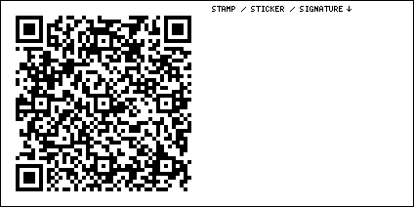

Santa Fe Trading Company
15464 7th St, Victorville CA 
This has been a family-owned business since forever. It used to be a gas station, then it was a candy store, now it’s something else entirely. They make their own pomegranate jelly, if that helps.

First Original McDonald’s Museum
1398 N E St, San Bernardino CA 

Mitla Cafe
602 N Mt Vernon Ave, San Bernardino CA 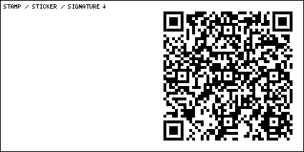

Wigwam Village Motel
2728 Foothill Blvd, San Bernardino CA 

Cucamonga Service Station
9670 Foothill Blvd, Rancho Cucamonga CA 
There might be a custom brick here from The Great Route 66 Centennial Convergence.

Sycamore Inn
8318 Foothill Blvd, Rancho Cucamonga CA 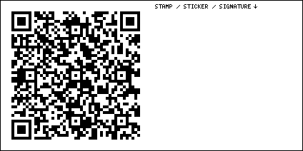

Magic Lamp Inn Restaurant
8189 Foothill Blvd, Rancho Cucamonga CA 
This place has a strict dress code and no mobile phones are allowed. I hope my leather jacket covered in paint marker art summarizing my entire philosophy of life in ten simple principles is ok.

Donut Man
915 E Rte 66, Glendora CA 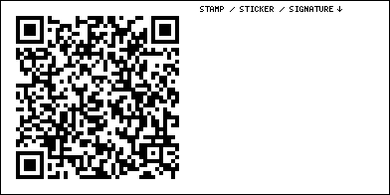
My philosophy of life, principle #1: I AM CONSCIOUS. I know this for sure.

Windmill Denny’s
7 E Huntington Dr, Arcadia CA 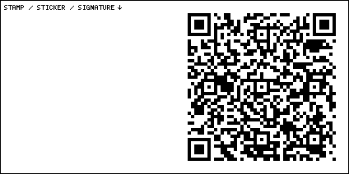
Principle #2: HAPPINESS IS GOOD. I know this for sure, too.

Saga Motor Hotel
1633 E Colorado Blvd, Pasadena CA 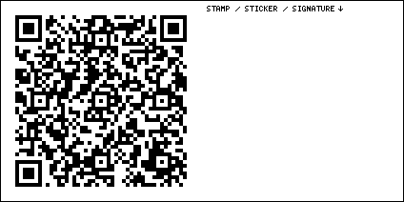
Principle #3: I CAN USUALLY TRUST MY SENSES. I have to either believe this, or choose not to function.

Shakers
601 Fair Oaks Ave, South Pasadena CA 
Principle #4: THE LAWS OF NATURE ARE CONSISTENT. I have to either believe this, or choose not to function.

Fair Oaks Pharmacy & Soda Fountain
1526 Mission St, South Pasadena CA 
Principle #5: THE LAWS OF HUMAN NATURE ARE CONSISTENT. This implies that we can figure out some rules of ethics, virtue, and morality.

Galco’s Old World Grocery
5702 York Blvd, Los Angeles CA 
Principle #6: REASON IS HOW WE ACQUIRE KNOWLEDGE. Deductive logic, like math, and inductive reasoning, like science, are how we understand the universe and how we understand ourselves.

Highland Park Bowl
5621 N Figueroa St, Los Angeles CA 
Principle #7: FREEDOM IS HOW WE ACHIEVE HAPPINESS. Most people agree that freedom makes them happy.

La Fuente Restaurant
5552 N Figueroa St, Los Angeles CA 
Principle #8: ECONOMIC FREEDOM IS HOW WE ACHIEVE PROSPERITY. Capitalism works. I define capitalism as “economic freedom,” not “cronyist plutocracy.” I assure you, I hate cronyist plutocracy as much as anyone. Capitalism doesn’t exist to hold poor people down. It exists to let brilliant people do brilliant things.

Cielito Lindo
E-23 Olvera St, Los Angeles CA 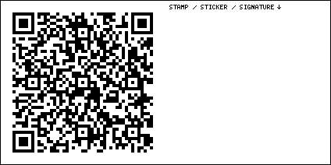
Principle #9: FREEDOM IS A POSITIVE-SUM GAME. If two people agree to participate in some type of financial or emotional transaction, they do it because they both feel like it will benefit them. It’s not that one of them is right, and one of them is wrong. They are both right. They both benefit. Therefore, every transaction makes the world a slightly better place.

Million Dollar Theater
307 S Broadway, Los Angeles CA 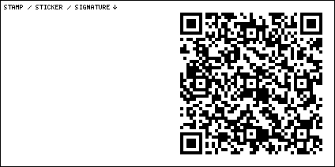
Principle #10: CREATE VALUE. It took me years to figure out a way to summarize my entire philosophy in a way that it would fit on a bumper sticker. If you gain nothing else from my existence in this universe, please take these two words with you and keep them handy in your mind. Steal these words, copy these words, say these words. “Create value.”

Clifton’s building
648 S Broadway, Los Angeles CA 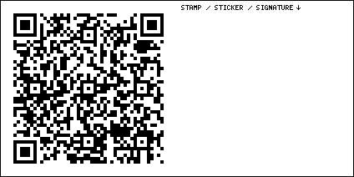
This spot is described as the “real” end of Route 66. But for a climax to our Route 66 story, I think we can do better. Keep going, it’s about to get good.

Orpheum Theatre
842 S Broadway, Los Angeles CA 

United Theater on Broadway
929 S Broadway, Los Angeles CA 

Petersen Automotive Museum
6060 Wilshire Blvd, Los Angeles CA 
The best car museum on Earth.

Tesla Diner
7001 Santa Monica Blvd, Los Angeles CA 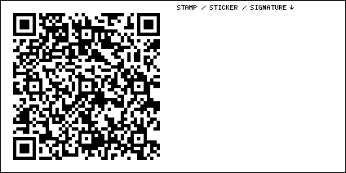
Retrofuturistic like nothing you’ve ever seen.

The Formosa
7156 Santa Monica Blvd, West Hollywood CA 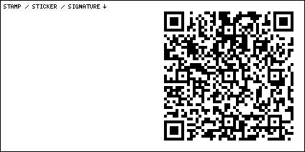

Irv’s Burgers
7998 Santa Monica Blvd, West Hollywood CA 

Barney’s Beanery
8447 Santa Monica Blvd, West Hollywood CA 

Tail O’ the Pup
8512 Santa Monica Blvd, West Hollywood CA 
I discovered this place when I was watching old episodes of The Rockford Files. They stopped here in the first episode. I had to know if it still existed. That led me to Alison Martino’s social media community Vintage Los Angeles. She did a report on the place, as it was being restored and moved. I visited it here, in its new location, as soon as it opened. Pay attention, because there is a secret door nearby.

NORMS Restaurant
470 N La Cienega Blvd, West Hollywood CA 
This is the oldest NORMS diner.

Edelweiss Chocolates
444 N Canon Dr, Beverly Hills CA 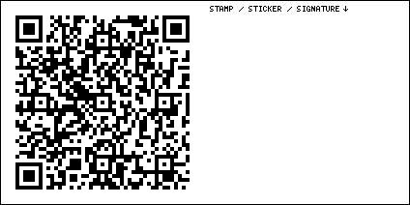
Vintage Los Angeles led me here, too.

Mel’s Drive-In
1670 Lincoln Blvd, Santa Monica CA 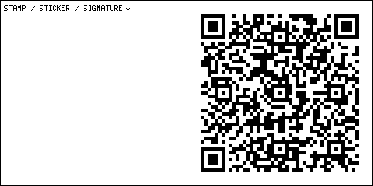
The last great diner on Route 66.

Cal Mar Hotel Suites
220 California Ave, Santa Monica CA 
I have stayed in this midcentury masterpiece at least a dozen times. I highly recommend it.

Santa Monica Pier
Santa Monica CA 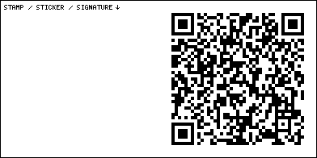
There is a small linoleum “Toynbee Tile” mosaic embedded in the asphalt at the crosswalk. The 66-To-Cali shack is the end of your journey.

Create value. Create value for people who pay you. That’s work. Create value for people who don’t pay you. That’s kindness. Create value for people you like. That’s friendship. Create value for people you don’t like. That’s self-preservation. Most of all, create value for yourself. That’s happiness.

