# # code to clear all plots in Rstudio:

> dev.off(dev.list()["RStudioGD"])

Problem: if the plot pane is empty, then it returns error:

“Error in if (which == 1) stop("cannot shut down device 1 (the null device)") :

argument is of length zero“. So, it does not work to include it inside the code!

> n.col = 6

> n.row = 6

# Though here 4 row is enough, but it puts the smallest number between the row and col for the col, so i had to put both as 6.

> par(mfrow = c(n.row, n.col)) # to have multiple plot per page. mfcol -> 1,3, 2,4

#after plot(...) Error in plot.new() : figure margins too large

solution:

> par(mar = c(0,1,3,2)) #by try and error

problem:

read the columns of the table as “factor” instead of “numeric”.

changing them to numeric by as.numeric() does not work, the values got totally changed.

reason: Whenever there is empty cells/rows in the data (I had rows for name “lm_preedicted”, “Ref”), then it will be read as factor instead of numeric, and cannot be retrieved by as.numeric() function.

solution: deleted the empty rows. => lmPlot.csv

>lm <- read.csv("lmPlot.csv")

>x= lm[1:7, 2]

> y = lm[8:14,2]

>plot(x,y, col = "blue", frame = F)

Problem- putting the most frequent one (here G) out of the scatterplot frame

solution: add xlim(from, to) and ylim(from, to)

>plot(x,y, col = "blue", frame = F, xlim = range(x), ylim = range(y))

> text(x,y, as.character(lm[1:7, 1]),cex= 0.7, pos=1)

> fit <- lm(y~x, data = lm)

> abline(fit, col = "red", lty = 2)

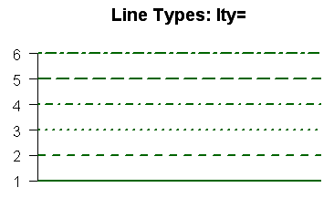

**correlation:**

# need a name (ex tst) for attributes extraction (p-value -> p.val, cor -> estimation)

>tst <- cor.test()

“ Pearson's product-moment correlation

data: x and y

t = 3.4495, df = 5, p-value = 0.01825

alternative hypothesis: true correlation is not equal to 0

95 percent confidence interval:

0.2338170 0.9756561

sample estimates:

cor

0.839124 “

#although it is shown as p-value and cor in summary, has to be called as p.value, . estimate

# to write the text over a plot

> m <- paste("corr=", as.character(round(tst$estimate, 2)), ",p=" ,as.character(round(tst$p.value,3)))

> mtext(m, side = 3, cex = 0.5)

# cex change the size of the font. cex <1 decrease the size and vice versa.

---------------------------------

Q1- correlations and p-values are different with Sara’s results !