Three Effects of PCL (Polycaprolactone) on Keyhole Dynamics in LPBF
316L stainless steel — 2026

Physical Framework: What We Observe and Why It Happens

Observed differences in PCL-coated cases
Synchrotron X-ray imaging of LPBF with 50 μm PCL-coated 316L reveals three systematic departures from uncoated baseline runs under identical laser parameters. First, the steady-state keyhole is approximately 10% shallower. Second, pore generation frequency is lower — fewer pores nucleate per unit scan length than in the uncoated baseline. Third, the pores that do nucleate — which in baseline cases survive as spherical voids carried into the solidified track — shrink progressively and in some instances disappear entirely in the coated cases. All three observations are reproducible across process parameters and motivate the analysis below.

How the PCL layer behaves during scanning
Rather than being uniformly ablated, the PCL coating adopts a characteristic suspended geometry during the scan. The Yb:fiber laser (λ≈1070 nm) is largely transmitted through the 50 μm PCL sheet [1] and is absorbed by the 316L substrate below. The primary heat source for the suspended canopy is the upward-flowing metal vapor jet from the keyhole mouth: at temperatures exceeding 2000°C this jet hits the underside of the PCL sheet directly at the keyhole entrance, breaking it down far faster than heat from the melt pool below.
When the PCL base contacts molten steel, the large temperature gradient vaporizes the coating at the interface immediately, generating a thin vapor cushion (Leidenfrost analogy) (see the screenshots). This cushion prevents bulk mixing of PCL into the melt; only the trace fraction η = 0.1–1% of PCL mass dissolves before the vapor film establishes itself.
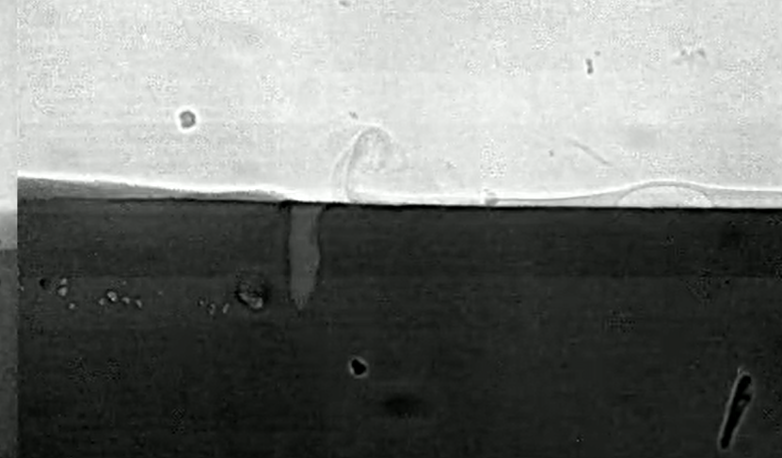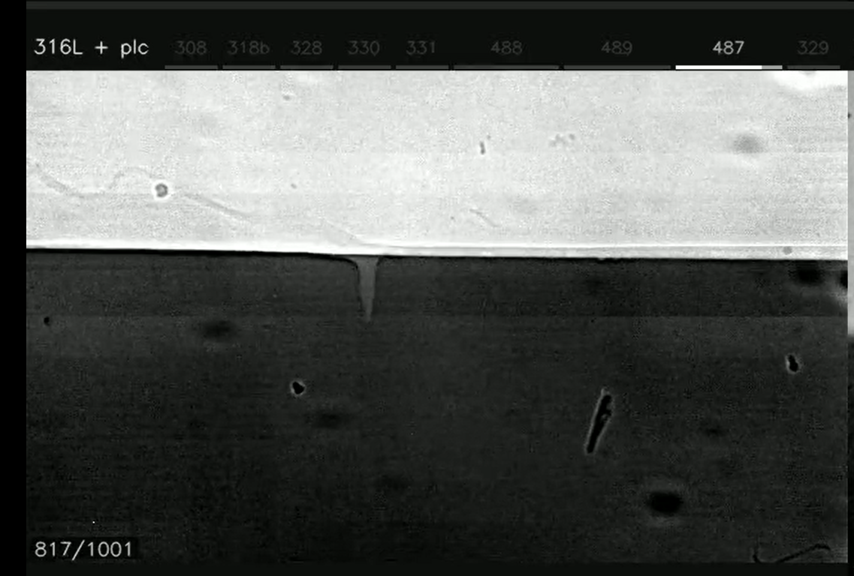
The surviving sheet adopts a canopy geometry: anchored at its forward edge to the cold substrate ahead of the scan zone, it rises above the melt pool with the lowest point at the keyhole entrance, sloping upward rearward above the re-solidifying track, with the trailing portion suspended above, partially enclosing the gas space and blocking fresh Ar from entering. The enclosed volume is expected to contain a significant fraction of PCL-derived vapor (H₂, CO), making the atmosphere at pore detachment compositionally distinct from the baseline pure-Ar case. The recoil-driven vapor jet sweeps these decomposition products back into the keyhole interior, actively enriching the enclosed atmosphere. Above ≈800°C, hydrocarbon cracking within the jet additionally yields carbon soot; soot particles reaching the melt dissolve as [C], contributing to the surface-tension shift discussed in Section 2.

Possible influence channels
With this physical picture established, the PCL canopy affects keyhole behavior and pore fate through three principal channels:
- Gas solubility: H₂ and CO inside detaching pores dissolve into the surrounding melt, reducing pore pressure and causing shrinkage or complete collapse.
- Surface tension: dissolved C and O alter σ(T) and the Marangoni coefficient dσ/dT, shifting the flow-reversal temperature T* and modifying melt-pool recirculation.
- Thermal energy: PCL decomposition consumes latent heat; pyrolysis gases may modify the effective power reaching the substrate.
Sections 1–3 address each in turn.

1. Gas Solubility: Why Voids Shrink in PCL-Coated Cases
When a keyhole pore detaches, it traps whatever gas filled the keyhole at that moment — a mixture of Ar shielding gas and metal vapor. As the pore moves away from the keyhole and cools, the metal vapor fraction condenses back into the surrounding melt, leaving Ar as the only non-condensable residual. In uncoated 316L this residual Ar does not dissolve in liquid steel, so the pore survives and is carried into the solidified track. Under the PCL canopy the enclosed atmosphere also contains H₂ and CO from PCL pyrolysis (CO₂ is negligible at keyhole temperatures — see below). Both H₂ and CO dissolve into or react with the surrounding liquid steel, removing gas from the pore and driving shrinkage or collapse. Ar stays behind as the residual bubble.
H₂ dissolves directly into the steel via Sievert's law. CO breaks down at the pore wall, transferring [C] and [O] to the melt. CO₂ is not a significant product at keyhole temperatures (Boudouard equilibrium suppresses it). The dissolution time τ for each species is estimated using steady-state diffusion from a spherical pore into an infinite melt, with the equilibrium concentration fixed at the pore surface and no accumulation in the surrounding liquid.
Dissolution time calculation (steady-state spherical diffusion):
Problem setup: R = 25 µm (pore radius), p = 1 atm (pore pressure), T = 1873 K (melt temperature), τ_life ≈ 1 ms (pore lifetime)
Moles in pore: n₀ = p·(4/3)πR³/(R_g·T) = 101 kPa × (4/3)π(25 µm)³ / (8.314 × 1873) ≈ 4.3×10⁻¹³ mol (R_g = 8.314 J/mol·K)
Dissolution model: J = 4πR·D·C_s → τ = n₀ / J; J: molar dissolution flux [mol/s], D: diffusivity of dissolved species in liquid Fe [m²/s], C_s: equilibrium gas concentration at pore wall [mol/m³]
PCL pyrolysis products (T > 800°C):
Repeat unit: C₆H₁₀O₂ → 5 H₂ + 2 CO + 4 C(soot) per repeat unit
Gas fractions: x_H₂ = 5/7 ≈ 0.71, x_CO = 2/7 ≈ 0.29; CO₂ negligible at T > 800°C (excess C converts any CO₂ back to CO); no N₂
H₂ (C_s ∝ √p_H₂, Sievert): τ_H₂ ∝ √(x_H₂) = √(5/7) ≈ 0.84 — corrected below.
Fraction and τ: CO and Ar obey linear Henry's law (C_s = K · p_i): x_i cancels in τ = n_i/J_i — τ is fraction-independent.
H₂ (x_H₂ = 5/7 ≈ 0.71; Sievert's law):
Equil. solubility: C_s = K_H × √(x_H₂ × p) = 88 × √(5/7) ≈ 74 mol/m³ (K_H = 28 cc/100 g at 1873 K)
Diffusivity/flux: n₀_H₂ = (5/7) × 4.3×10⁻¹³ ≈ 3.1×10⁻¹³ mol; D_H ≈ 1.6×10⁻⁸ m²/s → J_H = 4π × 25 µm × 1.6×10⁻⁸ × 74 ≈ 3.7×10⁻¹⁰ mol/s
Dissolution time: τ_H = n₀_H₂ / J_H = 3.1×10⁻¹³ / 3.7×10⁻¹⁰ ≈ 0.82 ms ≈ τ_life (1 ms) → dissolves essentially completely
CO (x_CO = 2/7 ≈ 0.29; linear Henry's law):
Equil. solubility: C_O,s = 345 mol/m³ (K_O, Henry's law constant for O in liquid Fe at 1873 K) × x_CO = 345 × (2/7) ≈ 99 mol/m³, n₀_CO = (2/7) × 4.3×10⁻¹³ ≈ 1.2×10⁻¹³ mol
Diffusivity/flux: D_O ≈ 2.9×10⁻⁹ m²/s → J_CO = 4π × 25 µm × 2.9×10⁻⁹ × 99 ≈ 9.0×10⁻¹¹ mol/s
Dissolution time: τ_CO = 1.2×10⁻¹³ / 9.0×10⁻¹¹ ≈ 1.4 ms > τ_life (1 ms) → CO partially dissolves
CO₂ (absent at T > 800°C — excluded from calculation):
At keyhole temperatures the Boudouard equilibrium (C + CO₂ ⇌ 2CO) strongly suppresses CO₂. PCL stoichiometry leaves no oxygen surplus for CO₂ (all 2 O atoms go to CO).
Ar (shielding gas residual; x_Ar uncertain — τ is fraction-independent for linear Henry):
Equil. solubility: C_s ≈ 10⁻⁴ mol/m³ (upper bound; Ar solubility in liquid Fe is near the detection limit)
Diffusivity/flux: D_Ar ≈ 2×10⁻⁹ m²/s (estimated; similar to D_O — Ar's near-zero dissolution is driven entirely by C_s, not by slow diffusion) → J_Ar = 4π × 25 µm × 2×10⁻⁹ × 10⁻⁴ ≈ 6.3×10⁻¹⁷ mol/s
Dissolution time: τ_Ar = n₀/J_Ar = 4.3×10⁻¹³ / 6.3×10⁻¹⁷ ≈ 6,800 s ≈ 1.9 h >> τ_life (1 ms) → effectively insoluble
→ H₂ (τ ≈ 0.82 ms) dissolves essentially completely; CO (τ ≈ 1.4 ms) partially dissolves; Ar (τ ≈ 6,800 s ≈ 7×10⁶ × τ_life (1 ms)) is effectively insoluble — residual bubble persists.

2. Surface Tension: C and O from PCL Dissolution
Dissolved C and O (from the η fraction) shift the Morohoshi (2013) [3] zero-crossing temperature T* — where dσ/dT = 0 and Marangoni flow reverses — from ~1787 K (pure 316L, σ = 1.865 N/m at 1873 K) to 1821 K (η = 0.1%) and 1963 K (η = 1%, σ = 1.768 N/m).
Morohoshi (2013) Fe–C–O model:
K(T,w_C,w_O) = 10^(−0.17 w_O − 0.427 w_C) × w_O × exp(29300/T − 10.9)
σ(T) = 1925 − 0.455(T − 1808) − 0.155 T ln(1 + K) [mN/m]
dσ/dT = −0.455 − 0.155 [ln(1+K) − K/(1+K) × 29300/T] [mN/m·K]
T* (dσ/dT = 0): ≈1821 K (η = 0.1%), ≈1963 K (η = 1%)
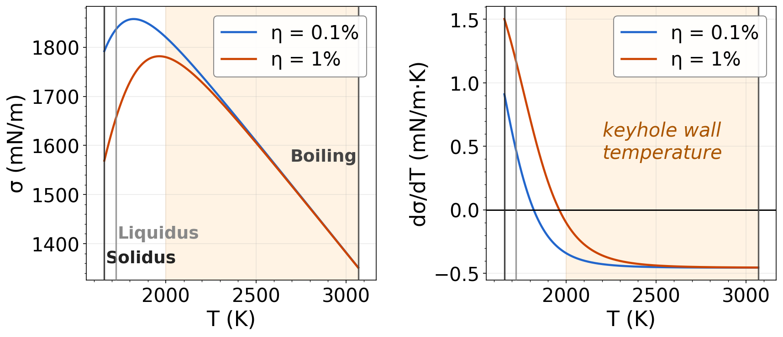
Fig. 1. σ(T) and dσ/dT for η = 0.1% and 1% (Morohoshi 2013 [3]). Shaded band: keyhole-wall range (2000–3068 K); vertical lines: solidus, liquidus, boiling point.
Within the keyhole-wall band both η curves nearly coincide: Marangoni driving at the keyhole walls is essentially unchanged by PCL dissolution. T* falls in the cooler near-surface region where the flow reversal alters melt-pool recirculation but does not directly affect keyhole stability or pore detachment.

3. Thermal Effect: Energy Budget
At P = 200 W, v = 200 mm/s the laser delivers 1 J/mm along the scan track. The energy required to fully decompose the 50 μm PCL strip intercepted by the 67 μm spot is ≈0.5% of this — far too small to account for the observed ~10% keyhole depth reduction . For context, Ye et al. [5] measured ~70% steady-state absorptivity for 316L; PCL backward gas redirection (Physical Framework) may reduce effective absorptivity further in coated cases by altering plume dynamics.
Energy calculation (PCL pyrolysis):
Strip width: w = 1.5 × d_spot = 1.5 × 67 µm ≈ 100 µm
E_L = P/v = 200 W / 200 mm·s⁻¹ = 1.0 J/mm
V_PCL/mm = w × h_PCL × 1 mm = 100×50 µm² × 1 mm ≈ 5.0×10⁻¹² m³/mm
m_PCL/mm = ρ_PCL × V = 1145 × 5.0×10⁻¹² ≈ 5.7×10⁻⁹ kg/mm
H_d ≈ 10⁶ J/kg (order-of-magnitude for polymer pyrolysis)
E_PCL/E_L = m·H_d / E_L ≈ 5.7×10⁻³ / 1.0 ≈ 0.57%
The mechanism behind the ~10% depth reduction remains unresolved (PCL changes boiling temperature?). Direct pyrolysis energy (0.5%) is negligible. Pyrolysis gases (H₂, CO) are largely transparent at 1070 nm, ruling out beam-blocking. Transient absorptivity changes vanish before steady state is established. The most likely explanation is a combination of Marangoni reversal (Section 2) and gas pressure from pyrolysis products accumulating inside the keyhole.

References
1. Acherjee, B. (2021). Laser transmission welding of polymers — a review on process fundamentals, material attributes, process parameters and joint properties. Opt. Laser Technol.144, 107372.
2. Elmer, J.W., Vaja, J., Carlton, H.D. & Pong, R. Effect of Ar and N₂ shielding gas on laser weld porosity in steel, stainless steels, and nickel. Welding J. .
3. Morohoshi, K. et al. (2013). Modeling of surface tension for liquid Fe–C–O alloys. ISIJ International.
4. Boorstein, W.M. (1967). Kinetics of solution of gases in liquid iron. PhD dissertation, Univ. Michigan.
5. Ye, J. et al. (2019). Energy coupling mechanisms and scaling behavior associated with LPBF. Adv. Eng. Mater.21(7), 1900185.

