Three Effects of PLC on Keyhole Dynamics in LPBF
316L stainless steel — 2026

Physical Framework: What We Observe and Why It Happens

Observed differences in PLC-coated cases
Synchrotron X-ray imaging of LPBF with 50 μm PLC-coated 316L reveals two systematic departures from uncoated baseline runs under identical laser parameters. First, the steady-state keyhole is approximately 10% shallower . Second, keyhole pores — which in baseline cases survive as spherical voids that are carried into the solidified track — shrink progressively and in some instances disappear entirely in the coated cases. These two observations are reproducible across process parameters and motivate the analysis below.

How the PLC layer behaves during scanning
Rather than being uniformly ablated, the PLC coating adopts a characteristic suspended geometry during the scan. The Yb:fiber laser (λ≈1070 nm) is largely transmitted through the 50 μm PLC sheet [1] and is absorbed by the 316L substrate below. The PLC is therefore heated indirectly, from below, by the laser-heated liquid metal.
When the PLC base contacts molten steel, the large temperature gradient vaporizes the coating at the interface immediately, generating a thin vapor cushion (Leidenfrost analogy). This cushion prevents bulk mixing of PLC into the melt; only the trace fraction η = 0.1–1% of PLC mass dissolves before the vapor film establishes itself.
The surviving sheet adopts a canopy geometry: anchored at its forward edge to the cold substrate ahead of the scan zone, it rises above the melt pool with the lowest point at the keyhole entrance, sloping upward rearward above the re-solidifying track, with the trailing portion suspended above, partially enclosing the gas space and restricting Ar ingress. The enclosed volume is expected to contain a significant fraction of PLC-derived vapor (H₂, CO, CO₂), making the atmosphere at pore detachment compositionally distinct from the baseline pure-Ar case.

Possible influence channels
With this physical picture established, the PLC canopy affects keyhole behavior and pore fate through three principal channels:
- Gas solubility: H₂ and CO inside detaching pores dissolve into the surrounding melt, reducing pore pressure and causing shrinkage or complete collapse.
- Surface tension: dissolved C and O alter σ(T) and the Marangoni coefficient dσ/dT, shifting the flow-reversal temperature T* and modifying melt-pool recirculation.
- Thermal energy: PLC decomposition consumes latent heat; pyrolysis gases may modify the effective power reaching the substrate.
Sections 1–3 address each in turn.

1. Gas Solubility: Why Voids Shrink in PLC-Coated Cases
Detaching keyhole pores are expected to contain primarily shielding gas and metal vapor; as the pore cools away from the keyhole the metal vapor fraction condenses back into the melt, leaving the non-condensable shielding gas as a stable bubble. In baseline 316L that residual gas is Ar, which is insoluble in liquid steel, so pores survive intact. Pores detaching under the PLC canopy are hypothesized to additionally inherit H₂ and CO from the enclosed pyrolysis atmosphere; both dissolve into the surrounding melt, driving progressive shrinkage or complete collapse.
Strongest analogue — Elmer et al. [2]: switching from Ar to N₂ shielding completely eliminated keyhole porosity in 304L and A36 steel while porosity persisted in Ni (low N solubility), confirming gas solubility as the controlling variable. N₂-filled pores dissolve via Sievert’s law, shrinking below the detection threshold.
Condition | Pore gas | Soluble? | Outcome
Baseline 316L / Ar | ~pure Ar | No | Pores survive
316L / N₂ | ~pure N₂ | Yes | Pores eliminated
PLC-coated 316L / Ar | Ar + H₂/CO | Partial | Partial shrinkage
H₂: dissolves via Sievert’s law — fast and endothermic, with the driving force strengthening as the pore cools. CO: governed by the Chipman equilibrium — slower and self-limiting as [C] and [O] accumulate at the pore wall.
Dissolution analysis:
Pore: d = 50 µm (R = 25 µm)
Lifetime: τ_life ≈ 1 ms
[%C] = 0.030, [%O] = 0.001 (316L)
H₂ — Sievert’s law:
Derive τ_H — the time it takes for H₂ gas inside a detached pore to fully dissolve into the surrounding liquid steel.
[H]_wt% = K_H(T) √(p_H₂/p°); K_H(1873 K) ≈ 28 cc/100 g [4]
C_eq ≈ 88 mol/m³ (from K_H, ρ_melt = 7000 kg/m³, p_H₂ = 1 atm)
n₀ = p_H₂ V / RT = 101 kPa × (4/3)π(25 µm)³ / (8.314 × 1873) ≈ 4.3×10⁻¹³ mol
δ = n₀ / (4πR² C_eq) ≈ 4.3×10⁻¹³ / (7.9×10⁻⁹ × 88) ≈ 0.62 µm
τ_H = π δ² / D_H; D_H ≈ 1.6×10⁻⁸ m²/s
τ_H ≈ π × (0.62 µm)² / 1.6×10⁻⁸ ≈ 75 µs << τ_life → dissolves completely
CO — Chipman equilibrium:
Derive p_CO,eq — the equilibrium CO partial pressure the liquid steel can sustain given its dissolved carbon and oxygen content.
log K_CO = 1160/T + 2.003; K_CO = p_CO / ([%C][%O])
At 1873 K: p_CO,eq = K_CO × [%C][%O] = 419 × 0.030 × 0.001 ≈ 0.013 atm (~80× below pore pressure)
→ pore volume shrinks by ≈ (H₂+CO) fraction; insoluble Ar persists as residual bubble

2. Surface Tension: C and O from PLC Dissolution
Dissolved C and O (from the η fraction) shift the Morohoshi (2013) [3] zero-crossing temperature T* — where dσ/dT = 0 and Marangoni flow reverses — from ~1787 K (pure 316L, σ = 1.865 N/m at 1873 K) to 1821 K (η = 0.1%) and 1963 K (η = 1%, σ = 1.768 N/m).
Morohoshi (2013) Fe–C–O model:
K(T,w_C,w_O) = 10^(−0.17 w_O − 0.427 w_C) × w_O × exp(29300/T − 10.9)
σ(T) = 1925 − 0.455(T − 1808) − 0.155 T ln(1 + K) [mN/m]
dσ/dT = −0.455 − 0.155 [ln(1+K) − K/(1+K) × 29300/T] [mN/m·K]
T* (dσ/dT = 0): ≈1821 K (η = 0.1%), ≈1963 K (η = 1%)
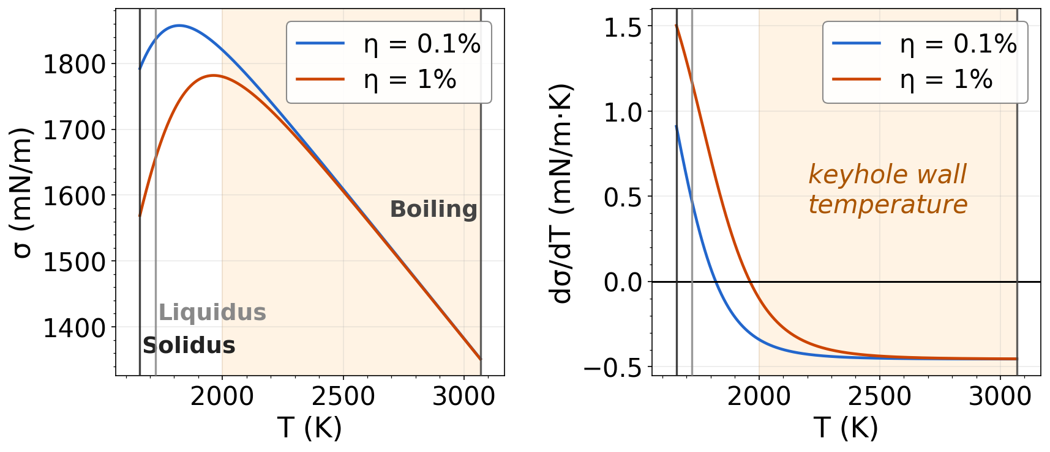
Fig. 1. σ(T) and dσ/dT for η = 0.1% and 1% (Morohoshi 2013 [3]). Shaded band: keyhole-wall range (2000–3068 K); vertical lines: solidus, liquidus, boiling point.
Within the keyhole-wall band both η curves nearly coincide: Marangoni driving at the keyhole walls is essentially unchanged by PLC dissolution. T* falls in the cooler near-surface region where the flow reversal alters melt-pool recirculation but does not directly affect keyhole stability or pore detachment.

3. Thermal Effect: Energy Budget
At P = 200 W, v = 200 mm/s the laser delivers 1 J/mm along the scan track. The energy required to fully decompose the 50 μm PLC strip intercepted by the 67 μm spot is ≈0.5% of this — far too small to account for the observed ~10% keyhole depth reduction . For context, Ye et al. [5] measured ~70% steady-state absorptivity for 316L; PLC backward gas redirection (Physical Framework) may reduce effective absorptivity further in coated cases by altering plume dynamics.
Energy calculation (PLC pyrolysis):
Strip width: w = 1.5 × d_spot = 1.5 × 67 µm ≈ 100 µm
E_L = P/v = 200 W / 200 mm·s⁻¹ = 1.0 J/mm
V_PLC/mm = w × h_PLC × 1 mm = 100×50 µm² × 1 mm ≈ 5.0×10⁻¹² m³/mm
m_PLC/mm = ρ_PLC × V = 1145 × 5.0×10⁻¹² ≈ 5.7×10⁻⁹ kg/mm
H_d ≈ 10⁶ J/kg (order-of-magnitude for polymer pyrolysis)
E_PLC/E_L = m·H_d / E_L ≈ 5.7×10⁻³ / 1.0 ≈ 0.57%
The mechanism behind the ~10% depth reduction remains unresolved. Direct pyrolysis energy (0.5%) is negligible. Pyrolysis gases (H₂, CO, CO₂) are largely transparent at 1070 nm, ruling out beam-blocking. Transient absorptivity changes vanish before steady state is established. The most likely explanation is a combination of Marangoni reversal (Section 2) and gas pressure from pyrolysis products accumulating inside the keyhole.

References
1. Acherjee, B. (2021). Laser transmission welding of polymers — a review on process fundamentals, material attributes, process parameters and joint properties. Opt. Laser Technol.144, 107372.
2. Elmer, J.W., Vaja, J., Carlton, H.D. & Pong, R. Effect of Ar and N₂ shielding gas on laser weld porosity in steel, stainless steels, and nickel. Welding J. .
3. Morohoshi, K. et al. (2013). Modeling of surface tension for liquid Fe–C–O alloys. ISIJ International.
4. Boorstein, W.M. (1967). Kinetics of solution of gases in liquid iron. PhD dissertation, Univ. Michigan.
5. Ye, J. et al. (2019). Energy coupling mechanisms and scaling behavior associated with LPBF. Adv. Eng. Mater.21(7), 1900185.

