Website Installation Instructions

Step 1: install Xampp.

Now go to the folder C:\xampp\htdocs\ and create a folder name “eProject1”

(\*please put the eProject file in C:\xampp\htdocs\eProject1)

Step 2: Go to Xampp and enable Apache and MySQL.

Step 3: Go to Google Chrome and enter localhost:80/PHPMyAdmin.



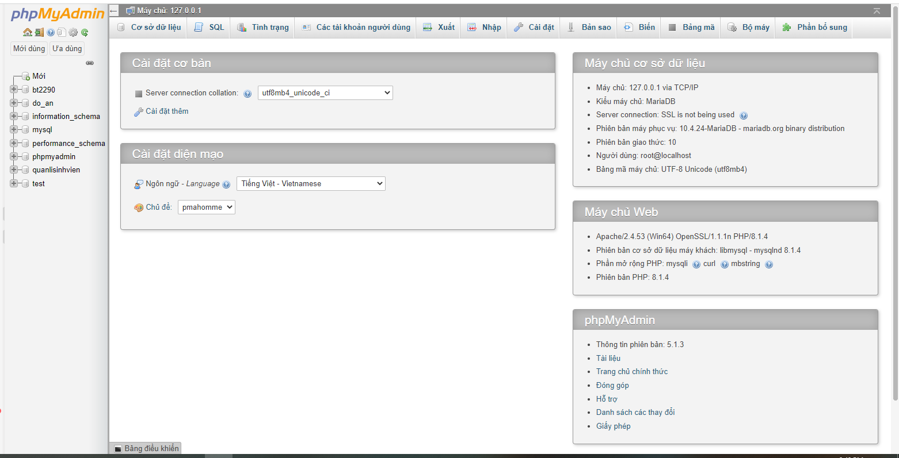

Step 4: Click on the database, and create a database named COSY.

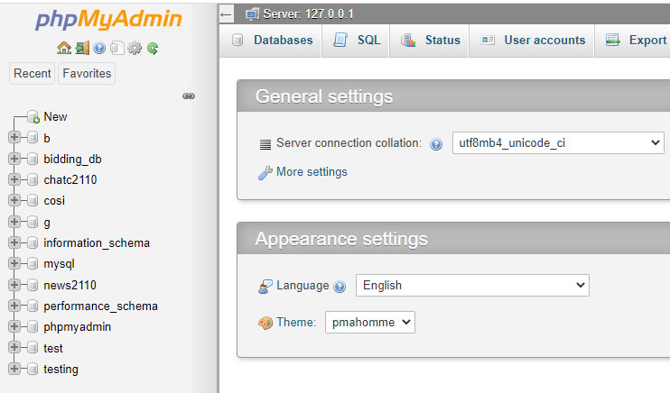







Step 5: Click on the newly created Database

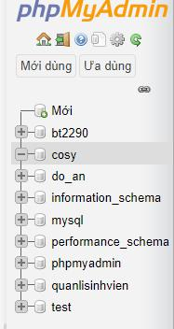

step 6: select the file cosy.sql placed in eProject1/Database

So we have finished the website installation, wish you success and a good experience when using the COSY website