
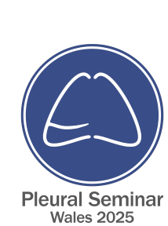
CERTIFICATE OF ATTENDANCE

Has attended the

‘16th Pleural Seminar Wales’

On

Friday 14th November 2025 At the Parkway Hotel, Cwmbran
16th Pleural Seminar for Wales ' has been approved by the Federation of the Royal Colleges of Physicians of the United Kingdom for 6 category 1 (external) CPD credit(s) : (code: 153330)

Dr Andreea Alina Ionescu
On behalf of the Faculty and Wales Pleural Group
Date: 14/11/2025

