Event and Wedding Venue Buyer Brief
  - 8595 US Highway 51 Cobden Illinois 62920
Position the property as a destination venue that can combine an atmospheric indoor reception hall, food service, decks, outdoor gathering areas, a stage, pond views, and flexible ceremony settings.
Working offering fact | Current information | Required control
Asking price | $749,000 in current marketing | Confirm before distribution
Land | Approximately 26.1 acres reported | Verify parcels and survey
Building area | 4,228 square feet on supplied floor plan; approximately 6,000 square feet in current marketing | Reconcile measurement basis
Existing assets | Kitchen, gathering rooms, fireplaces, decks, enclosed porch, stage, pond, and grounds visible in photography | Confirm inclusion, condition, permits, and parcel location

Current Interior and Buyer Concept
CURRENT CONDITION  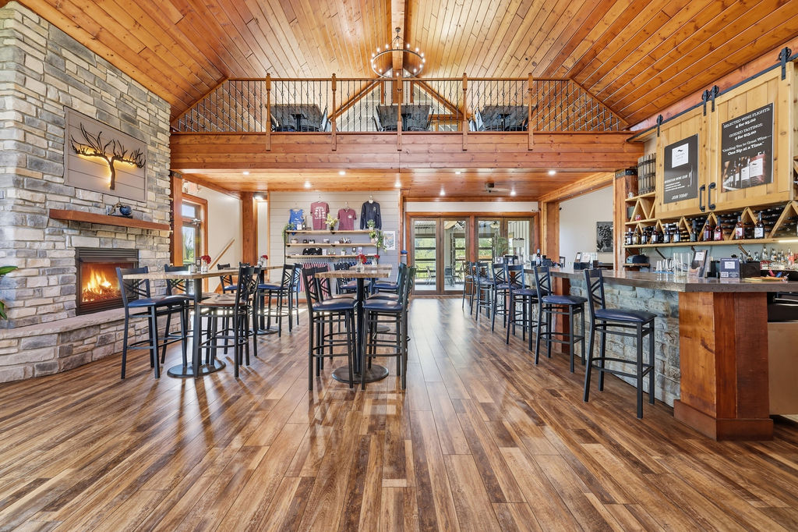 | CONCEPTUAL RENDERING  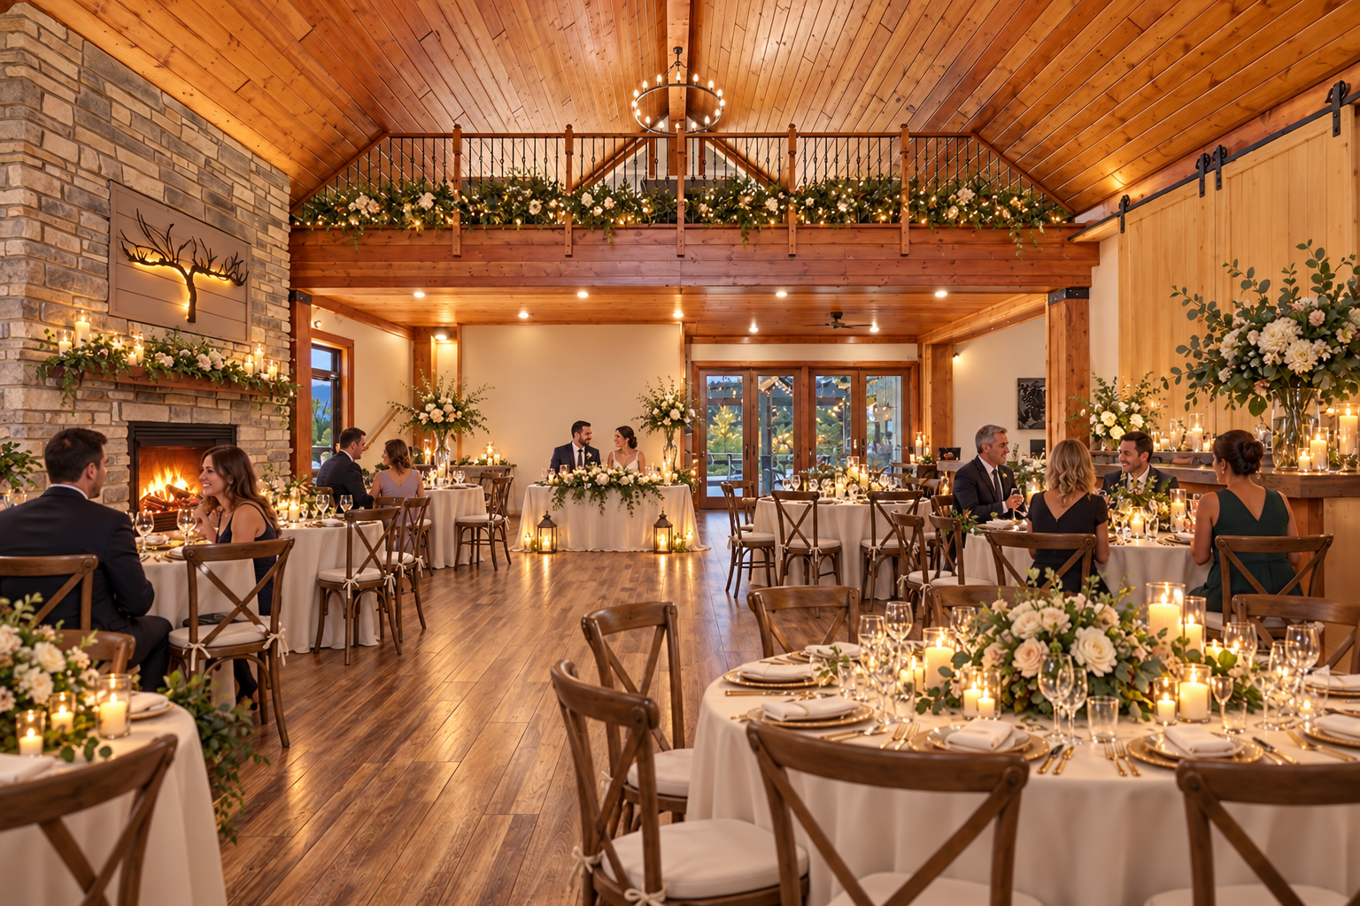
The conceptual rendering illustrates one possible operating presentation. It does not represent the property’s current condition, an approved use, code compliance, construction pricing, or items included in the sale.

Buyer Thesis and Operating Program
Position the property as a destination venue that can combine an atmospheric indoor reception hall, food service, decks, outdoor gathering areas, a stage, pond views, and flexible ceremony settings.

Priority Buyer Profiles
- Independent wedding and event venue operators
- Regional hospitality groups and restaurateurs
- Caterers or planners seeking an owned venue
- Owner operators expanding from a smaller venue

Why the Property Can Fit
- Visually distinctive lodge interior with wood ceilings and stone fireplaces
- Commercial kitchen infrastructure visible in the supplied photography
- Multiple indoor and outdoor gathering zones
- Existing amphitheater, decks, patios, pond, and landscaped grounds visible in the supplied photography

Illustrative Operating Program
- Main hall staged for receptions, banquets, and private events
- Upper level used for smaller gatherings, vendor staging, or VIP functions
- Enclosed porch used as a weather-protected ceremony or cocktail space
- Outdoor stage, lawns, decks, and pond used as coordinated event settings

Likely Improvement Priorities
- Coordinated event furniture, lighting, decor inventory, and acoustic treatment
- Professional AV, Wi-Fi, power distribution, and event-management systems
- Dedicated preparation, storage, vendor-loading, and waste-handling procedures
- Parking, circulation, life-safety, restroom, occupancy, and accessibility review

Buyer Facing Campaign Materials

Suggested Headline
A Southern Illinois destination setting for memorable indoor and outdoor events

Direct Outreach Message
This Cobden property offers a rare combination of lodge-style gathering space, commercial kitchen infrastructure, multiple decks and patios, an outdoor stage, pond, and landscaped acreage. We are inviting experienced venue and hospitality operators to evaluate it as a destination event platform, subject to their independent use and capacity approvals.

Recommended Image Sequence
- Current hero interior that clearly establishes the real building
- Matching conceptual rendering labeled Conceptual Rendering
- Commercial kitchen and food-service areas
- Enclosed porch, decks, and main gathering rooms
- Ground-level exterior and site amenities
- Verified floor plan and boundary exhibit once reconciled

Lead Qualification Questions
- What annual event volume and guest capacity support your model?
- Which functions must be indoors during poor weather?
- Do you require on-site lodging or can nearby lodging support the first phase?
- What capital budget is available for furniture, AV, life safety, and operations?
- Which licenses, catering arrangements, and alcohol policies would your model require?

Call to Action
Request the verified property package, schedule a private tour, and submit a written indication of intended use, acquisition structure, diligence needs, and timing.

Verification and Buyer Diligence
The campaign can present credible possibilities without representing them as approved or economically proven. Before public distribution, the seller and broker should reconcile the building-area discrepancy and confirm the exact sale perimeter.
Verify before relying | Reason
Parcels, legal descriptions, acreage, access, and boundaries | Photos do not establish which land or improvements convey.
Zoning, legal use, occupancy, parking, and event or lodging permissions | A conceptual use is not an entitlement.
Kitchen equipment ownership, inclusion, condition, and inspection status | Visible equipment may be leased, excluded, inactive, or require service.
Water, wastewater, electric capacity, fire protection, and accessibility | Operating capacity depends on infrastructure and code requirements.
Pond, stage, decks, outbuildings, signs, and outdoor-program permissions | Presence does not prove boundary location, compliance, or insurability.
Renovation scope, professional estimates, financing, and operating economics | Renderings do not establish cost, feasibility, revenue, or return.

Required Marketing Disclaimer
Conceptual renderings are provided solely to illustrate potential space planning and operating ideas. They do not depict current conditions, included personal property, approved uses, code compliance, construction scope, cost, capacity, revenue, or future performance. All dimensions, property facts, uses, improvements, permits, utilities, and economics must be independently verified by the buyer and appropriate professionals.
Prepared for customized buyer outreach September 2026

