Retreat and Hospitality Buyer Brief
  - 8595 US Highway 51 Cobden Illinois 62920
Present the existing gathering spaces and outdoor setting as a group retreat hub that can begin with meetings, meals, and programming, then add overnight accommodations only if approvals and economics support them.
Working offering fact | Current information | Required control
Asking price | $749,000 in current marketing | Confirm before distribution
Land | Approximately 26.1 acres reported | Verify parcels and survey
Building area | 4,228 square feet on supplied floor plan; approximately 6,000 square feet in current marketing | Reconcile measurement basis
Existing assets | Kitchen, gathering rooms, fireplaces, decks, enclosed porch, stage, pond, and grounds visible in photography | Confirm inclusion, condition, permits, and parcel location

Current Interior and Buyer Concept
CURRENT CONDITION  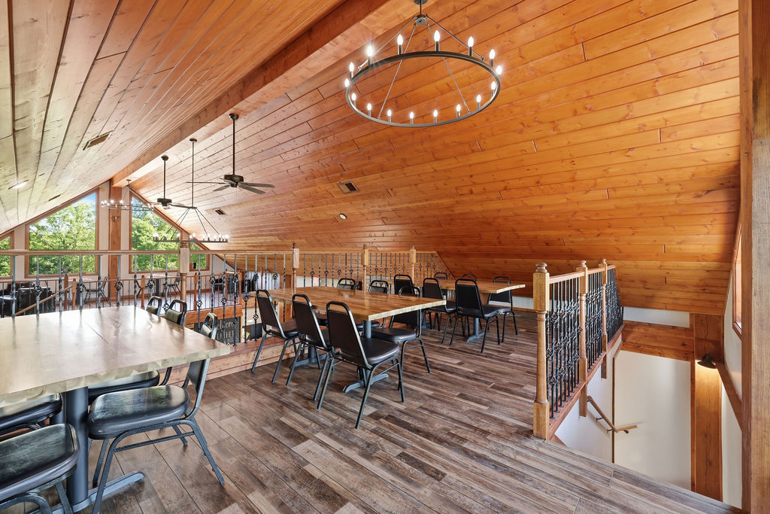 | CONCEPTUAL RENDERING  
The conceptual rendering illustrates one possible operating presentation. It does not represent the property’s current condition, an approved use, code compliance, construction pricing, or items included in the sale.

Buyer Thesis and Operating Program
Present the existing gathering spaces and outdoor setting as a group retreat hub that can begin with meetings, meals, and programming, then add overnight accommodations only if approvals and economics support them.

Priority Buyer Profiles
- Corporate retreat and leadership-program operators
- Wellness, yoga, and personal-development organizations
- Faith-based retreat operators
- Boutique hospitality groups seeking a Southern Illinois destination

Why the Property Can Fit
- Large and small gathering environments within one building
- Commercial food-service infrastructure for group meals
- Decks, lawns, pond, stage, and quiet wooded setting
- Regional destination character without dependence on winery positioning

Illustrative Operating Program
- Upper level configured for facilitated workshops and breakout groups
- Main hall used for meals, plenary sessions, and evening gatherings
- Enclosed porch used for wellness, informal learning, or weather-protected recreation
- Grounds used for reflection, team activities, and outdoor programming

Likely Improvement Priorities
- Modular workshop furniture, presentation technology, sound control, and reliable connectivity
- Hospitality service standards, guest check-in, storage, and scheduling systems
- Phased lodging study using partnerships first and on-site units only after approvals
- Accessibility, occupancy, parking, septic, fire protection, and overnight-use feasibility analysis

Buyer Facing Campaign Materials

Suggested Headline
A flexible gathering property for retreats, leadership programs, and group hospitality

Direct Outreach Message
The property combines warm lodge-style interiors, a commercial kitchen, multiple breakout environments, decks, lawns, a pond, and an outdoor stage. It may offer a compelling base for retreat and group-hospitality programming, with any overnight component evaluated separately through zoning, infrastructure, and financial diligence.

Recommended Image Sequence
- Current hero interior that clearly establishes the real building
- Matching conceptual rendering labeled Conceptual Rendering
- Commercial kitchen and food-service areas
- Enclosed porch, decks, and main gathering rooms
- Ground-level exterior and site amenities
- Verified floor plan and boundary exhibit once reconciled

Lead Qualification Questions
- Is your model day-use, overnight, or a phased combination?
- What is the typical group size and length of stay?
- Which food-service and meeting functions must be controlled in-house?
- Would nearby lodging partnerships satisfy the first operating phase?
- What infrastructure and entitlement budget can the project support?

Call to Action
Request the verified property package, schedule a private tour, and submit a written indication of intended use, acquisition structure, diligence needs, and timing.

Verification and Buyer Diligence
The campaign can present credible possibilities without representing them as approved or economically proven. Before public distribution, the seller and broker should reconcile the building-area discrepancy and confirm the exact sale perimeter.
Verify before relying | Reason
Parcels, legal descriptions, acreage, access, and boundaries | Photos do not establish which land or improvements convey.
Zoning, legal use, occupancy, parking, and event or lodging permissions | A conceptual use is not an entitlement.
Kitchen equipment ownership, inclusion, condition, and inspection status | Visible equipment may be leased, excluded, inactive, or require service.
Water, wastewater, electric capacity, fire protection, and accessibility | Operating capacity depends on infrastructure and code requirements.
Pond, stage, decks, outbuildings, signs, and outdoor-program permissions | Presence does not prove boundary location, compliance, or insurability.
Renovation scope, professional estimates, financing, and operating economics | Renderings do not establish cost, feasibility, revenue, or return.

Required Marketing Disclaimer
Conceptual renderings are provided solely to illustrate potential space planning and operating ideas. They do not depict current conditions, included personal property, approved uses, code compliance, construction scope, cost, capacity, revenue, or future performance. All dimensions, property facts, uses, improvements, permits, utilities, and economics must be independently verified by the buyer and appropriate professionals.
Prepared for customized buyer outreach September 2026

