Restaurant and Catering Buyer Brief
  - 8595 US Highway 51 Cobden Illinois 62920
Lead with the existing food-service infrastructure and indoor-outdoor dining environments while presenting private events, catering, and destination dining as complementary revenue channels rather than relying on a single dining room.
Working offering fact | Current information | Required control
Asking price | $749,000 in current marketing | Confirm before distribution
Land | Approximately 26.1 acres reported | Verify parcels and survey
Building area | 4,228 square feet on supplied floor plan; approximately 6,000 square feet in current marketing | Reconcile measurement basis
Existing assets | Kitchen, gathering rooms, fireplaces, decks, enclosed porch, stage, pond, and grounds visible in photography | Confirm inclusion, condition, permits, and parcel location

Current Interior and Buyer Concept
CURRENT CONDITION  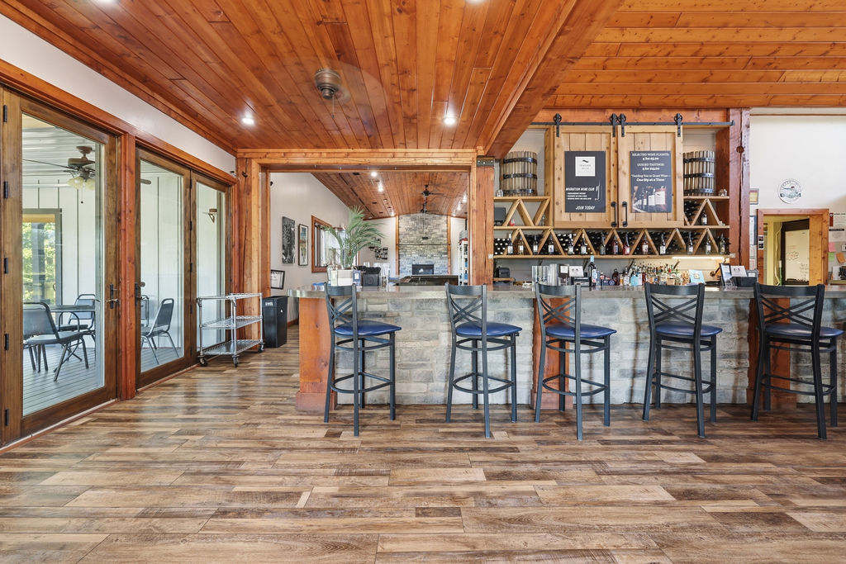 | CONCEPTUAL RENDERING  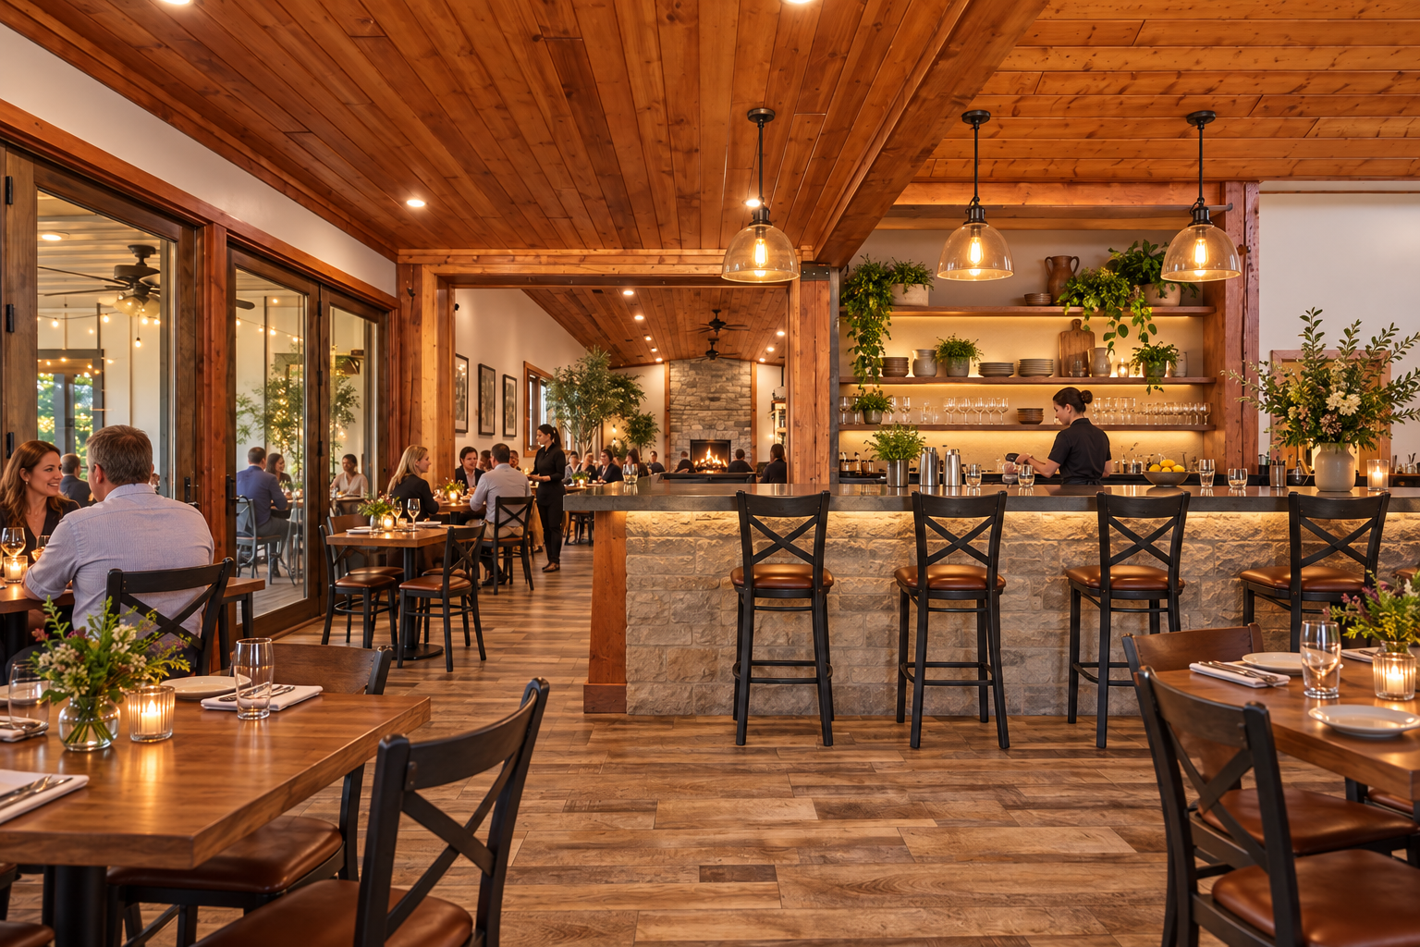
The conceptual rendering illustrates one possible operating presentation. It does not represent the property’s current condition, an approved use, code compliance, construction pricing, or items included in the sale.

Buyer Thesis and Operating Program
Lead with the existing food-service infrastructure and indoor-outdoor dining environments while presenting private events, catering, and destination dining as complementary revenue channels rather than relying on a single dining room.

Priority Buyer Profiles
- Established restaurant groups
- Catering companies seeking a production base and venue
- Chef-led destination concepts
- Food entrepreneurs evaluating commissary or shared-kitchen models

Why the Property Can Fit
- Commercial kitchen equipment and production areas visible in supplied photography
- Service bar and multiple dining or gathering zones
- Deck and patio seating with landscape views
- Event and catering opportunities that can complement restaurant trade

Illustrative Operating Program
- Main gathering room operated as destination dining and private-event space
- Decks and enclosed porch used for seasonal and all-weather seating
- Kitchen used for restaurant production, catering, or approved commissary functions
- Outdoor stage and grounds used for ticketed dining events or community programming where permitted

Likely Improvement Priorities
- Confirm equipment ownership, condition, capacity, and inclusion in the sale
- Update dining furniture, lighting, point-of-sale, service stations, and wayfinding
- Complete health, hood-suppression, grease, fire, occupancy, and accessibility reviews
- Build an operating plan that separates restaurant, catering, and private-event economics

Buyer Facing Campaign Materials

Suggested Headline
A destination dining and catering platform with room to host

Direct Outreach Message
This offering pairs visible commercial kitchen infrastructure with a lodge-style dining environment, service bar, enclosed porch, decks, patios, and event grounds. It may suit an operator seeking several complementary channels: destination dining, catering production, private events, and approved outdoor programming.

Recommended Image Sequence
- Current hero interior that clearly establishes the real building
- Matching conceptual rendering labeled Conceptual Rendering
- Commercial kitchen and food-service areas
- Enclosed porch, decks, and main gathering rooms
- Ground-level exterior and site amenities
- Verified floor plan and boundary exhibit once reconciled

Lead Qualification Questions
- Which kitchen equipment and production capacities are essential to your concept?
- Will the business emphasize dining, catering, events, or a blended model?
- What seating count and service flow does your plan require?
- Which licenses and inspections must be current before opening?
- What equipment replacement and working-capital budget is available?

Call to Action
Request the verified property package, schedule a private tour, and submit a written indication of intended use, acquisition structure, diligence needs, and timing.

Verification and Buyer Diligence
The campaign can present credible possibilities without representing them as approved or economically proven. Before public distribution, the seller and broker should reconcile the building-area discrepancy and confirm the exact sale perimeter.
Verify before relying | Reason
Parcels, legal descriptions, acreage, access, and boundaries | Photos do not establish which land or improvements convey.
Zoning, legal use, occupancy, parking, and event or lodging permissions | A conceptual use is not an entitlement.
Kitchen equipment ownership, inclusion, condition, and inspection status | Visible equipment may be leased, excluded, inactive, or require service.
Water, wastewater, electric capacity, fire protection, and accessibility | Operating capacity depends on infrastructure and code requirements.
Pond, stage, decks, outbuildings, signs, and outdoor-program permissions | Presence does not prove boundary location, compliance, or insurability.
Renovation scope, professional estimates, financing, and operating economics | Renderings do not establish cost, feasibility, revenue, or return.

Required Marketing Disclaimer
Conceptual renderings are provided solely to illustrate potential space planning and operating ideas. They do not depict current conditions, included personal property, approved uses, code compliance, construction scope, cost, capacity, revenue, or future performance. All dimensions, property facts, uses, improvements, permits, utilities, and economics must be independently verified by the buyer and appropriate professionals.
Prepared for customized buyer outreach September 2026

