Outdoor Recreation and Tourism Buyer Brief
  - 8595 US Highway 51 Cobden Illinois 62920
Use the enclosed porch and gathering rooms as an all-season visitor hub supporting guided experiences, rentals, group meals, orientation, and events tied to the broader Southern Illinois outdoor tourism market.
Working offering fact | Current information | Required control
Asking price | $749,000 in current marketing | Confirm before distribution
Land | Approximately 26.1 acres reported | Verify parcels and survey
Building area | 4,228 square feet on supplied floor plan; approximately 6,000 square feet in current marketing | Reconcile measurement basis
Existing assets | Kitchen, gathering rooms, fireplaces, decks, enclosed porch, stage, pond, and grounds visible in photography | Confirm inclusion, condition, permits, and parcel location

Current Interior and Buyer Concept
CURRENT CONDITION  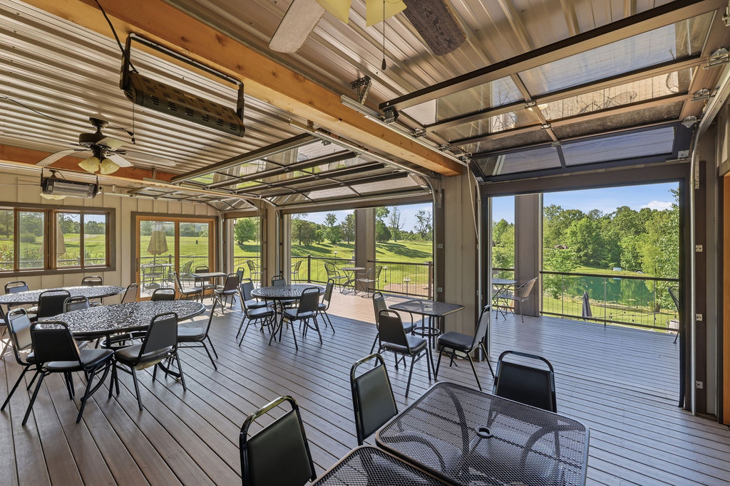 | CONCEPTUAL RENDERING  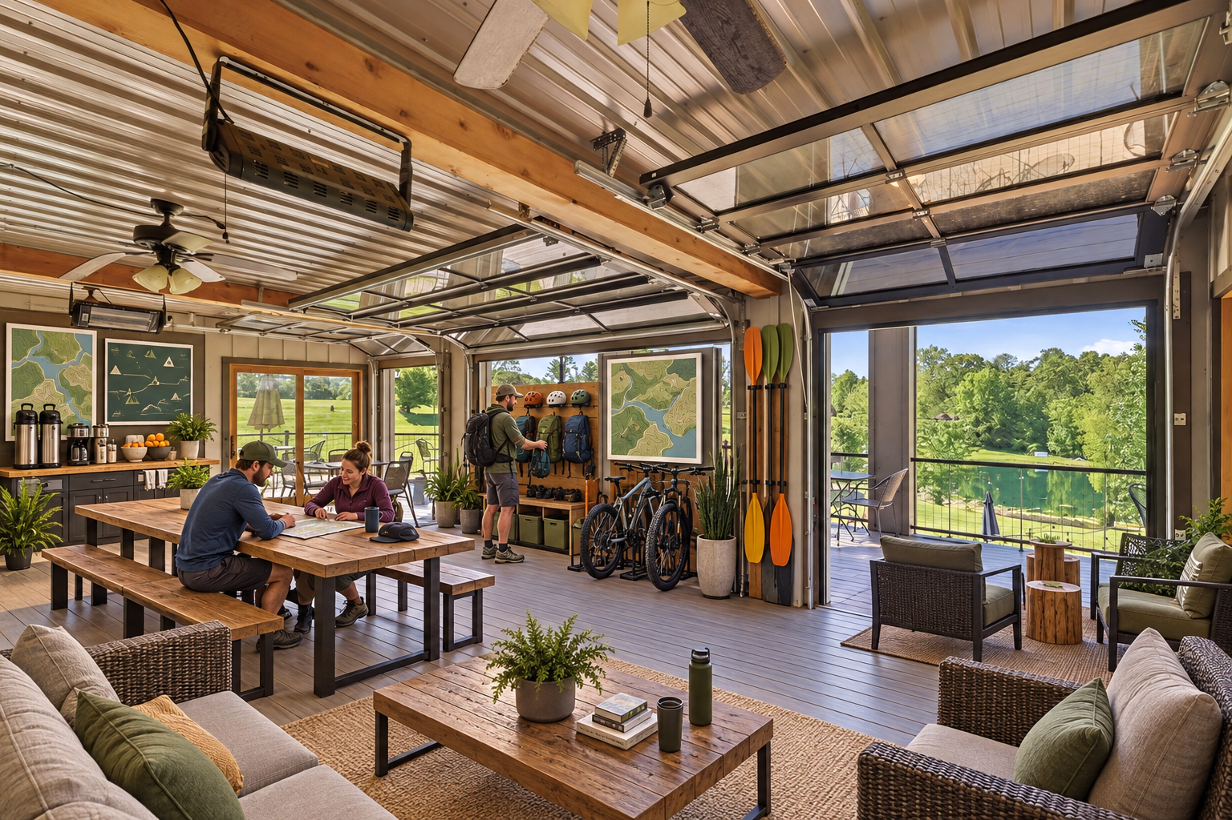
The conceptual rendering illustrates one possible operating presentation. It does not represent the property’s current condition, an approved use, code compliance, construction pricing, or items included in the sale.

Buyer Thesis and Operating Program
Use the enclosed porch and gathering rooms as an all-season visitor hub supporting guided experiences, rentals, group meals, orientation, and events tied to the broader Southern Illinois outdoor tourism market.

Priority Buyer Profiles
- Outfitters and guided-tour operators
- Cycling, hiking, paddling, and outdoor-experience companies
- Regional tourism entrepreneurs
- Membership clubs or recreation-focused hospitality operators

Why the Property Can Fit
- All-season enclosed porch with large operable glass doors
- Indoor gathering rooms, kitchen, restrooms, and decks
- Pond, lawns, stage, firepit settings, and wooded landscape visible on site
- Highway access and space for group arrival, subject to parking verification

Illustrative Operating Program
- Enclosed porch used for check-in, gear fitting, orientation, and guest lounge functions
- Main hall used for group meals, training, and evening programs
- Decks and grounds used for staging, recovery, and community events
- Kitchen supports groups, tours, and approved event catering

Likely Improvement Priorities
- Durable furnishings, secure gear storage, wash-down strategy, and guest lockers
- Operational plan for rentals, guided activities, waivers, and weather contingencies
- Wayfinding, connectivity, first-aid, accessibility, and emergency-response planning
- Confirm whether pond use, trails, signage, parking, and outdoor programs are permitted and insurable

Buyer Facing Campaign Materials

Suggested Headline
An all-season basecamp for Southern Illinois outdoor experiences

Direct Outreach Message
The property offers more than acreage: it includes indoor gathering space, an enclosed porch, commercial kitchen infrastructure, decks, event grounds, pond, and stage. An experienced outdoor operator could evaluate it as a visitor basecamp for orientation, guided experiences, group meals, rentals, and events, subject to use and insurance approvals.

Recommended Image Sequence
- Current hero interior that clearly establishes the real building
- Matching conceptual rendering labeled Conceptual Rendering
- Commercial kitchen and food-service areas
- Enclosed porch, decks, and main gathering rooms
- Ground-level exterior and site amenities
- Verified floor plan and boundary exhibit once reconciled

Lead Qualification Questions
- Which activities occur on site and which depart for regional destinations?
- What gear storage, cleaning, and security systems are required?
- What group size and vehicle mix must the site accommodate?
- Which activities create special insurance or permitting requirements?
- How will the business operate during poor weather and the off-season?

Call to Action
Request the verified property package, schedule a private tour, and submit a written indication of intended use, acquisition structure, diligence needs, and timing.

Verification and Buyer Diligence
The campaign can present credible possibilities without representing them as approved or economically proven. Before public distribution, the seller and broker should reconcile the building-area discrepancy and confirm the exact sale perimeter.
Verify before relying | Reason
Parcels, legal descriptions, acreage, access, and boundaries | Photos do not establish which land or improvements convey.
Zoning, legal use, occupancy, parking, and event or lodging permissions | A conceptual use is not an entitlement.
Kitchen equipment ownership, inclusion, condition, and inspection status | Visible equipment may be leased, excluded, inactive, or require service.
Water, wastewater, electric capacity, fire protection, and accessibility | Operating capacity depends on infrastructure and code requirements.
Pond, stage, decks, outbuildings, signs, and outdoor-program permissions | Presence does not prove boundary location, compliance, or insurability.
Renovation scope, professional estimates, financing, and operating economics | Renderings do not establish cost, feasibility, revenue, or return.

Required Marketing Disclaimer
Conceptual renderings are provided solely to illustrate potential space planning and operating ideas. They do not depict current conditions, included personal property, approved uses, code compliance, construction scope, cost, capacity, revenue, or future performance. All dimensions, property facts, uses, improvements, permits, utilities, and economics must be independently verified by the buyer and appropriate professionals.
Prepared for customized buyer outreach September 2026

