8595 US Highway 51 Buyer Concept Package Index
  - Six coordinated buyer campaigns with interior before and after concepts
This package divides the disposition campaign into six distinct buyer narratives. Each folder contains current interior photographs, a photorealistic conceptual rendering, and a customized buyer brief. The campaigns can run simultaneously while all inquiries remain in one qualification and follow-up system.
Campaign | Primary buyer | Interior concept
Event and Wedding Venue | Independent wedding and event venue operators | Main hall staged for receptions, banquets, and private events
Retreat and Hospitality | Corporate retreat and leadership-program operators | Upper level configured for facilitated workshops and breakout groups
Restaurant and Catering | Established restaurant groups | Main gathering room operated as destination dining and private-event space
Outdoor Recreation and Tourism | Outfitters and guided-tour operators | Enclosed porch used for check-in, gear fitting, orientation, and guest lounge functions
Institutional and Nonprofit | Regional nonprofits and foundations | Main hall configured for training, plenary sessions, meals, or community events
Adaptive Reuse and Investment | Owner-developers and operator-investors | Phase one: refreshed event, dining, meeting, or day-retreat operations

Campaign Controls
- Use the actual photograph first or beside the rendering so buyers can distinguish current condition from possibility.
- Label every transformed image Conceptual Rendering in the surrounding layout and retain the full disclaimer.
- Do not use winery-led language, winery buyer lists, tasting-room labels, or prominent wine imagery.
- Do not publish the building area until the 4,228-square-foot floor-plan total and approximately 6,000-square-foot marketing claim are reconciled.
- Do not state that a proposed use is permitted, financeable, profitable, insurable, or code compliant without written support.

Folder Contents
Folder | Current | Concept | Document
01_Event_Wedding_Venue | 3R9A2589_with_fire.jpg | Event_Wedding_Interior_Concept_01.png | 01_Event_Wedding_Venue_Buyer_Brief.docx
02_Retreat_Hospitality | 3R9A2667.jpg | Retreat_Hospitality_Interior_Concept_01.png | 02_Retreat_Hospitality_Buyer_Brief.docx
03_Restaurant_Catering | 3R9A2610.jpg | Restaurant_Catering_Interior_Concept_01.png | 03_Restaurant_Catering_Buyer_Brief.docx
04_Outdoor_Recreation_Tourism | 3R9A2718.jpg | Outdoor_Recreation_Interior_Concept_01.png | 04_Outdoor_Recreation_Tourism_Buyer_Brief.docx
05_Institutional_Nonprofit | 3R9A2634_with_fire.jpg | Institutional_Nonprofit_Interior_Concept_01.png | 05_Institutional_Nonprofit_Buyer_Brief.docx
06_Adaptive_Reuse_Investment | 3R9A2670.jpg | Adaptive_Reuse_Interior_Concept_01.png | 06_Adaptive_Reuse_Investment_Buyer_Brief.docx

Concept Gallery

Event and Wedding Venue
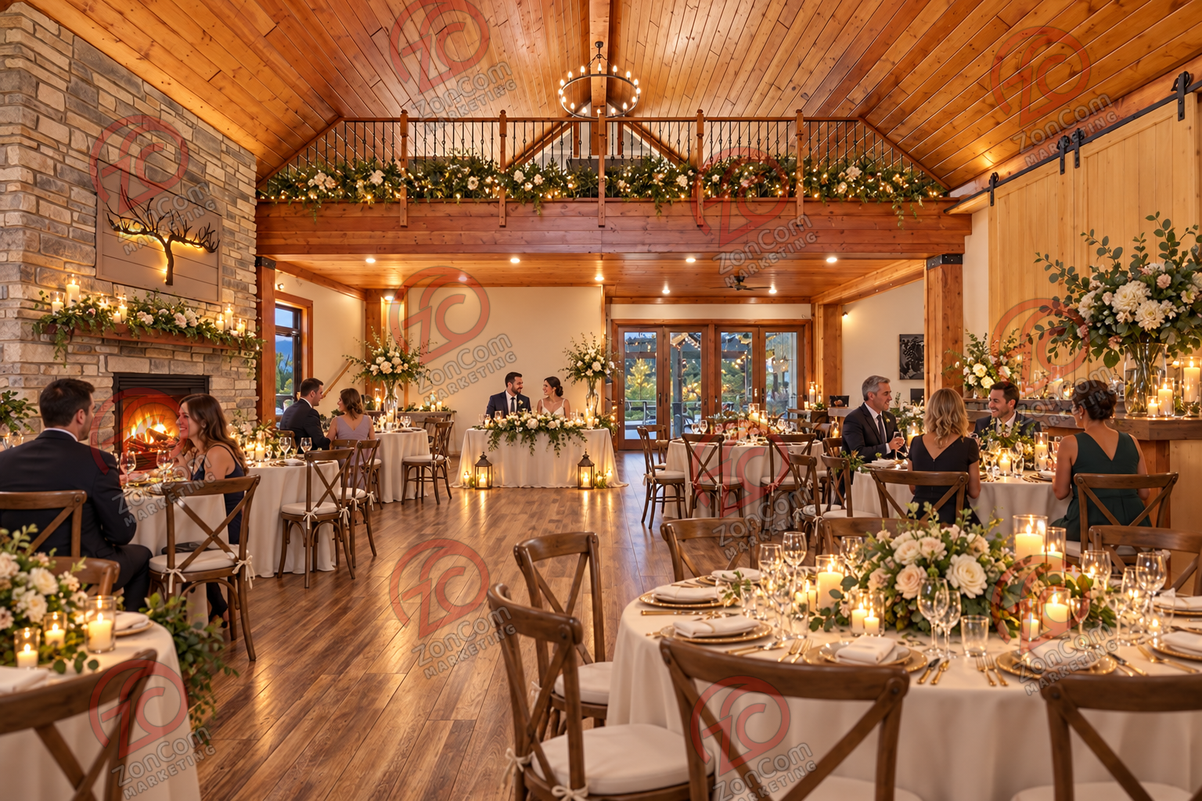
Conceptual Rendering

Retreat and Hospitality
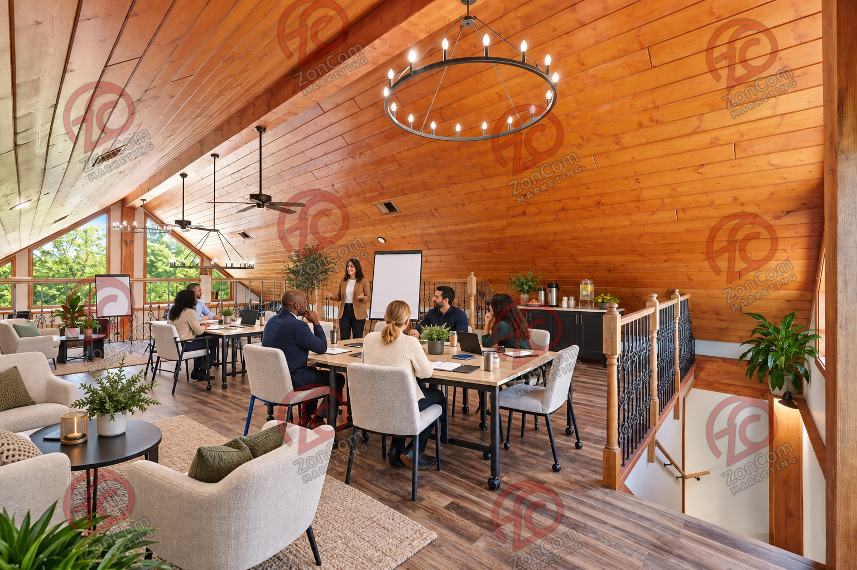
Conceptual Rendering

Restaurant and Catering
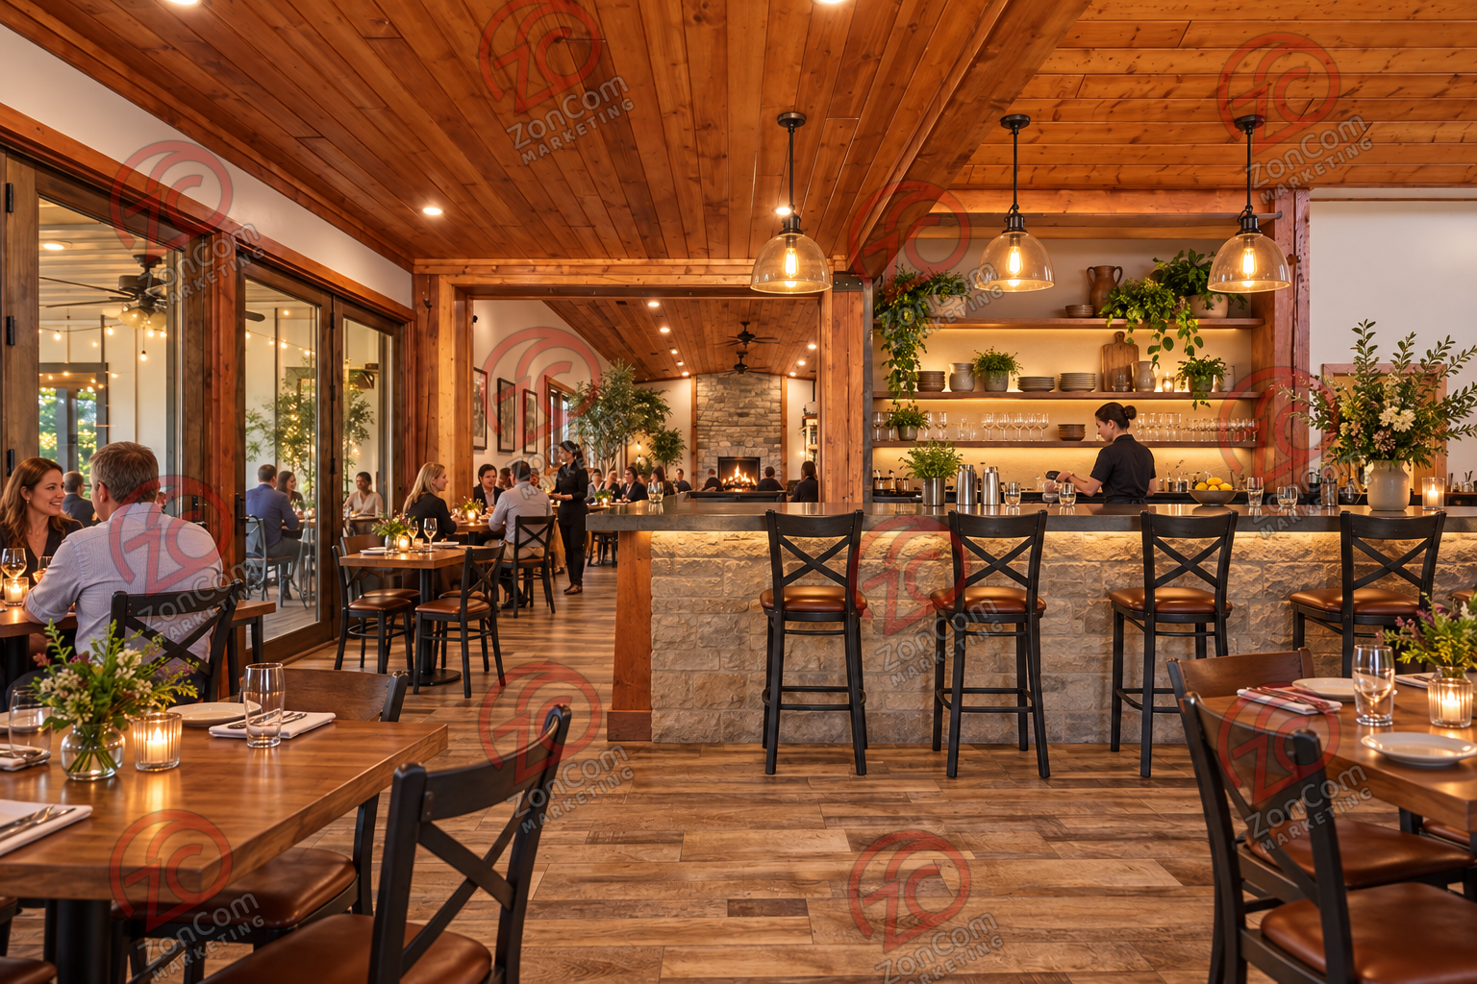
Conceptual Rendering

Outdoor Recreation and Tourism
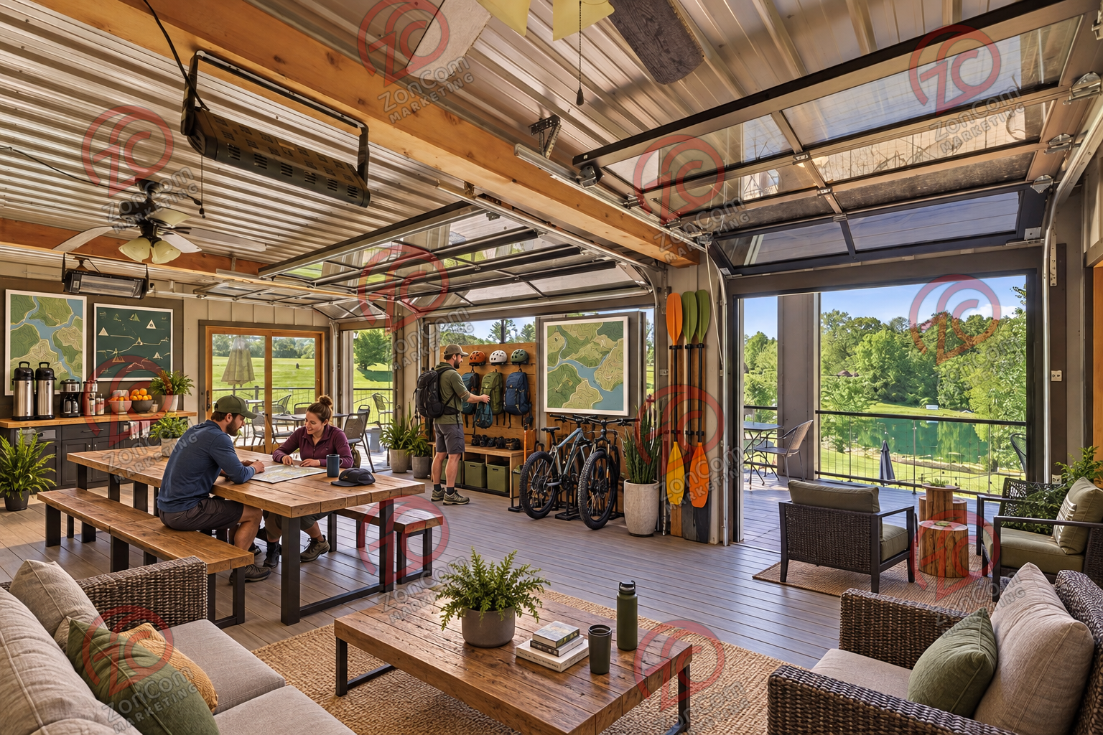
Conceptual Rendering

Institutional and Nonprofit
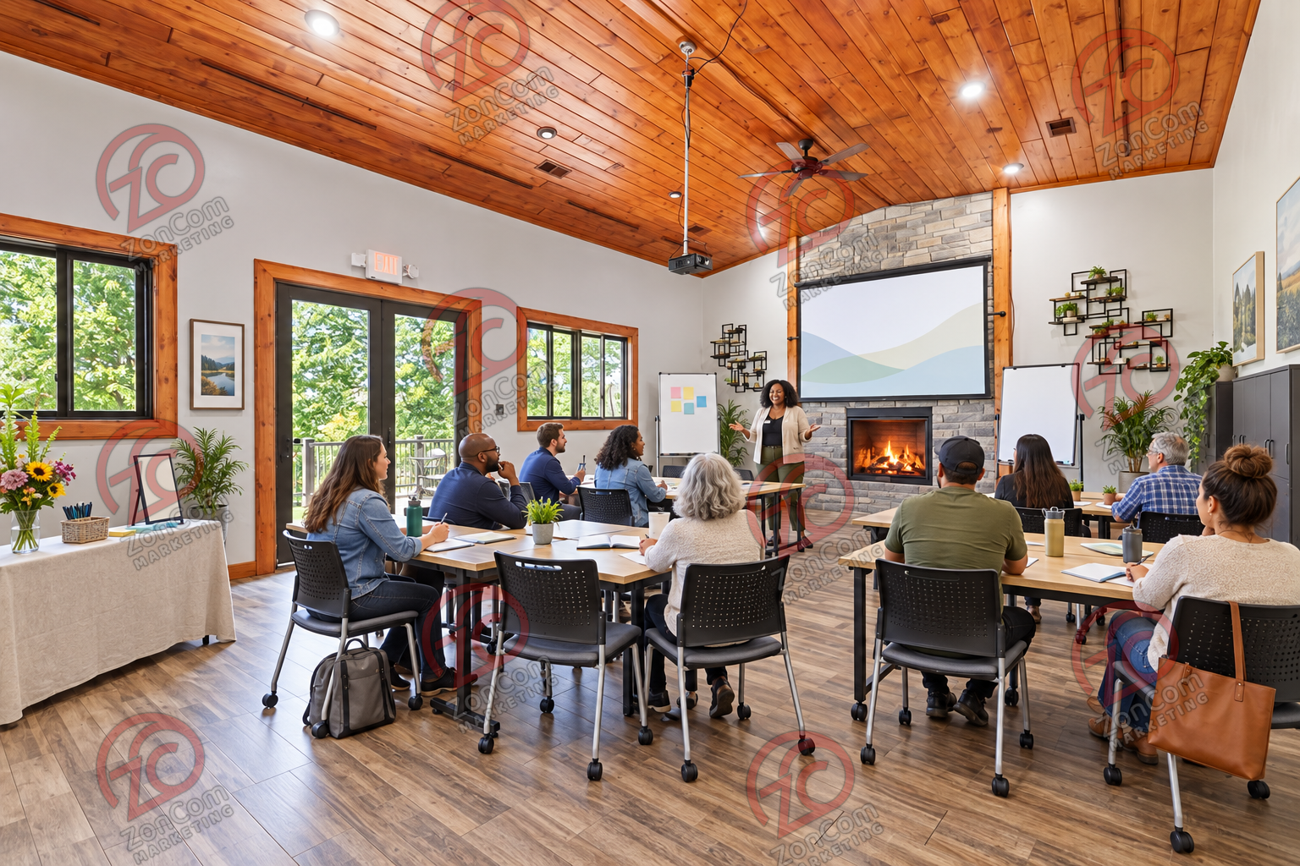
Conceptual Rendering

Adaptive Reuse and Investment
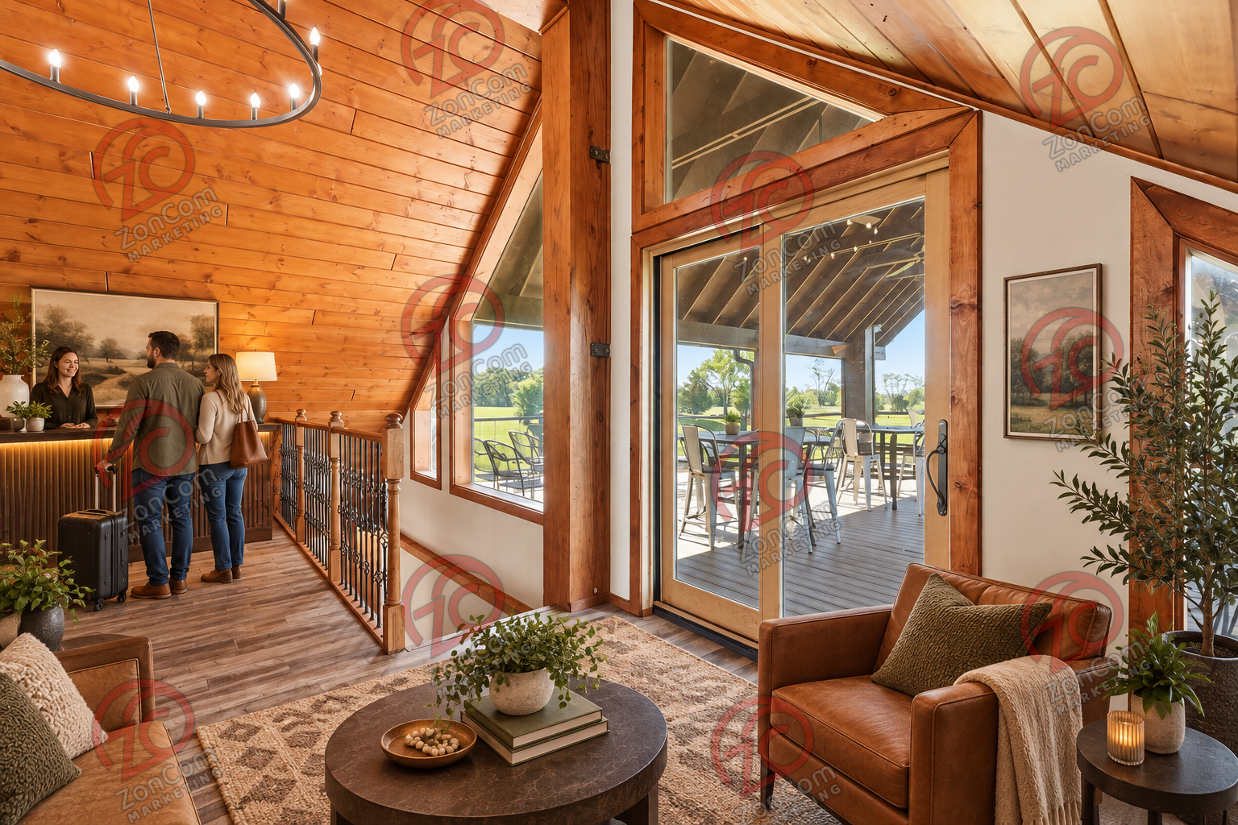
Conceptual Rendering
All renderings are illustrative only. See the individual buyer briefs for required disclaimers and diligence controls.

