Institutional and Nonprofit Buyer Brief
  - 8595 US Highway 51 Cobden Illinois 62920
Frame the property as a flexible program campus for training, community services, ministry retreats, education, or mission-based gatherings, supported by food service and substantial outdoor space.
Working offering fact | Current information | Required control
Asking price | $749,000 in current marketing | Confirm before distribution
Land | Approximately 26.1 acres reported | Verify parcels and survey
Building area | 4,228 square feet on supplied floor plan; approximately 6,000 square feet in current marketing | Reconcile measurement basis
Existing assets | Kitchen, gathering rooms, fireplaces, decks, enclosed porch, stage, pond, and grounds visible in photography | Confirm inclusion, condition, permits, and parcel location

Current Interior and Buyer Concept
CURRENT CONDITION  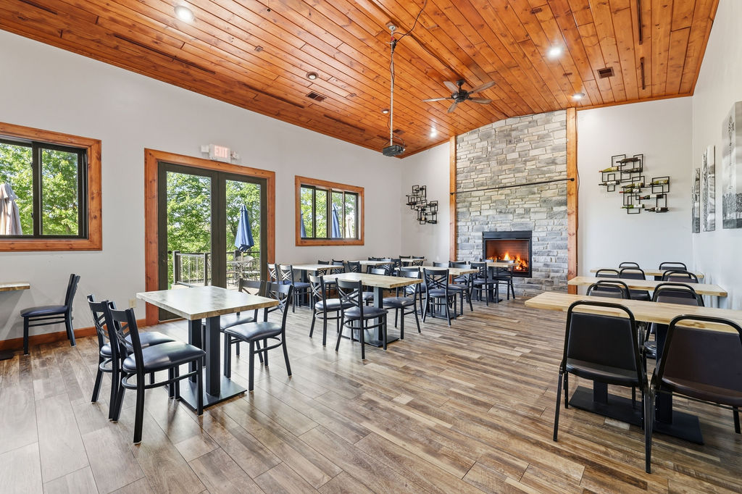 | CONCEPTUAL RENDERING  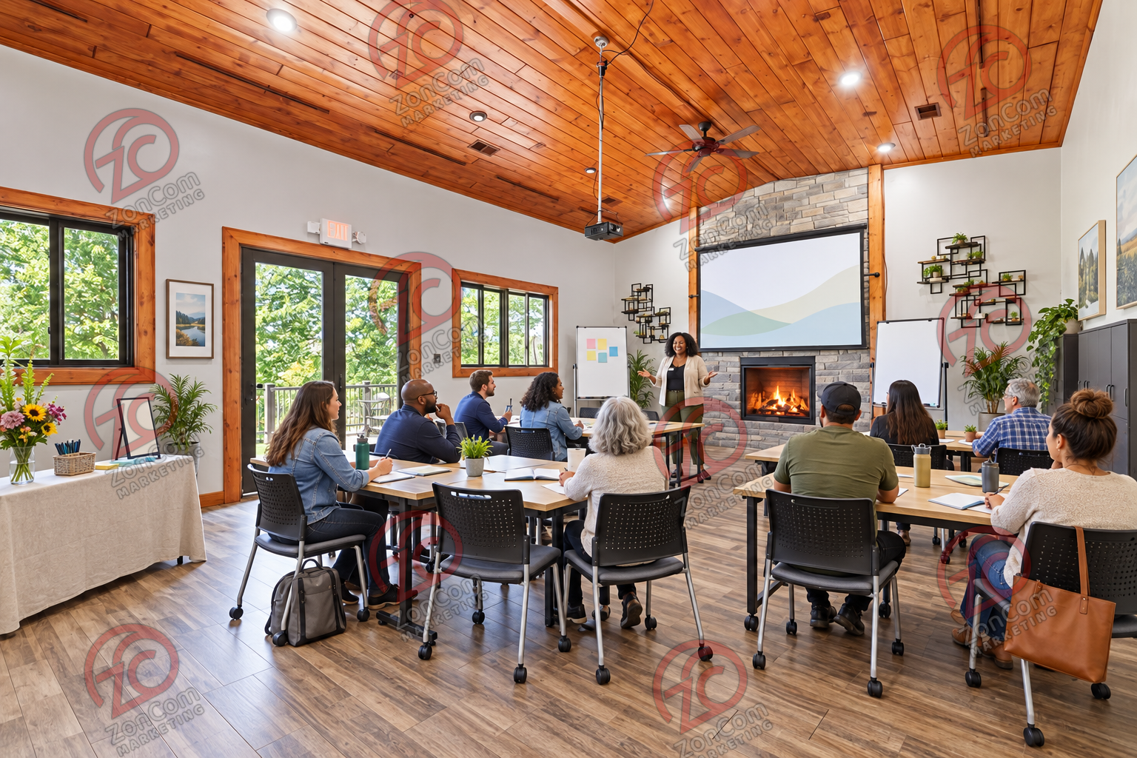
The conceptual rendering illustrates one possible operating presentation. It does not represent the property’s current condition, an approved use, code compliance, construction pricing, or items included in the sale.

Buyer Thesis and Operating Program
Frame the property as a flexible program campus for training, community services, ministry retreats, education, or mission-based gatherings, supported by food service and substantial outdoor space.

Priority Buyer Profiles
- Regional nonprofits and foundations
- Churches and faith-based organizations
- Education, workforce, and leadership programs
- Community-service and wellness organizations

Why the Property Can Fit
- Flexible group rooms with a warm, non-institutional character
- Kitchen infrastructure for programs and group meals
- Multiple restrooms, decks, outdoor stage, lawns, and pond setting
- Space for training, gatherings, fundraising events, and community programming

Illustrative Operating Program
- Main hall configured for training, plenary sessions, meals, or community events
- Upper floor used for breakout sessions, volunteer work, or smaller programs
- Enclosed porch used for flexible classroom, recreation, or dining overflow
- Outdoor areas used for mission-aligned programming where permitted

Likely Improvement Priorities
- Movable training furniture, AV, secure storage, reception, and administrative systems
- Accessibility, life-safety, occupancy, transportation, and safeguarding review
- Program calendar and space-sharing model to improve utilization
- Capital plan separating immediate furnishing needs from regulated building changes

Buyer Facing Campaign Materials

Suggested Headline
A welcoming Southern Illinois campus for programs, training, and community gatherings

Direct Outreach Message
The property combines lodge-style program space, a commercial kitchen, flexible upper and enclosed-porch areas, multiple outdoor settings, and landscaped acreage. It may allow a nonprofit or institution to bring training, meals, events, and outdoor programming together on one campus, subject to use and capacity approvals.

Recommended Image Sequence
- Current hero interior that clearly establishes the real building
- Matching conceptual rendering labeled Conceptual Rendering
- Commercial kitchen and food-service areas
- Enclosed porch, decks, and main gathering rooms
- Ground-level exterior and site amenities
- Verified floor plan and boundary exhibit once reconciled

Lead Qualification Questions
- Which programs, populations, and schedules must the campus support?
- What accessibility, transportation, and safeguarding standards apply?
- Will the organization occupy the property directly or share it with partners?
- What operating subsidy, earned income, or fundraising model supports ownership?
- Which grants or capital sources can fund acquisition and improvements?

Call to Action
Request the verified property package, schedule a private tour, and submit a written indication of intended use, acquisition structure, diligence needs, and timing.

Verification and Buyer Diligence
The campaign can present credible possibilities without representing them as approved or economically proven. Before public distribution, the seller and broker should reconcile the building-area discrepancy and confirm the exact sale perimeter.
Verify before relying | Reason
Parcels, legal descriptions, acreage, access, and boundaries | Photos do not establish which land or improvements convey.
Zoning, legal use, occupancy, parking, and event or lodging permissions | A conceptual use is not an entitlement.
Kitchen equipment ownership, inclusion, condition, and inspection status | Visible equipment may be leased, excluded, inactive, or require service.
Water, wastewater, electric capacity, fire protection, and accessibility | Operating capacity depends on infrastructure and code requirements.
Pond, stage, decks, outbuildings, signs, and outdoor-program permissions | Presence does not prove boundary location, compliance, or insurability.
Renovation scope, professional estimates, financing, and operating economics | Renderings do not establish cost, feasibility, revenue, or return.

Required Marketing Disclaimer
Conceptual renderings are provided solely to illustrate potential space planning and operating ideas. They do not depict current conditions, included personal property, approved uses, code compliance, construction scope, cost, capacity, revenue, or future performance. All dimensions, property facts, uses, improvements, permits, utilities, and economics must be independently verified by the buyer and appropriate professionals.
Prepared for customized buyer outreach September 2026

