Adaptive Reuse and Investment Buyer Brief
  - 8595 US Highway 51 Cobden Illinois 62920
Present the acquisition as a phased reuse opportunity: activate the existing gathering and food-service spaces first, validate demand, then pursue lodging or other expansion only after entitlement, infrastructure, cost, and return analysis.
Working offering fact | Current information | Required control
Asking price | $749,000 in current marketing | Confirm before distribution
Land | Approximately 26.1 acres reported | Verify parcels and survey
Building area | 4,228 square feet on supplied floor plan; approximately 6,000 square feet in current marketing | Reconcile measurement basis
Existing assets | Kitchen, gathering rooms, fireplaces, decks, enclosed porch, stage, pond, and grounds visible in photography | Confirm inclusion, condition, permits, and parcel location

Current Interior and Buyer Concept
CURRENT CONDITION  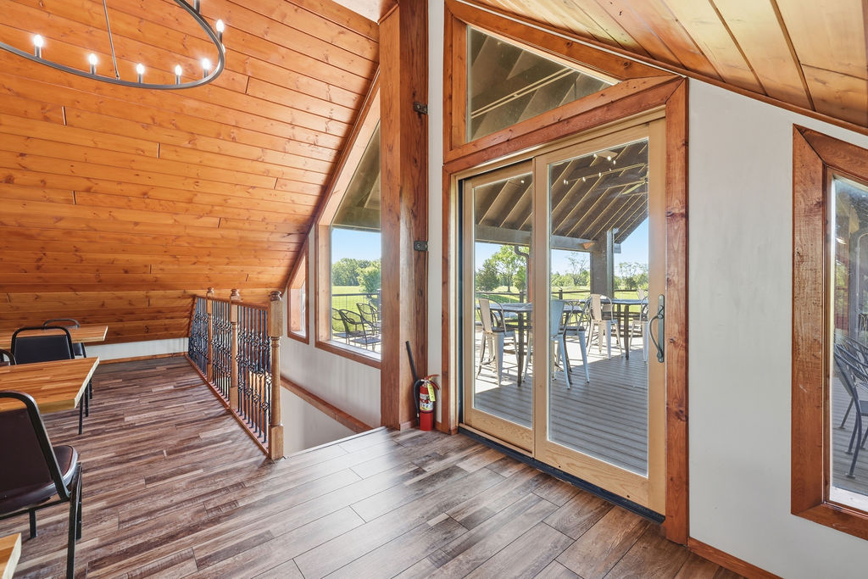 | CONCEPTUAL RENDERING  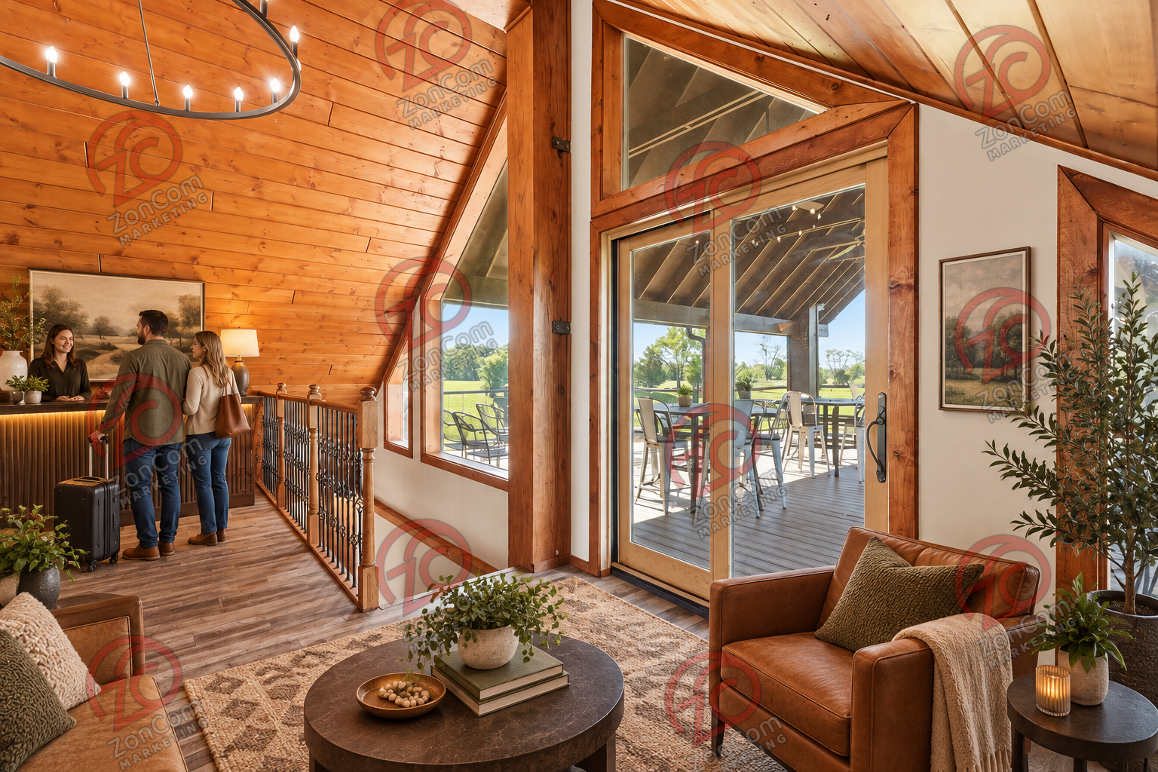
The conceptual rendering illustrates one possible operating presentation. It does not represent the property’s current condition, an approved use, code compliance, construction pricing, or items included in the sale.

Buyer Thesis and Operating Program
Present the acquisition as a phased reuse opportunity: activate the existing gathering and food-service spaces first, validate demand, then pursue lodging or other expansion only after entitlement, infrastructure, cost, and return analysis.

Priority Buyer Profiles
- Owner-developers and operator-investors
- Boutique hospitality and event investors
- Adaptive-reuse specialists
- Family offices or local investors partnering with an experienced operator

Why the Property Can Fit
- Existing character-rich building reduces the need to create a destination identity from scratch
- Several indoor and outdoor environments can support phased activation
- Commercial kitchen and event infrastructure may shorten selected operating pathways
- Acreage creates optionality, but only after boundary and entitlement verification

Illustrative Operating Program
- Phase one: refreshed event, dining, meeting, or day-retreat operations
- Phase two: boutique hospitality services and enhanced guest commons
- Phase three: approved lodging, wellness, or complementary structures if feasibility supports them
- Use partnerships and temporary programming to test demand before heavy capital deployment

Likely Improvement Priorities
- Complete title, survey, zoning, building, environmental, utility, and market diligence
- Resolve the discrepancy between the 4,228-square-foot floor-plan total and approximately 6,000 square feet in current marketing
- Prepare concept-level code, infrastructure, parking, and cost studies for each phase
- Select an experienced operator and build conservative sources-and-uses, stabilization, and exit cases

Buyer Facing Campaign Materials

Suggested Headline
A character-rich platform for phased hospitality and destination reuse

Direct Outreach Message
The property offers an existing destination building, commercial food-service infrastructure, varied gathering areas, decks, event grounds, pond, and acreage. The investment thesis is phased rather than speculative: activate existing spaces, validate demand, and pursue regulated expansion only when approvals, infrastructure, and returns are demonstrated.

Recommended Image Sequence
- Current hero interior that clearly establishes the real building
- Matching conceptual rendering labeled Conceptual Rendering
- Commercial kitchen and food-service areas
- Enclosed porch, decks, and main gathering rooms
- Ground-level exterior and site amenities
- Verified floor plan and boundary exhibit once reconciled

Lead Qualification Questions
- Which phase can generate revenue with the least entitlement and capital risk?
- Who will operate the property and what relevant experience do they bring?
- How will building area, equipment, parcel boundaries, and legal uses be verified?
- What return threshold and contingency reserve does the investment require?
- Which expansion ideas remain viable after parking, septic, fire, accessibility, and cost analysis?

Call to Action
Request the verified property package, schedule a private tour, and submit a written indication of intended use, acquisition structure, diligence needs, and timing.

Verification and Buyer Diligence
The campaign can present credible possibilities without representing them as approved or economically proven. Before public distribution, the seller and broker should reconcile the building-area discrepancy and confirm the exact sale perimeter.
Verify before relying | Reason
Parcels, legal descriptions, acreage, access, and boundaries | Photos do not establish which land or improvements convey.
Zoning, legal use, occupancy, parking, and event or lodging permissions | A conceptual use is not an entitlement.
Kitchen equipment ownership, inclusion, condition, and inspection status | Visible equipment may be leased, excluded, inactive, or require service.
Water, wastewater, electric capacity, fire protection, and accessibility | Operating capacity depends on infrastructure and code requirements.
Pond, stage, decks, outbuildings, signs, and outdoor-program permissions | Presence does not prove boundary location, compliance, or insurability.
Renovation scope, professional estimates, financing, and operating economics | Renderings do not establish cost, feasibility, revenue, or return.

Required Marketing Disclaimer
Conceptual renderings are provided solely to illustrate potential space planning and operating ideas. They do not depict current conditions, included personal property, approved uses, code compliance, construction scope, cost, capacity, revenue, or future performance. All dimensions, property facts, uses, improvements, permits, utilities, and economics must be independently verified by the buyer and appropriate professionals.
Prepared for customized buyer outreach September 2026

