Beyond the Optimum
Chemical Engineering Decisions with Multiple Objectives and Uncertainty
Technical companion to the keynote
Edwin Zondervan
University of Twente
Advanced Process Modeling Workshop, Saudi Aramco • October 2026
Purpose A compact technical tutorial for the methanol superstructure example behind the keynote: design alternatives, mathematical programming, Pareto analysis, ε-constraint optimization, scenario analysis, minimax regret, and the MATLAB workflow.
Scope note. The numerical cost and emissions indices are normalized and pedagogical. The example illustrates decision methodology; it is not an industrial techno-economic design model of a commercial methanol plant.

Contents
- The problem: which methanol process?
- Building the process superstructure
- From engineering alternatives to mathematical decisions
- Enumerating and evaluating the design space
- Single-objective optimization
- Multi-objective optimization and Pareto dominance
- The ε-constraint method
- Decision-making under uncertainty
- Minimax regret
- Inside the MATLAB package
- Extending the example
- From hybrid models to decisions

1. The problem: which methanol process?
Early process design rarely begins with one immutable flowsheet. The engineer must decide which technologies and connections should exist before continuous operating conditions can be optimized. The keynote therefore begins with a process-synthesis question: which methanol process should we optimize?
The teaching superstructure contains five yes/no technology choices:
Decision | Variable | Interpretation
Hydrogen route | y_H | 1 = electrolysis; 0 = purchased H₂
Renewable electricity | y_R | 1 = renewable supply enabled
Reactor system | y_T | 1 = two-stage reactor
Separation | y_S | 1 = enhanced separation
Heat integration | y_I | 1 = additional heat integration
Five binary variables create 2⁵ = 32 raw combinations before engineering logic is applied. Each feasible configuration receives an annualized cost index and an emissions index.
Design labels D1, D2, … are configuration identifiers. They are not a ranking.

2. Building the process superstructure
A superstructure keeps credible alternatives alive instead of committing to one flowsheet too early. Optional units and connections coexist in a single representation; optimization later selects among them.
- Purchase H₂ or produce H₂ by electrolysis.
- Allow renewable electricity when electrolysis is present.
- Use a baseline or two-stage reactor configuration.
- Use baseline or enhanced separation.
- Use baseline energy recovery or additional heat integration.

2.1 Engineering logic
Not every binary combination is meaningful. A simple relation used in the example is:
y_R ≤ y_H
Renewables are only activated when electrolysis is selected. Real industrial superstructures would contain many more logical, capacity, connectivity, thermodynamic and operability constraints.
Superstructure principle Do not choose the flowsheet first and optimize it second. Preserve alternatives until the optimization has compared them.

3. From engineering alternatives to mathematical decisions
y = [y_H, y_R, y_T, y_S, y_I]ᵀ, y_i ∈ {0,1}
The binary vector y describes topology. A larger mixed-integer model would add continuous variables x for flows, temperatures, pressures, duties, equipment sizes and operating conditions.

3.1 Generic mathematical program
min C(x,y)
subject to
h(x,y) = 0 process balances and constitutive equations
g(x,y) ≤ 0 operating, design and environmental constraints
y_R ≤ y_H engineering logic
xᴸ ≤ x ≤ xᵁ, y ∈ {0,1}⁵
The keynote example is deliberately small, so feasible configurations can be enumerated and evaluated directly. The same conceptual structure scales to MILP, MINLP, decomposition, surrogate-assisted optimization and metaheuristic search.

3.2 Performance measures
- C(d): normalized annualized cost index; lower is better.
- E(d): normalized emissions index; lower is better.

4. Enumerating and evaluating the design space
The computational workflow generates binary configurations, removes infeasible combinations and evaluates the remaining designs.
Illustrative MATLAB logic
Y = dec2bin(0:31,5) - '0'; % all five-bit configurations
feasible = Y(:,2) <= Y(:,1); % example logic: y_R <= y_H
Y = Y(feasible,:);

for k = 1:size(Y,1)
[cost(k),emissions(k)] = evaluate_design(Y(k,:),p);
end
In the package, model generation, analysis and plotting are separated into functions. This makes the example easier to audit, modify and ultimately share as a GitHub teaching package.
Pedagogical model The normalized relationships should be replaced by rigorous mass/energy balances, equipment models, economics and life-cycle inventories for research or industrial design.

5. Single-objective optimization
d* = arg min_d C(d)
With cost as the sole objective, the minimum-cost design has C = 100 and E = 100. If emissions are minimized instead, the preferred topology changes; the low-emissions extreme is approximately C = 118 and E = 38.
Both are mathematically optimal, but with respect to different objectives. This is the first central lesson of the keynote: the optimizer does not decide what matters.
Question Optimal according to what?

6. Multi-objective optimization and Pareto dominance
min_d ( C(d), E(d) )
Design A dominates design B if A is no worse in every objective and strictly better in at least one:
C_A ≤ C_B and E_A ≤ E_B, with at least one strict inequality
A non-dominated design is Pareto optimal. The set of non-dominated designs is the Pareto set; its image in objective space is the Pareto front.
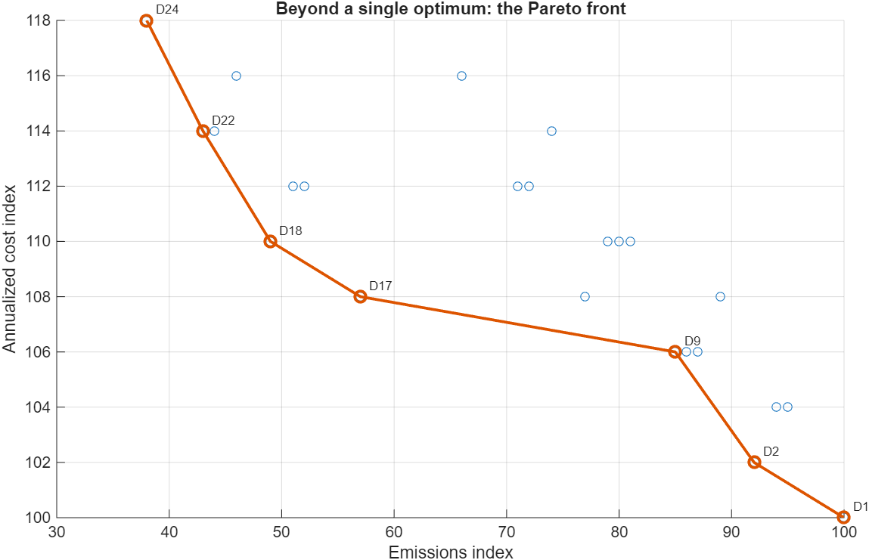
Figure 1. MATLAB output: feasible configurations and labelled Pareto front. D1 is the minimum-cost extreme and D24 the minimum-emissions extreme.
The labels connect objective-space points back to physical designs. Moving along the front therefore means changing technology choices, not merely changing coordinates.
A transparent Pareto filter
isPareto = true(n,1);
for i = 1:n
for j = 1:n
dominates = (C(j)<=C(i)) && (E(j)<=E(i)) && ...
((C(j)<C(i)) || (E(j)<E(i)));
if dominates
isPareto(i) = false;
break
end
end
end

7. The ε-constraint method: turning the carbon knob
min_d C(d) subject to E(d) ≤ ε
Cost remains the objective while emissions become a progressively tighter constraint. For every ε, the algorithm chooses the cheapest design satisfying the emissions limit.
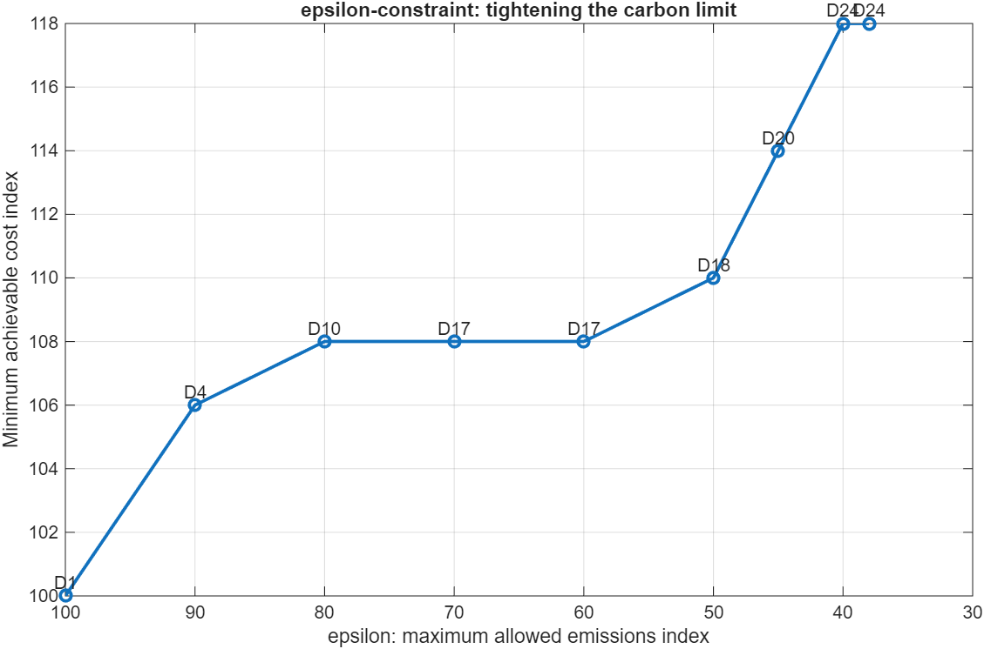
Figure 2. MATLAB ε-constraint output. Tightening the maximum allowable emissions raises the minimum achievable cost and causes discrete changes in the selected design.
Plateaus matter: D17, for example, can remain optimal over a range of ε. A stricter environmental limit may have no effect until a threshold is crossed, after which the optimal topology jumps.
epsGrid = [100 90 80 70 60 50 45 40 38];
for k = 1:numel(epsGrid)
ok = E <= epsGrid(k);
[bestCost(k),loc] = min(C(ok));
idx = find(ok);
bestDesign(k) = idx(loc);
end
Interpretation We do not just change a number. We change the plant.

8. Decision-making under uncertainty
The deterministic analysis assumes that the future parameters used in the model are known. In practice, H₂ and electricity prices, renewable availability, demand, carbon policy and process performance change.
Scenario | Prices | Renewables | Interpretation
Favourable | lower | abundant | benign operating/economic future
Reference | baseline | moderate | central planning assumptions
Stress | higher | limited | adverse future
Each Pareto design is re-evaluated under every scenario, creating a cost matrix C(d,s).
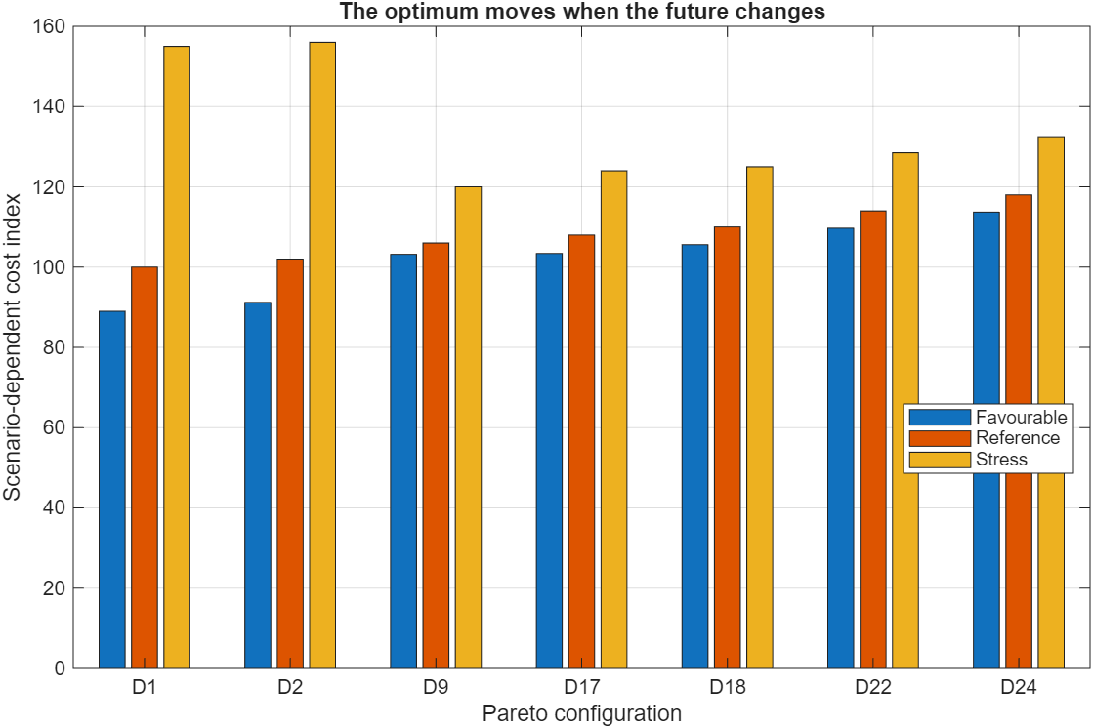
Figure 3. Scenario-dependent cost of Pareto configurations. D1 is attractive in favourable/reference conditions, while D9 is far less exposed to the stress future.
for s = 1:numel(scenarios)
for d = 1:nPareto
Cscen(d,s) = evaluate_scenario(paretoTbl(d,:),scenario(s));
end
end
The point is not that every scenario must have a different winner. The important observation is that the ranking and vulnerability of designs change when the assumed future changes.

9. Minimax regret
Regret compares a chosen design with the best design that could have been selected in hindsight after a scenario is known.
R(d,s) = C(d,s) − min_j C(j,s)
R_max(d) = max_s R(d,s)
d_MMR = arg min_d R_max(d)
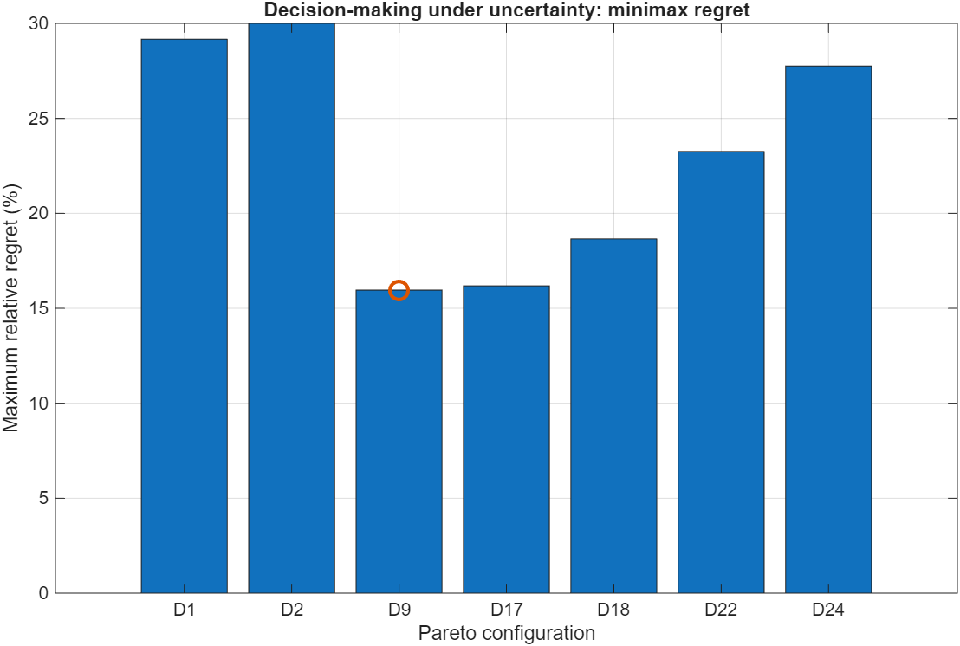
Figure 4. MATLAB output: maximum relative regret. D9 is highlighted as the minimax-regret solution in this teaching example.
D9 does not win every future. It is selected because its worst hindsight penalty is comparatively small. Minimax regret therefore represents a robust compromise rather than a universal optimum.

9.1 MATLAB calculation
bestByScenario = min(Cscen,[],1);
regret = Cscen - bestByScenario;
relativeRegret = 100*regret./bestByScenario;

maxRegret = max(relativeRegret,[],2);
[~,iMMR] = min(maxRegret);
minimaxDesign = paretoTbl.Design(iMMR);
Decision criterion Minimax regret is one attitude toward uncertainty. Expected value, worst-case optimization, chance constraints, CVaR, stochastic programming and robust optimization encode different attitudes and information assumptions.

10. Inside the MATLAB package
The package follows a reproducible sequence: define assumptions, generate configurations, calculate performance, identify the Pareto set, run ε-constraint analysis, evaluate scenarios, calculate regret and export figures.
Representative main.m structure
clear; close all; clc

p = define_parameters();
tbl = generate_configurations(p);
pareto = find_pareto(tbl);

plot_all_configurations(tbl,pareto);
plot_pareto_front(tbl,pareto);

epsResult = epsilon_constraint(tbl);
scen = scenario_analysis(pareto,p);
reg = minimax_regret(scen);

10.1 Robust figure export
The Windows path error encountered during development is avoided by explicitly creating the output directory and using fullfile:
figDir = fullfile(pwd,'figures');
if ~exist(figDir,'dir')
mkdir(figDir);
end

exportgraphics(gcf, ...
fullfile(figDir,'01_all_configurations.png'), ...
'Resolution',220);

10.2 Keep identifiers with data
tbl = table(designID,yH,yR,yT,yS,yI,cost,emissions);
paretoTbl = tbl(isPareto,:);
MATLAB tables are useful because the D-number, topology choices and performance values remain attached to the same row throughout plotting and scenario analysis.

11. Extending the example
The small model is useful because every element can be understood and then replaced by a more rigorous component without changing the overall architecture.
- Add continuous variables for reactor conditions, recycle, electrolyser capacity and equipment size, creating a true MINLP.
- Add water use, energy demand, flexibility or safety as additional objectives.
- Add a carbon price and inspect how the Pareto set changes.
- Replace discrete scenarios by probability distributions and compare expected-value and stochastic formulations.
- Add recourse: storage, feed switching, flexible production or modular expansion.
- Replace one algebraic performance relation by a machine-learning surrogate or hybrid physics/data model.
- Compare minimax regret with minimum expected cost or a worst-case robust solution.

11.1 Exercise: add one technology
Add a sixth binary variable for a new low-carbon technology. Rebuild the design space, update the logical constraints, identify the new Pareto set and ask where the new option becomes attractive. This single exercise connects superstructure design, mathematical programming, multi-objective optimization and decision-making.

12. From hybrid models to decisions
The workshop theme—hybrid modeling, advanced process modeling and machine learning—connects directly to the first part of the chain. Mechanistic models encode physics; data-driven models capture patterns from data; hybrid models combine both.
But the journey does not end with a more accurate model. Better models matter because they improve the alternatives we can evaluate, the trade-offs we can expose, and the decisions we can defend.
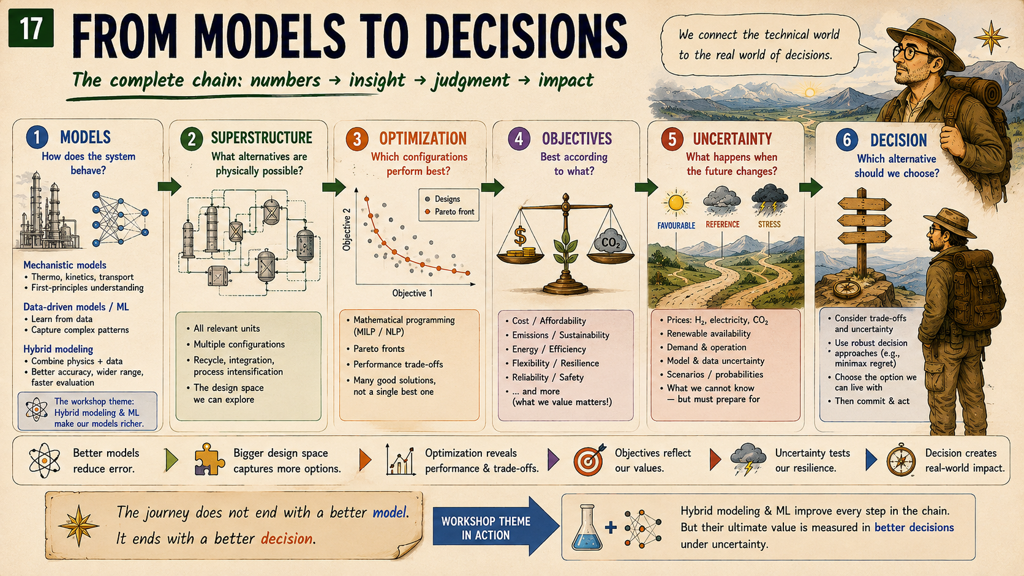
Figure 5. The complete keynote chain: models → superstructure → optimization → objectives → uncertainty → decision.
Layer | Question
Models | How does the system behave?
Superstructure | What alternatives are physically possible?
Optimization | Which configurations perform best?
Objectives | Best according to what?
Uncertainty | What happens when the future changes?
Decision | Which alternative should we choose?
Closing thought The optimum is an answer to a mathematical question. Engineering requires a decision.
Models predict. Optimization explores. Engineers decide.

Appendix A. Compact algorithmic summary
- Generate all candidate binary configurations.
- Apply engineering logic and retain feasible designs.
- Evaluate deterministic cost and emissions.
- Identify non-dominated designs.
- Generate the Pareto front and ε-constraint solutions.
- Re-evaluate selected designs under multiple futures.
- Calculate hindsight optima and scenario regret.
- Calculate maximum relative regret for every design.
- Use the results as decision support, not as a substitute for engineering judgment.

Appendix B. Notation
Symbol | Meaning
d | design/configuration
s | uncertainty scenario
x | continuous process/design variables
y | binary topology variables
C | annualized cost index
E | emissions index
ε | maximum allowed emissions index
R(d,s) | regret of design d in scenario s
R_max(d) | maximum regret across scenarios

Appendix C. Detailed pedagogical MINLP formulation
The keynote MATLAB package deliberately uses a compact normalized technology-selection model. For readers who want to see what a more explicit process-synthesis formulation could look like, this appendix develops a stylized steady-state methanol superstructure MINLP. It is consistent with the five binary decisions used in the lecture, but it is an extension of the teaching model, not the exact model currently solved by the MATLAB package.
Important distinction The equations below are meant to show the structure of a realistic process-systems formulation. They are not calibrated to an industrial methanol plant and should not be interpreted as validated process or economic data.

C.1 Process structure and notation
The system converts captured CO2 and hydrogen to methanol through the overall reaction CO2 + 3 H2 -> CH3OH + H2O. The superstructure includes purchased versus electrolytic H2, optional renewable electricity, a baseline versus two-stage reactor, baseline versus enhanced separation, and optional heat integration.
Symbol | Type | Meaning
y_H | binary | 1: H2 from electrolysis; 0: purchased H2
y_R | binary | 1: renewable electricity for electrolysis
y_T | binary | 1: two-stage / intercooled reactor
y_S | binary | 1: enhanced separation
y_I | binary | 1: heat integration
F_i^0 | continuous | fresh molar flow of component i
F_i^r | continuous | recycle molar flow of component i
F_i^in | continuous | reactor inlet molar flow of component i
F_i^out | continuous | reactor outlet molar flow of component i
xi | continuous | reaction extent
P_el | continuous | electrolyser electrical load
P_grid | continuous | grid electricity consumption
P_ren | continuous | renewable electricity consumption
Q_ext | continuous | external thermal utility
F_MeOH^prod | continuous | methanol product flow

C.2 Fresh-feed and recycle balances
For each species entering the reactor, fresh feed and recycle are mixed:
F_CO2^in = F_CO2^0 + F_CO2^r
F_H2^in = F_H2,pur + F_H2,el + F_H2^r
The simplified separator recycles unreacted CO2 and H2; methanol and water are withdrawn as product/by-product streams. If desired, the formulation can be expanded to include purge, dissolved gases and product impurities.

C.3 Reactor stoichiometric balances
With reaction extent xi for CO2 + 3H2 -> CH3OH + H2O:
F_CO2^out = F_CO2^in - xi
F_H2^out = F_H2^in - 3 xi
F_MeOH^out = F_MeOH^in + xi
F_H2O^out = F_H2O^in + xi
For the simplified model, fresh methanol and water at the reactor inlet are zero; any inlet methanol/water would arise only if such species were included in recycle.

C.4 Constitutive reactor relation
A compact way to represent the effect of the reactor-choice binary is to let the single-pass CO2 conversion depend on y_T:
X_CO2(y_T) = X_1 + (X_2 - X_1) y_T
xi = X_CO2(y_T) F_CO2^in
Here X_1 is the baseline single-stage conversion and X_2 the improved conversion for the two-stage/intercooled option. The product y_T F_CO2^in makes the relation mixed-integer nonlinear. In a MILP approximation, one could instead use disjunctive constraints or a big-M linearization.

C.5 Stoichiometric and operating constraints
F_H2^in >= 3 xi
r_min <= F_H2^in / F_CO2^in <= r_max
The second constraint bounds the H2/CO2 feed ratio around the desired operating region. It can be written without a ratio as r_min F_CO2^in <= F_H2^in <= r_max F_CO2^in.
F_CO2^in <= Cap_R,1 (1-y_T) + Cap_R,2 y_T
This simple capacity expression lets the selected reactor configuration determine the allowable throughput.

C.6 Separation and recycle constitutive equations
Let rho_CO2 and rho_H2 denote recycle recoveries. Enhanced separation changes the recoveries according to y_S:
rho_CO2(y_S) = rho_CO2,0 + Delta_rho_CO2 y_S
rho_H2(y_S) = rho_H2,0 + Delta_rho_H2 y_S
F_CO2^r = rho_CO2(y_S) F_CO2^out
F_H2^r = rho_H2(y_S) F_H2^out
The un-recycled fractions are purged or lost:
F_CO2^purge = (1-rho_CO2(y_S)) F_CO2^out
F_H2^purge = (1-rho_H2(y_S)) F_H2^out
Methanol recovery can be represented similarly. If eta_M denotes recovery to the methanol product:
eta_M(y_S) = eta_M,0 + Delta_eta_M y_S
F_MeOH^prod = eta_M(y_S) F_MeOH^out
F_MeOH^prod >= D_MeOH
The last equation is the production-demand constraint.

C.7 Product-quality constraint
If a simplified product stream contains methanol plus residual water, a minimum methanol mole fraction can be imposed in linear form:
F_MeOH^prod >= x_MeOH,min (F_MeOH^prod + F_H2O^prod)
A rigorous industrial model would use phase-equilibrium calculations and a complete separation train rather than this compact recovery model.

C.8 Hydrogen-supply logic
The electrolysis binary determines whether hydrogen is purchased or generated on site.
0 <= F_H2,el <= M_H2 y_H
0 <= F_H2,pur <= M_H2 (1-y_H)
Electrolyser power and hydrogen production are connected by the specific electrical demand e_el:
P_el = e_el F_H2,el

C.9 Renewable/grid electricity logic
Renewable electricity is only meaningful when electrolysis is installed:
y_R <= y_H
0 <= P_ren <= M_P y_R
0 <= P_grid <= M_P (y_H - y_R)
P_el = P_ren + P_grid
This version treats renewable and grid supply as mutually exclusive for transparency. A more realistic formulation would allow a continuous blend, storage, curtailment, time-varying electricity prices and renewable availability.

C.10 Energy demand and heat integration
Process heat demand can be written as the sum of reactor and separation duties:
Q_proc = q_rxn xi + q_sep(y_S) F_tot^out
q_sep(y_S) = q_sep,0 + Delta_q_sep y_S
Available recoverable heat is represented by:
Q_rec = q_rec xi
External thermal utility must cover the net duty after optional heat recovery:
Q_ext >= Q_proc - eta_HI y_I Q_rec
Q_ext >= 0
Again, y_I Q_rec is bilinear. It can remain in an MINLP or be linearized with an auxiliary variable and standard big-M/McCormick constraints.

C.11 Equipment/design-capacity constraints
F_H2,el <= Cap_el y_H
P_ren <= Cap_ren y_R
F_tot^out <= Cap_sep,0 (1-y_S) + Cap_sep,1 y_S
Q_rec <= Cap_HI y_I + M_Q (1-y_I)
These constraints ensure that a unit cannot carry flow or duty unless the corresponding technology is installed, and they permit alternative configurations to have different capacities.

C.12 Annualized cost objective
A representative annualized cost function is:
C = C_feed + C_util + C_cap
C_feed = p_CO2 F_CO2^0 + p_H2 F_H2,pur
C_util = p_grid P_grid + p_ren P_ren + p_Q Q_ext
C_cap = a_H y_H + a_R y_R + a_T y_T + a_S y_S + a_I y_I
Capacity-dependent capital terms can be added, for example k_el (F_H2,el)^alpha or linearized piecewise-capacity costs. For the keynote package, these detailed cost correlations are collapsed into normalized cost increments.

C.13 Environmental objective / constraint
A simple cradle-to-gate emissions expression is:
E = EF_H2 F_H2,pur + EF_grid P_grid + EF_ren P_ren + EF_Q Q_ext + MW_CO2 F_CO2^purge
The emission factors EF represent upstream or utility-related emissions. Renewable electricity can be assigned a low but nonzero lifecycle factor. If captured CO2 receives a credit or if methanol use-phase emissions are included, the system boundary must be stated explicitly.
For multi-objective optimization the model becomes:
min ( C(x,y), E(x,y) )
or, using the epsilon-constraint method:
min C(x,y) subject to E(x,y) <= epsilon

C.14 Complete compact MINLP
The complete pedagogical formulation can be summarized as:
min C(x,y) [or min (C,E)]
subject to:
- fresh-feed/recycle mixing balances;
- reactor stoichiometric balances;
- conversion relation xi = X_CO2(y_T) F_CO2^in;
- separator recovery and recycle equations;
- methanol production and quality constraints;
- electrolysis relation P_el = e_el F_H2,el;
- hydrogen-source exclusivity constraints;
- renewable/grid logic and y_R <= y_H;
- energy-balance and heat-integration constraints;
- equipment-capacity constraints;
- environmental constraint E <= epsilon when using epsilon-constraint;
- bounds x^L <= x <= x^U and y in {0,1}^5.

C.15 Why this is an MINLP
Nonlinearity enters through products such as y_T F_CO2^in, y_S F_i^out and y_I Q_rec, and potentially through nonlinear equipment-cost or thermodynamic relations. Binary variables make the problem discrete. Together, these features create a mixed-integer nonlinear program.
Source of complexity | Example | Possible treatment
binary-continuous product | y_T F_CO2^in | MINLP directly; big-M; convex-hull reformulation
nonlinear cost scaling | capacity^alpha | piecewise linearization; MINLP
phase equilibrium | K-values / flash equations | NLP equations; surrogate/hybrid model
logic | y_R <= y_H | linear binary constraint
multiple objectives | cost and emissions | epsilon-constraint; weighted sum; Pareto methods
uncertainty | prices / availability | scenarios; stochastic; robust; regret

C.16 How the detailed model would map into MATLAB
The present teaching package can be upgraded in two directions. A solver-based version could use intlinprog if all nonlinear relations are linearized, or fmincon inside a topology loop / a dedicated MINLP solver when nonlinear process equations are retained.
One practical MATLAB implementation route
% Pseudocode: topology-enumeration + continuous NLP
for k = 1:nTopologies
y = Y(k,:);

% continuous operating/design variables x
x0 = initial_guess(y);

% solve continuous process model for this topology
[xOpt,fval,exitflag] = fmincon( ...
@(x) annualized_cost(x,y,p), ...
x0, A, b, Aeq, beq, lb, ub, ...
@(x) process_constraints(x,y,p), options);

if exitflag > 0
results(k).cost = fval;
results(k).emissions = emissions(xOpt,y,p);
results(k).x = xOpt;
results(k).y = y;
end
end

% then apply Pareto filtering / epsilon constraints / scenarios
Connection to the keynote The normalized binary teaching model is intentionally simple enough to show every design point. This detailed MINLP shows what sits underneath the same conceptual chain once realistic process balances, utilities, equipment capacities and environmental accounting are introduced.

