**海欧派开发及使用一指禅**

1. **EulerPi购买连接**

<https://www.ebaina.com/ai/58>

1. **EulerPi单板硬件使用指导**

[欧拉派海鸥系列硬件特性 — openEuler Embedded在线文档 1.0.0](https://openeuler.gitee.io/yocto-meta-openeuler/master/bsp/arm64/hieulerpi/hardware_features.html)

1. **EulerPi镜像下载**

镜像文件包括Uboot、kernel和rootfs，需要拷贝到SD卡给海鸥派升级

**1、Uboot下载**

先下载Uboot链接[u-boot](https://gitee.com/HiEuler/u-boot/releases/tag/v2.0.0)

1. 欧拉派每日构建有三种镜像下载链接分别是：

1)普通版本镜像下载链接

[121.36.84.172/dailybuild/EBS-openEuler-Mainline/openeuler-2024-04-12-07-39-20/embedded_img/aarch64/sd3403/](http://121.36.84.172/dailybuild/EBS-openEuler-Mainline/openeuler-2024-04-12-07-39-20/embedded_img/aarch64/sd3403/)

需要下载下图中的两个红色标记镜像文件和Uboot

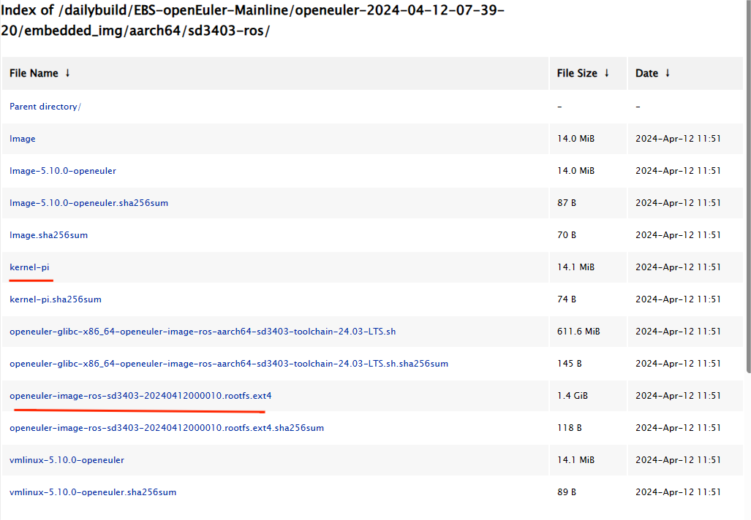

2)ROS版本镜像

<http://121.36.84.172/dailybuild/EBS-openEuler-Mainline/openeuler-2024-04-12-07-39-20/embedded_img/aarch64/sd3403-ros/>

3)Tiny版本镜像下载

等待链接更新

openEuler官网正式发布的版本

[openEuler下载 | 欧拉系统ISO镜像 | openEuler社区官网](https://www.openeuler.org/zh/download/?version=openEuler 22.03 LTS SP3)

1. **EulerPi镜像烧录并运行实例**

**1、烧录镜像**

<https://openeuler.gitee.io/yocto-meta-openeuler/master/bsp/arm64/hieulerpi/update.html>

2、运行示例

1）hdmi示例

2）usb_camera

**3)**Wifi拉mipi摄像头流

1. **EulerPi基础SDK的环境搭建与使用指导**
2. 基础SDK环境搭建指导
3. 下载SDK

[121.36.84.172/dailybuild/EBS-openEuler-Mainline/openeuler-2024-04-12-07-39-20/embedded_img/aarch64/sd3403/](http://121.36.84.172/dailybuild/EBS-openEuler-Mainline/openeuler-2024-04-12-07-39-20/embedded_img/aarch64/sd3403/)



1. 安装SDK

如下文档从第二节开始看

[快速上手 — openEuler Embedded在线文档 1.0.0 documentation (gitee.io)](https://openeuler.gitee.io/yocto-meta-openeuler/master/getting_started/index.html" \l "sdk)

1. 应用开发与编译指导

<https://gitee.com/HiEuler/externed_device_sample>

usb_camera输入编译与使用

[usb_camera · HiEuler/externed_device_sample](https://gitee.com/HiEuler/externed_device_sample/tree/master/usb_camera)

Hdmi输出

[hdmi · HiEuler/externed_device_sample](https://gitee.com/HiEuler/externed_device_sample/tree/master/hdmi)

Wifi拉mipi摄像头流

[mipi_vi · HiEuler/externed_device_sample](https://gitee.com/HiEuler/externed_device_sample/tree/master/mipi_vi)

1. **EulerPi的ROS SDK环境搭建与使用指导**

[嵌入式ROS运行时支持 — openEuler Embedded在线文档](https://openeuler.gitee.io/yocto-meta-openeuler/master/features/ros.html" \l "sdk)