# FRM学习笔记

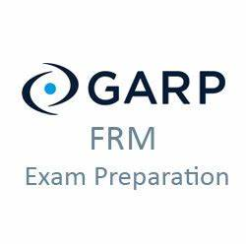

作者：Zongzhe

更新日期：2020年11月25日

邮箱：[zongzhe_chen@sina.com](mailto:zongzhe_chen@sina.com)

# 目录

FRM学习笔记 1

目录 2

概述 4

目的与受众 4

图例、规范，和指南 4

注意事项 4

沟通合作 4

章节概述与分数分布 5

Chapter 1 Basic Sense of Risks and Management 6

What Is Risk? 6

“度”的问题：Accept or Avoid Risk? 6

Is Risk Management Useful? 6

Risk Management Process 6

Management of Risk 7

Identification of Risk 7

Measure of Risk 8

Unexpected Loss (UL) 8

How Does Risk Management Add Value? 9

Is Risk Management Useful? 9

Expected Loss (EL, 预计损失) 9

Extreme Value - Tail Risk 9

Risk Relationship and Concentration 9

Balance Between Risk and Reward 10

The Conflict of Risk and Reward 10

Three Lines of Defense 三道防线 10

Chapter 2 Basic Risk Types 11

考试重点 11

A typology of risks for the banking industry 11

Typology of Risk Exposures 11

Chapter 3 How Do Firms Manage Financial Risk? 14

Risk Management Strategies 14

Risk Appetite 14

Determining a Bank’s Risk Appetite (定性表达) 14

Limits and Limit Standard Policies (定量表达) 14

Standards for Monitoring Risk 15

Use of Other Risk Transfer Tools 16

Warning! Hedging (对冲) May Go Wrong! 17

Chapter 4 the Governance of Risk Management 18

Introduction 18

Sarbanes-Oxley Act (SOX) 18

Key Post Crisis Corporate Governance Concerns 18

Basel III – Principles for Banks’ Governance 19

Dodd-Frank Act 20

The Infrastructure of Corporate Governance 20

Committees 21

The Right Degree of Independence for Risk Managers 22

The Independence of Risk Governance 22

Chapter 5 Credit Risk Transfer Mechanisms 24

Chapter 6 The Standard Capital Asset Pricing Model 24

Chapter 7 Arbitrage (套利) Pricing Theory 24

Chapter 8 Risk Aggregation and Reporting 24

Chapter 9 Enterprise Risk Management 24

Chapter 10 Learning from Financial Disasters 24

Chapter 11 Anatomy (剖析) of the Great Financial Crisis of 2007-2009 24

Chapter 12 GRAP Code of Conduct 24

附件和链接 25

学习视频链接 25

考试技巧 26

# 概述

## 目的与受众

此为FRM的学习笔记。受众为同样准备此考试的读者。

## 图例、规范，和指南

**关于层级架构**

1. 文档的层级为：章节-小节-考点。
2. 考点之中的分类和重点以“强调”的形式标出，并不计入标题的范畴。
3. 考点之中的重点以“明显强调”的形式标出，并不计入标题的范畴。
4. 考点的记忆方法和注意事项以“备注”的形式标出，并不计入标题的范畴。

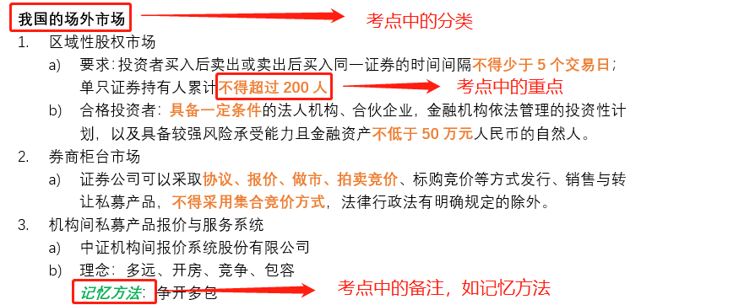

## 注意事项

在纯手打编辑过程中，由于时常开小差，难免有以下情况发生：

1. 由拼音输入法造成的同音异字：收市->收尸，制度->制毒，每位股东->美味股东
2. 由于手残造成的键盘输入错位：制度->致富，信誉->性欲

## 沟通合作

作者：Zongzhe，邮箱：[zongzhe_chen@sina.com](mailto:zongzhe_chen@sina.com)

# 章节概述与分数分布

第一章：Foundations of Risk Management（20分）

第二章：Quantitative Analysis（20分）

第三章：Financial Markets and Products（30分）

第四章：Valuation and Risk Models（30分）

# Chapter 1 Basic Sense of Risks and Management

Source: P1-P2

## What Is Risk?

**Possibility of the bad things that might happen**

It exists everywhere and anytime, we will focus on the financial world.

But it is not always a bad thing:

Good risk: Risks that have a positive expected payoff on a stand-alone basis.

Bad risk: Risks that can be expected to destroy value on a stand-alone basis.

Banks and other financial institutions cannot succeed without taking risks.

对风险的态度：Take, transfer (mitigate) or eliminate

Some examples:

* Safe arrival of shipments of goods
* Merchant loans and repayments.

## “度”的问题：Accept or Avoid Risk?

**Banks cannot operate with too much risk:**

Constrained by laws and regulations.

Limiting a bank's ability to attract deposits.

Derivative counterparties (交易对手) may be reluctant to deal with a bank with high risk.

Difficult to hire potential employees.

**Banks have to take some risk**

To create wealth for their shareholders.

## Is Risk Management Useful?

**Risk Management:**

How firms actively select the types and levels of risks that are appropriate for them to take.

**Risk management and risk taking aren't opposites, but two sides of the same coin.**

Together they drive all our modern economies.

It's all about making forward-looking choices about risk in relation to reward.

## Risk Management Process

|  |  |
| --- | --- |
| 1. Identify the risk 2. Analyze and measure risk 3. Assess the effects of all risks 4. Manage the risk using different kind of tools. | avatar |

## Management of Risk

|  |  |
| --- | --- |
| avatar | Avoid:  Transfer: 飞机延误保险  Accept: 人得感冒  Mitigate (缓释): |

## Identification of Risk

|  |  |
| --- | --- |
| There are things we know that we know. There are known unknowns... But there are also unknown unknowns.  Risk managers take responsibility for all kinds of risk, not just those that can be measured.  They must continuously search for "unknown unknowns".  其中Expected Loss 和 Unexpected Loss 是可计量，可计算的。 |  |

## Measure of Risk

EL = Expected Loss，例如银行知道某些信用卡会违约。一般是客户的钱。

UL = Unexpected Loss，一般是银行自己钱的损失。

Tail Loss: 尾部损失，极其不常见，通常损失巨大，需要外部介入或转移风险（如国家资助、购买保险）等等。

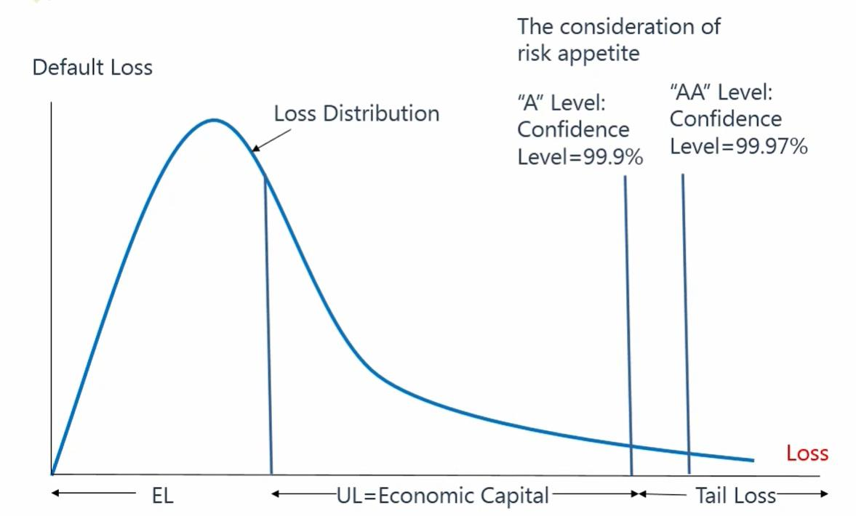

## Unexpected Loss (UL)

UL is the surprising loss that above the EL in bad days.

Value at risk (VaR) uses the loss distribution to estimate losses at given level of likelihood (confidence).

UL = VaR - EL

## How Does Risk Management Add Value?

**The goal of risk management for banks**

To determine the optimal level of risk that maximizes bank value; 风险管理不是最小化风险，也不是单纯的最大化公司价值，而是在一定条件下最大化公司价值。

Subject to the constraints imposed by regulators, laws, and regulations.

**A trade-off between return and risk**

Cost of taking on a single new risk < gain;

Risk-taking decisions must be assessed in terms of their impact on the overall risk.

Major challenge: the trade-off cannot be made in real time.

**Two ways that risk management can destroy value:**

1. Fail to ensure that the bank has the right amount of risk;
2. Fail to exercise the right amount of flexibility.
   1. Too restrictive: policemen
   2. Too flexible
   3. It is critical to strike the balance.

## Is Risk Management Useful?

**Blames for risk management**

Fail to prevent market disruptions or accounting scandals(丑闻);

Derivative markets make it easier to take on large amount of risk;

Sophisticated (精密的) financial engineering leads to the violent implosion（快速崩塌） of firms;

Only transfer risk to other firms;

Work to the short-term benefit.

## Expected Loss (EL, 预计损失)

**EL is the average loss expected to incur from a position or a portfolio. It can be estimated by historical data of a period of time.**

It can be treated as a predictable expense rather than a risk or uncertainty.

EL = EAD * LGD * PD for credit risk

EL can be calculated by the distribution of loss for market risk and operation risk.

## Extreme Value - Tail Risk

From the crisis lesson, we focus on the tail risk beyond confidence level which cannot be explained by VaR.

Extreme value theory(EVT, 极值理论) focuses on tail distribution to understand the black swans.

Expected shortfall is the EL of tail distribution.

## Risk Relationship and Concentration

**Relationship has obvious influence on portfolio’s(投资组合) risk, as well as concentration.**

Relationship between single assets can be estimated by covariance but this is very difficult across different risks.

Commercial real estate market is one of the clearest examples of how risk factors act together to produce waves of extreme loss (wrong-way risk)

**Concentration makes the probability of multiple losses high for a portfolio. As a result, we need more capital to cover the UL.**

## Balance Between Risk and Reward

**Reward should be considered by risk-adjusted return**

Risk adjusted return on capital (RAROC)

RAROC = reward/risk

Reward: after-tax risk-adjusted expected return

Risk: economic capital(就是UL)

## The Conflict of Risk and Reward

Rewards tied to short-term profits vs long-term risk taking.

Old compensation schemes were structured like call options for executives: unlimited upside but capped on the downside.

Now it is widely recognized that compensation is part of a sound risk culture.

G-20 recommendations include:

1. Deferral of certain compensation(年终奖分批发放);
2. Share-based remuneration(股权激励)
3. Claw-back provisions(表现不好收回奖金).

## Three Lines of Defense 三道防线

First line(业务部门): business line that generates, owns, and manages risk;

Second line(风控部门): risk managers that specialize in risk management and day-to-day oversight

Third line(审计部门): periodic independent oversight and assurance, such as internal audit

# Chapter 2 Basic Risk Types

Source: P2

## 考试重点

熟知名词，在给定的描述中能识别是什么样的风险。

## A typology of risks for the banking industry

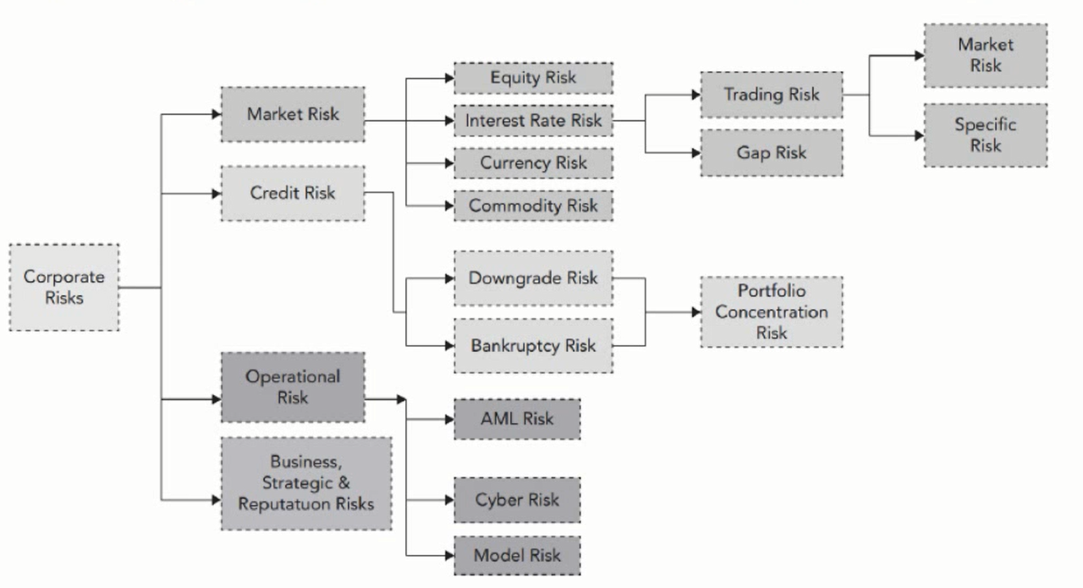

FRM主要立足于银行体系，而巴塞尔协定中对银行风险的界定分类主要是市场风险、信用风险，和操作风险，因此这里也是以这种界定为划分。

## Typology of Risk Exposures

**Market risk is the risk that changes in financial market prices and rates will reduce the value of a security or a portfolio. 只要在金融市场上，会导致价格出现变化的风险，就是市场风险。**

* Equity price risk
* Interest rate risk
* Currency (FX) risk 外汇风险
* Commodity price risk

**Market risk is driven by:**

* General market risk (systematic risk) 系统风险
* Specific risk (idiosyncratic/unsystematic risk) 非系统性风险

**Credit Risk:**

the risk of an economic loss from the failure of a counterparty to fulfill its contractual obligations, or from the increased risk of default during the term of the transaction

**Credit risk is driven by:**

* Probability of default (PD)
* Exposure amount at default (EAD)
* Loss given default (LGD)

**Credit risk type:**

* Default risk: 违约，借钱不还
* Bankruptcy risk: 直接破产，一般会和抵押物collateral 一同出现。
* Downgrade risk: 信用下调
* Settlement risk:

**Liquidity Risk**

**Funding Liquidity Risk:**

a firm’s ability to raise the necessary cash to roll over its debt; to meet the cash requirements, the margin requirements, and the collateral requirements; and to satisfy the need of capital withdrawals 资金周转不开

**Market (Trading) Liquidity Risk:**

An institution will not be able to execute a transaction at the prevailing market price because there is temporarily no appetite for the deal on the other side of the market

Endogenous vs. Exogenous 内生的 vs. 外生的

**Operational Risk:**

Refers to potential losses resulting from inadequate or failed internal processes, people, and systems or from external events

**It includes legal risk, but excludes business, strategic and reputational risk.**

* Human factor risk
  + Is a special form of operational risk. Such as pushing the wrong button on a computer.
* Technology risk
  + principally computer system risk, also falls into the operational risk category

**AML Risk:**

Anti money laundry and financing for terrorism

**Cyber Risk:**

The risk of hackers stealing and destroying data and compromising systems

**Data Privacy Risk:**

**Model Risk:**

The risk of potential indirect costs of relying on models

**Business Risk: 错误的估计了供需**

Lies at the heart of any business and includes all the usual worries of firms, such as customer demands, pricing decisions, supplier negotiations, and produce innovation management.

**Strategic Risk:**

Involves making critical, long-term decisions about the firm’s direction, often accompanied by major investments of capital, human resources, etc

损失量一般不可估计，属于known unknowns。

**Reputation Risk:**

The danger that a firm will suffer a sudden fall in its market standing or brand with the economic consequences

# Chapter 3 How Do Firms Manage Financial Risk?

Source: P2-3

## Risk Management Strategies

**Make 4 basic choices in risk management**

1. Avoid or undertake risk
2. Whether transfer risk to third parties
3. Mitigate risk or not
4. Assume or not assume risk. (其实就是accept/keep)

## Risk Appetite

Risk Appetite statement – “a written articulation of the aggregate level and types of risk that a firm will accept or avoid in order to achieve its business objectives.”

* The board must characterize an appropriate “risk appetite” for the firm.
* Be connected to a firm’s overall business strategy and capital plan.
* Clear communication throughout the firm of the firm’s risk appetite and risk position.
* Effective risk management program should be consistent with fundamental strategic and risk appetite choices.
* Risk appetites can be expressed in a number of ways, including quantitative and qualitative statements.

## Determining a Bank’s Risk Appetite (定性表达)

**Taking social costs into account**

* To maximize value for banks’ shareholders => generating systemic risk to society. (所以不能一味地让股东利益最大化)
* Regulators therefore impose restrictions (capital).
* Banks have to choose their level of risk subject to external constraints.

## Limits and Limit Standard Policies (定量表达)

An appropriate set of limits and authorities must be developed for each portfolio of business and for each type of risk.

Limits vary by the nature of the risk, the competitive positioning of the firm, and the span of its activities.

Limits should be related to VaR, scenario and stress testing to make sure the bank can survive in worst-case scenarios.

Practically speaking, these limits should be designed such that the probability of exceeding them during the normal situation of business is low.

|  |  |  |
| --- | --- | --- |
| Limit | Nature | Example Weakness |
| Stop Loss Limits  止损线 | Loss threshold and associated action (e.g. close out, escalation) | Will not prevent future exposure, only limit realized losses. |
| Notional Limits  本金限制 | Notional size of exposure | Notional amount may not be Strongly related to economic risk of derivative instruments, especially options.  在有杠杆的时候失效，因为风险会随着杠杆扩大。 |
| Risk Specific Limits  特定指标限制 | Limits referencing some special feature of risk in question (e.g. liquidity ratios for liquidity risk) | These limits are difficult to aggregate; may require special knowledge to interpret. |
| Maturity/Gap Limit | Limit amount of transactions that mature or reset/re-price in each time period | These limits reduce the risk that a large volume of transactions will need to be dealt with in a given time frame, with all the operational and liquidity risks this can bring. But they do not speak directly to price risk. |
| Concentration Limits | Limits of concentrations of various kinds (e.g. to individual counterparties, or product type) | These limits must be set with the understanding of correlation risks. They may not capture correlation risks in stressed markets. |
| Greek Limits | Option positions need to be limited in terms of their unique risk characteristics (e.g. delta, gamma, vega risk) | These limits suffer from all the classic model risks and calculation may be compromised at trading desk level without the right controls and independence. |
| Value-at-Risk (VaR) | Aggregate statistical number | VaR suffers from all the classic model risks and may be misinterpreted by senior management. Specially, VaR does not indicate how bad a loss might get in an unusually stressed market. |
| Stress, Sensitivity, and Scenario Analysis  压力测试 | These limits are based on exploring how bad things could get in a plausible worst-case scenario. Stress tests look at specific stresses. Sensitivity tests look at the sensitivity of a position or portfolio to changes in key variables. Scenario modeling looks at given real-world scenarios (hypothetical or historical). | Varies in sophistication. Dependent on deep knowledge of the firm’s exposures and market behavior. Difficult to be sure that all the bases are covered (e.g. there are endless possible scenarios).  一般不单独使用，需要和其他方法合用 |

## Standards for Monitoring Risk

**How should a bank monitor those limits?**

1. Market risk is most time-sensitive and requires continual monitoring.
2. Al market risk positions should be values daily.
3. All the assumptions should be verified.
4. Timely and meaningful reports.

**Data used in limit monitoring must be:**

1. Independent of the front office. 和前台部门分开
2. Reconciled with the entries in the bank’s official books.
3. In a proper format.

Threshold alert (e.g. 80% of the limit) 前期预警，也叫EWI (Early Warning Indicator)

1. Tier 1 limit exceedances are very dangerous for the bank and thus must be corrected immediately.
2. Tier 2 limit exceedances are less urgent and can be cleared within a few days or a week.

## Use of Other Risk Transfer Tools

**Commodity derivatives 合约**

比如：

* Aluminum swaps
* Natural gas and energy derivatives
* Wheat/Corn/Rice futures/swaps

**Interest rate risk and foreign exchange risk**

比如：

* Interest rate swaps
* Current swaps

注：FRM对股权类的风险管理涉及较少，因为涉及股票本身就是一件风险很大的项目。一般FRM涉及大宗商品，利率，和外汇。

|  |  |
| --- | --- |
| Instrument Type | Defining Features |
| Forward  远期 | It is a tailored agreement to exchange an agreed upon quantity of an asset at a pre-agreed price at some future settlement date.  The asset may be delivered physically, or the contract may stipulate a cash settlement (i.e. the difference between the agreed upon price and some specified spot or current price).  签个合同，在未来购买产品。 |
| Futures  期货 | It is an exchange-listed forward with standardized terms, subject to margining.  比Forward更加标准化。 |
| Swap  互换/掉期 | It is an OTC agreement to swap the cash flows (or value) associated with two different economic positions until (or at) the maturity of the contract.  For example, one side to an interest rate swap might agree to pay a fixed interest rate on an agreed upon notional amount for an agreed upon period, while the other agrees to pay the variable rate.  Swaps take different forms depending on the underlying market.  一般是连续的，多笔的Forward。多用于大宗商品。 |
| Call/Put Option  看涨/看跌期权 | The purchaser of a call/put option has the right, but not the obligation, to buy/sell the underlying asset at an agreed upon strike price, either at the maturity date (European option) or at any point during an agreed upon period (American option). |
| Exotic Option  奇异期权 | There are many different options beyond the standard or plain vanilla puts and calls.  These include Asian (or average price) options and basket options (based on a basket of prices). |
| Swaption  (Swap option) | It is the right, but not the obligation, to enter a swap at some future date at pre-agreed terms. |

## Warning! Hedging (对冲) May Go Wrong!

A firm may misunderstand the type of risk that it faces. It may map or measure the risk incorrectly, fail to notice changes in the market structure, or suffer from a rogue trader on its team.

风险虽然可以转移，但是不太可能被完全对冲掉。即对冲不能解决所有问题。比如和第三方签订合约时转移了价格风险，但是迎来了对方违约的信用风险。

**Some tips**

* Set clear goals
* Keep instruments and strategies simple 比如中海油和宝洁的案例
* Disclose the strategy and explain ramifications (影响)
* Provide resources and set limits for the strategy
* Stress test and set up early warning indicators
* Pay attention to counterparties and break-clause risk 比如对方违法
* Consider the ramifications of many different market scenarios, e.g. margin call (强制平仓)

# Chapter 4 the Governance of Risk Management

Source: P3

本章讲解风险管理的历史，公司的组织架构，以及一些分工问题。

## Introduction

主要是历史。其中文案了解即可，基本不作为考点。

**Corporate governance**

* The way in which companies are run
* Describes the roles and responsibilities of a firm’s shareholders, board of directors, and senior management, etc
* Three main regulatory acts making standards of corporate governance:
  + Sarbanes-Oxley Act 2007-2009次贷危机之前，现已形同虚设
  + Basel III 欧洲在次贷危机之后的法案
  + Dodd-Frank Act 美国在次贷危机之后的法案，现已形同虚设

## Sarbanes-Oxley Act (SOX)

Came into effect on July 30, 2003, creating stricter legal requirements for boards, senior management, and external/internal auditors 2003年提出，针对2001的安然事件。

**CEO and CFO must:**

* Ensure that reports filed with SEC (美国证监会) are accurate for publicly traded firms.
* Affirm that disclosures (披露) provide a complete and accurate presentation of their company’s financial conditions and operations.
* Be responsible for internal controls (内控), including their design and maintenance;
* Review annually the effectiveness of a firm’s reporting procedures and controls;
* Disclose the names of individuals who serve on the board audit committee.

## Key Post Crisis Corporate Governance Concerns

次贷危机过后的反思

**Stakeholder Priority 利益相关者的优先级**

Depositors 存款人, debt holders 债主, and taxpayers have a much stronger interest in minimizing the risk of bank failure than do most shareholders, who often seem to press for short-term results. 债主们希望最小化风险。

Shareholder empowerment, the usual remedy to corporate governance ills, may therefore be an inadequate solution for the banking industry’s woes.

**Board Composition 董事会的构成**

The crisis reignited a longstanding debate as to how to ensure bank boards can achieve the appropriate balance of independence, engagement, and financial industry expertise. 董事会需要有独立性，要参与事务，且是商业精英。

Analyses of dialed banks do not show any clear correlation between success and a predominance of either insiders or outsiders. One can note, however that failed bank Northern Tock had several banking experts on its board. 然而董事会中的专业性跟公司是否倒闭也没有强烈的相关性。即，董事会追求行业专家可以，但不一定必须是行业的顶尖专家。

**Board Risk Oversight 董事会的监督**

The importance of boards being proactive in risk oversight became increasingly recognized following the crisis. 董事会要倡导积极监督（主动监督）。

**Risk Appetite 风险偏好**

Regulators have pushed banks to articulate a formal, board-approved risk appetite that defines a firm’s willingness to undertake risk and tolerate threats to solvency. This can be translated into an enterprise-wide setting of risk limits. 风险偏好必须正式发文。

**Compensation 激励制度**

One of the board’s key levers in determining risk behavior is its control over compensation schemes. Boards have a duty to examine how pay structures might affect risk-taking and whether risk-adjustment mechanisms capture all key long-term risks. 激励制度不应引入风险问题。比如风险官不应接受股权激励，否则会采用一些有风险，但会使股价上涨的措施。

## Basel III – Principles for Banks’ Governance

**Board’s Overall Responsibilities**

The board has overall responsibility for the bank, including approving and overseeing management’s implementation of the bank’s strategic objectives, governance framework and corporate culture.

**Board Qualifications and Composition**

Board members should be and remain qualified, individually and collectively, for their positions. They should understand their oversight and corporate governance role and be able to exercise sound, objective judgment about the affairs of the bank.

**Board’s Own Structure and Practices**

The board should define appropriate governance structures and practices for its own work and put in place the means for such practices to be followed and periodically reviewed for ongoing effectiveness.

**Senior Management 高级管理层**

Under the direction and oversight of the board, senior management should carry out and manage the bank’s activities in a manner consistent with the business strategy, risk appetite, remuneration, and other policies approved by the board. 主要任务是执行董事会的要求。

**Governance of Group Structures 集团公司体系**

In a group structure, the board of the parent firm has the overall responsibility for the group and for ensuring the establishment and operation of a clear governance framework appropriate to the structure, business, and risks of the group and its entities. The board and senior management should know and understand the bank group’s organizational structure and the risks that it poses. 集团公司体系中，母公司负主要责任。

**Risk Management Function**

Banks should have an effective independent risk management function, under the direction of a chief risk officer (CRO), with sufficient stature, independence, resources, and access to the board.

**Risk Identification, Monitoring, and Controlling**

Risk should be identified, monitored, and controlled on an ongoing bank-wide and individual entity basis. The sophistication (复杂程度) of the bank’s risk management and internal control infrastructure should keep pace with changes to the bank’s risk profile, the external risk landscape, and to industry practice.

**Risk Communication**

An effective risk governance framework requires robust communication within the bank about risk, both across the organization and through reporting to the board and senior management. 交流必须是双向的，且基层员工应有途径向董事会报告（类似市长信箱）

**Compliance**

The bank’s board of directors is responsible for overseeing the management of the bank’s compliance risk. The board should establish a compliance function and approve the bank’s policies and processes for identifying, assessing, monitoring, reporting, and advising on compliance risk.

**Internal Audit**

The internal audit function should provide independency assurance to the board and should support the board and senior management in promoting an effective governance process and the long-term soundness of the bank.

## Dodd-Frank Act

The Dodd-Frank Act is a federal law with 2300 pages in USA that gives regulation of the financial industry.

The legislation aims to prevent another significant financial crisis by creating new financial regulatory processes that enforce transparency and accountability while implementing rules for consumer protection.

* Strengthening the Federal Reserve’s regulatory reach for systemic risk 赋予监管层更多权力
* Ending too-big-to-fail by creating an orderly liquidation authority
* Resolution plan called “living will” (遗嘱)
* Helping derivatives markets participants with counterparty risk 引入中央清算者CCP (Central Counter-Party)，就像淘宝的第三方
* The Volcker Rule 沃尔克法案，禁止自营。此法案对美国银行冲击非常大。
* Protecting consumers 自持/自留
* Stress testing 压力测试

## The Infrastructure of Corporate Governance

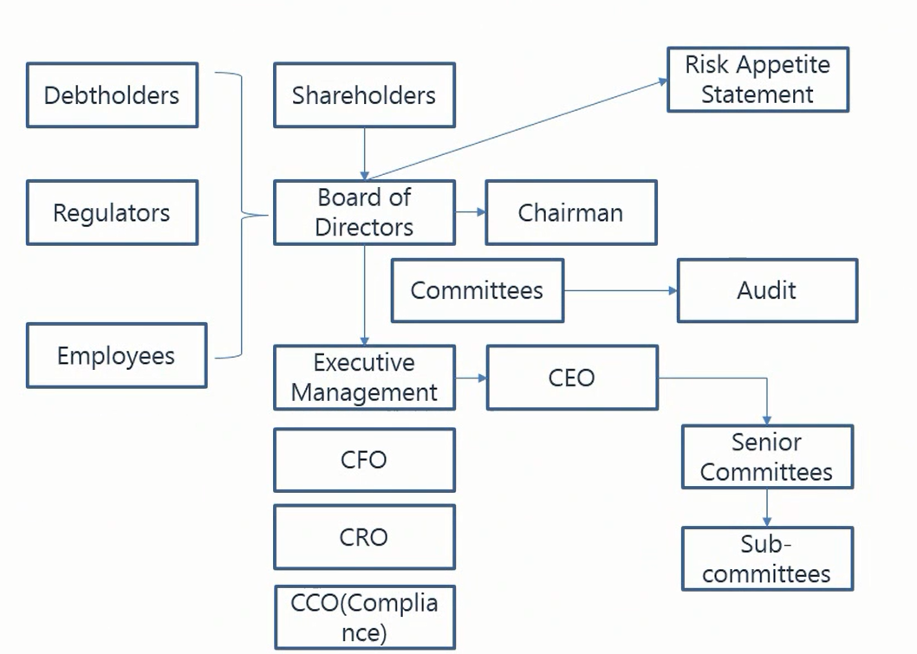

全体股东选举设置董事会（由债主、监管、员工组成），进而推出风险偏好的声明。

董事会选举出主席（董事长），和管理层（职业经理人）。

The Board of Directors

The board plays a central role ion risk management, especially in shaping and overseeing risk.

**The board should (Basic functions)**

* Look after the interests of shareholders (gatekeeper) 主要照顾股东利益
* Be responsible for the concerns of other stakeholders (debt holders and employees)
* Oversee executive management and alert for any conflict of interests between the management and stakeholders (agency problems) 以防高管出现代理问题
* Separate the role of the CRO and the chairman of the board 重点。CEO和chairman合在一起是不合适的。

**The board should (Advanced functions)**

* Decide appropriate risk appetite 不能因为是团队的指责而导致个人不作为
* Assess firm’s risk management systems and procedures
* Ensure major transactions are consistent with the risk authorized
* Keep the disclosure adequate and transparent
* Balance the risk and rewards
* Take the ultimate responsibility 核心，作为最终负责人
* Be trained on risk issues

## Committees

The board often delegates its power to some professional committees to implement risk appetite and break it down into a set of practical restrictions and limitations.

**Risk Management Committee 风险管理委员会**

* Set risk appetite on annual basis
* Translate the overall risk appetite into a set of limits
* Approve and independently review risk levels
* Report back to the board on a variety of items, such as all loans and credits over a specified dollar limit

**Risk Advisory Director: 当风险管理委员会中没有专家时，需要引入风险咨询顾问**

Is a member of the board who specializes in risk matters 一定要是专家

**Compensation Committee 薪酬管理委员会**

* Determine the compensation of top executives 员工的薪酬由CXO去定
* Be aligned with the long-term interests of stakeholders, and with risk-adjusted return on capital
* Removal of guaranteed bonuses 减少有保障的分红
* Stock-based compensation can encourage risk-taking 注意，CRO不适合此政策

**Audit Committee of the Board 审计管理委员会**

考试中经常需要和风险管理委员会做区分。通常审计管理委员会只会说“对”，“错”，“不知道”，“无可奉告”等，并对说过的话负责，不会提出建议。

* Independently verify whether the firm is doing what it claims to be doing 只做verify，不做suggestion
* Check for discrepancies and infringements in regulatory, legal, compliance, and risk management activities
* Assess the quality of reporting, compliance, internal control, and risk management processes
* Audit committee members are required to be knowledgeable, capable of independent judgment, financially literate (有知识), and have the utmost integrity (最大程度的诚信) 总之就是要有专业素养

## The Right Degree of Independence for Risk Managers

* Risk management is not an audit:
  + Auditors only have a verification function
* If risk managers are viewed as policemen:
  + It will face obstacles in gathering information
* The reporting lines of risk managers should be completely separate from the businesses
  + Business lines have a strong commitment to managing risk: business lines collaborate with risk managers.

## The Independence of Risk Governance

|  |  |  |
| --- | --- | --- |
| Senior Management 高管，整体评估   * Sets business level risk tolerances * Designs and manages policy * Evaluates performance | → | Business Line 前台   * Takes on and manages exposure to approved risks * Verifies valuations |
| ↑ |  | ↓ |
| Risk Management 后台   * Manages risk policy development and implementation * Monitors limits * Controls model implementation risks * Gives senior management independent risk assessments | ← | Finance & Operations 中台，提供支持   * Sets and manages valuation & finance policies * Oversees official valuations including independent verifications * Manages and supports analyses required for business planning * Ensures proper settlement / deal capture / documentation 文件归档 |

# Chapter 5 Credit Risk Transfer Mechanisms

Source: P4

## Use of Credit Risk Transfer Tools

Traditional transfer of credit risk

* Requiring collaterals 抵押物
* Purchasing insurance from third-party counter-parties 买保险
* Netting of exposures to counter-parties 净额结算，降低交易笔数
* Marking to market / Margining 保证金
* Termination by a set of trigger events 止损，有条件终止
* Reassignment of a credit exposure to another party 找接盘

Credit derivatives create new transfer strategies

Risk transfer and securitization (证券化) enables institutions to effectively tailor pools of credit-risk exposures by repackaging of risk 证券化是非常有效的危机转移机制

* The issuance of securitized loans soared from 0 in early 1990s to almost $5 trillion in 2006.
* A robust, liquid, and transparent market was built, and credit derivatives contributed to the process of credit price discovery.

## The Mechanics of Securitization

SPV (Special Purpose Vehicle)

|  |  |
| --- | --- |
| Uses of Funds | Sources of Funds |
| Collateralized Assets | Equity + Liabilities |
| Asset Pool   * ABS * Corporate Investment   Grade Loans   * Leveraged Loans杠杆贷款 * Mortgages 按揭 | Senior Bonds  Junior Bonds  Equity Tranche |

## From Buy-and-hold to Originate-to-distribute

资产证券化的优势：

* Originators benefited from greater capital efficiency (by Basel capital adequacy requirements) and enhanced funding opportunities, as well as lower earnings volatility 资本上有优势
* Investors benefited from a wider array of investments, allowing them to diversify their portfolios and better sync their risk/return profiles 投资者拥有更多的投资产品
* Borrowers benefited from the expansion of available credit and product options, as well as from the lower borrowing costs

## Issues Addressed in Securitization

Securitization amplified systemic risk during the crisis by allowing massive leverage and risk concentration in the financial sector

* Loan origination: compensation was tied to high loan volumes 激励方案和贷款规模绑定
* Securitization: the risk embedded was not transparent for investors 投资者缺少知情权
* Credit rating: overreliance on the accuracy and transparency of credit ratings
* Risk management: poor risk management in many segments (e.g. assessment, stress test)

# Chapter 6 the Standard Capital Asset Pricing Model

Source: P4-P5

## Markowitz Portfolio Theory马科维茨理论

Mean Variance Model

* Expected Return: E(R)
* Risk: σ（西格玛，表示标准差）

Indifferent Curve无差异曲线（等效用线）

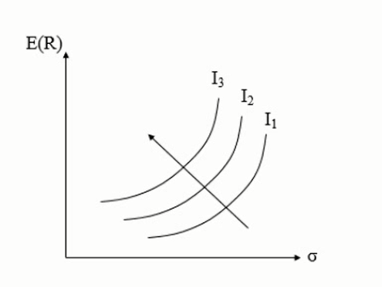

对于理性人的投资，既不是收益的最大化，也不是风险的最小化，而是收益的最大化。因此对于上图来说，I3曲线最佳。

但是此模型过于简单，没有考虑更加复杂的因素，如投资人的归属感、道德观念等。因此后人也会有很多的模型来改良它。

A rational person: 一个理性的人

* Risk aversion 风险厌恶者，马科维茨理论认为所有理性人都是风险厌恶型。
* Risk neutral 风险中性
* Risk preference 风险喜好者

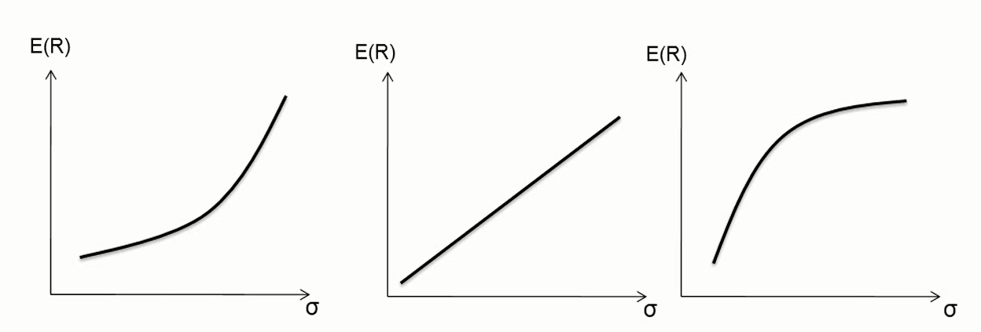

Assumptions about a Markowitz investor 一个完美的市场

1. No transaction costs
2. Assets are infinitely divisible 资产无限可分
3. The absence of personal income tax
4. An individual cannot affect the price of a stock by his trading
5. Investors make decision solely in terms of returns and standard deviation of the returns
6. Unlimited short sales are allowed
7. Unlimited lending and borrowing at the riskless rate
8. All investors have identical expectation: μ, σ, ρ
9. All assets are marketable

Markowitz Efficient Frontier 有效前沿

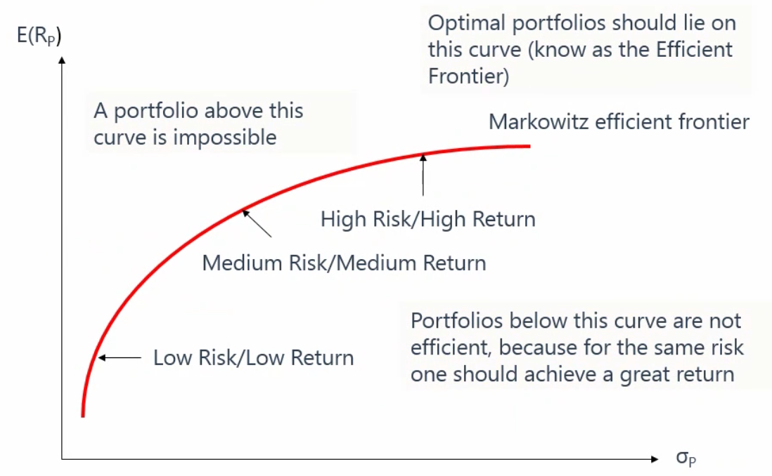

## Minimum Variance Portfolio 最小方差组合

Definition: the portfolio with the smallest variance among all possible portfolios on a portfolio possibilities curve.

最小方差组合是图形上风险最小的那个点。

The shape of the portfolio possibilities curve is best described in two pieces: 形状描述

1. The portion of the portfolio possibility curve that lies above the minimum variance portfolio is concave 上面的就是有效前沿，是凹的（哭脸形状）
2. The portion of the portfolio possibility curve that lies below the minimum variance portfolio is convex 下面的组合是无效的，是凸的（笑脸形状）

思考上述图形，风险不可能等于或是接近0，即不存在无风险投资。但是现实生活中此类投资是存在的，如银行活期存款，即使有风险，也无限接近与0。因此William Sharpe对马科维茨的图形做了改进。

## Capital Market Line (CML)

The point of tangency （切点） – Portfolio P, is known as the market portfolio. When one can lent or borrow money use riskless rate, investor will hold a combination of the market portfolio and the risk-free asset.

Risk-averse investors will create lower risk portfolios by lending (i.e. investing in the risk-free asset). More risk-tolerant investors will increase portfolio return by borrowing at the risk-free rate.

无风险投资组合是E（R）轴上的一个点。它与任何投资组合结合形成的新的投资组合都是线性关系。

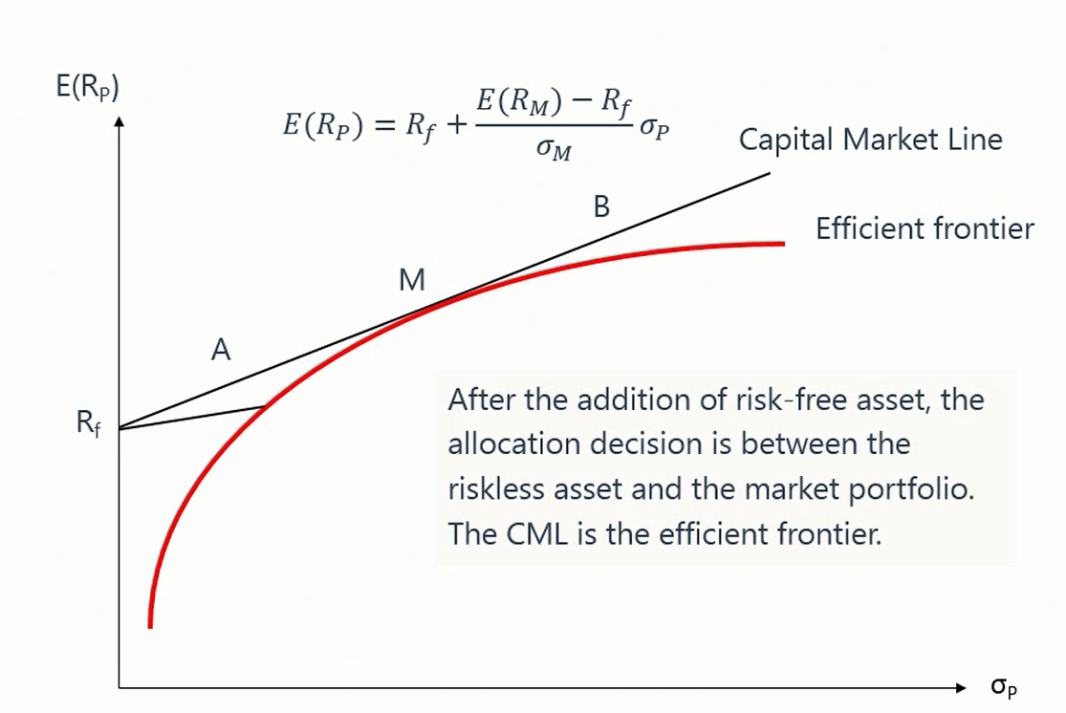

在这个状态下，马科维茨的有效前沿被AB射线取代。M点以外（如B点）代表加杠杆投资。

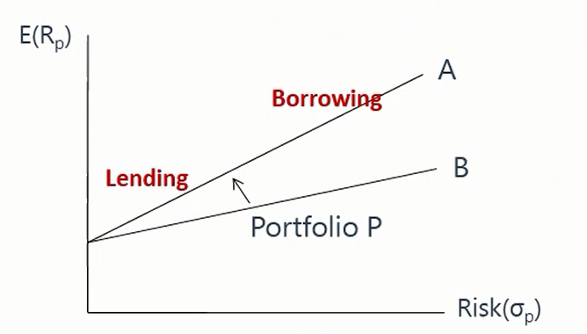

在P点左边的投资组合是由无风险投资（活期/借钱）和投资组合混合，成为Lending Portfolio。在P点右边是从银行借钱加杠杆投资，成为Borrowing Portfolio。

现实生活中，最接近P点的应该是囊括各种投资组合的产品，比如沪深300指数，标普500指数等（但是他们只是股票指数，因此仍然不够全面）。

# Chapter 7 Arbitrage (套利) Pricing Theory

# Chapter 8 Risk Aggregation and Reporting

# Chapter 9 Enterprise Risk Management

# Chapter 10 Learning from Financial Disasters

# Chapter 11 Anatomy (剖析) of the Great Financial Crisis of 2007-2009

# Chapter 12 GRAP Code of Conduct

# 附件和链接

## 学习视频链接

**乐橙网学习视频**

<https://www.bilibili.com/video/BV1Nb411G7oB>

# 考试技巧

1. 先找选项最长的，因为它信息最多。然后跟其他选项对比观察。