MEDICAL ASSISTANT CHATBOT

A Mini-Project Report

Table Of Contents

 | Contents | Page No
Acknowledgment |  | 5
Abstract |  | 6
List Of Figures |  | 7
List Of Abbreviations |  | 8
Introductions |  | 9
Literature Survey |  | 11
Methodology |  | 12
Implementation Details |  | 14
System Design |  | 18
Result |  | 20
Conclusion |  | 22
References |  | 23

ACKNOWLEDGEMENT

We extend our heartfelt gratitude to everyone who contributed to the successful completion of Medical Assistant Chatbot. Special appreciation goes to our project guide, Dr. Sonal Ayyappan, Head of the Dept. and Associate Professor, Dept. of Artificial Intelligence and Data Science, whose guidance and expertise were instrumental throughout the development process. Their insightful feedback shaped the project's direction and quality, and we're immensely thankful for their constant support.
Furthermore, we express our sincere appreciation to our Principal, Dr. Anitha G Pillai, for her visionary leadership and unwavering support. Her encouragement and guidance have been invaluable throughout this endeavor, and we are truly grateful for her belief in our abilities.
Additionally, we extend our gratitude to our project coordinator, Ms. Asha S Rakesh, Assistant Professor, Dept. of Computer Science and Engineering for her exceptional coordination and support. Her dedication to facilitating our progress and ensuring smooth communication has been integral to the success of this project.
We also extend our thanks to all mentors, peers, and loved ones whose support and collaboration enriched our journey. Their contributions, whether through sharing knowledge, offering feedback, or providing encouragement, played a crucial role in overcoming challenges and achieving our goals. Together, their collective efforts made this project possible, and we are deeply grateful for their unwavering dedication.

Advay Binu
Angelo Fijo
Arjun R K
Abhinav Jiju

ABSTRACT

Embracing the knowledge era in healthcare, this research explores a novel medical chatbot empowered by the formidable Llama 2 language model. Transcending the limitations of conventional chatbots, it leverages a trifecta of technological prowess: Llama 2's vast knowledge base and advanced understanding of medical language enable pinpoint- accurate responses, even to intricate inquiries. Streamlit's web framework sculpts an intuitive interface, empowering users to effortlessly navigate and visualize pertinent medical information. FAISS, the master of information retrieval, swiftly delivers curated medical resources tailored to the user's specific needs. This project paves the way for a future where medical chatbots, wielding the power of knowledge, empower individuals to navigate the complexities of healthcare with confidence.

LIST OF FIGURES

Fig.no | Title | Page No
3.1 | Model Diagram | 12
5.1 | Text Summarization | 18
5.2 | Transcript Summarization | 19
6.1 | Back end | 20
6.2 | Installing the Extension | 20
6.3 | Extension | 22
6.4 | Summarized Result | 22

LIST OF ABBREVIATIONS

ML Machine Learning
RAG Retrieval Augmented Generation
LLM Large Language Model
NLP Natural Language Processing

CHAPTER 1
INTRODUCTION
1.1 GENERAL BACKGROUND

Eyes are on the most important tools that is Llama2 Its encyclopedic knowledge and medical language and the proficiency ensure pinpoint-accurate responses, even to complex inquiries, StreamLit is a web framework sculpts an intuitive interface, enabling users to seamlessly navigate and visualize the gleaned medical information from the ingested data and FAISS is retrieval maestro swiftly delivers curated insights tailored to the user's specific needs within the provided context. Navigating the complexities of healthcare demands easy access to trustworthy medical information, a need often unmet by current chatbots. These systems often stumble on intricate inquiries or lack crucial context, hindering their ability to offer accurate and helpful responses. This research pioneers a revolutionary medical chatbot that reshapes the landscape by wielding the power of knowledge and context-aware processing. Unlike statically trained chatbots confined to pre-determined information, our proposed system thrives on a dynamic diet of medical knowledge. We harness the prowess of Llama 2, a language model notorious for its encyclopedic memory and nuanced understanding of medical language. Imagine throwing it a medical scenario PDF - it doesn't just memorize. It meticulously dissects the information, weaving it into the very fabric of its knowledge tapestry. This empowers the chatbot to transcend the limitations of static datasets, tackling even the most intricate, context-specific questions with precision and depth.
  - PURPOSE

The purpose of a medical assistant chatbot project is to provide users with instant and accurate information about medical conditions, symptoms, treatments, and general health inquiries. It aims to offer guidance, answer queries, and assist users in making informed decisions about their health.

  - SCOPE OF PROJECT

The project helps in providing reliable information on medical conditions, symptoms, and treatments Assisting users in assessing their symptoms and suggesting appropriate actions and also helps in providing basic first aid information and guiding users in an emergency situation.

CHAPTER 2 LITERATURE SURVEY
Speaker identification is meant to identify people by the unique characteristics of their
voices rather than to isolate separate words.

- J. Cahn et. al. This paper intends to unravel the attention and excitement surrounding Chatbots and their connection to conversational artificial intelligence. Both are gradually becoming more prevalent due to impressive advancements in machine learning, deep learning, and natural language comprehension.

- E. Tebenkov and I. Prokhorov et. al. Machine learning serves as a data analysis technique enabling analytical systems to learn while addressing numerous similar problems. Its premise lies in enabling these systems to identify patterns and make decisions with minimal human intervention. In training chatbots for automated interactions, completed dialogues between users serve as historical data. This article delves into various prevalent machine learning algorithms, detailing their applications in educating chatbots for effective communication.

- M. M. Hossain, S. Krishna Pillai, S. E. Dansy, and A. A. Bilong et. A chatbot is a software program that engages in conversations through text or speech. It serves various functions, such as swiftly responding to inquiries, providing information, facilitating product purchases, and enhancing customer service. Operated on Artificial Intelligence (AI) and Machine Learning frameworks, chatbots have gained popularity among businesses due to their capability to reduce customer service expenses and handle multiple users simultaneously. However, to optimize their performance across various tasks, it's crucial to enhance their efficiency.

CHAPTER 3 METHODOLOGY
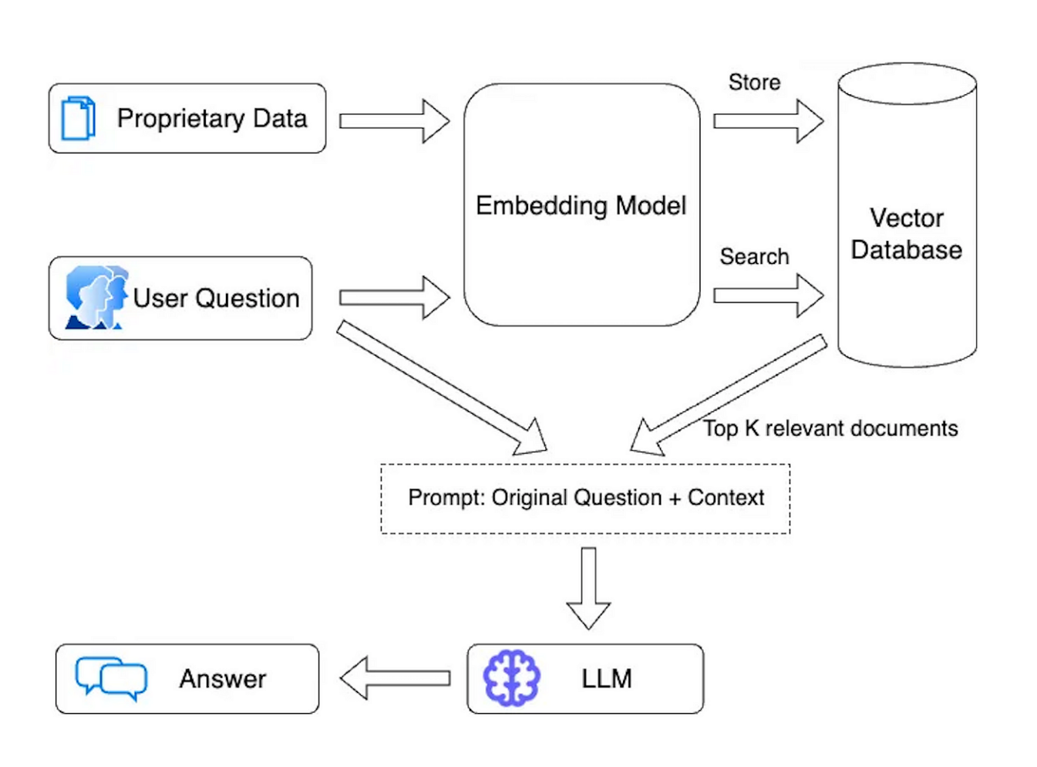
Fig 3.1 Model Diagram

- User Query:
The user inputs their required text as a query on to the application whether it maybe any questions or any facts or doubts related to any medical condition and clicks on the "Send" button provided by the application, it sends the query to the backend server. This query is later tokenized and processed.

- Tokenization:
After the user query is obtained it is then sent to the embedding model where the query is tokenized, meaning the query is split up into small tokens for further processing.

- Data Embedding:
This model converts the proprietary data into vector embeddings, which are
numerical representations of the data's semantic content. The generated embeddings
are stored in a vector database. This database allows for efficient searching and
retrieval of relevant documents based on their embeddings.

- User Query Processing:
The embedding of the user query is used to search the vector database. The database
retrieves the top K relevant documents (embeddings) that closely match the query
embedding.

- Contextual Prompt Creation:
For the Prompt Generation, the original user question and the context from the retrieved documents are combined to form a comprehensive prompt. This prompt is designed to provide the language model with sufficient context to generate a relevant and accurate response.

- Response Generation:
The LLM then based on the contextual prompt given, is fed into the large language model which here is the Llama2 model, which generates a detailed and coherent answer based on the provided context and query. Hence producing the desired response based on the user input query.

CHAPTER 4 IMPLEMENTATION DETAILS

  - SOFTWARE REQUIREMENT

Operating System:
Compatibility with Windows 10 and 11, macOS, or a Linux distribution with recent updates.

Web Browser:
Full support for Google Chrome, ensuring compatibility and optimal performance. Compatibility testing across other major browsers like Firefox and Edge for broader accessibility.

Python Environment:
Installation of Python 3.10 for backend development. The Streamlit Framework for frontend for the website and many from the lang-chain packages.

Dependencies:
Installation of necessary dependencies using pip, including Streamlit, Llama2 a language model, and transformers from the LangChain Community. The dependencies can be downloaded from reqirements.txt

Virtual Environment:
Setup of a virtual environment for isolated dependency management for Python.

Langchain Community Library:
Integration of Langchain libraries for most of the processing of most of the backend work.

Llama2 Language Model:
Integration of Llama2 language model library for NLP.

5.2. FUNCTIONAL REQUIREMENT

Transcript Retrieval

Requirement:
The system should be able to retrieve YouTube video transcripts using the YouTube Transcript API.

Criteria:
Upon user request the system accepts the YouTube video link and fetches the transcript data from the YouTube Transcript API.

Knowledge Base

Requirement:
The system must perform abstractive text summarization on the obtained YouTube video transcript.

Criteria:
Utilizing the trained model, we summarize the obtained transcript using abstract text summarization.

User Interaction

Requirement:
The application should provide a user-friendly interface.

Criteria:
The application’s User Interface is kept to the very minimal so that it is extremely user friendly. There is a specific space kept for user queries and upon clicking the sent button, the application should initiate the process and
provide back with relevant results.

HTTP REST API Calls

Requirement:
The system should establish HTTP REST API calls between the Chrome Extension and the backend.

Criteria:

Creating a Flask API Route with a GET HTTP request method, extract the YouTube video ID from the URL and triggering the transcript generation and summarization functions also returning the result with an HTTP status OK

Deployment Considerations

Requirement:
The system should provide guidance for loading and deploying the application.

Criteria:
The application includes a manifest file with essential details that instruct users to enable the user mode or developer and load the application in all of the desired platforms which are connected to the same network as the deployed device from the localhost link.

  - NON-FUNCTIONAL REQUIREMENTS

Performance and Scalability

Requirement:
The system must achieve real-time or near-real-time summarization for optimal user experience.

Criteria:
The execution of the program to be done within the acceptable time frame, considering the query length and the user queries.

Reliability and Usability

Requirement:
The system should minimize downtime and ensure a user-friendly interface.

Criteria:
Implemented error handling mechanisms to enhance reliability.

Security and Maintainability

Requirement:
The system must implement robust security measures and facilitate easy maintenance.

Criteria:
Ensures secure handling of user data during all processes.

Availability and Response Time

Requirement:
The application should be consistently available, and API calls must meet the required response time targets.

Criteria:
Implement strategies to minimize application downtime.
Optimize processes to achieve specified response time targets for application
execution and response time.

CHAPTER 5 SYSTEM DESIGN

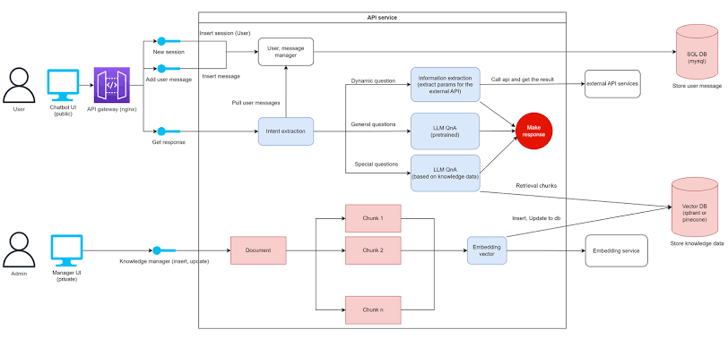

Fig 5.1 Design of System

Data Collection:

In the initial phase, the acquisition of data relevant to diseases, their prevention, and treatments is a fundamental step. This process may involve data sourcing from public databases or the collection of user inputs via surveys or questionnaires.
Data Cleansing and Preprocessing:

Subsequent to data collection, meticulous data cleansing and preprocessing are carried out. These activities aim to rectify errors, eliminate duplicates, and resolve inconsistencies. Additionally, natural language processing techniques are employed to extract key attributes from descriptions of diseases, preventive measures, and treatments.

Feature Extraction:
Pertinent features are then extracted from the preprocessed data. These features encompass typical symptoms, recommended remedies, and medications, forming the foundation for the chatbot’s algorithm training.

Model Training:
The development of the chatbot involves training various machine learning algorithms such as Llama 2, FAISS similarities, or Lang Chain. The model is trained using the preprocessed data to discern patterns and correlations between diseases and their respective treatment options

Assessment:
Following model training, an essential phase involves assessment. The model’s performance is evaluated in terms of accuracy, comprehensiveness, and user satisfaction. Evaluation metrics such as precision, recall, or mean average precision may be employed for this purpose.

Deployment:
Upon successful evaluation and optimization, the model is prepared for deployment on a website or mobile application, allowing users to interact with the system effectively.

CHAPTER 6 RESULT
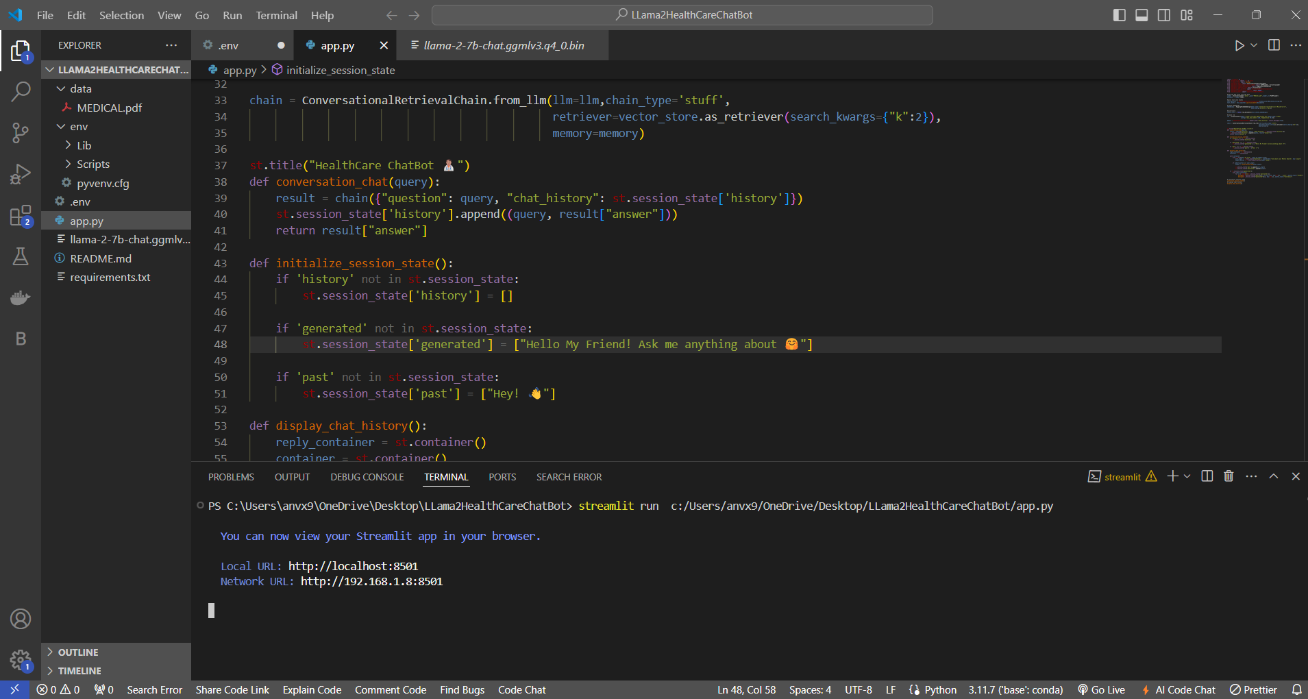

Fig 6.1 Execution on VS Code

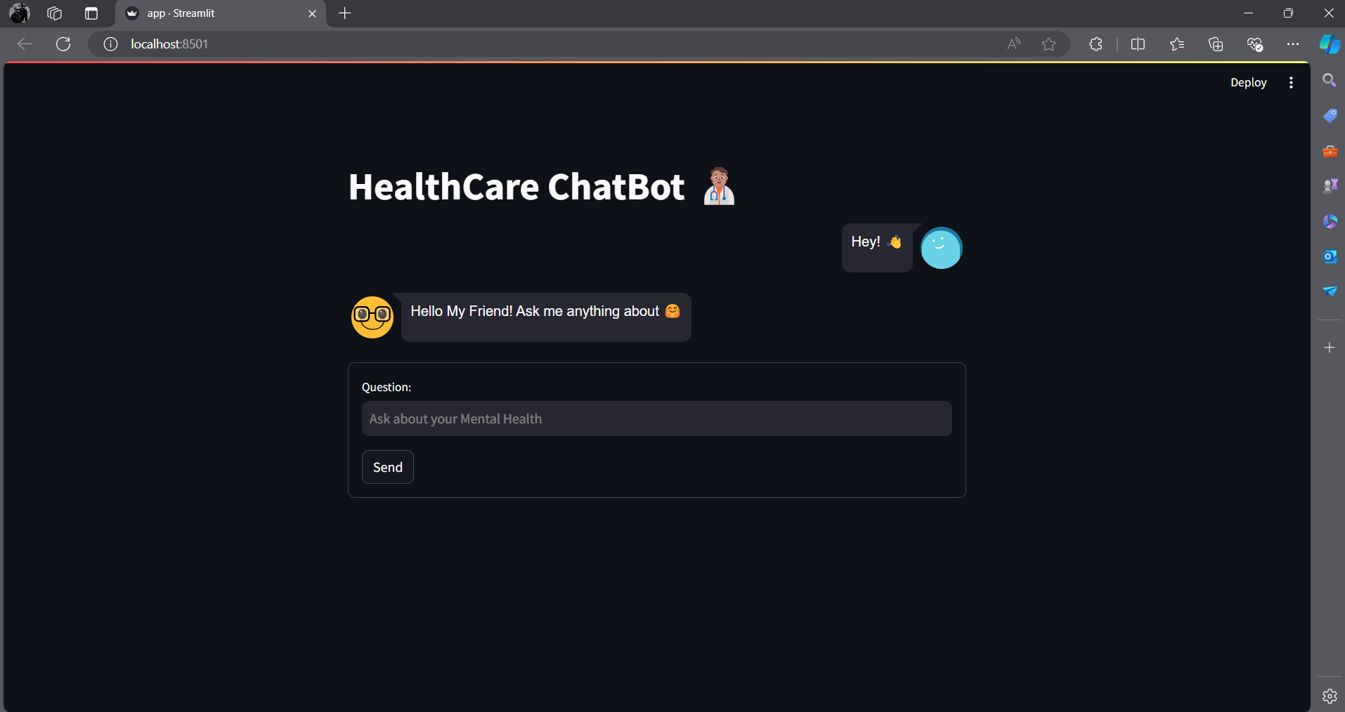
Fig 6.2 Local host on Edge (Desktop)
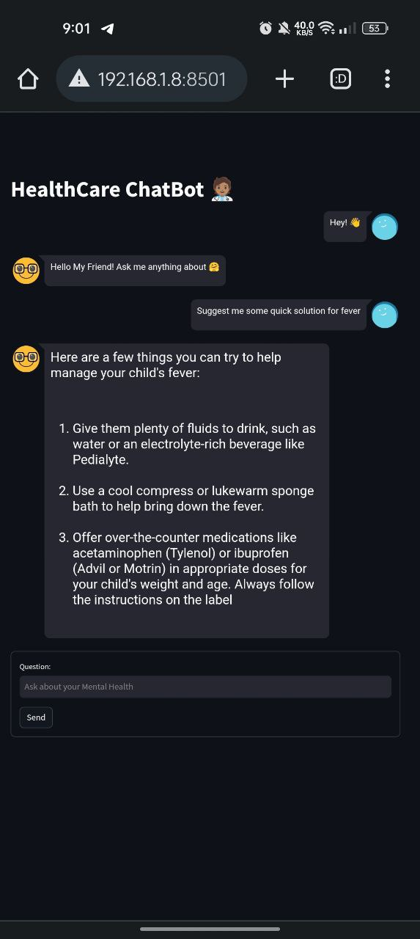

Fig 6.3 Localhost opened in Android

CHAPTER 7
CONCLUSION
Powered by the robust combination of Llama2 and Streamlit, this innovative medical chatbot elevates patient engagement by leveraging advanced NLP for precise symptom input and accurate information delivery. Continuously evolving with an eye towards the future, the chatbot's capabilities will be further refined through the integration of machine learning for adaptive responses and an expanding knowledge base. Additionally, emerging technologies hold promising avenues for enhancing user interactions and tailoring healthcare recommendations. This forward-thinking initiative not only addresses immediate healthcare needs but also establishes a platform built for ongoing improvement, adapting to user requirements and staying abreast of technological advancements.

REFERENCES

1. J. Cahn, ‘‘CHATBOT: Architecture, design, & development,’’ Dept. Com put. Inf. Sci., Univ. Pennsylvania School Eng. Appl. Sci., Philadelphia, PA, USA, Tech. Rep. EAS499

2. E. Tebenkov and I. Prokhorov, ‘‘Machine learning algorithms for teaching AI chat bots,’’

Proc. Computer Sci., vol. 190, pp. 735–744, Jan. 2021

3. R. Dharwadkar and N. A. Deshpande, ‘‘A medical chatbot,’’ Int. J. Computer Trends Technol., vol. 60, no. 1, pp. 41–45, 2018

4. "Llama2: A Pretrained Language Model for Medical Language Understanding and Generation" by Yifan Peng, Yinhan Liu, Shaohan Yang, Barret Zoph, Tao Jiang, and Yonghui Wu (2022)

5. "Faiss : A Library for Efficient Similarity Search" by H. Jegou, M. Douze, and C. Schmid (2011)

6. Hugging Face(www.huggingface.co)

