SRS DOCUMENT

GROUP MEMBERS

PROJECT GUIDE:

Contents

INTRODUCTION
  - Purpose
  - Scope of project
  - System Overview

GENERAL DESCRIPTION
  - Product Functions
  - User Characteristics
  - User Objective
  - General Constraints

FUNCTIONAL REQUIREMENTS
- NON-FUNCTIONAL REQUIREMENTS

SYSTEM REQUIREMENTS
  - Hardware Requirements
  - Software Requirements

SEQUENCE DIAGRAM 7.USER CASE MODEL 8.APPENDICES
9.1 References

INTRODUCTION

  - Purpose
The purpose of a medical assistant chatbot project is to provide users with instant and accurate information about medical conditions, symptoms, treatments, and general health inquiries. It aims to offer guidance, answer queries, and assist users in making informed decisions about their health.
  - Scope of project

The project aims to create a chatbot capable of providing medical assistance and information to users. It will be designed to interact with users in a conversational manner, providing answers to medical queries, scheduling appointments, providing reminders for medication, and offering general health advice.

  - System Overview
The system will consist of a chatbot interface accessible through various platforms such as web browsers, mobile applications, and messaging platforms. It will utilize natural language processing (NLP) techniques to understand user queries and provide accurate responses

GENERAL DESCRIPTION
  - Product Functions
The software offers the following key functions:

- Respond to user queries related to medical conditions, symptoms, treatments, and medications.
- Schedule appointments with healthcare professionals.
- Provide reminders for medication intake and appointments.
- Offer general health advice and tips.
- Maintain a conversational interface for user interaction.

  - User Characteristics
Users of the chatbot may include individuals seeking medical information, patients scheduling appointments, caregivers managing medication for their loved ones, and healthcare professionals seeking quick references.

  - User Objective

Users aim to obtain accurate and timely medical information, schedule appointments conveniently, and receive reminders for medication and appointments.

  - General Constraints
- Compliance with medical regulations and privacy laws (e.g., HIPAA).
- Integration with existing healthcare systems (e.g., appointment scheduling systems).
- Accuracy and reliability of information provided to users.
- Scalability to handle a large number of users simultaneously.

FUNCTIONAL REQUIREMENTS

Functional Requirements:

1) User Registration: Allow users to create accounts or use the chatbot without registration for personalized features.

2) User Authentication: Ensure secure access to user accounts and protect sensitive health information.

3) Natural Language Processing (NLP): Implement NLP algorithms for understanding and interpreting user queries in natural language.

4) Knowledge Base: Maintain an up-to-date database with accurate information on medical conditions, symptoms, treatments, medications, and general health advice.

5) Symptom Checker Algorithm: Develop an algorithm to assess user-reported symptoms and provide relevant information or suggest appropriate actions.

6) Medication Database: Include a comprehensive database of medications, including dosage, side effects, and potential interactions.

7) Appointment Scheduling System: Integrate with scheduling tools to facilitate the booking of medical appointments, including virtual consultations.

8) Healthcare Provider Integration: Connect with healthcare providers for virtual consultations or follow-up appointments.

9) Machine Learning (ML): Implement ML models for personalized recommendations, continuous improvement, and refining responses based on user interactions.

10)Security Measures: Implement robust security protocols to safeguard users' health data and ensure compliance with privacy regulations.

11) Multi-language Support: Support multiple languages to cater to a diverse user base.

12) Feedback Mechanism: Include a feedback system for users to provide input, helping improve the chatbot's performance.

NON-FUNCTIONAL REQIREMENTS

1) Performance: The chatbot should respond to user queries promptly, ensuring a seamless and quick user experience.

2) Reliability: The system should be reliable, minimizing downtime and ensuring users can access information when needed.

3)Scalability: The chatbot should be scalable to handle a growing user base and increased data volume without a significant decrease in performance.

4)Usability: The user interface should be intuitive, user-friendly, and accessible, catering to users with varying levels of digital literacy.

5) Accessibility: Ensure the chatbot is accessible to users with disabilities, complying with accessibility standards.

6) Security: Implement robust security measures to protect user data, ensuring confidentiality and compliance with privacy regulations.

7) Compatibility: The chatbot should be compatible with a variety of devices and platforms to reach a broader audience.

8) Maintainability: The system should be easily maintainable, allowing for updates, bug fixes, and improvements without significant disruptions.

SYSTEM REQUIREMENTS

  - Hardware Requirements
    - Processor

Minimum:
        - Dual-core processor to handle basic functionality.

Recommended:
        - Quad-core processor for improved performance, especially during text summarization processes.

    - Memory (RAM)

Minimum:
        - 4 GB RAM to support basic extension operations.

Recommended:
        - 8 GB or higher for enhanced system responsiveness, especially during concurrent tasks.

    - Storage

Minimum:
        - 20 GB available storage space for storing extension-related data.

Recommended:
        - Consider utilizing SSD for faster data access and retrieval.

    - Network Connectivity

o A stable internet connection is essential for API calls and overall extension functionality.

    - Graphics

o Standard integrated graphics are sufficient for the operation of the extension.

    - Operating System

Compatibility:
        - The extension should be compatible with Windows, and Linux operating systems.

    - Web Browser

o The extension should support and operate seamlessly within Google Chrome.

    - Input Devices

o Standard keyboard and mouse for user interaction with the extension.

    - Display

o A standard monitor with a minimum resolution of 1024x768.

  - Software Requirements
    - Operating System

      - Compatibility with Windows 10, macOS, or a Linux distribution with recent updates.

    - Web Browser

      - Full support for Google Chrome, ensuring compatibility and optimal performance.
      - Compatibility testing across other major browsers like Firefox and Edge for broader accessibility.

    - Python Environment

      - Installation of Python 3.x for backend development.

    - Flask Framework

      - Utilization of the Flask framework for creating the backend RESTful API.

    - Dependencies

      - Installation of necessary dependencies using pip, including Flask, Llama2 model and transformers[torch].

    - Virtual Environment

      - Setup of a virtual environment for isolated dependency management.

    - Llama2 Language Model

      - Integration of Llama2 language model library for abs text summarization.

    - Chrome Extension Development

      - Use of a text editor or integrated development environment (IDE) for extension development (e.g., Visual Studio Code).

SEQUENCE DIAGRAM

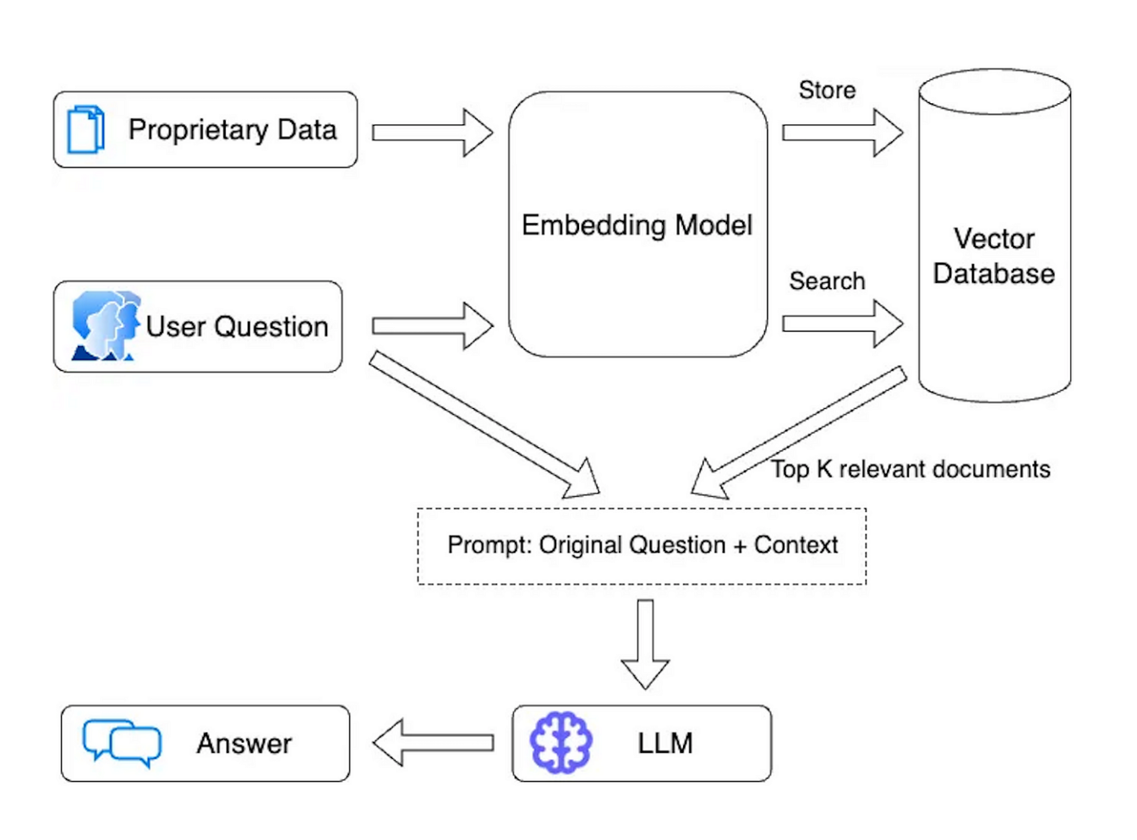

- USE CASE MODEL

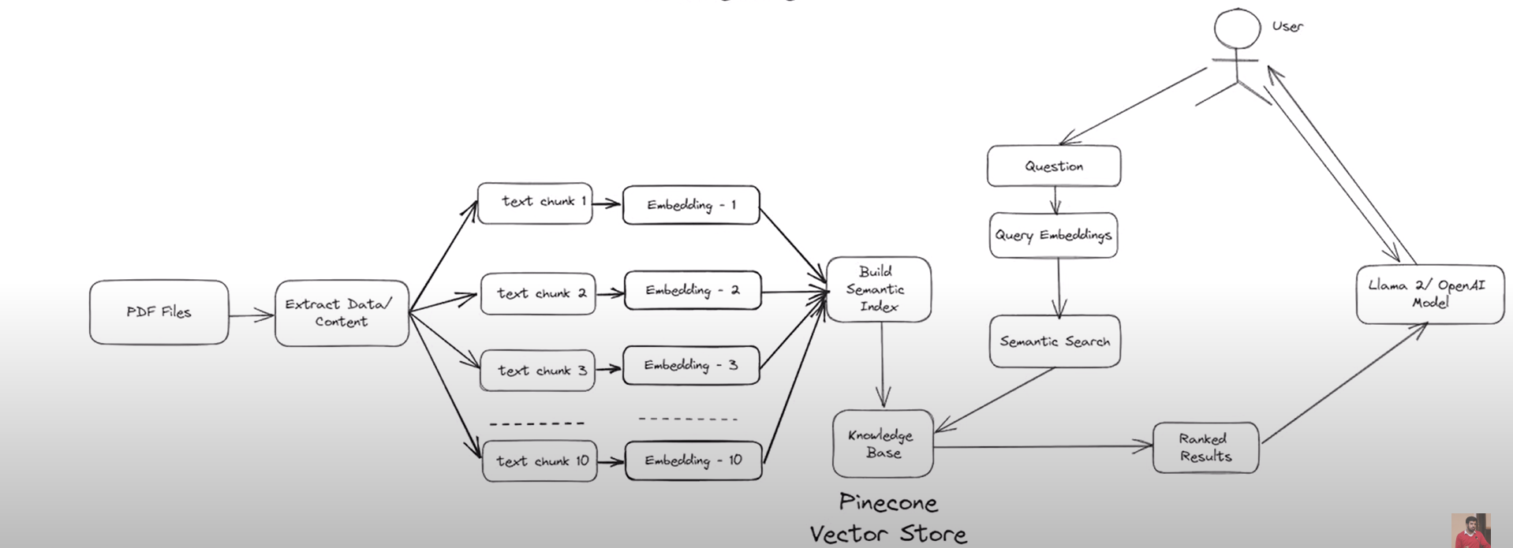

APPENDICES

  - References
- Bui, Duy Q., et al. "An evaluation of medical chatbots based on real-life doctor-patient conversations." npj Digital Medicine 3.1 (2020): 1-9.
- Pratap, Abhinav, et al. "Chatbots in telehealth: A study of the impact of personality and emotions in health-related outcomes." Computers in Human Behavior 110 (2020): 106370.
- Wikipedia

